A Mini-Project Report on

**RESTAURANT MANAGEMENT SYSTEM**

Submitted by

**Shreekanth Dash (19GACSE053)**

**Shubham N J (19GACSE057)**

**5th Semester, CSE**

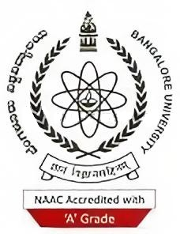

Under the guidance of

**Dr. Dharamendra Chouhan**

**Associate Professor**

**Dept. of CSE**

**UVCE**

**Mrs. Suhasini Bagalkot**

**Guest Faculty**

**Dept. of CSE**

**UVCE**

**Department of Computer Science and Engineering**

**UNIVERSITY VISVESVARAYA COLLEGE OF ENGINEERING**

K.R. Circle, Bengaluru- 560001

March-2022

Bangalore University

**UNIVERSITY VISVESVARAYA COLLEGE OF ENGINEERING**

K.R. Circle, Bengaluru- 560001



**Department of Computer Science and Engineering**

**CERTIFICATE**

This is to certify that **Shubham N J** of 5th Semester, B.Tech, Computer Science and Engineering, bearing the register number **19GACSE057** has submitted the DBMS Mini-Project Report on **“RESTAURANT MANAGEMENT SYSTEM”**, in partial fulfilment for the DBMS Lab, prescribed by the Bangalore University for the academic year 2021-22.

|  |  |  |
| --- | --- | --- |
| **Dr. Dharamendra Chouhan** | **Mrs. Suhasini Bagalkot** | **Dr. H. S. Vimala** |
| **Associate Professor** | **Guest Faculty** | **Chairperson** |
| **Dept. of CSE** | **Dept. of CSE** | **Dept. of CSE** |
| **UVCE** | **UVCE** | **UVCE** |

**Examiners:**

|  |  |
| --- | --- |
| 1. **……………………………** | 1. **……………………………** |