**CHAPTER 4**

**RESULTS AND SCREENSHOTS**

**4.1 Home page**

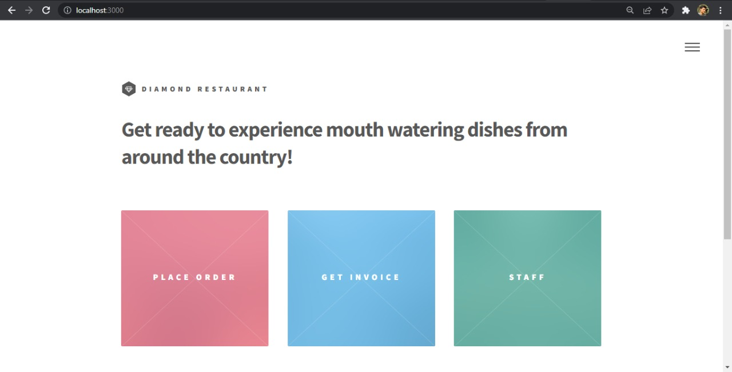

**4.2 Manager page(for Menu Form)**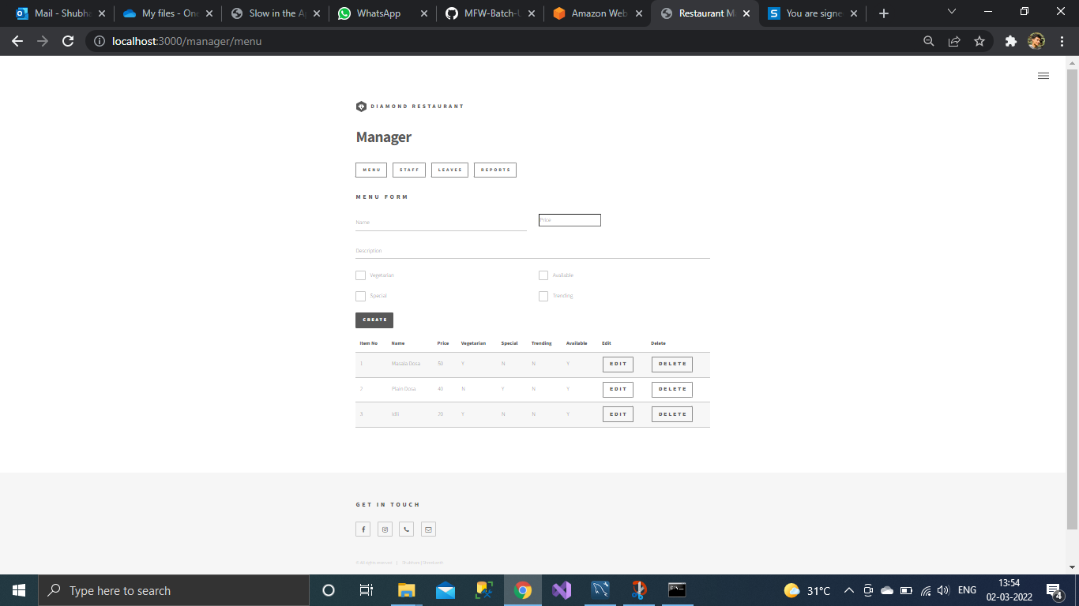

**4.3 Manager page(for Staff Form)** 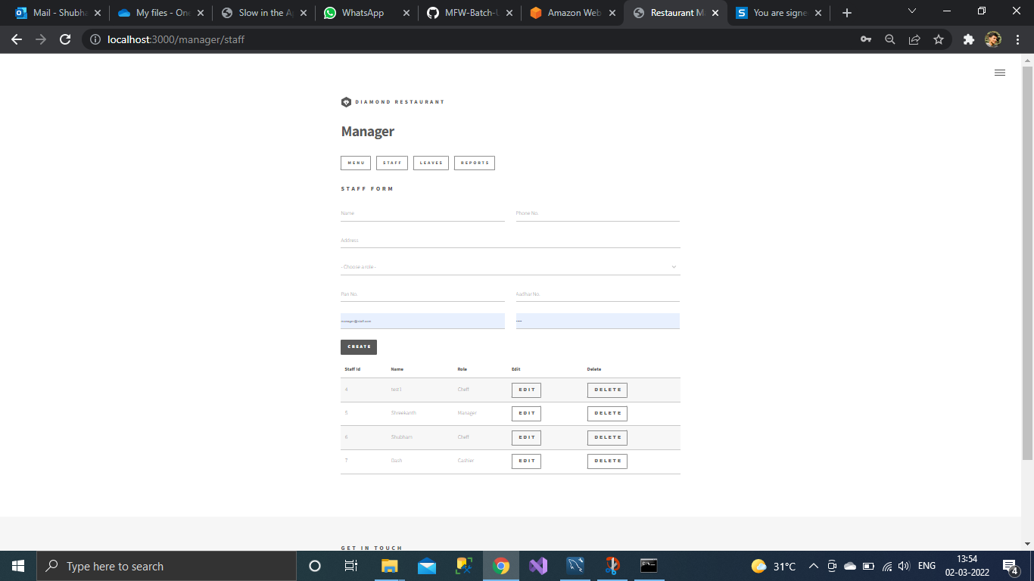

**4.4 Manager page(for Reports Form)**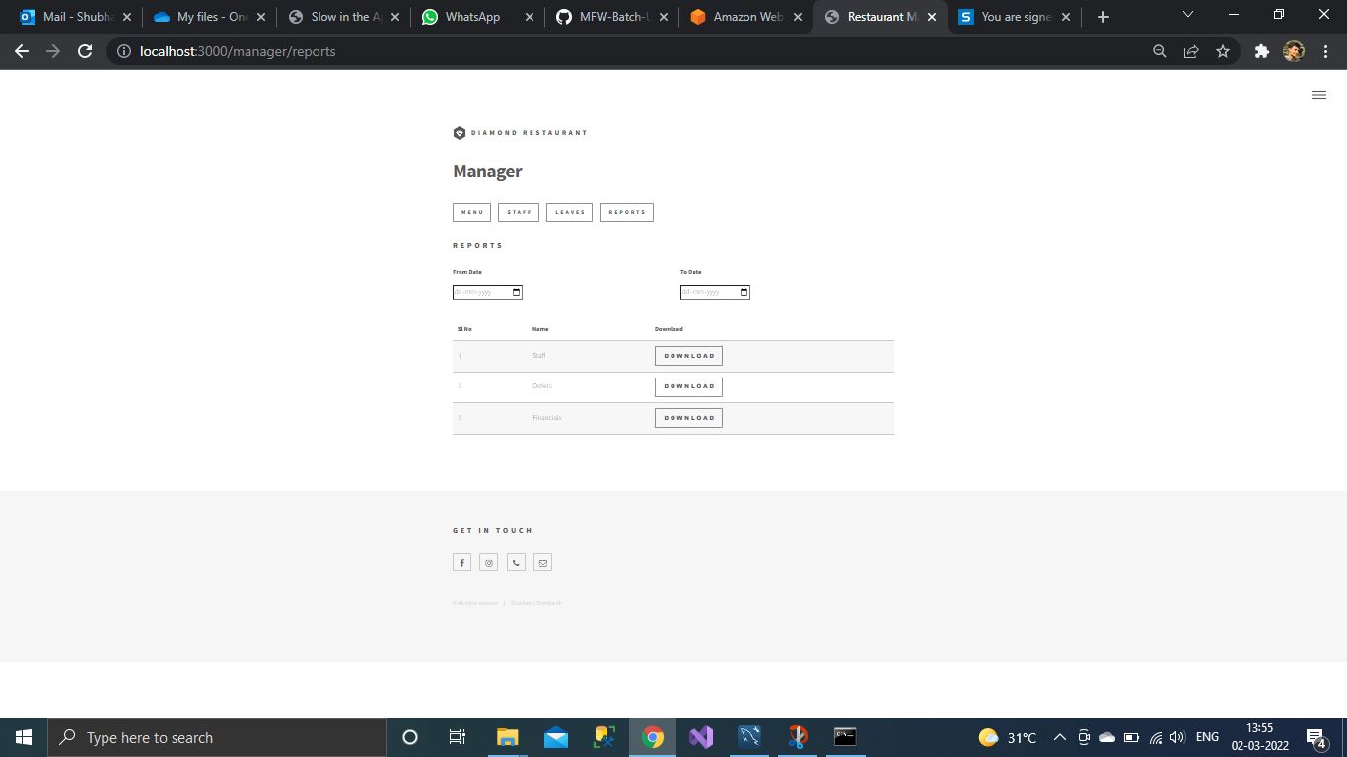

**4.5 Attendance Window for all Staff Employees** 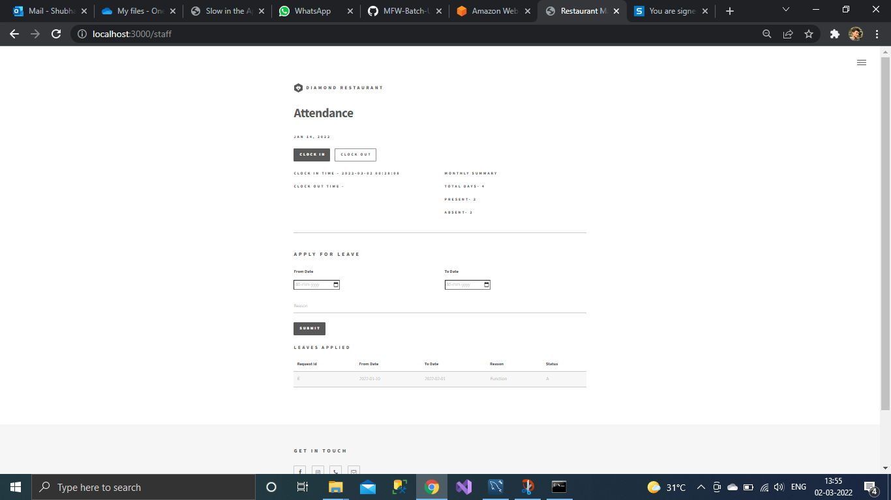

**4.6 Staff Window to apply Leave 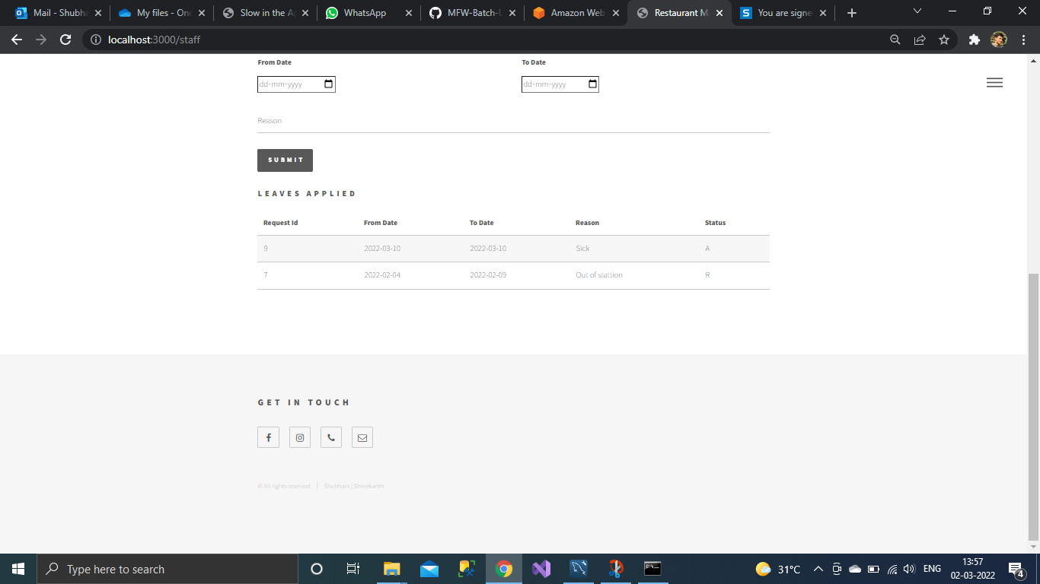4.7 Customer page**