Lab 1 (2%)

Built-in numeric, categorical, date functions

acknowledgment

We, VEDANT PATEL, SOPHIA HUYNH, DIVNOOR SINGH BHANDOHAL declare that the attached assignment is our own work in accordance with the Seneca Academic Policy. No part of this assignment has been copied manually or electronically from any other source (including web sites) **or distributed to other students.**

Specify below what each member has done towards the completion of this work:

Name Task(s)

1- DIVNOOR SINGH BHANDOHAL 1-4

2- SOPHIA HUYNH 5-7

3- VEDANT PATEL 8-10

Part III: Review of SQL SELECT statement

You are to create a new database named “AviaCo” and run the sql script you are given to create the tables in the database.

For each of the following questions, write the sql query (in text) and show the result set underneath each SQL query.

1. Show the customer code, first and last name of customers whose balance is positive and have their area code 713.

**Query:** select cus_code, cus_lname , cus_fname from CUSTOMER

Where (CUS_BALANCE > 0) AND cus_areacode = 713;

**Result:**

1. Show all customers by displaying the customer first and last name, area code and phone number and balance as just one column (concatenated) named customers.

**Query:**

select CONCAT(cus_fname,' ',cus_lname,', ',cus_areacode,', ',cus_phone, ',',cus_balance) AS Customers from CUSTOMER ;

**Result:**

1. Show the last name and first name all in capital letters of all employees whose last name starts with 'O'.

**Query:**

select UPPER(cus_lname) as First_name , UPPER(cus_fname) as Last_name from customer

WHERE cus_lname like 'o%';

**Result:**

1. Check whether some customer phone numbers are invalid. Show the customer code whose phone number is less than 8 characters length.

**Query:**

select cus_code from customer

Where LEN(cus_phone) = 8;

**Result:**

1. Display the customer code and phone number and the last 4 characters of the phone number in a separate column. Provide the alias “last 4 dig” for last 4 characters of the phone number column.

SELECT RIGHT(CUS_PHONE, 4) AS "LAST_4_DIG"

FROM CUSTOMER

1. Write a query that changes any s (lower or upper case) in the first name of customers to $. List only those that their names changes.

SELECT REPLACE(CUS_FNAME, 's', '$') as CUS_FNAME

FROM CUSTOMER

WHERE CUS_FNAME LIKE '%[s]%'



1. Each charter is characterized by a traveled distance. The goal is to inspect the charter distances across all charters using basic statistical measures. Show the min, max, avg and standard deviation for charters. Round up the values with 2 digits for precision points. show the coefficient of variation (CV) of the charter distances in percentages. The cv is calculated by dividing the standard deviation by the mean.

SELECT MAX(CHAR_DISTANCE) AS MAX, MIN(CHAR_DISTANCE) AS MIN, ROUND(AVG(CHAR_DISTANCE), 2) AS AVG, ROUND(STDEV(CHAR_DISTANCE), 2) AS STD_DEV

FROM CHARTER;



1. Show the charter trip, charter dates using format code 1, and the difference in years from current date and charter year of travel named ‘operated since’.

Select CHAR_TRIP , convert(varchar, CHAR_DATE, 1) AS START_DATE , DATEDIFF(YEAR,CHAR_DATE, GETDATE()) AS OPERATE_SINCE from CHARTER

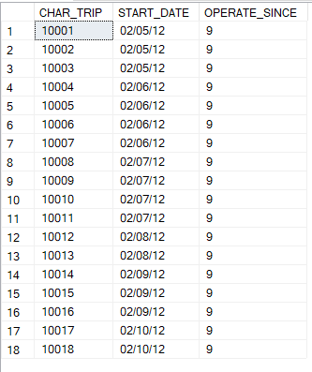

1. Show the charters that operated on days 5 and 6 of the month of February of 2012. use day() and month() functions in your query. Use day(), month() and year() functions.

select CHAR_TRIP, CHAR_DATE,AC_NUMBER FROM CHARTER

WHERE DAY(CHAR_DATE) in (5,6)

AND

MONTH(CHAR_DATE) LIKE 2

AND

YEAR(CHAR_DATE) LIKE 2012

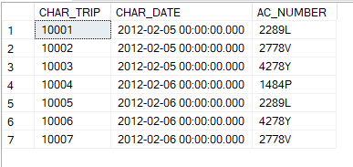

1. The employees can retire after 20 years (240 months) from their hire date. List the employees (id, last name, first name) and their retirement date (label the column), sorted from the earliest to the latest retirement.

Refer to this link: <https://www.w3schools.com/sql/func_sqlserver_dateadd.asp>

SELECT EMP_NUM AS EMP_ID , EMP_LNAME AS LAST_NAME, EMP_FNAME AS FIRST_NAME, DATEADD(YEAR, 20, EMP_HIRE_DATE)AS RETIREMENT_DATE FROM EMPLOYEE

ORDER BY RETIREMENT_DATE

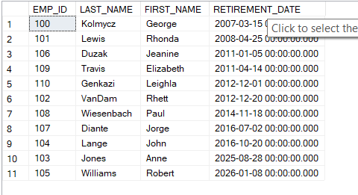

Grading rubrics

Each question is worth 5pts. Total is 50 pts.

If the output is included without the query, the answer is worth 0.