Lab 2 (2%)

join, group by, having, views

topics

join, group by, having, views

acknowledgment

We, DIVNOOR BHANDOHAL, VEDANT PATEL, AND SOPHIA HUYNH, declare that the attached assignment is our own work in accordance with the Seneca Academic Policy. No part of this assignment has been copied manually or electronically from any other source (including web sites) **or distributed to other students.**

Specify below what each member has done towards the completion of this work:

Name Task(s)

1- Vedant Patel 1-4

2- Divnoor Bhandohal 5-7

3- Sophia Huynh 8-10

Before you start

You are to use database named “AviaCo” you are given under Lab1. If you already run the script and have the tables you can start doing following questions.

Instructions

For each of the following questions write the SQL query (in text) and show the result set underneath each SQL query.

1. Show all charter trip codes and their crews (show the crew employee number, first and last name and the crew job).

Order the rows by charter trip number.

1. Show all charter trip codes, date, destination, distance and hours flown and charter crews (show the crew employee number, first and last name and the crew job).

Order the rows by charter trip number.

Format the charter dates based on format code 1 (MM/DD/YY)

1. Show all customer (the customer code, first and last name) and their booked charter trip (show the charter codes, date, destination, distance, hours flown, charter crews (show the crew employee number, first and last name and the crew job).
2. Show all aircraft model codes and the number of aircrafts associated with each.
3. show the customers and the number of charters they have booked. Show the customer code, last and first name (all concatenated) and the number of associated charters.

select CONCAT(c.cus_fname,' ' , c.cus_lname , ', ', c.cus_code) as Customer_Information, count( ch.CHAR_TRIP) ' Number of Booked Charters' from customer c INNER JOIN Charter ch

ON c.cus_code = ch.cus_code

Group by c.CUS_FNAME, c.CUS_LNAME, c.CUS_CODE;

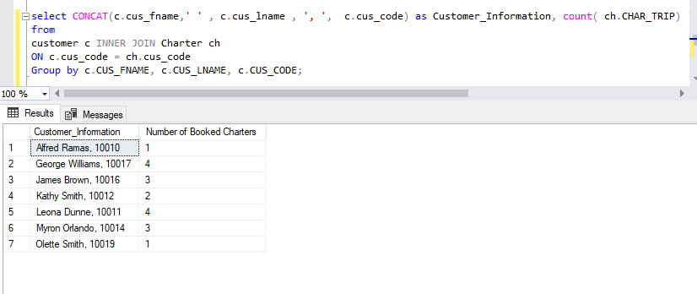

1. show the crew and the number of charters they were on. result set should include emp_num, emp_fname, emp_lname, and number of charters.

Select CONCAT(e.emp_num, ' ', e.emp_fname, ', ', e.emp_lname) as Employee_information , count(c.CHAR_TRIP) as 'Number of Trips' from employee e INNER JOIN crew c ON e.emp_num = c.emp_num

group by e.emp_num , e.emp_fname, e.emp_lname ;

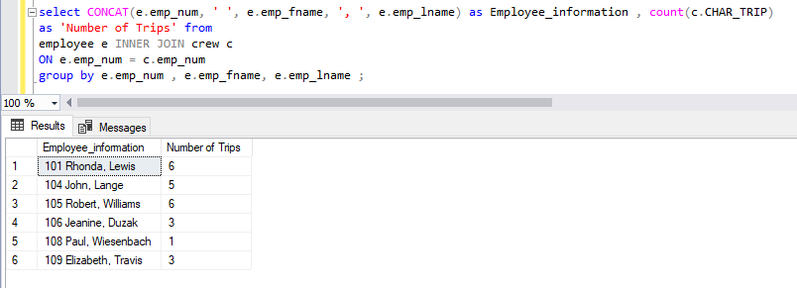

1. Extract the first two characters of the model code and count the number of aircrafts for each.

select SUBSTRING(mod_code , 1,2) as Model, count (AC_NUMBER )

as 'Number of Aircrafts' from AIRCRAFT

Group by mod_code ;

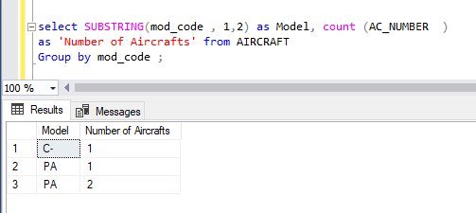

1. Show all charter trip codes, the charter distance and whether the distance is less than 1000 miles or larger than 1000 miles.

use IIF function, <https://www.w3schools.com/sql/func_sqlserver_iif.asp>

SELECT CHAR_TRIP, CHAR_DISTANCE,

IIF(CHAR_DISTANCE<1000, '<1000', '>1000') as 'LESS_OR_MORE'

FROM CHARTER;

1. Count the number of charters whose distance is less than 1000 and those that have a distance larger than 1000. Then calculate the proportions of the charters in each bin.

-- cast the count as float so you get the ratio instead of 0.

SELECT COUNT(CHAR_DISTANCE) as 'CHARTERS',

IIF(CHAR_DISTANCE<1000, '<1000', '>1000') as 'LESS_OR_MORE'

FROM CHARTER

GROUP BY IIF(CHAR_DISTANCE<1000, '<1000', '>1000')

1. Show the total fuel consumption, the total distance traveled, and the total hours flown per aircraft for aircrafts whose total hours flown is more than 15 hours.

SELECT AC_NUMBER, SUM(CHAR_FUEL_GALLONS) as TOTAL_FUEL_CONSUMPTION, SUM(CHAR_DISTANCE) as TOTAL_DISTANCE, SUM(CHAR_HOURS_FLOWN) as TOTAL_HOURS_FLOWN

FROM CHARTER

GROUP BY AC_NUMBER

HAVING SUM(CHAR_HOURS_FLOWN) > 15

SUBMISSION

Submit your lab2_group#.doc file on BB.