Lab 5 (2%)

Triggers

topics

* Triggers: <https://docs.microsoft.com/en-us/sql/relational-databases/triggers/dml-triggers?view=sql-server-ver15>

Group work acknowledgment

We, Divnoor Bhandohal, Sophia Huynh, declare that the attached assignment is our own work in accordance with the Seneca Academic Policy. No part of this assignment has been copied manually or electronically from any other source (including web sites) **or distributed to other students.**

Specify below what each member has done towards the completion of this work:

Name Task(s)

1- Divnoor Bhandohal 1-2

2- Sophia Huynh 2-3

3-

Before you start

You are to create a new database named “AviaCo” and run the sql script you are given to create the tables in the database.

If you already have the database created,

* delete all data from all tables and run all the insert commands all over again.

Or

* delete the existing aviaco database you already have, recreate a database named AviaCo and then run the sql script as is.

Instructions

Answer each of the following questions and show the result set underneath each part.

1. [10pts] Create a trigger named checkCrew that fires with a 'instead of' statement when a crew record is inserted in the crew table.

When there is already a crew with the same crew job on the same charter, print a message that says: ‘There is already a [job] on the trip’. Otherwise, insert the row in the crew table. See the testing commands below.

create trigger checkCrew ON crew

INSTEAD Of insert

as

select * from crew order by CHAR_TRIP;

BEGIN

declare @charter int, @e_num int, @job varchar(20)

select @e_num = EMP_NUM from inserted

select @charter = Char_trip from inserted

Select @job = CREW_JOB from inserted

If exists (select * from crew where CREW_JOB = @job AND CHAR_TRIP = @charter)

BEGIN

print 'There is already a '+ @job + ' on the crew'

END

else

BEGIN

Insert into crew (CHAR_TRIP ,EMP_NUM ,CREW_JOB)

Select i.CHAR_TRIP, i.EMP_NUM, i.CREW_JOB from inserted i;

select TOP 5 * from crew order by CHAR_TRIP;

END

END

Go

**Testing and output:**

Show the top 5 rows from the crew table:

select * from crew order by CHAR_TRIP;

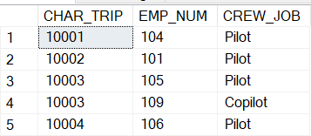

**Testing 1:**

insert into crew values (10002, 104, 'Copilot');

output: Show the top 5 rows from the crew table.

The insert should go through and add the highlighted row as shown below.

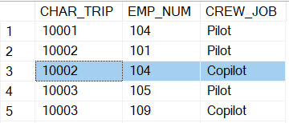

**Testing 2:**

insert into crew values (10003, 109, 'Pilot');

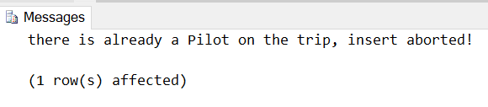

1. [10pts] Create a trigger named addRating on EARNEDRATING table that adds the inserted rating code to PIL_RATINGS in the PILOT table.

create trigger addRating

ON EARNEDRATING After insert As

Begin

DECLARE @emp_num int, @r_code VARCHAR(10);

Set @emp_num = (select emp_num from inserted);

set @r_code = (SELECT RTG_CODE FROM inserted);

UPDATE Pilot

SET PIL_RATINGS += '/' + @r_code

WHERE EMP_NUM = @emp_num;

END

GO

**Before trigger:**

select * from EARNEDRATING;

output: top 8 rows

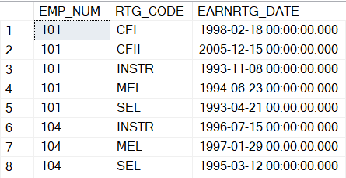

select * from PILOT;

output:

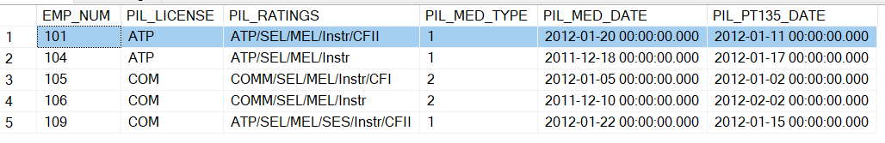

**Fire the trigger:**

insert into EARNEDRATING values (101, 'SES', '2021-01-01')

**After trigger:**

select * from EARNEDRATING;

output: top 8 rows

insert went through, highlighted row is added

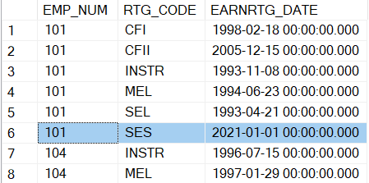

select * from PILOT;

output:

SES is appended to PIL_RATINGS

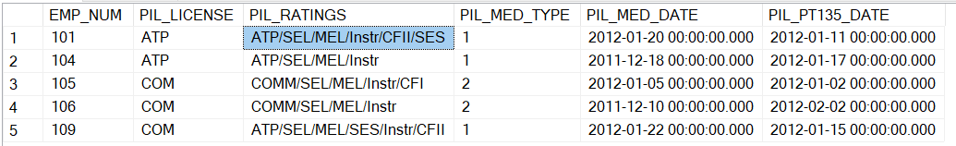

1. [15pts] Create a trigger named update_cusbalance that fires after a charter record is inserted in the charter table. The customer balance should be incremented by the charter charges calculated as CHAR_DISTANCE (given in inserted) * MOD_CHG_MILE (from the model table given the AC_number in inserted).

create trigger update_cusbalance

on CHARTER

after insert

as

begin

declare @code int

declare @ac_num varchar(5)

declare @distance real

declare line_cursor CURSOR

for select CUS_CODE, AC_NUMBER, CHAR_DISTANCE from inserted;

OPEN line_cursor;

FETCH NEXT FROM line_cursor INTO @code, @ac_num, @distance;

WHILE @@FETCH_STATUS = 0

BEGIN

declare @model varchar(10)

select @model = MOD_CODE from AIRCRAFT where @ac_num = AC_NUMBER

declare @miles real

select @miles = MOD_CHG_MILE from MODEL where @model = MOD_CODE

declare @balance real

select @balance = @distance* @miles

update CUSTOMER

set CUS_BALANCE = CUS_BALANCE + @balance

where @code = CUS_CODE

FETCH NEXT FROM line_cursor INTO @code, @ac_num, @distance;

END

close line_cursor;

DEALLOCATE line_cursor;

end

go

**Testing scenario 1: one-row insert**

**Before trigger:**

select * from customer where cus_code = 10010;

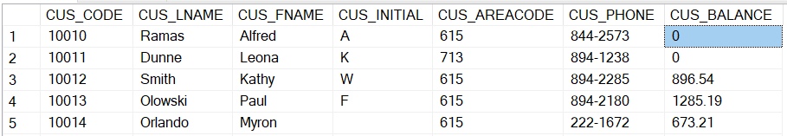

**Fire the trigger:**

insert into CHARTER values(10019, '2012-02-09', '2778V', 'MQY', 312, 1.5, 0, 67.2, 0, 10010);

**After the trigger:**

select * from charter where char_trip = 10019;

output:



select * from customer where cus_code= 10010;

output: top 5 rows. cus_balance updated.

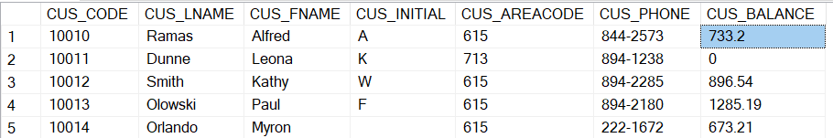

**Testing scenario 2: multi-row insert, with diff cus_code**

**Before trigger:**

select * from customer where cus_code in (10011, 10012);

output:



**Fire the trigger:**

insert into CHARTER values

(10020, '2012-02-09', '2778V', 'MQY', 312, 1.5, 0, 67.2, 0, 10011),

(10021, '2012-02-09', '2289L', 'MQY', 250, 1.5, 0, 67.2, 0, 10012);

**After trigger:**

select * from charter where char_trip in (10020, 10021);

output:



select * from customer where cus_code in (10011, 10012);

output:

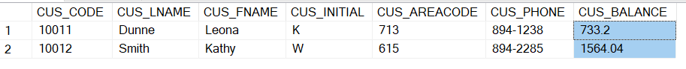

**Testing scenario 3: multi-row insert, with same cus_code**

**Before trigger:**

select * from customer where cus_code=10016;

output:



**Fire the trigger:**

insert into CHARTER values

(10022, '2012-02-09', '2778V', 'MQY', 312, 1.5, 0, 67.2, 0, 10016),

(10023, '2012-02-09', '2289L', 'MQY', 250, 1.5, 0, 67.2, 0, 10016);

**After the trigger:**

select * from charter where char_trip in (10022, 10023);

output:



select * from customer where cus_code=10016;



Manual calculation:

-- MOD_CHG_MILE= 2.35

-- CHAR_DISTANCE= 312

-- cus_balance increment by 733.2

-- MOD_CHG_MILE= 2.67

-- char_distance= 250

-- cus_balance increment by 667.5

-- total increment for cus 10016 is : 733.2 + 667.5

SUBMISSION

Submit your lab5_GroupX.doc file on BB. Replace X with your group number.

If a student does not contribute to the work, do not list his/her name(s) under the group section in the lab file and will get 0.