Activity 1: I realized I had forgotten to put .innerHTML which allows for me to replace the original text with the book name

Output:

Activity 2:

Output:

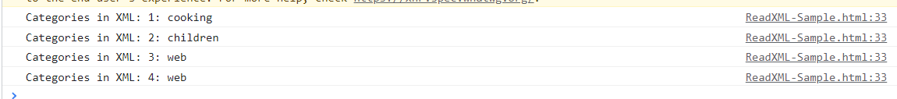

Activity 3:

Validation:

