5. Experiment
5.1 Experimental Setup
This section describes the datasets, model architectures, preprocessing steps, training configuration, and evaluation metrics used to compare a custom lightweight Convolutional Neural Network (CNN) with the standard ResNet34 architecture for a multi-class image classification task.
5.1.1 Dataset
We used a custom garbage classification dataset containing six categories: cardboard, glass, metal, paper, plastic and trash. The dataset was divided into training set which was used for learning the model parameters and test set which was used to evaluate the generalization ability of the trained model.
The training set contains a total of 2,164 images, and the test set contains 363 images. The class distribution is shown below:
 | cardboard | glass | metal | paper | plastic | trash
train | 345 | 429 | 351 | 509 | 413 | 117
test | 58 | 72 | 59 | 85 | 69 | 20
Table 5.1 Dataset Size
For the CNN, images were resized to 32x32 pixels. And for ResNet34, images were center-cropped to 224x224 pixels. All images were normalized using the standard ImageNet statistics: mean = [0.485, 0.456, 0.406] and std = [0.229, 0.224, 0.225].
5.1.2 Model Architectures
The CNN model in this project is a lightweight architecture consisting of two convolutional layers followed by three fully connected layers. It has approximately 81K parameters and serves as a simple baseline.
The ResNet34 is a deep residual network composed of four main stages with residual blocks, totaling approximately 21.3 million parameters. It is widely used in image classification tasks due to its strong feature extraction capability.
5.1.3 Environment
The framework is PyTorch. The hardware is NVIDIA GeForce RTX 4060 Laptop GPU. The libraries used in this experiment is torch, torchvision, matplotlib, scikit-learn, seaborn and so on.
5.1.4 Training Configuration
Optimizer is Stochastic Gradient Descent (SGD). Learning Rate is 0.001. Momentum is 0.9. Batch Size is 6. Epoch is 50. Loss Function is CrossEntropyLoss.
5.1.5 Evaluation Metrics
To evaluate and compare the performance of the CNN and ResNet34 models, we adopted several standard classification metrics.
- Accuracy: Accuracy is the percentage of correctly classified samples out of the total number of samples. We report both training accuracy and test accuracy to assess how well each model generalizes beyond the training data.
- Confusion Matrix: The confusion matrix provides a detailed view of prediction results across all classes. Each row represents the actual class, and each column represents the predicted class.
- Parameter Count: To measure model complexity, we compute the number of trainable parameters in each model.
- Training Time: We track total training time for each model as an indirect measure of training efficiency.
5.2 Results and Comparison
This section compares the performance of the custom CNN and the ResNet34 model based on test accuracy, training behavior, model complexity, and confusion matrix analysis.
5.2.1 Model Complexity
Model | Parameters | Training Time (s)
CNN | 80,866 | 1439
ResNet34 | 21,291,974 | 3473
Table 5.2 Model Complexity
The custom CNN is extremely lightweight, containing less than 0.4% of the parameters of ResNet34, and it also trains significantly faster. This makes CNN attractive for resource-constrained environments. In contrast, ResNet34 is a deep architecture composed of residual blocks that enable effective training at large scale, though at the cost of increased computational demand.
5.2.2 Training Dynamics
The training behaviors of the CNN and ResNet34 models were observed by tracking training accuracy, test accuracy, loss curves, and the difference between training and test performance over 50 epochs.
5.2.2.1 CNN
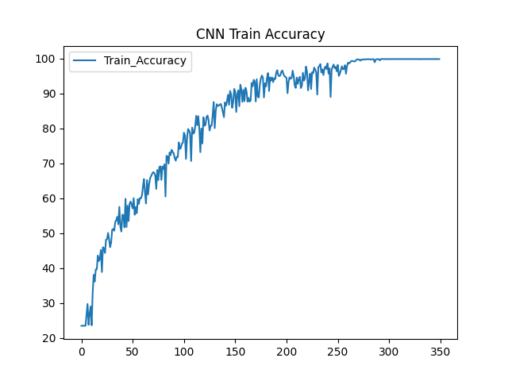
Figure 5.1 CNN Train Accuracy
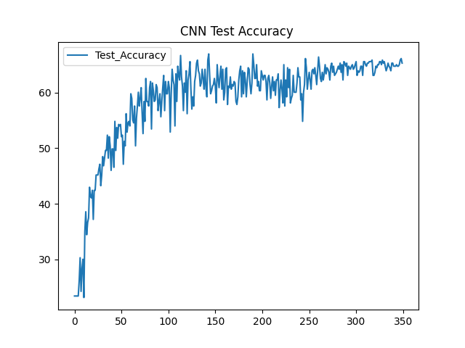
Figure 5.2 CNN Test Accuracy while Training
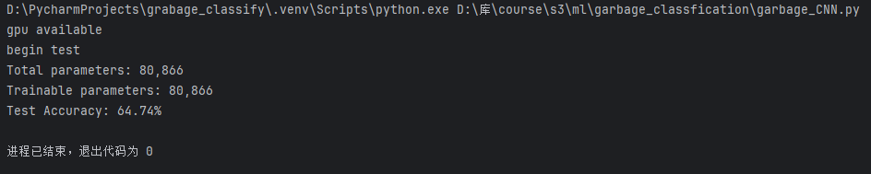
Figure 5.3 CNN Test Accuracy
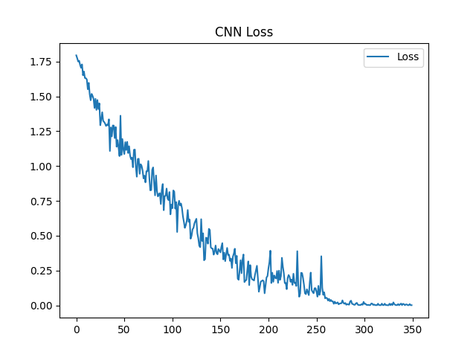
Figure 5.4 CNN Loss
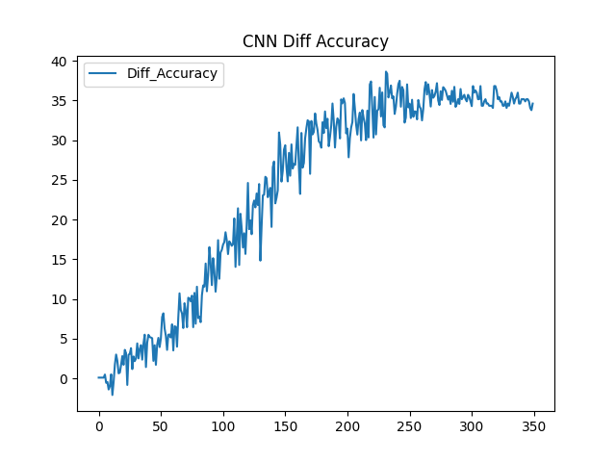
Figure 5.5 CNN Diff Accuracy
The CNN model exhibited fast and confident learning in the early epochs:
- Training accuracy rapidly increased and reached 99.91%, indicating the model quickly learned to classify the training set with almost perfect accuracy.
- Test accuracy peaked early at 64.74%, then plateaued with minimal improvement across later epochs, despite continuous improvement in training accuracy.
- Loss curve dropped sharply toward zero, which aligns with the near-perfect training accuracy.
- Diff accuracy (train acc - test acc) increased steadily over time, revealing a growing generalization gap — the model was overfitting.
This overfitting is likely due to the CNN's shallow architecture and limited parameter capacity (~81K), which constrain its ability to extract generalizable features, especially in the presence of class imbalance and visually similar categories.
Despite high learning efficiency and low computational cost, CNN’s training dynamics clearly show that its ability to generalize is limited.
5.2.2.2 ResNet34
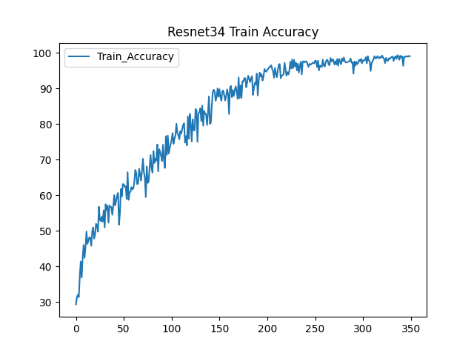
Figure 5.6 ResNet34 Train Accuracy
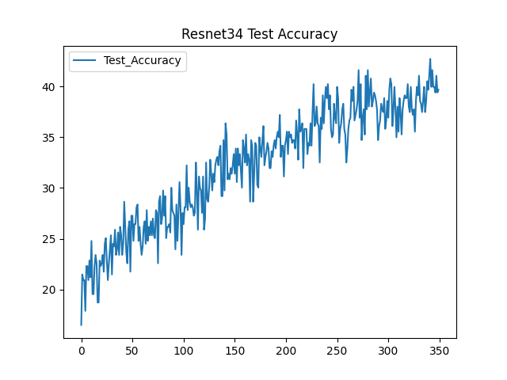
Figure 5.7 ResNet34 Test Accuracy while Training
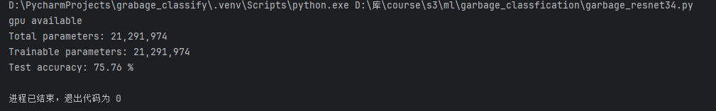
Figure 5.8 ResNet34 Test Accuracy
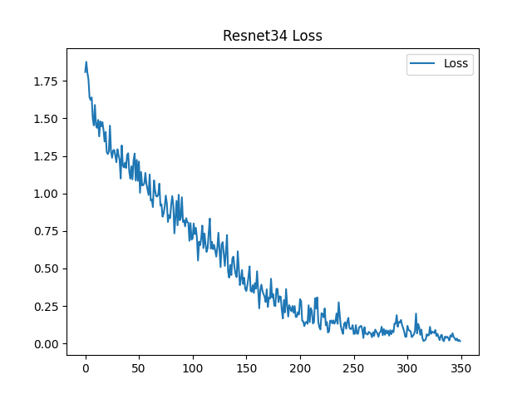
Figure 5.9 ResNet34 Loss
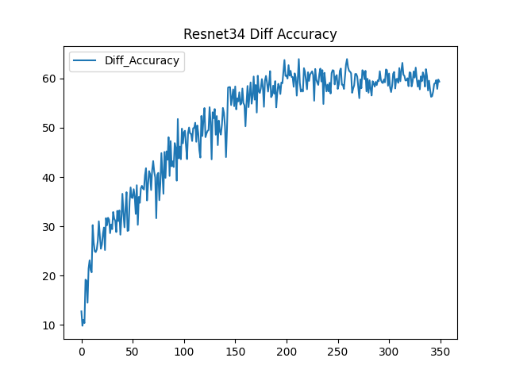
Figure 5.10 ResNet34 Diff Accuracy
Compared to the CNN, the ResNet34 model exhibited more stable and consistent training dynamics, indicative of better generalization and less overfitting.
- Training accuracy reached 99.08%, slightly lower than the CNN’s near-perfect 99.91%, suggesting the model avoided overfitting to noise or outliers in the training data.
- Test accuracy achieved 75.76%, significantly outperforming the CNN (+11%). This indicates the ResNet34 model learned more robust and transferable representations from the training data.
- Loss curve decreased steadily over time, showing no signs of instability or vanishing gradients, despite the model's depth.
- Diff accuracy curve remained relatively small throughout training. This small generalization gap highlights ResNet34’s ability to retain high accuracy on unseen data while avoiding overfitting.
The reasons of ResNet34’s superior performance are below:
- Deep residual connections, which allow gradients to flow more easily through the network during backpropagation, mitigating the vanishing gradient problem.
- A much larger parameter capacity (~21M parameters), enabling the model to learn complex, high-level features necessary for distinguishing between visually similar classes like paper vs. cardboard or trash vs. plastic.
- Smoother convergence, as shown in the accuracy and loss curves, reflecting a well-behaved optimization process.
These dynamics make ResNet34 more suitable for real-world applications where generalization and robustness are critical.
5.2.3 Generalization Performance
Model | Train Accuracy | Test Accuracy
CNN | 99.91% | 64.74%
ResNet34 | 99.08% | 75.76%
Table 5.3 Model Performance
Despite both models achieving high training accuracy, ResNet34 achieved a much higher test accuracy (+11%). This shows that depth and architectural enhancements (such as residual connections) enable better feature representation and resistance to overfitting, even when trained on the same data and for the same number of epochs.
5.3 Error Analysis and Confusion Discussion
This section focuses on analyzing the common failure patterns observed in the predictions made by both the CNN and ResNet34 models. We base this analysis primarily on the confusion matrices and class-level performance discrepancies.
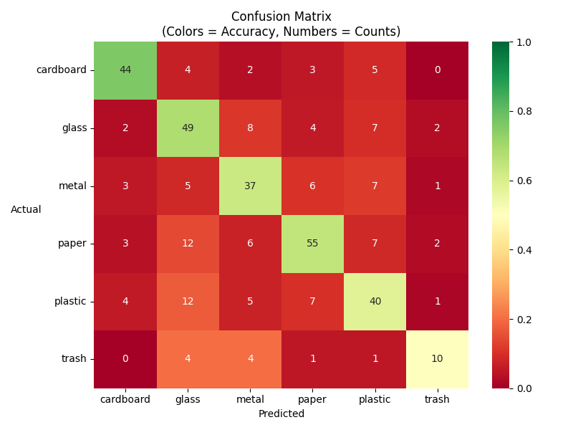
Figure 5.11 CNN Confusion Matrix
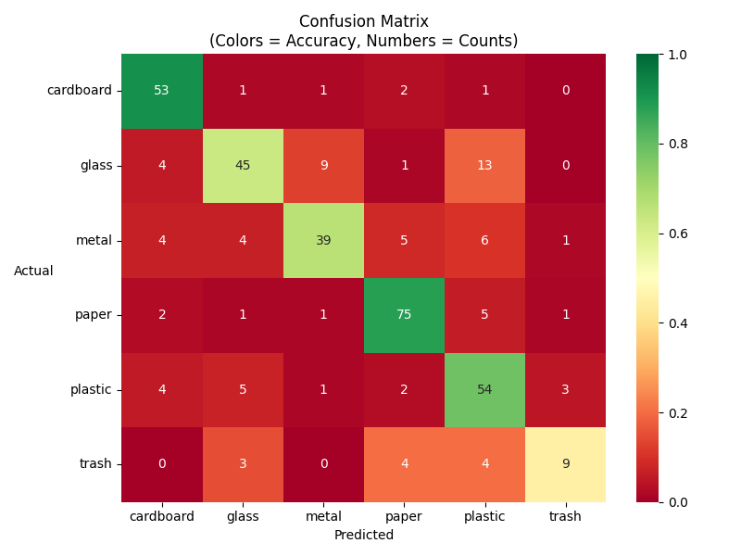
Figure 5.12 ResNet34 Confusion Matrix
5.3.1 CNN Confusion Matrix
The confusion matrix of the CNN model reveals several key patterns that reflect the model's limitations in class-level discrimination:
- Paper vs. Glass: The model frequently misclassifies paper as glass (12 cases) and vice versa (4 cases). This suggests that these two classes may share overlapping visual features—such as translucency or texture patterns—that a shallow CNN fails to distinguish effectively.
- Plastic vs. Glass: There is also substantial confusion between plastic and glass (12 misclassifications), likely due to similar surface reflectance or shapes in the dataset.
- Trash: The trash category has the lowest classification accuracy, with only 10 out of 20 test samples correctly identified. This is likely due to its significantly smaller representation in the dataset (117 training samples vs. 350–500 for other classes), which limits the model's ability to learn its features effectively.
While classes like glass, paper, and plastic have relatively strong diagonal values, the model still makes errors across almost all categories, indicating a lack of robustness in feature separation.
Overall, the confusion matrix demonstrates that the CNN struggles particularly with visually similar and underrepresented classes, which is consistent with its overfitting behavior observed in training curves.
5.3.2 ResNet34 Confusion Matrix
The ResNet34 confusion matrix shows notable improvements over the CNN baseline, especially in overall diagonal dominance. However, certain areas of class-level confusion still persist:
- Plastic vs. Glass: The model continues to confuse plastic and glass, with 5 plastic samples misclassified as glass and 13 glass samples misclassified as plastic. Despite the overall improvement in accuracy, this indicates that the model still struggles with distinguishing translucent or similarly shaped materials, even with its deeper architecture.
- Metal vs. Glass: Notably, the confusion between metal and glass remains essentially unchanged. The ResNet34 model misclassifies 9 glass samples as metal, which is similar to the 8 such misclassifications observed in the CNN model. This suggests that the deeper architecture and residual connections in ResNet34 did not significantly enhance discrimination between these two visually similar categories.
- Trash Class: As with CNN, the trash category remains a challenge. Only 9 out of 20 samples are correctly classified, showing that ResNet34, while better, is still affected by data imbalance and intra-class variability.
Most of categories such as paper, cardboard, and plastic showed marked improvement. For example, paper was correctly classified 75 times, with minimal misclassification, and cardboard accuracy increased to 53 correct predictions.
These results confirm that ResNet34’s deep residual architecture enhances feature learning and inter-class separation, especially for well-represented classes. However, it still struggles when class similarity or data scarcity dominate.
5.3.3 Summary
The confusion matrix analysis shows that ResNet34 significantly improves classification accuracy across most categories compared to CNN, especially for well-represented classes like paper and cardboard. However, confusion between visually similar classes such as glass and metal, as well as persistent misclassification of trash due to data imbalance, remain challenges for both models. Overall, ResNet34 demonstrates stronger generalization, but further improvements could be made through targeted data augmentation or class-specific enhancements.
5.4 Conclusion
In this experiment, we compared a lightweight CNN and a deep ResNet34 model on a garbage classification task. The CNN, though efficient and fast to train, suffered from overfitting and limited generalization, achieving a test accuracy of 64.74%. In contrast, ResNet34 leveraged its deeper architecture and residual connections to achieve a significantly higher test accuracy of 75.76%, with more stable training dynamics and improved class-wise performance. While challenges remain—particularly in distinguishing visually similar and underrepresented classes—our results demonstrate that model depth and architectural design play a critical role in balancing accuracy and generalization in real-world classification tasks.

