Elasticsearch

这里只是Elasticsearch的安装，记录一些安装步骤。

一、下载Elasticsearch

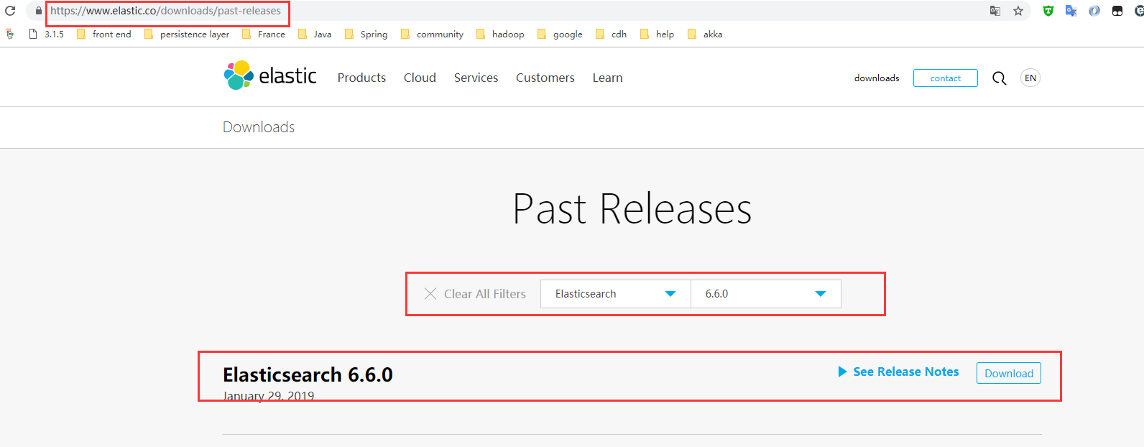下载链接地址https://www.elastic.co/downloads/past-releases在该页面选择Elasticsearch并选择版本号，这里用的是6.6.0，如下图1.1所示

图1.1下载页面

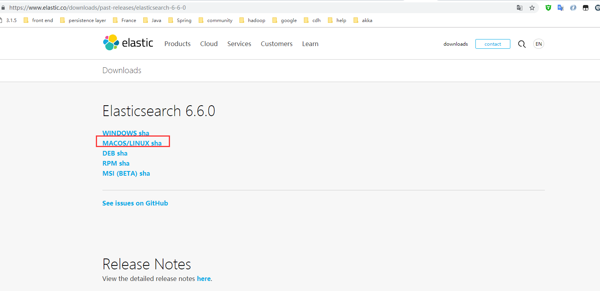在改页面选择下，跳转到下载页面，这里我们是安装在centos7所以选择的是MACOS/LINUX sha，如下图1.2

图1.2下载

在页面点击MACOS/LINUX sha进行下载。

二．安装配置

把下载的elasticsearch-6.6.0.tar.gz上传到centos7服务器上，并解压。

配置elasticsearch是在它的主目录下面config文件夹下的elasticsearch.yml文件。通过命令vi/vim或winSCP软件进入到相应的目录打开文件进行编辑。

这里进行配置了部分属性有如下：

|  |
| --- |
| cluster.name: my-logs-cluster  node.name: node-1  path.data: /soft/ELK/data/es/path/to/data  path.logs: /soft/ELK/data/es/path/to/logs  http.port: 9200  network.host: sv1  discovery.zen.ping.unicast.hosts: ["sv1", "sv2","sv3"] |

配置完成之后进行保存。

三．启动与解决问题

3.1启动

这里没有配置环境变量直接在elasticsearch主目录执行命令

|  |
| --- |
| bin/elasticsearch -d |

注意：这里不能用户root用户启动，如果用root启动将会报错，错误如下：

|  |
| --- |
| [2019-03-03T13:52:51,498][ERROR][o.e.b.Bootstrap ] [node-3] Exception  java.lang.RuntimeException: can not run elasticsearch as root  at org.elasticsearch.bootstrap.Bootstrap.initializeNatives(Bootstrap.java:103) ~[elasticsearch-6.6.0.jar:6.6.0]  at org.elasticsearch.bootstrap.Bootstrap.setup(Bootstrap.java:170) ~[elasticsearch-6.6.0.jar:6.6.0]  at org.elasticsearch.bootstrap.Bootstrap.init(Bootstrap.java:333) [elasticsearch-6.6.0.jar:6.6.0]  at org.elasticsearch.bootstrap.Elasticsearch.init(Elasticsearch.java:159) [elasticsearch-6.6.0.jar:6.6.0]  at org.elasticsearch.bootstrap.Elasticsearch.execute(Elasticsearch.java:150) [elasticsearch-6.6.0.jar:6.6.0]  at org.elasticsearch.cli.EnvironmentAwareCommand.execute(EnvironmentAwareCommand.java:86) [elasticsearch-6.6.0.jar:6.6.0]  at org.elasticsearch.cli.Command.mainWithoutErrorHandling(Command.java:124) [elasticsearch-cli-6.6.0.jar:6.6.0]  at org.elasticsearch.cli.Command.main(Command.java:90) [elasticsearch-cli-6.6.0.jar:6.6.0]  at org.elasticsearch.bootstrap.Elasticsearch.main(Elasticsearch.java:116) [elasticsearch-6.6.0.jar:6.6.0]  at org.elasticsearch.bootstrap.Elasticsearch.main(Elasticsearch.java:93) [elasticsearch-6.6.0.jar:6.6.0]  [2019-03-03T13:52:51,514][WARN ][o.e.b.ElasticsearchUncaughtExceptionHandler] [node-3] uncaught exception in thread [main]  org.elasticsearch.bootstrap.StartupException: java.lang.RuntimeException: can not run elasticsearch as root  at org.elasticsearch.bootstrap.Elasticsearch.init(Elasticsearch.java:163) ~[elasticsearch-6.6.0.jar:6.6.0]  at org.elasticsearch.bootstrap.Elasticsearch.execute(Elasticsearch.java:150) ~[elasticsearch-6.6.0.jar:6.6.0]  at org.elasticsearch.cli.EnvironmentAwareCommand.execute(EnvironmentAwareCommand.java:86) ~[elasticsearch-6.6.0.jar:6.6.0]  at org.elasticsearch.cli.Command.mainWithoutErrorHandling(Command.java:124) ~[elasticsearch-cli-6.6.0.jar:6.6.0]  at org.elasticsearch.cli.Command.main(Command.java:90) ~[elasticsearch-cli-6.6.0.jar:6.6.0]  at org.elasticsearch.bootstrap.Elasticsearch.main(Elasticsearch.java:116) ~[elasticsearch-6.6.0.jar:6.6.0]  at org.elasticsearch.bootstrap.Elasticsearch.main(Elasticsearch.java:93) ~[elasticsearch-6.6.0.jar:6.6.0]  Caused by: java.lang.RuntimeException: can not run elasticsearch as root  at org.elasticsearch.bootstrap.Bootstrap.initializeNatives(Bootstrap.java:103) ~[elasticsearch-6.6.0.jar:6.6.0]  at org.elasticsearch.bootstrap.Bootstrap.setup(Bootstrap.java:170) ~[elasticsearch-6.6.0.jar:6.6.0]  at org.elasticsearch.bootstrap.Bootstrap.init(Bootstrap.java:333) ~[elasticsearch-6.6.0.jar:6.6.0]  at org.elasticsearch.bootstrap.Elasticsearch.init(Elasticsearch.java:159) ~[elasticsearch-6.6.0.jar:6.6.0]  ... 6 more |

所以这里要普通的用户启动。

3.2修改系统的配置

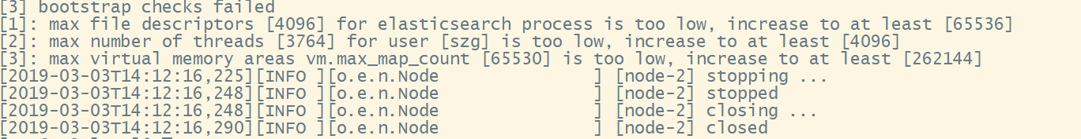当你启动之后。通过jps查看是否Elasticsearch进程，如果没有去查看日志找错误。这里发现了一些错误如下图3.1

图3.1错误

这里有3个too low,并且at least。通过百度进行解决配置。这里参考了这一篇博客<https://blog.csdn.net/qq_33363618/article/details/78882827>

进行配置如下：

使用root用户vi /etc/security/limits.conf追加如下配置

|  |
| --- |
| * soft nofile 65536  * hard nofile 131072  * soft nproc 2048  * hard nproc 4096 |

使用root用户vi /etc/sysctl.conf追加如下配置

|  |
| --- |
| vm.max_map_count=655360 |

并执行命令

|  |
| --- |
| sysctl -p |

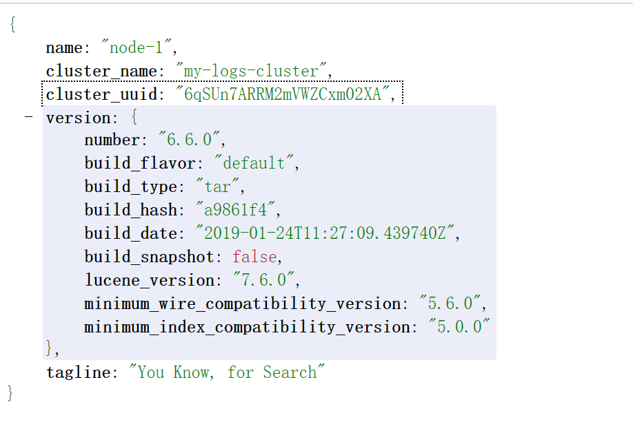再进行启动，并查看进程。如果都还在没有在浏览器输入该节点的ip: 9200进行访问得到如下结果