#262530

# Adobe Launches Firefly Video Model and Enhances Image, Vector and Design Models

Monday, October 14, 2024 6:00 AM

[*Download the PDF*](/news/downloads/pdfs/2024/10/101424-adobemax-firefly.pdf#_blank)

<https://youtu.be/puEgugluadk?si=n4I3VyqQgNkhXeai?hidetitle=1>

* The Adobe Firefly Video Model (beta) expands Adobe's family of creative generative AI models and is the first publicly available video model designed to be safe for commercial use
* Enhancements to Firefly models include 4x faster image generation and new capabilities integrated into Photoshop, Illustrator, Adobe Express and now Premiere Pro
* Firefly has been used to generate 13 billion images since March 2023 and is seeing rapid adoption by leading brands and enterprises

**MIAMI BEACH, Fla. – October 14, 2024 –** Today, at [Adobe MAX](https://max.adobe.com/) – the world’s largest creativity conference – Adobe (Nasdaq: ADBE) announced the expansion of its Firefly family of creative generative AI models to video, in addition to new breakthroughs in its Image, Vector and Design models and significant momentum in Firefly’s adoption by leading brands and enterprises. The [Firefly Video Model](https://blog.adobe.com/en/publish/2024/10/14/generate-video-beta-on-firefly-web-app), now in limited public beta, is the first publicly available video model designed to be commercially safe. Since Firefly’s first beta release in March 2023, it has been used to generate more than 13 billion images – an increase of more than 6 billion over the past six months.

“The usage of Firefly within our creative applications has seen massive adoption, and it’s been inspiring to see how the creative community has used it to push the boundaries of what’s possible,” said Ely Greenfield, chief technology officer, digital media at Adobe. “We’re thrilled to bring creative professionals even more tools for ideation and creation, all designed to be commercially safe.”

**New Firefly-powered Offerings**

The Firefly Video Model (beta) extends Adobe’s family of generative AI models, which already includes an Image Model, Vector Model and Design Model, making Firefly the most comprehensive model offering for creative teams. It is available today through a limited public beta to garner initial feedback from a small group of creative professionals, which will be used to continue to refine and improve the model.

Within one year of being launched, Firefly was brought into Photoshop, Express, Illustrator, Substance 3D and more, while supporting various workflows in Creative Cloud applications. Firefly also supports text prompts in over 100 languages and enables users around the world to create stunning content that is designed to be safe for commercial use.

New Firefly offerings in Creative Cloud available today include:

* **Generative Extend (beta) for perfectly timed video edits:** Powered by the Firefly Video Model and now available in the Premiere Pro beta, [Generative Extend](https://blog.adobe.com/en/publish/2024/10/14/generative-extend-in-premiere-pro) allows you to extend clips to cover gaps in footage, smooth out transitions, or hold on shots longer for perfectly timed edits.
* **Text to Video & Image to Video (beta) for improved user controls and stunning video clips**: Powered by the Firefly Video Model and now rolling out in limited public beta in the [Firefly web app](https://blog.adobe.com/en/publish/2024/10/14/generative-extend-in-premiere-pro), creators can access new Text to Video and Image to Video capabilities. With Text to Video, video editors can generate video from text prompts, access a variety of camera controls such as angle, motion and zoom to finetune videos, and reference images for B-Roll generation that seamlessly fill gaps in a video timeline. Image to Video capabilities allow creators to bring still shots or illustrations to life by transforming them into stunning live action clips.
* **Firefly Image 3 enhancements for faster generations:** With the latest evolution of Firefly Image 3 Model, creators of all levels can ideate by generating images in seconds with results that are up to 4x faster than previous models – available today on the Firefly web app.
* **Generative Workspace (beta) in Photoshop**: Powered by Adobe Firefly, Generative Workspace in [Photoshop](https://blog.adobe.com/en/publish/2024/10/14/photoshop-delivers-powerful-innovation-for-image-editing-ideation-3d-design-more) allows designers to ideate, brainstorm and iterate concepts simultaneously to achieve their vision while producing stunning visuals faster and more intuitively than ever before.
* **Firefly Vector Model (beta) Advancements in Illustrator**: Adobe Illustrator brought Generative Shape Fill (beta), Generative Recolor and Text to Pattern, all powered by the latest Firefly Vector Model (beta) earlier this year, empowering designers to quickly ideate or add detailed vectors in their own unique style to existing artwork and designs. With the latest version of Firefly Vector Model, creators can now further control the density of elements in a single pattern to change how tightly the elements are packed together.

Adobe also previewed [Project Concept](https://blog.adobe.com/en/publish/2024/10/14/new-creative-beginnings-gen-ai-redefining-ideation-with-project-concept), a new capability for multiplayer, collaborative, creative concept development bringing the ability to remix images in real time so creative professionals can concept live in a single canvas.

**Content Creation at Scale with New Enterprise Offerings**

Additionally, in Firefly Services, a collection of creative and generative APIs for enterprises, Adobe unveiled new offerings to scale production workflows. This includes [Dubbing and Lip Sync](https://blog.adobe.com/en/publish/2024/10/14/oliver-supercharges-its-ai-content-creation-with-help-from-adobe-firefly-services) now in beta, which uses generative AI for video content to translate spoken dialog into different languages, while maintaining the sound of the original voice with matching lip sync. Additionally, ‘Bulk Create, Powered by Firefly Services’ is now in beta and will enable creative professionals to edit large volumes of images more efficiently, streamlining tasks such as resizing or background removal.

To date, Adobe Firefly has been used by Adobe customers including PepsiCo/Gatorade, IBM, Mattel, IPG Health, Deloitte and others, to optimize workflows and scale content creation so creatives can spend more time exploring their creative visions.

**Driving Responsible Innovation with Adobe Firefly**

Firefly powers generative AI tools designed for creative needs, use cases, and workflows. Adobe trained its [Firefly generative AI models](https://www.adobe.com/ai/overview/firefly/gen-ai-commitments.html) on licensed content, such as Adobe Stock and public domain content. In addition, Adobe’s AI features are developed in accordance with the company’s [AI Ethics principles](https://www.adobe.com/ai/overview/ethics.html) of accountability, responsibility, and transparency.

Since founding the [Content Authenticity Initiative](https://contentauthenticity.org/#_blank) in 2019, Adobe has championed the widespread adoption of [Content Credentials](https://contentcredentials.org/%22%20/o%20%22https://contentcredentials.org/) as the industry standard for transparency in digital content, now supported by over 3,700 members. Content Credentials, which act like a “nutrition label” for digital content to show how it was created and edited, are applied to select Firefly-powered features across Creative Cloud to indicate the use of generative AI.

**Pricing and Availability**

The Firefly Video Model is in limited public beta on firefly.adobe.com. Join the waitlist [here](https://www.adobe.com/products/firefly/features/ai-video-generator.html). During this limited public beta, generations are free. Adobe will share more information about Firefly video generation offers and pricing when the Firefly Video Model moves out of limited public beta.

## About Adobe

Adobe is changing the world through digital experiences. For more information, visit [www.adobe.com](https://cts.businesswire.com/ct/CT?id=smartlink&url=http%3A%2F%2Fwww.adobe.com&esheet=53380676&newsitemid=20230413005364&lan=en-US&anchor=www.adobe.com&index=10&md5=415c333dd2658050a4e133a58c1983ec).

© 2024 Adobe. All rights reserved. Adobe and the Adobe logo are either registered trademarks or trademarks of Adobe in the United States and/or other countries. All other trademarks are the property of their respective owners.

## Public relations contact

Cassandra Beck  
Adobe  
[cbeck@adobe.com](mailto:cbeck@adobe.com)

CardTitle

Adobe Launches Firefly Video Model and Enhances Image, Vector and Design Models

Created

2024-10-14

CardImage

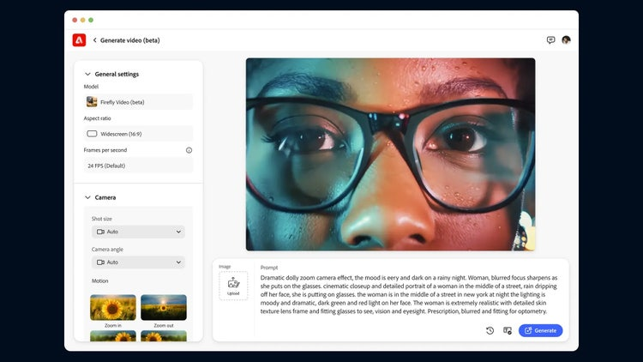

CardImageAltText

Image for Firefly Video Model

CardDescription

Adobe announced the expansion of its Firefly family of creative generative AI models to video, in addition to new breakthroughs in its Image, Vector and Design models and significant momentum in Firefly’s adoption by leading brands and enterprises.

ContentType

caas:content-type/newsroom

Tags

caas:newsroom/article/cc,

caas:newsroom/article/events,

caas:newsroom/article/max,

Details

cta1Text

Read now

cta1URL

| Metadata | |
| --- | --- |
| Title | Adobe Launches Firefly Video Model and Enhances Image, Vector and Design Models |
| Description | Adobe announced the expansion of its Firefly family of creative generative AI models to video, in addition to new breakthroughs in its Image, Vector and Design models and significant momentum in Firefly’s adoption by leading brands and enterprises. |
| Image |  |