#262530

# Adobe Launches GenStudio for Performance Marketing to Accelerate Campaigns for Marketing and Creative Teams with Generative AI and Deep Insights

Monday, October 14, 2024 6:00 AM

[*Download the PDF*](/news/downloads/pdfs/2024/10/101424-genstudioperformancemarketing.pdf#_blank)

<https://video.tv.adobe.com/v/3435058/?hidetitle=1>

* GenStudio for Performance Marketing is the latest enterprise application within Adobe GenStudio, Adobe’s existing end-to-end content supply chain solution that optimizes the process of planning, creating, managing, activating and measuring content for marketing campaigns and personalized customer experiences
* Adobe’s new generative AI-first application brings marketers and creatives together to scale on-brand digital experiences through Adobe Firefly and third-party large language models, with the ability to organize, generate, remix and measure content variations that span use cases across performance, social, email, growth and paid media marketing
* Adobe unveiled expanded, integrated partnerships today with Google’s Campaign Manager 360, Meta, Microsoft Advertising, Snap and TikTok, where brands will soon be able to activate campaigns instantly across platforms and make timely adjustments via direct performance insights—along with native integrations across Adobe Experience Cloud applications

**SAN JOSE, Calif. — Oct. 14, 2024** — Today, Adobe (Nasdaq:ADBE) announced the general availability of [Adobe GenStudio for Performance Marketing](https://business.adobe.com/products/genstudio-for-performance-marketing.html), a new generative AI-first application that empowers brands and agencies to accelerate the delivery of global advertising and marketing campaigns. The new offering addresses one of the biggest challenges facing businesses today, where the need for highly personalized, on-brand and performant content—across a myriad of channels and geographies—is outstripping available resources. In fact, between now and 2026, nearly two-thirds of marketers* believe the demand for content will grow by at least five times, driven by consumers who expect brand experiences that are dynamic and personalized to their interests.

With GenStudio for Performance Marketing, brands have a single, self-service application to create paid social ads, display ads, banners, marketing emails and more—all with a new level of speed and agility—by leveraging pre-approved, on-brand content. It brings together creative teams that define the foundational requirements of a brand, including guidelines around brand voice, channels and images, with marketing teams that need to deliver variations at scale for demanding channels such as paid media.

“Delivering impactful global campaigns hinges on the ability to bring marketing and creative teams closer together, with generative AI-powered workflows that eliminate cumbersome and inefficient processes,” said Varun Parmar, general manager, Adobe GenStudio. “Adobe GenStudio for Performance Marketing enables creatives to focus on delivering deep creative designs that amplify a brand, while empowering their marketing counterparts to create the high volume of content variations that are needed to drive customer engagement, personalization and conversion.”

Robust features in GenStudio for Performance Marketing empower users to locate brand-approved assets and create content variations with generative AI tools such as Adobe Firefly, and third-party large language models for creating copy in emails, paid media and display ads—all while helping users ensure compliance with defined brand standards. Through expanded, integrated partnerships with Google’s Campaign Manager 360, Meta, Microsoft Advertising, Snap and TikTok, teams will soon be able to quickly activate campaigns and get direct performance insights. This allows marketers and creatives to see what resonates with consumers and the key reasons why: Adobe’s AI features can discern attributes that make up an image or video including objects in the content, background and foreground colors, the presence of people, audio genres and much more.

Adobe is also working closely with its broad ecosystem of agency partners—including Accenture Song, Dentsu, Havas, IBM Consulting, Interpublic Group, Media.Monks, Omnicom, Publicis, Stagwell and WPP —to drive customization, integration and value-added needs for customers across industry verticals.

GenStudio for Performance Marketing is the latest application for brands and agencies within [Adobe GenStudio](https://business.adobe.com/solutions/content-supply-chain.html), Adobe’s end-to-end content supply chain solution that optimizes the process of planning, creating, managing, activating and measuring content for marketing campaigns and personalized customer experiences. This includes applications across Adobe Experience Cloud and Adobe Creative Cloud such as Adobe Workfront, Frame.io, Adobe Firefly Services, Adobe Firefly Custom Models, Adobe Express, Adobe Experience Manager and Adobe Content Analytics.

Adobe GenStudio for Performance Marketing enables brands to:

* **Find and reuse brand-approved assets**: A built-in content repository allows users to find brand-approved assets (images, logos, videos and more) for creating marketing content such as paid social, display ads, banners and emails. For brands using Adobe Experience Manager Assets, two-way sync ensures assets can easily be reused across campaigns, without needing to start from scratch.
* **Create and remix on-brand content**: Creative teams are often burdened with adjusting and creating high volumes of content variations for their marketing counterparts. With GenStudio for Performance Marketing, marketers can self-service with routine tasks and free up creative resources to focus on higher value work, while ensuring strong brand compliance. Users can create and remix content through tools such as Adobe Firefly—for generating images designed for safe commercial use—or through third-party language models to create copy. The content can then be matched with different audience segments, to drive personalization at scale.
* **Protect brand equity**: Millions of dollars are invested each year to create and define a brand. As generative AI reshapes content creation, teams need hardened guardrails. Brand guidelines (fonts, tone of voice, channel requirements) can be easily uploaded and standardized across the new application—along with any pre-defined templates. A brand check feature, powered by AI, automatically inspects generated content and alerts creative and marketing teams when additional attention might be needed for content that is potentially out of brand compliance. Automated multi-step review workflows, powered by a native integration with Adobe Workfront, then provide an additional layer of oversight before any content is delivered externally.
* **Activate campaigns (coming soon)**: Users will soon be able to publish content experiences directly to social media channels including Meta, TikTok and Snap, or through display ad campaigns on Google’s Campaign Manager 360 and Microsoft Advertising properties. Integration with Adobe Journey Optimizer, when released, will also allow users to activate experiences on owned channels such as email and web. The ability to automatically activate new content will speed up the delivery of advertising and marketing campaigns, giving teams the ability to adjust experiences in real-time as trends or needs change.
* **Uncover actionable insights**: Customer preferences are constantly changing, often on a daily or even hourly basis. GenStudio Insights provides attribute level-insights, pinpointing colors, objects, styles, audio genre and more that are resonating with target audiences. Users can also bring in direct performance insights from Meta and will soon be able to connect to additional partners including Microsoft Advertising, Snap and TikTok, creating a holistic view of campaign performance so teams can adjust and optimize content in a timely fashion. Integrations across Adobe Experience Cloud applications such as Adobe Journey Optimizer, which is under development, will allow users to bring in insights to ensure consistency in how customers are engaged on every touchpoint.

Global technology leader Lenovo participated in the GenStudio for Performance Marketing beta program. Since Lenovo communicates with their customers through dozens of channels and platforms, the company recognizes the need for hyper-personalization to connect their products with the right audiences. See how they will leverage the new application [here.](https://business.adobe.com/blog/the-latest/lenovo-talks-adobe-genstudio-for-performance-marketing)

**Collaboration with Technology Partners**

Adobe has collaborated with its technology partners to bring activation and insights features that are coming soon to GenStudio for Performance Marketing:

“From generating high-quality leads to driving awareness, Campaign Manager 360 helps marketers reach their desired audiences across websites, apps, video content and more, to accomplish their business goals,” said Stephen Yap, managing director, Google Marketing Platform. “Having compelling creative content that is tailored to the right audience is key to driving engagement, and Adobe GenStudio for Performance Marketing empowers brands to execute this at scale across any of the ad formats offered by Google.”

“We believe in the power of generative AI to unlock advertisers’ full creative potential and quickly build ad creatives at scale,” said Cynthia Dinh, director of strategic monetization partnerships, Meta. “Our integration with Adobe is one of a variety of ways that we’re working to make the ad creative process as seamless and efficient as possible for businesses.”

“Generative AI is a powerful tool to enable richer insights, deeper personalization for consumers, greater efficiency and performance for marketers, and a more empowered advertising ecosystem,” said Lynne Kjolso, vice president of global partnerships and retail media, Microsoft Advertising. “Our engagement with Adobe GenStudio will bring our joint innovations to a broader set of marketers, helping them reach high-quality audiences with ease and greater impact.”

“Snapchat provides a dynamic way for marketers to reach a valuable, highly engaged audience where they naturally have fun talking to friends and consuming content,” said Ali Rana, global head of business development, revenue and product partnerships, Snap Inc. “The ability to optimize ad content based on changing trends and market conditions is key to helping marketers drive their business goals. With Adobe GenStudio for Performance Marketing, we’re offering brands a way to not only create compelling ad experiences quickly and easily, but to back them with actionable engagement insights as well.”

"At TikTok, we're always looking for ways to help marketers drive impact," said Lorry Destainville, global head of monetization and product partnerships, TikTok. "We are excited to further expand our partnership with Adobe, giving marketers the tools to scale and optimize their content for their performance campaigns."

## About Adobe

Adobe is changing the world through digital experiences. For more information, visit [www.adobe.com](https://cts.businesswire.com/ct/CT?id=smartlink&url=http%3A%2F%2Fwww.adobe.com&esheet=53380676&newsitemid=20230413005364&lan=en-US&anchor=www.adobe.com&index=10&md5=415c333dd2658050a4e133a58c1983ec).

© 2024 Adobe. All rights reserved. Adobe and the Adobe logo are either registered trademarks or trademarks of Adobe in the United States and/or other countries. All other trademarks are the property of their respective owners.

*\*Adobe Survey of 2,841 marketers in markets including the U.S., Australia, France, Germany, India, Japan, and the U.K. (fielded from Feb. 27 to Mar. 7, 2024)*

## Public relations contact

Kevin Fu  
Adobe  
[kfu@adobe.com](mailto:kfu@adobe.com)

## Downloads



[Download](/news/downloads/images/2024/10/genstudio-content-creation-and-compliance.png#_blank)

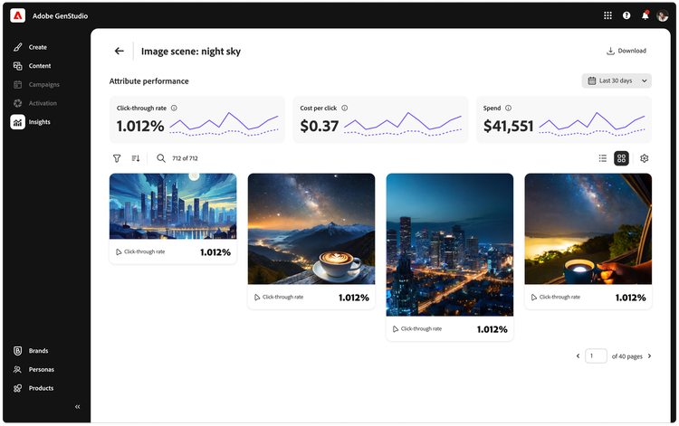

[Download](/news/downloads/images/2024/10/genstudio-insights.png#_blank)

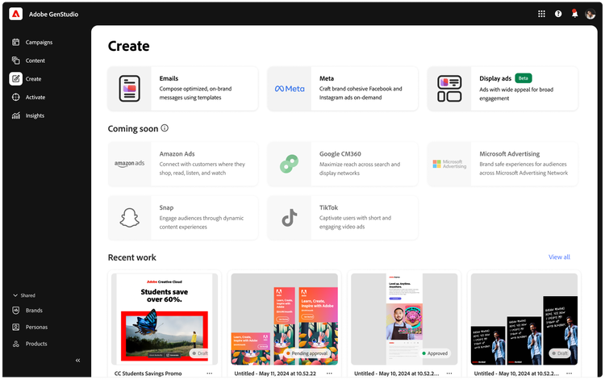

[Download](/news/downloads/images/2024/10/genstudio-landing-page.png#_blank)

style

Three up, m spacing, grid-width-8, static-links

CardTitle

Adobe Launches GenStudio for Performance Marketing to Accelerate Campaigns for Marketing and Creative Teams with Generative AI and Deep Insights

Created

2024-10-14

CardImage



CardImageAltText

Image for GenStudio for Performance Marketing

CardDescription

[Adobe announced the general availability of Adobe GenStudio for Performance Marketing, a new generative AI-first application that empowers brands and agencies to accelerate the delivery of global advertising and marketing campaigns.

ContentType

caas:content-type/newsroom

Tags

caas:newsroom/article/cc,

caas:newsroom/article/events,

caas:newsroom/article/max,

Details

cta1Text

Read now

cta1URL

| Metadata | |
| --- | --- |
| Title | Adobe Launches GenStudio for Performance Marketing to Accelerate Campaigns for Marketing and Creative Teams with Generative AI and Deep Insights |
| Description | Adobe announced the general availability of Adobe GenStudio for Performance Marketing, a new generative AI-first application that empowers brands and agencies to accelerate the delivery of global advertising and marketing campaigns. |
| Image |  |