#262530

# New Innovations in Photoshop and Illustrator Transform Creative Workflows and Deliver More Speed, Precision and Power Than Ever Before

Monday, October 14, 2024 6:00 AM

[*Download the PDF*](/news/downloads/pdfs/2024/10/101424-adobemax-illustratorphotoshopinnovations.pdf#_blank)

<https://youtu.be/T9LCGpDC5Yg?hidetitle=1>

* Photoshop introduces powerful new innovations for graphic design and creative imaging including automatic image distraction removal, an all-new Generative Workspace (beta) and powerful new 3D workflows, in addition to top community productivity and performance requests
* Photoshop’s Generative Fill, Generative Expand, Generate Similar and Generate Background, powered by the latest Firefly Image 3 Model are now generally available and help creators jumpstart creative ideation
* Illustrator’s latest innovations supercharge core design workflows with all-new Objects on Path, Enhanced Image Trace and Generative Shape Fill (beta) powered by the Firefly Vector Model

**MIAMI BEACH, Fla. — October 14, 2024 —** Today at [Adobe MAX](https://max.adobe.com/) – the world’s largest creativity conference – Adobe (Nasdaq:ADBE) announced breakthrough innovations in [Adobe Photoshop](https://www.adobe.com/products/photoshop.html) and [Adobe Illustrator](https://www.adobe.com/products/illustrator.html) that deliver unmatched power and precision across core graphic design, illustration and creative imaging workflows, while bringing unprecedented levels of speed and productivity. The latest Photoshop and Illustrator releases support creative professionals across all steps of their creative process from ideation to production and introduce breakthrough new workflows and performance enhancements that eliminate hours of tedious work, giving creative professionals more time to spend pushing their creative vision further.

“The world’s most creative people across industries trust Photoshop and Illustrator to help them realize their visions in stunning and breathtaking ways,” said Ashley Still, senior vice president, digital media at Adobe. “We’re thrilled to introduce transformative innovations across our flagship design apps that bring the creative community the most powerful creative tools yet.”

**Unlocking Unprecedented Power, Precision & Speed**

The latest release improves day to day workflows for creative professionals working across photography, graphic design, illustration, fashion design, animation, interior design and beyond. It’s now more seamless than ever to edit digital images and create stunning designs across all types of content including digital art and animations, print materials, digital banners, storyboards, marketing materials and beyond with differentiated color, texture, lighting and style across 2D and 3D assets.

New innovations in Photoshop:

* **Remove Tool** adds new **Distraction Removal** smart technology to help remove unwanted objects including people, wires and cables with speed and ease.
* All-new **Generative Workspace** (beta) ,powered by Adobe Firefly, helps designers ideate, brainstorm, and iterate concepts simultaneously, so creators can achieve their vision and produce stunning visuals faster and more intuitively than ever before.
* New **Adobe Substance 3D Viewer** app (beta) integrates with the Photoshop beta app, expanding imaging workflows by delivering new ways for graphic designers to seamlessly view and edit 3D editable Smart Objects across their 2D designs in Photoshop.
* Now generally available, **Generative Fill**, **Generative Expand**, **Generate Similar** and **Generate Background**, powered by **Adobe Firefly Image 3 Model**, delivers new ways to ideate and create.
* Additional valuable workflow enhancements including **OCIO Configuration** enables designers to control, convert and preserve color workflows at higher quality across programs for best-in-class color management, as well as **32-bit Workflow for HDR** which delivers superb image quality, detail and color precision.

New innovations in Illustrator:

* Unveiled as a Sneak at MAX 2023, **Project Neo** web app (beta) helps designers seamlessly create and edit 3D designs including color, shape, lighting and perspective, and bring them into Illustrator for their everyday design workflows.
* All-new **Objects on Path** empowers users to quickly attach, arrange, and move objects along any path of their art board with maximum speed and precision.
* **Enhanced Image Trace** helps designers seamlessly convert graphics to vectors easier, faster, and more accurately than ever before for further editing and customization across design workflows.
* Powered by the Firefly Vector Model, **Generative Shape Fill** (beta) accelerates creative workflows and empowers designers to quickly add detailed vectors to shapes by entering text prompts directly in the Contextual Taskbar.
* General availability of **Mockup** delivers the ability to easily create high-quality visual prototypes of art on objects like product packaging, apparel and more by automatically adjusting the art to fit the curves and edges of the real-life object.
* **Powerful performance improvements** including the Enclosed Selection Mode for the Rectangular Marquee tool, Star as a Live Shape, ability to now Export as PDF, Resized Artboard, Quick Gradient Creation and [more](https://blog.adobe.com/en/publish/2024/09/23/top-10-requested-features-for-illustrator-indesign) optimize everyday Illustrator operations to boost productivity and empower speed and ease across workflows.

**Empowering Creators through Responsible Innovation**

Adobe is committed to being a trusted partner for creators, integrating technology into its tools in ways that respects and supports the creative community. Adobe takes a creator-first approach to AI innovations, ensuring that its AI features are built in accordance with the company’s [AI Ethics principles](https://www.adobe.com/ai/overview/ethics.html) of accountability, responsibility, and transparency.

Adobe champions transparency in digital content, advocating for the widespread adoption of [Content Credentials](https://contentcredentials.org/) – a 'nutrition label' for digital content that can show who created it, how it was made, and whether AI was involved. Adobe has been integrating Content Credentials across its Creative Cloud apps, including Photoshop, where creative professionals can apply Content Credentials to their work to provide information about themselves and their editing process.

Adobe also recently [announced](/news/2024/10/aca-announcement) a new free web app, Adobe Content Authenticity, which is designed to help creators protect and gain attribution for their work. With the new web app, creators can easily apply Content Credentials in batch to sign their work with their name, social media websites and more. In addition, the Generative AI Training and Usage Preference in the web app allows creators to use Content Credentials to signal if they do not want their content used by or to train other generative AI models on the market. A free, public beta of the web app will be available in Q1 2025.

**Availability**

Photoshop and Illustrator’s latest releases are available globally today. Explore more details about today’s releases in [Photoshop](https://blog.adobe.com/en/publish/2024/10/14/photoshop-delivers-powerful-innovation-for-image-editing-ideation-3d-design-more) and [Illustrator](https://blog.adobe.com/en/publish/2024/10/14/even-more-speed-precision-power-get-started-latest-illustrator-indesign-features-creative-professionals) on the Adobe blog.

## About Adobe

Adobe is changing the world through digital experiences. For more information, visit [www.adobe.com](https://cts.businesswire.com/ct/CT?id=smartlink&url=http%3A%2F%2Fwww.adobe.com&esheet=53380676&newsitemid=20230413005364&lan=en-US&anchor=www.adobe.com&index=10&md5=415c333dd2658050a4e133a58c1983ec).

© 2024 Adobe. All rights reserved. Adobe and the Adobe logo are either registered trademarks or trademarks of Adobe in the United States and/or other countries. All other trademarks are the property of their respective owners.

## Public relations contact

Erin Di Leva  
Adobe  
[edileva@adobe.com](mailto:edileva@adobe.com)

## Downloads



[Download](/news/downloads/images/2024/10/genworkspace.jpg#_blank)

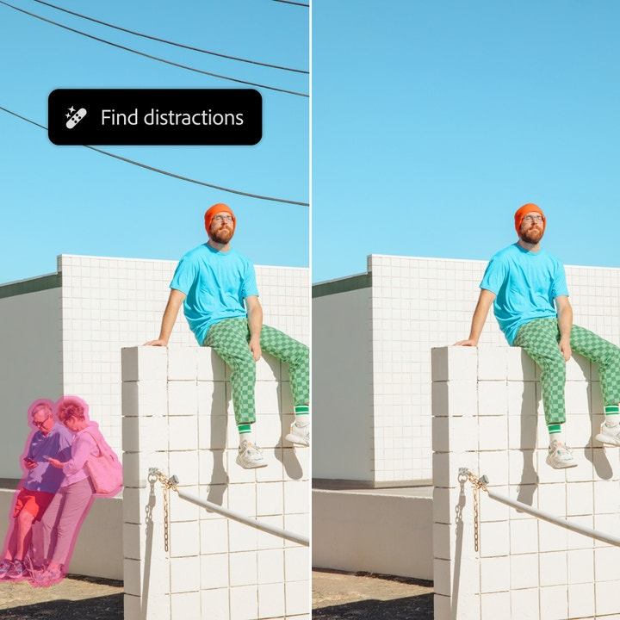

[Download](/news/downloads/images/2024/10/distraction-removal.jpg#_blank)

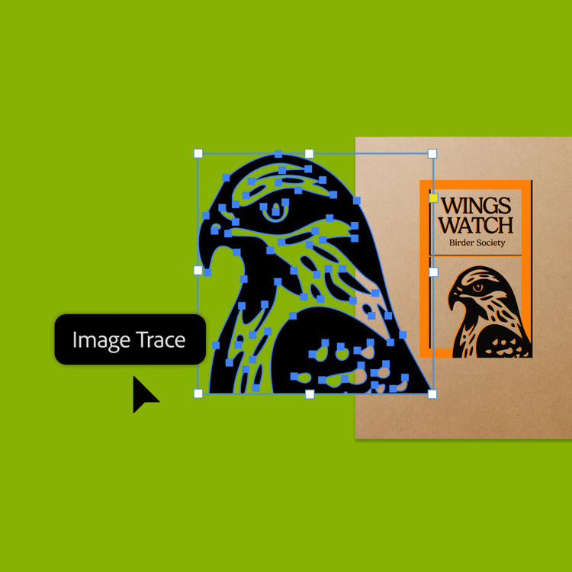

[Download](/news/downloads/images/2024/10/image-trace.png#_blank)

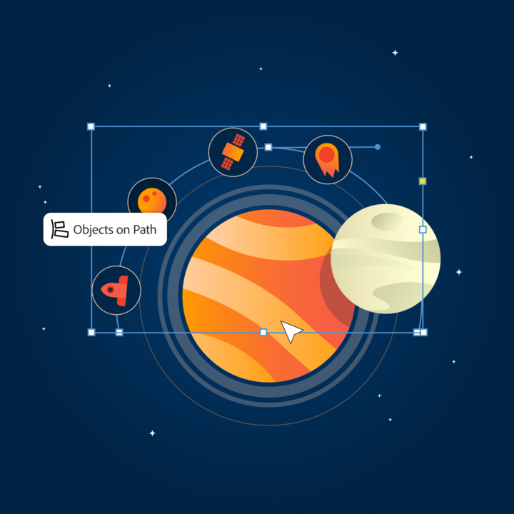

[Download](/news/downloads/images/2024/10/objects-on-path.png#_blank)

style

Three up, m spacing, grid-width-8, static-links

CardTitle

New Innovations in Photoshop and Illustrator Transform Creative Workflows and Deliver More Speed, Precision and Power Than Ever Before

Created

2024-10-14

CardImage



CardImageAltText

Image for new innovations in Photoshop and Illustrator

CardDescription

Adobe announced breakthrough innovations in Adobe Photoshop and Adobe Illustrator that deliver unmatched power and precision across core graphic design, illustration and creative imaging workflows, while bringing unprecedented levels of speed and productivity.

ContentType

caas:content-type/newsroom

Tags

caas:newsroom/article/cc,

caas:newsroom/article/events,

caas:newsroom/article/max,

Details

cta1Text

Read now

cta1URL

| Metadata | |
| --- | --- |
| Title | New Innovations in Photoshop and Illustrator Transform Creative Workflows and Deliver More Speed, Precision and Power Than Ever Before |
| Description | Adobe announced breakthrough innovations in Adobe Photoshop and Adobe Illustrator that deliver unmatched power and precision across core graphic design, illustration and creative imaging workflows, while bringing unprecedented levels of speed and productivity. |
| Image |  |