#262530

# EA Sports and Adobe Join Forces to Transform Team Builder In College Football 25

Thursday, October 24, 2024 10:00 AM

[*Download the PDF*](/news/downloads/pdfs/2024/10/102424-ea-sports-and-adobe-join-forces.pdf)

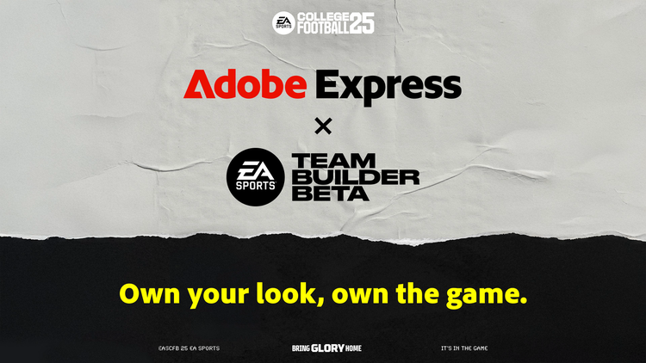

**SAN JOSE, Calif.— October 24, 2024 —** Electronic Arts Inc. (Nasdaq:EA), alongside EA SPORTS™ and Adobe (Nasdaq:ADBE), announced a new partnership that will bring Adobe Express, the easy-to-use make-anything app, into the Team Builder mode of EA Sports College Football 25. The collaboration brings Adobe Express to over one million users in Team Builder and will dynamically elevate the user experience by providing innovative tools for team customization, allowing players to express their creativity in new and exciting ways.

“We’re thrilled to partner with Adobe Express to bring its functionality to Team Builder, empowering our users to showcase their creativity,” said Jeff Skelton, Head of Technology Partnerships for EA. “This integration brings additional customization options and takes the design experience to the next level of innovation. We can't wait to see how players personalize their teams in exciting new ways.”

**Adobe Express Makes It Easy to Customize Team Uniforms, Helmets and More for Free**

Adobe Express brings together the best of Adobe’s industry-leading creative tools, responsible AI and a massive library of professional-grade assets into an app that’s quick and easy for everyone to use.

Millions of solopreneurs, SMBs, marketers and business users turn to Adobe Express to promote and grow their ideas, passions and businesses. Adobe Express also brings easy content creation to where millions more people work, with integrations into popular productivity platforms like Google Drive, ChatGPT and Slack.

The new partnership between EA SPORTS and Adobe Express will give College Football 25 players the ability to make their teams stand out on the field and on social media with custom logo, helmet, jersey and home-field designs that reflect their personal style and passions. With Adobe Express in Team Builder, players can now:

* **Access Adobe’s professional-grade assets**. Players can choose from more than 500,000 royalty-free Adobe Stock photos, 290,000 icons and 44,000 designs, including shapes, illustrations, brushes, textures, frames and more.
* **Leverage their own content**. Players can bring their own photos or images into Adobe Express to create new designs.
* **Generate designs with responsible AI**. Players simply type in what they want to see and Adobe Express quickly generates designs they can choose from. Adobe Express features powered by Adobe’s Firefly generative AI model, are designed to be commercially safe so players can post their creations online and on social with confidence.
* **Share on social**. With Adobe Express, it’s simple for players to showcase their in-game designs with friends and fans on their favorite social media platforms.

“College Football 25 players bring a passion and pride to their teams. With Adobe Express in EA Sports' Team Builder mode, it’s now easy for players to translate that passion into a team look and personality that’s uniquely theirs and they can showcase to the world,” said Aubrey Cattell, VP Creative Cloud Developer Platform and Partner Ecosystem. “We’re incredibly excited to put Adobe’s world-class creative tools 'in the game' for such a highly engaged audience.”

To learn more about how the new Adobe Express features in [Team Builder](https://www.ea.com/games/ea-sports-college-football/team-builder/landing) work, visit this [blog](https://blog.adobe.com/en/publish/2024/10/24/your-team-way-create-own-dream-adobe-express-ea-sports-college-football-25).

## About Adobe

Adobe is changing the world through digital experiences. For more information, visit [www.adobe.com](https://cts.businesswire.com/ct/CT?id=smartlink&url=http%3A%2F%2Fwww.adobe.com&esheet=53380676&newsitemid=20230413005364&lan=en-US&anchor=www.adobe.com&index=10&md5=415c333dd2658050a4e133a58c1983ec).

© 2024 Adobe. All rights reserved. Adobe and the Adobe logo are either registered trademarks or trademarks of Adobe in the United States and/or other countries. All other trademarks are the property of their respective owners.

## Public relations contact

Marlee Bever  
Adobe  
[mbever@adobe.com](mailto:mbever@adobe.com)

CardTitle

EA Sports and Adobe Join Forces to Transform Team Builder in College Football 25

Created

2024-10-24

CardImage



CardImageAltText

Image of Adobe and EA Sports Team Builder Integration

CardDescription

Electronic Arts Inc., alongside EA SPORTS™ and Adobe, announced a new partnership that will bring Adobe Express, the easy-to-use make-anything app, into the Team Builder mode of EA Sports College Football 25.

ContentType

caas:content-type/newsroom

Tags

caas:newsroom/article/cc

Details

cta1Text

Read now

cta1URL

| Metadata | |
| --- | --- |
| Title | EA Sports and Adobe Join Forces to Transform Team Builder in College Football 25 |
| Description | Electronic Arts Inc., alongside EA SPORTS™ and Adobe, announced a new partnership that will bring Adobe Express, the easy-to-use make-anything app, into the Team Builder mode of EA Sports College Football 25. |