#262530

# Adobe Express Accelerates On-Brand Content Creation for Global Enterprises with New Capabilities

Wednesday, October 9, 2024 06:00 AM

[*Download the PDF*](/news/downloads/pdfs/2024/10/10924-adobe-express-enterprise-release.pdf#_blank)

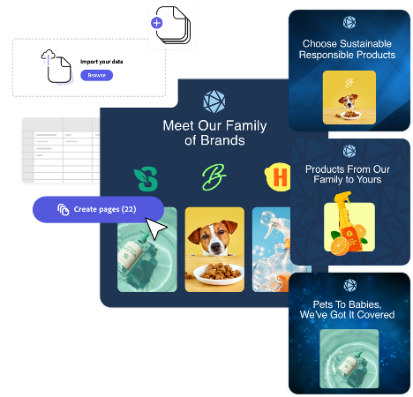

* Leading brands and agencies like Dentsu, Havas, Prudential, Virgin Australia and Workday rely on Adobe Express to create professional looking content at scale – with features powered by Firefly generative AI designed to be safe for commercial use
* Powerful new features, seamless workflows with Creative Cloud and 150+ add-ons with leading social, productivity and collaboration apps empower marketing, HR, sales and communications teams to easily create on-brand assets and get campaigns to market faster
* Rapid growth of Adobe Express ecosystem now reaches more enterprise users where they work through integrations with leading platforms like ChatGPT, Google, Slack, Wix and now Box, Hubspot and Webflow – as well as Adobe apps like Acrobat and GenStudio

**SAN JOSE, Calif. — October 9, 2024** — Today, Adobe (Nasdaq:ADBE) announced new Adobe Express innovations to empower the world’s largest enterprises to accelerate and scale on-brand content creation while collaborating more seamlessly and productively across teams, agencies and partners.

Adobe Express is playing a critical role in enterprises’ content supply chains, enabling everyone in the organization to create on-brand business and marketing content – with AI-powered features designed to be commercially safe. Adobe Express is seeing strong momentum, with a rapidly expanding ecosystem and new enterprise customers including ABB, Ad Council, Aon, Denstu, Havas, IBM, Red Hat, Owen Jones, Prudential, Tata Consultancy Services, Virgin Australia and Workday. Adobe Express also enables creative professionals to take their content further with easy video, design, animation and social capabilities and to collaborate easily and securely across the creation process.

Available starting October 14, new Adobe Express features will enable marketers and business users to make more professional-looking content, create and get campaigns into market faster and help ensure brand consistency. New integrations with Adobe InDesign and Adobe Lightroom will enable Creative Cloud users to work and share seamlessly across applications, teams and external stakeholders.

“Adobe already provides the most comprehensive set of content supply chain solutions in the industry and with Adobe Express, we’re unlocking on-brand content creation for everyone in the enterprise at unprecedented scale and ease,” said Govind Balakrishnan, Senior Vice President, Adobe Express and Creative Cloud Services. “We are excited to see so many incredible brands and agencies adopting and getting value from Adobe Express.”

**Adobe Express for Business: Empower, Supercharge, Enable, Protect**

New Adobe Express innovations include capabilities to:

* **EMPOWER everyone to easily create anything,** building upon a collection of professionally designed templates, Adobe’s industry-leading creative tools and unmatched multimedia library of millions of professional-grade assets, including photos, videos, fonts, music tracks and design assets:
  + **Animate Scenes:** Add motion to an entire design in one click, instantly animating every component including text, images and shapes. Use AI to highlight key information like CTAs and headlines.
  + **Long-form Text Reflow**: Rearrange assets and reflow copy for a better layout across key assets like multipage brochures, documents, flyers, and more in seconds.
  + **Infographics support:** Create graphs, bar charts and now tables easily in Adobe Express,
  + **Draw Shape**: Add hand-drawn elements for a more organic look and feel.
  + **Presentation Enhancements**: Robust support for presentations just got better. Import existing PowerPoint slides with higher fidelity, add graphs and tables, easily find and replace text and hide slides. iPad and Mobile support now available for presentations.

“Empowering our employees with the tools needed to create compelling content and design assets is critical to driving employee productivity,” said Ali Fuller, senior vice president, experience, Workday. “We look forward to using the new capabilities in Adobe Express to make it even easier for our teams to deliver engaging user experiences.”

* **SUPERCHARGE employees with AI,** bolstering AI superpowers in Adobe Express that currently include the ability to generate and customize production-ready assets and produce variations in a few clicks:
  + **Rewrite Text**: Easily rephrase, shorten or change the tone of copy in a single click.
  + **Translate Text:** Translate text into 46 languages and choose between formal and informal tones. Contextually aware translation capabilities keep messaging intent clear.
  + **Resize with Expand**: Resize content for every social channel and expand images to fit every layout.
* **ENABLE every team with access to approved assets,** building upon Adobe Express’ capabilities that enable anyone in an organization to produce, share and apply brand kits across teams quickly and easily:
  + **Firefly Custom Model Integration:** Make use of custom models trained on branded assets to create extraordinary campaigns that match a brand’s specific style. Available as an add-on to Adobe Express.
  + **One-click Apply Brand and On-brand Recolor:** Easily apply all brand elements or brand colors across multiple pages for one-click brand and visual consistency.
  + **Adobe InDesign Convert and Import**: Building on the ability to bring Adobe Photoshop and Adobe Illustrator filles, user can now bring InDesign files into Adobe Express and instantly convert them into layered Adobe Express files for further editing or publishing.
  + **Adobe Lightroom Integration**: Working in Adobe Express, users can browse and add photos from their Lightroom library to their designs — right within the app

“With Adobe Express, our design team has the creative space and time to work on bigger, more meaningful projects while still maintaining a top layer of quality control,” said Zubair Khatry, Creative Studio Lead at Virgin Australia.

* **PROTECT your brand with generative AI designed to be commercially safe** with Adobe Firefly, and guardrails that provide brand stewards with oversight and assurance, including new features:
  + **Controlled Templates with enforced locks and brand controls:** Give creative studios more options to enforce brand integrity.
  + **Shared Calendars:** provide brand stewards and other teams with the ability to review and edit all planned social posts before publishing.

Adobe recently enabled nearly 30,000 employees across every department with lockable branded templates, which protects brand while empowering teams to create the content they need to do their jobs. According to Chief Brand Officer Heather Freeland: “Empowering teams across the company with brand templates and assets is a powerful way to scale our brand, while enabling our creative teams to stay focused on the big idea.”

**Integration with Adobe GenStudio**

Adobe Express for Enterprise is seamlessly integrated with Adobe Acrobat, Creative Cloud and AEM Assets, as well as [Adobe GenStudio](https://business.adobe.com/products/genstudio.html), the company’s forthcoming end-to-end content lifecycle solution. Adobe GenStudio enables marketers to reuse existing brand-approved content, generate variations for digital channels, activate content in Adobe and third-party applications and measure content performance. Deeply integrated into Adobe GenStudio, Adobe Express supports the ability to remix approved assets and directly edit content without requiring specialized creative skills.

**Growing Adobe Express Ecosystem Sees Rapid Expansion**

Adobe Express is a trusted partner ecosystem for business users and teams with mission-critical integrations and more than 150 add-ons to enable seamless cross-app workflows that empower every customer to work where and how they want – easier, better and faster. The number of apps in the Adobe Express Add-On marketplace has more than tripled in the last year and includes apps help users streamline workflows (Dropbox, Google Drive, and AEM Assets), enhance expressiveness (TikTok’s Symphony Assistant and Commercial Music Library and HeyGen's AI Avatars) and support accessible and inclusive design (Contrast Checker and Color Blindness Simulator).

Adobe Express has significantly expanded its reach over the last six months through integrations with **NEW platform partners Box (beta), Hubspot and Webflow,** which join existing partners, including, Slack, Google (Google Slides, Google Drive, Google Photos), ChatGPT and Wix, as well as Adobe apps like Acrobat and GenStudio (beta) – meeting more enterprise users where they work. Adobe is also working with Microsoft to develop the Adobe Express Agent for Microsoft Copilot to unlock new levels of creativity and productivity for enterprise employees. Adobe and Miro are working together to integrate Adobe Express into Miro’s visual workspace environment, fostering cross-functional collaboration and creative iteration for Miro’s 80 million business users. More information about the growing Adobe Express ecosystem [here](https://blog.adobe.com/en/publish/2024/10/09/growing-our-partner-ecosystem-bringing-adobe-express-where-billion-people-work-every-day).

**Pricing and Availability**

All new Adobe Express enterprise features will be available starting October 14, 2024. All third-party add-ons and platform integrations are available immediately. For more information, visit <https://www.adobe.com/express/business>.

## About Adobe

Adobe is changing the world through digital experiences. For more information, visit [www.adobe.com](https://cts.businesswire.com/ct/CT?id=smartlink&url=http%3A%2F%2Fwww.adobe.com&esheet=53380676&newsitemid=20230413005364&lan=en-US&anchor=www.adobe.com&index=10&md5=415c333dd2658050a4e133a58c1983ec).

© 2024 Adobe. All rights reserved. Adobe and the Adobe logo are either registered trademarks or trademarks of Adobe in the United States and/or other countries. All other trademarks are the property of their respective owners.

## Public relations contact

Lisa Davis  
Adobe  
[davisl@adobe.com](mailto:davisl@adobe.com)

## Downloads



[Download](/news/downloads/images/2024/10/adobe-express-enterprise-rewrite-and-resize.png#_blank)

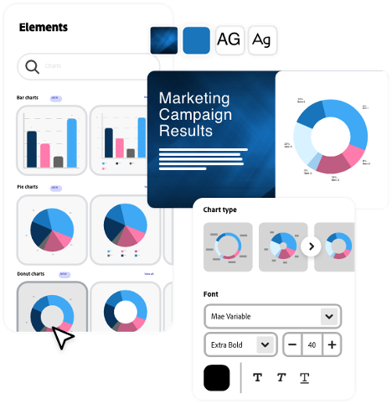

[Download](/news/downloads/images/2024/10/adobe-express-enterprise-text-and-data-visualization.png#_blank)

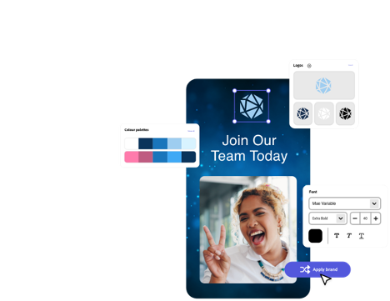

[Download](/news/downloads/images/2024/10/adobe-express-enterprise-custom-models-and-one-click-apply-brand.png#_blank)

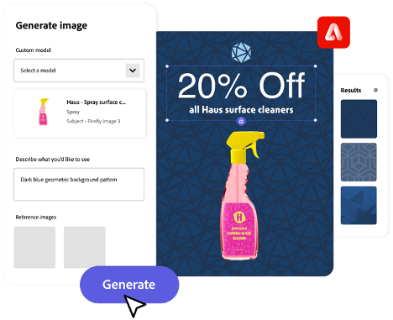

[Download](/news/downloads/images/2024/10/adobe-express-enterprise-generate-image.png#_blank)

style

Three up, m spacing, grid-width-8, static-links

CardTitle

Adobe Express Accelerates On-Brand Content Creation for Global Enterprises with New Capabilities

Created

[2024-10-09]

CardImage



CardImageAltText

Image of Adobe Express for Enterprise

CardDescription

New Adobe Express innovations to empower the world’s largest enterprises to accelerate and scale on-brand content creation while collaborating more seamlessly and productively across teams, agencies and partners.

ContentType

caas:content-type/newsroom

Tags

caas:newsroom/article/cc,

caas:newsroom/article/max,

Details

cta1Text

Read now

cta1URL

| Metadata | |
| --- | --- |
| Title | Adobe Express Accelerates On-Brand Content Creation for Global Enterprises with New Capabilities |
| Description | New Adobe Express innovations to empower the world’s largest enterprises to accelerate and scale on-brand content creation while collaborating more seamlessly and productively across teams, agencies and partners. |
| Image |  |