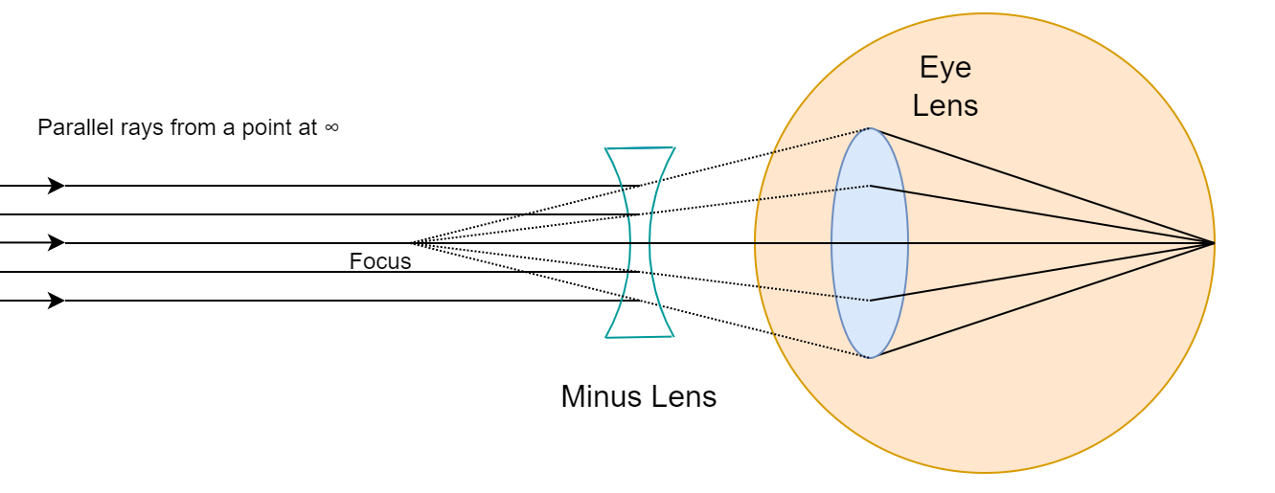

Eyes, Geometrical Optics and Solving the Mystery behind Myopia
Shivam Maurya @shvmaurya

Appendix
Rigorous proofs of some theoretical results are given.

Ideal thin-lens (planar profile) and the relation between object and image distance (the thin-lens relation)
In this text, we will focus on deriving the dimensionless relationship between object and image distances for the converging (convex) lens only which was used to arrive at the thin-lens relation.
Although, all the illustrations and considerations in this text are in 2D, they extend and apply equally well in 3-Dimensions of the real world.
The thin-lens relation also determines the magnification factor. An ideal thin-lens itself can be completely described with only two physical parameters along with its principal axis – its focal length along the axis and its aperture.
These two parameters are sufficient to explain the vast majority of image formed by real-world lenses and their observed properties in physical experiments. From a theoretical standpoint, ideal thin-lenses are extremely interesting.

Definition of an Object and its Image in Geometric Optics
An object is considered to be a collection of object points. From each such object point, rays of light can be assumed to originate/diverge in all directions.
Similarly, an image is considered to be a collection of image points. At each image point, rays of light from some object point can be assumed to terminate/converge.
A useful trick is to express Aperture size, object and image distances as some multiple of focal length. This Appendix utilizes normalized distances with respect to focal lengths in order to simplify derivations with no loss in generality.

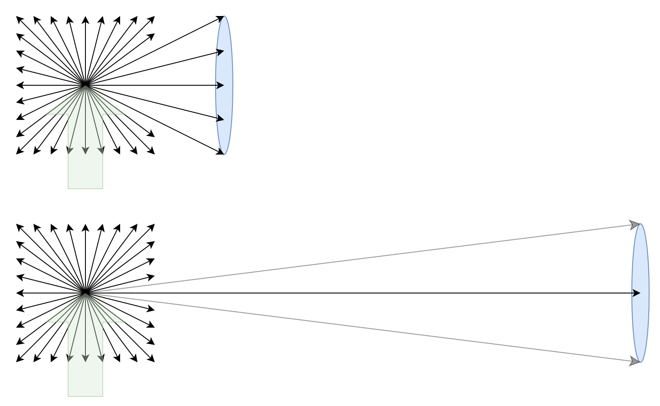
An object point on an object emitting rays of light in all directions. As distance increases, angle between rays emitted by a point on an object starts decreasing with the rays themselves appearing almost parallel at very large distances from the lens.

An application of the above distinction is to consider the commonly mentioned ‘virtual images’ in many texts to have properties more like objects rather than images because light rays seem to originate from them. From our standpoint, it makes more sense to use the term virtual object instead of the term virtual images.
For analysis of systems consisting of multiple optical elements, the ‘virtual image’ formed by an object and lens combination can be replaced solely by the virtual object alone without affecting the rest of the system. Any subsequent observation of such a virtual object by our eyes or a camera then results in the formation of an actual (real) image. Henceforth, the use of the word image in this text will always mean real image from now on.
Criteria 1: For formation of an image point, demonstrating the intersection of any two rays emerging from an object point is sufficient. A point on an object and its subsequent image always has a one-to-one correspondence.

Calculating deviation of a light ray incident on an ideal lens
Assumption 2a: The focal length defines the convergence/divergence point (focus) for all rays of light parallel to the principle axis of the lens. The extent of admission of such parallel rays onto the lens profile is given by the Aperture size. This is like a parabolic concave mirror converging all incoming parallel rays to its focus.
Thus in this sense, a thin-lens is essentially a theoretical object and we needn’t concern ourselves with the implementation details of how it achieve such ‘focusing’ of light rays.
Assumption 2b: All rays of light passing perpendicular to the principle axis (wavefront not normally incident on the lens profile) passes unchanged (due to the inherent thinness and planar nature of the lens profile).
Thus, a ray incident on the lens profile can have both a tangential component which passes through the lens profile unchanged and a component normally incident to the lens profile which must pass through the focus.
The lens is presumed thin because of this aforementioned property of not interacting with the light rays tangential to the lens profile.
The ray diagrams given below demonstrate application of this rule to show deviation for various incident rays by breaking them into their normal and tangential components with respect to the lens profile.
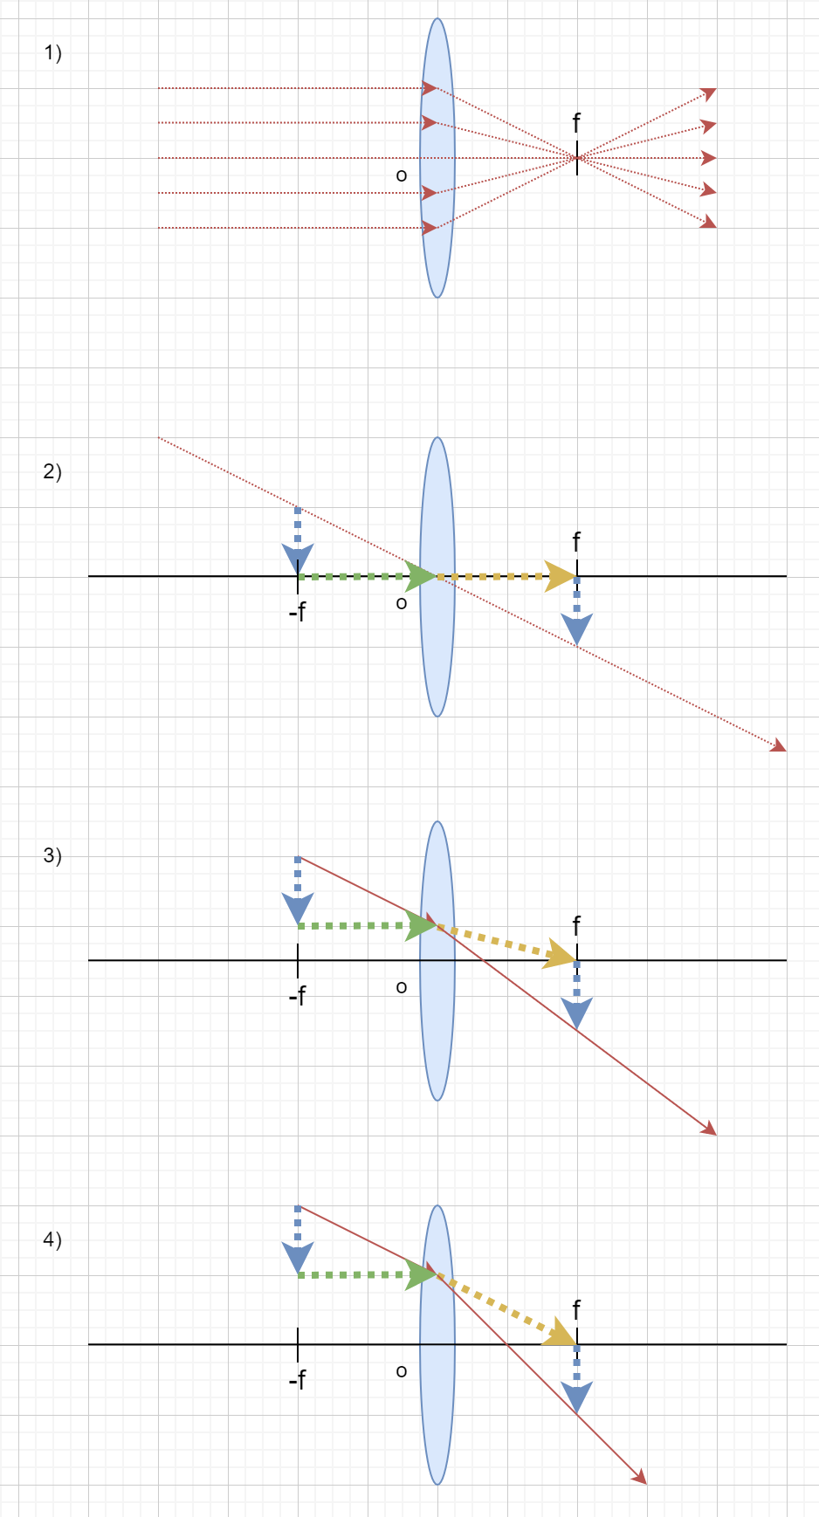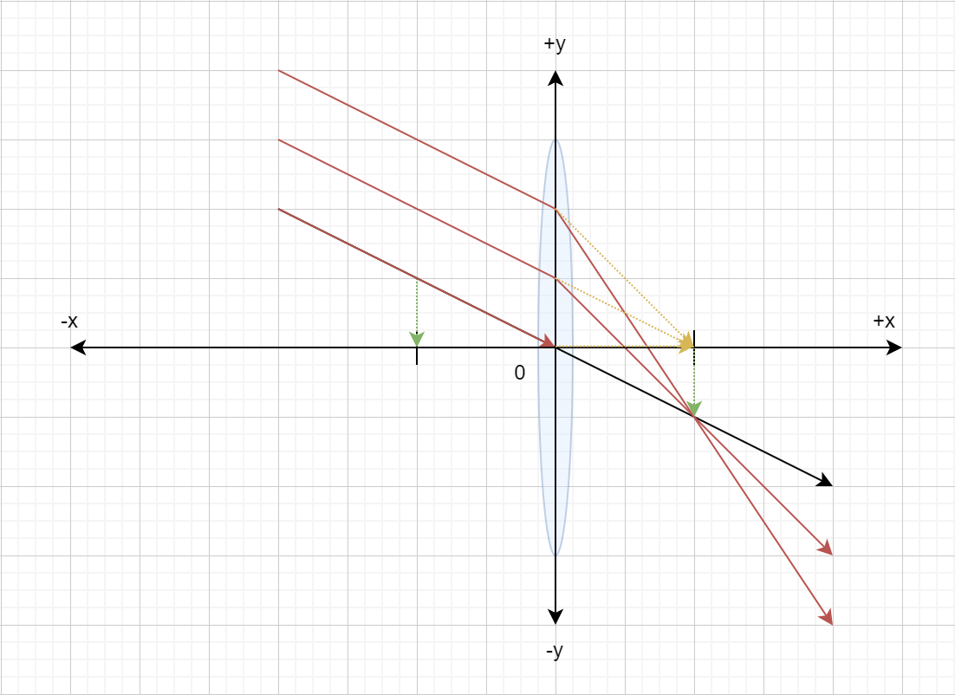
In all three cases, we can observe that the length of the vertical dashed component is the same when calculated at equal distances from both sides of the lens (in this case, it’s being calculated at the focus). The amount of deviation a ray undergoes depends on both where it’s hitting the Aperture and the angle it makes with the lens profile.
Consideration of these assumptions results in simplified rule for all rays incident on an ideal thin converging (plus) lens and is sufficient to explain image formation by ideal thin-lenses.
A verification of this simple rule for an edge case corresponding to image formation at 2f is being provided below.
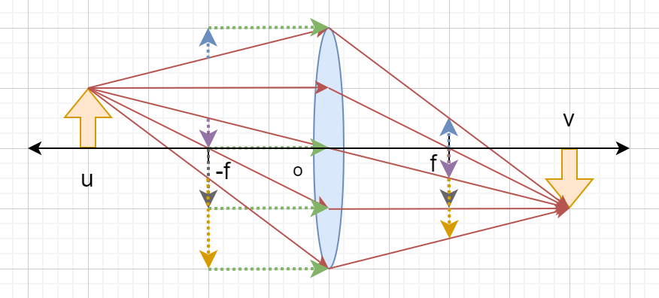
In this particular edge case example, we’ve shown the convergence of five such rays at a single point when showing that only two meet at the image point is sufficient.
The most commonly stated rules for image formation in school textbooks namely:
- A ray of light parallel to the principle axis passes through focus.
- A ray of light passing through optical centre of the lens passes unchanged.
Can be satisfyingly explained by the assumptions 2a and 2b stated above. Rule 2 given above is the one determining the magnification ratio because the image point will always lie on the ray which passes unaffected through the optical centre of the lens.

Deriving the relation for normalized object and image distances (k and j relation):
For a converging lens with a given focal length, two distinct cases of rays intersection are possible according to the rules for ray deviations:
- Virtual object formation when u (object) is situated at a distance less than the focal length f. Light rays from an object point appear to be coming from a point on a virtual object.
- Image formation when u (object) is situated at a distance greater than the focal length f. Light rays from a point appear to be converging to an image point.
Both of these cases can be seen in illustrations below with an object of same height placed at varying distances with an additional illustration of an object situated exactly at the focus (no intersection of light rays):
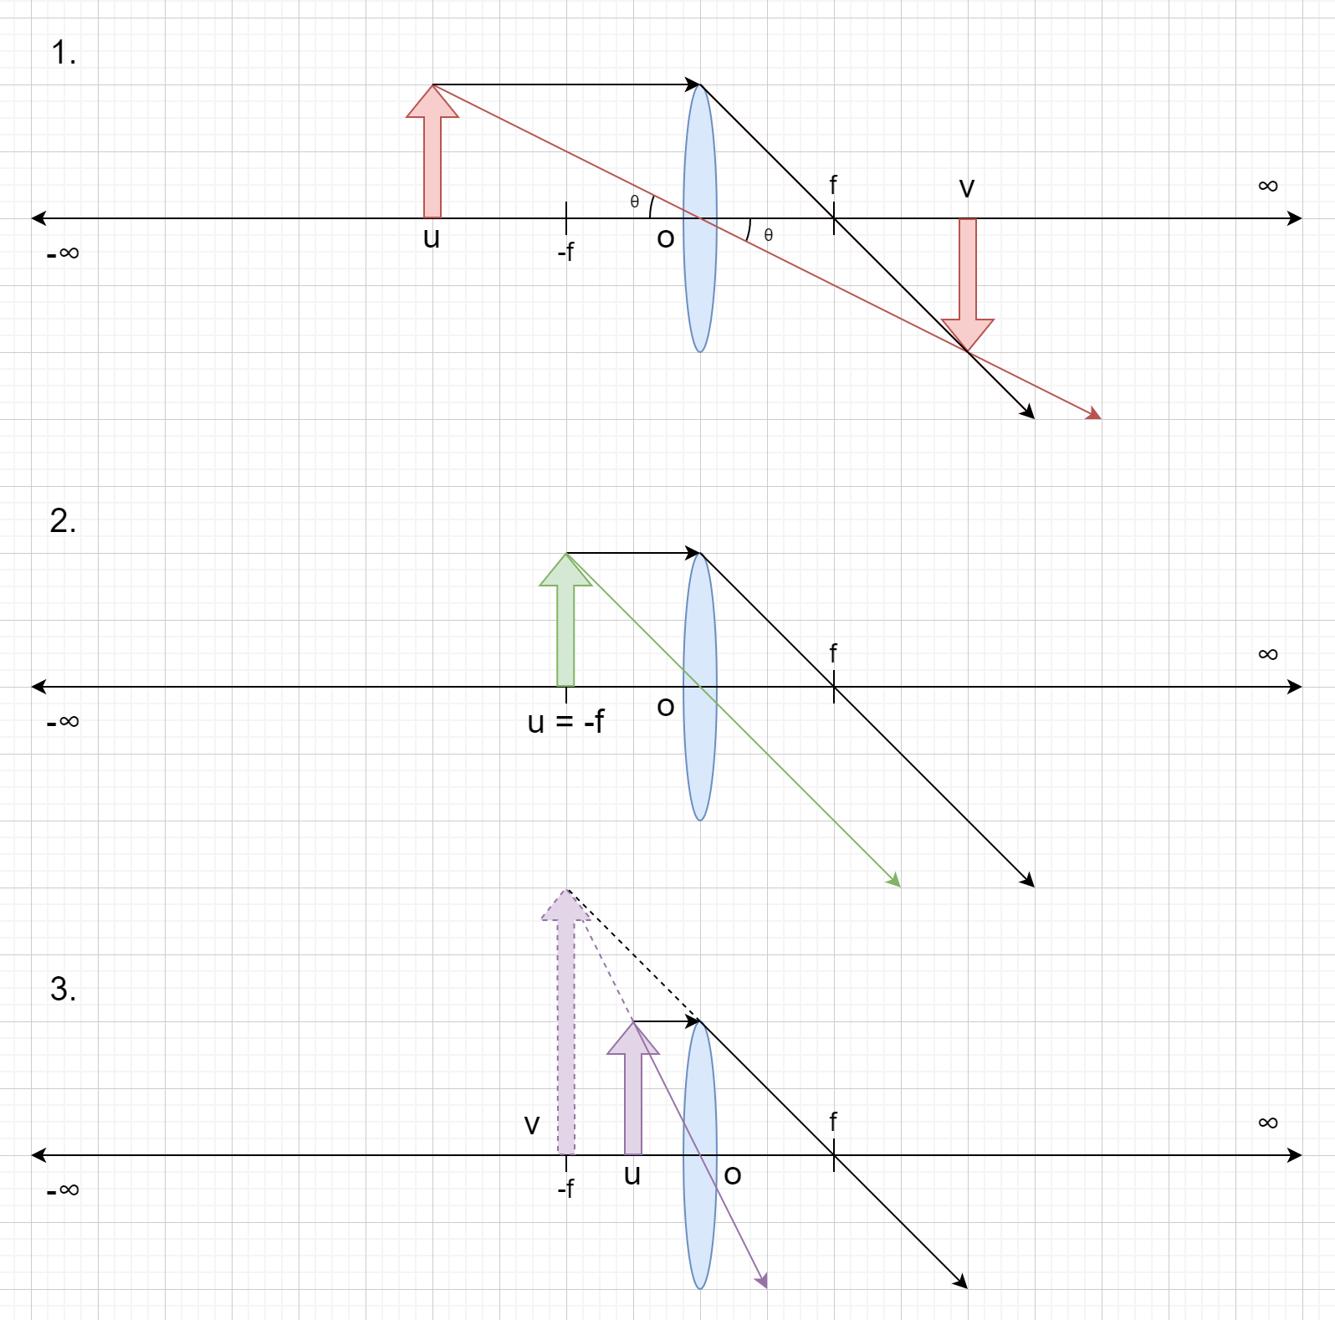
In all the three situations, the ray that passes through focus has the same slope -h/f where h is the height of object. But, the slope of line passing through the optical centre depends on the object distance in all three.
Depending on whether this slope is greater than or lesser than the line passing through focus determines where these two lines meet and whether an image is formed or not. Precisely, a light ray emerging from a point on an object of height h located to the ‘left’ of focus passing through the optical centre will always have a less negative slope.

The derivation for a converging lens:
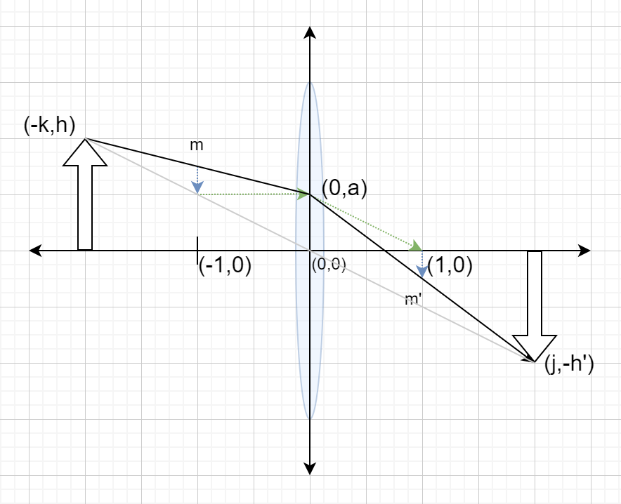
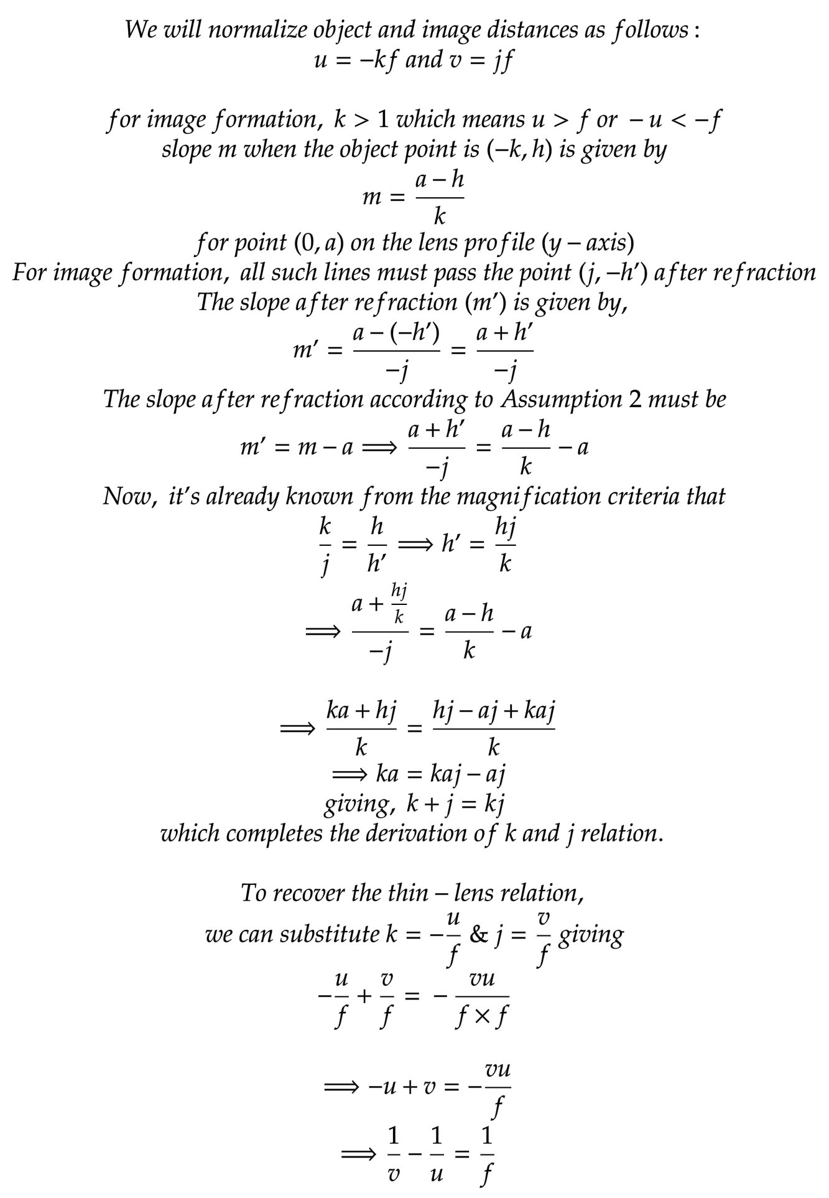
For calculation of image distance, we assume the right-handed co-ordinate system’s origin to be centred on the lens. A simple thin-lens will always have two foci. It depends on the signed power (converging or diverging) of lens that determines the sign of focus and consequently its position relative to the object. In this text, we are concerned with real images and hence only the converging lens. The results though are equally applicable to both with appropriate co-ordinate conventions.
For a converging (+) lens, the focus is on the opposite side of the lens from object.

Deriving the power (inverse of focal length) addition rule:
The power addition rule can easily be derived from the thin-lens relation by considering two ‘thin’ lenses with different focal lengths placed together such that the distance between them can be neglected.
Here, v and u denote the image and object distances respectively with subscripts denoting which lens they are referring to.
The power of a lens is the inverse of its focal length. The Dioptre (m⁻¹) is one such unit of power.
Assuming focal length f₁ for Lens L₁ and f₂ for Lens L₂. Then the image distance for Lens L₁ is given by,

Because the distance between the two lenses is negligible, this resultant image now gets further refracted as an object by lens L₂. The corresponding final image formation distance is given by (where u₂ = v₁).

This implies that the combined lenses act as a lens of focal length which is basically the law of addition of lens powers.
For a combination of more than two lenses closely put together, we can proceed by combining two lenses together at a time until only one remains.
Whenever we use the term focal length or lens power it should be assumed to mean the exact same physical quantity.

Distance between optical system (eye/camera) and introduced lens
Wearing a lens in this context means placing that lens closely (whether in the form of glasses, contacts) in front of an optical instrument (Human eye or a camera).
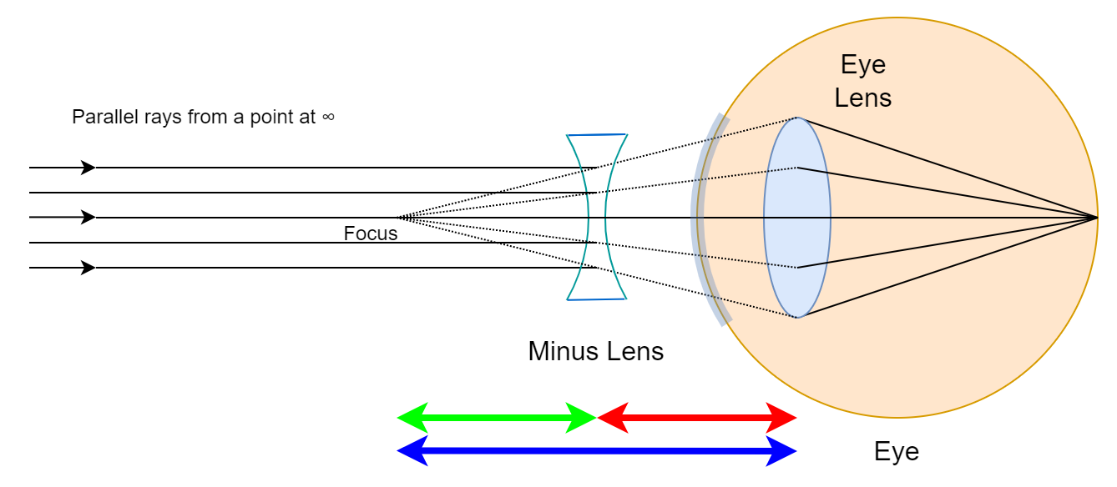
Consider an average myopic eye, unable to focus beyond the strict distance of 51 cm. Let’s assume the eyeglasses situate the lens at a distance of 1cm from the eye’s optical centre. Then it’s intuitively clear that the minus lens must make the object at infinity appear at 50 cm from the lens in order for this eye to achieve apparent focus at infinity.
The actual power of the eye is ~1.96 D SPH. The power of minus lens required is -2.0 D SPH. The difference between them is smaller than the commercially available power increments available for prescription lenses which is ±0.25 D SPH.
From the example outlined above we can see that the distance between eye and lens is not significant unless we venture into territories of high powers (~4 to 5 D).
Consider a very myopic eye, unable to focus beyond the strict distance of 5 cm. Let’s assume the eyeglass situate the lens at a distance of 1cm from the eye just like earlier example. Then it’s intuitively clear that the minus lens must apparently bring the object at infinity closer to 4 cm in order for this eye to achieve apparent focus at infinity.
The actual power of the eye is 20 D SPH. The power of lens required for Myopia compensation is -25 D SPH. The difference has now become very significant!
In actual real-world, the autorefractors most commonly employed to determine refractive errors themselves do not have an error lesser than around ±0.125 D.

Derivation of Depth of Field (DOF) using k & j relation:
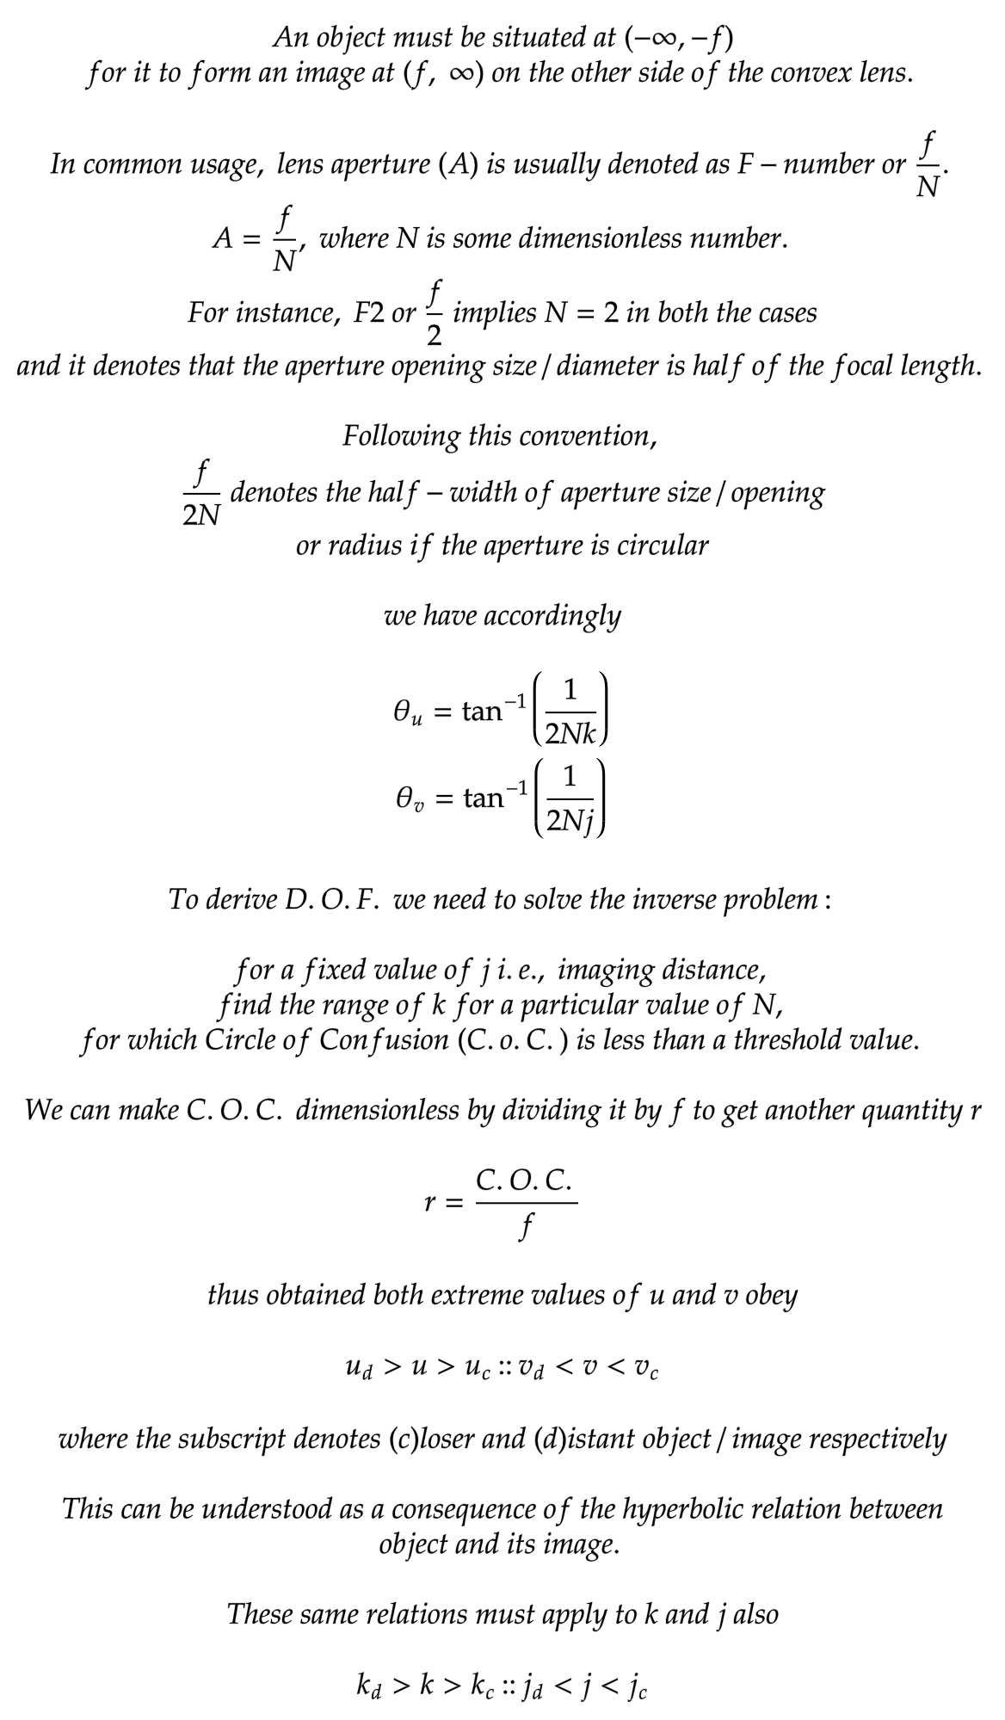
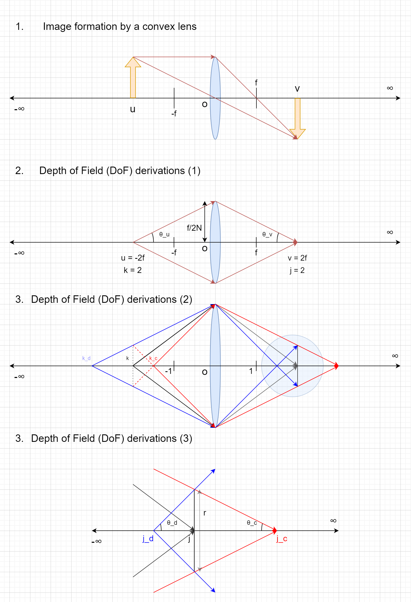
The sample DOF diagrams are given to scale for ease of visualization.
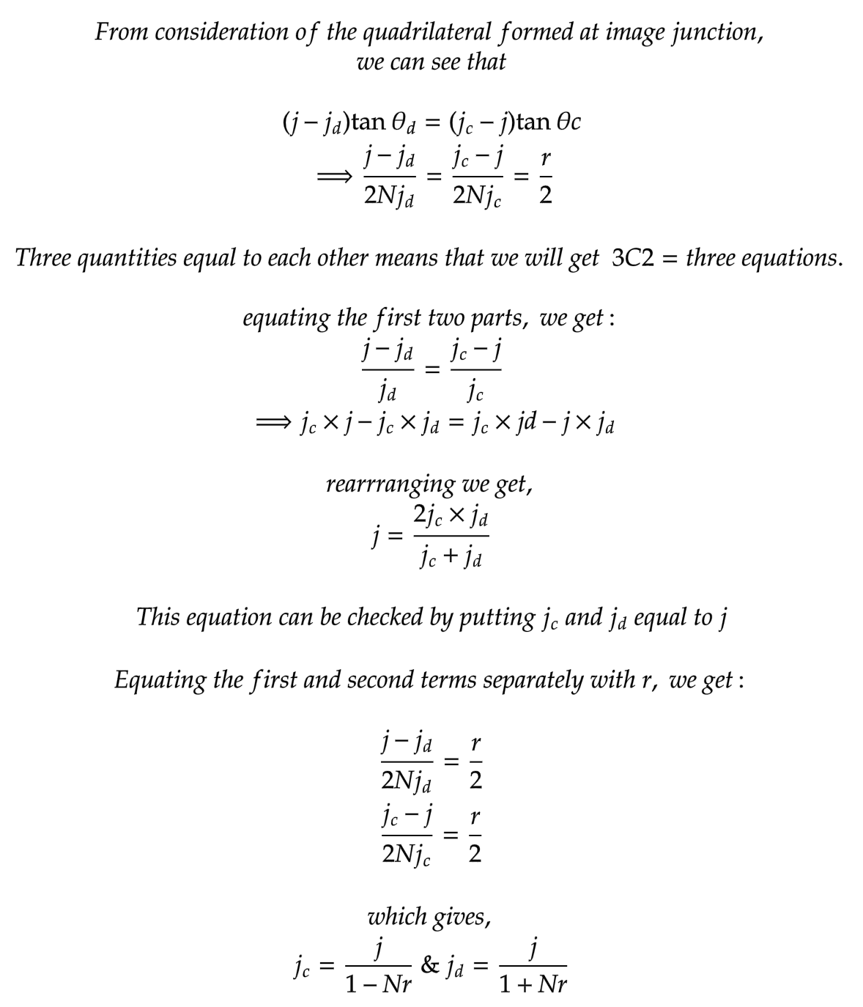
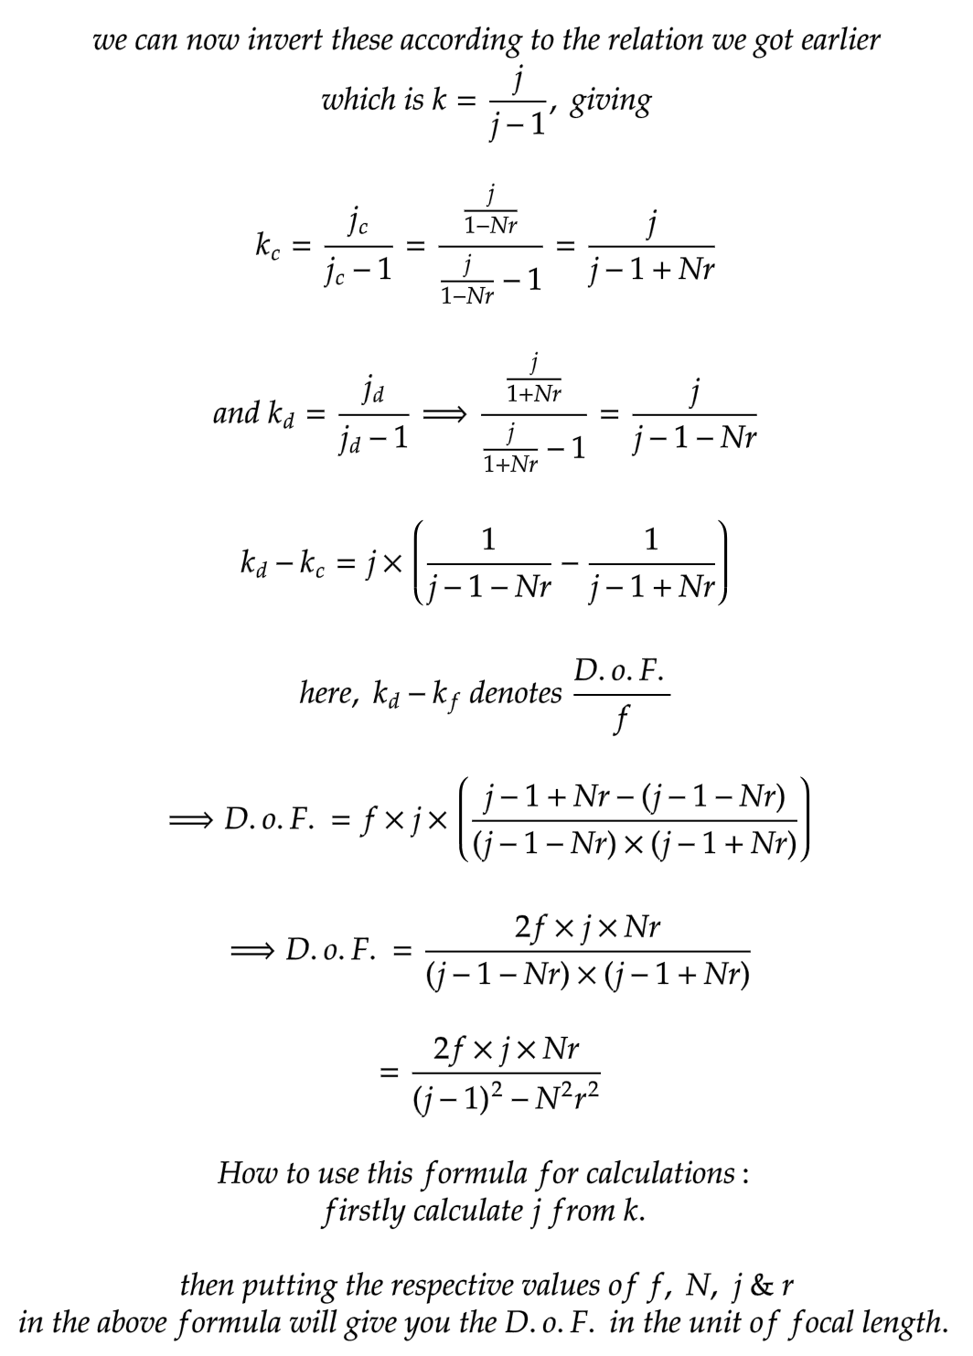
Two interesting DOF scenarios are detailed below:
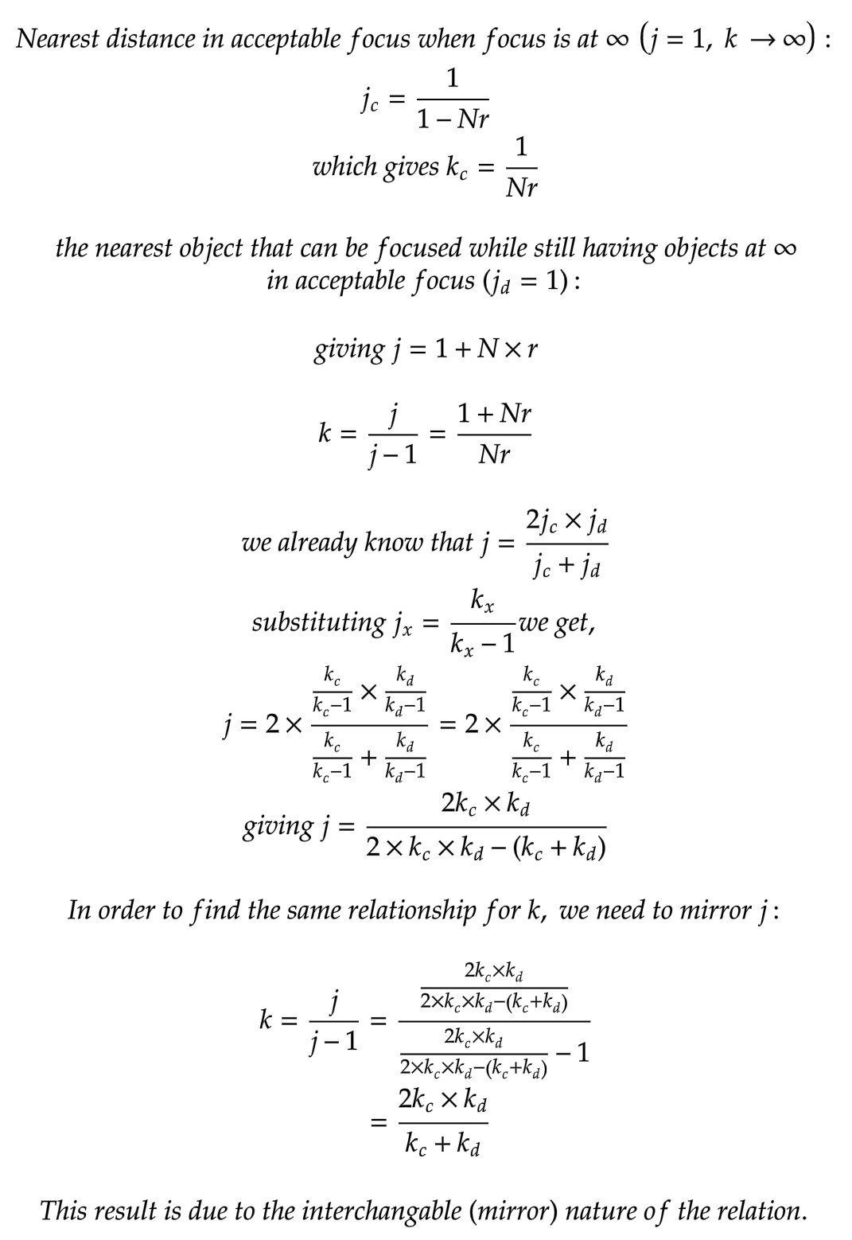
_END of Appendix_

