

IT342-[Section]
System Integration and Architecture

System Design Document (SDD)

Project Title: Medify - Medication Inventory & Expense Tracker
Prepared By: Jaquez, Sheena Mae Sadagnot

Version: 1.2
Date: February 20, 2026
Status: Draft

REVISION HISTORY TABLE
Version | Date | Author | Changes Made | Status
0.1 | 02/20/26 | Jaquez, Sheena Mae Sadagnot | Initial draft | Draft
0.2 | [Date] | [Your Name] | Added API specifications | Review
0.3 | [Date] | [Your Name] | Updated database design | Review
0.4 | [Date] | [Your Name] | Added UI/UX designs | Review
0.5 | [Date] | [Your Name] | Incorporated feedback | Revised
0.6 | [Date] | [Your Name] | Final review and corrections | Final
1 | [Date] | [Your Name] | Baseline version for development | Approved

TABLE OF CONTENTS
Contents
EXECUTIVE SUMMARY 4
1.0 INTRODUCTION 5
2.0 FUNCTIONAL REQUIREMENTS SPECIFICATION 5
3.0 NON-FUNCTIONAL REQUIREMENTS 8
4.0 SYSTEM ARCHITECTURE 9
5.0 API CONTRACT & COMMUNICATION 10
Authentication Endpoints 11
User Registration 11
User Login 11
6.0 DATABASE DESIGN 13
7.0 UI/UX DESIGN 14
8.0 PLAN 17

EXECUTIVE SUMMARY
1.1 Project Overview
Medify is a medication tracking application that enables users to log their medication purchases, monitor their medication inventory and manage their healthcare spending. The system includes a Spring Boot backend API, React web application, and Android mobile app, all integrated to provide a consistent medication management experience across platforms. Users can register accounts, maintain medication records, and track their medication expenses through an intuitive dashboard interface.
1.2 Objectives
- Develop a fully functional medication tracking MVP with user authentication, medication management, and expense monitoring.
- Implement a three-tier architecture using Spring Boot (backend), React (web), and Android (mobile).
- Create RESTful APIs for communication between all system components
- Design a responsive user interface that works consistently across web and mobile platforms.
- Deploy all system components to production-ready environments
1.3 Scope
Included Features:
- User registration and authentication (email/password)
- User profile management (name, profile pic, email, password)
- Dashboard displaying:
  - List of current medications
  - Total weekly/monthly medication expenses
  - Recently added medications
- Complete medication CRUD operations
- Automatic total expense calculation
- Responsive web interface
- Native Android mobile application
- Role-based access

Excluded Features:
- Real payment gateway integration
- Product reviews and ratings system
- Email notification system
- Social media login integration
- Advanced analytics dashboard
- Real payment gateway integration
- Barcode scanning for medication entry
- Integration with pharmacy systems

1.0 INTRODUCTION
1.1 Purpose
This document serves as the comprehensive design specification for the Medify MVP system. It provides detailed requirements, architectural decisions, API contracts, database design, and implementation roadmap to guide development and ensure all components integrate seamlessly.

2.0 FUNCTIONAL REQUIREMENTS SPECIFICATION
2.1 Project Overview
Project Name: Medify
Domain: Healthcare / Personal Finance
Primary Users:
- Adults with maintenance medicine
- Caregivers
Problem Statement: Users need a simple way to track medication their medication inventory and monitor healthcare spending without complex features.
Solution: A medication tracker focusing on core CRUD operations with automatic expense calculation and clear dashboard visualization

2.2 Core User Journeys
Journey 1: First-time User Registration
- User visits web application
- Clicks "Sign Up" and creates account with name, email, and password
- Lands on empty dashboard
- Click "Add Medication" to log medication
- Enters medication details (name (generic + brand), dosage, purpose, quantity, price)
- Click “Add Purchase” to log first purchase
- System saves record and updates dashboard with new medication inventory log
- Enters medication quantity and date
- System saves record and updates dashboard with new expense total

Journey 2: Regular User Managing Medications
- User logs in with existing credentials
- Views dashboard showing current medications list
- Checks total weekly/monthly expenses
- Adds new medication inventory
- Adds new medication purchase
- Edits an existing record to correct quantity
- Deletes a duplicate entry
- Dashboard updates automatically after each action
Journey 3: Weekly / Monthly Expense Review
- User logs in at week/month end
- Views dashboard with accumulated weekly/monthly total
- Reviews list of all medications for the week/month
- Identifies high-cost medications
- Optionally filters by date range to see specific period expenses
2.3 Feature List (MoSCoW)
MUST HAVE
- User authentication (register, login, logout)
- User profile management
- Dashboard with: list of current medication, weekly/monthly expense review, recently added medications
- Add medication record (name, dosage, purpose, quantity, price, date)
- View medication history
- Edit existing medication records
- Delete medication records
- Automatic total expense calculation
- Responsive design for all screen sizes
- Role-based access
- Google OAuth Login
- Email Sending (SMTP) for email verification
SHOULD HAVE
- Filter medications by week/month
- Sort medication list by date, name, or price
- Confirmation dialogs for delete actions
- Password reset functionality
- Upload profile image
COULD HAVE
- Medication category tagging (prescription, OTC, supplements)
- Chart visualization of monthly expenses
- Dark mode theme
- Push notifications
- Upload prescription (pdf/image)
- Real-time feature
WON'T HAVE
- Admin panel for user management
- Export medication data to CSV
- Real payment processing
- Email/SMS notifications
- Pharmacy integration
- Prescription refill reminders
- Insurance calculations
- Multi-language support

2.4 Detailed Feature Specifications
Feature: User Authentication
- Screens: Registration, Login, Forgot Password
- Fields: Name, Email, Password, Confirm Password
- Validation: Email format, password strength, uniqueness
- API Endpoints: POST /auth/register, POST /auth/login, POST /auth/logout,
- Security: JWT tokens, password hashing with BCrypt
Feature: Dashboard
- Screens: Main Dashboard
- Display: Welcome header, Current medications list, Weekly/Monthly expense summary card, Recently added medications section.
- Data Display: Table/list view of medications with columns: Medicine Name, Dosage, Quantity, Price, Date
- Calculations: Sum of all medication prices for current month
- API Endpoints: GET /api/dashboard, GET /api/medications/recent.

Feature: Medication Management (Transactional Function)
- Screens: Add Medication, Edit Medication, Medication List
- Input Fields: Medicine name (text), Dosage (text), Purpose (text), Quantity (number), Price (decimal), Date purchased (date)
- Calculations: Total expense = sum of all medication prices (automatic)
- Validation: Required fields, positive numbers for quantity and price, date not in future
- API Endpoints: GET /api/medications, GET /api/medications/{id}, POST /api/medications, PUT /api/medications/{id}, DELETE /api/medications/{id}

Feature: Profile Management
- Screens: Profile View, Edit Profile
- Fields: Name, Email (read-only), Password change option
- Functions: View profile details, update name, change password
- API Endpoints: GET /api/users/profile, PUT /api/users/profile
2.5 Acceptance Criteria
AC-1: Successful User Registration
- Given I am a new user
- When I enter my name, valid email, and strong password
- And confirm password matches
- And click "Create Account"
- I receive a confirmation email
- I click on confirm account on email
- I am redirected to the website
- Then my account should be created
- And I should be automatically logged in
- And redirected to my empty dashboard
AC-2: Add Medication Record
- Given I am logged in as a registered user
- When I navigate to "Add Medication"
- And enter "Hydroxychloroquine", "200mg", purpose “SLE”, quantity "20", price "P45.50", date "2026-03-15"
- And click "Save"
- Then the medication should appear in my medications list
- And my monthly total should update to include P45.50
- And the medication should show in "Recently Added" section

AC-3: Edit Existing Record
- Given I am logged in and have medications in my list
- When I click "Edit" on a medication
- And change the quantity from "20" to "30"
- And save changes
- Then the medication record should update
- And the weekly/monthly total should recalculate automatically

AC-4: Delete Medication
- Given I am logged in and viewing my medications
- When I click "Delete" on a specific medication
- And confirm the deletion
- Then the medication should be removed from my list
- And the monthly total should recalculate excluding that medication

AC-5: Dashboard Monthly Total
- Given I have multiple medications from February 2026
- When I view my dashboard in March 2026
- Then I should see February ‘s total displayed
- And see all February’s medications listed

3.0 NON-FUNCTIONAL REQUIREMENTS
3.1 Performance Requirements
- API response time: ≤ 5 seconds for 90% of requests
- Web page load time: ≤ 5 seconds on broadband
- Mobile app cold start: ≤ 5 seconds
- Support 10-15 concurrent users
- Database queries complete within 500ms
- File upload size max 5MB per files
- Dashboard Load: ≤ 5 seconds

3.2 Security Requirements
- HTTPS for all communications
- JWT token authentication
- Password hashing with BCrypt
- No plain-text passwords
- ≤ 5 seconds
- XSS protection
- Rate limiting: 5 login requests/15 minutes
- Admin endpoints require role verification
- Accept only images (.jpg, .png) for profile pictures
- Password: minimum of 6 characters must have at least 1 Capital Letter, 1 number/symbol

3.3 Compatibility Requirements
- Web Browsers: Chrome, Firefox, Safari, Edge
- Android: API Level 34 (Android 14)
- Screen Sizes: Mobile (360px+), Desktop (1024px+)
- Operating Systems: Windows 10+, macOS 10.15+

3.4 Usability Requirements
- New user can add first medication within 3 minutes
- Consistent menu on all pages
- Clear error messages: "Invalid email or password"
- Mobile has buttons minimum 44x44px (use framework defaults)
- Confirmation dialogs before delete operations
- Show helpful messages when the list is empty (e.g., "No medications yet. Click + to add")

3.4 Technology Specific Constraints
- Backend: Java 17, Spring Boot 3.x, Spring Security +JWT, PostgreSQL
- Web Frontend: React JS
- Android Mobile: Kotlin, XML UI, API Level target: 34

4.0 SYSTEM ARCHITECTURE
4.1 Component Diagram
Note: This should be a component diagram
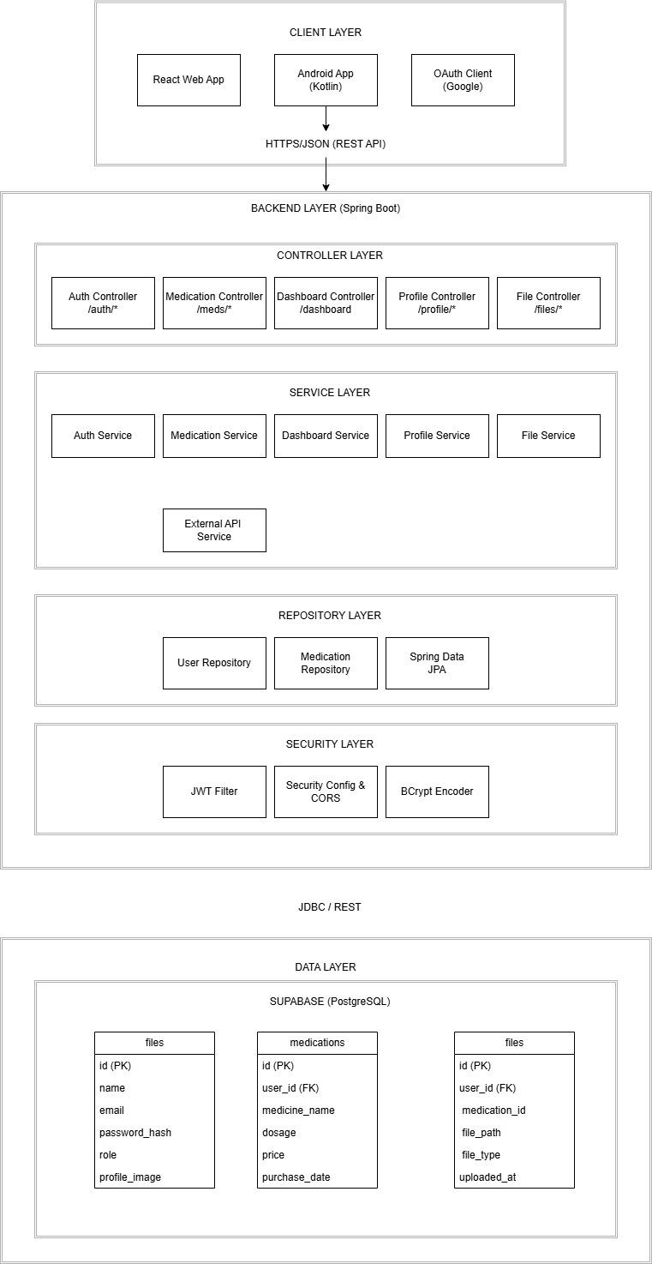
Technology Stack:
- Backend: Java 17, Spring Boot 3.x, Spring Security, Spring Data JPA
- Database: PostgreSQL 14+
- Web Frontend: React 18, JavaScript, Tailwind CSS, Axios
- Mobile: Kotlin, Jetpack Compose, Retrofit, Room
- Build Tools: Maven (Backend), npm/yarn (Web), Gradle (Android)
- Deployment: Render (Backend), Vercel/Netlify (Web), APK (Mobile)

5.0 API CONTRACT & COMMUNICATION
5.1 API Standards
Base URL | https://[server_hostname]:[port]/api/v1
Format | JSON for all requests/responses
Authentication | Bearer token (JWT) in Authorization header
Response Structure | {  "success": boolean,  "data": object|null,  "error": {  "code": string,  "message": string,  "details": object|null  },  "timestamp": string  }

5.2 Endpoint Specifications

Authentication Endpoints

User Registration
Description | User Registration
API URL | /auth/register
HTTP Request Method | POST
Format | JSON for all requests/responses
Authentication | None
Request Payload | {  “email”: <email>,  “password”: <password>,  “firstname”: <firstname>,  “lastname”: <lastname>,  }
Response Structure | {  "success": boolean,  "data": {  user {  “email”: <email>,  “firstname”: <firstname>,  “lastname”: <lastname>,  },  “accessToken”: <token>,  “refreshToken”: <token>,  },  "error": {  "code": string,  "message": string,  "details": object|null  },  "timestamp": string  }

User Login
Description | User Login
API URL | /auth/login
HTTP Method | POST
Format | JSON for all requests/responses
Authentication | None
Request Payload | {  “email”: <email>,  “password”: <password>,  }
Response Structure | {  "success": boolean,  "data": {  “user”: {  “email”: <email>,  “firstname”: <firstname>,  “lastname”: <lastname>,  “role”: <role>,  },  “accessToken”: <token>,  “refreshToken”: <token>,  },  "error": {  "code": string,  "message": string,  "details": object|null  },  "timestamp": string  }

5.3 Error Handling
HTTP Status Codes
- 200 OK - Successful request
- 201 Created - Resource created
- 400 Bad Request - Invalid input
- 401 Unauthorized - Authentication required/failed
- 403 Forbidden - Insufficient permissions
- 404 Not Found - Resource doesn't exist
- 409 Conflict - Duplicate resource
- 500 Internal Server Error - Server error

Error Code Examples

Example 1 | json  {  "success": false,  "data": null,  "error": {  "code": "AUTH-001",  "message": "Invalid credentials",  "details": "Email or password is incorrect"  },  "timestamp": "2024-01-28T10:30:00Z"  }
Example 2 | {  "success": false,  "data": null,  "error": {  "code": "VALID-001",  "message": "Validation failed",  "details": {  "email": "Email is required",  "password": "Must be at least 8 characters"  }  },  "timestamp": "2024-01-28T10:30:00Z"  }

Common Error Codes
- AUTH-001: Invalid credentials
- AUTH-002: Token expired
- AUTH-003: Insufficient permissions
- VALID-001: Validation failed
- DB-001: Resource not found
- DB-002: Duplicate entry
- BUSINESS-001: Insufficient stock
- SYSTEM-001: Internal server error

6.0 DATABASE DESIGN
6.1 Entity Relationship Diagram
Note: This should be an ERD (Database Schema)
Detailed Relationships:
- One-to-One: User ↔ Cart (Each user has exactly one cart)
- One-to-Many: User → Orders (User can have multiple orders)
- One-to-Many: Cart → CartItems (Cart contains multiple items)
- One-to-Many: Order → OrderItems (Order contains multiple items)
- Many-to-One: CartItems → Product (Items reference products)
- Many-to-One: OrderItems → Product (Items reference products)

Key Tables:
- users - User accounts and authentication
- products - Product catalog information
- carts - Shopping cart per user
- cart_items - Items in shopping cart
- orders - Customer orders
- order_items - Items in each order
- refresh_tokens - JWT refresh tokens\

Table Structure Summary:
- users: id, email, password_hash, full_name, role, created_at
- products: id, name, description, price, stock, image_url, category
- carts: id, user_id, created_at
- cart_items: id, cart_id, product_id, quantity
- orders: id, order_number, user_id, total, status, shipping_address
- order_items: id, order_id, product_id, product_name, quantity, price

7.0 UI/UX DESIGN
7.1 Web Application Wireframes
Note: This should be wireframes from Figma
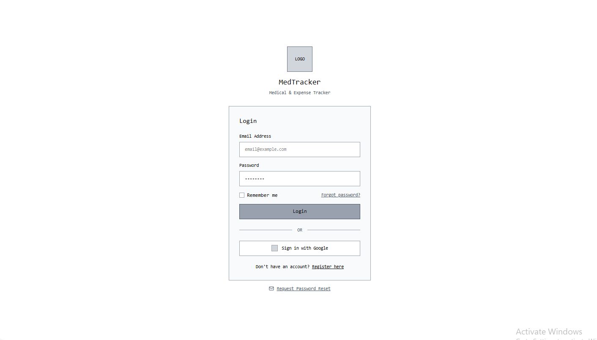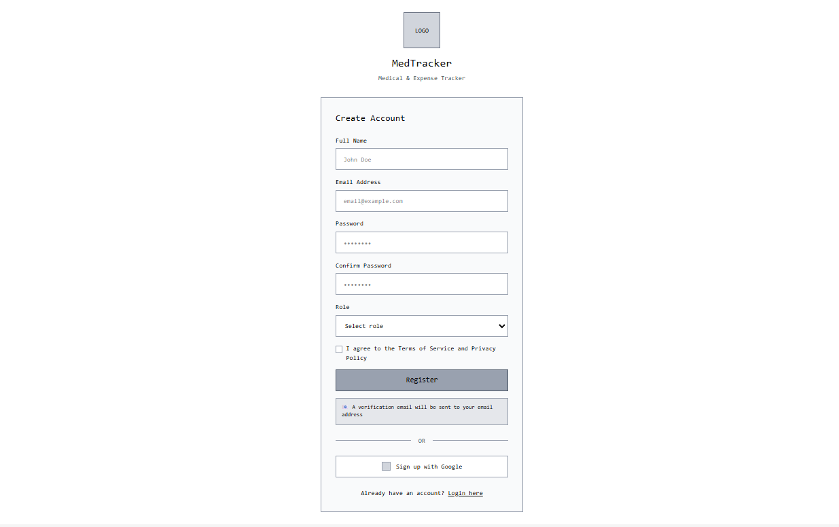
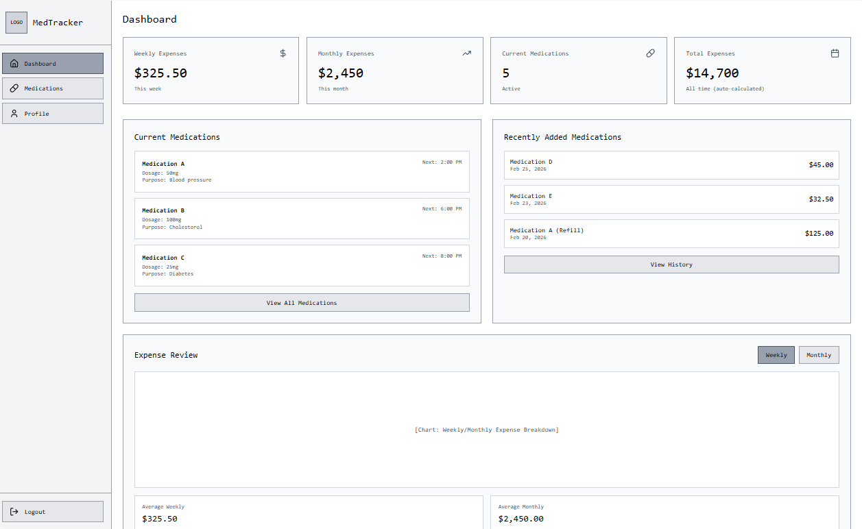
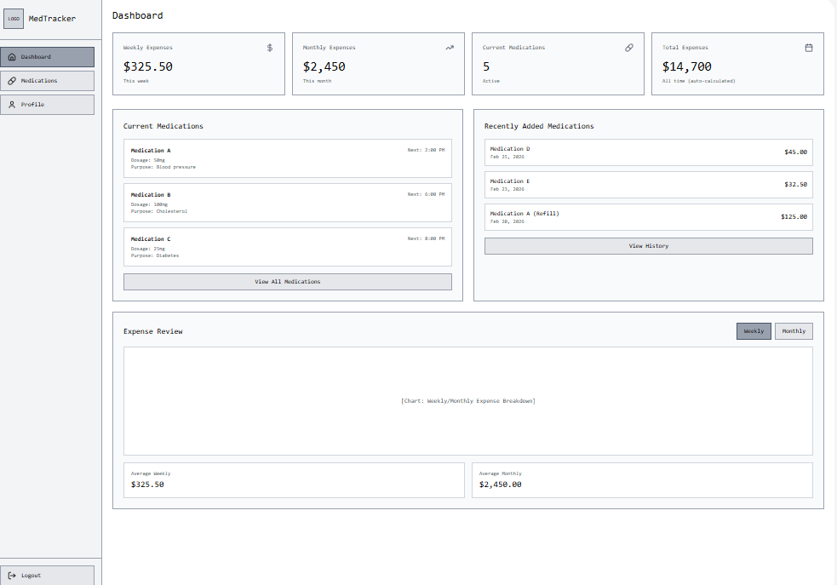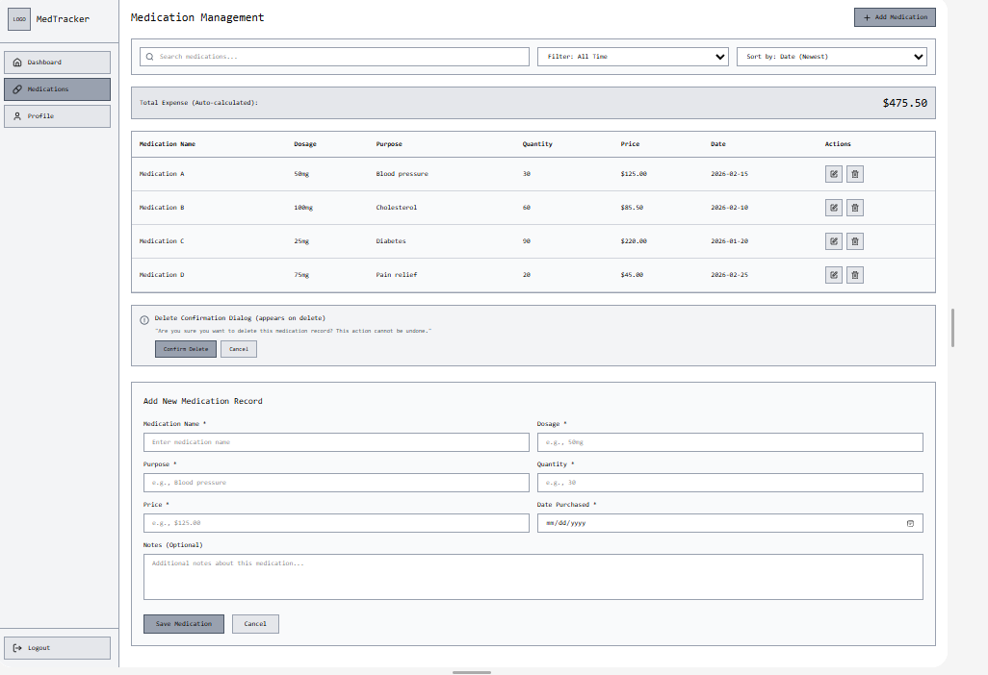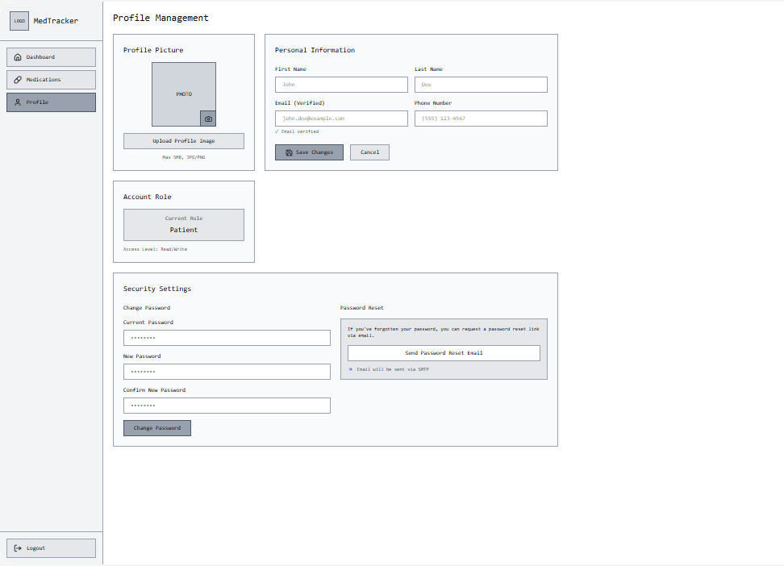

7.2 Mobile Application Wireframes
Note: This should be wireframes from Figma
Bottom Navigation
[🏠 Home] [🔍 Search] [🛒 Cart] [👤 Profile]
Home Screen
Search Bar
Product Grid (2 columns)
Swipe gestures for quick actions
Pull to refresh

Product Detail Screen
Back arrow
Product image (swipeable gallery)
Product info
Quantity selector
"Add to Cart" fixed bottom button

Cart Screen
Edit mode for quantity updates
Swipe to remove items
Order summary sticky bottom
Checkout button

Checkout Flow
Step indicator: Cart → Shipping → Payment → Confirm
Address form (auto-complete)
Order summary
Place order button
Mobile-Specific Features:
- Touch-optimized buttons (min 44x44px)
- Gesture support (swipe, pull-to-refresh)
- Offline caching for product images
- Bottom navigation for main actions
- Simplified forms for mobile input
Design System:
- Colors: Primary (#2563EB), Secondary (#7C3AED), Success (#10B981), Error (#EF4444)
- Typography: Inter font family, responsive sizing
- Spacing: 8px grid system
- Components: Consistent buttons, inputs, cards, modals
- Responsive: Mobile-first approach, breakpoints at 640px, 768px, 1024px

8.0 PLAN
8.1 Project Timeline
Phase 1: Planning & Design (Week 1-2)
Week 1: Requirements & Architecture
Day 1-2: Project setup and documentation
Day 3-4: Complete FRS and NFR
Day 5-7: System architecture design

Week 2: Detailed Design
Day 1-2: API specification
Day 3-4: Database design
Day 5-6: UI/UX wireframes
Day 7: Implementation plan finalization

Phase 2: Backend Development (Week 3-4)
Week 3: Foundation
Day 1: Spring Boot setup with dependencies
Day 2: Database configuration and entities
Day 3: JWT authentication implementation
Day 4: User management endpoints
Day 5: Product CRUD operations

Week 4: Core Features
Day 1: Cart functionality
Day 2: Order management
Day 3: Search and filtering
Day 4: Error handling and validation
Day 5: API documentation and testing

Phase 3: Web Application (Week 5-6)
Week 5: Frontend Foundation
Day 1: React setup with TypeScript
Day 2: Authentication pages (login, register)
Day 3: Product listing page
Day 4: Product detail page
Day 5: Shopping cart implementation

Week 6: Complete Web Features
Day 1: Checkout flow
Day 2: Order history and confirmation
Day 3: Admin dashboard
Day 4: Responsive design polish
Day 5: API integration and testing

Phase 4: Mobile Application (Week 7-8)
Week 7: Android Foundation
Day 1: Android Studio setup and project structure
Day 2: Authentication screens
Day 3: Product browsing
Day 4: Shopping cart
Day 5: API service layer

Week 8: Complete Mobile App
Day 1: Checkout flow
Day 2: Order management
Day 3: UI polish and animations
Day 4: Testing on emulator/device
Day 5: APK generation and documentation

Phase 5: Integration & Deployment (Week 9-10)
Week 9: Integration Testing
Day 1: End-to-end testing across platforms
Day 2: Bug fixes and optimization
Day 3: Security review
Day 4: Performance testing
Day 5: Documentation updates

Week 10: Deployment
Day 1: Backend deployment (Railway/Heroku)
Day 2: Web app deployment (Vercel/Netlify)
Day 3: Mobile APK distribution
Day 4: Final testing
Day 5: Project submission
Milestones:
- M1 (End Week 2): All design documents complete
- M2 (End Week 4): Backend API fully functional
- M3 (End Week 6): Web application complete
- M4 (End Week 8): Mobile application complete
- M5 (End Week 10): Full system deployed and integrated
Critical Path:
- Authentication system (Week 3)
- Product catalog API (Week 3-4)
- Shopping cart functionality (Week 4)
- Checkout process (Week 6)
- Cross-platform testing (Week 9)
Risk Mitigation:
- Start with simplest working version of each feature
- Test integration points early and often
- Keep backup of working versions
- Focus on core functionality before enhancements

