**Citi Bike Analysis**

**Phenomenon 1** - How does station popularity affects the usage statistics and also do month and ride times play a role in city ride planning?

Upon initial analysis, we found that Grove St. Path is by far the most popular station for both starting and ending trips.

While Union St, and Jackson Square are among the least popular starting stations, their usage statistics are still high on an average.

The stations that are having less average no. of users can be used for other opportunities like consolidation, advertising, or removal.

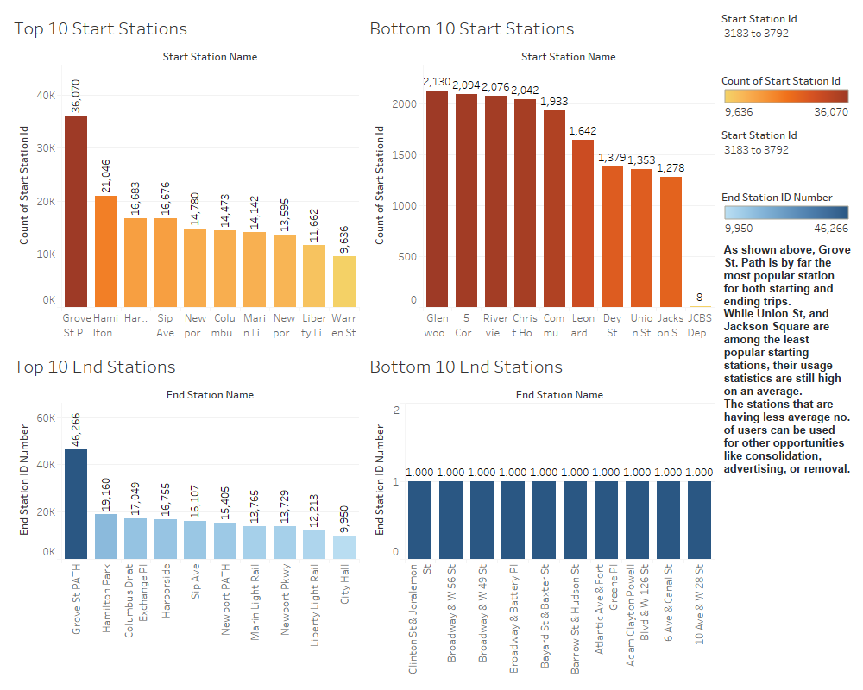

The monthly ridership peaks during the months of Aug-Sep after which a steep fall is observed during the winter months.

We found, through trends in the data, that all Citi Bike locations are having a majority of trip starts before noon in the morning and between 5-6 in the evening.

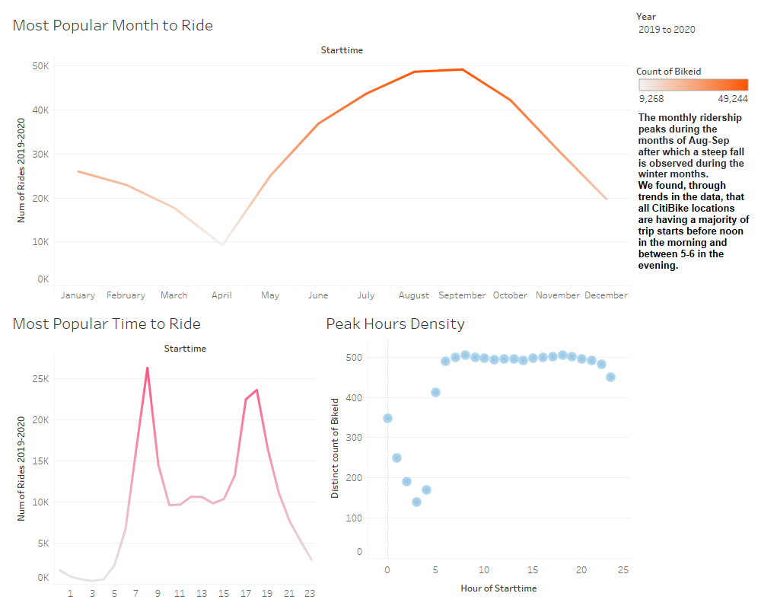

**Phenomenon 2** – How does user demographics affect the ridership growth? What’s the current bikes usage trend during 2019-2020: Is there any effect of Covid19?

Males have a 65.50% majority compared to the female userbase of 24.50%.

The majority of subscribers are males. This could be due to the large population of working-class males in the area. Also, the main usage of the bikes for ages 30-80 are the trips shorter than 15 minutes. It's also interesting to see age groups, specifically around 20- and 50-years having trips closer to an hour and so! 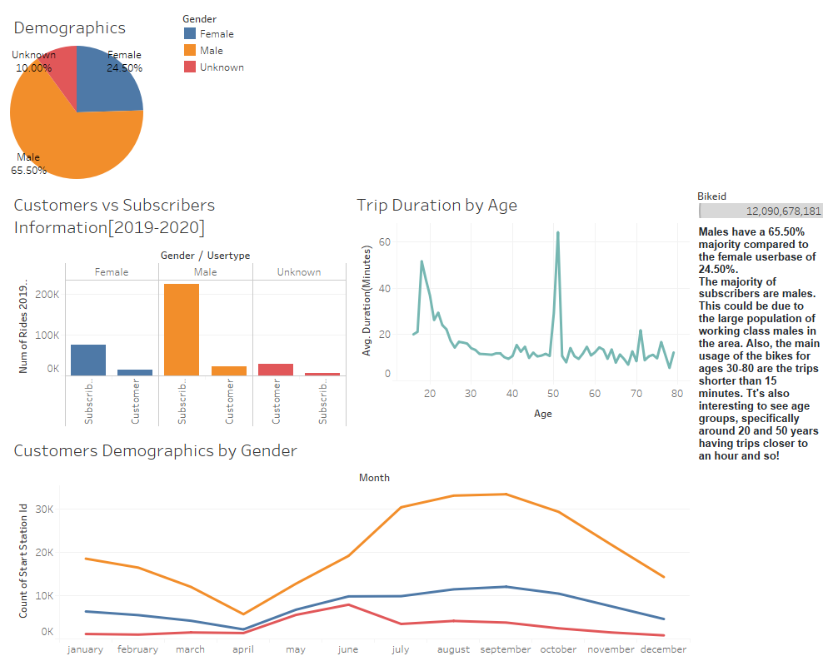

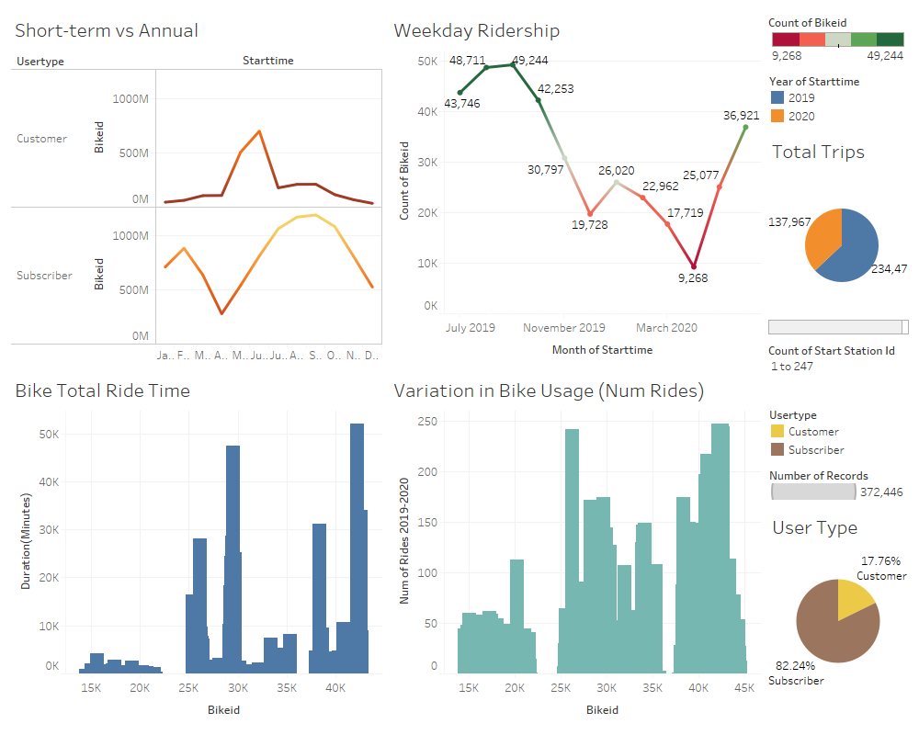 The trend in bikes usage has been steady throughout 2019. However, the number of total trips in 2020 has decreased to 137,967 compared to 234,479 in 2019. As we know, it was mostly lockdown phase between April-June’20 and hence the drop could be associated with Covid19 quarantine efforts.

**City Official Maps Analysis**

It is interesting to note that the most popular start and the end station is Grove St Path station. This Bike station is the main station for the riders to connect with NJ Transit PATH train service (train service is marked on the map).

Also, there is huge potential for riders to end their trip along the river and carry their bikes on the ferry or path to get across the river.

A userbase needs to be developed among users under the age of 20.

This can be done by increasing the utility of stations in the Baldwin and Sip Ave. locations and also areas around universities and schools.

