Evaluation of Tcp Ledbat in NS3

Low Extra Delay Background Transport (LEDBAT) is an experimental delay-based congestion control algorithm that seeks to utilize the available bandwidth on an end-to-end path while limiting the consequent increase in queueing delay on that path. LEDBAT uses changes in one-way delay measurements to limit congestion that the flow itself induces in the network.

A brief intro of TCP Ledbat:
As we know that being fair to every flow in the network is not a good thing to do. Background applications like Software update, downloading large files comes under the situation where we can be unfair as per the network situations. So that a bandwidth sensitive flow can survive easily during background flow. LEDBAT does this job very nicely.
It is delay based congestion control algorithm i.e. it uses one way delay to measure congestion in the network. Hence it is faster than general congestion control algorithms as other algorithms find congestion when packets are either dropped or marked. Here we assume that clocks at sender and reciever side are synchronised. When sender attaches timestamp to every packet sent, reciever recieves the packet and calculates the one-way-delay. Then it sends the calculated delay through the ACK packet. Now sender picks this value, adds it into the current delay queue and also updates the base delay queue(this queue stores the minimum delay). Now this base delay queue can give the minimum one-way-delay observed which would approximately be the sum of necessary delays excluding queueing delay. Hence difference of the value between current delay and base delay will give the queueing delay. Now this calculated queueing delay will be compared with TARGET value. This TARGET value is the queueing delay that LEDBAT wants to introduce in the buffer. So if the TARGET value is greater than calculated queueing delay, Congestion window(cwnd) will be increased by some value and vice versa. The TARGET value must be less than the maximum queueing delay a queue can sustain, otherwise their will always be packet losses. Also during packet losses, TCP LEDBAT behaves like TCPNewReno i.e it reduces its cwnd by half only once per RTT.

Overview of steps:

Reciever’s side, on receiving a data packet:
delay=SystemTime-Timestamp

Sender’s side, on receiving an ACK:
currentdelay = acknowledgement.delay
basedelay = min (basedelay, currentdelay)
queuingdelay = currentdelay - basedelay
offtarget = (TARGET - queuingdelay) / TARGET
cWnd += GAIN * offtarget * bytesnewlyacked * MSS / cWnd

Evaluation of Tcp Ledbat using Dumbbell topology in different situations:

- Throughput Evaluation:-

1) Enabling LEDBAT on all TCP sockets:
In this situation we are just enabling Ledbat on all TCP sockets and starting all communication at the same time. The dumbbell topology used has 5 senders, 5 recievers and 2 routers. Initially as their exist a bottleneck link between the routers, that would resist the throughput to grow. Initially channel’s bandwidth grows exponentially because of slow start and then it reaches its maximum utilization and hence becomes constant. This is as shown below. The below graph is between average throughput(bits/sec) and time(sec).
This graph was same for all flows as all started at the same time with similar base conditions. This is just an idea of how Ledbat behaves similar to other TCPs in normal conditions.
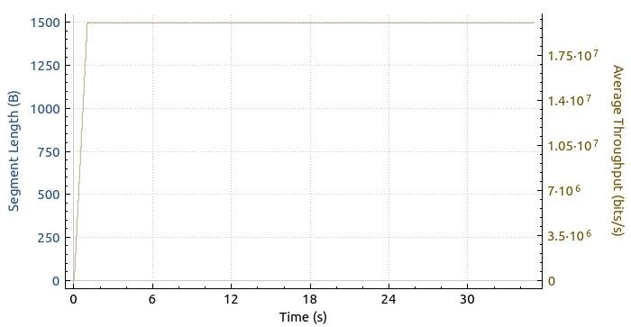

2) Enabling LEDBAT on one device and TCP NewReno on other devices:
In dumbbell topology, we are enabling Ledbat on one device and other devices are by default TCP NewReno as a congestion control algorithm. Now we are starting Ledbat device and NewReno devices at the same time. In all these cases, the packet size taken is 1446 bytes. Point to point data rate between routers is 75Mbps and between router-device is 20 Mbps. Point-to-point latency 0.00025 ms.
- When both flows start sending data at the same time at 0 seconds ->
Initially when all devices start sending data, they will go with slow start and when Ledbat realizes state of congestion, queue was already been filled by TCP flows and packets start dropping. Now both Ledbat and TCP flows reduces its cwnd window to half but because of timeout, cwnd goes to zero. Because of this gap of no packet sent, the throughput decreases. Then both again starts with slow start and average throughput again gains its value and reaches its maximum level. This is as shown below. Hence the graph remains same for ledbat and tcp flow.
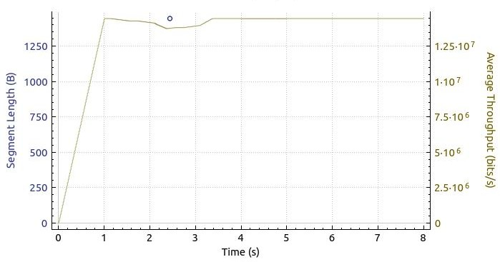

- Fairness Evaluation:-

1) Fairness among LEDBAT Flows:
As we know that LEDBAT was designed for better utilization of link capacity and LEDBAT is not fair for backgound transport so that it could help bandwidth sensitive traffic.
LEDBAT has a problem called as “Latecomer’s advantage”. In this situation, a LEDBAT flow is already under congestion avoidance phase and changing its cwnd value after every ACK recieved. Hence maintaining a TARGET amount of queueing delay. When a new LEDBAT flow enters into this channel, it wrongly estimates the base delay as the one-way-delay calculated by this latecomer will always have TARGET amount of delay added to it. Hence it will try to add more of its own TARGET₂ delay on the queue. Now old flow will sense more queueing delay. Hence will reduce its flow in the network. On other side, the latecomer will keep on adding TARGET₂ amount of queueing delay. This process keeps on going untill latecomer fetches the bandwidth from the previous LEDBAT flow. This latecomer’s advantage. This can be seen in the below graph.

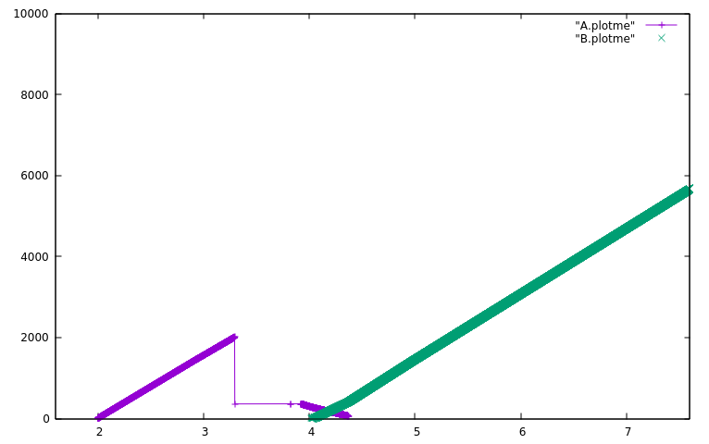
Time(sec)
Congestion Window (Bytes)

2) Fairness with TCP flows:
Ledbat is very active in estimating congestion. When a ledbat flow runs along with TCP flows, initially tey both start with slow start. But later on when congestion grows, Ledbat estimates it earlier than normal TCP flow and hence slows down its cwnd growth. But TCP flow is continuously increasing queueing delay which leads to Ledbat’s cwnd decrease-window phase. As shown in graph, both flows are in slow start before 2.5 sec. But later on TCP increases its cwnd value exponentially but Ledbat is showing conservative behaviour. When estimated queueing delay becomes greater than Ledbat’s TARGET value, it then slowly decreases its cwnd value. On other side, TCP flow has shifted itself to additive increase nature. As queueing delay is still increasing, Ledbat decreases its cwnd value continuously to zero giving advantage other TCP flows. Hence Ledbat is quite fair with TCP flows.

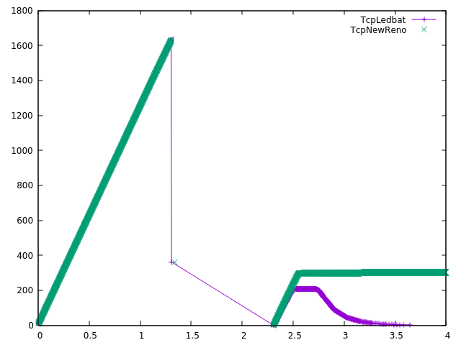
Congestion Window (Bytes)
Time(sec)

