C++
Yes, it is possible to create objects even when the constructor is private, without any error, but only in certain special scenarios, such as:
- Using a friend function
- Using a friend class
- Using a static method inside the same class

#include <iostream>
using namespace std;
class MyClass {
private:
MyClass() {
cout << "Private constructor called!" << endl;
}
public:
static MyClass createObject() {
return MyClass(); // Allowed: inside the class
}
};

int main() {
MyClass obj = MyClass::createObject(); // No error
return 0;
}

Example 2: Object Created by a Friend Function
#include <iostream>
using namespace std;

class MyClass {
private:
MyClass() {
cout << "Constructor called by friend!" << endl;
}
friend void create(); // Friend function
};

void create() {
MyClass obj; // Allowed: friend has access to private constructor
}

int main() {
create(); // No error
return 0;
}
1. What are lvalues and rvalues in C++?
Answer:
- An lvalue (locator value) represents an object that occupies identifiable memory (e.g., variable name).
- An rvalue is a temporary value that doesn’t have a persistent memory address (e.g., x + y).
Example:
int x = 10; // x is lvalue, 10 is rvalue
int &ref = x; // valid
int &ref2 = 20; // ❌ Error, can't bind lvalue ref to rvalue

what is the use of virtual keyword in c++ give 5 examples and explain
one class is there in c++ program ...while creating an object in showing an error...what will the problem?
what is virtual function and pure virtual function with an example?
https://chatgpt.com/c/68413706-b460-800b-b368-b5480f9b310f

Top Reasons Why Object Creation Fails in C++
✅ 1. Constructor is private or protected
class MyClass {
private:
MyClass() {} // private constructor
};

int main() {
MyClass obj; // ❌ Error: 'MyClass::MyClass()' is private
}
🔸 Solution: Make the constructor public, or use a factory method or Singleton pattern.

✅ 2. Class Has a Pure Virtual Function (Abstract Class)
class Base {
public:
virtual void show() = 0; // pure virtual
};

int main() {
Base obj; // ❌ Error: Cannot instantiate abstract class
}
🔸 Solution: Don't create objects of abstract class; derive and implement the pure virtual function.

✅ 3. No Matching Constructor Found
class MyClass {
public:
MyClass(int a) {}
};
int main() {
MyClass obj; // ❌ Error: No default constructor
}
🔸 Solution: Either pass the required parameters or define a default constructor.

✅ 4. Compiler Error in Member Declaration
class MyClass {
int a = "hello"; // ❌ Wrong type assignment
};
🔸 Solution: Check all member variable types and initializations.

✅ 5. Forward Declaration Without Definition
class MyClass; // forward declaration only

int main() {
MyClass obj; // ❌ Error: incomplete type
}
🔸 Solution: Include the full class definition before using it.

✅ 6. Missing #include or Namespace
string name = "Test"; // ❌ Error: ‘string’ was not declared
🔸 Solution: Add:
cpp
CopyEdit
#include <string>
using namespace std;

What is a Virtual Function?
A virtual function is a member function in the base class that you expect to be overridden in derived classes.
It enables runtime polymorphism — the function call is resolved at runtime, not compile time.
#include <iostream>
using namespace std;
class Animal {
public:
virtual void sound() {
cout << "Animal makes a sound\n";
}
};

class Dog : public Animal {
public:
void sound() override {
cout << "Dog barks\n";
}
};

int main() {
Animal* a = new Dog(); // base class pointer to derived class
a->sound(); // Output: Dog barks (runtime polymorphism)
delete a;
}
• sound() is virtual, so Dog's version is called at runtime.
• If virtual was not used, Animal's version would be called.

What is a Pure Virtual Function?
A pure virtual function is a virtual function with no implementation in the base class, and it makes the class abstract.
virtual void sound() = 0; // Pure virtual
- Any class with at least one pure virtual function cannot be instantiated.
- Derived classes must override the pure virtual function.

🔸 Example: Pure Virtual Function
#include <iostream>
using namespace std;
class Animal {
public:
virtual void sound() = 0; // Pure virtual function
};

class Dog : public Animal {
public:
void sound() override {
cout << "Dog barks\n";
}
};

int main() {
Animal* a = new Dog(); // Cannot create Animal object directly
a->sound(); // Output: Dog barks
delete a;
}
Key Point:
- Animal is an abstract class.
- You must override sound() in Dog, otherwise you’ll get a compiler error.

Data types in Cpp:
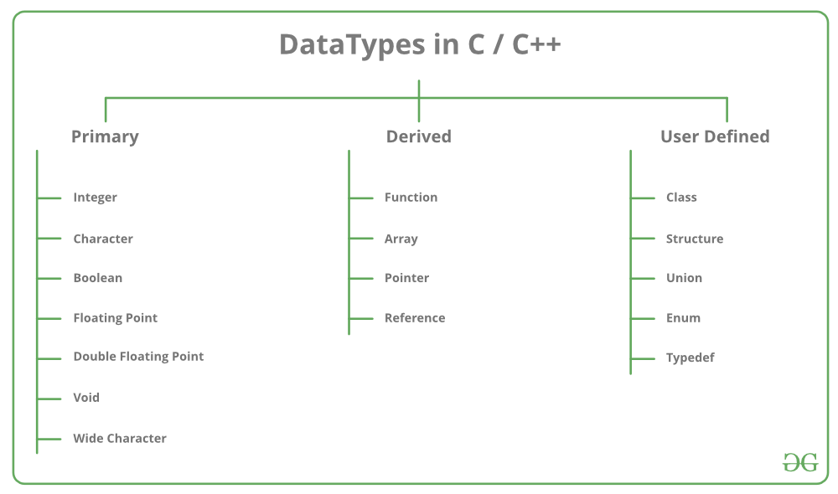

What is the difference between struct and class in C++?
- In C++, the default access level for members in a struct is public, while in a class it is private.
- Similarly, when inheriting, a struct uses public inheritance by default, whereas a class uses private inheritance.
- Typically, struct is used for simple data structures that mainly hold data without complex behavior.
- On the other hand, class is designed to support full object-oriented programming with a focus on encapsulation.
- Both struct and class allow member functions to be defined inside them.
- They also both support constructors and destructors to manage object lifecycle.
- Both can participate in inheritance, including multiple and virtual inheritance.
- Both support access specifiers like public, private, and protected to control member visibility explicitly.
- Data hiding is less common with struct because of its default public access, whereas it is a common practice in class due to the default private access.
- Semantically, struct is usually used to represent plain-old-data types, while class is used to represent objects that encapsulate both data and behavior.

What is a reference variable?
A reference variable in C++ is an alias for another variable. It must be initialized at the time of declaration and cannot be null or changed to reference another variable later. And it does not occupy any memory. References are declared using the ampersand symbol (&). They are commonly used for function arguments and return values to avoid copying large objects and to allow modification of original data. References make the code cleaner and more efficient since they avoid unnecessary copying and enable pass-by-reference semantics. Unlike pointers, references do not require dereferencing using the * operator. References also help implement operator overloading and complex data structures efficiently.

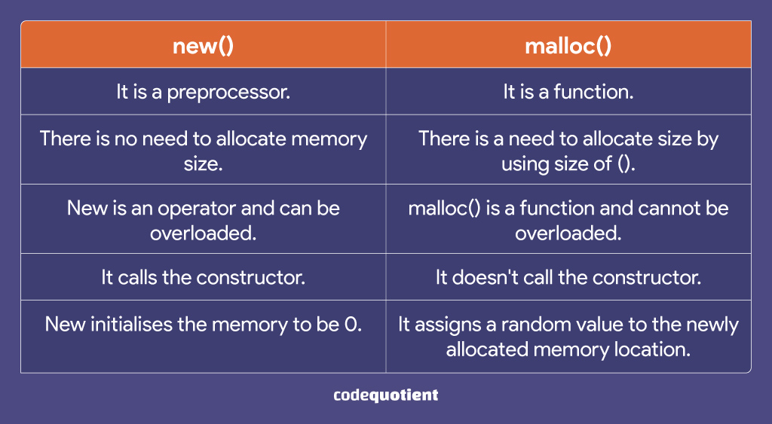
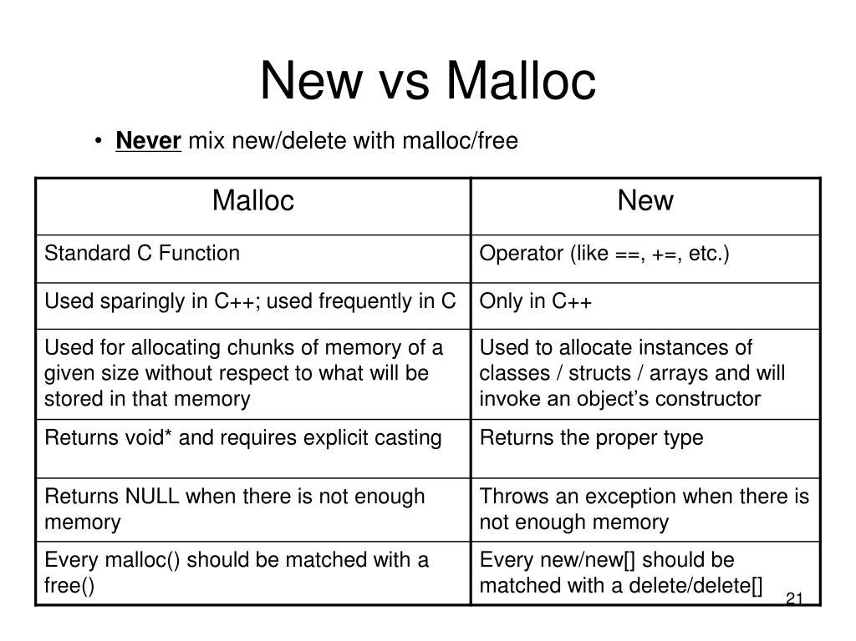

- malloc() is a C library function that allocates raw memory and returns a void pointer, while new is a C++ operator that allocates memory and also calls the constructor of an object.
- malloc() requires explicit typecasting, but new automatically returns the correct type pointer.
- malloc() does not initialize memory, whereas new can initialize objects during allocation.
- Memory allocated with malloc() must be freed using free(), while memory from new must be released using delete.
- new is safer, more type-aware, and preferred in C++ compared to malloc().

Constructor:
A constructor is a special member function of a class that is automatically called when an object of that class is created. Its main purpose is to initialize the object’s data members or allocate resources. Constructors have the same name as the class and do not have a return type, not even void. They can be overloaded to allow different ways of initializing an object.
Destructor:
A destructor is a special member function that is automatically called when an object goes out of scope or is explicitly deleted. Its role is to clean up any resources the object may have acquired during its lifetime, such as freeing memory or closing files. The destructor has the same name as the class, preceded by a tilde (~), and it also does not have a return type or take parameters.

Object-Oriented Programming (OOP) is a method of designing software around real-world entities called objects.
It uses classes as blueprints and objects as instances.
The main principles are encapsulation, inheritance, polymorphism, and abstraction.
OOP improves code reusability, scalability, and maintainability.
Languages like C++, Java, and Python commonly support OOP.
Reusability: The ability to use existing code in different parts of a program or in new projects without rewriting it.
Scalability: The ability of a program or system to handle increasing load, users, or data smoothly without major changes.
Maintainability: The ease with which code can be understood, fixed, or improved when requirements change.

Namespace:
In C++, a namespace is a declarative region that provides a scope for identifiers like variables, functions, and classes.
Its main purpose is to organize code into logical groups for better readability.
It also helps prevent naming conflicts, which are common when combining multiple libraries or working on large projects.
Namespaces are defined using the namespace keyword.
We access their members using the scope resolution operator (::).

1. What is the difference between struct and class in C++?
In C++, both struct and class can hold variables and functions, and both can support features like inheritance, constructors, destructors, and member functions.
The key difference lies in the default access specifier – in a struct, members are public by default, while in a class, members are private by default.
This makes struct more suitable for grouping simple data, similar to C structures, while class is preferred for object-oriented programming with encapsulation.
For example, struct Point { int x, y; }; exposes members directly, but class Student { int roll; }; hides them unless specified.
Despite this, both can be used interchangeably if access specifiers are explicitly mentioned.
In practice, struct is often chosen for plain data structures, while class is used when designing complex objects with methods and hidden data.

2. What is the difference between compile-time and run-time polymorphism?
Polymorphism means "many forms," and in C++ it comes in two types: compile-time and run-time.
Compile-time polymorphism is achieved using function overloading and operator overloading, where the compiler determines which function to call during compilation.
This gives faster execution but less flexibility, as the decision is made before the program runs.
Run-time polymorphism is achieved using virtual functions with inheritance, where the actual function that gets called depends on the object type at runtime.
This is done internally using the vtable (virtual table) and vptr (virtual pointer) mechanism.
Thus, compile-time polymorphism provides efficiency, while run-time polymorphism provides flexibility and extensibility in object-oriented design.

3. What is the use of virtual functions in C++?
Virtual functions are special member functions declared with the keyword virtual in the base class.
They enable runtime polymorphism, allowing a derived class to override the behavior of a base class method.
At runtime, the function called depends on the actual object type being pointed to, not the pointer type.
For example, if a Base* pointer points to a Derived object, a virtual function call will invoke the Derived version.
This ensures that the correct implementation is executed in inheritance hierarchies.
Internally, C++ implements this using a vtable (virtual table) mechanism.
Virtual functions are fundamental for achieving dynamic behavior in OOP designs.

4. What is the difference between shallow copy and deep copy?
When copying objects in C++, we can either make a shallow copy or a deep copy.
A shallow copy simply copies the object’s references or pointers, meaning both objects will point to the same memory location.
This can be problematic because changes in one object may unintentionally affect the other.
A deep copy, on the other hand, duplicates the entire object, including allocating new memory for dynamic data.
This ensures both objects are independent and do not interfere with each other.
In C++, deep copy can be implemented using a copy constructor or by overloading the assignment operator.
For objects managing dynamic memory, always prefer deep copy to avoid dangling pointers or double deletions.

5. What is a pure virtual function and abstract class in C++?
A pure virtual function is a function declared in a class with the syntax virtual void func() = 0;.
Such a function provides a common interface but leaves implementation to derived classes.
A class that contains at least one pure virtual function is known as an abstract class.
Abstract classes cannot be instantiated directly; they can only be used as base classes.
They enforce that all derived classes must provide an implementation for the pure virtual functions.
This forms the basis for interface-style programming in C++, promoting polymorphism and code reusability.
For example, class Shape { virtual void draw() = 0; }; forces all derived classes like Circle or Rectangle to implement draw().

6. Explain the concept of friend function in C++.
A friend function is a function that is not a member of a class but is granted access to its private and protected members.
It is declared inside a class with the keyword friend.
Friend functions are useful when you need non-member functions (like operator overloads) to access internal class data.
For example, the operator<< used with cout is often implemented as a friend function.
Friendship can also be extended to entire classes, where one class is declared as a friend of another.
However, overusing friend functions can break the principle of encapsulation because it exposes private data.
Thus, they should be used carefully only when necessary.

7. What is the difference between malloc/free and new/delete in C++?
malloc() and free() are C-style memory management functions, while new and delete are C++ operators.
malloc only allocates raw memory and returns a void* pointer, which needs to be typecast in C++.
It also does not call constructors when allocating objects.
new, on the other hand, allocates memory and also calls the constructor automatically, initializing the object.
Similarly, delete not only frees memory but also calls the destructor.
This makes new/delete type-safe and object-oriented, whereas malloc/free are lower-level.
Therefore, in C++, new/delete are safer and preferred for dynamic memory allocation.

8. What are smart pointers in C++?
Smart pointers are wrapper classes around raw pointers, introduced in C++11 to simplify memory management.
They automatically manage the lifetime of dynamically allocated objects and free memory when no longer needed.
The main types are unique_ptr, shared_ptr, and weak_ptr.
- unique_ptr owns a resource exclusively.
- shared_ptr allows multiple ownership and uses reference counting.
- weak_ptr prevents circular references in shared_ptr.
By automating deallocation, smart pointers prevent memory leaks and dangling pointer issues.
They are an essential part of modern C++ best practices.

9. What is multiple inheritance and what problems can it cause?
Multiple inheritance allows a class to inherit from more than one base class.
This is useful when a class needs to combine features from different classes.
However, it can cause the diamond problem, where ambiguity arises if two base classes share a common ancestor.
For example, a class D inheriting from both B1 and B2, which both inherit from A, may face duplicate copies of A.
C++ solves this using virtual inheritance, ensuring only one shared copy of the base class exists.
While multiple inheritance is powerful, it should be used carefully to avoid complexity and ambiguity.

10. What is the difference between overloading and overriding in C++?
Overloading and overriding are both forms of polymorphism but differ in scope and behavior.
Overloading happens when multiple functions with the same name exist in the same class but with different parameter lists.
It is resolved at compile time and is known as compile-time polymorphism.
Overriding, on the other hand, occurs in inheritance when a derived class redefines a base class’s virtual function.
It is resolved at runtime using dynamic dispatch and requires the base function to be virtual.
Thus, overloading gives flexibility within a class, while overriding ensures correct behavior across class hierarchies.

11. What is the difference between pointers and references in C++?
A pointer is a variable that stores the memory address of another variable, while a reference is an alias for an existing variable.
Pointers can be reassigned to point to different objects, but a reference must always refer to the same object once initialized.
Pointers can be NULL, while references cannot be null and must always refer to a valid object.
Accessing members through a pointer requires the dereference operator (*), whereas references use the normal dot operator.
References are generally safer and easier to use, while pointers provide more flexibility in low-level memory manipulation.
Thus, references are often used in function parameters, while pointers are used for dynamic memory handling.

12. What are function templates and class templates in C++?
Templates in C++ allow writing generic code that works with any data type.
A function template lets you define a single function that can operate on different types, for example, template<typename T> T add(T a, T b).
A class template allows creating generic classes, such as template<typename T> class Stack.
Templates promote code reusability and eliminate duplication by handling multiple data types with a single definition.
They form the basis of the Standard Template Library (STL) in C++.
With templates, C++ supports both compile-time type safety and flexibility in programming.

13. What is exception handling in C++ and how is it implemented?
Exception handling in C++ provides a way to handle runtime errors gracefully without crashing the program.
It uses three keywords: try, throw, and catch.
Code that may cause an error is placed in a try block, errors are raised using throw, and handled in the catch block.
For example:
try { throw 10; } catch (int e) { cout << "Error: " << e; }
This mechanism allows separating error-handling code from normal logic.
It improves program stability, but exceptions should not be overused as they add overhead.

14. What is an inline function in C++?
An inline function is a function where the compiler replaces the function call with the actual function code during compilation.
This reduces the overhead of function calls and improves performance for small, frequently used functions.
It is declared using the inline keyword.
However, making large functions inline can increase the size of the executable due to code duplication.
Modern compilers automatically decide inlining based on optimization levels, even without the keyword.
Thus, inline functions are best used for small utility functions like getters or arithmetic operations.

15. What is the difference between stack memory and heap memory in C++?
Stack memory is used for static memory allocation like local variables and function calls.
It is managed automatically and deallocated once the function ends.
Heap memory is used for dynamic allocation, created using new/malloc and freed with delete/free.
Stack memory is faster but limited in size, while heap memory is larger but slower due to manual management.
Incorrect use of heap can lead to memory leaks and dangling pointers.
Thus, stack is ideal for temporary variables, while heap is used for objects with dynamic lifetimes.

16. What is the Rule of Three/Five in C++?
The Rule of Three states that if a class needs a destructor, a copy constructor, or a copy assignment operator, it likely needs all three.
This is because they deal with proper memory/resource management.
With C++11, the Rule of Five was introduced, adding move constructor and move assignment operator.
This ensures safe handling of dynamic resources during both copying and moving.
If these functions are not defined, the compiler generates default ones which may cause shallow copies.
Following this rule prevents memory leaks, double deletions, and undefined behavior in classes with dynamic memory.

17. What are virtual destructors in C++ and why are they needed?
A virtual destructor ensures that when deleting an object through a base class pointer, the derived class destructor is also called.
Without a virtual destructor, only the base class destructor runs, leading to resource leaks in the derived class.
They are declared using virtual ~ClassName() {}.
This is especially important in polymorphic classes where objects are created dynamically.
Virtual destructors ensure proper cleanup of resources like memory, file handles, or sockets.
Thus, whenever a class has virtual functions, its destructor should also be declared virtual.

18. What is RAII (Resource Acquisition Is Initialization) in C++?
RAII is a programming idiom in C++ where resource management is tied to object lifetime.
When an object is created, it acquires resources (like memory, file, or mutex), and when it goes out of scope, its destructor automatically releases them.
For example, std::lock_guard locks a mutex in its constructor and unlocks it in the destructor.
This ensures exception safety because resources are released automatically even if errors occur.
RAII is the foundation for smart pointers, file streams, and containers in C++.
It simplifies resource management and prevents leaks.

19. What is the difference between deep copy and move semantics in C++11?
A deep copy creates a completely independent copy of an object by duplicating its resources.
This requires extra memory and time.
Move semantics, introduced in C++11, transfer ownership of resources from one object to another instead of copying.
This is achieved using rvalue references (&&) in move constructors and move assignment operators.
Move semantics improve performance by avoiding unnecessary copies in temporary objects.
For example, returning a large vector from a function benefits greatly from move semantics.

20. What is the difference between std::vector and std::array in C++?
std::vector is a dynamic container that can grow or shrink at runtime, while std::array is a fixed-size container introduced in C++11.
std::vector stores elements in heap memory and manages resizing automatically.
std::array stores elements in stack memory and has a size fixed at compile time.
Both provide iterators and work with STL algorithms.
Use std::vector when you need flexibility and dynamic resizing.
Use std::array when the size is known at compile time and you want better performance with stack allocation.

21. What is the difference between pass by value, pass by reference, and pass by pointer in C++?
In pass by value, a copy of the variable is passed to the function, so changes inside the function do not affect the original variable.
In pass by reference, the actual variable is passed using a reference (&), so modifications inside the function directly change the original.
In pass by pointer, the address of the variable is passed, and changes through dereferencing affect the original variable.
Pass by value is safer but slower for large objects due to copying overhead.
Pass by reference and pointer avoid copying, but references are safer (cannot be null), while pointers are more flexible (can be reassigned).
Thus, the choice depends on whether safety or flexibility is more important.

22. What is the difference between const, constexpr, and mutable in C++?
const makes a variable unmodifiable after initialization, ensuring data safety.
constexpr is introduced in C++11 to declare expressions that are evaluated at compile time, improving performance.
For example, constexpr int size = 10; ensures size is a compile-time constant.
mutable allows a member of a class to be modified even in a const object, which is useful in cases like caching.
For example, mutable int cache; can be changed inside a const function.
Thus, const ensures immutability, constexpr enables compile-time evaluation, and mutable gives controlled flexibility.

23. What is the difference between static polymorphism and dynamic polymorphism in C++?
Static polymorphism (compile-time) occurs when the function call is resolved at compile time, using function overloading or templates.
It provides better performance since no runtime overhead exists.
Dynamic polymorphism (runtime) happens when the function call is resolved at runtime using virtual functions and inheritance.
This adds flexibility but involves overhead from vtables.
For example, operator overloading is static polymorphism, while overriding a virtual function is dynamic polymorphism.
Thus, static polymorphism is faster, while dynamic polymorphism is more flexible.

24. What is the difference between static, global, and local variables in C++?
A local variable is declared inside a function and exists only during that function’s execution.
A global variable is declared outside all functions and is accessible throughout the program.
A static variable preserves its value across function calls but has limited scope (function-level or file-level).
Static variables are initialized only once and retain their last value between calls.
For example, a counter declared static inside a function will keep incrementing across multiple calls.
Thus, scope and lifetime are the key differences among local, global, and static variables.

25. What is the difference between copy constructor and assignment operator in C++?
A copy constructor initializes a new object from an existing object at the time of creation.
For example: ClassA obj2 = obj1; calls the copy constructor.
The assignment operator is used when an already existing object is assigned the values of another object.
For example: obj2 = obj1; calls the assignment operator.
If not defined explicitly, the compiler generates default versions, but they may perform shallow copies.
Thus, in classes managing dynamic resources, both should be defined carefully to avoid memory issues.

