Definition of I²C Protocol:
I²C (Inter-Integrated Circuit) is a synchronous, multi-master, multi-slave, serial communication protocol designed by Philips Semiconductors (now NXP) for short-distance communication between integrated circuits. It uses only two bidirectional lines:
- SDA (Serial Data Line) for data transfer
- SCL (Serial Clock Line) for clock synchronization.
It supports only MSB first serial data transfer order between master and slave.
I²C enables communication between one or more master devices and multiple slave devices over the same two lines, with each device identified by a unique 7-bit or 10-bit address. The protocol supports features like acknowledgement, arbitration, and clock stretching, which make it reliable even in multi-master systems.
It is widely used in embedded systems for communication with peripherals such as sensors, RTCs, EEPROMs, displays, and ADCs due to its simplicity, efficiency, and low pin count. It operates in multiple speed modes, ranging from 100 kbps in standard mode to 3.4 Mbps in high-speed mode.
Because I²C uses only two wires and supports many devices, it’s a simple and flexible way to connect low-speed components like sensors or displays to a microcontroller on the same board. That’s why it’s commonly used in embedded systems.
Coming to the I²C bus conditions, including how START, STOP, and data transmission work on the SDA and SCL lines…
1. Idle Condition:
- SDA = High, SCL = High
- This is the default state of the I²C bus when it's not in use.
START Condition:
The master initiates communication by pulling SDA from High to Low while SCL remains High.
Bit Detection & Data Transfer:
- Data on SDA must be stable when SCL is High.
- That means:
  - SCL High = Bit is being read.
  - SCL Low = Data can change.
- The data is transferred one bit per clock cycle.
- Devices sample the data on the rising edge of SCL.
So in simple terms:
- When SCL is low, devices are allowed to change the SDA line (data bit).
- When SCL is high, the SDA value is latched (read).
STOP Condition:
- Once data transfer is complete, the master sends a STOP condition.
- This is done by making SDA go from Low to High while SCL is still High.
- It indicates the end of communication on the bus.

→ SDA high, SCL high → Idle condition
→ SDA high to low, SCL high → START condition
→ While SCL high → Bit detect
→ While SCL low → Data allowed to change
→ SDA low to high, SCL high → STOP condition

The structure of a standard I²C data frame:
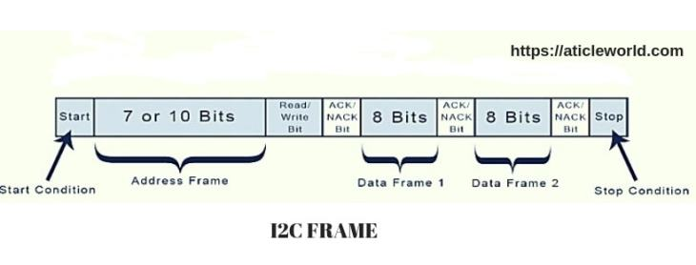
Now coming to how communication works:
1. Start Condition
- Communication begins with a START condition.
- It is indicated when the SDA line goes from HIGH to LOW while the SCL line is HIGH.
- It signals all slave devices to be ready for communication.

🧩 2. Address Frame
- Next, the Master sends the 7-bit address of the target slave device.
- Immediately after the address, 1 bit is sent to indicate the operation:
  - 0 = Write
  - 1 = Read
- So this becomes an 8-bit frame (7-bit address + 1-bit R/W).
- Acknowledgement (ACK):
The addressed slave responds by pulling the SDA line low, which is called an ACK bit. This confirms it has received the address.

3. Data Frame
- After addressing, data transfer begins.
- Each data byte is 8 bits long, sent by either master or slave (depending on R/W bit).
- After each byte, the receiver sends an ACK/NACK bit:
  - ACK (0): More data expected
  - NACK (1): No more data

🧩 4. Stop Condition
- Communication ends with a STOP condition.
- It is indicated when SDA goes from LOW to HIGH while SCL is HIGH.
- It frees the bus and signals that the transfer is complete.

Let me also touch on some key features and advantages:
- It supports multi-mastering, which means more than one master can be connected to the bus. However, arbitration ensures that only one master controls the bus at a time.
- It’s commonly used for short-distance, low-speed communication in embedded systems, like connecting microcontrollers to sensors, EEPROMs, RTCs, etc.

Speed modes include:
- Standard mode: up to 100 kbps, distance up to 1–2 meters
- Fast mode: up to 400 kbps, distance up to 1 meter
- Fast Mode Plus: up to 1 Mbps, distance up to 0.5 meters
- High-speed mode: up to 3.4 Mbps, distance less than 0.3 meters

I2C Bus Arbitration :
In I2C communication, multiple master devices can share the same bus. Arbitration is the process of deciding which master gets control of the bus when two or more masters initiate a transmission simultaneously. Arbitration ensures that only one master communicates at a time, while the other masters back off gracefully without data corruption.
Each master begins transmitting its data (usually starting with the address of the slave it wants to contact). While doing so, it also monitors the SDA line to check if the value on the bus matches what it is trying to send. I2C uses open-drain logic, meaning devices can only pull the line low; a high is achieved by pull-up resistors. So if a master tries to send a ‘1’ but sees a ‘0’ on the line, it realizes that another master is also transmitting and has higher priority, so it stops immediately.
This bit-by-bit arbitration continues until one master wins by successfully transmitting a '1' when all others also send '1'. This makes the process non-destructive because no data is lost—losing masters just stop and retry later.
Arbitration typically takes place during the transmission of the slave address and R/W bit. The master with the lowest address (in binary) wins arbitration, because ‘0’ dominates over ‘1’ on an open-drain bus. Once a master loses arbitration, it switches to a passive role and waits until the bus becomes free (i.e., after a STOP condition).
This mechanism enables multi-master communication without collisions or errors, making I2C highly reliable and efficient for systems with more than one master, such as in industrial controllers or advanced sensor networks. However, proper software support is required to detect arbitration loss and retry communication gracefully.

Clock Stretching in I2C
Clock stretching is a fundamental feature of the I2C protocol that allows a slave device to control the speed of data transfer by holding the clock line (SCL) low to delay the master. This mechanism is essential when the slave needs more time to process data or prepare the next byte...
In I2C, the clock line (SCL) is typically controlled by the master to synchronize data transfer on the data line (SDA). However, slaves can temporarily hold the SCL line low after receiving a clock pulse from the master. This "stretching" of the clock line effectively pauses communication until the slave is ready to proceed.
The need for clock stretching arises because I2C devices can have different internal speeds and capabilities. For example, a slow EEPROM or a sensor with complex processing might need more time before responding. Without clock stretching, the slave could miss data or respond incorrectly if the master clocks out data too quickly.
When the slave holds the SCL line low, the master must wait until the slave releases it, ensuring synchronization without data loss. This makes I2C flexible and robust for mixed-speed device environments. Masters detect clock stretching by monitoring the SCL line and waiting for it to go high before continuing the next clock pulse.
Overall, clock stretching enhances the reliability of the I2C bus by accommodating slower devices, preventing data corruption, and maintaining seamless synchronization in multi-device systems.
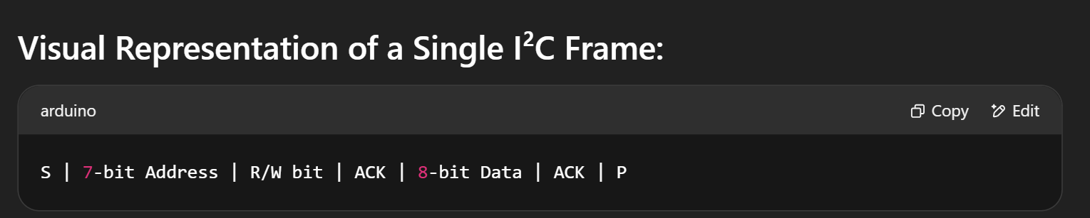

What do you mean by master and slave in I²C?
Master:
- The device that initiates and controls the communication.
- It generates the clock signal (SCL).
- It starts and stops the data transfer by sending start and stop conditions.
- It addresses the slave devices to communicate with them.
- Can send or receive data depending on the operation.
Slave:
- The device that responds to the master’s requests.
- It listens to the bus and waits for its address.
- It receives commands from the master and sends or receives data accordingly.
- Multiple slaves can be connected on the same I²C bus, each having a unique address.

What is ACK and NACK in I²C?
ACK (Acknowledge) is sent by receiver to indicate data was received.
It’s a LOW level (0) on SDA during 9th clock pulse.
NACK (Not Acknowledge) is HIGH (1), indicating data not received or end of communication.
Used to detect device presence or end of transmission.
Master monitors ACK/NACK after each byte.
What is ACK and NACK in I2C?
ACK (Acknowledge) and NACK (Not Acknowledge) are 1-bit signals used to confirm successful data reception. After 8 bits of data, the receiver pulls SDA low (ACK) during the 9th clock pulse. If it leaves SDA high, it’s a NACK, meaning either it didn’t receive the data or wants to end communication. This ensures reliable communication.
What is repeated start in I²C?
A repeated start avoids a stop condition between transmissions.
It keeps the bus active and control with the master.
Useful for combined read/write without releasing the bus.
Looks like a normal start condition on the bus.
All devices must support it.
What are the addressing modes in I2C?
I2C supports two addressing modes:
- 7-bit addressing: Supports up to 128 unique addresses (0–127)
- 10-bit addressing: Supports up to 1024 unique addresses
Most devices use 7-bit addressing. The address is sent by the master at the start of communication, followed by the R/W bit to indicate direction.
- What are the roles of master and slave in I2C?
- The master controls the clock line (SCL), initiates communication, and decides whether to read or write. The slave responds only when addressed. A system can have multiple slaves and even multiple masters, though multi-master support adds complexity with arbitration and clock synchronization.

- 9. How does arbitration work in I2C?
- When multiple masters try to control the bus, arbitration ensures only one succeeds. Each master monitors SDA while sending data. If it sees a '0' while sending a '1', it loses arbitration and backs off. This bitwise arbitration process prevents data collisions and ensures orderly communication.

- 10. What happens if two devices transmit data at the same time?
- In a multi-master system, both devices begin transmission. As each bit is sent, devices monitor the bus. The device that sends '1' but sees '0' loses arbitration. The winner continues, and the loser stops transmitting. This ensures data integrity without damaging the bus or devices.
- 11. What is clock stretching in I2C?
- Clock stretching allows a slave to slow down the master by holding the SCL line low after a clock pulse. The master must wait until the slave releases SCL high before continuing. This is useful for slaves that need more time to process data before sending or receiving more.

- 12. How does I2C handle multiple slave devices?
- Each slave is assigned a unique address. During communication, the master sends the address; only the matching slave responds. This makes I2C scalable and suitable for applications with many peripherals using just two lines. Proper address management is essential to avoid conflicts.

- 13. What are the limitations of I2C?
- I2C is limited in speed, distance (short-range only), and number of devices (due to address and capacitance constraints). It’s not suitable for high-speed or long-distance communication. Also, open-drain lines and pull-up resistors can cause slower rise times and power consumption.

- 14. What is the difference between I2C and SPI?
- I2C uses two lines (SDA, SCL) and supports multi-master, while SPI uses at least four (MISO, MOSI, SCLK, SS) and is faster. I2C supports addressing and is simpler for many slaves, but slower. SPI is full-duplex and better for high-speed, short-distance communication without address overhead.

- 15. Can we connect multiple masters in I2C?
- Yes, I2C supports multi-master configuration, but it adds complexity. Each master must check bus availability before initiating communication. Arbitration and synchronization ensure no conflicts. However, multi-master setups are rare in practice due to increased firmware complexity.

- 16. What is a repeated START condition?
- A repeated START is issued without sending a STOP in between communications. It allows the master to maintain control of the bus while initiating a new operation (like switching from write to read). It prevents other masters from taking control during a transaction.

- 17. Why are pull-up resistors needed in I2C?
- SDA and SCL are open-drain, meaning devices can only pull them low. Pull-up resistors bring them to logic high when released. Without pull-ups, the lines would float, causing unpredictable communication. The resistor value affects rise time and must match the bus capacitance.

- 18. How to detect if I2C bus is busy?
- Before starting communication, the master checks if both SDA and SCL are high (idle state). If either line is low, the bus is busy—possibly due to ongoing transmission or a stuck slave. In software, a master waits until both lines are free before initiating a transaction.

- 19. What is bus capacitance in I2C and why does it matter?
- Each device and trace adds capacitance to the bus, which slows down signal rise times. High capacitance can cause data corruption at high speeds. I2C specs recommend a maximum of 400 pF total bus capacitance. Using proper layout and limiting devices helps maintain performance.

- 20. What is the difference between I2C and UART?
- I2C is a synchronous protocol using clock and data lines, supports multi-master/multi-slave, and is good for onboard communication. UART is asynchronous, uses start/stop bits, and is best for point-to-point communication over longer distances. UART is simpler but lacks addressing and multi-device support.

