What is a Device Driver?
You can start like this:
- First of all, let us understand what a device driver actually is.
- A device driver is simply a software module that acts as a bridge between the operating system and the hardware device.
- In simple words, the hardware cannot directly talk to the OS, and the OS cannot directly talk to the hardware.
- So, the device driver comes in between and provides the correct language or protocol for communication.
- For example, if you connect a keyboard or a USB drive, the operating system itself doesn’t know the hardware’s internal details — it depends on the driver.
- The driver contains the necessary instructions to control the hardware, like how to initialize it, read from it, or write to it.
- Without a driver, the operating system will not understand how to use the hardware device.
- That is why we say a driver acts as a translator between software and hardware.
- In Linux, device drivers are mostly implemented as kernel modules, so they run in kernel space for direct hardware access.

Part 2: Why do we need Device Drivers?
- Now, after understanding what a device driver is, let us see why we actually need them.
- Every hardware device is different — a hard disk works differently from a printer, and a printer works differently from a network card.
- The operating system cannot include detailed knowledge of every possible hardware device in the world.
- So, instead of hardcoding device details into the OS, we use device drivers.
- Drivers abstract the hardware complexity and give a uniform interface to the operating system.
- For example, when we save a file, the OS just calls the file system interface — it doesn’t care whether the storage is HDD, SSD, or pen drive. The driver takes care of the hardware-specific operations.
- Device drivers also make it easier to add support for new hardware without changing the OS itself.
- They also improve portability — the same Linux kernel can run on different machines, and only drivers need to change for the specific hardware.
- Drivers also provide safety and security because they run in kernel space and enforce controlled access to hardware.
- Finally, without device drivers, the operating system and applications would be useless because they cannot interact with the physical devices like display, network, or storage.

User Space and Kernel Space in Linux
- To understand device drivers, first we must know about User Space and Kernel Space in Linux.
- Linux divides memory into two regions: User Space and Kernel Space.
- User Space is where normal applications like browsers, text editors, or media players run.
- Programs in user space have restricted access — they cannot directly touch the hardware or critical memory.
- This restriction is important because if user programs directly access hardware, one small mistake can crash the whole system.
- On the other hand, Kernel Space is where the Linux kernel and device drivers run.
- Kernel space has full access to hardware resources like CPU, memory, and I/O devices.
- That’s why device drivers, which need to control hardware, are mostly written to run in kernel space.
- But we cannot let user programs run in kernel space, otherwise security and stability would be lost.
- So, Linux uses a system call interface as a gateway between user space and kernel space.
- Whenever a user program needs to talk to hardware, it makes a system call, which transfers control into kernel space.
- For example, when you call read() or write() in C, you are in user space, but the kernel driver executes the actual hardware operations in kernel space.
- This separation improves security, because user processes cannot directly damage kernel data.
- It also improves stability, because even if one application crashes, the kernel and other apps remain safe.
- In summary, user space is for applications, kernel space is for drivers and the core OS, and system calls act as the bridge between them.

Steps of What Happens During a System Call (read()/write())
- User Space Call → The application calls read(fd, buf, count) or write(). This is just a libc wrapper that prepares arguments and executes a special CPU instruction (syscall on x86, svc on ARM) to enter the kernel.
- Trap to Kernel → The CPU switches from user mode to kernel mode, saving registers and program counter, and jumps to the kernel’s syscall entry point.
- Syscall Dispatch → The kernel looks up the syscall number in its syscall table and jumps to the correct handler (sys_read() / sys_write()).
- Argument Validation → The kernel then checks the arguments: is the file descriptor valid? is the memory address safe to use?
- File Lookup → The kernel finds the struct file* for the given fd using the process’s file descriptor table. This structure contains the driver’s function pointers in file_operations.
- VFS Layer → The syscall handler calls the Virtual File System (VFS), which provides a uniform interface and then calls the appropriate driver callback (file->f_op->read() / write() or read_iter() / write_iter()).
- Driver Execution → The device driver now runs in kernel space. It may access hardware registers, prepare DMA, or use kernel buffers. If data is not ready, the driver may put the process to sleep on a waitqueue.
- Interrupt Handling → If the driver sleeps, the hardware later signals readiness via an interrupt. The IRQ handler (top-half) quickly acknowledges and schedules bottom-half work, which then wakes up the sleeping process.
- Data Transfer → Once data is ready, the driver copies it safely to or from user space using copy_to_user() / copy_from_user(). If invalid memory is given, it returns -EFAULT.
- Return to User → The driver returns the number of bytes transferred (or error code). VFS updates file position if needed. The syscall return path restores registers, switches back to user mode, and libc sets errno if there was an error. The user program finally receives the result.

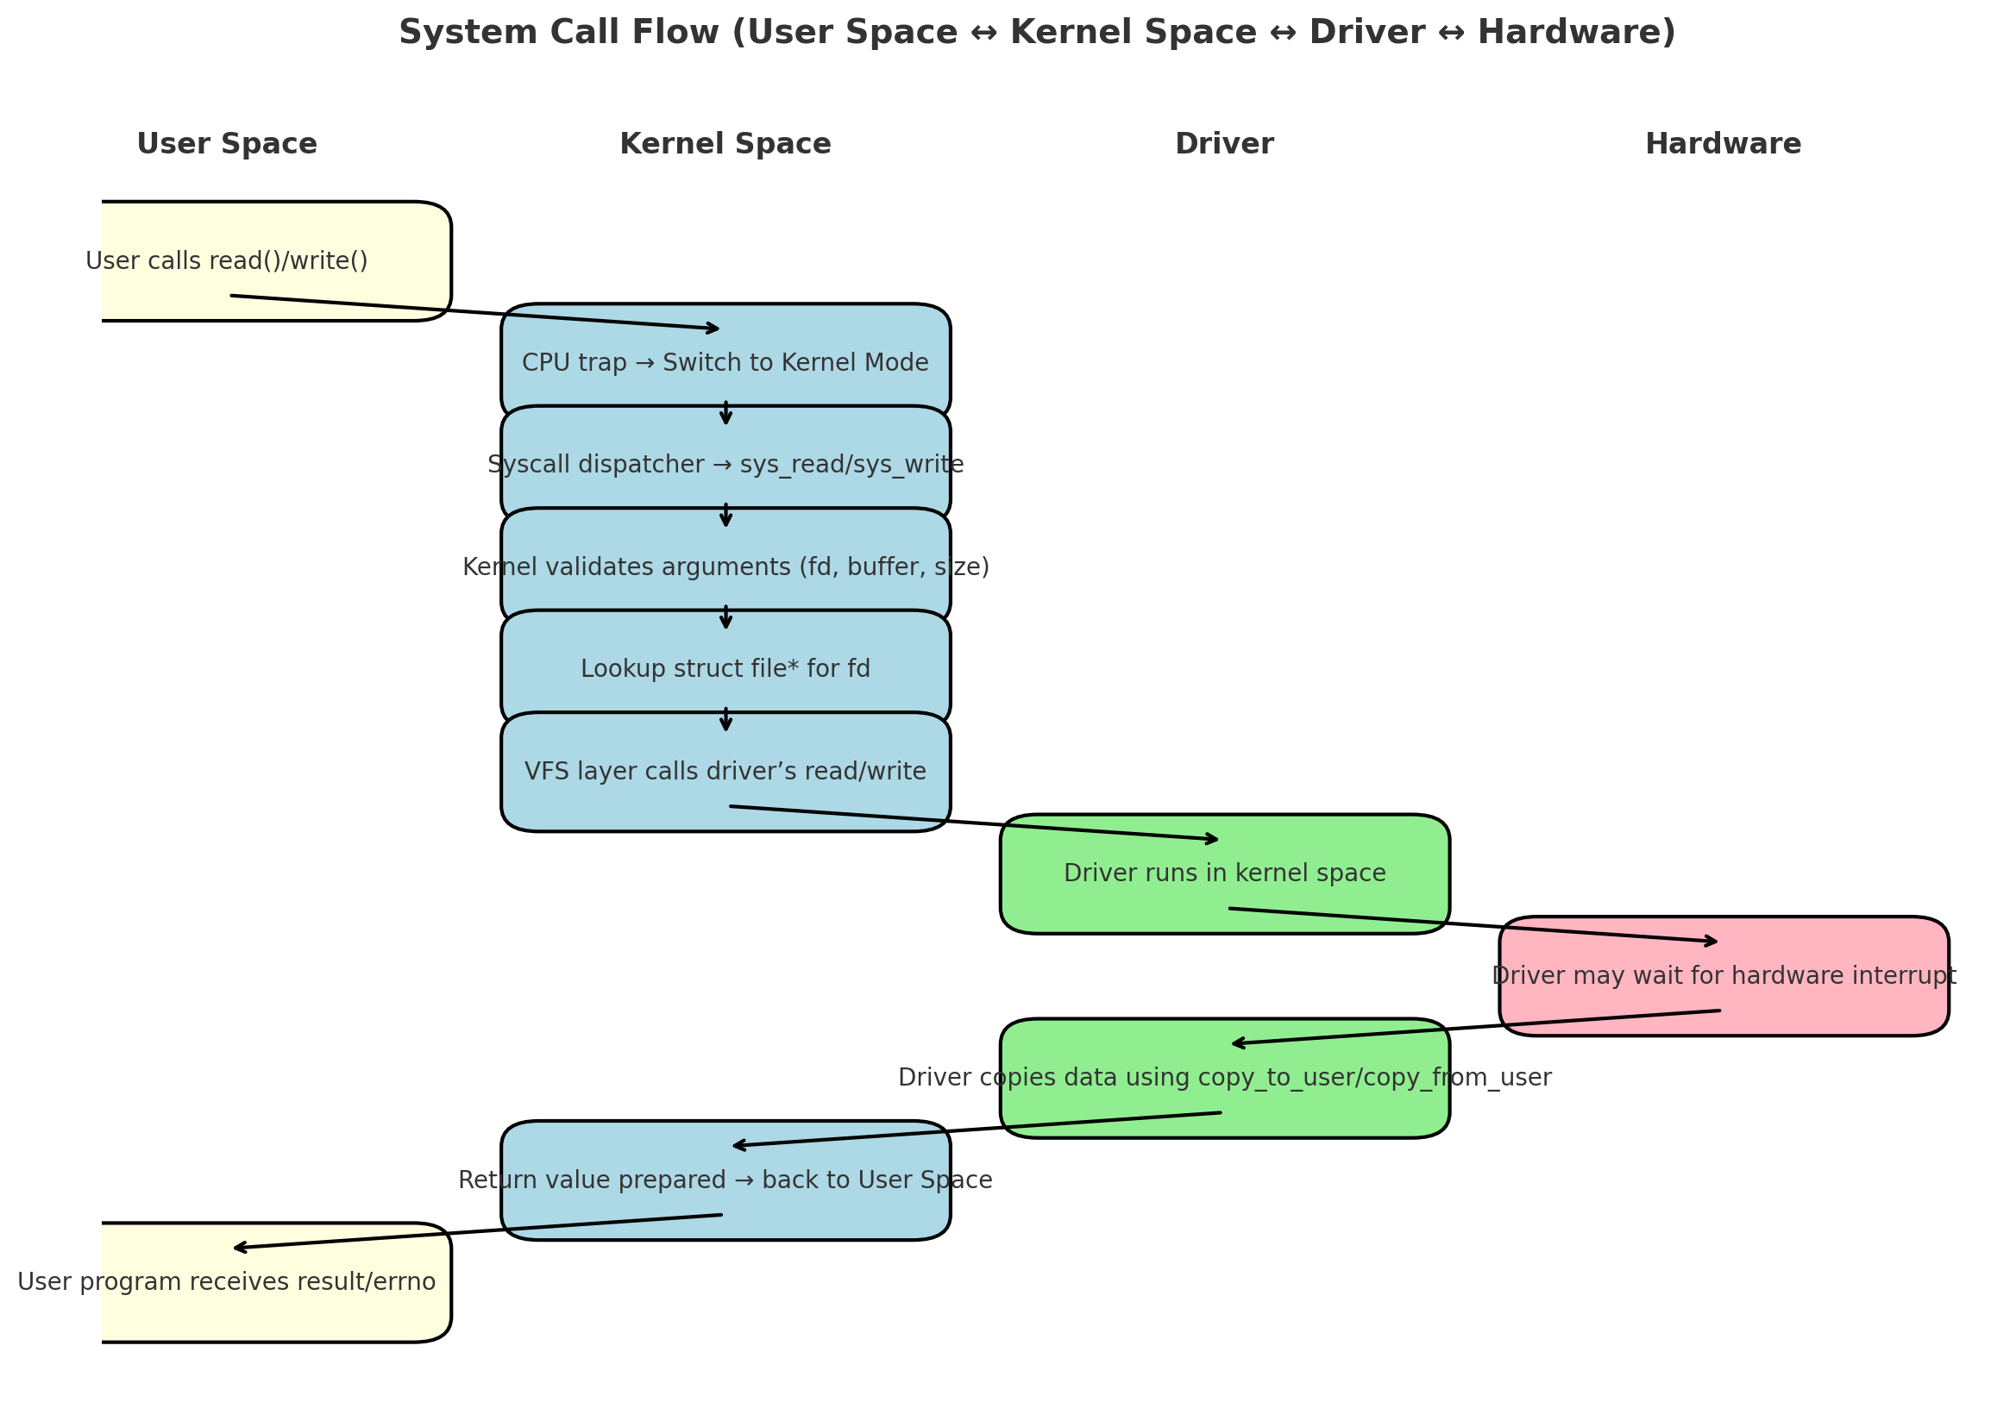
In Linux device drivers, there are some common terminologies we should know.
First is Device Files, which appear in /dev and allow user programs to talk to hardware using normal system calls like open, read, and write.
Second is Device Numbers, where every device file is identified by a major and minor number – these tell the kernel which driver to use and which exact device it refers to.
And third is Kernel Modules, where drivers are written as loadable modules that can be inserted or removed from the kernel dynamically using commands like insmod, rmmod, and checked with lsmod.

Why Major and Minor Numbers are Needed
- In Linux, every device is treated like a file under /dev, and when we use system calls like read() or write(), the kernel must know which driver should handle the request and which exact device to talk to.
- Simply having a device name is not enough for the kernel, so it uses major and minor numbers to map system calls to the correct driver and the correct device instance.
- In short, these numbers act like an address system, where the major number points to the driver (the street), and the minor number points to the specific device (the house).
🔹 Major Number (3 big lines)
- The major number tells the kernel which driver is responsible for handling a group of devices.
- When a system call comes from user space, the kernel looks at the major number to directly find the correct driver entry points (open, read, write, etc.).
- For example, all hard disks may share the same major number, meaning they are all controlled by the same disk driver.

🔹 Minor Number (3 big lines)
- The minor number is used to identify a specific device instance within the group of devices handled by the same driver.
- While the major number ensures the correct driver is called, the minor number tells the driver which exact device is being accessed.
- All devices /dev/ttyS0, /dev/ttyS1, /dev/ttyS2 share the same major number because they use the same driver.
- Each has a different minor number so the driver knows which one is being accessed.
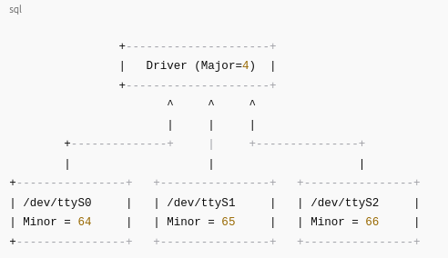

insmod
- insmod means Insert Module, and it is used to manually load a driver module (.ko file) into the kernel.
- It simply places the module into kernel memory and links it, but does not resolve dependencies, so you must insert supporting modules manually.
- Example: sudo insmod mydriver.ko → if successful, you can see a confirmation using dmesg.
🔹 rmmod
- rmmod means Remove Module, and it is used to unload or remove a driver from the kernel memory.
- Once removed, the driver’s functionality is no longer available, and any devices linked to it will stop working.
- Example: sudo rmmod mydriver → after removal, you can again check dmesg for confirmation messages.
🔹 modinfo
- modinfo displays information about a kernel module without inserting it into the kernel.
- It provides useful details like module name, description, author, license, parameters, and dependencies.
- Example: modinfo mydriver.ko → helps developers and users to understand what the driver does before loading it.
🔹 modprobe
- modprobe is a smarter tool than insmod, because it not only inserts a module but also automatically loads any dependencies required by that module.
- Similarly, it can also remove a module along with its unused dependencies using modprobe -r.
- Example: sudo modprobe mydriver → easier and safer than using insmod because it handles everything automatically.

🔹 printk()
- printk() is like printf() but for the kernel space, used by driver developers to print messages from inside the kernel.
- These messages go into the kernel log buffer and help in debugging the driver by showing what is happening inside.
- Example: printk(KERN_INFO "Driver initialized successfully\n"); → prints an info-level message.
🔹 dmesg
- dmesg is a command-line tool used to display messages stored in the kernel log buffer, which are usually written using printk().
- It is very helpful to check whether a driver was loaded properly, whether it reported any errors, or whether hardware is detected.
- Example: run dmesg | tail right after insmod to see the latest driver messages.
🔹 Log Levels in printk
- printk() supports different log levels, which tell the kernel how important or urgent the message is.
- For example:
  - KERN_EMERG → emergency, system unusable.
  - KERN_ERR → error messages.
  - KERN_WARNING → warning but not fatal.
  - KERN_INFO → general info.
  - KERN_DEBUG → debugging details.
- Using correct log levels helps developers separate critical errors from normal info during debugging.

Types:
1.character
2)Block Device Driver :
*It is a type of driver that handles data in a fixed size of blocks called sectors.
*Data is transferred through a buffered cache and can be accessed from any location at a given point.
*The file system interacts with block driver to manage and organize data on storage medium.
*Rather than system calls,they use kernel's block I/O subsystem to send/receive data.
*Examples : Hard disk drives, USB flsh drives, CD-ROM drives
3)Network device driver:
*It is a type of driver that manages transmission and reception of data packets over a network.
*They manage data in packets through packet buffers which hold data packets temporarily.
*The driver uses networking structures and functions to manage network interfaces and packet transfers rather than system calls.
*These drivers manages the flow of data pckets over a physical interface but doesn't handle data storage or addressable blocks.
*They are not associated with any file systems.
*Examples : Ethernet cards, Wi-Fi adapters etc.
Character Driver :
🔹 Introduction
A Character Driver is a type of Linux device driver that allows communication with hardware devices by transferring data one character (byte) at a time.
It is the simplest and most common type of driver, widely used in embedded systems.
Examples include UART, keyboard, mouse, serial ports, and sensors.
Character drivers interact with hardware through device files located in the /dev directory.
Each device file is identified by a major number (to link with driver) and a minor number (to differentiate devices).
When the user calls system calls like open(), read(), or write(), the request goes to the character driver, which then talks to the hardware.
They are needed because many devices send or receive streams of data instead of blocks or packets.
For example, a UART sends characters one by one, and the driver ensures this data is properly handled.
Without the character driver, applications in user space would have no way to directly communicate with such devices.
A character driver implements file operations like open, close, read, write, and ioctl.
These functions define how the user program interacts with the device.
For example, read() may fetch sensor data, and write() may send commands to the device.”
For example, if you connect a USB-to-Serial converter, Linux creates a device file like /dev/ttyUSB0.
When you run a program to send or receive data through it, the character driver handles the actual communication with the hardware.

let’s look at one of the most important components inside a char driver – the file_operations structure.
Every time a user program tries to open, read, write, or control the device, the kernel needs to know which function in our driver should handle it. That’s exactly what file_operations does – it connects system calls from user-space to our driver functions in the kernel.”
What is file_operations?
- In Linux, every character device driver communicates with user-space programs through a set of standard operations.
- These operations are defined in a struct file_operations, which is like a menu of functions that the kernel can call when a user program interacts with your device.
- Whenever a program does something like open("/dev/mydevice") or read(fd, buf, len), the kernel looks into your file_operations to know which function in your driver should handle that request.
- Analogy: Think of file_operations as a remote control for your device. Each button on the remote (open, read, write, ioctl, release) has a specific function defined in your driver.

static struct file_operations fops = {
.owner = THIS_MODULE, // Prevents unloading when in use
.open = my_open, // Called when device is opened
.read = my_read, // Called when data is read
.write = my_write, // Called when data is written
.unlocked_ioctl = my_ioctl, // Called for control operations
.release = my_release // Called when device is closed
};
fops is passed to register_chrdev or cdev_init so the kernel knows how to handle system calls for this device.
Let’s look at some of the key members of this structure:
- owner – This tells the kernel which module owns this driver. It prevents the module from being unloaded while in use, ensuring system stability.
- open() – Called when a user program opens the device file. We can use this to initialize the hardware, allocate buffers, or perform checks.
- read() – Called when the program reads data from the device. It uses copy_to_user() to safely transfer data from kernel space to user space.
- write() – Called when the program writes data to the device. It uses copy_from_user() to get data from user space into the kernel.
- unlocked_ioctl() – This is for device-specific control operations, like setting a threshold, changing modes, or retrieving status.
- release() – Called when the device file is closed. Here we free resources or stop hardware operations.

Device Registration in Char Drivers
“Once the driver code is written, the kernel doesn’t automatically know about your device. Just writing functions like open, read, or write is not enough. We need to formally register our device with the kernel, so the kernel knows:
- Which driver corresponds to which major number, and
- Which operations (defined in file_operations) are available for that device.
This process is called device registration. Without this step, even if your driver is loaded, the kernel cannot connect /dev/mydevice with your driver’s functions.”

1️.Two Ways of Registration
A) Static Registration – register_chrdev
- In this method, the programmer chooses a major number manually.
- You tell the kernel something like:
“Hey kernel, I want to use major number 240. If someone opens /dev/mydevice, please call the functions in my file_operations.”
- Syntax:
int register_chrdev(unsigned int major, const char *name, const struct file_operations *fops);
Parameters:
  - major → fixed number chosen by you (e.g., 240).
  - name → name of your device (appears in /proc/devices).
  - fops → pointer to your file_operations structure.
- Returns:
  - Success → major number allocated.
  - Failure → negative error code.
- Limitation: If another driver is already using the same major number, a conflict occurs and registration fails. This is why static registration is not flexible.

B) Dynamic Registration – alloc_chrdev_region
- Instead of hardcoding a major number, we ask the kernel to dynamically assign one.
- This avoids conflicts and is the modern, recommended approach.
- Syntax:
int alloc_chrdev_region(dev_t *dev, unsigned baseminor, unsigned count, const char *name);
Parameters:
- dev → pointer where kernel stores the allocated major + minor number.
- baseminor → starting minor number (usually 0).
- count → number of devices you want to register under this driver.
- name → name of your device.
- After this call, we can extract major and minor numbers using:

Why cdev?
“When we use the older API register_chrdev(), we don’t need to worry about cdev. That’s because register_chrdev() internally creates and registers a cdev structure for us. It’s a one-step process – we just give it a major number and file_operations, and the kernel handles the rest.
But in the newer and more flexible method, when we use alloc_chrdev_region() or register_chrdev_region(), the kernel only reserves the device numbers for us. It does not automatically attach our driver logic to those numbers. That’s where cdev comes in – it acts as a bridge between the device numbers and the driver’s file_operations structure.
So in short:

- With register_chrdev() → no manual cdev needed (kernel does it internally).
- With modern APIs (alloc_chrdev_region, register_chrdev_region) → we must manually create, initialize, and register a cdev.”

🔹 cdev_init()
- cdev_init() is the first step in creating a character device object.
- It sets up the cdev structure and links it with our driver’s file_operations table.
- Without this step, the kernel would not know which functions (open, read, write, etc.) belong to this device.
👉 In simple terms: cdev_init() tells the kernel: “This is my character device, and here are the operations it supports.”
🔹 cdev_add()
- Once initialized, cdev_add() registers the cdev with the kernel and associates it with the previously allocated major and minor numbers.
- This is the step that actually makes the device live in the kernel. After cdev_add(), the device is officially recognized, and system calls like open() or read() will be routed to your driver.
- If you forget cdev_add(), the device exists only in your code but is invisible to the kernel.
👉 In simple terms: cdev_add() tells the kernel: “Here is my device object – please start using it with this major/minor.”

🔹 cdev_del()
- When the module is unloaded, cdev_del() is used to unregister and remove the cdev from the kernel.
- This ensures that no dangling device entry remains, which could otherwise cause kernel crashes or undefined behavior if user programs try to access it.
- It is always paired with cdev_add() – whatever we add, we must also delete.
👉 In simple terms: cdev_del() tells the kernel: “I am done – please forget this device and free all resources.”

// 1. Initialize cdev structure and link with file_operations
void cdev_init(struct cdev *cdev, const struct file_operations *fops);

// 2. Add cdev to kernel and associate with device numbers
int cdev_add(struct cdev *cdev, dev_t dev, unsigned int count);

// 3. Remove cdev from kernel during cleanup
void cdev_del(struct cdev *cdev);

cdev_init(), cdev_add(), cdev_del()
These are used to register your character device with the kernel.
- cdev_init() → Initializes a struct cdev object and links it with your struct file_operations. Think of it as “preparing the device’s behavior”.
- cdev_add() → Registers that initialized cdev with the kernel, making it available under the assigned major/minor number. Without this, your device is not active.
- cdev_del() → Removes/unregisters the character device from the kernel when unloading your module.

1. copy_from_user()
📌 What it is:
- copy_from_user() is a kernel function used to safely copy data from user space to kernel space.
- It prevents direct access to user-space pointers inside kernel code.
🔧 Prototype:
long copy_from_user(void *kernel_buffer, const void __user *user_buffer, unsigned long count);
to: Kernel-space buffer to store the data.
- from: User-space pointer.
- n: Number of bytes to copy.
"copy_from_user() is used to transfer data from user space to kernel space. It returns non-zero on failure (e.g., if the pointer is invalid)."
// Write
static ssize_t my_write(struct file *file, const char __user *user_buf, size_t len, loff_t *offset) {
if (len >= BUF_SIZE)
len = BUF_SIZE - 1;
if (copy_from_user(kernel_buffer, user_buf, len))
return -EFAULT;
kernel_buffer[len] = '\0'; // Null-terminate
printk(KERN_INFO "Received from user: %s\n", kernel_buffer);
return len;
}

2. copy_to_user()
📌 What it is:
- copy_to_user() is used to send data from kernel space back to user space safely.
- Ensures memory safety and prevents kernel from directly writing to user-space addresses.
🔧 Prototype:
long copy_to_user(void __user *user_buffer, const void *kernel_buffer, unsigned long count);
to: User-space pointer to store result.
- from: Kernel buffer.
- n: Number of bytes to copy.
copy_to_user() is used to send data from the kernel to a user-space variable. It ensures the destination is valid and avoids segmentation faults."
/ /Read
static ssize_t my_read(struct file *file, char __user *user_buf, size_t len, loff_t *offset) {
size_t data_len = strlen(kernel_buffer);
if (copy_to_user(user_buf, kernel_buffer, data_len))
return -EFAULT;

return data_len;
}
--------------------------------------------------------------------------------------------------------------------
What is ioctl()?
ioctl stands for I/O control, and it's a system call used in device drivers to send control commands between user space and kernel space — beyond just read() and write() operations.
static long my_ioctl(struct file *file, unsigned int cmd, unsigned long arg);

“Now, apart from the standard operations like open, read, and write, many devices need special control commands. For example, changing the baud rate of a UART, setting the threshold temperature for a sensor, or telling an LED to turn ON or OFF.
That’s where IOCTL, or Input/Output Control, comes in. It allows us to define custom commands so that user programs can directly control the device in ways that are not possible with just read/write.

struct file *file – Pointer to the file structure representing the open device file.
cmd – the command number defined by _IO, _IOW, _IOR, or _IOWR.
arg – typically a pointer to user-space data to pass or receive.

Usage of ioctl():

#define IOCTL_SET_NUM _IOW(MAJOR_NUM, 0, int)
#define IOCTL_GET_NUM _IOR(MAJOR_NUM, 1, int)

static int value = 0;

static long my_ioctl(struct file *file, unsigned int cmd, unsigned long arg) {
switch (cmd) {
case IOCTL_SET:
if (copy_from_user(&value, (int __user *)arg, sizeof(int)))
return -EFAULT;
printk(KERN_INFO "IOCTL SET: %d\n", value);
break;

case IOCTL_GET:
if (copy_to_user((int __user *)arg, &value, sizeof(int)))
return -EFAULT;
printk(KERN_INFO "IOCTL GET: %d\n", value);
break;

default:
return -EINVAL;
}
return 0;
}

2. IOCTL Command Definitions
In the driver, we use macros to define unique commands.
The macros are:
- _IO(type, nr)
  - For simple commands with no data transfer.
  - Example: Turn LED ON or OFF.
  - Just tells the driver to “do something”.
- _IOR(type, nr, datatype)
  - “Read” command – used when user wants to read data from the driver.
  - Example: Get current temperature from sensor.
  - Driver will use copy_to_user() to send data back.
- _IOW(type, nr, datatype)
  - “Write” command – used when user sends data to the driver.
  - Example: Set threshold value.
  - Driver will use copy_from_user() to receive the value.
- _IOWR(type, nr, datatype)
  - Combination of both Read and Write.
  - Example: Send a request and also get updated data.
3. Magic Number
- Each IOCTL command must be unique.
- To avoid clashes between different drivers, Linux uses a magic number (an arbitrary unique number for your driver).
- Usually chosen between 0x01 to 0xFF or a character.
- Example:

What Happens When ioctl() is Used?
Step-by-step flow:
- User-space program calls ioctl(fd, command, arg);.
- The kernel checks the file_operations structure of the device.
- It finds the driver’s unlocked_ioctl() function.
- The driver’s ioctl handler receives → (cmd, arg).
- The driver checks which command was sent (using switch(cmd)).
- Based on command:
  - If _IO → just perform an action (e.g., LED ON).
  - If _IOR → driver writes data into arg using copy_to_user().
  - If _IOW → driver reads data from arg using copy_from_user().
  - If _IOWR → driver does both.
- The driver executes the hardware action and returns status.

#include <linux/module.h>
#include <linux/fs.h> // For register_chrdev
#include <linux/uaccess.h> // For copy_to_user, copy_from_user

#define DEVICE_NAME "mychardev"
#define MY_MAJOR 240 // Static major number

// ----------------------------
// File operations
// ----------------------------
static int my_open(struct inode *inode, struct file *file)
{
pr_info("Device opened\n");
return 0;
}

static int my_release(struct inode *inode, struct file *file)
{
pr_info("Device closed\n");
return 0;
}

static ssize_t my_read(struct file *file, char __user *buf, size_t len, loff_t *off)
{
char msg[] = "Hello from kernel!\n";
if (copy_to_user(buf, msg, sizeof(msg)))
return -EFAULT;
return sizeof(msg);
}

static ssize_t my_write(struct file *file, const char __user *buf, size_t len, loff_t *off)
{
char kbuf[100];
if (len > 99) len = 99;
if (copy_from_user(kbuf, buf, len))
return -EFAULT;
kbuf[len] = '\0';
pr_info("Received: %s\n", kbuf);
return len;
}

// ----------------------------
// File operations structure
// ----------------------------
static struct file_operations fops = {
.owner = THIS_MODULE,
.open = my_open,
.release = my_release,
.read = my_read,
.write = my_write,
};

// ----------------------------
// Init & Exit
// ----------------------------
static int __init my_init(void)
{
int ret = register_chrdev(MY_MAJOR, DEVICE_NAME, &fops);
if (ret < 0) {
pr_err("Failed to register device\n");
return ret;
}
pr_info("Registered char device with major %d\n", MY_MAJOR);
return 0;
}

static void __exit my_exit(void)
{
unregister_chrdev(MY_MAJOR, DEVICE_NAME);
pr_info("Unregistered char device\n");
}

module_init(my_init);
module_exit(my_exit);

MODULE_LICENSE("GPL");
MODULE_AUTHOR("Your Name");
MODULE_DESCRIPTION("Character Device Driver Skeleton");

Feature | /proc (procfs) | /sys (sysfs)
Purpose | Process and kernel info | Kernel object representation (devices, drivers, classes)
Introduced | Early Linux (2.0) | Linux 2.6
Structure Type | Text-based and ad-hoc | Hierarchical (kobject-based)
Usage | Debugging, stats, process info | Hardware/device configuration
Implementation | Uses proc_create() and proc_ops | Uses kobject, sysfs_create_file()
Mount Point | /proc | /sys
Example File | /proc/meminfo, /proc/modules | /sys/class/net/, /sys/block/
Recommended Use | For runtime statistics | For configuration and device attributes

