Explain the TCP three way handshake:
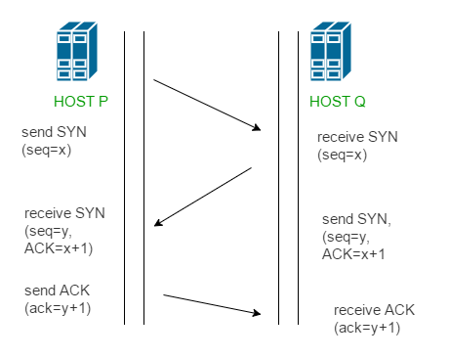
The TCP Three-Way Handshake is the process used to establish a reliable connection between a client and a server in a TCP/IP network. It ensures that both sides are ready to send and receive data, and it synchronizes sequence numbers for reliable communication.
Steps Involved in the TCP Three-Way Handshake
🔹 1. SYN (Synchronize)
- The client initiates the connection by sending a SYN (synchronize) packet to the server.
- It includes an initial sequence number (ISN) chosen by the client.
- This indicates that the client wants to establish a connection and begin communication.
🔹 2. SYN-ACK (Synchronize-Acknowledge)
- The server responds with a SYN-ACK packet.
- It acknowledges the client's SYN (by setting the ACK number = client's ISN + 1) and also sends its own SYN with its own ISN.
- This confirms that the server is ready to establish the connection.
🔹 3. ACK (Acknowledge)
- The client sends a final ACK packet back to the server.
- This packet acknowledges the server’s SYN (ACK number = server’s ISN + 1).
- Once this is received, the connection is established, and data transfer can begin.

IP HEADER STRUCTURE:
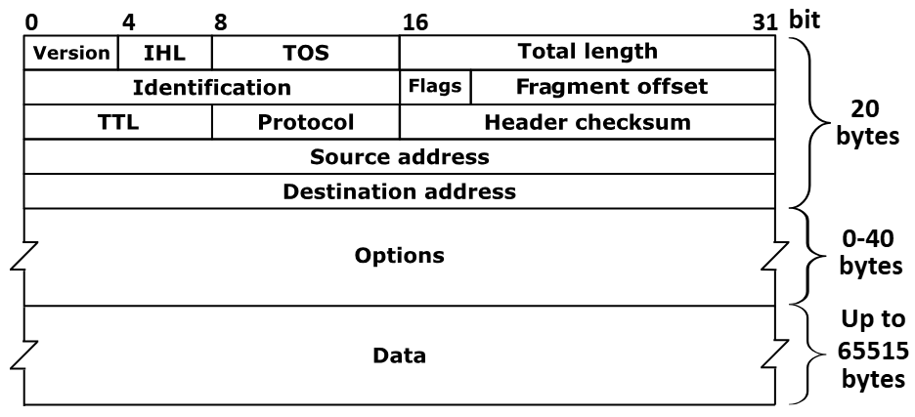
IP Header Structure:
The IP header is a part of every IP packet and contains critical information used for routing and delivering packets across networks. The most common version is IPv4, and it has a 20-byte minimum header (without options).
Breakdown of IPv4 Header Fields (20 bytes minimum)
Field Name | Size (bits) | Description
Version | 4 | Specifies the IP version (usually 4 for IPv4)
IHL (Header Length) | 4 | Number of 32-bit words in the header (minimum value is 5 → 20 bytes)
Type of Service (ToS) | 8 | Indicates packet priority or QoS (Quality of Service)
Total Length | 16 | Total size of the IP packet (header + data)
Identification | 16 | Used to identify fragments of a single IP packet
Flags | 3 | Control or identify fragmentation (e.g., DF, MF)
Fragment Offset | 13 | Position of a fragment in the original packet
Time to Live (TTL) | 8 | Limits the packet's lifetime (prevents infinite loops)
Protocol | 8 | Indicates the higher-level protocol (e.g., TCP = 6, UDP = 17)
Header Checksum | 16 | Error-checking for the header only
Source IP Address | 32 | IP address of the sender
Destination IP Address | 32 | IP address of the receiver
Options (optional) | variable | Used for extra features like security, timestamps, etc.
Padding | variable | Ensures header ends on a 32-bit boundary

✨ Key Points to Highlight in an Interview
- The header is essential for routing, delivery, and error-checking.
- TTL prevents packets from looping endlessly in the network.
- Fragmentation fields help split large packets for networks with small MTUs.
- The Protocol field helps IP hand off data to the correct upper layer (like TCP or UDP).
- The Header Checksum ensures the integrity of the header, not the entire packet.

What is ARP and Its Use?

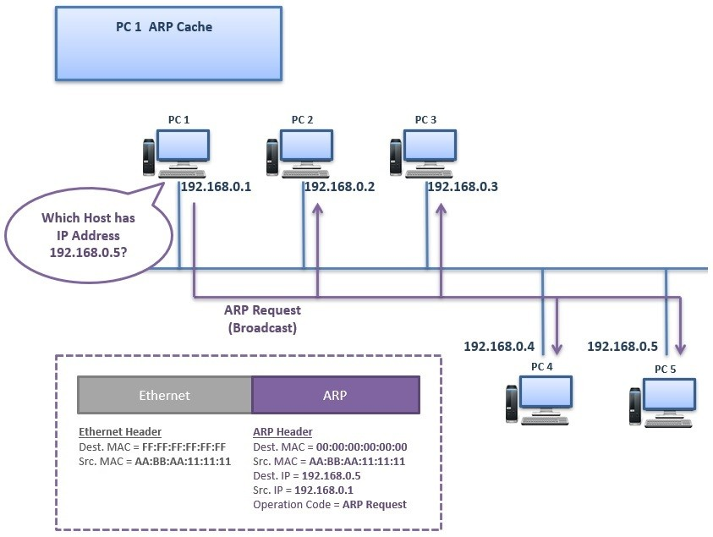
ARP (Address Resolution Protocol) is a network protocol used to map an IP adress to a MAC (Media Access Control) address in a local area network (LAN).
Scenario from the Diagram:
- PC 1 wants to communicate with PC 5.
- PC 1 knows the IP address of PC 5 (192.168.0.5), but does not know its MAC address.
- To find the MAC address, PC 1 uses the ARP protocol.

🔄 Step-by-Step Explanation of the ARP Process in This Diagram:
✅ Step 1: ARP Request (Broadcast)
- PC 1 generates an ARP Request asking:
“Who has IP address 192.168.0.5? Tell me your MAC address.”
- This ARP Request is broadcast to all devices on the local network (same subnet).
🧾 Details of the ARP Request:
- Destination MAC (Ethernet): FF:FF:FF:FF:FF:FF → Broadcast
- Source MAC: AA:BB:AA:11:11:11 (PC 1's MAC)
- Sender IP: 192.168.0.1 (PC 1's IP)
- Target IP: 192.168.0.5 (IP of PC 5)
- Target MAC: 00:00:00:00:00:00 (unknown)

📡 Step 2: ARP Request Reaches All PCs
- PCs 2, 3, 4, and 5 all receive the broadcast.
- Each checks: “Is the IP in the request (192.168.0.5) my IP?”
- Only PC 5 says “Yes!”

✅ Step 3: ARP Reply (Unicast)
- PC 5 sends an ARP Reply directly (unicast) to PC 1.
“I am 192.168.0.5, and my MAC address is AA:CC:DD:22:22:22.”
- This ARP reply contains:
  - Source IP: 192.168.0.5
  - Source MAC: AA:CC:DD:22:22:22 (PC 5's MAC)
  - Destination IP: 192.168.0.1 (PC 1)
  - Destination MAC: AA:BB:AA:11:11:11 (PC 1's MAC)

📘 Step 4: Update ARP Cache
- PC 1 stores this mapping in its ARP cache:
192.168.0.5 → AA:CC:DD:22:22:22
- Now, PC 1 can directly send data to PC 5 using its MAC address.

🧠 Summary in One Line (Good for Interview):
“In this diagram, ARP allows PC 1 to discover PC 5's MAC address by broadcasting a request. PC 5 replies with its MAC, enabling direct communication within the local network.”

✅ Interview Points to Highlight:
- ARP is used only in local networks.
- ARP Request is broadcast, ARP Reply is unicast.
- Information is cached to avoid repeated broadcasts.
- Essential for IP-to-MAC translation in IPv4 networks.
If the IP address is known, why can’t the sender just send the message directly? Why is the MAC address needed?
Detailed Explanation
🔷 1. IP Address = Logical Address
- IP addresses are like street addresses: they help identify where a packet needs to go across networks.
- But just like a postman needs the house number (not just the name), a device on a LAN needs the MAC address to deliver the packet physically.
🔷 2. MAC Address = Physical Address
- MAC address is like the house's unique number or door label in a building.
- On an Ethernet or Wi-Fi network, switches and NICs (network interface cards) use MAC addresses to deliver frames between devices.
🔷 3. How Data Travels
- When PC 1 wants to send data to PC 5:
  - It creates an IP packet with destination IP: 192.168.0.5.
  - But that packet must be wrapped inside an Ethernet frame for actual delivery on the local network.
  - This frame requires a destination MAC address.
  - Without the MAC address, the Ethernet frame can’t be sent, and the data won’t reach the destination.

🖼️ Think of it Like This:
- IP address: Tells you the person to deliver the letter to.
- MAC address: Tells the postman exactly which door in the apartment building to put the letter in.
- Even if you know the name and street (IP), you still need the door number (MAC) to actually deliver it.

✅ Conclusion:
The IP address is used for routing across networks, but the MAC address is required for local delivery of frames within the same subnet. That’s why ARP is essential — to translate the known IP into the required MAC for actual transmission.

OSI Model vs TCP/IP Model :
- Both models are used to understand and design network communication protocols.
- They break down the communication process into layers, each with specific responsibilities.
Layer Mapping: OSI vs TCP/IP
OSI Layer | TCP/IP Equivalent
7. Application | Application
6. Presentation | Application
5. Session | Application
4. Transport | Transport
3. Network | Internet
2. Data Link | Network Access
1. Physical | Network Access
The OSI model is a theoretical 7-layer model that helps understand network architecture, while the TCP/IP model is a practical 4-layer model that drives real-world networking, including the Internet.
- OSI = conceptual, TCP/IP = practical.

OSI Model vs TCP/IP Model :
- The OSI model stands for Open Systems Interconnection, and it was developed by ISO International Organization for Standardization as a conceptual framework.
- The TCP/IP model stands for Transmission Control Protocol/Internet Protocol, and it was developed by the U.S. Department of Defense to support real network communication.
- The OSI model has 7 layers, while the TCP/IP model has only 4 layers.
- The layers of the OSI model are: Application, Presentation, Session, Transport, Network, Data Link, and Physical.
- The TCP/IP model has: Application, Transport, Internet, and Network Access layers.
- The OSI model is protocol-independent and theoretical, mainly used as a teaching and reference tool.
- TCP/IP is a protocol-based model that is widely used in real-world networking, especially in the Internet.
- Both models use TCP and UDP at the transport layer, and IP and ICMP at the network layer.
- The OSI model clearly separates each function into 7 distinct layers for better understanding and design.
- In TCP/IP, some OSI layers like Presentation and Session are merged into the Application layer.
- The Application layer in TCP/IP handles everything from the OSI Application, Presentation, and Session layers.
- The Transport layer is common in both models and includes protocols like TCP and UDP.
- The Network layer in OSI maps to the Internet layer in TCP/IP.
- The Data Link and Physical layers in OSI are combined as the Network Access layer in TCP/IP.
- The OSI model is more detailed and educational, but not implemented directly in most networks.
- TCP/IP is practical and robust, forming the foundation of all Internet communications today.
- In summary, OSI is good for understanding and design, while TCP/IP is what actually runs the Internet.

We have unique ip address, then why we need mac address?
Even though IP addresses are unique, they work at the network layer (Layer 3), whereas actual data transfer on a local network happens at the data link layer (Layer 2) using MAC addresses. The MAC address is essential for physical delivery of data on local networks.
🧩 Detailed Interview-Style Explanation:
- IP addresses are logical addresses used to identify devices across networks, such as the internet.
- However, on a local area network (LAN), data must be physically delivered using MAC addresses.
- When a packet is sent, it is first encapsulated inside an Ethernet frame (or Wi-Fi frame) that requires a destination MAC address.
- Network switches and hardware on the LAN do not understand IP addresses — they forward frames based on MAC addresses only.
- That’s why even if a device knows the destination IP, it must first use ARP (Address Resolution Protocol) to find the corresponding MAC address before it can send the data.
- The MAC address ensures that the data reaches the correct device within the local network.
- Once the data reaches a router, the IP address is used to decide where the packet goes next (routing).
- So, IP is for logical routing across networks, and MAC is for actual delivery within the local link.
🏡 Real-Life Analogy:
Think of IP address as a person’s name and city, but the MAC address is like their exact apartment number inside the building. You need both to ensure the message gets delivered to the right door.
✅ Conclusion Line (Interview):
"So even with a unique IP, we need the MAC address because the final delivery on a local network happens using Ethernet frames that require MAC addresses. Without it, data wouldn’t reach the correct machine physically."

Connection-Oriented Communication:
- It establishes a connection between sender and receiver before data is transferred.
- It works like a telephone call – first, you dial and connect, then talk, then disconnect.
- It ensures reliable delivery, in-order packets, and error checking.
- If any packet is lost, it is retransmitted.
- Acknowledgements are used to confirm successful delivery.
- Used when reliability is critical (e.g., file transfer, emails, web browsing).
- Example protocol: TCP (Transmission Control Protocol).
Connectionless Communication:
- No need to establish a connection before sending data.
- Works like sending a letter or postcard – you send it and hope it reaches.
- Each packet (datagram) is sent independently.
- No guarantee of delivery, no acknowledgements, and packets may arrive out of order.
- It's faster and uses less overhead.
- Used for applications where speed is more important than reliability, like video streaming or VoIP.
- Example protocol: UDP (User Datagram Protocol).

