I2C is device into device and bus device"
In Linux, the I2C subsystem is made of two main components:
- I2C Adapter (Bus Controller): Represents the physical I2C master controller (hardware).
- I2C Client (Slave Device): Represents the device connected to the bus (e.g., EEPROM, sensors, etc.).

🔹 "Device is classified into driver and client"
- Driver: Contains the code that knows how to talk to a particular I2C device. It implements the probe, remove, read/write logic, etc.
- Client: Represents the actual slave device on the bus. It includes:
  - I2C address
  - Pointer to the adapter (which bus it’s connected to)
  - Device-specific info
- The I2C core is the central piece of the Linux I2C subsystem.
It handles:
- Device/driver registration (i2c_add_driver, i2c_register_adapter, etc.)
- Matching drivers to devices using names or device tree/ACPI
- Routing I/O calls (i2c_master_send, i2c_smbus_read_byte_data, etc.) to the correct adapter/algorithm
- i2c_adapter — Represents the I2C bus controller (master). It’s the driver for the actual hardware.
- i2c_algorithm — Attached to the adapter. This defines the low-level implementation of communication (i.e., how master_xfer, smbus_xfer, etc. are done).
So you can think of it like:
The adapter is the controller (hardware + driver), and the algorithm defines how to communicate over that controller — kind of like a backend engine.
Steps that involve while writing the I2C device driver are given below.
.Get the I2C adapter.

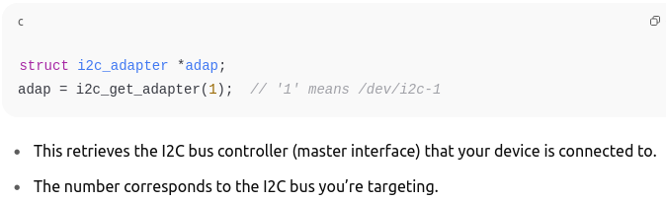

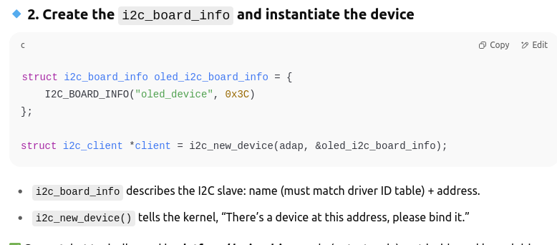

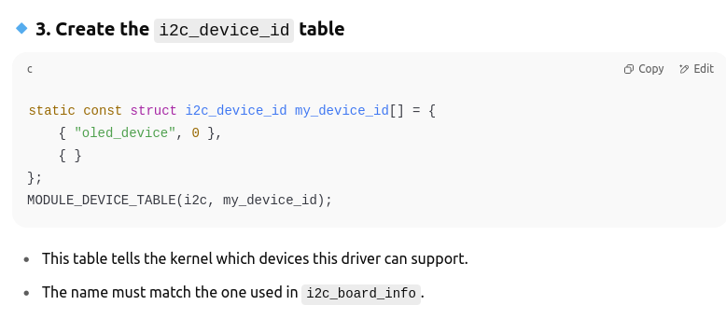
.

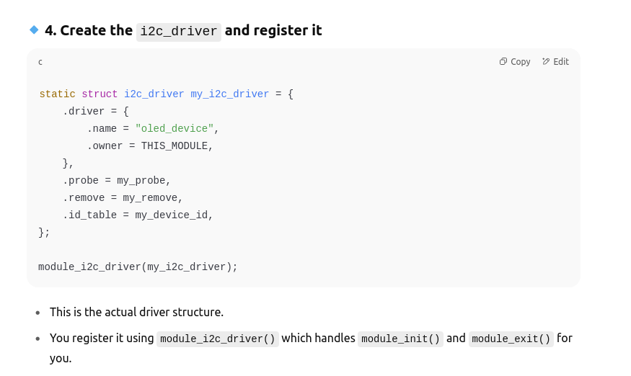

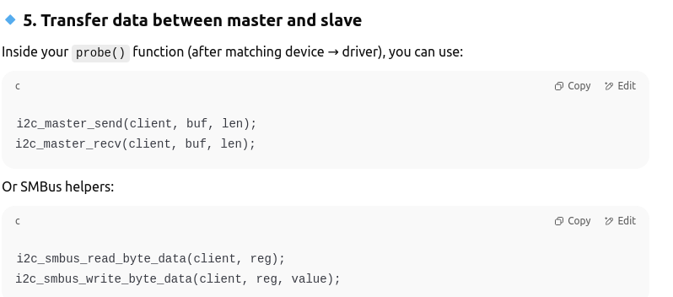

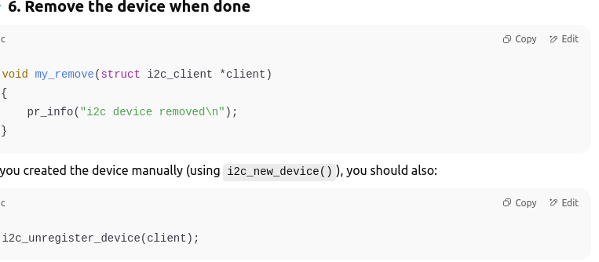
jdd

READ & WRITE COMMANDS

i2c_master_send()

Purpose:
Sends raw bytes from master to slave device.
Prototype:
int i2c_master_send(struct i2c_client *client, const char *buf, int count);
Example:
char buf[2] = {0x01, 0xAB}; // Write 0xAB to register 0x01
i2c_master_send(client, buf, 2);

🔹 i2c_master_recv
Purpose:
Reads raw bytes from the slave device.
Prototype:
int i2c_master_recv(struct i2c_client *client, char *buf, int count);
Example:
char val;
i2c_master_recv(client, &val, 1);

🔹 i2c_smbus_write_byte
Purpose:
Writes a single byte to the slave (without a register address).
Prototype:
int i2c_smbus_write_byte(struct i2c_client *client, u8 value);
Example:
i2c_smbus_write_byte(client, 0xAB);

🔹 i2c_smbus_read_byte
Purpose:
Reads a single byte from the slave (no register involved).
Prototype:
Int i2c_smbus_read_byte(struct i2c_client *client);
Example:
int data = i2c_smbus_read_byte(client);

🔹 i2c_smbus_write_byte_data
Purpose:
Writes a byte to a specific register of the slave.
Prototype:
int i2c_smbus_write_byte_data(struct i2c_client *client, u8 command, u8 value);
Example:
i2c_smbus_write_byte_data(client, 0x01, 0xAB); // Write 0xAB to register 0x01

i2c_smbus_read_byte_data
Purpose:
Reads a byte from a specific register.
Prototype:
int i2c_smbus_read_byte_data(struct i2c_client *client, u8 command);
Example:
int val = i2c_smbus_read_byte_data(client, 0x01);

🔹 i2c_smbus_write_word_data
Purpose:
Writes a 16-bit word to a specific register.
Prototype:
int i2c_smbus_write_word_data(struct i2c_client *client, u8 command, u16 value);
Example:
i2c_smbus_write_word_data(client, 0x02, 0x1234);

🔹 i2c_smbus_read_word_data
Purpose
Reads a 16-bit word from a specific register.
Prototype:
int i2c_smbus_read_word_data(struct i2c_client *client, u8 command);
Example:
int word = i2c_smbus_read_word_data(client, 0x02);

🔹 i2c_smbus_write_i2c_block_data
Purpose:
Writes a block of data to a register.
Prototype:
int i2c_smbus_write_i2c_block_data(struct i2c_client *client, u8 command, u8 length, const u8 *values);
Example:
u8 data[3] = {0xAA, 0xBB, 0xCC};
i2c_smbus_write_i2c_block_data(client, 0x10, 3, data);

🔹 i2c_smbus_read_i2c_block_data
Purpose:
Reads a block of data from a register.
Prototype:
int i2c_smbus_read_i2c_block_data(struct i2c_client *client, u8 command, u8 length, u8 *values);

u8 buf[10];
i2c_smbus_read_i2c_block_data(client, 0x10, 10, buf);

- STRUCT I2C_CILENT

struct i2c_client {
unsigned short flags; /* I2C_CLIENT_TEN for 10-bit addr */
unsigned short addr; /* chip address - NOTE: 7-bit */
char name[I2C_NAME_SIZE]; /* name of the device */
struct i2c_adapter *adapter;/* the adapter we sit on */
struct device dev; /* the device structure */
int irq; /* irq number for device */
struct list_head detected; /* used with legacy drivers */
};

- struct i2c_device_id
struct i2c_device_id {
char name[I2C_NAME_SIZE];
kernel_ulong_t driver_data; /* Data private to the driver */
};

