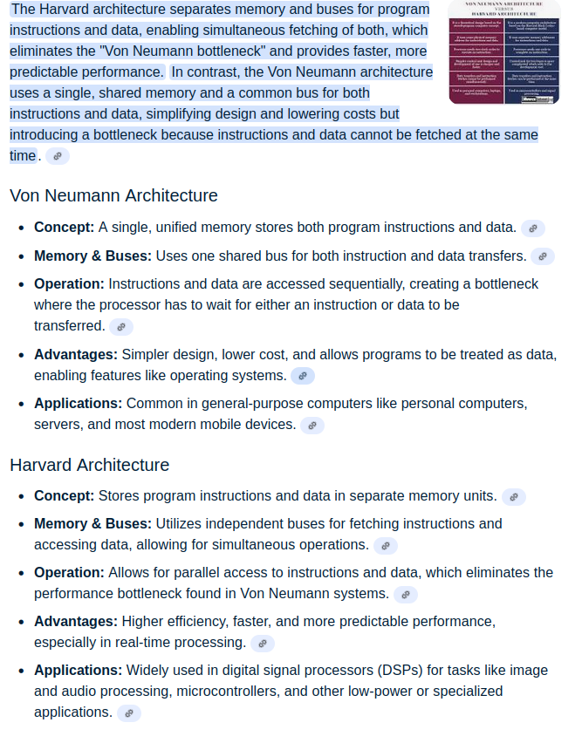
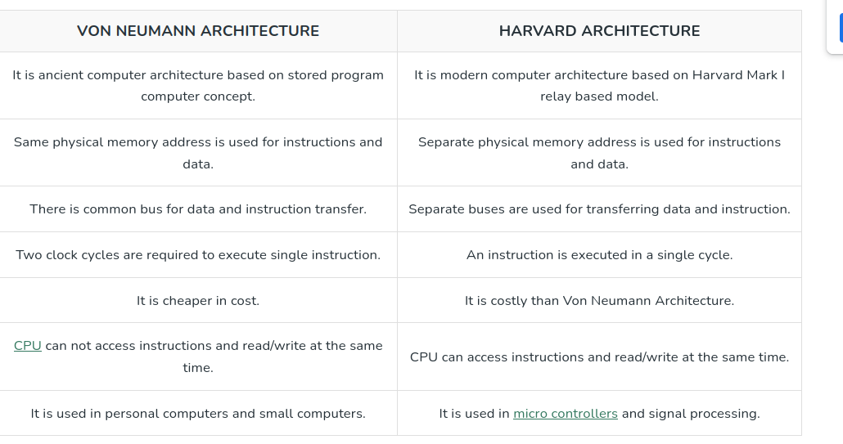

1. CISC (Complex Instruction Set Computer)
- Definition: Processor architecture with a large set of complex instructions, some of which can perform multi-step operations in a single instruction.
- Philosophy: Hardware does more, software does less.
- Features:
  - Many instructions (hundreds).
  - Instructions can be of variable length (e.g., 16, 32, 64 bits).
  - One instruction may take multiple cycles.
  - More addressing modes (ways to access memory).
  - Examples: x86, Intel 8086, VAX, Motorola 68000.
- Advantages:
  - Easier to write assembly code (since one instruction can do a lot).
  - Smaller program size (fewer lines of code).
- Disadvantages:
  - Complex hardware → higher power consumption.
  - Harder to optimize pipelines.
  - Generally slower clock speeds compared to RISC.

2. RISC (Reduced Instruction Set Computer)
- Definition: Processor architecture with a small, simple set of instructions, designed to execute very fast.
- Philosophy: Software does more, hardware does less.
- Features:
  - Few instructions (typically less than 100).
  - Fixed instruction length (often 32 bits).
  - Each instruction executes in a single clock cycle (ideally).
  - Load/store architecture (only load/store instructions access memory; others operate on registers).
  - Examples: ARM, MIPS, SPARC, RISC-V, PowerPC.
- Advantages:
  - Simple hardware, easier pipelining, and parallelism.
  - Higher performance per watt (energy-efficient).
  - Faster execution due to uniform instruction length.
- Disadvantages:
  - Programs may need more instructions (larger code size).
  - More dependency on compiler optimization.

3. Key Differences
Feature | CISC | RISC
Instruction Set | Large & complex | Small & simple
Instruction Length | Variable | Fixed
Execution Cycles | Multiple cycles per instruction | Mostly single cycle
Memory Access | Allowed in many instructions | Only Load/Store instructions
Hardware Complexity | High | Low
Code Size | Small | Large
Performance | Slower (per cycle) | Faster (per cycle)
Examples | x86, Intel, AMD | ARM, MIPS, RISC-V

1. ARM Overview
- ARM stands for Advanced RISC Machine.
- It is a RISC (Reduced Instruction Set Computer) architecture, meaning:
  - Small, simple, fixed-length instructions.
  - Most instructions execute in 1 clock cycle → faster.
  - Emphasis on load/store architecture (operations mostly on registers; memory access only via load/store).
- Popular in microcontrollers, smartphones, embedded systems, etc.
- Variants include ARM7, ARM9, Cortex-M, Cortex-A, Cortex-R.

2. Key Features of ARM Architecture
- 32-bit RISC architecture (some variants also support 16-bit “Thumb” instructions).
- Harvard-style pipeline:
  - Separate instruction and data buses → faster execution.
- Registers:
  - 16 general-purpose registers (R0–R15 in ARM7)
  - R15 = Program Counter (PC)
  - R14 = Link Register (LR)
  - R13 = Stack Pointer (SP)
- Modes of operation:
  - ARM supports multiple processor modes:
    - User Mode → normal application execution
    - FIQ, IRQ → fast and normal interrupts
    - Supervisor, Abort, Undefined → OS or exception handling
- Instruction sets:
  - ARM (32-bit) → full instructions
  - Thumb (16-bit) → smaller code, good for memory-constrained systems

3. Memory Architecture
- Load/Store architecture: CPU operates on registers, memory accessed only via LDR/STR instructions.
- Supports linear 32-bit address space.
- Can be connected to external memory (SRAM, Flash) and peripherals (GPIO, UART, ADC, etc.) via memory-mapped I/O.

4. Pipeline
- ARM7 (like in LPC2129) uses 3-stage pipeline:
  - Fetch – fetch instruction from memory
  - Decode – decode instruction
  - Execute – perform operation
- Pipelines improve instruction throughput.

5. Interrupts
- ARM7 has two main types:
  - IRQ (Interrupt Request) → normal interrupts
  - FIQ (Fast Interrupt Request) → high-priority, faster service

ARM Architecture Summary Table
Feature | Description
Core type | RISC 32-bit
Pipeline | 3-stage (Fetch → Decode → Execute)
Registers | 16 (R0-R15)
Modes | User, FIQ, IRQ, Supervisor, Abort, Undefined, System
Instruction sets | ARM (32-bit), Thumb (16-bit)
Memory architecture | Load/store, linear address space
Interrupts | IRQ, FIQ
"ARM architecture is preferred in embedded systems for several reasons. First, it is a RISC-based processor, which means it has a simple instruction set that allows most instructions to execute in a single clock cycle. This makes ARM highly efficient and low-power — ideal for battery-operated devices like smartphones, IoT gadgets, or wearables.
Second, ARM cores are scalable: the same architecture is used in tiny microcontrollers like LPC2129 as well as in high-performance processors for smartphones. It also has strong ecosystem support, with multiple RTOS, compilers, and development tools, which makes development faster and easier.

1. ARM Instruction Set
- Definition:
The ARM instruction set is the standard set of instructions that the ARM processor executes. It is 32-bit, meaning each instruction is 32 bits wide.
- Characteristics:
  - 32-bit instructions → more powerful, can handle complex operations in a single instruction.
  - Supports conditional execution for almost all instructions (like ADDNE, MOVEQ).
  - Optimized for performance in general-purpose applications.
  - Instructions are typically word-aligned, i.e., must start at addresses divisible by 4.
- Example Instruction:
ADD R0, R1, R2 ; R0 = R1 + R2

. Thumb Instruction Set
- Definition:
The Thumb instruction set is a compressed 16-bit version of the ARM instruction set. It was introduced to save memory and improve code density.
- Characteristics:
  - 16-bit instructions → smaller, which reduces memory usage.
  - Not all ARM instructions are available in Thumb mode, but most common operations are.
  - Better code density → useful for embedded systems with limited memory.
  - Can be switched dynamically between ARM mode (32-bit) and Thumb mode (16-bit) using a bit in the program counter (PC).
ADD R0, R1, R2 ; Still adds R1 + R2, but encoded in 16 bits

3. ARM Versions
- ARMv4/v5 → Early mobile/embedded processors.
- ARMv6 → First used in Raspberry Pi 1.
- ARMv7 → Introduced Cortex-A (applications), Cortex-R (real-time), and Cortex-M (microcontrollers).
- ARMv8 → Added 64-bit support (AArch64) while keeping backward compatibility with 32-bit (AArch32).
- ARMv9 → Latest, adds enhanced security, AI/ML instructions, and better performance.

4. ARM Processor Families
- Cortex-A → High-performance application processors (smartphones, tablets).
- Cortex-R → Real-time processors (automotive, robotics, safety systems).
- Cortex-M → Microcontrollers (IoT, wearables, consumer electronics).
- Neoverse → Data center and cloud CPUs.

5. ARM Instruction Set
- ARM (32-bit instructions) – standard RISC instructions.
- Thumb (16-bit compressed) – reduces memory usage.
- Thumb-2 (mixed 16/32-bit) – balance between performance & size.
- AArch64 (64-bit) – supports 64-bit registers and addressing.

6. Why ARM is Popular
- Low Power Consumption (phones, IoT).
- High Performance due to pipelining and RISC efficiency.
- Scalability: From small microcontrollers (Cortex-M0) to powerful CPUs (Cortex-A78, Neoverse).
- Large Ecosystem: Used in Raspberry Pi, smartphones (Qualcomm Snapdragon, Apple M1/M2/M3 chips are ARM-based), and embedded systems.

Features of ARM7 Architecture

1. RISC Architecture
- ARM7 is based on RISC (Reduced Instruction Set Computer) principles.
- Fixed-length (32-bit) instructions → simple and fast decoding.
- Load–store architecture: only load/store instructions access memory, ALU works with registers.

2. Instruction Sets
- ARM instruction set (32-bit) → powerful, full operations.
- Thumb instruction set (16-bit) → compact code size, useful for memory-constrained embedded systems.
- Switch between ARM and Thumb states at runtime (BX instruction).

3. Pipeline
- Uses a 3-stage pipeline:
  - Fetch → Decode → Execute
- Improves throughput by overlapping instruction execution.

4. Registers
- Total 37 registers (but only 16 visible at a time).
- General-purpose registers: R0–R12.
- Special registers:
  - R13 → Stack Pointer (SP)
  - R14 → Link Register (LR)
  - R15 → Program Counter (PC)
- CPSR (Current Program Status Register) → condition flags (N, Z, C, V), interrupt disable bits, mode bits.
- SPSR (Saved Program Status Registers) for exception handling.

5. Operating Modes
ARM7 supports 7 processor modes:
- User (normal program execution).
- FIQ (Fast Interrupt).
- IRQ (Normal Interrupt).
- Supervisor (SVC) (OS calls).
- Abort (memory faults).
- Undefined (invalid instruction trap).
- System (privileged mode for OS).
👉 Different modes have banked registers for faster context switching.

6. Conditional Execution
- Almost every ARM instruction can be conditionally executed using condition codes (EQ, NE, GT, LT, etc.).
- Reduces need for branching → improves pipeline efficiency.

7. Memory Interface
- 32-bit address bus → can access up to 4 GB of memory.
- 32-bit data bus for word transfers.
- Supports byte (8-bit), halfword (16-bit), and word (32-bit) data sizes.

8. Exception Handling
- Supports interrupts (IRQ, FIQ) and exceptions.
- Uses vector table (reset, undefined, SWI, prefetch abort, data abort, IRQ, FIQ).

9. Low Power Features
- ARM7 cores are widely used in embedded/portable systems due to low power consumption.
- Idle and power-down modes available.

10. Coprocessor Interface
- Supports external coprocessors (like FPU, system control coprocessor).
- Common one: CP15 (system control, cache/MMU in advanced ARM7 versions).

11. Debug Support
- JTAG interface for debugging and boundary scan.

✅ Summary (Interview-style answer)
ARM7 architecture is a 32-bit RISC-based architecture with:
- 3-stage pipeline (fetch, decode, execute)
- Dual instruction sets (ARM 32-bit and Thumb 16-bit)
- 37 registers (with banked registers for modes)
- 7 processor modes (User + 6 privileged)
- Conditional execution of instructions
- 4 GB memory address space
- Low power design for embedded applications
- Support for interrupts, exceptions, and coprocessors

