In System A, I combined a keyboard driver and a user-space socket client. The user program does nothing until it gets a signal from the driver. The driver sends that signal only when a specific key is pressed. This way, kernel events directly control user-space actions.”

Your Case: read() + waitqueue
- User process calls read()
  - In driver my_read() → sees no event available (flag == 0).
  - Kernel puts process into TASK_INTERRUPTIBLE state and adds it to the waitqueue.
  - Scheduler removes process from run queue → CPU can schedule others.
- Keyboard interrupt occurs
  - IRQ handler executes inside driver.
  - It sets flag = 1 and calls wake_up_interruptible(&wq).
- Waitqueue wakeup
  - Kernel marks the sleeping process as TASK_RUNNING (not directly “running on CPU”, but eligible).
  - The process is put back into the run queue.
- Scheduler picks it
  - At the next scheduling decision, the CPU looks at the run queue.
  - If the woken-up process has priority and CPU is available → it is scheduled, and read() returns to user space with data.

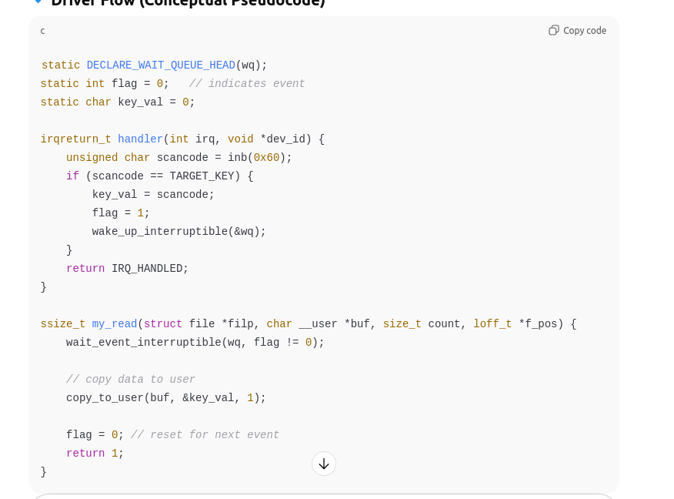
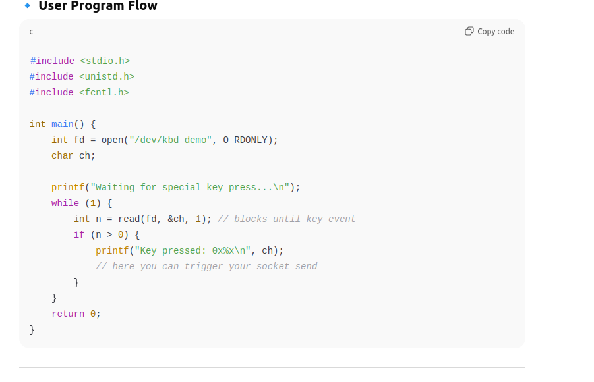
\

“If I don’t use waitqueues, then my driver’s read() would either block forever (bad design) or return immediately with an error, forcing the user process to poll. Polling wastes CPU cycles and power, because the process keeps waking and retrying. Waitqueues are the standard way in Linux to efficiently put the process to sleep and wake it only when the event occurs.”

“Besides waitqueues, Linux offers signals, poll/select/epoll, netlink sockets, and even sysfs/procfs entries for event notification.
- Waitqueues are the simplest and most common for blocking I/O.
- Signals are lightweight but less reliable for multiple events.
- Netlink is preferred for structured kernel–user messaging.
- poll/select/epoll are ideal when a user program monitors multiple file descriptors.
Choice depends on the nature of the event and scalability requirements.”
When mixing custom UART and default UART, I ensure both sides use the same baud rate, parity, stop bits. Since UART is byte-stream oriented, I also handle endianness and framing by transmitting the random number as an ASCII string with a newline. On the driver side, I check FIFO readiness before writing, and on the Pi side I read until delimiter. Flow control is disabled unless I wire RTS/CTS. Finally, I test with minicom first to validate transmission before running my programs.”

// system_b_server_uart.c
#include <stdio.h>
#include <stdlib.h>
#include <unistd.h>
#include <string.h>
#include <fcntl.h>
#include <termios.h>
#include <time.h>
#include <arpa/inet.h>

#define PORT 9000
#define UART_DEV "/dev/ttyS0"

int main() {
// --- Create Socket Server ---
int server_fd, client_fd;
struct sockaddr_in address;
int addrlen = sizeof(address);

server_fd = socket(AF_INET, SOCK_STREAM, 0);
if (server_fd < 0) { perror("socket"); exit(EXIT_FAILURE); }

address.sin_family = AF_INET;
address.sin_addr.s_addr = INADDR_ANY;
address.sin_port = htons(PORT);

if (bind(server_fd, (struct sockaddr*)&address, sizeof(address)) < 0) {
perror("bind"); exit(EXIT_FAILURE);
}

if (listen(server_fd, 1) < 0) { perror("listen"); exit(EXIT_FAILURE); }

printf("System B: Waiting for connection...\n");
client_fd = accept(server_fd, (struct sockaddr*)&address, (socklen_t*)&addrlen);
if (client_fd < 0) { perror("accept"); exit(EXIT_FAILURE); }

char buf[32];
int n = recv(client_fd, buf, sizeof(buf)-1, 0);
if (n < 0) { perror("recv"); exit(EXIT_FAILURE); }
buf[n] = '\0';
printf("Received command: %s\n", buf);

close(client_fd);
close(server_fd);

// --- Play audio if command matches ---
if (strncmp(buf, "CMD:PLAY", 8) == 0) {
system("aplay beep.wav &"); // demo audio

// --- Open UART ---
int fd = open(UART_DEV, O_RDWR | O_NOCTTY);
if(fd < 0) { perror("open UART"); return 1; }

struct termios tty;
tcgetattr(fd, &tty);
cfsetospeed(&tty, B115200);
cfsetispeed(&tty, B115200);
tty.c_cflag = (tty.c_cflag & ~CSIZE) | CS8;
tty.c_cflag |= (CLOCAL | CREAD);
tty.c_cflag &= ~(PARENB | PARODD | CSTOPB | CRTSCTS);
tty.c_lflag = 0;
tty.c_oflag = 0;
tty.c_cc[VMIN] = 1;
tty.c_cc[VTIME] = 0;
tcsetattr(fd, TCSANOW, &tty);

// --- Generate random number ---
srand(time(NULL));
int rand_num = rand() % 100;
printf("Generated number: %d\n", rand_num);

// --- Send number over UART ---
char msg[16];
snprintf(msg, sizeof(msg), "%d\n", rand_num);
write(fd, msg, strlen(msg));
close(fd);
}

return 0;
}

rasp:
// rpi_custom_uart.c
#include <linux/module.h>
#include <linux/init.h>
#include <linux/fs.h>
#include <linux/uaccess.h>
#include <linux/wait.h>
#include <linux/sched.h>
#include <linux/interrupt.h>
#include <linux/io.h>

#define DEVICE_NAME "custom_uart"
#define UART0_BASE 0x3F201000 // PL011 UART base on Pi 3/4
#define UART0_DR 0x00
#define UART0_FR 0x18
#define UART0_IBRD 0x24
#define UART0_FBRD 0x28
#define UART0_LCRH 0x2C
#define UART0_CR 0x30
#define UART0_IMSC 0x38

static void __iomem *uart_base;
static int major;
static DECLARE_WAIT_QUEUE_HEAD(uart_waitqueue);
static char rx_buf[32];
static int data_ready = 0;

// IRQ handler for UART RX
static irqreturn_t uart_irq_handler(int irq, void *dev_id) {
static int idx = 0;
while (!(readl(uart_base + UART0_FR) & (1 << 4))) { // RXFE=0
char c = readl(uart_base + UART0_DR) & 0xFF;
rx_buf[idx++] = c;
if(c == '\n') {
rx_buf[idx] = 0;
data_ready = 1;
wake_up_interruptible(&uart_waitqueue);
idx = 0;
}
}
return IRQ_HANDLED;
}

// Read function for user-space
static ssize_t uart_read(struct file *file, char __user *buf, size_t count, loff_t *ppos) {
if(wait_event_interruptible(uart_waitqueue, data_ready))
return -ERESTARTSYS;
copy_to_user(buf, rx_buf, strlen(rx_buf));
data_ready = 0;
return strlen(rx_buf);
}

static struct file_operations fops = {
.owner = THIS_MODULE,
.read = uart_read,
};

static int __init uart_init(void) {
uart_base = ioremap(UART0_BASE, 0x1000);
major = register_chrdev(0, DEVICE_NAME, &fops);

// Initialize UART: 115200, 8N1, FIFO
writel(0, uart_base + UART0_CR); // Disable
writel((1 << 4) | (1 << 5), uart_base + UART0_LCRH); // 8-bit + FIFO
writel(1, uart_base + UART0_CR); // Enable UART
writel(1 << 4, uart_base + UART0_IMSC); // Enable RX interrupt

request_irq(57, uart_irq_handler, 0, DEVICE_NAME, NULL); // IRQ may vary
return 0;
}

static void __exit uart_exit(void) {
free_irq(57, NULL);
unregister_chrdev(major, DEVICE_NAME);
iounmap(uart_base);
}

module_init(uart_init);
module_exit(uart_exit);
MODULE_LICENSE("GPL");

#include <stdio.h>
#include <stdlib.h>
#include <fcntl.h>
#include <unistd.h>
#include <linux/i2c-dev.h>
#include <sys/ioctl.h>
#include <string.h>
#include <stdint.h>

#define OLED_ADDR 0x3C
#define I2C_BUS "/dev/i2c-1"

int oled_fd;

// Send a command to SSD1306
void oled_write_cmd(uint8_t cmd) {
uint8_t buf[2] = {0x00, cmd};
write(oled_fd, buf, 2);
}

// Send data to SSD1306
void oled_write_data(uint8_t *data, size_t len) {
uint8_t buf[len+1];
buf[0] = 0x40;
memcpy(&buf[1], data, len);
write(oled_fd, buf, len+1);
}

// Initialize SSD1306 OLED
void oled_init() {
oled_fd = open(I2C_BUS, O_RDWR);
if(oled_fd < 0) { perror("open i2c"); exit(1); }
ioctl(oled_fd, I2C_SLAVE, OLED_ADDR);

uint8_t init_seq[] = {
0xAE, // Display off
0x20, 0x00, // Horizontal addressing
0xB0, // Page 0
0xC8, // COM scan direction
0x00, 0x10, // Column addr
0x40, // Set start line
0x81, 0xFF, // Contrast
0xA1, // Segment remap
0xA6, // Normal display
0xA8, 0x3F, // Multiplex ratio
0xD3, 0x00, // Display offset
0xD5, 0xF0, // Display clock divide
0xD9, 0x22, // Precharge
0xDA, 0x12, // COM pins
0xDB, 0x20, // VCOMH
0x8D, 0x14, // Charge pump
0xAF // Display ON
};
for(int i=0; i<sizeof(init_seq); i++)
oled_write_cmd(init_seq[i]);
}

// Simple function to clear display
void oled_clear() {
uint8_t zero[128];
memset(zero, 0x00, 128);
for(int page=0; page<8; page++) {
oled_write_cmd(0xB0 + page); // Set page
oled_write_cmd(0x00); // Column low
oled_write_cmd(0x10); // Column high
oled_write_data(zero, 128);
}
}

// Display a single-line text (basic, only ASCII 32-127)
void oled_display_text(const char *text) {
// For simplicity, using 5x8 font
extern uint8_t font5x8[96][5]; // Load or define a 5x8 font array
uint8_t buf[128];
memset(buf, 0, 128);

int i=0;
while(text[i] && i<16) { // max 16 chars per line
memcpy(&buf[i*6], font5x8[text[i]-32], 5);
buf[i*6+5] = 0x00; // space between chars
i++;
}
oled_write_cmd(0xB0); // Page 0
oled_write_cmd(0x00);
oled_write_cmd(0x10);
oled_write_data(buf, 128);
}

int main() {
// --- Read number from custom UART ---
int uart_fd = open("/dev/custom_uart", O_RDONLY);
if(uart_fd < 0) { perror("open UART"); return 1; }
char buf[32];
read(uart_fd, buf, sizeof(buf));
close(uart_fd);

int random_num;
sscanf(buf, "%d", &random_num);

// --- Initialize OLED ---
oled_init();
oled_clear();
oled_display_text("Guess number:");

// --- Ask user ---
int guess;
printf("Enter your guess: ");
scanf("%d", &guess);

// --- Display result ---
char msg[32];
if(guess == random_num)
snprintf(msg, sizeof(msg), "Correct!");
else
snprintf(msg, sizeof(msg), "Wrong! Num:%d", random_num);

oled_clear();
oled_display_text(msg);

close(oled_fd);
return 0;
}

Future Extensions
- Add multi-user guessing game: multiple RPi devices receiving numbers.
- Include networked scoring system displayed on OLED.
- Use PWM or LED indicators for correct/wrong guesses.
- Extend UART driver to support bidirectional communication.
- Integrate temperature or sensor data from RPi as additional game input.
- Implement web interface on System B to control the game remotely.

Sample Explanation for Interview
1. Introduction:
"My project is a multi-system interactive number guessing game that demonstrates Linux system programming, kernel driver development, UART communication, sockets, and I²C display integration. It involves three main systems: System A, System B, and a Raspberry Pi."

2. System Overview:
"System A is a user client that reads keyboard input. When the user presses a specific key, it sends a command over a TCP socket to System B. System B is a socket server running on another x86 system. Upon receiving the command, it plays an audio beep, generates a random number, and sends it to the Raspberry Pi using UART communication."
"The Raspberry Pi runs a custom UART driver that receives the number and signals a user-space program. The program then prompts the user to guess the number and displays the result (correct or wrong) on an I²C OLED display."

3. Technical Highlights:
- "Socket programming: We implemented a client-server model using TCP sockets to send commands between System A and System B."
- "Default UART on System B: We used Linux termios APIs to configure the UART and send data to the Raspberry Pi."
- "Custom UART driver on Raspberry Pi: Accessed real PL011 UART registers, enabled RX interrupts, and used a waitqueue to wake the user program efficiently."
- "I²C OLED: We used real SSD1306 commands over /dev/i2c-1 to display the guessing prompt and results."
- "Waitqueue mechanism: Ensures the user program waits without busy-waiting until the random number is received."

4. Challenges Faced and Solutions:
- "Interrupt handling in custom UART driver: We ensured proper FIFO handling and avoided data loss by waking user-space with waitqueues."
- "Synchronization between UART and user program: Waitqueues were used to prevent busy waiting and CPU wastage."
- "Reliable inter-system communication: We handled socket and UART communication carefully to avoid race conditions."
- "Displaying on real OLED: Mapping ASCII characters to the 5x8 font and sending SSD1306 commands over I²C was challenging, which we solved using a proper initialization sequence."

5. Tools and Technologies Used:
"C programming for kernel and user-space, Linux kernel APIs, termios for UART, socket APIs, ioctl, I²C APIs, x86 PCs and Raspberry Pi hardware, I²C OLED (SSD1306), audio playback using aplay."

6. Demonstration Flow:
"In a demo, I press a key on System A → System B receives it, plays a beep and generates a random number → the number is sent via UART → Raspberry Pi receives it via custom UART → the user program asks for the guess → result is displayed on OLED."

7. Future Extensions:
"The project can be extended to a multi-user game, include sensor-based inputs, integrate scoring over network, add LED indicators, or create a web interface for remote gameplay."

Tips While Explaining
- Start with the big picture (three systems and their roles).
- Use a diagram to show data flow: System A → B → Pi → OLED.
- Highlight technical skills you used (kernel driver, UART, sockets, I²C).
- Mention challenges and your solutions to show problem-solving.
- Finish with future scope to show forward thinking.

UARTs on BCM2711
The BCM2711 provides multiple UARTs, but main ones are:
UART | Type | Notes
PL011 UART0 | Full-featured, 16-byte FIFO, interrupt-capable | Typically used for serial console or reliable communication
Mini UART | Simplified UART, tied to core clock | Lower priority, no FIFO, often used for Bluetooth on Pi 4 by default
UART1…3 | Exposed on GPIO / HAT via device tree | Optional, needs configuration in DT overlays

I²C Basics
I²C is a master-slave communication protocol:
- Master initiates communication (here, Raspberry Pi).
- Slave responds (here, OLED display).
- Every slave device on the I²C bus has a unique 7-bit address.
- Communication uses SDA (data) and SCL (clock) lines.

2️⃣ How Raspberry Pi “Knows” the OLED
- Slave Address:
  - The OLED (SSD1306) has a default I²C address, usually 0x3C or 0x3D.
  - This address is hardcoded in the OLED controller, or configurable via pins on the OLED board (like SA0).
- I²C Communication Flow:
  - Master sends START condition.
  - Master sends 7-bit slave address + R/W bit.
  - If the device matches the address, it responds with ACK.
  - Then the master sends commands or data.
Example (in your code):

