How are init and exit functions called automatically in Linux drivers?

1. The role of module_init() and module_exit() macros
- In every driver/module, you don’t call init and exit functions yourself.
- Instead, you write something like:

static int __init my_init(void)
{
printk(KERN_INFO "Driver loaded\n");
return 0;
}

static void __exit my_exit(void)
{
printk(KERN_INFO "Driver unloaded\n");
}

module_init(my_init);
module_exit(my_exit);
- Here, module_init() and module_exit() are macros defined in <linux/init.h>.

What do these macros actually do?
- module_init(my_init) → Places a pointer to my_init into a special kernel section (.initcall) used for initialization routines.
- module_exit(my_exit) → Places a pointer to my_exit into another section that the kernel looks at when unloading modules.
So, when:
- You load a module with insmod or modprobe → The kernel finds your function pointer in the .initcall section and calls your init function.
- You unload a module with rmmod → The kernel finds your function pointer in the .exit section and calls your exit function.

During Kernel Boot (for built-in drivers)
- If a driver is compiled into the kernel itself (not a module), then my_init is placed in the kernel’s global initcall table.
- During boot, the kernel goes through all initcalls and executes them → this is how built-in drivers initialize automatically.

4. During Module Load/Unload (for loadable modules)
- When you run insmod mydriver.ko:
  - Kernel loads the module into memory.
  - It looks at the module_init section → finds your init function → calls it automatically.
- When you run rmmod mydriver:
  - Kernel looks at the module_exit section → calls your exit function → then unloads the module from memory.

✅ Interview one-liner answer:
Init and exit functions are called automatically because the module_init() and module_exit() macros store their addresses in special kernel sections (.initcall, .exit). The kernel execution framework calls these functions when the module is loaded or unloaded.

Common Header Files in Linux Device Drivers

1. <linux/module.h>
- Why?
Contains macros & definitions for writing kernel modules.
- Provides: MODULE_LICENSE, MODULE_AUTHOR, module_init, module_exit, THIS_MODULE, etc.

2. <linux/init.h>
- Why?
Provides macros like __init, __exit, module_init(), module_exit().
- Used to mark functions/data as initialization-only or cleanup-only.

3. <linux/kernel.h>
- Why?
Contains basic kernel functions and macros.
- Provides: printk(), min(), max(), error codes (-EINVAL, -ENOMEM), etc.

4. <linux/fs.h>
- Why?
Required for file operations in character/block drivers.
- Provides: struct file_operations, struct inode, struct file, function prototypes for open, read, write, ioctl.

5. <linux/cdev.h>
- Why?
Provides APIs for character device registration.
- Provides: struct cdev, cdev_init(), cdev_add(), cdev_del().

6. <linux/uaccess.h>
- Why?
Provides functions to safely transfer data between user space and kernel space.
- Provides: copy_to_user(), copy_from_user(), get_user(), put_user().

7. <linux/slab.h>
- Why?
For dynamic memory allocation in the kernel.
- Provides: kmalloc(), kfree(), vmalloc(), vfree().

8. <linux/device.h>
- Why?
Contains definitions for device model support.
- Provides: class_create(), device_create(), device_destroy().

9. <linux/kdev_t.h>
- Why?
For handling device numbers (major, minor).
- Provides: MKDEV(), MAJOR(), MINOR().

10. <linux/errno.h>
- Why?
Contains standard error codes used by drivers (-EBUSY, -EFAULT, -EINVAL, etc.).

11. <linux/interrupt.h>
- Why?
For interrupt handling.
- Provides: request_irq(), free_irq(), irqreturn_t, tasklets, softirqs.

12. <linux/workqueue.h>
- Why?
For deferred work processing.
- Provides: workqueues, schedule_work(), delayed work.

13. <linux/mutex.h> / <linux/spinlock.h> / <linux/semaphore.h>
- Why?
For concurrency control ad synchronization.
- Provides: mutex_init(), mutex_lock(), spin_lock(), down(), up().

14. <linux/delay.h>
- Why?
Provides delay functions.
- Provides: msleep(), udelay(), mdelay().

Kernel Modules Basics
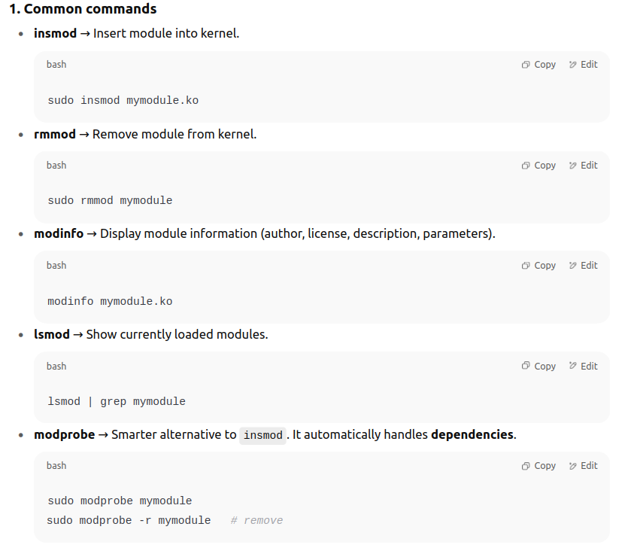
A Linux Kernel Module (LKM) is a piece of code that can be loaded/unloaded into the kernel at runtime without rebooting the system.

What is printk?
- printk is the kernel equivalent of printf in user space.
- Since the kernel does not have access to the standard C library (libc), functions like printf are unavailable.
- So, the kernel provides printk to print messages to the kernel log buffer.
- printk is the kernel’s way of printing messages.
It supports log levels, stores output in the kernel log buffer, and is mainly used for debugging and reporting status inside kernel space
These logs can be read using tools like:
- dmesg
- /var/log/kern.log (on some distros)

Log Levels
- Each printk message can be tagged with a priority level to indicate its importance.
- They are defined in linux/kernel.h as macros:
Macro | Description
KERN_EMERG | Emergency (system is unusable, e.g., panic)
KERN_ALERT | Action must be taken immediately
KERN_CRIT | Critical conditions (e.g., serious errors)
KERN_ERR | Error conditions
KERN_WARNING | Warning conditions
KERN_NOTICE | Normal but significant messages
KERN_INFO | Informational messages
KERN_DEBUG | Debug-level messages

Where do these messages go?
- Stored in the kernel ring buffer.
- You can see them by:
  - Running dmesg
  - Checking /proc/kmsg
  - Syslog/rsyslog/journald (depending on distro)

Newer Alternative → pr_* helpers
Instead of always writing printk(KERN_INFO ...), kernel provides wrappers:
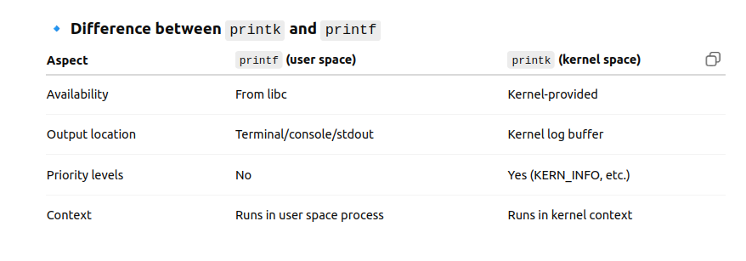
hfhf

Message goes into the kernel’s log buffer (ring buffer)
  - Kernel maintains a circular (ring) buffer in memory.
  - Every new printk entry is appended at the "end".
  - If the buffer becomes full, oldest messages are overwritten (FIFO style).
  - Each log entry includes:
    - Message text
    - Timestamp
    - Log level (INFO, ERR, etc.)
    - CPU ID (optional, SMP systems)
This buffer lives in kernel space and is not directly visible to user processes.
- User-space tools fetch the buffer
  - /proc/kmsg: Exposes the log buffer as a file.
  - dmesg: Reads from the ring buffer through the kernel API (syslog() system call, not to be confused with syslog daemon).
  - Logging daemons (like rsyslog, systemd-journald) also read from /proc/kmsg and store logs in files like /var/log/kern.log.

What is dmesg?
- dmesg = “display message”
- It’s a user-space command-line tool that shows the contents of the kernel ring buffer, which stores messages generated by the kernel (via printk).

🔹 Purpose of dmesg
- To view kernel messages such as:
  - Boot-time messages (hardware detection, driver loading)
  - Device driver logs (printk)
  - Kernel warnings and errors
  - Interrupt or hardware-related events
It is mainly used for debugging and troubleshooting hardware or drivers.

🔹 Where does dmesg get its messages from?
- The kernel stores logs in a circular ring buffer in memory.
- dmesg fetches these logs using:
  - syslog() system call (not the same as syslog daemon)
  - or by reading from /proc/kmsg
So, dmesg is just a viewer for kernel messages.

How dmesg works internally
- dmesg calls the syslog() system call with SYSLOG_ACTION_READ_ALL or SYSLOG_ACTION_READ.
This copies the kernel’s log buffer into user space.
int syslog(int type, char *buf, int len);
- type = what to do (clear buffer, read buffer, etc.)
- buf = user-space buffer to store logs
- len = size of buffer
- syslog() fetches data from the ring buffer maintained in kernel (printk.c inside kernel source).
- dmesg then prints this data on your terminal.

. /proc/kmsg
- What it is:
A pseudo-file in the /proc filesystem that directly exposes the kernel’s ring buffer.
- Source of logs:
Kernel itself (same as dmesg).
- Content:
Raw kernel log entries, including priority levels and sequence numbers.
- How it’s used:
  - Read by logging daemons like rsyslog, klogd, or systemd-journald.
  - Example:

3. journalctl -k
- What it is:
A systemd utility to query logs stored by systemd-journald.
- Source of logs:
journald daemon reads from /proc/kmsg (or /dev/kmsg in newer systems) and writes them to its persistent storage in /var/log/journal/.
- Content:
Kernel messages, but with full timestamps, user-space context, and preserved across reboots.
- Example:

What are Kernel Log Levels?
- When you use printk (or pr_info, pr_err, etc.) inside the Linux kernel, each message is tagged with a priority level.
- This log level tells the kernel (and logging tools) how important or severe the message is.
- Based on this level:
  - The kernel decides whether to print it to the console immediately.
  - Logging daemons (rsyslog, journald) can filter, store, or forward the message.

Standard Log Levels
Defined in include/linux/kern_levels.h:
Level No. | Macro | Description
0 | KERN_EMERG | Emergency: System is unusable (e.g., kernel panic)
1 | KERN_ALERT | Alert: Action must be taken immediately
2 | KERN_CRIT | Critical: Serious conditions (e.g., hardware failure)
3 | KERN_ERR | Error: Recoverable errors
4 | KERN_WARNING | Warning: Something is wrong but not fatal
5 | KERN_NOTICE | Normal but important condition
6 | KERN_INFO | Informational messages
7 | KERN_DEBUG | Debug-level messages (used for development/testing)

Console Log Level Control
- Not all log levels are printed to the console (screen).
- Which levels show depends on the console log level stored in /proc/sys/kernel/printk.
Check current value:
cat /proc/sys/kernel/printk
Example output:
4 4 1 7Meaning:
- Current console log level = 4 (warnings and above are shown on console)
- Default log level = 4
- Minimum log level = 1
- Boot-time default = 7
You can change it:
echo 7 | sudo tee /proc/sys/kernel/printk

1. What is cdev?
- cdev is a kernel structure (struct cdev) used to represent a character device inside the kernel space.
- It stores information like:
  - Which file_operations (open, read, write, ioctl, etc.) are linked to this device.
  - Which major/minor numbers it corresponds to.
  - Internal references for the VFS (Virtual File System) to call into your driver.
👉 Think of cdev as the kernel’s internal representation of your driver.

🔹 2. What is a Device Node?
- A device node is a special file in /dev created using mknod or udev.
- Example: /dev/mychardev
- It has:
  - File type → character (c) or block (b)
  - Major number → identifies the driver
  - Minor number → identifies a specific device handled by that driver
👉 Think of the device node as the user’s entry point into the driver (visible in user space).

🔹 3. Relationship between cdev and Device Node
- When you run open("/dev/mychardev"):
  - Kernel looks at the device node’s major/minor numbers.
  - Finds the matching cdev structure (registered by your driver).
  - Redirects system calls (open, read, write) to the file_operations in that cdev.
👉 So:
- cdev = Kernel object representing your driver.
- Device node = User-space handle that points to that cdev.
- cdev is the bridge.
- It connects device node (major/minor) with driver function
- Device Node (/dev/mydevice)
- │
- ▼
- Major/Minor numbers (from inode)
- │
- ▼
- cdev (struct cdev in kernel)
- │
- ▼
- file_operations (your driver functions)

🔹 Real-World Example: Keyboard
- Device Node: /dev/input/event0 (created by udev)
- Major/Minor: Example → 13:64
- cdev: Inside kernel, struct cdev links to keyboard driver’s file_operations (so read() on /dev/input/event0 goes to keyboard_read()).

1. struct file_operations
- This is a table of function pointers in your driver that implement the behavior of system calls.
- Example: when a process does open("/dev/mydev"), the kernel calls your driver’s my_open() function via the pointer stored in this table.
struct file_operations fops = {
.owner = THIS_MODULE,
.open = my_open,
.release = my_release,
.read = my_read,
.write = my_write,
};So, file_operations = How userspace system calls get mapped to driver functions.

2. cdev Structure
- struct cdev is the kernel’s internal representation of your character device.
- It links two worlds:
  - Major/minor numbers (unique identity of the device)
  - File operations (how the device actually behaves)
nternally: my_cdev.ops = &fops;
Now, the kernel knows:
"For this device (later identified by major/minor), use these file operation functions."

4. cdev_add()
- This step makes your device "live" in the kernel.
- You pass:
  - pointer to cdev
  - device number (dev_t, which encodes major + minor)
  - count (how many minors you want to register in one go)
dev_t dev;
alloc_chrdev_region(&dev, 0, 1, "mydev");
cdev_add(&my_cdev, dev, 1);
Internally:
- The kernel links dev_t (major:minor) → struct cdev in its internal device table.
- From now on, if someone does open("/dev/mydev"), the kernel looks up the major:minor, finds your cdev, and then calls the functions in fops.

5. cdev_del()
- Removes the cdev from the kernel device table (cleanup when unloading your module).
cdev_del(&my_cdev);

How it all connects:
- alloc_chrdev_region() → reserves major/minor numbers.
- cdev_init() → tells the kernel which functions (fops) belong to your driver.
- cdev_add() → binds those fops with the major/minor number(s).
- mknod /dev/mydev c <major> <minor> → creates a device node so userspace can access it.
- Userspace open("/dev/mydev") → kernel looks up major/minor → finds cdev → uses fops → jumps into your driver code.
register_chrdev() is an old helper function that registers a character device driver with the kernel.
👉 In simple terms:
- You give it a major number, a name, and a set of file operations (struct file_operations).
- The kernel then creates an internal cdev object, ties it to your fops, and marks that major number as belonging to your driver.
- It also adds an entry in /proc/devices so user space knows about it.
So yes, you are right — register_chrdev()’s purpose is just:
Reserve the major number
Register your driver’s file_operations with the kernel
Allow syscalls (open, read, write, etc.) on that major number to reach your driver

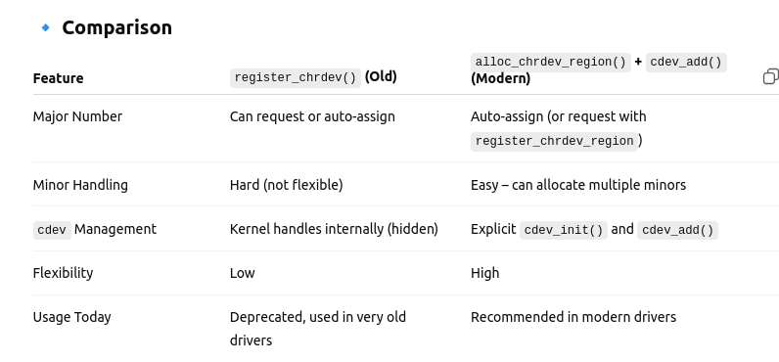

What is ioctl?
- ioctl stands for I/O Control.
- It’s a system call in Linux/Unix (int ioctl(int fd, unsigned long request, ...)) that allows user-space programs to send control commands to device drivers.
- While read() and write() are for regular data transfer, ioctl() is used for special or device-specific operations that don’t fit well into read()/write().
📌 Example:
- A sound card driver may use read() to get audio samples, but to set the volume you need ioctl().
- A terminal device uses ioctl() for changing baud rate or line discipline.

2. Function Prototype

int ioctl(int fd, unsigned long request, ...);

fd → File descriptor (returned by open() on device file in /dev/).

request → Command code (predefined constant, driver-specific).

... → Argument (could be integer, pointer to struct, etc.).

Returns:

0 on success

-1 on failure (with errno set)

3. How It Works Internally
- In user space:
  - You call ioctl(fd, request, arg).
- In kernel space:
  - The kernel forwards the request to the driver’s unlocked_ioctl (or legacy ioctl) function in the driver’s file_operations structure.
- The driver then interprets the request code and performs the operation.
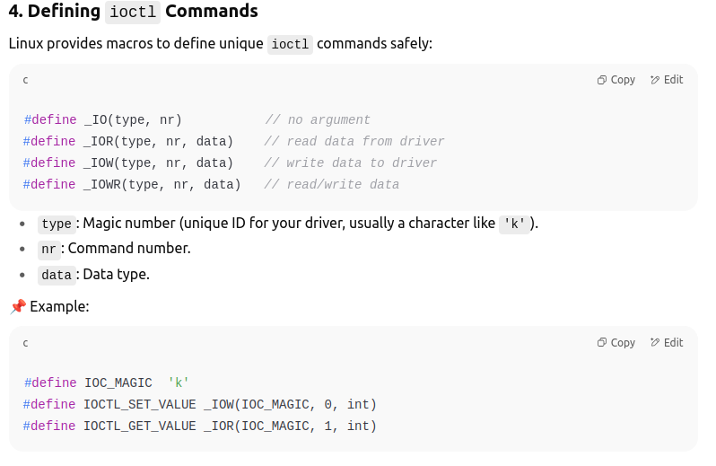
Why Use ioctl?
- Provides flexibility: Can handle many different commands.
- Efficient way to perform control/configuration tasks.
- Keeps read()/write() clean for actual data transfer

1. Creating Multiple Device Instances
Normally with alloc_chrdev_region() you can reserve a range of minor numbers. Each minor number represents a different instance of your device.
Example:
#define DEVICE_NAME "multi_demo"
#define DEVICE_COUNT 2 // two devices: /dev/multi_demo0 and /dev/multi_demo1

static dev_t dev_base;
static struct cdev cdev_array[DEVICE_COUNT];
- If alloc_chrdev_region(&dev_base, 0, DEVICE_COUNT, DEVICE_NAME) is called and dev_base is 240:0,
  - You’ll get 240:0 → /dev/multi_demo0
  - and 240:1 → /dev/multi_demo1.

2. Per-Device Private Data
Each device can have its own private data structure. This avoids global variables being shared across instances.
Example structure:
struct multi_dev {
int stored_value;
struct mutex lock; // per-device lock
};
We’ll allocate one such struct for each device.
In open(), we can attach the corresponding device struct to file->private_data, so every file operation knows which instance it belongs to.

3. Exclusive Access Handling
Sometimes you want only one process to open the device at a time. This can be enforced by maintaining an open flag inside the per-device struct.
Example:
struct multi_dev {
int stored_value;
struct mutex lock;
bool is_open;
};
In open():
- Check is_open.
- If already true, return -EBUSY.
- Otherwise set it true.
In release():
- Reset is_open = false.
Example program

#include <linux/module.h>
#include <linux/fs.h>
#include <linux/uaccess.h>
#include <linux/cdev.h>
#include <linux/mutex.h>

#define DEVICE_NAME "multi_demo"
#define DEVICE_COUNT 2

struct multi_dev {
int stored_value;
struct mutex lock;
bool is_open;
};

static dev_t dev_base;
static struct cdev cdev_array[DEVICE_COUNT];
static struct multi_dev devices[DEVICE_COUNT];

static int multi_open(struct inode *inode, struct file *file)
{
int minor = MINOR(inode->i_rdev);
struct multi_dev *dev = &devices[minor];

if (mutex_lock_interruptible(&dev->lock))
return -ERESTARTSYS;

if (dev->is_open) {
mutex_unlock(&dev->lock);
return -EBUSY; // already in use
}

dev->is_open = true;
file->private_data = dev; // attach per-device data
mutex_unlock(&dev->lock);

printk(KERN_INFO "%s%d opened\n", DEVICE_NAME, minor);
return 0;
}

static int multi_release(struct inode *inode, struct file *file)
{
struct multi_dev *dev = file->private_data;

mutex_lock(&dev->lock);
dev->is_open = false;
mutex_unlock(&dev->lock);

printk(KERN_INFO "%s released\n", DEVICE_NAME);
return 0;
}

static ssize_t multi_read(struct file *file, char __user *buf, size_t len, loff_t *ppos)
{
struct multi_dev *dev = file->private_data;
char kbuf[32];
int ret, size;

size = snprintf(kbuf, sizeof(kbuf), "%d\n", dev->stored_value);
if (*ppos >= size) return 0; // EOF

if (len > size - *ppos) len = size - *ppos;
ret = copy_to_user(buf, kbuf + *ppos, len);
if (ret) return -EFAULT;

*ppos += len;
return len;
}

static ssize_t multi_write(struct file *file, const char __user *buf, size_t len, loff_t *ppos)
{
struct multi_dev *dev = file->private_data;
char kbuf[32];
int value;

if (len >= sizeof(kbuf)) return -EINVAL;
if (copy_from_user(kbuf, buf, len)) return -EFAULT;
kbuf[len] = '\0';

if (kstrtoint(kbuf, 10, &value)) return -EINVAL;

dev->stored_value = value;
return len;
}

static struct file_operations fops = {
.owner = THIS_MODULE,
.open = multi_open,
.release = multi_release,
.read = multi_read,
.write = multi_write,
};

static int __init multi_init(void)
{
int i;
alloc_chrdev_region(&dev_base, 0, DEVICE_COUNT, DEVICE_NAME);

for (i = 0; i < DEVICE_COUNT; i++) {
cdev_init(&cdev_array[i], &fops);
cdev_add(&cdev_array[i], MKDEV(MAJOR(dev_base), MINOR(dev_base) + i), 1);

mutex_init(&devices[i].lock);
devices[i].stored_value = 0;
devices[i].is_open = false;

printk(KERN_INFO "%s%d registered\n", DEVICE_NAME, i);
}
return 0;
}

static void __exit multi_exit(void)
{
int i;
for (i = 0; i < DEVICE_COUNT; i++) {
cdev_del(&cdev_array[i]);
}
unregister_chrdev_region(dev_base, DEVICE_COUNT);
printk(KERN_INFO "multi_demo unloaded\n");
}

module_init(multi_init);
module_exit(multi_exit);

MODULE_LICENSE("GPL");

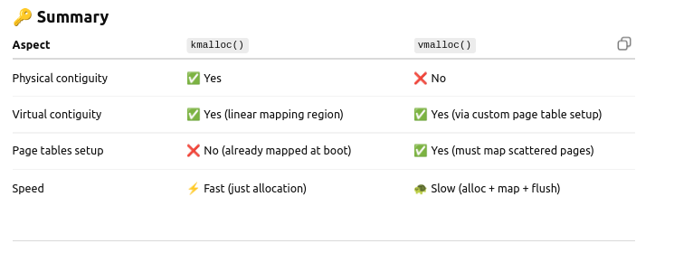

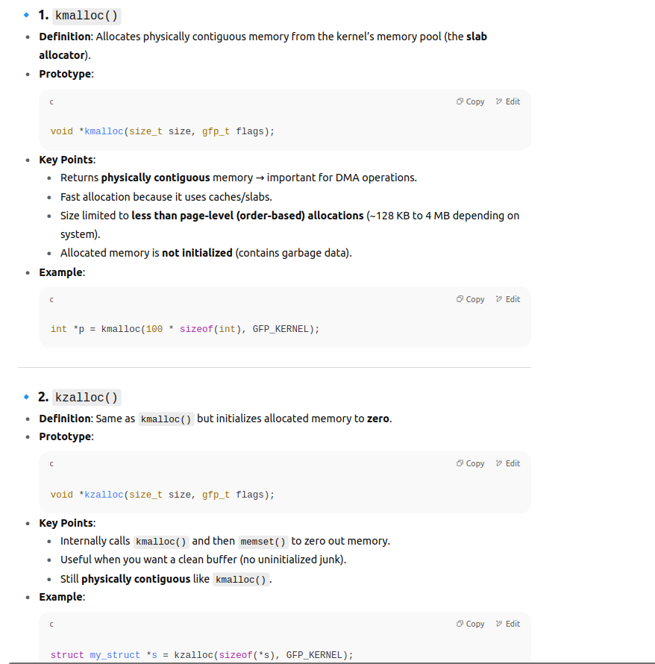

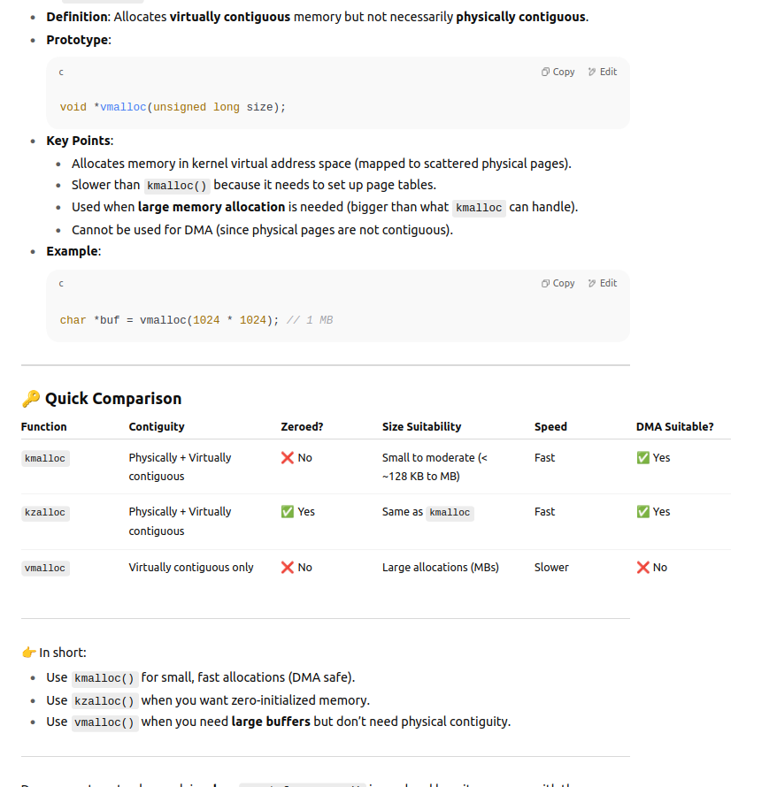

Why kmalloc() is fast
- Memory from kmalloc() comes from the low-level buddy allocator + slab/slub caches.
- That memory lies in the direct-mapped region of kernel virtual memory:
  - Linux kernel maps all physical RAM (or a big chunk) into a linear virtual address range at boot.
  - Example on x86:
Physical 0x00000000 ---> Virtual 0xC0000000
Physical 0x00100000 ---> Virtual 0xC0100000
So when kmalloc() allocates pages, those pages already have page table mappings (created at boot).
- That means:
✅ No need to set up new page tables.
✅ Just pick a chunk of contiguous pages and return a pointer.

🔹 Why vmalloc() is slow
- vmalloc() cannot rely on physical contiguity.
- It takes scattered physical pages and maps them into a virtually contiguous region.
- To do this, it must:
  - Allocate multiple physical pages (can be non-contiguous).
  - Create new page table entries for each mapping.
  - Update TLB/cache (expensive operation).
- Hence, vmalloc() incurs overhead in:
  - Page table setup.
  - TLB flushes.
  - More complex bookkeeping.

kmalloc()
- Region: Allocates memory from the direct-mapped region (also called low memory zone).
- Virtual = Physical + PAGE_OFFSET:
The kernel has a linear mapping of physical memory into virtual addresses.
So for memory allocated by kmalloc(), the kernel virtual address directly maps to contiguous physical pages.
  - Example:

Virtual = Physical + PAGE_OFFSET
Physical Contiguity: The allocation is physically contiguous (important for DMA, hardware buffers).
- Page Tables: Technically, page tables exist for everything, but since this region is direct-mapped at boot, there’s no need to build new page tables per allocation — translation is trivial (just an offset).
→ That’s why kmalloc() is fast.

🔹 vmalloc()
- Region: Allocates memory from the vmalloc area (high memory virtual region).
- Non-contiguous physical memory:
vmalloc() gives you virtually contiguous addresses, but under the hood, it can map scattered physical pages.
- Page Tables Required: To glue these scattered physical pages into one virtually contiguous block, the kernel must create/update page table entries.
→ That’s why vmalloc() is slower and involves TLB pressure.
- Useful when: Large memory requests that don’t need physical contiguity (e.g., software buffers, not DMA).

⚡ Key Difference
- kmalloc() → Fast, physically contiguous, direct mapping (no extra page table setup).
- vmalloc() → Slower, virtually contiguous only, requires extra page table mappings.

👉 So your doubt:
Yes, even kmalloc() memory needs page tables (everything in virtual memory does), but since it lives in the direct-mapped region, the mapping is already pre-established at boot and very simple (just an offset). That’s why it feels like "no page tables are required," while for vmalloc(), the kernel must explicitly set them up.

