Kernel OOPS & Panics

Kernel Oops:
A Kernel Oops happens when the kernel detects an invalid operation, such as trying to access memory it shouldn't. It's like a recoverable error. The kernel tries to continue running, but things might get unstable.
- What it means: The system can often continue running after an Oops, but its state is now unreliable. Further errors are likely.
- Why it happens: Usually due to a bug in a driver or kernel code. Common causes include null pointer dereferences, accessing freed memory, or writing to read-only memory.
- How to recognize: The Oops message will print a detailed stack trace, register values, and information about the faulting instruction. This info is invaluable for pinpointing the source of the problem.
Kernel Panic:
A Kernel Panic is more severe than an Oops. It indicates that the kernel has encountered a critical error from which it cannot recover. The system halts to prevent further damage or data corruption.
- What it means: The system cannot continue to operate safely. It's a "stop the world" moment.
- Why it happens: Often caused by serious issues like memory corruption, hardware failures, or critical kernel code bugs. An Oops can sometimes lead to a Panic if the corruption is severe enough.
- How to recognize: The Panic message will be displayed on the console, often with a stack trace similar to an Oops. The system will then halt or reboot, depending on the configuration.
Kernel Panic Analysis

Capturing the Panic Information
When a panic occurs, the system usually freezes or reboots. You cannot solve a panic without the Oops message or Stack Trace.
- Console Output: If you have physical or serial console access, the panic details are printed there.
- kdump/kexec: This is the standard tool for production. When a panic occurs, kdump boots a secondary "capture" kernel to save the memory state of the crashed kernel into a file called vmcore.
- pstore: If the hardware supports it, Linux can save the last dmesg logs into persistent RAM or EFI variables, which can be read after reboot at /sys/fs/pstore.
Crash Dump Analysis - Kdump/Kexec
kexec (short for kernel execution) is a mechanism that allows you to boot a new Linux kernel directly from the currently running one.
kdump is the standard crash-dumping mechanism for Linux. It is built on top of kexec. When the main kernel panics, kdump ensures that we can capture the state of memory (a "core dump") for later analysis.
It is a two kernel Statergy so to use this we have to build the kernel image with KEXEC and KDUMP symbols enable – Refer debugging doc
TWO Kernel Stratergy
kdump works by keeping a second, tiny kernel sitting in a "reserved" slice of RAM, waiting for a disaster.
- Production Kernel: The main kernel you use every day. At boot, it sets aside a small piece of memory (e.g., 128MB or 256MB) using the boot parameter crashkernel=X.
- Capture Kernel: A minimalistic kernel (often the same binary, but with fewer drivers) is pre-loaded into that reserved memory using kexec -p. It just sits there, dormant.
- The Panic: When the Production Kernel crashes, it doesn't reboot. It triggers the kexec jump to the Capture Kernel.
- The Dump: The Capture Kernel boots up in its tiny slice of RAM. Crucially, it treats the rest of the system's RAM (where the crashed kernel lived) as a raw data file, usually exposed via /proc/vmcore.
- Saving the File: The Capture Kernel runs a service (like makedumpfile) to copy that /proc/vmcore to your disk (usually /var/crash/) or over the network via SSH/NFS.
Capture Kernel
- When linux boots normally, it sets aside reserved a fixed memory region of RAM just for dump capture kernel. This region is called crash kernel memory.
- Bcoz when normal kernel is running , devices doing DMA will directly into RAM on their own. If you don’t reserve a memory, these DMA could overwrite the memory where you planned to load dump capture kernel.
Flow:
Primary kernel boots
→ Crashkernel memory reserved
→ kdump service starts
→ kexec preloads crash kernel + initramfs
→ (system runs normally)

[CRASH]
→ Kernel detects unrecoverable error
→ panic()
→ crash_kexec() / machine_kexec()
→ Crash kernel boots
→ /proc/vmcore created
→ makedumpfile saves vmcore to /var/crash
→ Crash kernel reboots
How to do Crash Dump Analysis in RPI
Prerequisistes :
1. Raspberry pi – 64bit OS only
2. CONFIG_KEXEC=y
CONFIG_CRASH_DUMP=y
CONFIG_PROC_VMCORE=y
These should be enable in image. If not rebuild image.
3. Install kdump tools
sudo apt install kdump-tools makedumpfile
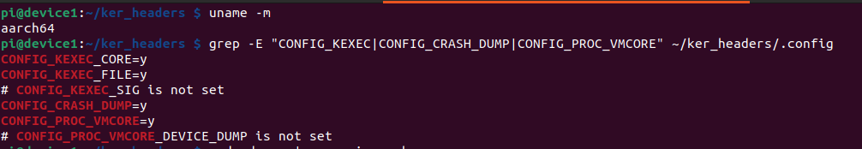
Step 1: Reserve kernel Crash kernel Memory
Add crashkernel=256M at end of line in : sudo vi /boot/firmware/cmdline.txt
sudo reboot
Step 2: Verify crash kernel memory reserve by dmesg command - sudo dmesg | grep -i crash
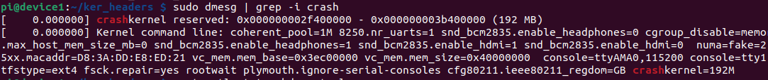
Step 3: Check kdump service status
systemctl status kdump-tools -> If disabled execute below command
sudo systemctl enable kdump-tools
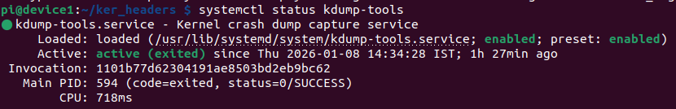
Step 4: Verify crash kernel loaded
sudo kdump-config show --> If it says not loaded check below steps if loaded go to step 5
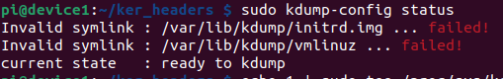
- Update the kdump default configuration:
  - sudo vi /etc/default/kdump-tools
  - Ensure the following lines are set correctly
KDUMP_KERNEL=/boot/firmware/kernel8.img --->Should point to image
KDUMP_INITRD=/boot/initrd.img-$(uname -r) -->should be initrd path
---> if initrd path is not found do this sudo update-initramfs -c -k $(uname -r)
---> sudo kdump-config unload # Clear any old attempts
---> sudo kdump-config load
---> sudo kdump-config status
Step 5: Trigger a Crash
echo 1 | sudo tee /proc/sys/kernel/sysrq // Enable sysrq
echo c | sudo tee /proc/sysrq-trigger // Trigger Crash
What happens:
- Primary kernel panics
- kexec jumps to crash kernel
- Crash kernel boots & vmcore is captured
- System reboots (or halts)
Step 6: After Reboot
ls /var/crash -> you find a folder with Timestamp when crash occured
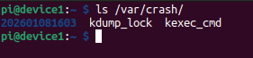
Step 7: Crash dump analysis (actual debugging)
sudo crash vmlinux /var/crash/<TimeStamp>/dump.<Timestamp>
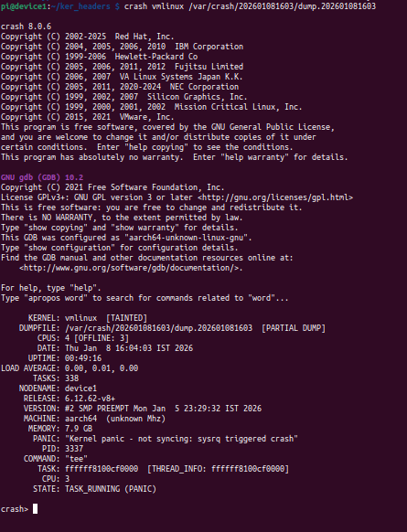
You are now at the crash> prompt
Context
Command | Usage | Description
sys | sys | Displays kernel version, uptime, and the Panic String (why it died).
log | log | Prints the kernel message buffer (dmesg). Look at the very bottom for the "Oops" or "Panic" message.
ps | ps | Lists all processes. Look for the > symbol; this marks the active task that crashed the CPU.

Crash Site
Command | Usage | Description
bt | bt | Backtrace: Shows the stack trace. The top-most functions (excluding panic handlers) are where the bug is.
set | set -p | Shows the current context (PID, task address, CPU) you are investigating.
dis | dis -l <address> | Disassemble: Translates a hex address back into assembly. The -l flag shows the C source file and line number.

OOPS Analysis
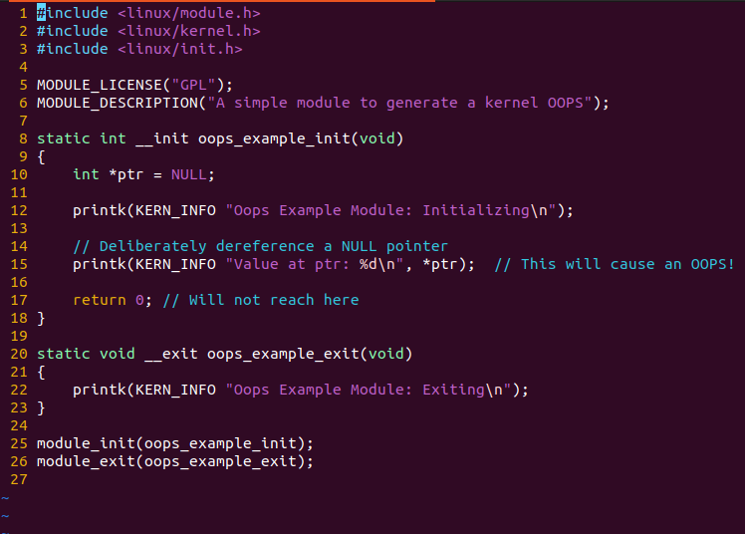
When your driver triggers an error, the kernel generates an " Oops " message. Think of this not as a failure, but as a fantastic, detailed bug report! It's the kernel's way of telling you exactly what went wrong, providing a roadmap to a solution. Unlike a full-blown panic that halts the system, an Oops kills only the offending process , leaving a treasure trove of diagnostic data for you to analyze.
oops_ex.c

sudo dmesg to see the Oops Message
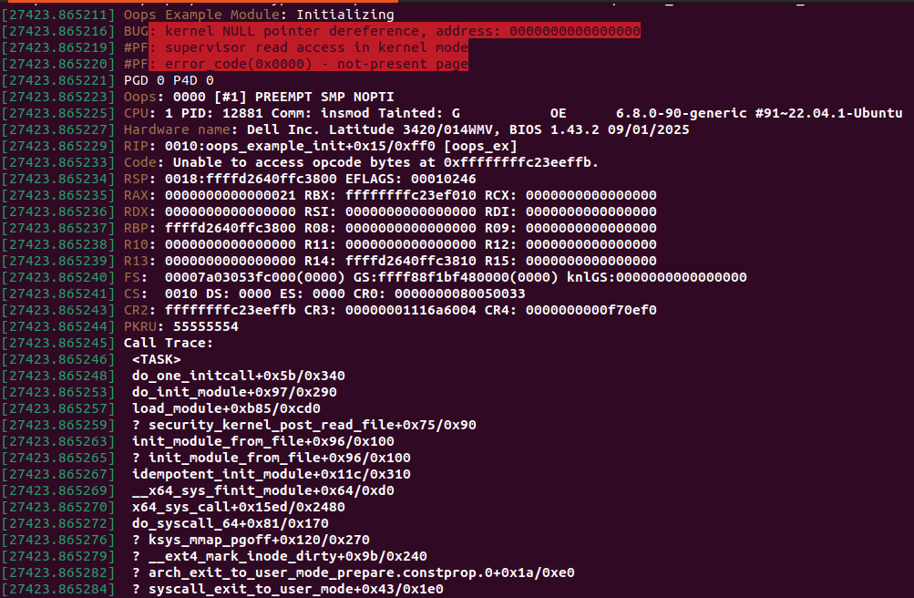
Lets analyze the Oops Message
1. The Error Summary – Tell about nature of failue
- BUG: kernel NULL pointer dereference: The code tried to read from or write to memory address 0000000000000000. Since that address is reserved and empty, the CPU triggered a hardware exception.
- #PF: supervisor read access in kernel mode: This confirms the processor (in supervisor/kernel mode) tried to read a page that wasn't there.
- Oops: 0000 [#1] PREEMPT SMP NOPTI: This is the first Oops since boot (#1). PREEMPT SMP tells us the kernel is configured for multi-core processing and preemption.
- CPU: 1 PID: 12881: dentifying the CPU and process involved
2. The Location – Instruction Pointer - This points directly to the instruction that caused the fault
RIP: 0010:oops_example_init+0x15/0xff0 [oops_ex]
The crash happened in module oops_ex in function oops_example_init at offset 0x15
>> addr2line -f -e oops_ex.ko 0x15
oops_example_init
/home/mirafra/ldd_exp_batch/Linux_Device_Drivers_notes/Kernel_Debugging/Oops/oops_ex.c:9
or objdump to see the instruction

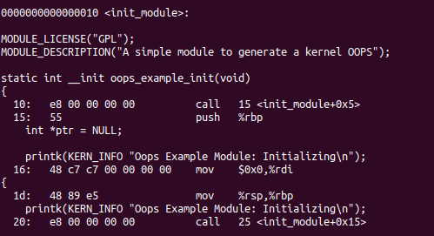
3. The Register State – Registers show the state of CPU at exact moment of oops.
- RSP (Stack Pointer): Points to the top of the current "Stack." The stack is where the kernel stores temporary data and return addresses for functions.
- RBP (Base/Frame Pointer): Usually points to the base of the current function's stack frame. It helps the kernel "trace back" through previous functions to create the Call Trace.
- EFLAGS: A collection of "status bits." It tells us if the last math operation resulted in zero, if interrupts were enabled, or if there was a carry/overflow.

General Purpose Registers (RAX, RBX, etc.)
Register | Common Role in Kernel | Your Log Value
RAX | Accumulator; used for arithmetic and function return values. | 0x0000000000000021
RDI | 1st argument passed to a function. | 0x0000000000000000
RSI | 2nd argument passed to a function. | 0x0000000000000000
RDX | 3rd argument passed to a function. | 0x0000000000000000
RCX | 4th argument; also used as a loop counter. | 0x0000000000000000
RBX | A "callee-saved" register; used for general storage. | Ffffffffc23ef010

CR0 / CR4: These hold "flags" that enable features like Write Protection, Virtualization, or SMEP (Supervisor Mode Execution Prevention), which prevents the kernel from executing code in user-space memory (a security feature).
CR2 (Faulting Address): This is vital. When a "Page Fault" occurs, the CPU stores the memory address that caused the trouble here.
CR3: Points to the Page Tables. This is how the CPU translates "Virtual" memory (which programs use) into "Physical" RAM.
CS (Code Segment): 0010 is the standard value for the Linux Kernel code segment.
PKRU (Protection Key Rights Userspace): A newer register used to manage memory protection keys, allowing the kernel to "lock" specific parts of memory.
R10, R11: Used as temporary storage.
R12, R13, R15: These are preserved registers. If your code wasn't doing complex calculations or using many variables, these often remain zero.

