Kernel Modules
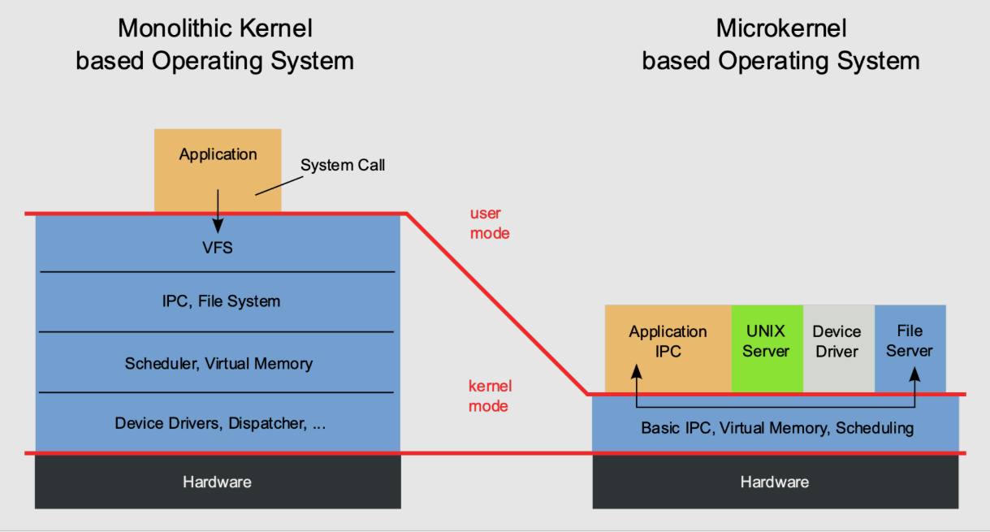

Monolithic Kernel:
A monolithic kernel integrates all essential operating system services, including process management, memory management, device drivers, file systems, and system calls, into a single large kernel binary running in supervisor mode. It provides high performance and efficient system calls due to tight integration.
Ex: Linux, Unix
Micro Kernel:
A microkernel aims to minimize the amount of code running in privileged mode. It includes only the most essential services in the kernel (e.g., inter-process communication, scheduling, basic memory management), delegating other services like device drivers and file systems to user space.
Kernel Modules:
A monolithic kernel, though faster than a microkernel, has the disadvantage of lack of modularity and extensibility. On modern monolithic kernels, this has been solved by using kernel modules.
“A kernel module (or loadable kernel mode) is an object file that contains code that can extend the kernel functionality at runtime (it is loaded as needed); When a kernel module is no longer needed, it can be unloaded. Most of the device drivers are used in the form of kernel modules.”
------------------------------------------------------------------------------------------------------------------------An example of a kernel module
Below is a very simple example of a kernel module. When loading into the kernel, it will generate the message "Hi". When unloading the kernel module, the "Bye" message will be generated.
#include <linux/kernel.h> //defines macros related to prinfk
#include <linux/init.h> //defines macros and functions primarily related to the initialization and exit phases of the kernel and kernel modules.
#include <linux/module.h> // provides the necessary definitions and macros required for writing loadable kernel modules.

MODULE_DESCRIPTION("My kernel module");
MODULE_AUTHOR("Me");
MODULE_LICENSE("GPL");

static int dummy_init(void) //Invoked when module is loaded in to the kernel
{
printk("Hi\n");
return 0;
}

static void dummy_exit(void) //Invoked when module is removed in to the kernel
{
printk("Bye\n");
}

module_init(dummy_init); //module_init and module_exit lines use special kernel macros to
module_exit(dummy_exit); // indicate the role of these two functions.

Build Module

obj-m += first_module.o

all:
make -C /lib/modules/$(shell uname -r)/build M=$(PWD) modules

clean:
make -C /lib/modules/$(shell uname -r)/build M=$(PWD) clean
%ls
first_module.c Makefile
%make
%ls
first_module.c first_module.ko first_module.mod first_module.mod.c first_module.mod.o first_module.o Makefile modules.order Module.symvers
------------------------------------------------------------------------------------------------------------------------
What are absolute minimum components a module should have?
- Header files: linux/init.h linux/module.h for module macros and function.
- Entry and exit functions: Every module must have an initialization function (entry point) called when the module is loaded into the kernel, and a cleanup function (exit point) called just before it is removed.
- Macros: module_init() and module_exit to tell the kernel which functions are the entry and exit points.
- License Declaration: The MODULE_LICENSE() macro is required to specify the module's license (e.g., "GPL"). Without this, the kernel will complain and "taint"(corrupt) the kernel when the module is loaded.

Why there is no main function?
Because this isn’t an independent program. It’s a library of sorts that gets linked into the kernel.
Init acts as main for initialization and exit acts as destructor.

Why cannot I compile this with GCC?
- A kernel module must be compiled with the same configuration (compiler flags, architecture settings, kernel version, exported symbols) as the running kernel. The build system for external modules (called kbuild) takes care of this.
- The kernel’s own build system has many internal rules (for example for symbol versioning, linking modules, generating .modinfo, tracking dependencies, using Module.symvers, etc) that a simple gcc invocation would miss.
- Using make + -C <kernel_build_dir> M=<module_dir> modules ensures that the module’s object (.o) and final module (.ko) are built in the correct environment. If you bypass that you risk compatibility issues (module won’t load, mismatched symbols, etc).
- The module is not a regular user-space application; you’re building code to be inserted into the kernel. That requires correct linking (not linking to libc, etc), correct macros (__KERNEL__, MODULE, etc), correct include paths, etc. A plain gcc module.c will not handle all that.

What are the critical risks of kernel programming compared to userspace?
There is no memory protection. A mistake (like a null pointer dereference, buffer overflow, or not handling error) will not cause a segmentation fault; it will cause a kernel panic and crash the entire system. Always test on virtual or non-critical machine.
- Why no protection to memory in kernel?
  - The kernel runs in Ring 0(Previleged mode). At this level CPU disables many hardware level protections because kernel must have direct, unrestricted access to all physical memory and hardware. The kernel is the final authority, there is nothing above it to protect it from itself.
  - If user space tries to access invalid memory, MMU catches this violation and sends an interrupt to kernel. Then Kernel sends SIGSEGV signal to programm killing only that process.
  - If kernel space program accesses an invalid address, there is no higher authority to inercept and safely kill the problematic code. The hardware throws an exception, the kernel’s exceotion handler realizes the system integrity is compromised, and it stops execution completley , displaying “Kernel Panic” message.

------------------------------------------------------------------------------------------------------------------------

Init macro
Purpose:
- module_init() macro specifies the entry point function that will be called when the kernel module is loaded ( via insmod or modprobe).
- It provides the kernel with a known, standard way to find and execute a module’s startup code, ensuring proper initialization of the module’s functionality.
Prototype:
module_init(init_function_name);
- Paramters : init_function_name – The name of the function written to initialize module.
- The User-Defined function Prototype:
static int __init init_functionvoid)
{
// Initialization code here
// e.g., printk("Hello, Kernel!\n");
// e.g., register_chrdev(...)
return 0; //Success
}
- Static : Restricts function visibility to this file. To prevent other parts of the kernel from directly calling it after the module has been loaded.
- __init : This macro marks the function as being used only during module initialization. The kernel can free the memory occupied by this function after the module is loaded, especially if the module is dynamically loaded and not built directly into the kernel.
- The return type, indicating success(0) or failure(negative int).
Dependency:
- Header : <linux/init.h>
- Kernel must be configured to support module loading.
Implementation details:
- module_init() is called by kernel module loader duirng the module loading process.
- It is a liner macro that olaces the address of your init_function into a special section( .initcall) of modulex executable file.
- Control flow:
  - User runs insmod my_module.ko
  - Kernel allocates memory for the module and loads its code.
  - When the module is loaded , the kernel traverses .initcall section and calls all the registered init functions.
------------------------------------------------------------------------------------------------------------------------
Exit macro
Purpose:
- module_exit() macro specifies the exit point function that will be called when the kernel module is unloaded via rmmod.
- It provides a clean, standardized way for a module to release all resources, unregister interfaces, and shut down safely before its code is removed from kernel.

Prototype:
module_init(exit_function_name);
- Paramters : exit_function_name – The name of the function written to clean up module.
- The User-Defined function Prototype:
static void __exit exit_function(void)
{
// clean up code here
// e.g., printk("Hello, Kernel!\n");
return;
}
  - Static : Restricts function visibility to this file. To prevent other parts of the kernel from directly calling it after the module has been loaded.
  - __exit : A macro hint to the kernel that this function is used only at module exit. For a non-loadable module it can be completley discarded.
  - The function return nothing.
Dependency:
- Header : <linux/init.h> (defines module_exit and __exit macro)
- Kernel must be configured to support module unloading.
- This function must reverse all the oprations performed by module_init function.
Implementation details:
- This macro places the address of your exit_function address into a special section (.exitcall) of modulex executable file.
- Control flow:
  - User runs rmmod my_module
  - Kernel finds function pointer in the .exitcall section.
  - Kernel calls exit_function.
------------------------------------------------------------------------------------------------------------------------
Printk function
Purpose:
- printk (print kernel) is the primary logging mechanism for the linux kernel. Unlike printf it is specifically designed to work in kernel space where many limitations exit.
- Provides a mechanism for kernel code to log debug info, warnings, and other messages to various outputs (console, log files, kernel buffers) for system monitoring and debugging.

Prototype:
int printk(const char *fmt, ...);
- Parameters:
  - fmt – Format string (similar to printf)
  - ... – Variable arguments corresponding to the format specifiers
- Return value:
  - Returns the number of characters written
  - May return 0 if the message is suppressed due to log level settings

Log Levels (Priority):
- Log level specifies the importance of the message.
printk(KERN_INFO "Hello Kernel\n");

Log Level Macro | Priority | Description
KERN_EMERG | 0 | System is unusable
KERN_ALERT | 1 | Immediate action required
KERN_CRIT | 2 | Critical conditions
KERN_ERR | 3 | Error conditions
KERN_WARNING | 4 | Warning conditions
KERN_NOTICE | 5 | Normal but significant
KERN_INFO | 6 | Informational messages
KERN_DEBUG | 7 | Debug messages

Dependency:
#include <linux/kernel.h> // printk
#include <linux/printk.h> // log level macros

Implementation Details:
The generated messages will not be displayed on the console but will be saved in a specially reserved memory area for this, from where they will be extracted by the logging daemon (syslog). To display kernel messages, you can use dmesg command or inspect the logs.
------------------------------------------------------------------------------------------------------------------------
Loading and Unloading Module
%sudo insmod ./first_module.ko
%lsmod //To check module loaded
%sudo dmesg | tail //To check last 10 logs
%sudo rmmod

- Each module is made up of object code (not linked into a complete executable) that can be dynamically linked to the running kernel by the insmod program and can be unlinked by the rmmod program.
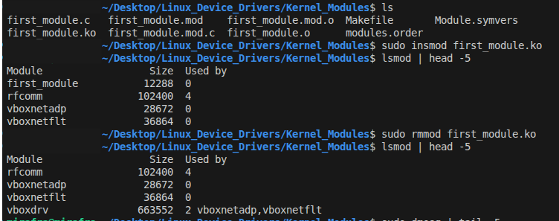
insmod
insmod (insert module) is a user-space command used to load a kernel module into the running Linux kernel. It inserts a .ko (kernel object) file directly into the kernel.
sudo insmod <ko object>

Functionality:
- Loads the specified kernel module into kernel space
- Calls the module’s initialization function registered using module_init()
- Allocates required kernel resources
rmmod
rmmod (remove module) is a user-space command used to unload a kernel module from the kernel.
sudo rmmod <module>

Functionality:
- Removes a loaded kernel module
- Calls the module’s cleanup function registered using module_exit()
- Frees all allocated resources
lsmod
lsmod (list modules) displays all currently loaded kernel modules.

Functionality:
- Reads information from:
/proc/modules
dmesg
dmesg (diagnostic message) is a user-space command used to display messages from the kernel ring buffer.
- It allows users and developers to:
- View kernel messages generated by printk()
- Debug kernel modules and device drivers
- Inspect boot-time and runtime kernel events
- Kernel messages are stored in a specially reserved memory area (ring buffer) and are not always printed directly to the console.
Option | Description
dmesg | Display all kernel messages
dmesg -c | Display and clear the ring buffer
dmesg -w | Display messages in real-time
dmesg -T | Show human-readable timestamps
dmesg -l <level> | Filter by log level (err, warn, info, debug)
`dmesg | tail`
`dmesg | grep `
modinfo
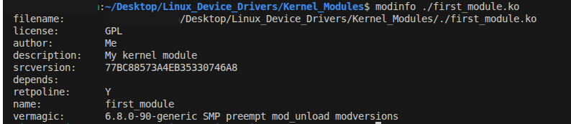
modinfo (module information) is a user-space command used to display metadata about a kernel module.
- It provides information embedded in the .ko file at compile time.
- Useful for:
- Understanding module properties
- Checking dependencies
- Verifying kernel compatibility
- Inspecting module parameters
Modprobe
base.c driver.c
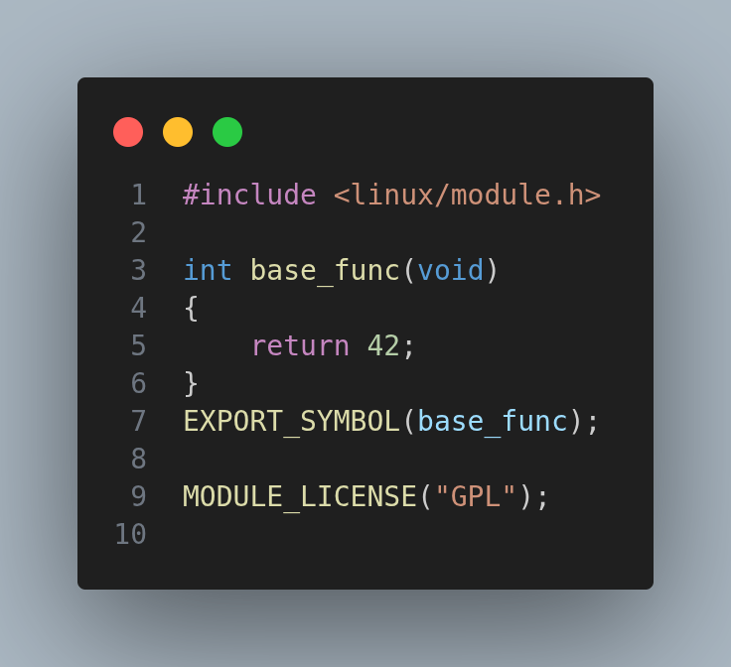
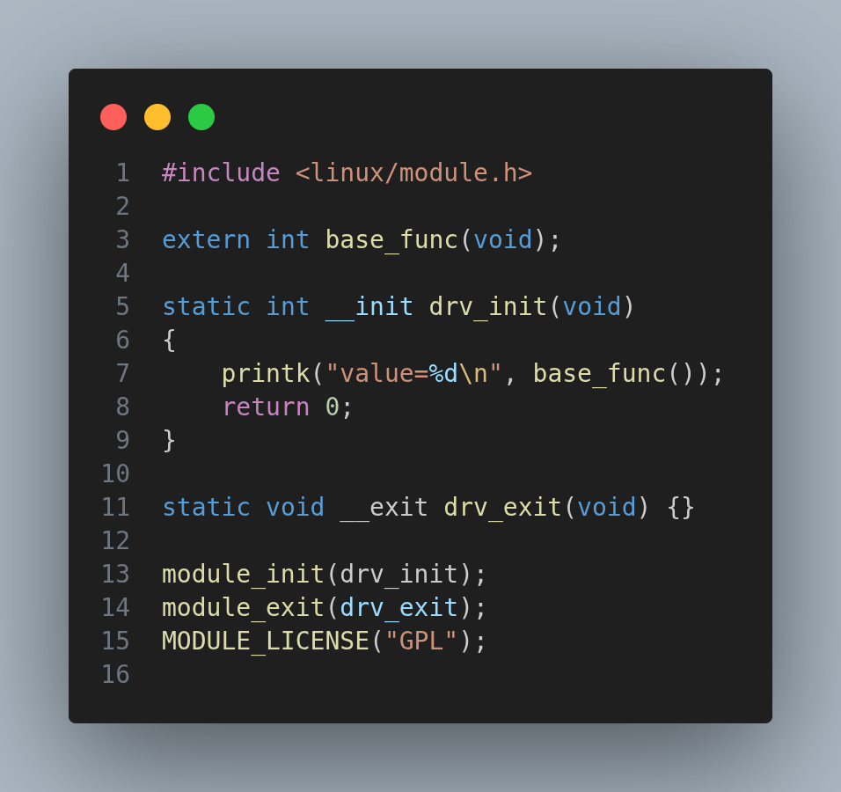
sudo insmod driver.ko
insmod: ERROR: could not insert module driver.ko: Unknown symbol in module
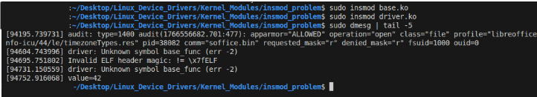
Solution by modprobe
You compile module and dependicies
↓
You copy them to /lib/modules/$(uname -r)/
↓
You run depmod
↓
Dependency info is generated
↓
run modprobe driver
↓
modprobe can now find + load it

depmod -> Kernel modules can depend on hundreds of other modules.
If modprobe had to:
- Open every .ko
- Read symbols
- Compute dependencies every time
→ loading would be slow and complex.

Solution: Precompute dependencies once
depmod is the tool that:
- Scans all .ko files
- Extracts:
  - Exported symbols
  - Required symbols
- Builds dependency maps

