Exercise 0 – Kernel Source Code Navigation

Objective
Become familiar with navigating the Linux kernel source using tools such as cscope or LXR.

Tasks
- Using cscope or LXR, locate the definitions of the following symbols in the Linux kernel source code:
  - module_init()
  - module_exit()
- Answer the following:
  - What do the module_init() and module_exit() macros do?
  - What are init_module() and cleanup_module()?
  - How are they related to the macros above?
- Locate the variable:
  - ignore_loglevel
- Answer:
  - What is the purpose of ignore_loglevel?
  - Where and how is it used inside the kernel?
1) Cscope
Cscope (often written as cscope) is a powerful, text-based tool used by programmers to browse and navigate large source code projects.
Using cscope you can find:
- Global definitions: Where a function, variable, or macro is defined.
- Call sites: Which functions call a specific function (the "caller").
- Callees: Which functions are called by a specific function.
- Symbol usage: Everywhere a specific symbol (variable, etc.) appears.
- Text strings: A specific string of text throughout the project.
- File searching: Quickly locate a file or find files that #include a specific header.
Steps:
git clone https://git.kernel.org/pub/scm/linux/kernel/git/torvalds/linux.git
cd linux
make cscope
cscope -d ---> Launch cscope and u find menu like below type and search
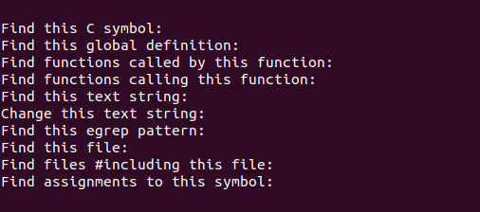
LXR stands for Linux Cross-Referencer.
While cscope is a tool you run locally in your terminal, LXR is a web-based tool. It allows you to browse through millions of lines of source code using just a web browser, with every function, variable, and macro turned into a clickable hyperlink.
How it works
- Click a function call: It takes you directly to that function's definition.
- Click a variable: it shows you every file where that variable is used.
- Switch versions: You can easily jump between different versions of the kernel (e.g., from version 5.10 to 6.1) to see how the code has changed.
Open:
👉 https://elixir.bootlin.com/linux/latest/source
This lets you:
- Search symbols
- Jump to definitions
- Browse call graphs
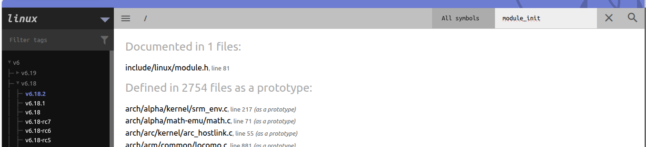
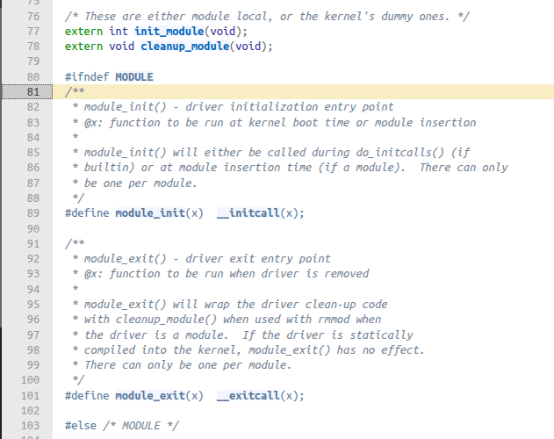

2. The Macros: module_init() and module_exit()
These are the modern, standard way to tell the kernel which functions to run when your module starts and stops.
- module_init(my_init_func): This macro registers your initialization function. When you run insmod or modprobe, the kernel executes my_init_func. It is typically used to allocate resources, register device drivers, or initialize hardware.
- module_exit(my_exit_func): This macro registers your cleanup function. When you run rmmod, the kernel executes my_exit_func. It is responsible for "undoing" everything the init function did—freeing memory, unregistering drivers, etc.

2. The Functions: init_module() and cleanup_module()
These are the actual symbols the kernel's module loader looks for inside the binary (.ko file).
In the early days of Linux (before 2.4 kernels), you didn't have macros. You were forced to name your functions exactly init_module() and cleanup_module(). If you named them anything else, the kernel wouldn't know how to start your driver.

3. How are they related?
The macros are actually wrappers that rename your custom-named functions to the names the kernel expects.
When you write:
static int __init my_driver_start(void) { ... }
module_init(my_driver_start);
The module_init macro uses a C trick (an alias) to map my_driver_start to the symbol init_module.

Why use the macros instead of the old functions?
- Readability: You can give your functions meaningful names (e.g., usb_vkeyboard_init).
- Built-in vs. Module: If you compile your driver directly into the kernel (not as a .ko file), module_init handles the logic of placing your function into a special memory section (.init.text). Once the kernel boots and runs that code, it frees that memory to save RAM. The old init_module function name doesn't support this "memory-saving" feature as easily.

Exercise 1 – Basic Kernel Module

Objective
Build and load a simple kernel module using the lab infrastructure.

Tasks
- Generate the skeleton for the task named:
1-2-test-mod
- From the tools/labs directory, run:
$ LABS=kernel_modules make skels
$ make build
- Verify that the kernel module is successfully built.
- Copy the module to the virtual machine, boot it, and:
  - Load the module
  - Unload the module
- Observe the messages printed during load and unload.

Exercise 2 – printk and Log Levels

Objective
Understand how kernel log levels affect message visibility.

Tasks
- Load the module from Exercise 1.
- Observe the virtual machine console.
- Answer:
  - Why are printk() messages displayed directly on the VM console?
- Configure the system so that:
  - Messages are not displayed on the serial/VM console
  - Messages can only be seen using dmesg
Hint:
  - Write a suitable value to:
/proc/sys/kernel/printk
  - Use a log level lower than the one used in the module’s printk() calls
- Reload and unload the module.
- Verify:
  - No messages appear on the VM console
  - Messages are visible via dmesg

Exercise 3 – Kernel Module Compilation Errors

Objective
Identify and fix kernel module compilation errors.

Tasks
- Generate the skeleton for the task:
3-error-mod
- Compile the module.
- Observe the compilation errors.
- Answer:
  - Why do these compilation errors occur?
  - How does this module differ from the previously working module?
Hint:
  - Compare function prototypes and required kernel entry points.
- Modify the module source code to fix the errors.
- Recompile and test the module by:
  - Loading it into the kernel
  - Unloading it successfully

Exercise 4 – Multi-Source Kernel Modules

Objective
Create a kernel module from multiple source files.

Tasks
- Navigate to:
4-multi-mod/
- Inspect the following files:
  - mod1.c
  - mod2.c
- Note:
  - mod2.c only defines a function used by mod1.c
- Modify the Kbuild file so that:
  - A single kernel module named:
multi_mod.ko
is built from both source files.
Hint:
  - Refer to the Compiling kernel modules section of the lab.
- Compile the module.
- Copy it to the VM, boot, and:
  - Load the module
  - Unload the module
- Verify that all expected messages appear correctly.

Exercise 5 – Kernel Oops Debugging

Objective
Understand kernel oops messages and debug them.

Tasks
- Navigate to:
5-oops-mod/
- Inspect the C source file.
  - Identify where the fault is likely to occur.
- Modify the Kbuild file to add:
-g
to the compilation flags.
- Compile the module and load it into the kernel.
- Observe the kernel oops message.
- Identify:
  - The memory address at which the oops occurred
Hint:
  - Extract the value of the instruction pointer (EIP/RIP) from the oops log.
- Determine:
  - Which instruction caused the oops
Hint:
  - Use:
    - /proc/modules to find the module load address
    - objdump and/or addr2line on the host system
- Attempt to unload the module.
- Observe and explain:
  - Why the module cannot be unloaded after the oops

Exercise 6 – Kernel Module Parameters

Objective
Pass parameters to a kernel module at load time.

Tasks
- Navigate to:
6-cmd-mod/
- Inspect cmd_mod.c.
- Compile and copy the module to the VM.
- Load the module and observe the printk() message.
- Unload the module.
- Without modifying the source code:
  - Load the module so that the printed message is:
Early bird gets tired
Hint:
  - The variable str is a module parameter
  - Pass parameters using the insmod command

Exercise 7 – Process Information from Kernel Space

Objective
Access process information from within the kernel.

Tasks
- Generate the skeleton for:
7-list-proc
- Modify the code to display:
  - Process ID (PID)
  - Executable name
- The information must be printed:
  - When the module is loaded
  - When the module is unloaded
- Use:
  - struct task_struct
  - The current pointer
Hints:
  - Use LXR or cscope to inspect struct task_struct
  - Look for the field with the comment containing executable
  - Include:
#include <linux/sched.h>
- Compile, copy, boot the VM, and load the module.
- Unload the module.
- Repeat loading and unloading multiple times.
- Observe and explain:
  - Why the displayed PIDs differ each time
  - Why /sbin/insmod and /sbin/rmmod appear as executables

