---------------------------------------Device Trees------------------------------------------------
A Device Tree (DT) is a structured way to describe hardware to the Linux kernel.
It tells the kernel:
- What devices exist (CPU, memory, USB, UART, I2C, GPIO, etc.)
- Where they are located (addresses, registers)
- How they are connected (interrupts, buses, clocks)
- Which devices are enabled or disabled

** The Device Tree is the blueprint of your hardware that helps the kernel understand and use it properly.
Why ?
In the past, hardware details were hard-coded inside the Linux kernel. That meant every time you worked with new hardware, you had to modify and rebuild the kernel.
This was slow and inflexible.
So with Device Tree
- One kernel can support many boards.
- Hardware changes can be handled by updating the Device Tree, not the kernel itself.
- It saves time, makes Linux portable, and keeps the kernel clean.
At its core, a Device Tree is a hierarchical tree of nodes and properties.
- Nodes: Represent hardware components (CPUs, memory, buses, and peripherals like I2C or SPI sensors).
- Properties: Key-value pairs that describe the component (e.g., the memory address, interrupt lines, or GPIO pins).
The device tree is typically stored as a text file with a ".dts" or ".dtsi" extension. It can be compiled into a binary format known as a Device Tree Blob (DTB). The DTB is then loaded by the bootloader during system initialization.
Device Tree decouples the Hardware Description from the Software Implementation.
- Hardware engineers define the pins and addresses in the DTS.
- Software engineers write the driver once, and it "binds" to the hardware whenever the Device Tree says a compatible device is present.

DTSI (Device Tree Source Include)
The .dtsi file is an "Include" file. It is essentially a template used to store shared hardware descriptions to avoid code duplication.
It typically describes the System on Chip (SoC)—the components that are the same across dozens of different boards (like the CPU cores, memory controllers, and internal buses).
File extension: .dtsi
What is inside a .dtsi?
SoC-level or common hardware
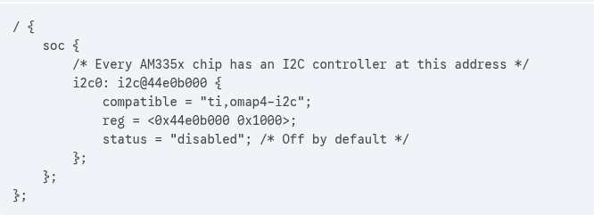
DTS — Device Tree Source
- A text file
- Describes the hardware of ONE specific board
- Written by board designers / BSP developers
File extension: .dts

What is inside a .dts?
Board-specific things:
- Which peripherals are enabled
- Which GPIO pins are used
- Which UART is connected to console
- Board LEDs, buttons, sensors
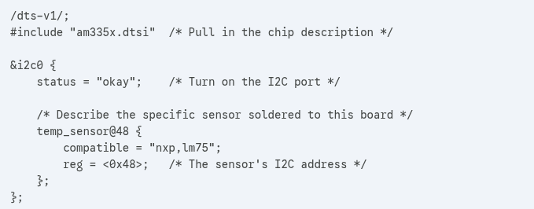
DTB — Device Tree Blob
- Binary compiled output
- Machine-readable
- Loaded by bootloader
- Used by kernel only
File extension: .dtb
How Compiled ?
A tool called the DTC (Device Tree Compiler) takes the .dts (and its included .dtsi files) and "flattens" them into a single binary file.
dtc -I dts -O dtb myboard.dts -o myboard.dtb
dtc = Device Tree Compiler
-I dts = Input format is DTS (Device Tree Source)
-O dtb =Output format is DTB (Device Tree Blob)
myboard.dts = Input File
-o myboard.dtb = Output File Name
** BLOB stands for Binary Large Object.
DTS Syntax and Writing
DTS Syntax Basics
A Device Tree is a tree of nodes. Every node can have Properties (data) and Child Nodes.
- File Header: Must start with /dts-v1/;. - Tells dtc this is a DTS file.
- Root Node: Every tree starts with / { ... };.
Nodes – Everything is a node in DT
node-name@unit-address {  property = value;  }; | serial@40004000 {  compatible = "st,stm32-uart";  };
- Comments: Uses C-style comments (/* ... */ or //).
- PropertyA key-value pair: name = value;
- Labels: Used to reference other nodes (e.g., my_uart: serial@...).
uart1: serial@40004000 { };

- Endings: Every node and property must end with a semicolon ;.
Every "leaf" node (a device) generally requires these fields:

Mandatory Fields
- compatible: The most important field. It is a string (or list of strings) that matches the device to a driver (e.g., "ti,omap4-i2c").
- reg: Defines the physical memory address and the length of the registers. Format: <address length>.
- status: While technically optional, it is treated as mandatory in practice. Set to "okay" to enable the device or "disabled" to ignore it.
Address/Size Cells:In Device Tree syntax, #address-cells and #size-cells are the "instruction manual" for how to read the numbers inside the reg property of child nodes.
Cell: A single 32-bit integer (4 bytes).
- #address-cells: Tells the kernel: "To read an address for my children, look at this many 32-bit cells."
- #size-cells: Tells the kernel: "To read the size/length for my children, look at this many 32-bit cells."
Analogy
Imagine I give you a string of digits: 10203040
If I tell you "Addresses are 2 digits and Sizes are 2 digits," you read it as:
- Address: 10, Size: 20
- Address: 30, Size: 40
#address-cells = <1>;
#size-cells = <1>;
/* reg = <Address Size> */
reg = <0x40000000 0x00001000>;
The Kernel reads the first value as the start and the second as the length.
Common Mistakes (Important!)
- Missing Semicolons: Forgetting the ; after a closing brace }; or a property is the #1 cause of compiler errors.
- Unit Address Mismatch: The address in the node name (e.g., sensor@48) must match the first value in the reg property (reg = <0x48>;).
- Compatible String Typos: If you write "nxp,lm-75" instead of "nxp,lm75", the driver will never load (the "handshake" fails).
- Address/Size Cells: Forgetting #address-cells or #size-cells in a parent node makes the child nodes' reg properties unreadable by the kernel.
Simple DTS Example: "The LED & Button Board"
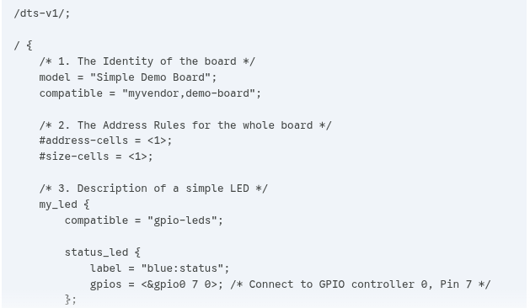
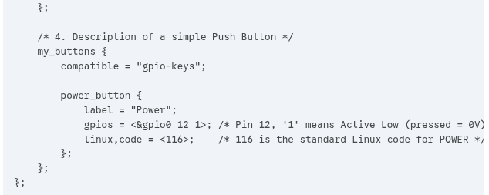
Device Tree Binding
"Binding" is the process where the Kernel connects a Device Tree Node to a Software Driver.
A DTS binds to a driver during kernel boot (or module load) when the kernel creates a device from the DTB and matches the device’s compatible string with a driver’s of_match_table.
DTB parsing happens during early kernel initialization because this is the earliest stage where the kernel has enough execution environment to parse structured data, and the latest stage where hardware description is still required to correctly initialize memory, CPUs, interrupts, and devices.
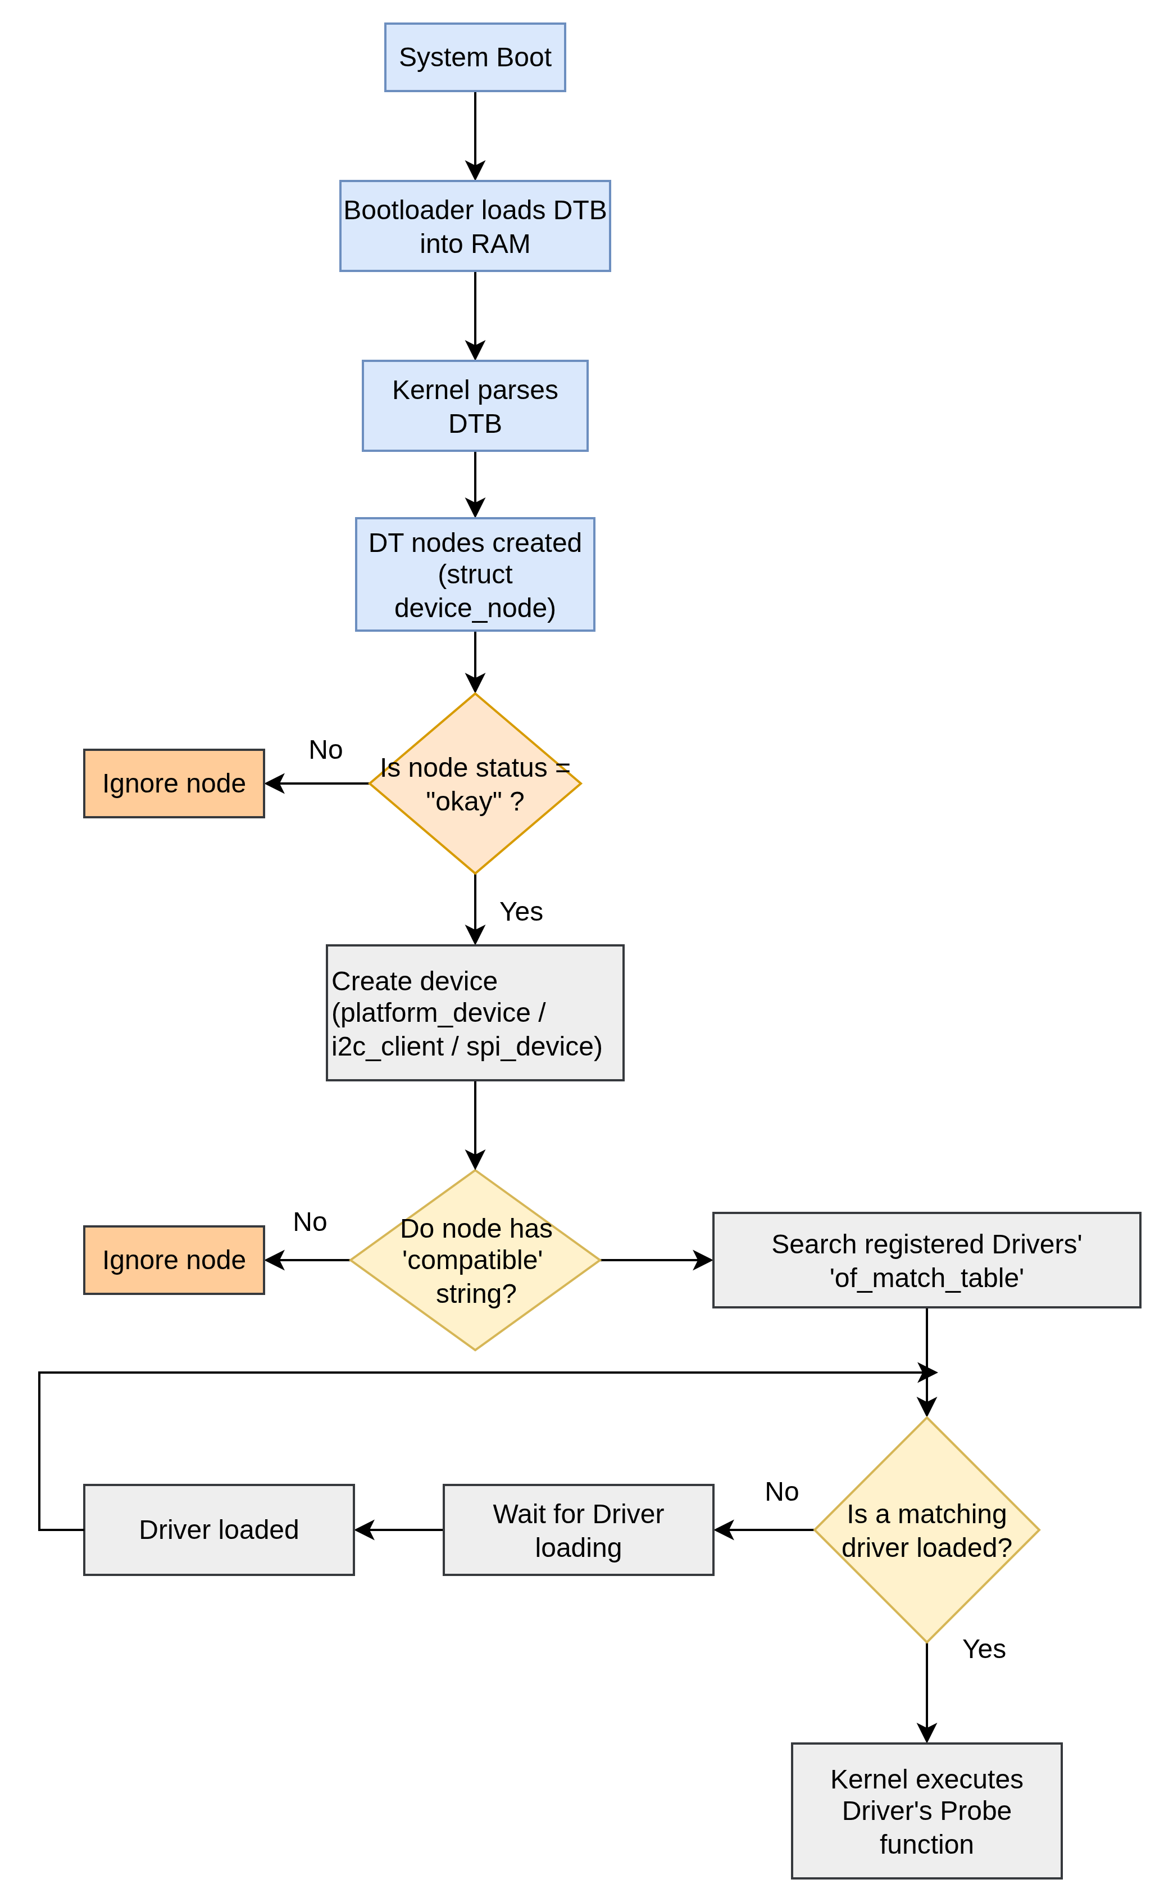
Binding flow
Device Tree Overlay (DTBO)
In a standard setup, the Device Tree is static. It's loaded once when the computer starts. But what if you plug in a hardware accessory (sensor) after the board is already designed? You don't want to rewrite the entire main dts file. Instead, you use an Overlay.
Why do we need it?
- Modularity: You can create one main system image for a thousand users, and each user can "overlay" their specific hardware (a screen, a motor controller, etc.).
- Live Updates: On some systems, you can load an overlay while the computer is running without rebooting.
- Hardware Expansion: Boards like Raspberry Pi or BeagleBone have expansion headers. Since the manufacturer doesn't know what you will plug in, they provide overlays for common accessories.
How to write overlay ? The Overlay Code (green_led.dts)
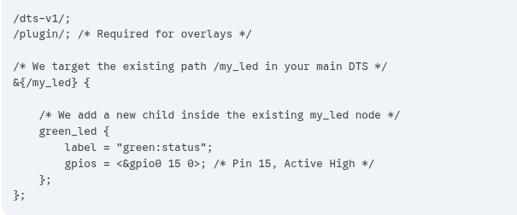
If you modify your main.dts to include a label like my_led_label: my_led, the overlay becomes much cleaner. This is the "Industry Standard" way.
my_led_label: my_led { /* Added 'my_led_label:' here */
compatible = "gpio-leds";
...
};
The overlay
/dts-v1/;
/plugin/;

&my_led_label {
green_led {
label = "green:status";
gpios = <&gpio0 15 0>;
};
};
How to compile it ?
dtc -I dts -O dtb -o my_sensor.dtbo my_sensor.dts
How to bind it ?
There are two main ways to tell the kernel to apply the overlay:

->At Boot Time (Common for Raspberry Pi)
You put the .dtbo file in a specific folder (like /boot/overlays/) and add a line to a config file:
- File: config.txt
- Line: dtoverlay=my_sensor

-> At Runtime (Using ConfigFS)
On some Linux systems, you can inject it while the system is running:
- Mount the config file system.
- Create a directory for your overlay.
- cat the binary .dtbo into the "dtoverlay" path.
- The kernel immediately sees the new hardware and looks for a driver.

