------------------------------------GPIO Drivers---------------------------------------------
To do before writing driver
- Understand Rasberrypi GPIO hardware.
- Understand Linux GPIO Framework Concepts

1. GPIO Hardware

There are 58 General-Purpose Input/Output (GPIO) lines split into three banks. Bank 0 contains GPIOs 0 to 27, bank 1 contains GPIOs 28 to 45, and bank 2 contains GPIOs 46 to 57. All GPIO pins have at least two alternative functions within BCM2711.
The GPIO register base address is 0x7e200000.
- GPIO Function Select Registers (GPFSELn)
  - The function select registers are used to define the operation of the general-purpose I/O pins. (Input, Output, or one of the Alternate Functions).
  - There are 6 registers (GPFSEL0 to GPFSEL5) to cover all 54 pins. GPFSEL0 controls pins 0-9. GPFSEL1 controls pins 10-19, and so on.
  - In each register , each pin uses 3 bits.
000 = GPIO Pin is an input.
001 = GPIO Pin is an output.
100 – 111 = Alternate Functions (0 – 5)
- GPIO Output Set and Clear Registers (GPSETn & GPCLRn)
  - Unlike some microcontrollers where you toggle a "Data" register, Broadcom uses a Write-1-to-Action design. This prevents "Read-Modify-Write" errors where you might accidentally change other pins.
  - GPSET (Set) - GPSET0 (Pins 0-31) and GPSET1 (Pins 32-53).
Writing a 1 to the bit corresponding to the pin sets it HIGH. Writing a 0 has no effect.
  - GPCLR (Clear) - GPCLR0 (Pins 0-31) and GPCLR1 (Pins 32-53).
Writing a 1 to the bit corresponding to the pin clears it to LOW. Writing a 0 has no effect.
- GPIO Pin Level Registers (GPLEVn)
  - GPLEV0 (Pins 0-31) and GPLEV1 (Pins 32-53).
  - These are Read-Only registers. Used when a pin is configured as an Input (to read a button) or to verify the state of an Output.

2. Linux GPIO Framework
In the Linux kernel, the GPIO Framework (also known as gpiolib) is a software layer that manages all General Purpose Input/Output pins on a system. It acts as an intermediary (a "middleman") between the hardware-specific registers and the drivers that want to use those pins.
struct gpio_chip
This structure represents a single instance of a GPIO controller (a "bank"). So BCM2711 has 3 instanced of struct gpio_chip.
It lives in the Hardware Abstraction Layer (HAL) of the kernel. You will find implementations of this structure in the kernel source tree under: drivers/gpio/gpio-*.c
It is used during the Driver Probing phase.
- The kernel detects a GPIO hardware device (via Device Tree or ACPI).
- The specific GPIO driver for that hardware allocates and fills out a struct gpio_chip.
- The driver calls gpiochip_add_data() to register it
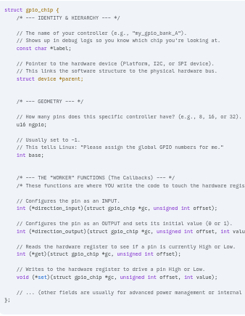
The structure is defined in <linux/gpio/driver.h>
struct gpio_ops
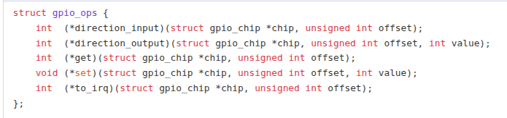
A gpio_ops struct is essentially a function table that abstracts low-level hardware access for GPIO pins.
It allows the kernel’s GPIO subsystem (or the driver’s higher-level code) to call generic functions without knowing the exact hardware details.
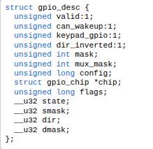
struct gpio_desc
A "handle" or "object" representing a single physical pin. Think of it as a pointer to a specific GPIO line. It provides an opaque handle to a GPIO line, replacing the older integer-based GPIO
numbering system.
The Old Style: Integer-based API (gpio_*)
In this style, a GPIO was just a number (e.g., GPIO 17). You would hardcode numbers or pass them via header files. here was no "ownership." If two drivers called gpio_request(17,...) at the same time, it was hard to track. Also, it couldn't handle "Active Low" logic automatically you had to manually write 1 for high and 0 for low in your code, even if the hardware was wired backward.
The New Style: Descriptor-based API (gpiod_*)
In the modern API, you don't use numbers. You use a pointer to an opaque object: struct gpio_desc. It is type-safe, namespace-aware, and integrates better with the Linux device model.
Feature | Legacy API (Old) | Modern API (New) | Why it's better
Header File | <linux/gpio.h> | <linux/gpio/consumer.h> | Better organization.
Data Type | unsigned int gpio | struct gpio_desc * | Opaque and type-safe.
Allocation | gpio_request() | gpiod_get() | Links to Device Tree automatically.
Direction | gpio_direction_output() | gpiod_direction_output() | Same logic, safer handle.
Set Value | gpio_set_value(17, 1) | gpiod_set_value(desc, 1) | Handles "Active Low" for you.
Cleanup | gpio_free(17) | gpiod_put(desc) | Part of the device lifecycle.
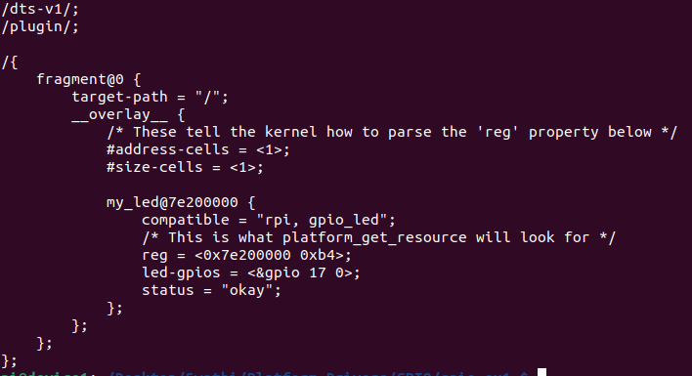
*** devm_gpiod_get(). The devm_ prefix tells the kernel: "When this driver is unloaded, automatically release this GPIO for me." It prevents memory and resource leaks.
TASK 1: Write DTS for GPIO 17
TASK 2 : Write Platform Driver Skeleton
get

