------------------------------------Platform Drivers---------------------------------------------

Classification of Device Drivers
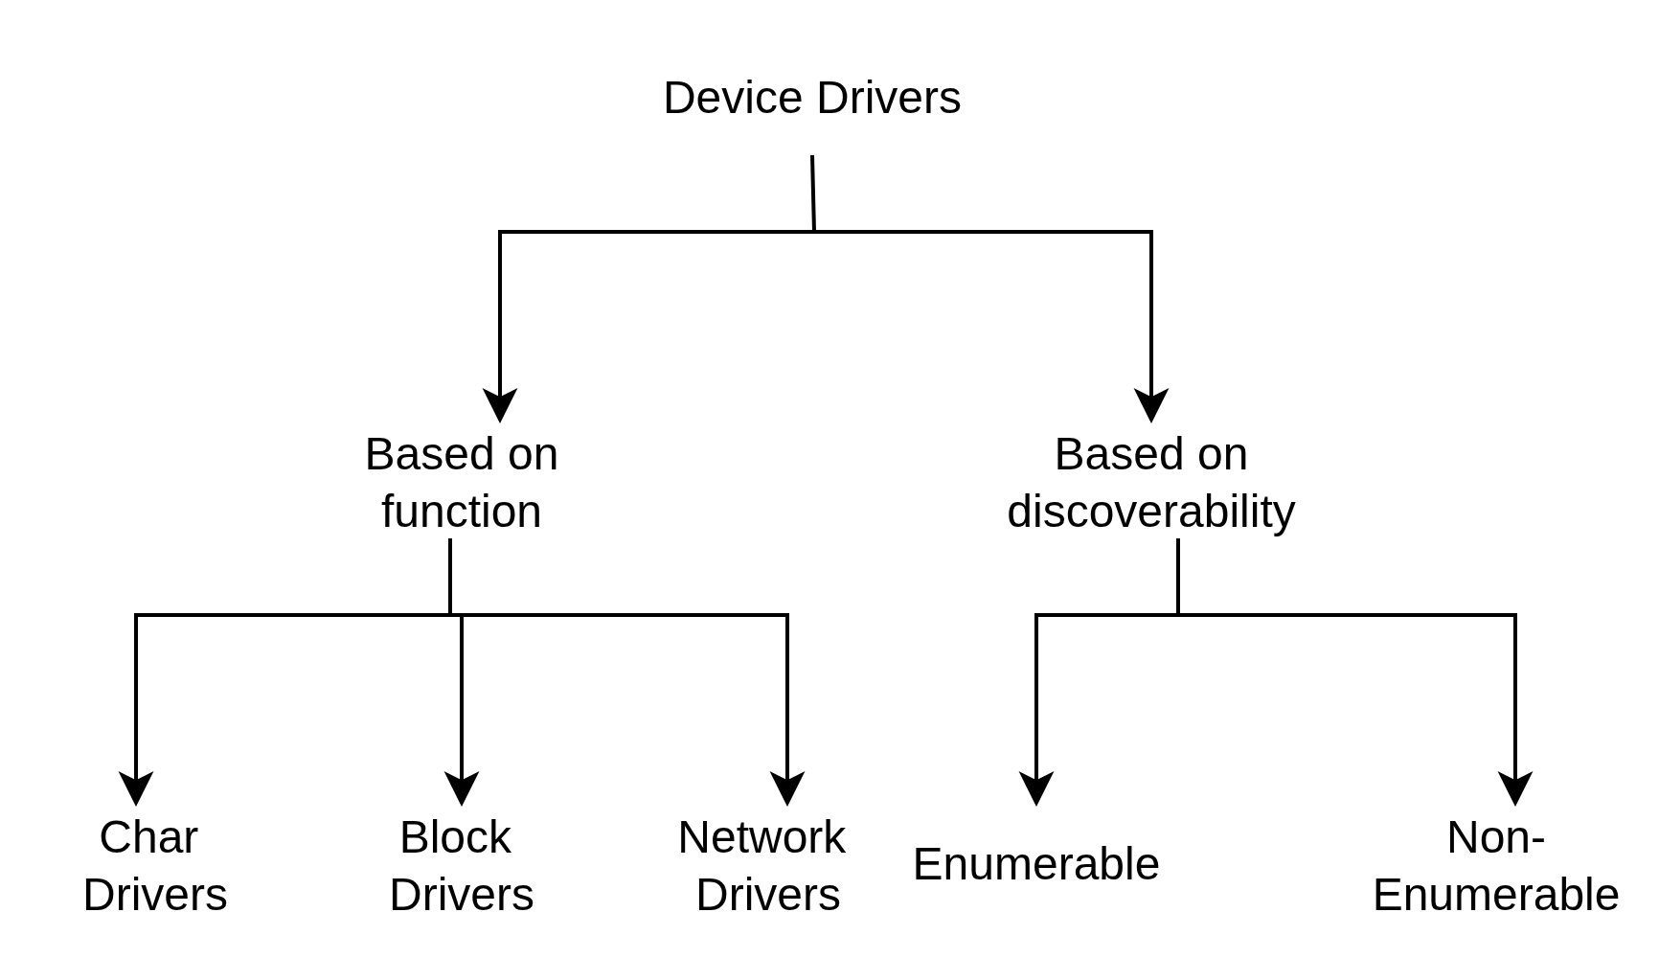
In the Linux kernel, devices are broadly classified into two categories based on how the system finds them: Enumerable (Bus-based) Devices and Non-Enumerable (Platform) Devices.
While the standard classification (Character, Block, Network) tells us what t he device does, this discoverability classification tells us how the kernel meets the hardware.
Enumerable Devices:
Enumerable devices refers to devices that can be detected and identified by a host system.
These devices live on "smart" buses. They follow a strict protocol that allows the CPU to query them. The kernel doesn't need to be told the device is there; it "scans" the bus and the device introduces itself.
Examples: USB, PCI, PCIe.
Every enumerable devices carries a digital "Passport" called a Descriptor. This is a small block of data stored in the device's firmware that tells the OS exactly what it is.
The two most important pieces of information in this passport are:
- Vendor ID (VID): A 16-bit number assigned to the company (e.g., 0x046D for Logitech).
- Product ID (PID): A 16-bit number assigned by the company to that specific model (e.g., 0xC077 for an Optical Mouse).
How it works ?
- Electrical Wake-up: The device pulls a voltage line high, signaling the Host controller that "something is plugged in."
- Generic Handshake: The Host resets the connection and talks to the device at a default "waiting room" address (Address 0).
- The Identity Query: The Host sends a GET_DESCRIPTOR command, and the device replies with its unique Vendor ID (VID) and Product ID (PID).
- Official Registration: The Host assigns the device a unique address (e.g., Address 4) to prevent it from clashing with other devices.
- Driver Search: The Kernel takes the VID/PID, scans its internal "lookup table," and loads the specific driver that matches those numbers.
- Binding: The Kernel attaches that driver to the hardware port, and the device becomes ready for use.
Plug in: The mouse says: "I am VID:046d (Logitech), PID:c077, and I belong to Class 03 (HID)."
- Step 1 (Specific): Kernel looks for a driver matching 046d:c077.
- Step 2 (Generic): If no specific driver is found, it looks for a driver matching Class 03.
- Step 3 (Bind): The generic usbhid driver "binds" to the mouse.

Non-Enumerable Devices
These are often called Platform Devices. They are "dumb" because they have no built-in logic to report their identity. They just sit at a specific memory address and wait for electrical signals.
Non-enumerable devices are typically those that cannot be discovered through standard bus enumeration mechanisms. These devices may be hardware resources that are accessed through memory-mapped registers and are often integrated into System on Chips (SoCs) or Chipsets.
Memory Mapping
In an SoC (System on Chip) like the Raspberry Pi, everything is accessed through Memory-Mapped I/O (MMIO).
The CPU has a massive range of addresses. Some addresses lead to RAM, but others are "magic" addresses that lead directly to hardware controllers (UART, I2C, etc.).
- If the CPU writes a byte to address 0xfe201000, it isn't saving a number to memory; it is physically pushing data into the UART Transmit Register.
How it works:
Since the hardware is silent, the kernel must be "fed" a description of the hardware via a Device Tree or Platform Data.
The "Map": The Device Tree tells the kernel: "At memory address 0xfe201000, there is a UART controller. It's an ARM PrimeCell PL011. Use the 'uart-pl011' driver."
Driver Matching: The kernel matches the driver based on a "compatible" string (a text name) rather than a hardware ID.

Platform Drivers Terminologies
Term | Analogy | Real-World Example (UART)
Platform Device | The "Hardware" | "I am a UART controller at address 0x3F201000."
Platform Driver | The "Operator" | "I am the PL011 driver; I know how to send characters."
Platform Bus | The "Matchmaker" | "I see a PL011 driver and a UART device; I'll connect them."
Platform Device (The Hardware Representation)
A Platform Device is a software structure in the kernel (struct platform_device) that represents a "dumb" piece of hardware. Because this hardware cannot identify itself, the kernel creates this object based on information from the Device Tree.
** It represents where the hardware is and what it is, but it doesn't know how to use it.
Platform devices are given a name, used in driver binding, & a list of resources such as addresses.

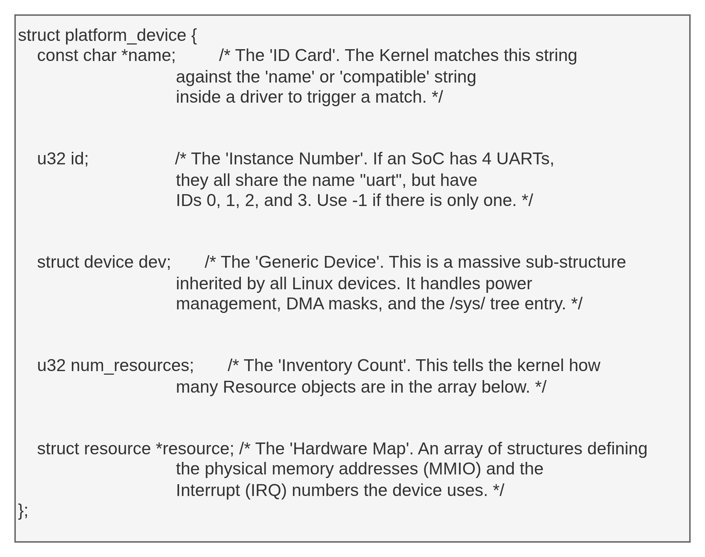

Platform Driver (The Software Logic)
A Platform Driver is the code (struct platform_driver) that contains the instructions on how to operate a specific type of hardware. It sits in the kernel waiting for a device to appear that it knows how to handle.
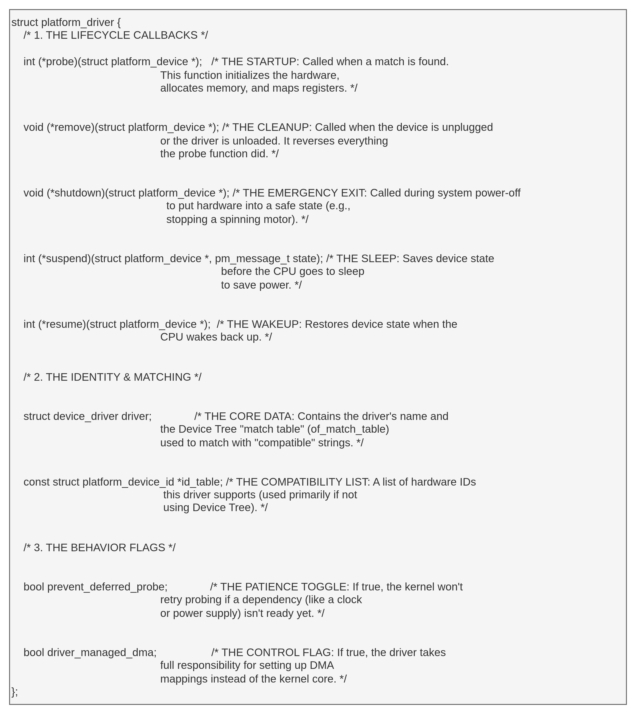
** It represents how to talk to the hardware.
While struct platform_device represents the hardware, struct platform_driver represents the software (the logic). This structure is a collection of "callback functions"—pointers to code that the kernel will run at specific moments in the device's lifecycle. They support power management and shutdown notifications using the standard conventions:
Platform Bus (The Matchmaker)
In Linux, every device must live on a "Bus." While USB devices live on the USB Bus, "dumb" SoC devices live on a virtual bus called the Platform Bus.
The Platform Bus is a pseudo-bus (it doesn't physically exist like a wire; it's a software construct). Its primary job is Matching. i.e, it connects the Device (Hardware Info) to the Driver (Software Logic).
Dummy Platform Driver code : Educational
dummy_platform.c
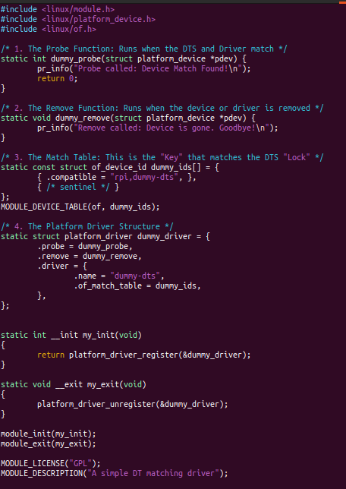
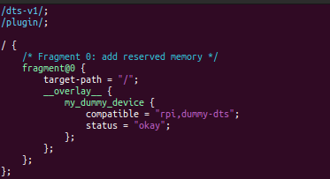
dummy_overlay.dtso
struct of_device_id: This is a standard template (a form) provided by Linux. "OF" stands for Open Firmware, which is the historical name for Device Tree technology.
- dummy_ids[]: This is just the name of the list. You can call it anything, but we usually use something like ids or match_table.
MODULE_DEVICE_TABLE(of, summy_ids): exports this list. It tells the Kernel's "Hotplug" system: "Hey, if you ever see hardware with the 'compatible' strings found in magic_ids, please wake me up and load this driver!"

1. platform_driver_register
When your driver module is loaded into the kernel, it needs to announce its presence. It calls platform_driver_register to hand its the struct platform_driver to the Kernel.
- What it does: It adds your driver to a linked list of "Platform Drivers" that the kernel manages.
- The Matchmaking Trigger: The moment you call this, the kernel immediately takes your driver's Match Table and starts scanning all the Device Tree nodes that don't have a driver yet.
- The Result: If it finds a match (e.g., rpi,dummy_dts), the kernel immediately calls your probe() function.

2. platform_driver_unregister
When you want to remove your driver (for example, by running sudo rmmod), the kernel must clean up.
- What it does: It tells the kernel, "I am no longer available to handle hardware. Take me off your list."
- The Cleanup Trigger: If your driver was currently "bound" to a piece of hardware, the kernel will first call your .remove() function to safely shut down the hardware before removing the driver from the system.
- Why it's vital: If you remove a driver without unregistering it, the kernel might try to call the driver’s code later, find that the code is gone, and crash (Kernel Panic).
Probe()
probe() is the first function called by the kernel once a match is found between your driver and a Device Tree node. Here initialization for a specific piece of hardware is done.
The probe() function's responsibility is to make the hardware actually usable by the operating system. When it runs, it usually performs these four steps:
- Get hardware resources
- Initialize hardware
- Allocate driver private data
- Register kernel interfaces
- Make device usable
APIs used
- platform_get_resource - get a resource for a device
platform_get_resource() fetches resources from the platform_device structure, and those resources were already populated earlier by the kernel from the Device Tree (or board files).
dev - platform device
type - resource type
Type | Meaning
IORESOURCE_MEM | Memory-mapped registers
IORESOURCE_IRQ | Interrupt number
IORESOURCE_DMA | DMA channel
IORESOURCE_IO | I/O ports (x86)
num - resource index -> Devices can have multiple resources of same type.
reg = <0x1000 0x100>,
<0x2000 0x100>;
platform_get_resource(pdev, IORESOURCE_MEM, 0);
platform_get_resource(pdev, IORESOURCE_MEM, 1);
Returns :
platform_get_resource() does NOT parse DTS.
It simply returns: &pdev->resource[index]
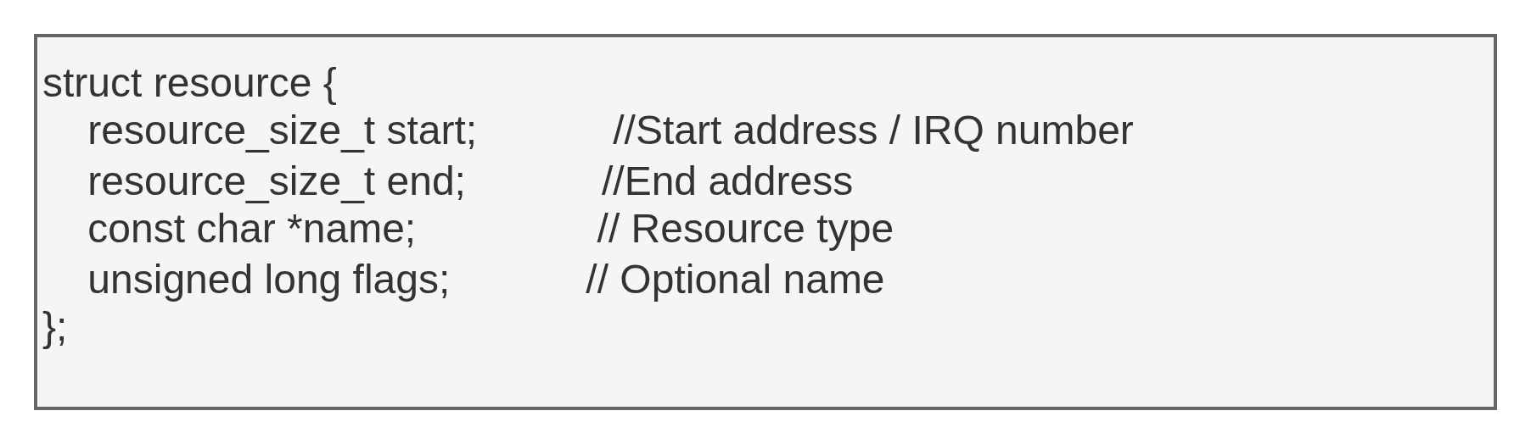
- devm_ioremap_resource() - It reserves, validates, and maps a physical MMIO resource into kernel virtual address space, using device-managed lifetime handling.
Does 3 steps internally
Validates resource types : res->flags & IORESOURCE_MEM
Reserves memory region : request_mem_region(res->start, size, dev_name(dev));
-> This prevents two drivers from using same registers.
Maps physical to kernel virtual address : ioremap(res->start, resource_size(res));
Registers devm cleanup handler : When driver removed
Kernel automatically iounmap(), release_mem_region()
Returns:
A pointer to the mapped MMIO region - void __iomem *base;
On failure returns ERR_PTR(-ENOMEM), ERR_PTR(-EBUSY), ERR_PTR(-EINVAL)
Why __iomem matters
-> Tells sparse/static analyzers this pointer refers to I/O memory
-> Prevents accidental dereferencing like normal RAM
-> Forces use of helpers: readl, writel
3. platform_set_drvdata, platform_get_drvdata
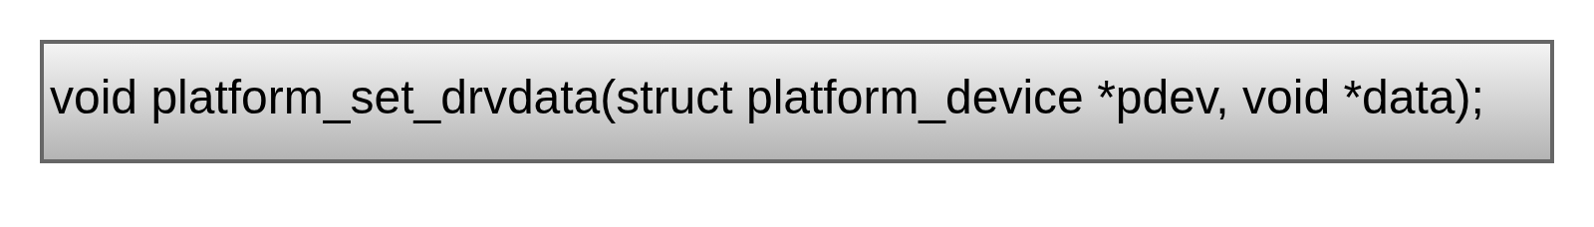
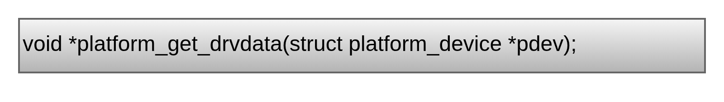
It stores a pointer (data) inside the platform_device structure so that the driver can retrieve it later.
i.e, pdev->dev.driver_data = data;
i.e, data = pdev->dev.driver_data;

