Kernel Threads
Threads
A thread is an independent flow of control that operates within the same address space as other independent flows of control within a process.

One process can have multiple threads, with each thread executing different code concurrently, while sharing data and synchronizing much more easily than cooperating processes. Threads require fewer system resources than processes, and can start more quickly. Although threads can be scheduled, they exist in the context of their process.

- The following list indicates what is managed at process level and shared among all threads within a process:
  - Address space
  - System resources, like files or terminals
  - Signal list of actions.
- The process remains the swappable entity. Only a few resources are managed at thread level, as indicated in the following list:
  - State
  - Stack
  - Signal masks.
Kernel threads
These threads run in kernel space and have full access to kernel memory and resources. Device drivers often use kernel threads for tasks that need to run asynchronously or in the background, such as handling interrupts or managing hardware resources.
The TCB, in the Linux kernel, is represented by the task_struct. It's a data structure that contains all the information needed to manage a thread. Think of it as the thread's identity card and management center all rolled into one!
- Thread ID (TID) and Process ID (PID): Unique identifiers.
- State: The current state of the thread (e.g., running, sleeping, ready).
- Stack pointer: Pointer to the thread's kernel stack.
- Program counter: The address of the next instruction to be executed.
- Registers: CPU registers.
- Scheduling information: Priority, scheduling policy, etc.
- Memory management information: Pointers to memory maps.
- File system information: Open files, current working directory.
- Signal information: Signal handlers and masks.
- Parent process: Pointer to the parent process's task_struct.
- List of children: Pointers to child processes' task_structs.
- CPU usage: Accounting information.
Where it is stored?
The task_struct is stored in kernel memory. When a new thread or process is created, the kernel allocates memory for its task_struct. The location is dynamic and managed by the kernel's memory allocator. You can get a pointer to the current thread's task_struct using the current macro in kernel code.
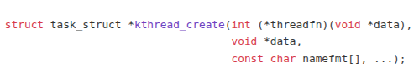
APIs Used
Necessary headers: linux/kthread.h
1) Kernel Thread Create
Parameters
threadfn → Function pointer to the thread’s main function.
Must return int and take a void * argument.
Should periodically check kthread_should_stop() to know when to exit.
data → Pointer to data passed to the thread function.
namefmt → Thread name format string (like printf), followed by optional arguments.

Return Value
On success → Pointer to a task_struct representing the new thread (but not started yet).
On failure → ERR_PTR(error_code).
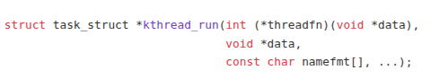
**** kthread_create() only creates the thread; it does not start it. You must call wake_up_process() to start execution.
int wake_up_process(struct task_struct *task);
2) Thread Create + Run
This is a handy wrapper around kthread_create() and wake_up_process(). It creates a kernel thread and immediately wakes it up to start running. It's a convenient way to get a thread up and running quickly.
On success → Pointer to a task_struct representing the new thread.
On failure → ERR_PTR(error_code).
3) kthread_should_stop():
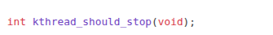
Inside your kernel thread function, periodically call this function. It checks if the thread has been signaled to stop. If it returns true, your thread should exit gracefully
Return value:
- 1 (true) → The thread should exit.
- 0 (false) → Continue running.
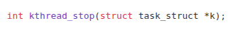
4) kthread_stop().
It is a Linux kernel API used to stop a kernel thread that was created with kthread_create() or kthread_run().

