Day10
-----
date and time modules in python → datetime, tzinfo, zoneinfo, time, pytz

Packages- collections of modules
------------------------------
add the `__init__.py` file in the root folder.
- Not necessary to initialize
- you do it when you want to explicitly define your package folder
- execute some code or set package level variables or initialize components
- using the file to expose only specific functions or classes
- cleaner import statements
- some frameworks or tools may require this file to correctly identify directories as packages

importing package
folder used: day10
- let’s say we have three print statements one in `__init__.py` file and other two in the modules (called at module level) within the package folder
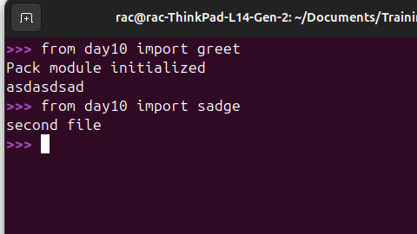
- On importing the package we will get only one print statement called from the `__init__.py` file.
- Once package is initialized in a python process it need not be executed again for subsequent submodule imports
- we know on `import package`, `__init__.py` is executed.
- Therefore we can add what all needs to be executed in the `init` file like say `sadge.py` I can add import statement in init file. `from . import sadge` or `from .greet import greet`.
.toml file → what is the use of this file? →
→ dependency tree
` requirements.txt usage
→ Site packages?
-----------------------------
requests module
-----------------------------
→ Microservices -
→ REST API discussion
→ CRUD ops etc
→ request URL params

--------------
Tasks given
---------------
-- explore http status codes
-- come up with some functionality using weatherapi.com API. (3 to 4 functionalities)
-- query train API IRCTC?
-- weather.gov (explore) https://mausam.imd.gov.in/(explore documentation)
-- Generate the normally distributed records (data is normally distributed, give me the values)
-- tomorrow exam

