Name: Shweta Chauhan
Lab: Lab 1
Date: 3/17/2022

- Program Description:
The purpose of this program is to print name, lab name and current date an dtime. To print, I have used the print() function. Passed the variables inside the print() function with formatting to include spaces before the output.
In addition to that I have imported the datetime class from datetime module in my source code. I have used the now() function from datetime class to get the current date and time. I have also used strftime() function to convert date and time objects to their string representation. The format uses abbreviated month name followed by day of the month and year. I have used a 12 hour clock format for printing in the format HH:MM:SS with the locale’s AM or PM.

- Program Source Code:
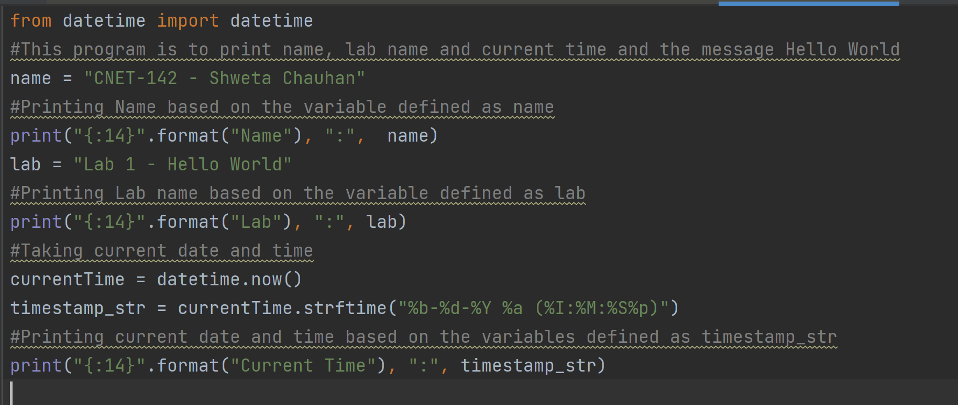

- Program Output

