Name: Shweta Chauhan
Lab: Lab 2
Date: 3/20/2022

- Program Description:
The purpose of this program is to calculate car efficiency based on inputs from the user for miles per gallon, capacity and cost per gallon. Once the car efficiency is calculated, the program display how efficient is the car. To get inputs from the suer I have used input() function. Based on the inputs, cost of driving 100 miles and distance on a tank of gas is calculated.
After that if, elif and else statements are used to examine how efficient the car is based on miles per gallon. In order to do that comparison operators are used within if else statements to reach the results.

- Program Source Code:
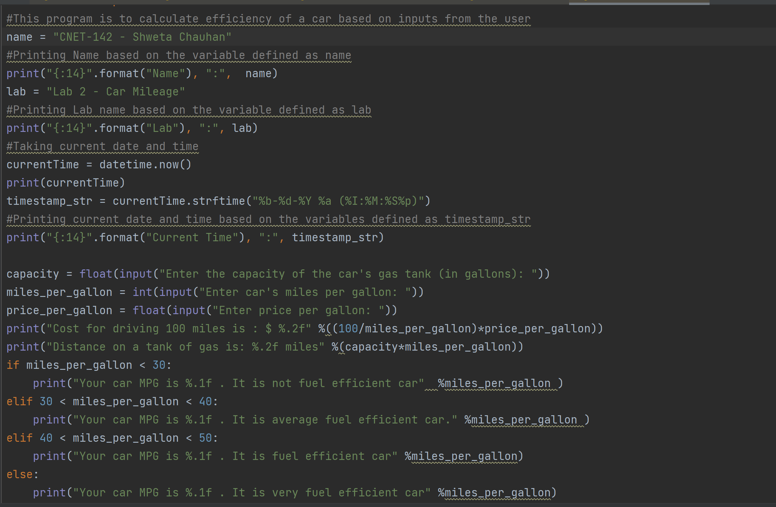

- Program Output
Test Case #1
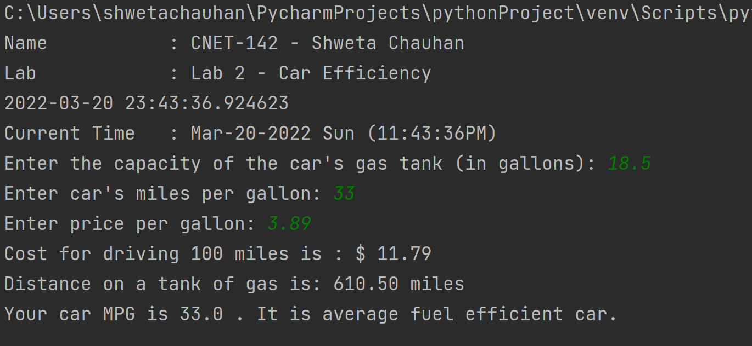

Test Case #2
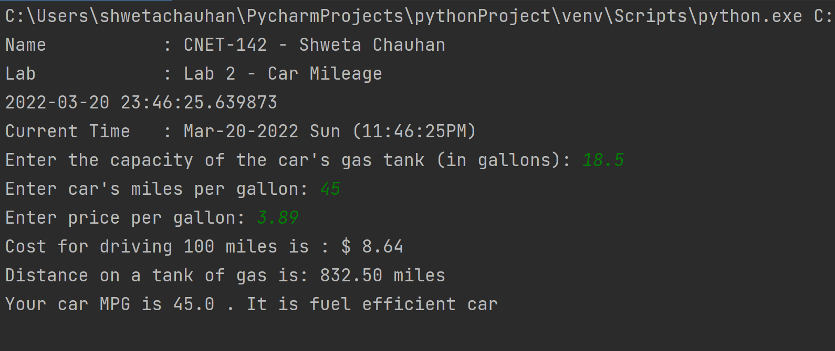

Test Case #3
