Name: Shweta Chauhan
Lab: Lab 3
Date: 4/3/2022
- Program Description:
The purpose of this program is to calculate interest rate based on inputs given by the user and running these inputs in a while loop . The program shows how a while loop can be run multiple times to collect user inputs till conditions are met. Here we used input function to collect user inputs for principal, rate of interest, time and how many time a year the interest was compounded. Based on these values, total and interest paid was calculated. The user was asked to input the values multiple times, till the user entered 0 upon which the program exits. To print name and time,, function call was used and function defined in another program was imported into the source code of this program.
- Program Source Code:
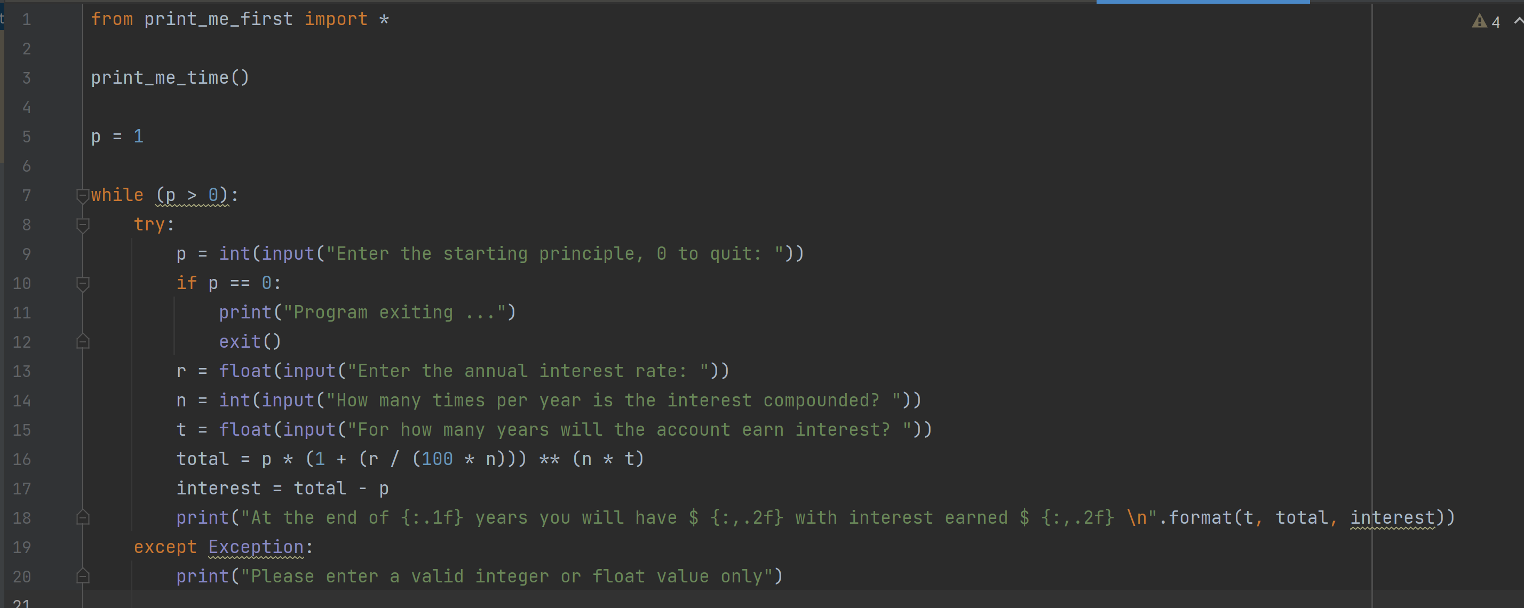
- Program Output
