Name: Shweta Chauhan
Lab: Lab 4
Date: 4/10/2022
- Program Description:
The purpose of this program is to calculate interest rate and mortgage based on user inputs. The program uses functions defined in different programs which are called from a main program which is where the program execution begins.
There are in totdal 4 functions defined.- Mortgage, Interest calculator, print user and main. Main function is the starting point of program and based on inputs different functions are called.
- Program Source Code:
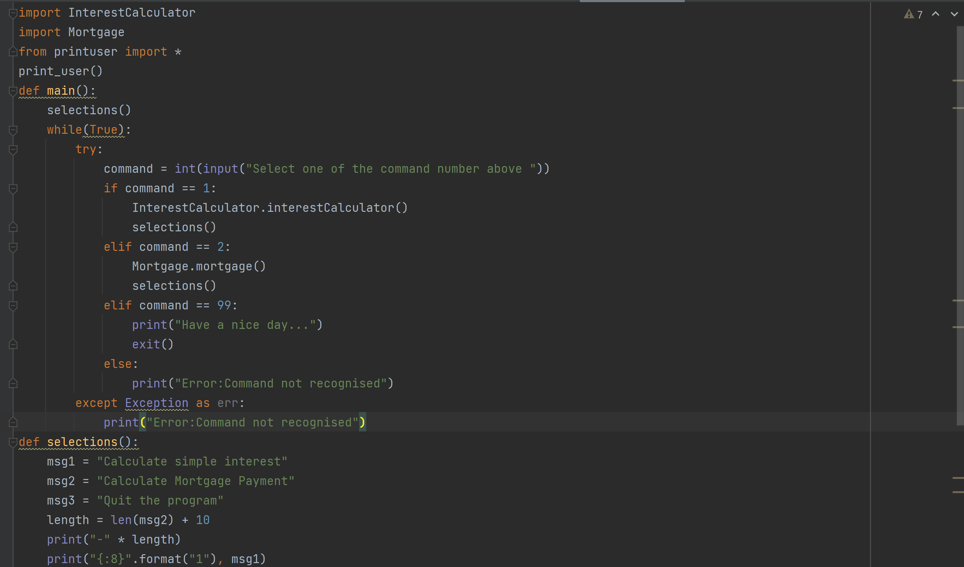
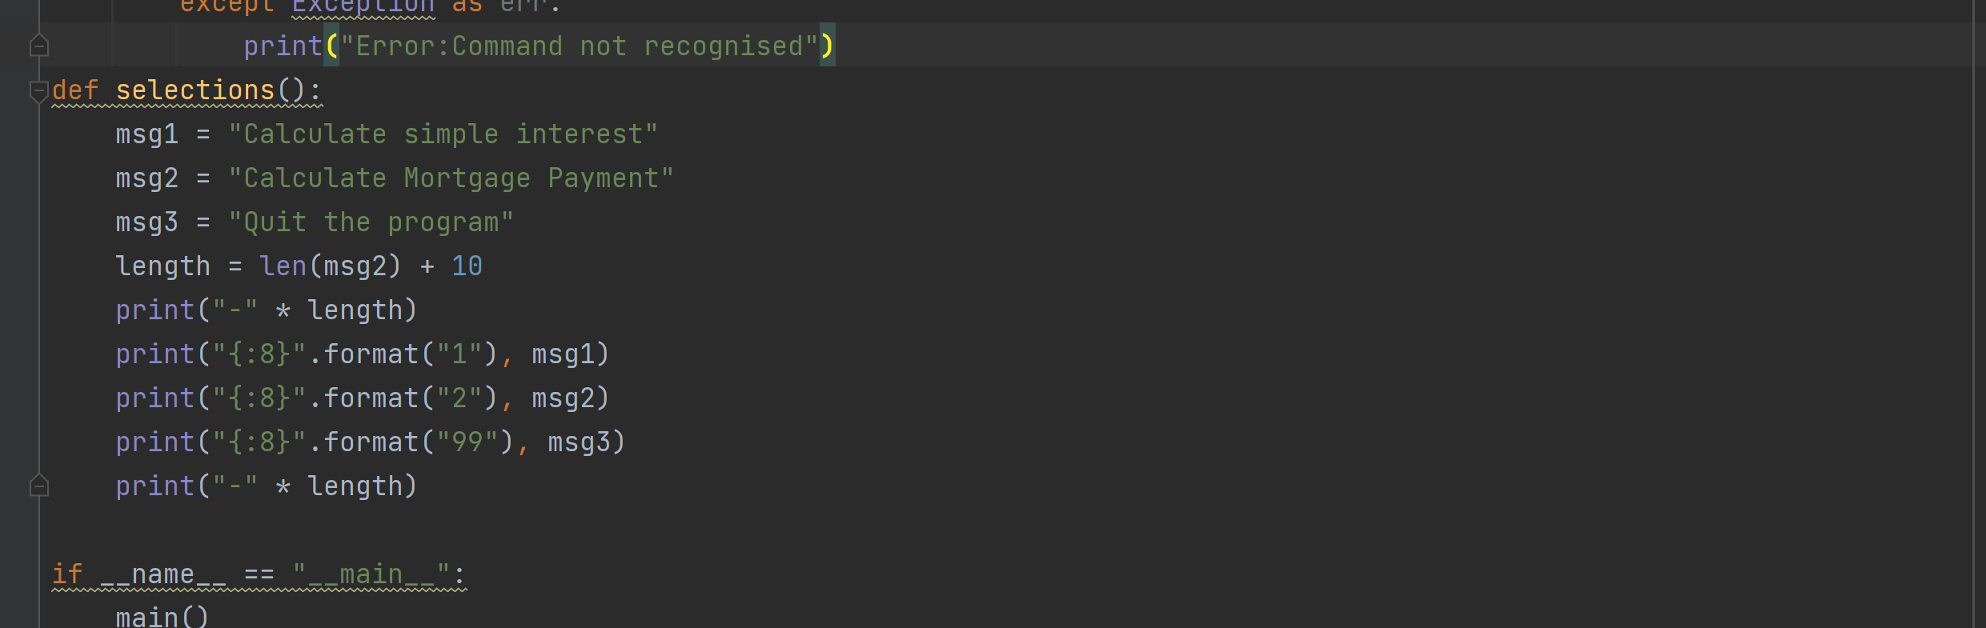
- Program Output
