Name: Shweta Chauhan
Lab: Lab 4
Date: 4/10/2022
- Program Description:
The purpose of this program is to read data from a file and make use of lists and tuple and output contents of the file. The information that’s calculated form the file is no of lines, characters, words etc.
- Program Source Code:

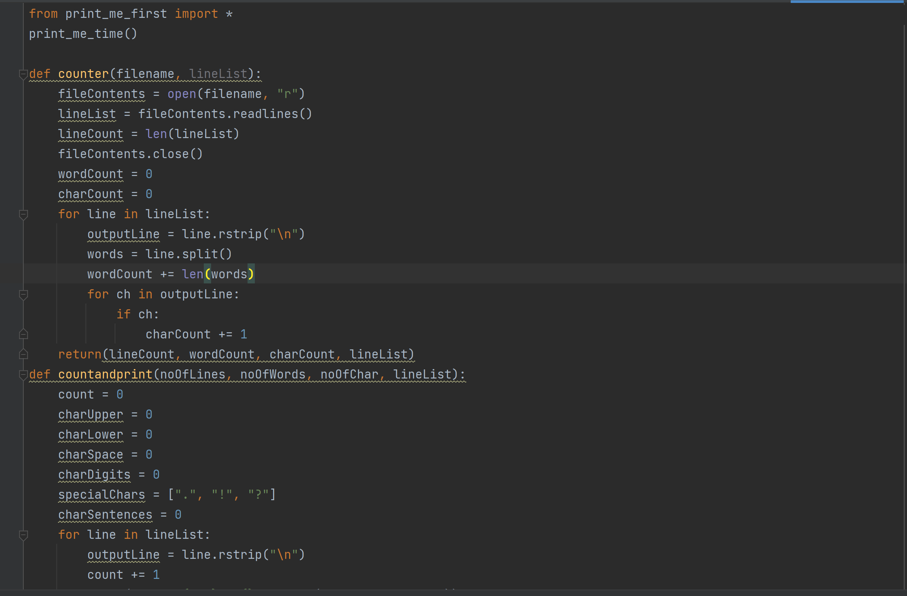
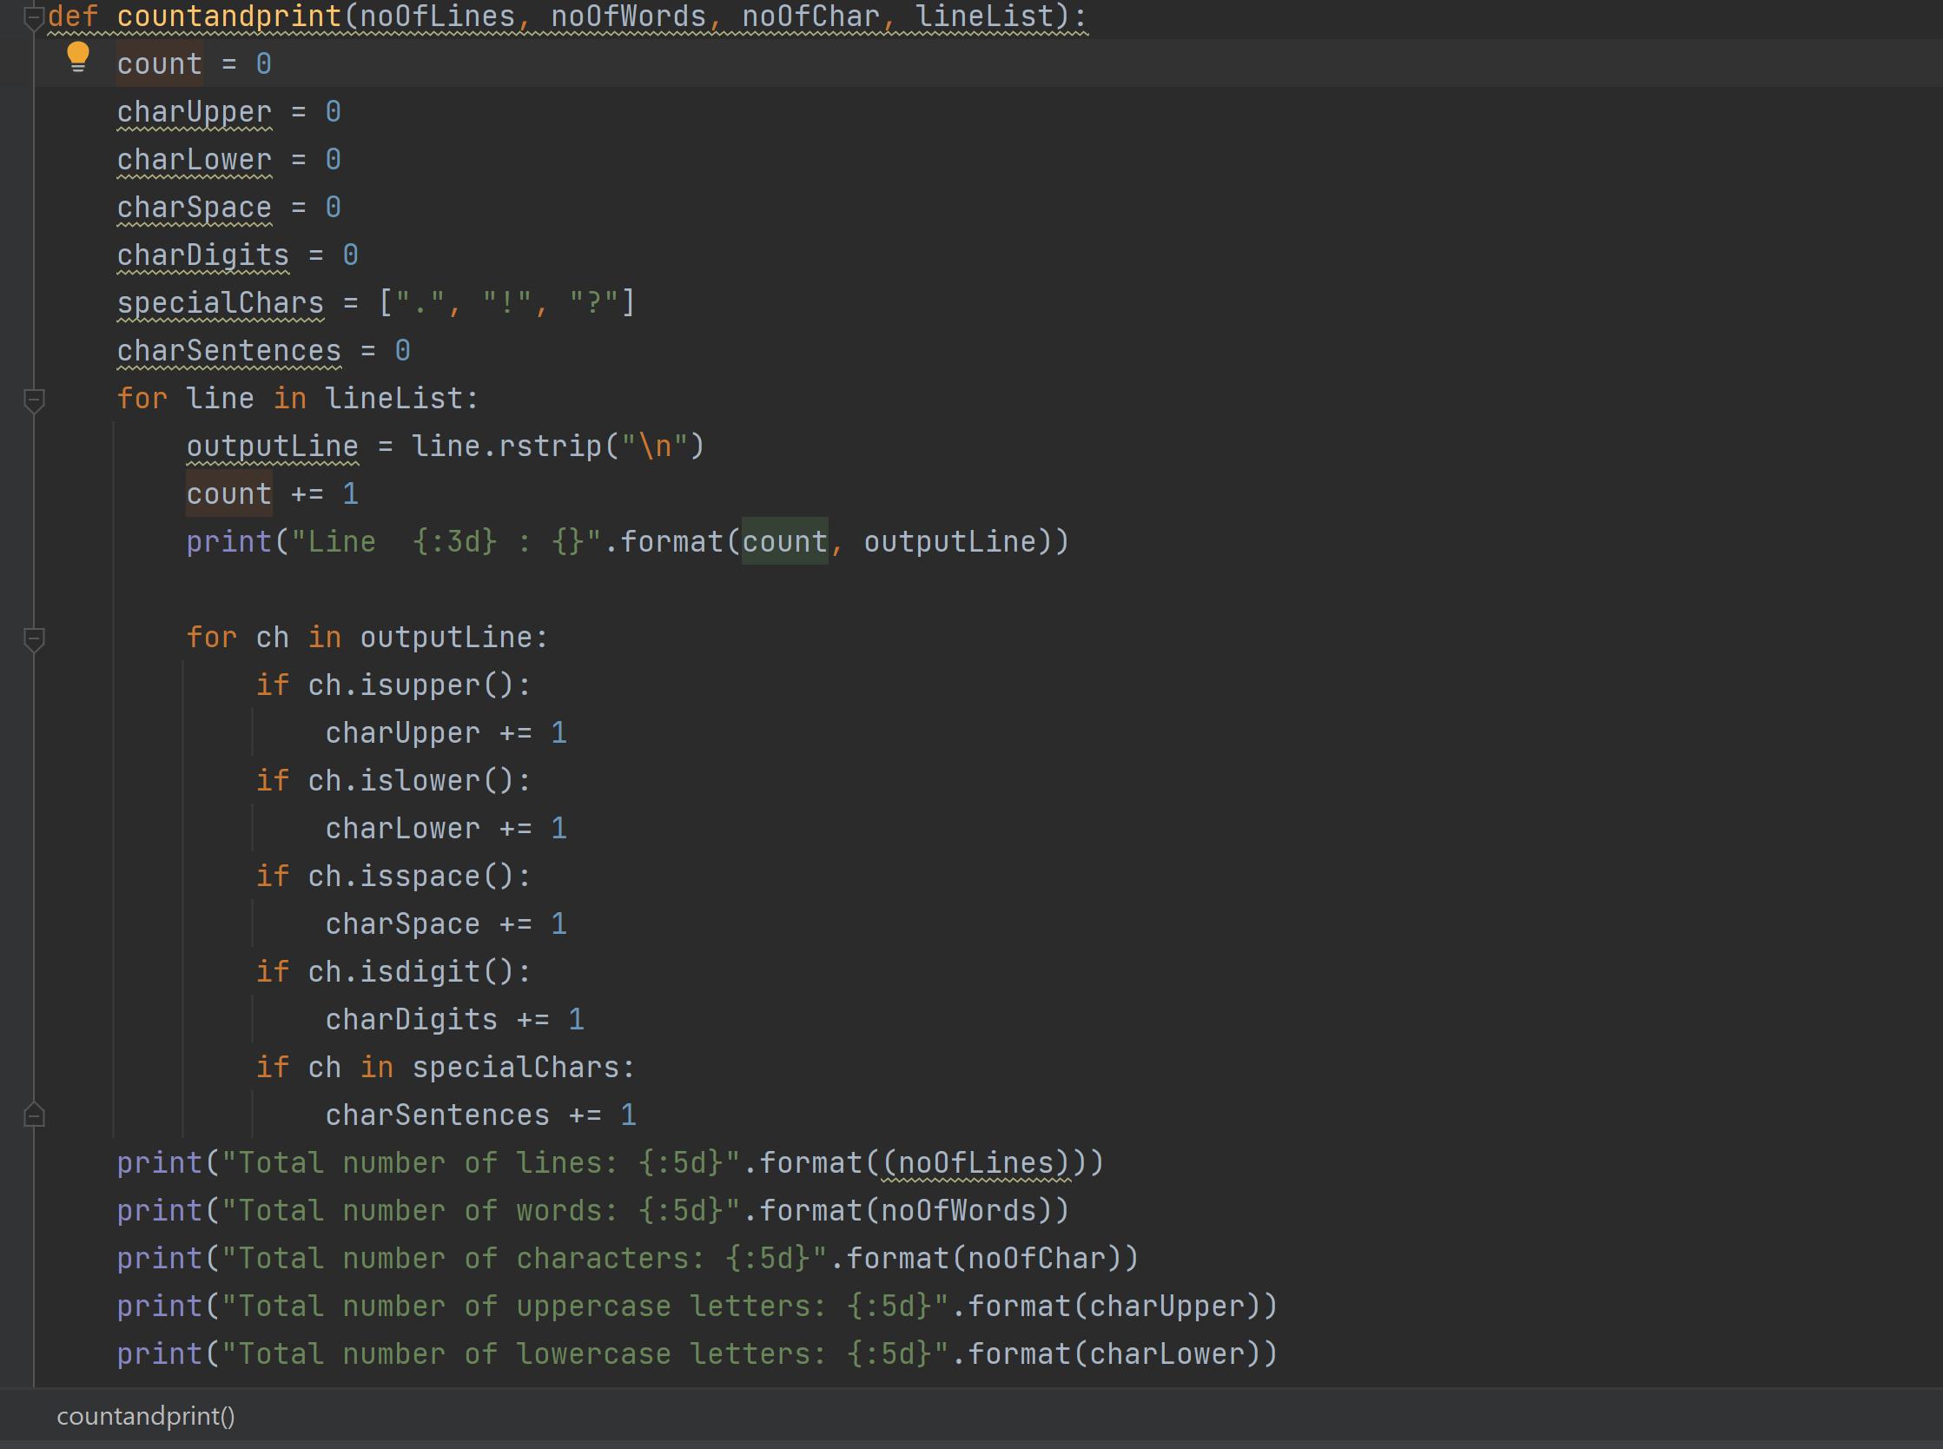
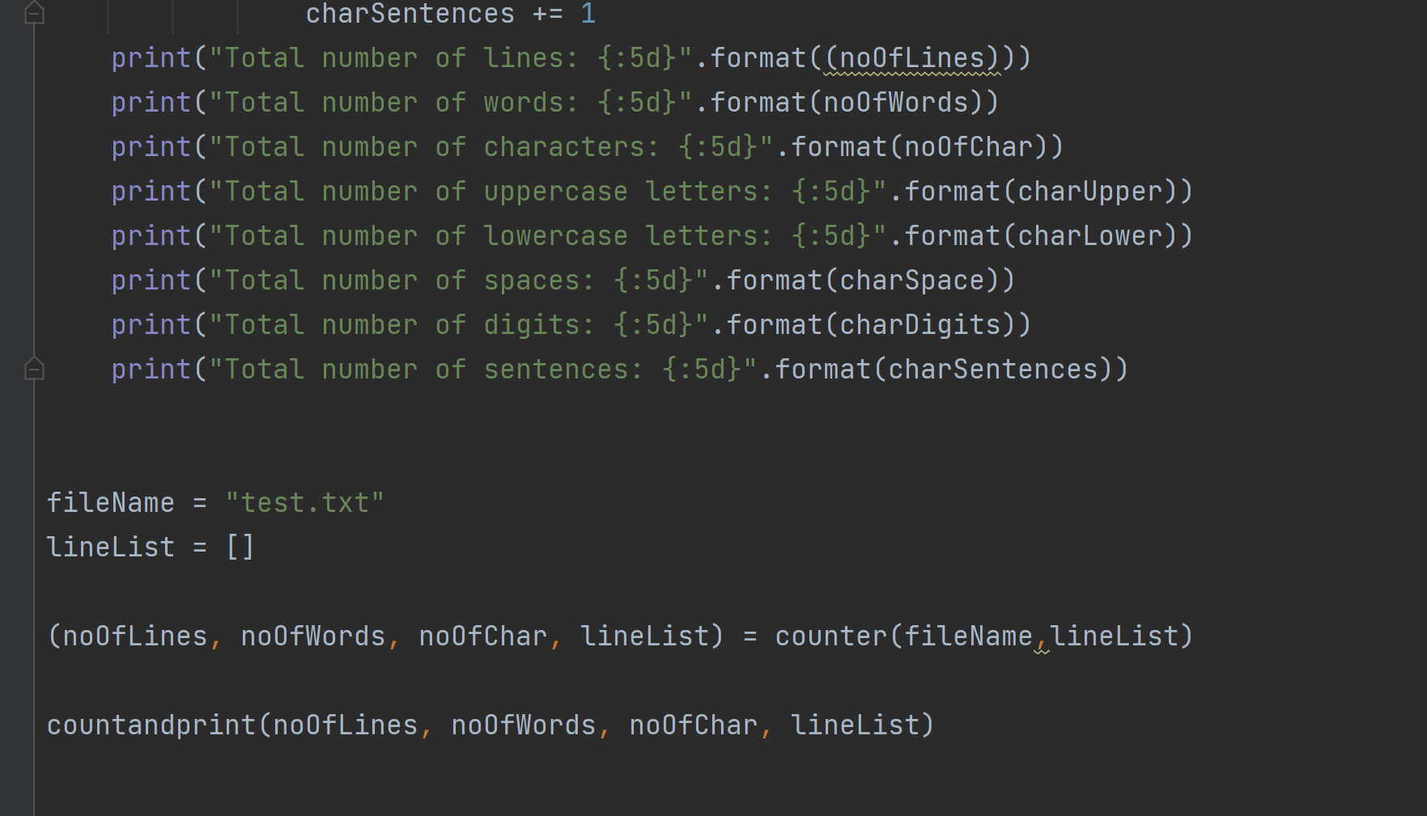
- Program Output
