Name: Shweta Chauhan
Lab: Lab 6
Date: 4/24/2022
- Program Description:
The purpose of this is to create a dictionary. This dictionary is then passed on to a Json file, which is first created and contents of dictionary are loaded into it. Once the Json file is created, a dictionary is then used to read its contents. The values of the dictionary are then searched to find required values within it.
In this program, we have learnt the concept of dictionary, nested dictionary and reading their values, and json files.
- Program Source Code:
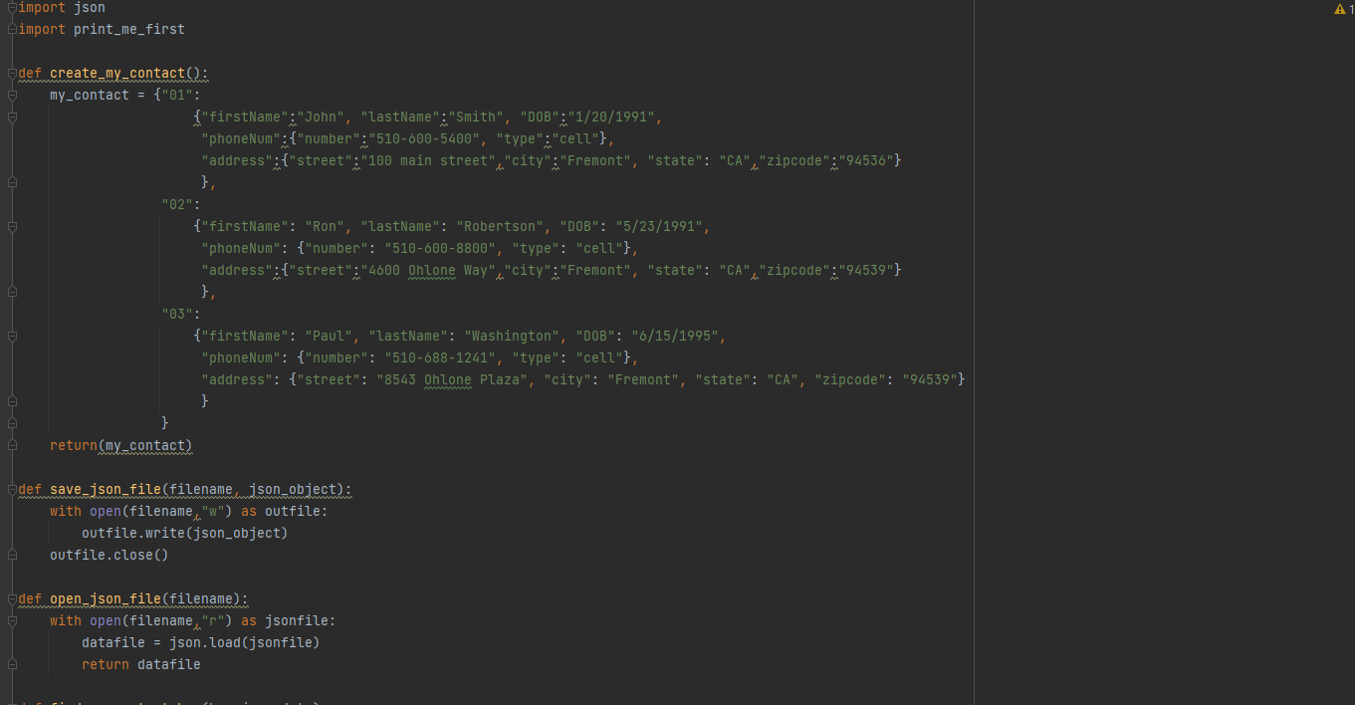
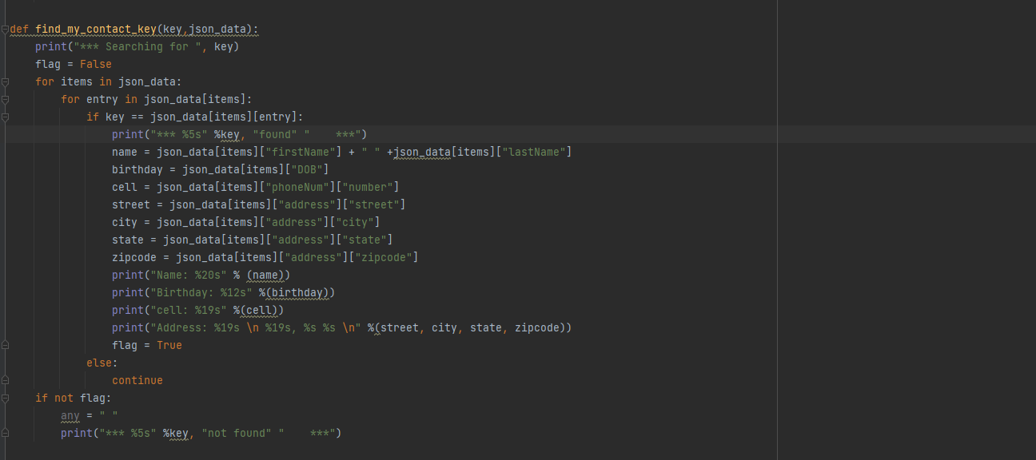
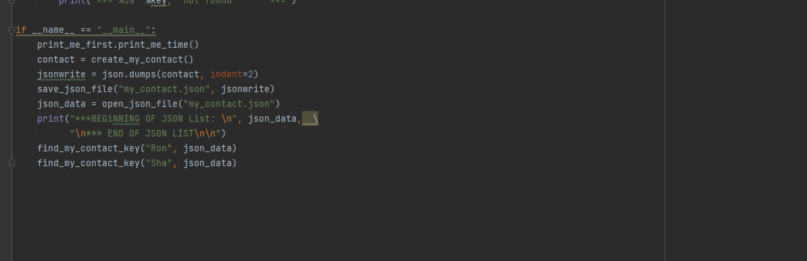
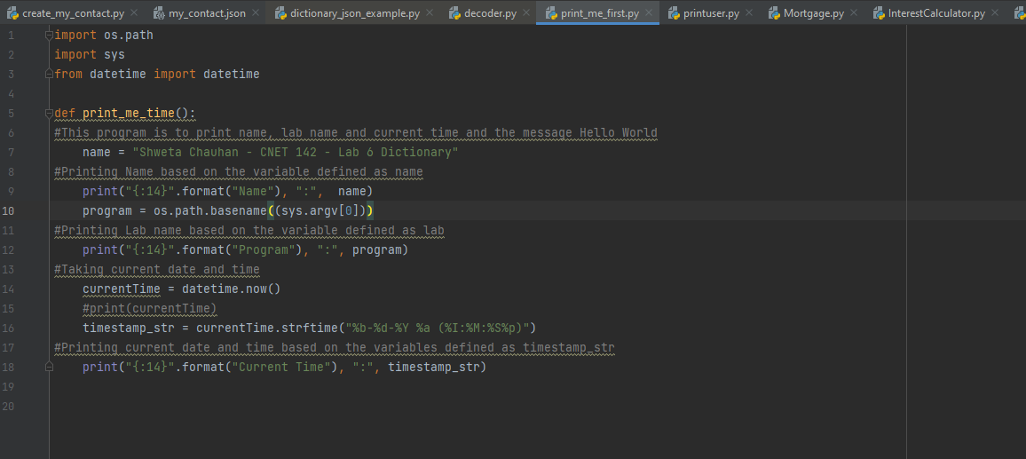

- Program Output
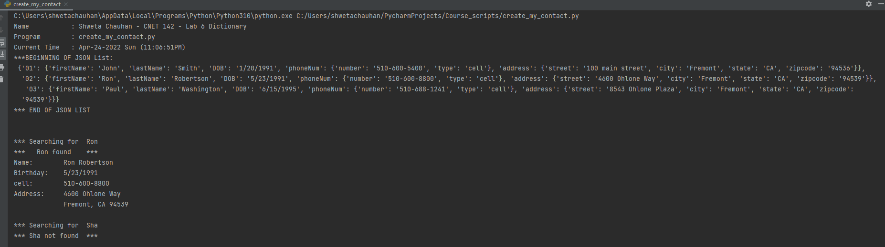

Json file Output:
