Name: Shweta Chauhan
Lab: Lab 7
Date: 5/1/2022
- Program Description:
The purpose of program is to use Python’s turtle library to create a GUI which shows the map os USA in the background. The program then prints flag of USA, Olympic rings . In addition tpo that using turtle’s write function, the heading for the screen is written as US Olympic team followed by Name, time and program name on bottom right corner of the screen. There are 3 programs used- main program where the Olympic rings are printed, US flag program which is imported in the Olympic Rings program, print me program which is again imported in the Olympic rings program. Source code for all the 3 programs are given below
- Program Source Code:

Olympic Rings:
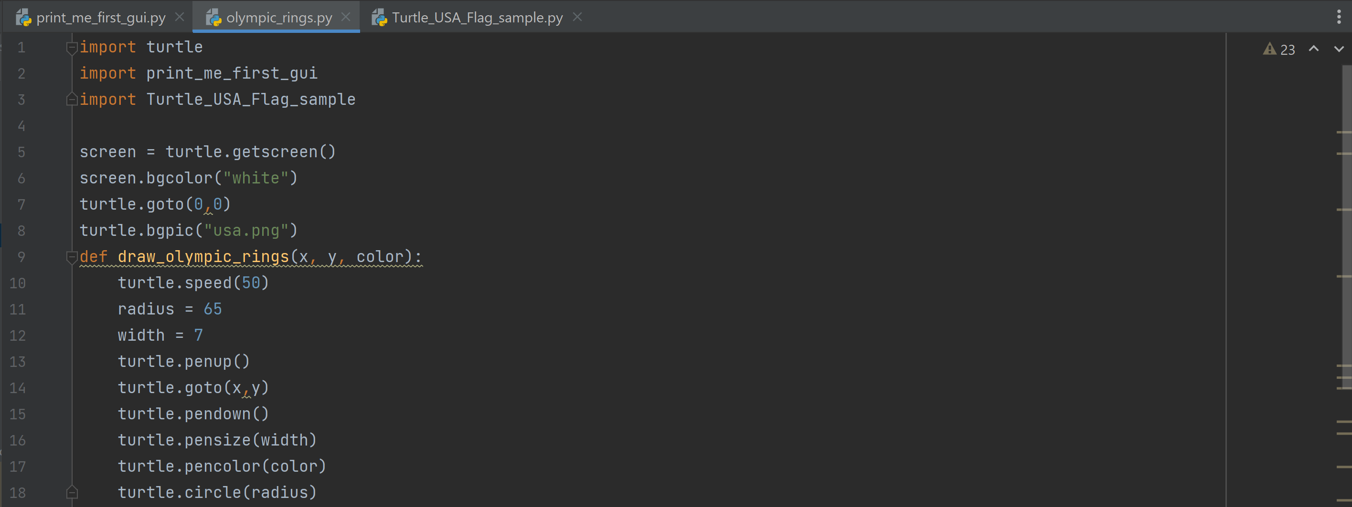
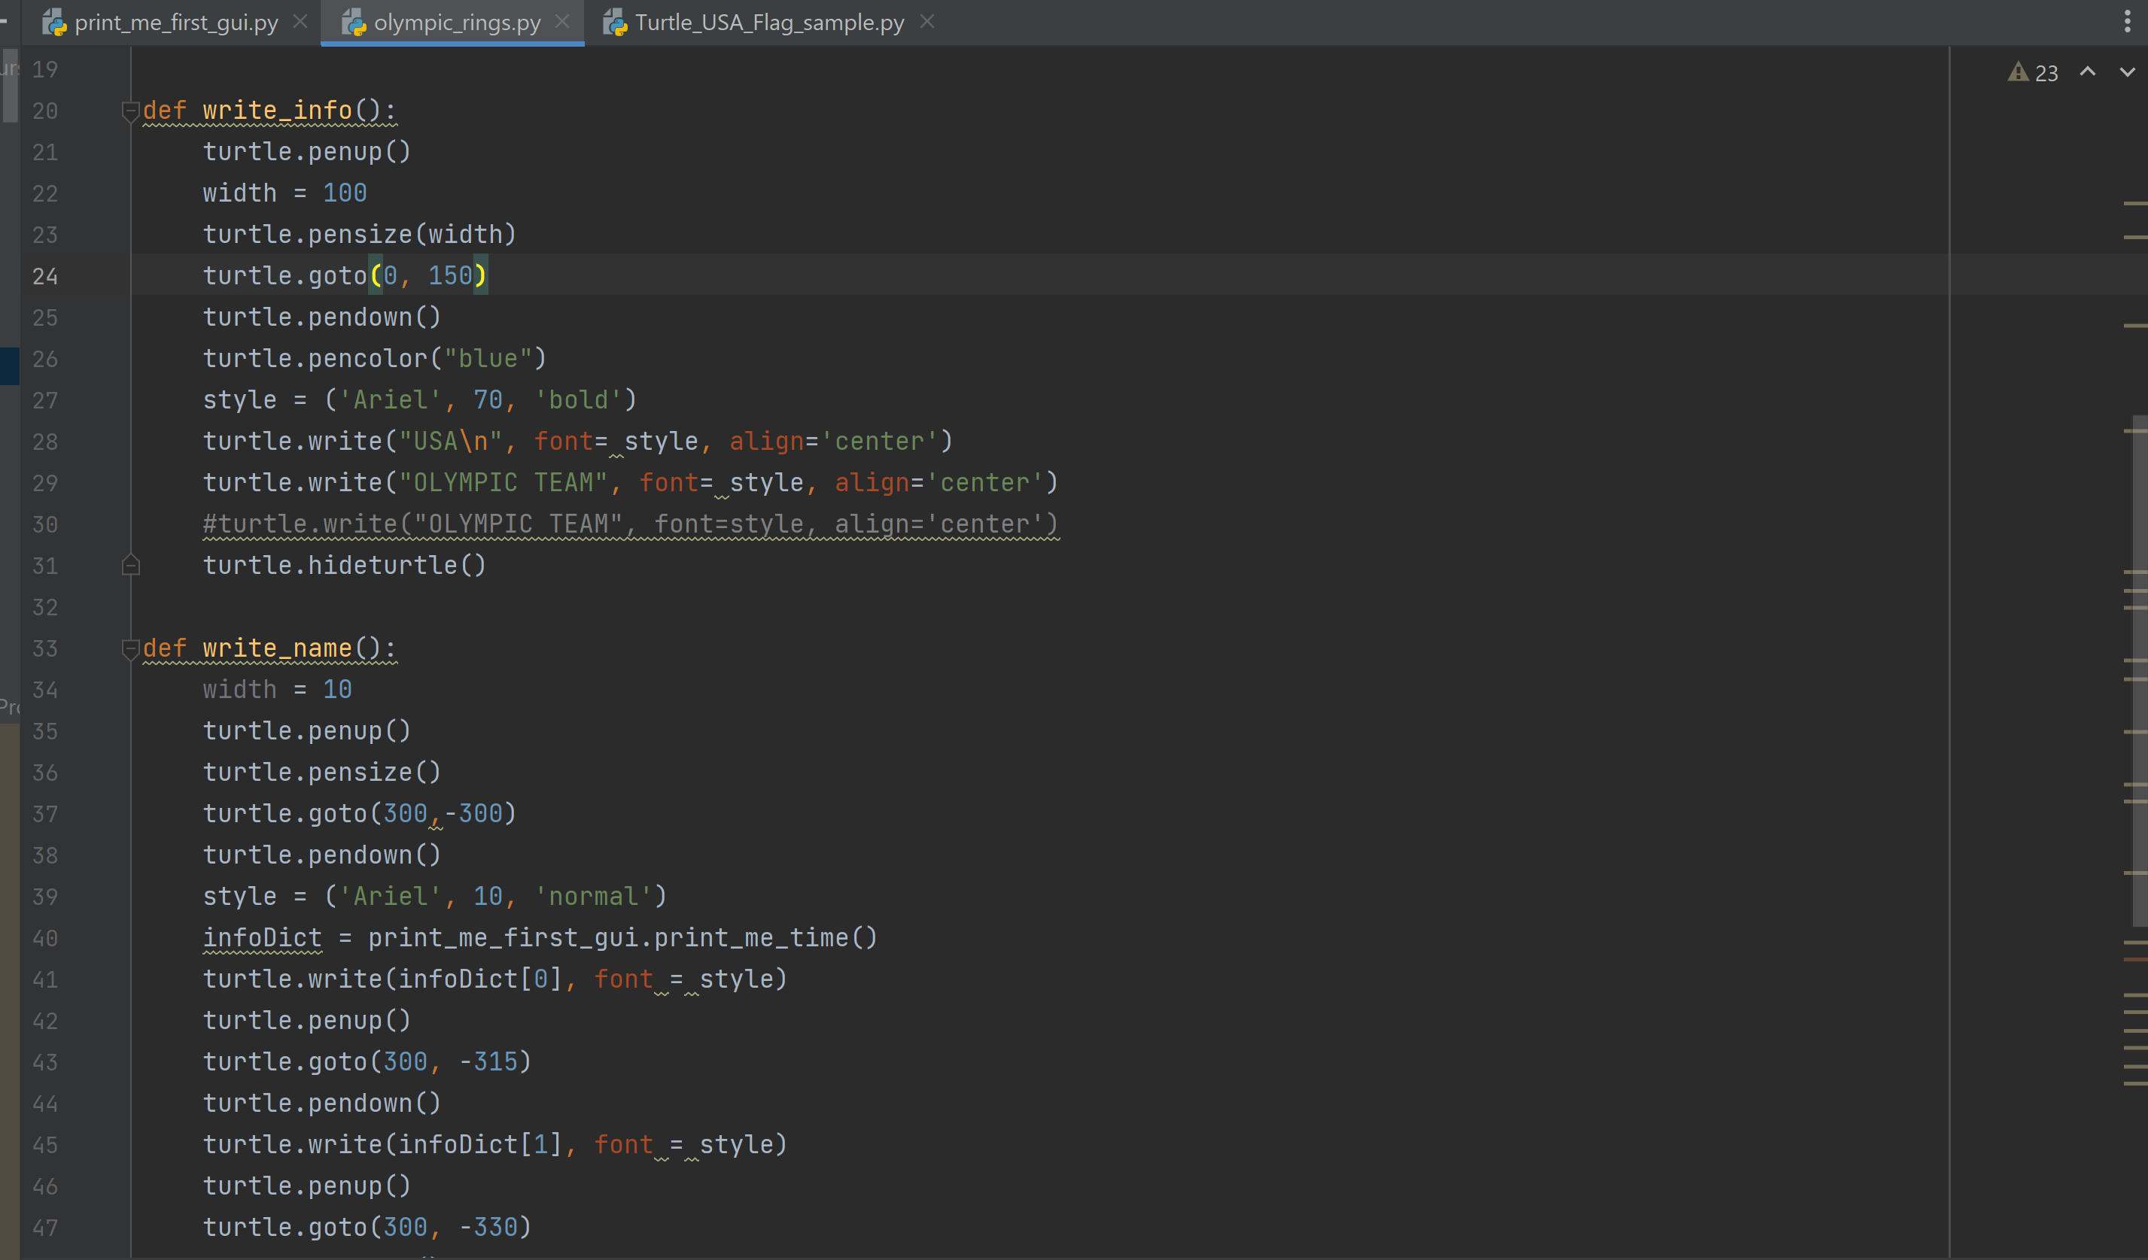
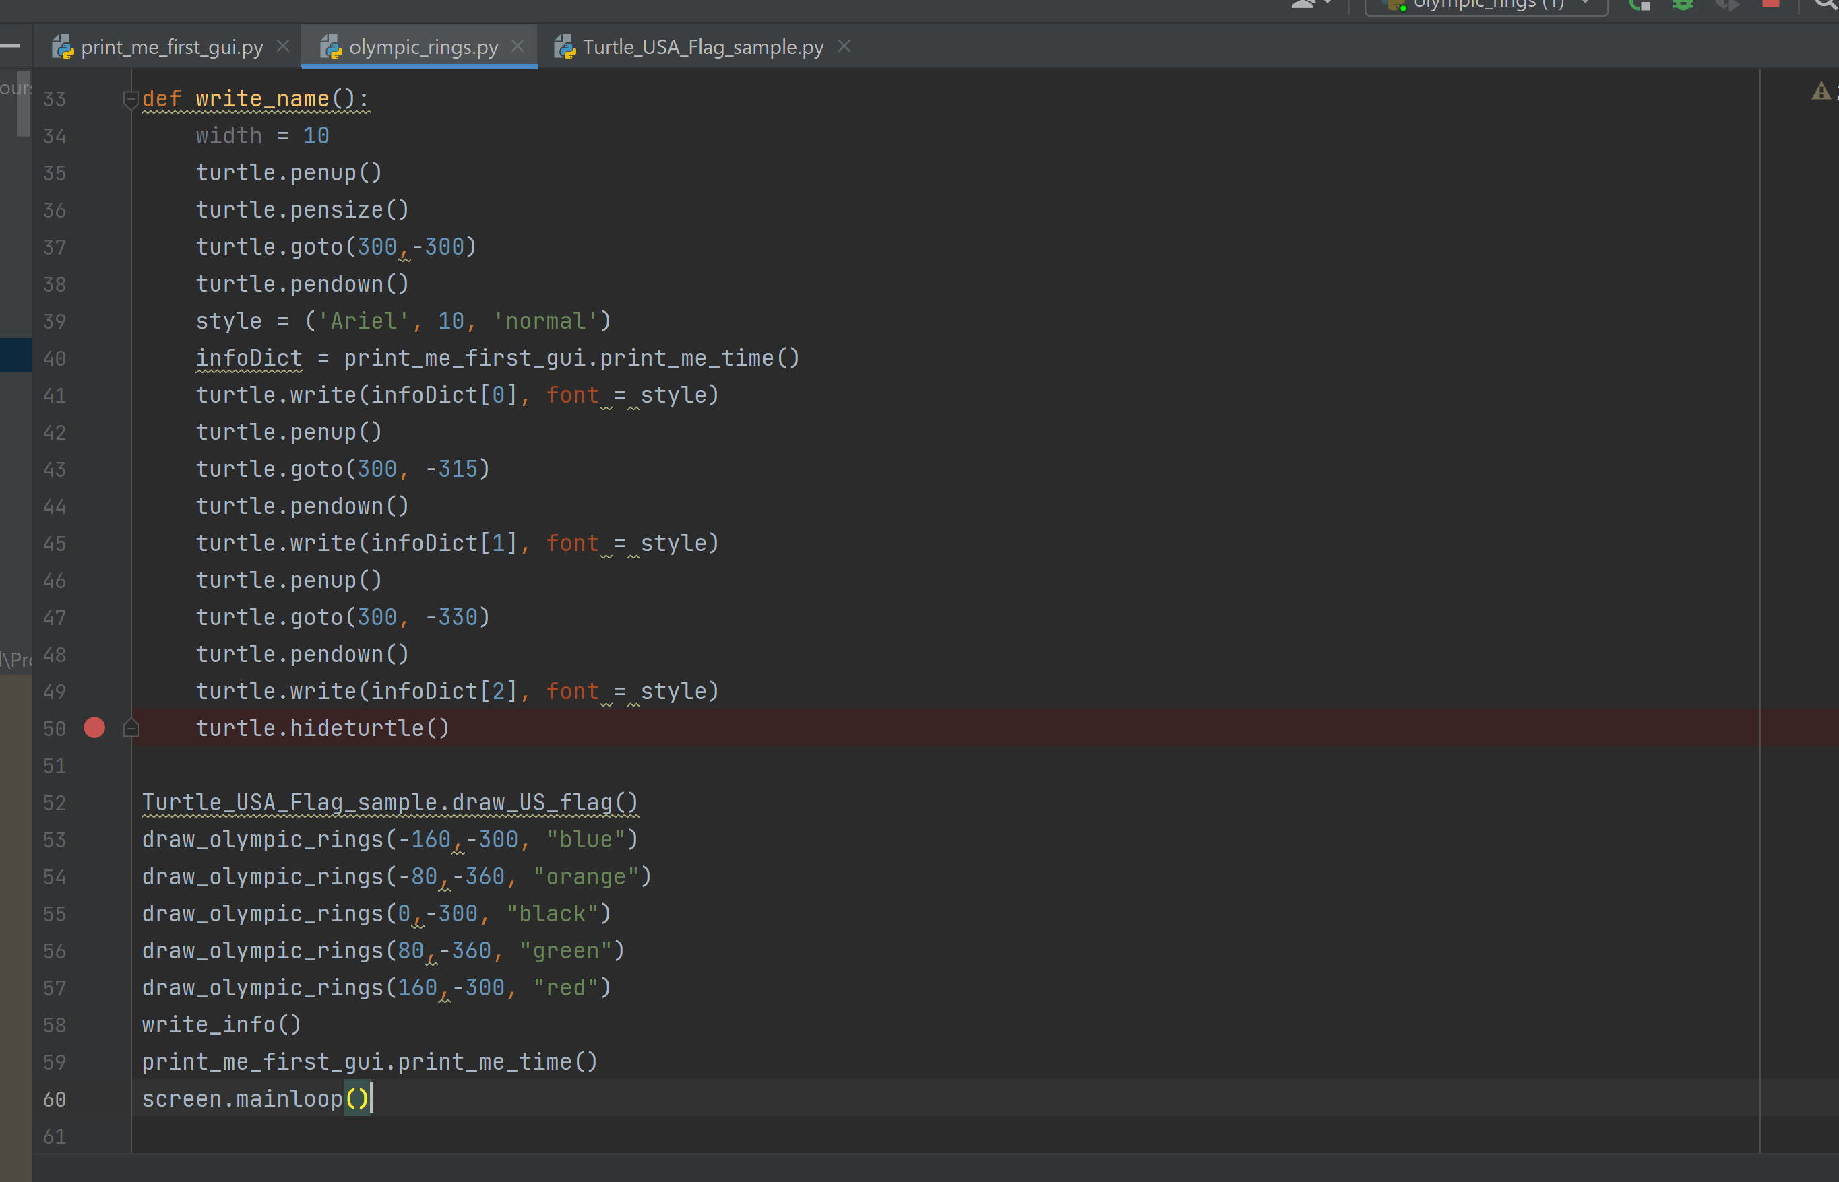

Print Name(print_me_first_gui.py):
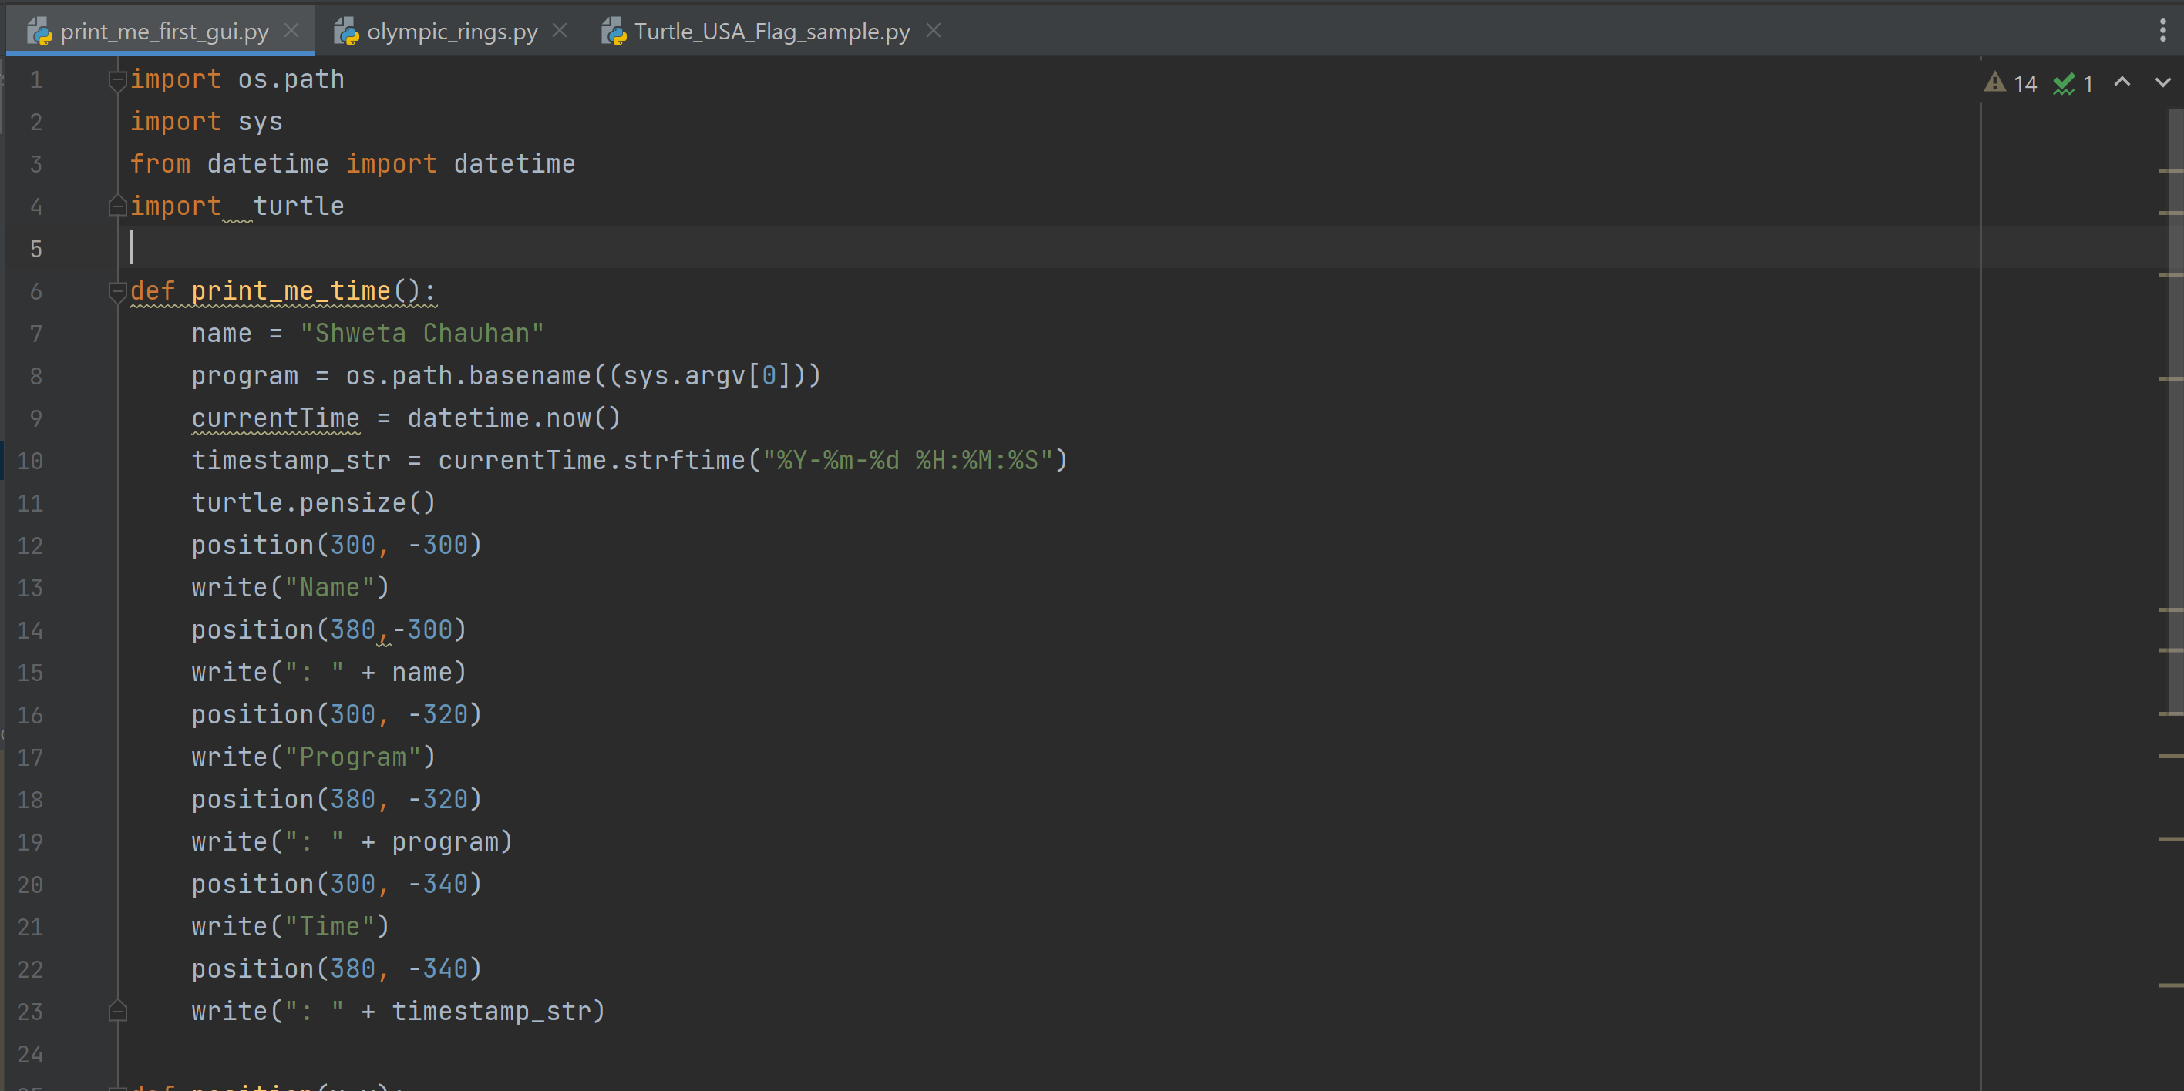
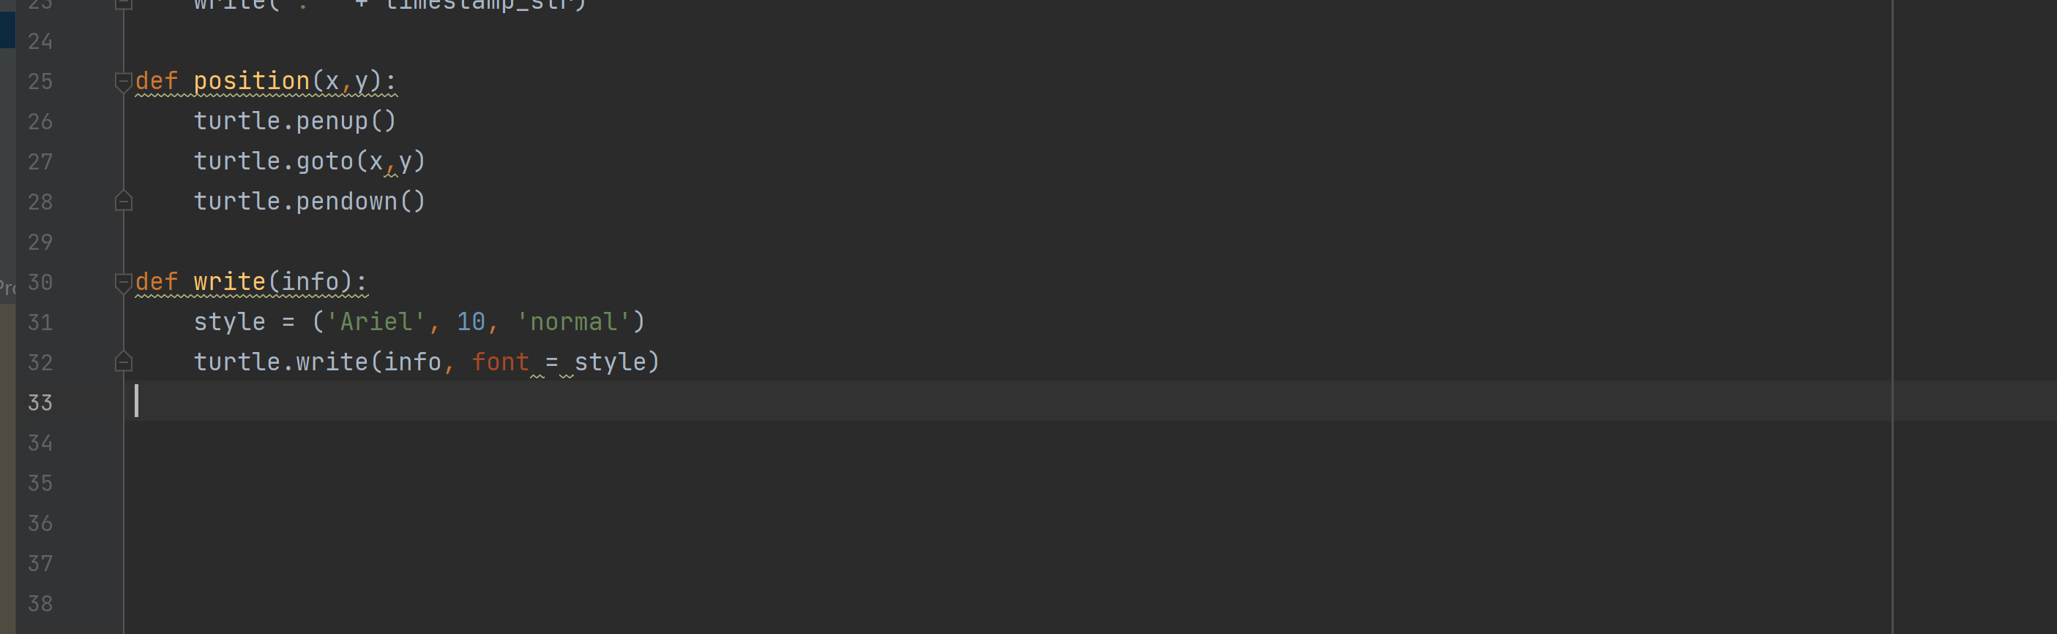

- Program Output
