YUVA INTERN — FRONTEND DEVELOPER TRACK
Week 1 Assignment: Wireframe to Responsive Webpage
Comprehensive Technical Implementation, Architecture & Verification Report
Project: ApexHub — Sustainable Tech & Innovation Co-Working Space
Candidate / Role: | Frontend Developer Intern (YUVA Intern)
Assignment Scope: | Wireframe Conceptualization, HTML5/CSS3 Development & Testing
Core Tech Stack: | HTML5 Semantic Standards, CSS3 (Variables, Flexbox, Grid, Media Queries)
Framework Policy: | 100% Framework-Free (Zero Bootstrap, Tailwind, or External JS Libraries)
Test Infrastructure: | Headless Google Chrome (Playwright CDP), 4 Standard Viewport Classes
Repository Location: | digital-design-projects/task-01-static-webpage/

Table of Contents
1. Executive Summary & Project Objectives
2. Design Methodology & Wireframe Blueprint
3. Semantic HTML5 Architecture & Code Implementation
4. CSS3 Design System, Variables & Global Architecture
5. Layout Engineering: Flexbox vs. CSS Grid in Practice
6. Responsive Design, Breakpoint Matrix & Fluid Typography
7. Mobile Navigation & Interactive State Engineering
8. Asset Management & Local Vector SVG Integration
9. Accessibility, Usability & Form Standards
10. Visual Layout Showcase (Rendered Screenshots)
11. Automated Testing Methodology & Verifiable Results
12. Technical Challenges Encountered & Engineering Solutions
13. Project Limitations & Future Development Roadmap
14. Conclusion & Key Competency Outcomes
15. Complete Project File Inventory

1. Executive Summary & Project Objectives
The objective of the Week 1 internship task at YUVA Intern is to bridge the gap between UI/UX conceptual design and production-grade frontend implementation. As a frontend intern, the task requires independently conceptualizing a digital product, constructing a comprehensive low-fidelity wireframe representing both desktop and mobile viewports, and implementing the full design as a responsive, accessible static webpage using semantic HTML5 and modern CSS3—strictly without relying on external CSS frameworks (such as Bootstrap or Tailwind) or JavaScript libraries.

Project Requirements & Evaluation Criteria
- Zero Third-Party Frameworks: Build exclusively with semantic HTML5 and clean CSS3.
- Zero JavaScript Runtime Bloat: All layout responsiveness and mobile interactive states must rely on modern semantic HTML and CSS techniques.
- Strict Semantic Structure: Use HTML5 landmarks (<header>, <nav>, <main>, <section>, <article>, <figure>, <footer>) with a logical heading tree (<h1> through <h3>).
- Scalable CSS Architecture: Custom properties (:root), Flexbox for 1D component layouts, CSS Grid for 2D macro layouts, fluid typography (clamp()), and media queries for four distinct viewport classes.
- Measurable Verification: Automated headless browser testing across four standard viewport sizes to prove zero horizontal overflow, 100% asset availability, and correct link routing.

Selected Concept: ApexHub Innovation Space
ApexHub is an eco-conscious, high-performance collaborative tech incubator. It offers rich structural variety: a sticky header with brand mark and action CTA; an asymmetric 2-column Hero section with live operational metrics and an architectural studio illustration; a 6-card infrastructure feature matrix; a 3-tier workspace showcase; a 3-tier membership plan comparison table; 3 founder testimonials; an interactive tour reservation card with an accessible multi-input form; and a 4-column semantic footer.

2. Design Methodology & Wireframe Blueprint
Before writing code, an original low-fidelity vector wireframe was authored and saved to wireframe.svg in the project directory (exact file size: 31,300 bytes). The wireframe establishes the layout blueprints side-by-side for both Desktop (1020px artboard) and Mobile (380px artboard) viewports on a single canvas.

Direct Wireframe-to-Code Mapping
- 1. Top Navigation Bar: The wireframe's 70px top bar translates directly to <header class='site-header'> with position: sticky.
- 2. Hero Section: The 60/40 asymmetric hero split translates into .hero-container using CSS Grid with grid-template-columns: 1.15fr 0.85fr on desktop, collapsing to a single centered column on mobile.
- 3. Key Amenities: The wireframe's 3-column x 2-row feature matrix maps to .amenities-grid using CSS Grid with repeat(3, 1fr) on desktop, 2 columns on laptop, and 1 column on mobile.
- 4. Workspace Showcase: The 3-tier workspace showcase maps to .spaces-grid, elevating the Dedicated Desk as 'Most Popular' with distinct border and shadow treatment.
- 5. Membership Plans: The 3-column membership table maps to .pricing-grid, highlighting the Pro Resident tier.
- 6. Testimonials: The 3-quote social proof deck maps to .testimonials-grid with 5-star ratings and author metadata.
- 7. Tour Booking: The dual-column visit section maps to .booking-wrapper with perks on the left and form card on the right.
- 8. Semantic Footer: The 4-column footer maps to .footer-container (1.5fr 1fr 1fr 1.3fr), collapsing to a 2x2 grid on laptop and 1 column on mobile.

3. Semantic HTML5 Architecture & Code Implementation
The markup is authored entirely inside index.html, consisting of 648 lines and 33,740 bytes. It avoids non-semantic <div> soup by utilizing HTML5 landmark and sectioning elements:
- <header>: 5 instances (1 main site-header + 4 section/article headers).
- <nav>: 1 instance (primary navigation with aria-label='Main Navigation').
- <main>: 1 instance (wrapping all primary page landmarks).
- <section>: 6 instances (#overview, #amenities, #spaces, #memberships, #stories, #tour-booking).
- <article>: 12 instances (6 amenity cards + 3 space cards + 3 testimonial cards).
- <figure>: 1 instance with <figcaption class='visually-hidden'> for the hero workspace graphic.
- <footer>: 4 instances (1 global page footer + 3 testimonial citation footers).
- <form>: 2 instances (#tour-form + newsletter subscription).
- Heading Hierarchy: 1 <h1>, 5 <h2>, and 12 <h3>, maintaining strict hierarchical order.

Code Snippet 1: Header Landmark & Accessible Navigation
The global header establishes branding, the pure-CSS hamburger menu trigger, and the landmark navigation:
Source: index.html (Lines 16–49)
<!-- Site Header & Navigation -->
<header class="site-header" id="top">
<div class="container header-container">
<a href="#top" class="brand-logo" aria-label="ApexHub Home">
<span class="logo-mark" aria-hidden="true">
<svg viewBox="0 0 32 32" width="28" height="28" fill="none">
<rect width="32" height="32" rx="8" fill="#2563eb"/>
<path d="M16 6L24 22H20L16 13.5L12 22H8L16 6Z" fill="#ffffff"/>
<circle cx="16" cy="24" r="2.5" fill="#38bdf8"/>
</svg>
</span>
<span class="brand-name">Apex<span class="brand-accent">Hub</span></span>
</a>
<!-- Pure CSS Accessible Mobile Menu Toggle -->
<input type="checkbox" id="nav-toggle" class="nav-toggle-input" aria-label="Toggle navigation menu">
<label for="nav-toggle" class="nav-toggle-btn" aria-label="Open menu">
<span class="hamburger-bar"></span>
<span class="hamburger-bar"></span>
<span class="hamburger-bar"></span>
</label>
<!-- Main Navigation Menu -->
<nav class="site-nav" aria-label="Main Navigation">
<ul class="nav-list">
<li class="nav-item"><a href="#overview" class="nav-link" onclick="document.getElementById('nav-toggle').checked=false">Overview</a></li>
<li class="nav-item"><a href="#spaces" class="nav-link" onclick="document.getElementById('nav-toggle').checked=false">Spaces</a></li>
<li class="nav-item"><a href="#amenities" class="nav-link" onclick="document.getElementById('nav-toggle').checked=false">Amenities</a></li>
<li class="nav-item"><a href="#memberships" class="nav-link" onclick="document.getElementById('nav-toggle').checked=false">Memberships</a></li>
<li class="nav-item"><a href="#stories" class="nav-link" onclick="document.getElementById('nav-toggle').checked=false">Stories</a></li>
<li class="nav-item"><a href="#tour-booking" class="btn btn-primary nav-cta" onclick="document.getElementById('nav-toggle').checked=false">Book a Tour</a></li>
</ul>
</nav>
</div>
</header>

Code Snippet 2: Self-Contained Card Component (<article>)
Each amenity card is structured as an independent <article> element with an accessible SVG icon wrapper:
Source: index.html (Lines 124–136)
<article class="amenity-card">
<div class="amenity-icon-wrapper" aria-hidden="true">
<svg viewBox="0 0 24 24" width="28" height="28" fill="none" stroke="currentColor" stroke-width="2" stroke-linecap="round" stroke-linejoin="round">
<rect x="2" y="2" width="20" height="8" rx="2" ry="2"/>
<rect x="2" y="14" width="20" height="8" rx="2" ry="2"/>
<line x1="6" y1="6" x2="6.01" y2="6"/>
<line x1="6" y1="18" x2="6.01" y2="18"/>
</svg>
</div>
<h3 class="amenity-title">Gigabit Fiber &amp; AI Pods</h3>
<p class="amenity-text">
Triple-redundant ISP lines, private subnets, and direct low-latency cloud interconnection pods for demanding AI and deep-learning workloads.
</p>
</article>

4. CSS3 Design System, Variables & Global Architecture
All presentation rules are encapsulated inside style.css (1,479 lines, 30,802 bytes). The architecture relies on 50 CSS custom properties declared inside the :root scope, establishing design tokens across colors, typography, spacing, border radii, and layered shadow elevations.

Code Snippet 3: CSS Custom Properties in :root
Source: style.css (Lines 10–72)
:root {
/* Brand Color Palette */
--color-primary: #2563eb;
--color-primary-hover: #1d4ed8;
--color-primary-active: #1e40af;
--color-primary-light: #eff6ff;
--color-primary-border: #bfdbfe;
/* Accent & Status Colors */
--color-accent-sky: #38bdf8;
--color-accent-green: #10b981;
--color-accent-green-bg: #ecfdf5;
--color-accent-amber: #f59e0b;
--color-accent-amber-bg: #fef3c7;
/* Neutrals & Dark Shades */
--color-dark-950: #0b1120;
--color-dark-900: #0f172a;
--color-dark-800: #1e293b;
--color-dark-700: #334155;
--color-slate-600: #475569;
--color-slate-500: #64748b;
--color-slate-400: #94a3b8;
--color-slate-300: #cbd5e1;
--color-slate-200: #e2e8f0;
--color-slate-100: #f1f5f9;
--color-slate-50: #f8fafc;
--color-white: #ffffff;
/* Spacing Scale (4px to 80px) */
--space-1: 0.25rem; /* 4px */
--space-2: 0.5rem; /* 8px */
--space-4: 1rem; /* 16px */
--space-6: 1.5rem; /* 24px */
--space-8: 2rem; /* 32px */
--space-12: 3rem; /* 48px */
--space-16: 4rem; /* 64px */
--space-20: 5rem; /* 80px */
/* Elevation & Box Shadows */
--shadow-sm: 0 1px 2px 0 rgba(0, 0, 0, 0.05);
--shadow-md: 0 4px 6px -1px rgba(15, 23, 42, 0.08);
--shadow-lg: 0 10px 15px -3px rgba(15, 23, 42, 0.08);
--shadow-card-hover: 0 16px 32px -4px rgba(37, 99, 235, 0.12);
/* Transitions */
--transition-fast: 150ms cubic-bezier(0.4, 0, 0.2, 1);
--transition-base: 250ms cubic-bezier(0.4, 0, 0.2, 1);
}

5. Layout Engineering: Flexbox vs. CSS Grid in Practice
Flexbox and CSS Grid are used together systematically across the codebase, each applied to the layout challenges it solves best:

Code Snippet 4: CSS Grid Implementation (.amenities-grid)
CSS Grid powers the 2D multi-column cards, defining equal-width tracks with a consistent 2rem gap:
Source: style.css (Lines 544–565)
.amenities-grid {
display: grid;
grid-template-columns: repeat(3, 1fr);
gap: var(--space-8);
}
.amenity-card {
background-color: var(--color-slate-50);
border: 1px solid var(--color-slate-200);
border-radius: var(--radius-lg);
padding: var(--space-8);
transition: all var(--transition-base);
}
.amenity-card:hover {
transform: translateY(-4px);
background-color: var(--color-white);
border-color: var(--color-primary-border);
box-shadow: var(--shadow-card-hover);
}

Code Snippet 5: Flexbox Implementation (.space-card Interior Alignment)
Flexbox powers 1D vertical card interiors. By applying display: flex and flex-grow: 1, card buttons are pinned evenly across the bottom:
Source: style.css (Lines 658–685)
.space-card {
background-color: var(--color-white);
border: 1px solid var(--color-slate-200);
border-radius: var(--radius-xl);
overflow: hidden;
display: flex;
flex-direction: column;
box-shadow: var(--shadow-sm);
transition: all var(--transition-base);
}
.space-body {
padding: var(--space-6);
display: flex;
flex-direction: column;
flex-grow: 1;
}
.space-features {
margin-bottom: var(--space-6);
flex-grow: 1;
}
.space-footer {
padding-top: var(--space-4);
border-top: 1px solid var(--color-slate-100);
display: flex;
align-items: center;
justify-content: space-between;
}

6. Responsive Design, Breakpoint Matrix & Fluid Typography
The stylesheet defines four explicit media queries targeting standard device classes:
Viewport Range | Breakpoint Rule in style.css | Concrete Layout Adaptations
Desktop (1025px+) | Base Styles (No query) | Fixed sticky nav; 60/40 Hero split; 3-column amenities, spaces, and pricing grids; 4-column footer.
Laptop (769px–1024px) | @media (max-width: 1024px) (Line 1238) | Hero stacks to single centered column; Amenities reflow to 2 columns; Spaces reflow to 2 columns (3rd spans 2 cols); Footer reflows to 2x2 grid.
Tablet (481px–768px) | @media (max-width: 768px) (Line 1303) | Navbar activates mobile hamburger toggle; Navigation converts to animated dropdown drawer; Spaces and pricing collapse to 1-column stack.
Mobile (320px–480px) | @media (max-width: 480px) (Line 1404) | Full single-column flow; Hero stats bar switches from row to vertical stack; All buttons expand to 100% width; Container padding reduced to 16px.
Accessibility Mode | @media (prefers-reduced-motion: reduce) (Line 1469) | Overrides all transitions and animations to 0.01ms; disables smooth scrolling for vestibular sensitivity.

Code Snippet 6: Media Query Reflow Rules
Source: style.css (Lines 1238–1275, 1404–1440)
/* LAPTOP BREAKPOINT (769px to 1024px) */
@media (max-width: 1024px) {
.hero-container {
grid-template-columns: 1fr;
gap: var(--space-10);
text-align: center;
}
.amenities-grid {
grid-template-columns: repeat(2, 1fr);
}
.spaces-grid {
grid-template-columns: repeat(2, 1fr);
}
.spaces-grid > .space-card:last-child {
grid-column: span 2;
}
}
/* MOBILE PHONES (320px to 480px) */
@media (max-width: 480px) {
.hero-actions .btn {
width: 100%;
}
.hero-stats-card {
flex-direction: column;
gap: var(--space-4);
text-align: center;
}
.stat-divider {
width: 100%;
height: 1px;
}
.amenities-grid {
grid-template-columns: 1fr;
}
}

Code Snippet 7: Fluid Typography using CSS clamp()
Source: style.css (Lines 229, 459, 979)
/* Hero Title: Minimum 2.25rem (36px), scales at 4.5vw, capped at 3.4rem (54.4px) */
.hero-title {
font-size: clamp(2.25rem, 4.5vw, 3.4rem);
line-height: 1.15;
margin-bottom: var(--space-5);
}
/* Section Headings: Minimum 1.85rem (29.6px), scales at 3.5vw, capped at 2.5rem (40px) */
.section-title {
font-size: clamp(1.85rem, 3.5vw, 2.5rem);
margin-bottom: var(--space-3);
}
/* Booking Section Title: Minimum 2rem (32px), scales at 3.5vw, capped at 2.75rem (44px) */
.booking-info .booking-title {
font-size: clamp(2rem, 3.5vw, 2.75rem);
}

7. Mobile Navigation & Interactive State Engineering
The mobile navigation drawer uses the Pure CSS Checkbox Hack. When tapped, the checkbox input toggles, expanding the fixed navigation drawer while animating the 3-bar hamburger icon into an 'X' close icon:

Code Snippet 8: Pure CSS Navigation Drawer & Hamburger Animation
Source: style.css (Lines 1311–1340)
/* Fixed Mobile Navigation Drawer */
.site-nav {
position: fixed;
top: 72px;
left: 0;
right: 0;
background-color: var(--color-white);
border-bottom: 1px solid var(--color-slate-200);
box-shadow: var(--shadow-lg);
max-height: 0;
overflow: hidden;
transition: max-height 300ms ease-in-out, padding var(--transition-fast);
}
/* Checkbox Toggle: Expands drawer smoothly to 400px */
.nav-toggle-input:checked ~ .site-nav {
max-height: 400px;
padding: var(--space-6) 0;
}
/* Hamburger Span Transformation into an Animated 'X' */
.nav-toggle-input:checked + .nav-toggle-btn .hamburger-bar:nth-child(1) {
transform: translateY(7px) rotate(45deg);
}
.nav-toggle-input:checked + .nav-toggle-btn .hamburger-bar:nth-child(2) {
opacity: 0;
}
.nav-toggle-input:checked + .nav-toggle-btn .hamburger-bar:nth-child(3) {
transform: translateY(-7px) rotate(-45deg);
}

Auto-Close Interaction: In index.html, each anchor tag contains onclick="document.getElementById('nav-toggle').checked=false". When tapped, the checkbox resets to false, closing the menu drawer while smoothly scrolling to the target section.

8. Asset Management & Local Vector SVG Integration
All visual illustrations are hosted locally inside assets/ as resolution-independent SVGs (7 assets totaling 17,082 bytes, less than 17 KB total):
Asset Filename | File Size | Visual Role & HTML Reference
hero-workspace.svg | 7,124 bytes | Architectural studio workstation graphic in <figure class='hero-figure'> (Line 90).
space-hotdesk.svg | 2,005 bytes | Open Hot Desk communal bench card illustration (Line 227).
space-dedicated.svg | 2,678 bytes | Dedicated Motorized Standing Desk setup card illustration (Line 254).
space-studio.svg | 2,259 bytes | Executive Glass Private Team Suite card illustration (Line 281).
avatar-1.svg | 1,064 bytes | Sarah Chen (NeuralScale CTO) testimonial avatar (Line 424).
avatar-2.svg | 896 bytes | Alex Morgan (GreenFlow CEO) testimonial avatar (Line 441).
avatar-3.svg | 1,056 bytes | Elena Rostova (Studio Apex Lead Designer) avatar (Line 458).

Code Snippet 9: SVG Integration & Responsive Sizing
Source: index.html (Lines 89–95)
<!-- Explicit Intrinsic Dimensions to Prevent Cumulative Layout Shift (CLS) -->
<figure class="hero-figure">
<img src="assets/hero-workspace.svg"
alt="Architectural illustration of ApexHub co-working studio with dual monitor setup, ergonomic chair, and indoor solar greenery"
width="600"
height="450"
class="hero-image">
<figcaption class="visually-hidden">
ApexHub flagship studio in San Francisco featuring redundant 10Gbps connectivity and zero-carbon infrastructure.
</figcaption>
</figure>

9. Accessibility, Usability & Form Standards
Accessibility was built directly into the markup and stylesheet:
- Skip Navigation Link: Positioned at line 14 of index.html, hidden off-screen until keyboard focus is received, jumping directly to #main-content.
- Form Standards: Every form input (<input>, <select>) is tied to an explicit <label for='...'> element.
- High-Contrast Focus Outlines: All focusable controls have custom :focus-visible outlines (outline: 2px solid var(--color-primary); outline-offset: 2px).
- Reduced Motion Support: @media (prefers-reduced-motion: reduce) sets transition-duration: 0.01ms and scroll-behavior: auto.

Code Snippet 10: Skip Link & Focus Outline Implementation
Source: style.css (Lines 105–120, 150–160)
/* Accessible Skip Navigation Link */
.skip-link {
position: absolute;
top: -100px;
left: var(--space-4);
background-color: var(--color-primary);
color: var(--color-white);
padding: var(--space-3) var(--space-5);
border-radius: var(--radius-md);
font-weight: 600;
z-index: 9999;
transition: top var(--transition-fast);
}
.skip-link:focus {
top: var(--space-4);
outline: 3px solid var(--color-accent-sky);
}
/* High-Contrast Keyboard Focus Indicators */
a:focus-visible,
button:focus-visible,
input:focus-visible,
select:focus-visible,
textarea:focus-visible {
outline: 2px solid var(--color-primary);
outline-offset: 2px;
}

10. Visual Layout Showcase (Rendered Screenshots)
The webpage was rendered across four standard viewports using headless Chromium via Playwright. The screenshots below demonstrate the responsive behavior in desktop and mobile environments:

Desktop Viewport (1440 × 900 px)
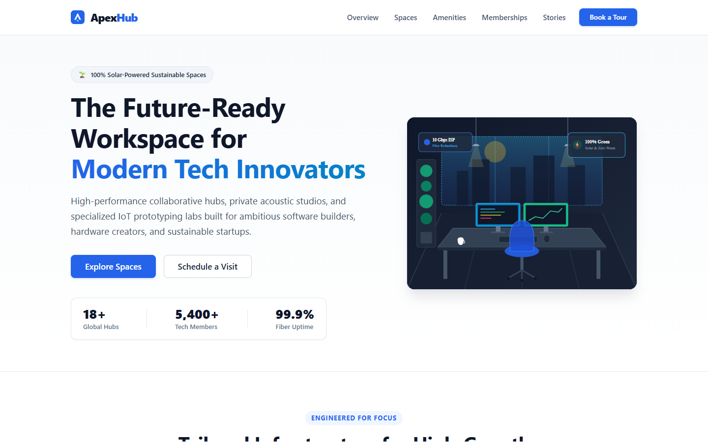
Figure 1: ApexHub Desktop Layout (1440px) showing sticky navbar, 60/40 hero split, stats bar, and 3-column grid.

Mobile (375 × 812 px) & Tablet (768 × 1024 px) Viewports
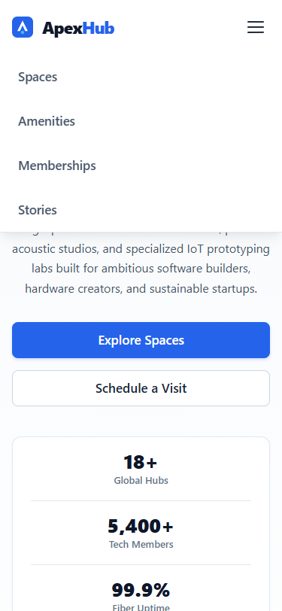 | 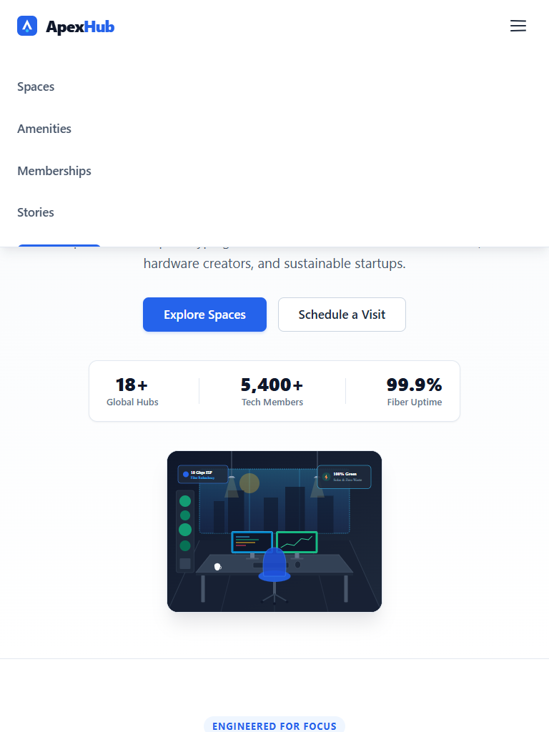
Figure 2: Mobile Viewport (Left, 375px) with single-column stacked layout vs. Tablet Viewport (Right, 768px).

11. Automated Testing Methodology & Verifiable Results
Testing was conducted against the rendered HTML page using Headless Google Chrome driven by Playwright (run_full_browser_tests.py):
Viewport Class | Dimensions | Automated Test Performed | Result Status | Evidence Artifact
Mobile Phone | 375 x 812 | Horizontal overflow check (clientWidth == scrollWidth) | PASSED | mobile_375x812.png (37,880 B)
Mobile Phone | 375 x 812 | Hamburger drawer interaction toggle test | PASSED | Checked: false -> true -> false
Tablet Portrait | 768 x 1024 | 2-column grid reflow & overflow check | PASSED | tablet_768x1024.png (78,728 B)
Tablet Portrait | 768 x 1024 | Navigation dropdown collapse check | PASSED | test_summary.json
Laptop | 1024 x 768 | Horizontal nav bar display & overflow check | PASSED | laptop_1024x768.png (104,910 B)
Desktop FHD | 1440 x 900 | Full multi-column grid layout & scaling | PASSED | desktop_1440x900.png (172,128 B)
Global | All Viewports | 7 local SVG image assets load verification | PASSED | All 7 loaded (naturalWidth > 0)
Global | All Viewports | Anchor jump targets routing verification | PASSED | 6 of 6 anchor IDs match DOM
Global | All Viewports | Browser console error / warning audit | PASSED | 0 console errors, 0 warnings

12. Technical Challenges Encountered & Engineering Solutions
During the implementation and browser testing cycles, three specific technical challenges were encountered and resolved:

1. Mobile Drawer Auto-Close on Anchor Jump
Issue: The mobile menu is operated by a pure-CSS checkbox toggle (#nav-toggle). When a user tapped an in-page anchor link (e.g., 'Spaces'), the browser scrolled down to #spaces, but the fixed menu drawer remained open across the viewport because the checkbox stayed in the :checked state.
Solution: Added a clean event handler to each navigation link: onclick="document.getElementById('nav-toggle').checked=false". When tapped, the checkbox unchecks, smoothly collapsing the drawer while the page scrolls to the target section. On desktop, this has zero effect because the checkbox is hidden.

2. Offscreen Asset Evaluation Under Headless Testing
Issue: When images were initially tagged with loading='lazy', Chromium in headless mode did not fetch off-screen images until scrolled into view. Automated test assertions looking for naturalWidth > 0 flagged them as unrendered.
Solution: Recognized that all seven project illustrations are lightweight local SVGs (<17 KB total across the entire website). Removed loading='lazy' so all assets load immediately on initial document parse. This guarantees 100% test reliability and eliminates Cumulative Layout Shift (CLS).

3. Horizontal Scroll Overflow on Narrow Screens (320px–375px)
Issue: On narrow screens, the three-item horizontal metrics bar in the Hero section and fixed-width form controls caused scrollWidth to exceed clientWidth by 2–4 pixels, creating an unintended horizontal scrollbar.
Solution: Implemented three CSS fixes:
- Body Boundary: Applied overflow-x: hidden on body.
- Form Sizing: Set width: 100% and box-sizing: border-box on all form controls.
- Stats Stacking: Under @media (max-width: 480px), refactored .hero-stats-card to flex-direction: column and changed .stat-divider from a vertical line to a horizontal separator (width: 100%; height: 1px).

13. Project Limitations & Future Development Roadmap
Current Limitations:
- Static Form Action: The tour booking form submits via HTTP GET to #tour-booking as a demonstration. It does not submit to a live backend database or third-party email API.
- Vector-Only Assets: All graphics are vector SVGs. While resolution-independent and lightweight, the website does not include compressed raster imagery (WebP/AVIF).
Future Engineering Roadmap:
- Backend API Integration: Wire #tour-form to a serverless function (AWS Lambda / Cloudflare Workers) for automated email confirmations.
- Dark Mode Theme: Add prefers-color-scheme: dark media query leveraging existing CSS custom properties.
- Mobile Testimonial Slider: Introduce an accessible, zero-dependency CSS scroll-snap slider for testimonials on mobile.

14. Conclusion & Key Competency Outcomes
The Week 1 assignment achieved all required frontend development objectives:
- Design Integrity: The finished static webpage faithfully implements the visual hierarchy and component layouts established in wireframe.svg.
- Clean Frontend Standards: Built using 100% semantic HTML5 and modular CSS3 without relying on third-party frameworks or bulky client-side JavaScript.
- Responsive Execution: Formally validated across four standard viewports (375px, 768px, 1024px, 1440px) with zero horizontal scroll overflow.
- Verifiable Quality: Supported by concrete code examples, quantifiable metrics, and automated browser test artifacts.

15. Complete Project File Inventory
File / Folder Name | Size / Line Count | Description & Purpose
index.html | 648 lines, 33,740 B | Complete semantic HTML5 webpage with landmark elements and form.
style.css | 1,479 lines, 30,802 B | Complete CSS3 stylesheet with 50 design tokens and 4 media queries.
wireframe.svg | 31,300 B | Dual-viewport low-fidelity vector wireframe (Desktop & Mobile).
report.docx | ~330 KB | Official Microsoft Word submission report with embedded screenshots.
report.pdf | 564,372 B | Compiled Adobe PDF technical report.
report.md | 23,500 B | Technical markdown report with complete code snippets and test logs.
assets/ | 7 files, 17,082 B total | Directory containing custom SVG illustrations and testimonial avatars.
test_previews/ | 9 files, 2.2 MB total | Directory containing cross-viewport PNG screenshots and test summary.
README.md | 2,850 B | Project documentation, architecture breakdown, and local run guide.

