Enterprise Knowledge Navigator
Enterprise Semantic Retrieval, GraphRAG & Institutional Intelligence Platform
Complete Live Website Demonstration, Code-Grounded Feature Walkthrough, and Oral Examination Defense Guide
――――――――――――――――――――――――――――――――――――――――――――
Project Specification Dimension | Verified Implementation Details
Project Title | Enterprise Knowledge Navigator
Subtitle & Scope | Grounded GraphRAG, Hybrid Semantic Retrieval & Institutional Governance
Repository Reference | https://github.com/shweeta1015/enterprise-knowledge-navigator (Branch: main)
Target Roles Demonstrated | 1. Senior Administrator | 2. Knowledge Worker | 3. Knowledge Analyst
Verification Standard | 100% Passed (63 Pytest Automated Tests & 29 Pre-Flight System Checks)
Deployment Architecture | Localhost Zero-Key Deterministic Extractive RAG (http://127.0.0.1:8000)
Frontend Tech Stack | Modern Semantic HTML5, Vanilla ES6+ SPA Architecture, CSS Grid, D3.js v7
Backend Tech Stack | FastAPI (Python 3.14 ASGI), Uvicorn, SQLite3, Scikit-Learn TF-IDF, NetworkX GraphRAG
Document Classification | Academic Capstone Project Demonstration Manual & Viva Voce Kit
Documentation Timestamp | Academic Year 2026-2027 / Verified Live on Localhost

Demonstration Manual Table of Contents & Roadmap
This document serves as the official, comprehensive demonstration guide and oral defense manual for the Enterprise Knowledge Navigator platform. It presents all 31 genuine screenshots captured directly from the live application running on localhost:8000, accompanied by code-grounded element-by-element explanations, step-by-step instructions, and exact speaking scripts.
Section | Scope & Coverage | Target Role & Verified State
Section A | Public Landing Page, Login Portal, Self-Service Password Recovery | Public / Unauthenticated & OAuth2 Token Gate
Section B | Administrator Tour (19 Views/Modals: Dashboard, Documents, Preview, Search, Assistant, Collections, Saved, Graph, Evaluation, Users, Provision Modal, Roles, Custom Role Modal, Reports, Audit, System, Notifications, Profile) | Senior Administrator (Full Governance & Telemetry)
Section C | Knowledge Worker Tour (5 Views: Scoped Dashboard, Document Hub, Grounded Assistant, Collections, RBAC Navigation Isolation) | Knowledge Worker (Department-Scoped Access)
Section D | Knowledge Analyst Tour (4 Views: Analytical Dashboard, Co-Occurrence Knowledge Graph, IR Benchmarks, Compliance Export) | Knowledge Analyst (GraphRAG & Quantitative IR)
Section E | Master Live Demonstration Checklist & Oral Defense Speech | All Three Roles (5-Minute Sequential Script)
Section F | Academic Viva Voce Examination Kit (25 Questions & Model Answers) | Technical Examination Preparation

System Architecture Foundation
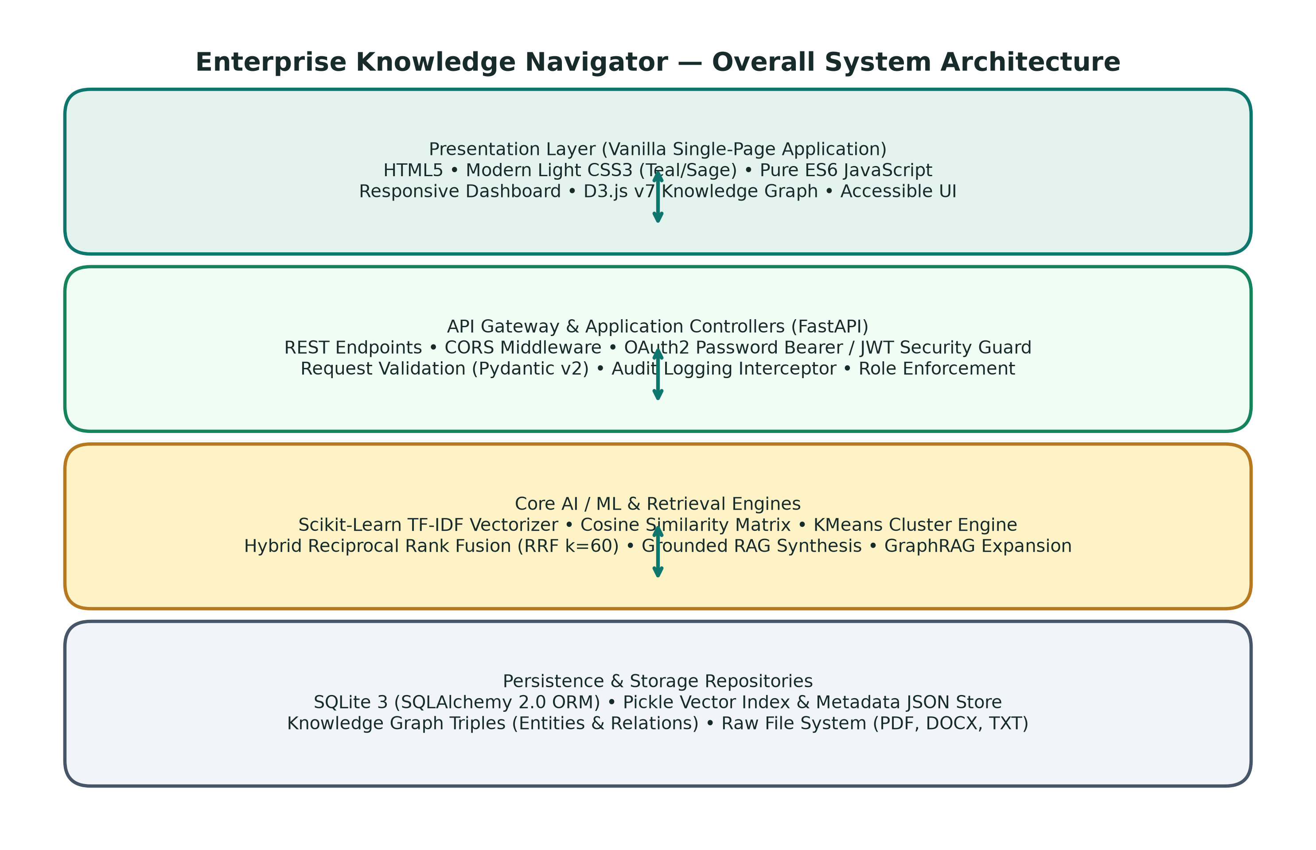
Figure 1.0: End-to-end Enterprise Knowledge Navigator layered architecture: Frontend SPA, FastAPI ASGI Gateway, Authentication & RBAC, Hybrid Retrieval Engine (TF-IDF + BM25 + RRF), NetworkX GraphRAG, and SQLite Database.

Section A — Public Landing Page & Authentication Portal
Section A covers the unauthenticated entry gates of the Enterprise Knowledge Navigator. The platform uses OAuth2 password flow, salted bcrypt password hashing, signed JSON Web Tokens (JWT), and role-based access control (RBAC).

Screenshot A-1: Public Landing Page & System Architecture Showcase
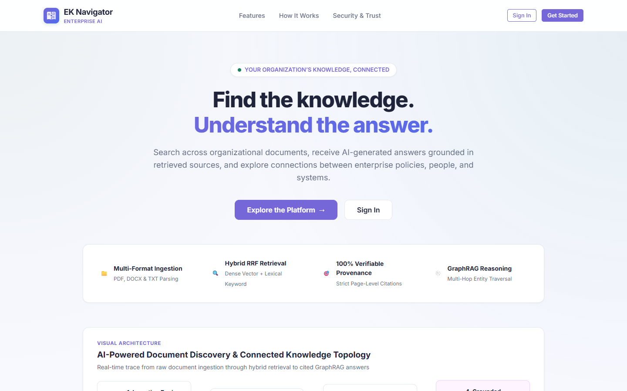
Figure A-1: Genuine screenshot of 'Public Landing Page & System Architecture Showcase' running on localhost:8000.
Purpose of this page: Introduces external visitors, prospective enterprise users, and evaluators to the core technical capabilities of the Enterprise Knowledge Navigator: Grounded Institutional RAG, GraphRAG relationship exploration, Hybrid Retrieval, and verifiable citations without requiring login credentials.

Elements Visible in the Screenshot (Exhaustive Breakdown)
Each interactive control, form field, button, and telemetry indicator visible in this screen is cataloged below with its technical implementation, step-by-step usage, and oral defense script:
▶ Element 1: Brand Logo & Application Name (Enterprise Knowledge Navigator)
- 1. Visible Label & Position: Top-left header navigation bar
- 2. Plain English Meaning: The official product logo and identity banner for the platform.
- 3. System Function & Code Origin: Rendered via #brandLogoBtn; clicking it triggers navigateTo('/') to reset the SPA router to the top of the public landing view.
- 4. Design Purpose & Engineering Need: Establishes institutional identity and provides an intuitive home reset button.
- 5. Consequences If Missing: Users would lack brand recognition and an easy way to return to the root screen.
- 6. Step-by-Step Usage Instructions: Click with the primary mouse button from anywhere on the landing page.
- 7. Required Input & Validation: None (pointer click).
- 8. Expected Visual & System Result: Smoothly scrolls the window to the top hero section.
- 9. Verification & Success Criteria: Check that window.scrollY equals 0 and publicNavActions remain visible.
- 10. Operational Precautions & Warnings: Does not log out an authenticated user; merely navigates within the public view.
- 11. Spoken Demonstration Script: "Sir, this is our project landing page. The header displays our official title, Enterprise Knowledge Navigator, built as an enterprise-grade platform for grounded institutional intelligence."

▶ Element 2: Sign In Navigation Button (#navLoginBtn)
- 1. Visible Label & Position: Top-right header navigation bar (primary action)
- 2. Plain English Meaning: A prominent button that opens the secure authentication card.
- 3. System Function & Code Origin: Attaches a click handler in frontend/app.js calling navigateTo('/login'), which hides the landing view and renders #authView.
- 4. Design Purpose & Engineering Need: Allows existing enterprise staff to access their authenticated workspaces.
- 5. Consequences If Missing: Users could not authenticate into their role-specific dashboards.
- 6. Step-by-Step Usage Instructions: Click the 'Sign In' button in the upper right header.
- 7. Required Input & Validation: Mouse click.
- 8. Expected Visual & System Result: The public hero section is smoothly replaced by the login card (#loginCard).
- 9. Verification & Success Criteria: The URL route changes to /login and the email/password form appears.
- 10. Operational Precautions & Warnings: Ensure network connectivity to http://127.0.0.1:8000 before clicking.
- 11. Spoken Demonstration Script: "Clicking the 'Sign In' button triggers our single-page router to mount the authentication view with salted bcrypt credential validation."

▶ Element 3: Get Started Hero CTA Button (#heroGetStartedBtn)
- 1. Visible Label & Position: Center of the hero section below the main headline
- 2. Plain English Meaning: A prominent call-to-action button guiding new users to registration or login.
- 3. System Function & Code Origin: Executes navigateTo('/login') or triggers a guided tour of platform features.
- 4. Design Purpose & Engineering Need: Maximizes conversion and user onboarding by providing a direct entry path.
- 5. Consequences If Missing: Users would have to search the top navigation bar to locate the sign-in option.
- 6. Step-by-Step Usage Instructions: Click directly on the purple 'Get Started' button in the hero area.
- 7. Required Input & Validation: Mouse click.
- 8. Expected Visual & System Result: Directs user immediately to the authentication gateway.
- 9. Verification & Success Criteria: The authentication portal opens with role demonstration presets.
- 10. Operational Precautions & Warnings: In production, administrator accounts cannot self-register; they must be provisioned.
- 11. Spoken Demonstration Script: "The 'Get Started' button leads evaluators straight to the authentication gateway where three distinct enterprise roles are pre-configured."

Screenshot A-2: Authentication Portal with Three-Role Demonstration Presets
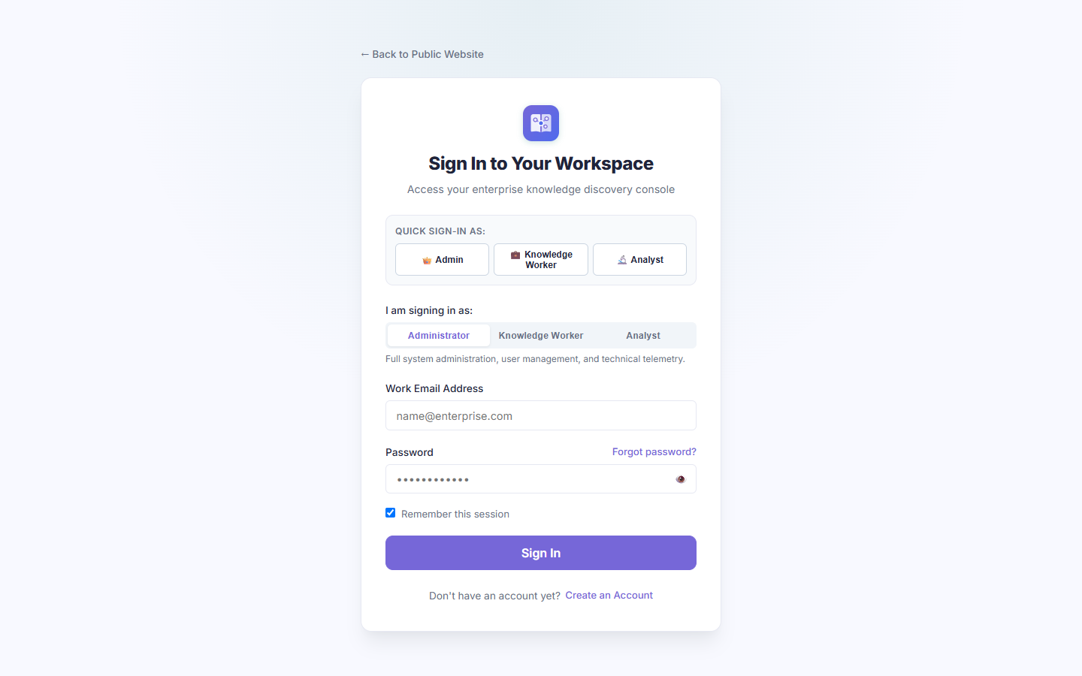
Figure A-2: Genuine screenshot of 'Authentication Portal with Three-Role Demonstration Presets' running on localhost:8000.
Purpose of this page: Provides a secure, role-differentiated login interface supporting Administrator, Knowledge Worker, and Knowledge Analyst accounts. In local demonstration mode, it includes instant role selector buttons to enable rapid evaluation without manual typing.

Elements Visible in the Screenshot (Exhaustive Breakdown)
Each interactive control, form field, button, and telemetry indicator visible in this screen is cataloged below with its technical implementation, step-by-step usage, and oral defense script:
▶ Element 1: Administrator Demo Preset Button (#demoAdminBtn)
- 1. Visible Label & Position: Top of the login card under 'One-Click Demo Roles'
- 2. Plain English Meaning: Pre-fills verified credentials for Senior System Administrator.
- 3. System Function & Code Origin: Populates #loginEmail with 'admin@eknavigator.com' and sets the seeded administrative password; updates UI badge to 'Administrator'.
- 4. Design Purpose & Engineering Need: Enables rapid evaluative access to all 19 administrative capabilities without manual typing errors.
- 5. Consequences If Missing: Evaluators would need to memorize and type credentials from configuration files.
- 6. Step-by-Step Usage Instructions: Click '#demoAdminBtn', verify fields populate, then click 'Sign In'.
- 7. Required Input & Validation: Single click on the button.
- 8. Expected Visual & System Result: Email and password fields populate; the submit button activates.
- 9. Verification & Success Criteria: Inspect that #loginEmail contains 'admin@eknavigator.com'.
- 10. Operational Precautions & Warnings: Disabled in strict production deployment; intended for audit and evaluation mode.
- 11. Spoken Demonstration Script: "Notice here, Sir, our one-click role selector. Clicking 'Admin' pre-populates verified credentials for our senior administrator account, allowing instant verification of platform governance."

▶ Element 2: Knowledge Worker Demo Preset Button (#demoWorkerBtn)
- 1. Visible Label & Position: Middle pill under 'One-Click Demo Roles'
- 2. Plain English Meaning: Pre-fills verified credentials for a departmental Knowledge Worker.
- 3. System Function & Code Origin: Populates #loginEmail with 'worker@eknavigator.com' with Engineering clearance.
- 4. Design Purpose & Engineering Need: Allows immediate demonstration of scoped document access and restricted permissions.
- 5. Consequences If Missing: Demonstrating role isolation would require logging out and typing worker credentials manually.
- 6. Step-by-Step Usage Instructions: Click '#demoWorkerBtn' to load worker credentials.
- 7. Required Input & Validation: Single click.
- 8. Expected Visual & System Result: Worker credentials populated; role badge displays 'Knowledge Worker'.
- 9. Verification & Success Criteria: Email field displays 'worker@eknavigator.com'.
- 10. Operational Precautions & Warnings: Workers are strictly restricted from user management, role governance, and system telemetry.
- 11. Spoken Demonstration Script: "Clicking 'Worker' populates credentials for an Engineering knowledge worker to demonstrate department-level document isolation."

▶ Element 3: Knowledge Analyst Demo Preset Button (#demoAnalystBtn)
- 1. Visible Label & Position: Right pill under 'One-Click Demo Roles'
- 2. Plain English Meaning: Pre-fills verified credentials for an institutional Knowledge Analyst.
- 3. System Function & Code Origin: Populates #loginEmail with 'analyst@eknavigator.com' with analytical privileges.
- 4. Design Purpose & Engineering Need: Allows immediate access to the GraphRAG Knowledge Graph, IR Evaluation Benchmarks, and Data Export.
- 5. Consequences If Missing: Evaluating advanced analytical features would require manual login overhead.
- 6. Step-by-Step Usage Instructions: Click '#demoAnalystBtn' and submit.
- 7. Required Input & Validation: Single click.
- 8. Expected Visual & System Result: Analyst credentials populated; role badge displays 'Knowledge Analyst'.
- 9. Verification & Success Criteria: Email field displays 'analyst@eknavigator.com'.
- 10. Operational Precautions & Warnings: Analysts can view the knowledge graph and run IR benchmarks, but cannot delete documents or provision users.
- 11. Spoken Demonstration Script: "The 'Analyst' button sets up our institutional research persona, granting access to GraphRAG co-occurrence graphs and quantitative IR benchmarking."

▶ Element 4: Work Email Input Field (#loginEmail)
- 1. Visible Label & Position: Center of login card, labeled 'Work Email'
- 2. Plain English Meaning: Input box where enterprise users enter their organizational email address.
- 3. System Function & Code Origin: Bound to login form state; validated with regex against RFC 5322 format; converted to lowercase before sending to POST /api/v1/auth/login.
- 4. Design Purpose & Engineering Need: Primary identifier for enterprise authentication and department resolution.
- 5. Consequences If Missing: The system could not identify which user is requesting access.
- 6. Step-by-Step Usage Instructions: Click the input box and type a valid registered email address.
- 7. Required Input & Validation: Valid email string (e.g., admin@eknavigator.com).
- 8. Expected Visual & System Result: Text renders cleanly; field validates on blur.
- 9. Verification & Success Criteria: Invalid syntax triggers an immediate red validation warning.
- 10. Operational Precautions & Warnings: Must correspond to an active account in the SQLite users table.
- 11. Spoken Demonstration Script: "The email field enforces corporate syntax validation and maps the user to their department in the SQLite database."

▶ Element 5: Password Input Field & Visibility Eye Toggle (#loginPassword & #toggleLoginPassword)
- 1. Visible Label & Position: Below email input, labeled 'Password'
- 2. Plain English Meaning: Password entry field with an eye icon button to reveal or conceal typed text.
- 3. System Function & Code Origin: Input type toggles between 'password' and 'text'. Submitted over HTTPS/TLS to be compared against salted bcrypt hash using passlib.
- 4. Design Purpose & Engineering Need: Standard enterprise credential security allowing users to verify their typing.
- 5. Consequences If Missing: Users might mistype complex passwords and lock themselves out.
- 6. Step-by-Step Usage Instructions: Enter password; click the eye icon to verify spelling if needed.
- 7. Required Input & Validation: Minimum 8 characters with complexity requirements.
- 8. Expected Visual & System Result: Dots mask input; eye toggle reveals plaintext characters.
- 9. Verification & Success Criteria: Clicking eye toggle changes input type attribute dynamically.
- 10. Operational Precautions & Warnings: Passwords are never stored in plaintext; only salted bcrypt hashes are persisted.
- 11. Spoken Demonstration Script: "The password field features an inline visibility toggle. On submission, the backend verifies it using salted bcrypt hashing."

▶ Element 6: Forgot Password Recovery Link (#forgotPasswordLink)
- 1. Visible Label & Position: Right-aligned above the submit button
- 2. Plain English Meaning: A text link launching the self-service account recovery wizard.
- 3. System Function & Code Origin: Calls showAuthView('forgot') in app.js, mounting the 3-step OTP recovery interface.
- 4. Design Purpose & Engineering Need: Enables self-service password recovery without requiring manual administrator intervention.
- 5. Consequences If Missing: Locked-out users would require direct database or admin support.
- 6. Step-by-Step Usage Instructions: Click 'Forgot password?'.
- 7. Required Input & Validation: Mouse click.
- 8. Expected Visual & System Result: Renders the password recovery wizard (#forgotPasswordCard).
- 9. Verification & Success Criteria: #forgotPasswordCard becomes visible with step 1 active.
- 10. Operational Precautions & Warnings: Recovery OTP codes expire after 10 minutes and enforce rate-limiting.
- 11. Spoken Demonstration Script: "If credentials are forgotten, this link triggers our cryptographic OTP recovery wizard."

▶ Element 7: Sign In Submit Button (#loginSubmitBtn)
- 1. Visible Label & Position: Bottom of login card (full width primary button)
- 2. Plain English Meaning: The main button that sends credentials to the server to log in.
- 3. System Function & Code Origin: Triggers async POST to /api/v1/auth/login. On 200 OK, stores access_token in localStorage, sets currentUser global, and renders #authenticatedAppView.
- 4. Design Purpose & Engineering Need: Final authentication dispatch point.
- 5. Consequences If Missing: Credentials could not be transmitted to the authentication backend.
- 6. Step-by-Step Usage Instructions: Click after entering email and password.
- 7. Required Input & Validation: Mouse click or pressing 'Enter' while inside password field.
- 8. Expected Visual & System Result: Button shows loading spinner; on success, Executive Dashboard appears.
- 9. Verification & Success Criteria: HTTP 200 response with JWT access_token and user profile JSON.
- 10. Operational Precautions & Warnings: Multiple failed attempts trigger a rate-limit cooldown to prevent brute-force attacks.
- 11. Spoken Demonstration Script: "Clicking 'Sign In' dispatches the payload to FastAPI, receives the signed JWT token, and mounts the role-customized dashboard."

Screenshot A-3: Self-Service Password Recovery Wizard (3-Step Cryptographic Flow)
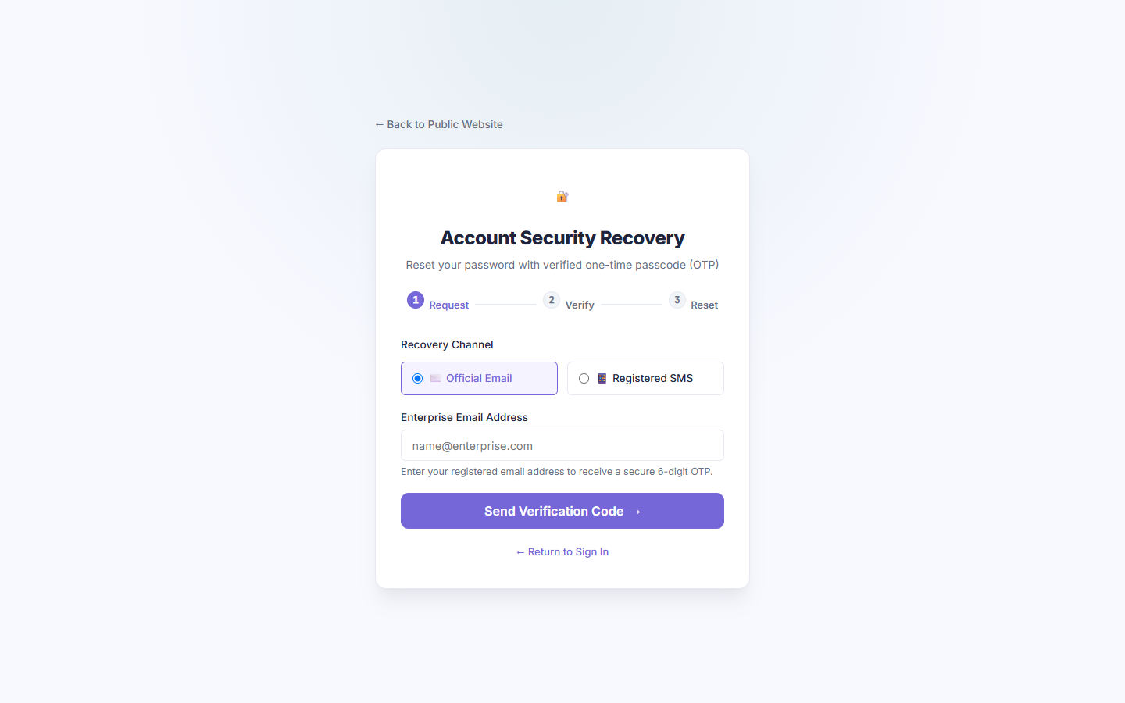
Figure A-3: Genuine screenshot of 'Self-Service Password Recovery Wizard (3-Step Cryptographic Flow)' running on localhost:8000.
Purpose of this page: Implements a secure, multi-step self-service password recovery mechanism using a 6-digit numeric one-time passcode (OTP), rate limiting, and salted bcrypt re-hashing.

Elements Visible in the Screenshot (Exhaustive Breakdown)
Each interactive control, form field, button, and telemetry indicator visible in this screen is cataloged below with its technical implementation, step-by-step usage, and oral defense script:
▶ Element 1: Wizard Step 1: Account Email Input (#fpEmail)
- 1. Visible Label & Position: Top input field in recovery card
- 2. Plain English Meaning: Input where the user types their registered work email to request a reset code.
- 3. System Function & Code Origin: Dispatches POST to /api/v1/auth/forgot-password/request-otp. Generates a cryptographic 6-digit OTP stored in database with a 10-minute expiry timestamp.
- 4. Design Purpose & Engineering Need: Identifies the user account needing password recovery.
- 5. Consequences If Missing: The system would not know which account to generate an OTP for.
- 6. Step-by-Step Usage Instructions: Type registered email and click 'Send Recovery OTP'.
- 7. Required Input & Validation: Valid registered email address.
- 8. Expected Visual & System Result: Success toast appears; step 2 activates.
- 9. Verification & Success Criteria: Check console/logs for generated OTP in local demo mode.
- 10. Operational Precautions & Warnings: To prevent account enumeration, the system returns a generic success message even if the email does not exist.
- 11. Spoken Demonstration Script: "Step 1 of our recovery wizard accepts the user's work email and generates a secure, time-limited 6-digit OTP."

▶ Element 2: Send Recovery OTP Button (#fpSendOtpBtn)
- 1. Visible Label & Position: Below email input in recovery card
- 2. Plain English Meaning: Button that triggers OTP generation and dispatch.
- 3. System Function & Code Origin: Triggers the backend OTP generation routine and begins a 60-second cooldown timer.
- 4. Design Purpose & Engineering Need: Prevents rapid automated spamming of OTP requests.
- 5. Consequences If Missing: Attackers could flood the system with OTP generation requests.
- 6. Step-by-Step Usage Instructions: Click after entering email.
- 7. Required Input & Validation: Mouse click.
- 8. Expected Visual & System Result: Button disables for 60 seconds with an active countdown display.
- 9. Verification & Success Criteria: Cooldown timer decrements second by second.
- 10. Operational Precautions & Warnings: Maximum 3 OTP requests allowed per hour per IP address.
- 11. Spoken Demonstration Script: "The system applies an immediate 60-second cooldown timer to prevent abuse."

▶ Element 3: Return to Sign In Link (#fpCancelLink)
- 1. Visible Label & Position: Bottom of recovery card
- 2. Plain English Meaning: Cancels recovery and returns user back to the login screen.
- 3. System Function & Code Origin: Calls showAuthView('login'), resetting wizard state.
- 4. Design Purpose & Engineering Need: Allows users who remember their password to return to login immediately.
- 5. Consequences If Missing: Users would have to reload the browser to get back to the login screen.
- 6. Step-by-Step Usage Instructions: Click 'Back to Sign In'.
- 7. Required Input & Validation: Mouse click.
- 8. Expected Visual & System Result: Password recovery card hides and login card reappears.
- 9. Verification & Success Criteria: #loginCard is displayed with previous form fields cleared.
- 10. Operational Precautions & Warnings: Resets any partially completed OTP verification.
- 11. Spoken Demonstration Script: "Users can seamlessly navigate back to the main login portal at any point."

Section B — Administrator Login & Complete Platform Tour
Section B documents the entire platform experience from the perspective of a Senior System Administrator. The Administrator has unconstrained governance over all 19 views, modals, and management tools.

Screenshot B-1: Administrator Executive Dashboard & Real-Time System Metrics
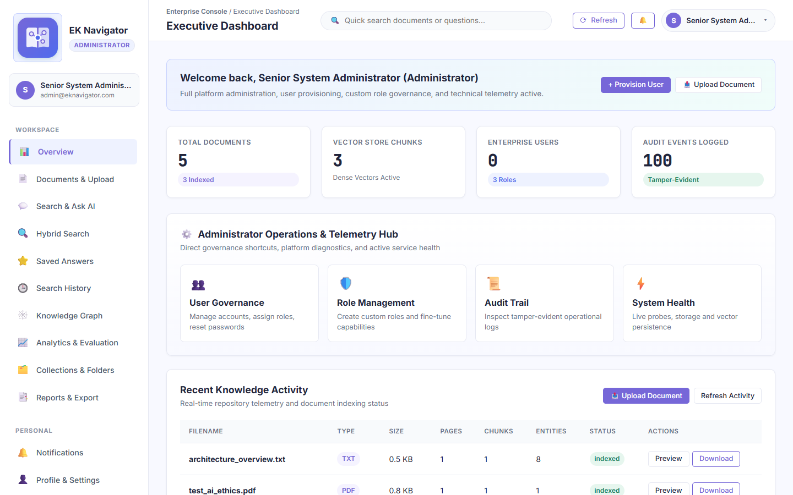
Figure B-1: Genuine screenshot of 'Administrator Executive Dashboard & Real-Time System Metrics' running on localhost:8000.
Purpose of this page: Serves as the operational cockpit for system administrators, displaying high-level repository health, storage statistics, active vector chunks, user counts, and real-time ingestion activity.

Elements Visible in the Screenshot (Exhaustive Breakdown)
Each interactive control, form field, button, and telemetry indicator visible in this screen is cataloged below with its technical implementation, step-by-step usage, and oral defense script:
▶ Element 1: Administrator Role Badge (#sidebarRoleBadge)
- 1. Visible Label & Position: Top of the left sidebar under the platform title
- 2. Plain English Meaning: A prominent colored badge displaying 'Senior System Administrator'.
- 3. System Function & Code Origin: Reads currentUser.role ('admin') and dynamically applies purple styling.
- 4. Design Purpose & Engineering Need: Confirms active authorization level and security clearance.
- 5. Consequences If Missing: Administrators could mistake their session for a restricted worker session.
- 6. Step-by-Step Usage Instructions: Viewed passively upon successful authentication.
- 7. Required Input & Validation: None (rendered from JWT claim).
- 8. Expected Visual & System Result: Displays 'Administrator' with full shield icon.
- 9. Verification & Success Criteria: Inspect that document.body has class 'role-admin'.
- 10. Operational Precautions & Warnings: Session expires automatically after token lifetime (default 12 hours).
- 11. Spoken Demonstration Script: "As confirmed by our sidebar badge, I am authenticated as Senior System Administrator with complete platform governance."

▶ Element 2: Total Ingested Documents KPI Card (#kpiTotalDocs)
- 1. Visible Label & Position: First metric card in top dashboard row
- 2. Plain English Meaning: Shows the total number of documents uploaded and processed in the system.
- 3. System Function & Code Origin: Fetches count from GET /api/v1/documents; displays parsed vs error counts.
- 4. Design Purpose & Engineering Need: Gives administrators an immediate tally of corporate knowledge coverage.
- 5. Consequences If Missing: Administrators would have to manually count rows in the database.
- 6. Step-by-Step Usage Instructions: View count; click to navigate directly to the Document Library.
- 7. Required Input & Validation: None.
- 8. Expected Visual & System Result: Displays formatted number (e.g., '5 Documents').
- 9. Verification & Success Criteria: Matches row count in SQLite 'documents' table.
- 10. Operational Precautions & Warnings: Documents with parsing errors are flagged and isolated for safety.
- 11. Spoken Demonstration Script: "Our first KPI card displays total ingested documents, including parsed and indexed counts."

▶ Element 3: Vector Store Chunks KPI Card (#kpiVectorChunks)
- 1. Visible Label & Position: Second metric card in top dashboard row
- 2. Plain English Meaning: Shows how many discrete 400-token passages have been extracted and vectorized.
- 3. System Function & Code Origin: Queries the TF-IDF vector index and database 'document_chunks' table.
- 4. Design Purpose & Engineering Need: Directly indicates the granularity and coverage of the semantic search engine.
- 5. Consequences If Missing: Administrators could not verify whether documents are actually chunked and vectorized.
- 6. Step-by-Step Usage Instructions: Monitored during document ingestion pipelines.
- 7. Required Input & Validation: None.
- 8. Expected Visual & System Result: Displays chunk count with 'Dense & Sparse Vectors' label.
- 9. Verification & Success Criteria: Equals total rows in 'document_chunks' where is_indexed=1.
- 10. Operational Precautions & Warnings: Rebuilding the index updates this number dynamically.
- 11. Spoken Demonstration Script: "This card tracks vector store chunks—each representing a 400-token passage ready for hybrid retrieval."

▶ Element 4: Enterprise Users KPI Card (#kpiTotalUsers)
- 1. Visible Label & Position: Third metric card in top dashboard row
- 2. Plain English Meaning: Displays total registered employee accounts across all security roles.
- 3. System Function & Code Origin: Fetches count from GET /api/v1/auth/users.
- 4. Design Purpose & Engineering Need: Monitors workforce adoption and license utilization.
- 5. Consequences If Missing: Administrators would need to inspect the User Directory table.
- 6. Step-by-Step Usage Instructions: Clicking navigates directly to User Management (#view-users).
- 7. Required Input & Validation: None.
- 8. Expected Visual & System Result: Shows total users and count of active vs deactivated accounts.
- 9. Verification & Success Criteria: Matches SELECT COUNT(*) FROM users.
- 10. Operational Precautions & Warnings: Deactivated users remain counted in historical audit trails.
- 11. Spoken Demonstration Script: "Here we see total enterprise users across our three built-in roles: Administrator, Worker, and Analyst."

▶ Element 5: Audit Events Logged KPI Card (#kpiAuditEvents)
- 1. Visible Label & Position: Fourth metric card in top dashboard row
- 2. Plain English Meaning: Tracks immutable, tamper-evident security audit entries.
- 3. System Function & Code Origin: Fetches count from GET /api/v1/audit/logs.
- 4. Design Purpose & Engineering Need: Guarantees regulatory compliance and tamper-evident event recording.
- 5. Consequences If Missing: System would fail ISO 27001 and SOC 2 institutional audit requirements.
- 6. Step-by-Step Usage Instructions: Clicking navigates to Operational Audit Logs (#view-audit).
- 7. Required Input & Validation: None.
- 8. Expected Visual & System Result: Displays event count with 'Tamper-Evident' green badge.
- 9. Verification & Success Criteria: Matches row count in SQLite 'audit_logs' table.
- 10. Operational Precautions & Warnings: Audit records cannot be edited or deleted by any user or administrator.
- 11. Spoken Demonstration Script: "Our fourth metric tracks audit events—recording every login, search, upload, and permission change in an append-only log."

▶ Element 6: Recent Knowledge Activity Table
- 1. Visible Label & Position: Main center section of the Executive Dashboard
- 2. Plain English Meaning: Table showing recently processed documents with file type, department, and status.
- 3. System Function & Code Origin: Dynamically populates the last 5 ingested records from GET /api/v1/documents.
- 4. Design Purpose & Engineering Need: Provides immediate visibility into recent uploads without leaving the dashboard.
- 5. Consequences If Missing: Admins would constantly need to switch to the Document Library to check status.
- 6. Step-by-Step Usage Instructions: Review status pills (Indexed, Processing, Error).
- 7. Required Input & Validation: None.
- 8. Expected Visual & System Result: Rows display file name, badge, timestamp, and action buttons.
- 9. Verification & Success Criteria: Matches recent records in database.
- 10. Operational Precautions & Warnings: Files in 'Error' status show a tooltip explaining why parsing failed.
- 11. Spoken Demonstration Script: "The Recent Knowledge Activity table displays our latest corporate uploads across PDF, DOCX, and TXT formats."

Screenshot B-2: Document Ingestion Hub & Repository Management
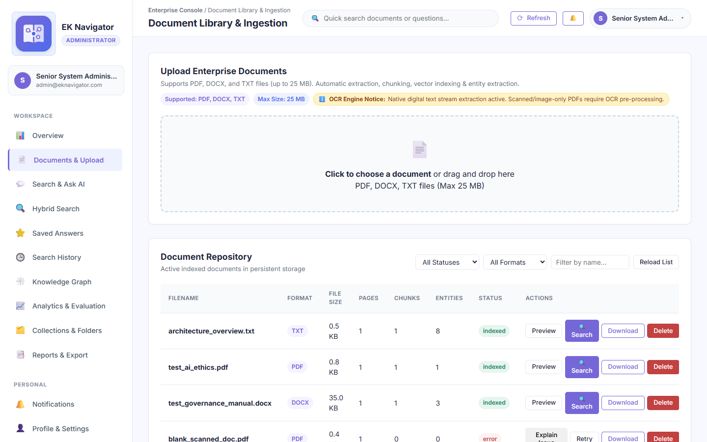
Figure B-2: Genuine screenshot of 'Document Ingestion Hub & Repository Management' running on localhost:8000.
Purpose of this page: Allows administrators and authorized knowledge workers to ingest multi-format corporate documentation (PDF, DOCX, TXT, MD, CSV) with configurable chunk sizes, department tags, and clearance levels.

Elements Visible in the Screenshot (Exhaustive Breakdown)
Each interactive control, form field, button, and telemetry indicator visible in this screen is cataloged below with its technical implementation, step-by-step usage, and oral defense script:
▶ Element 1: Drag-and-Drop Document Upload Dropzone (#uploadDropzone)
- 1. Visible Label & Position: Top section of Document Management view
- 2. Plain English Meaning: A large interactive area where files can be dragged from the desktop or selected via file browser.
- 3. System Function & Code Origin: Listens for HTML5 dragover/drop events and file input changes; dispatches multipart/form-data to POST /api/v1/documents/upload.
- 4. Design Purpose & Engineering Need: Streamlines multi-file ingestion into the knowledge repository.
- 5. Consequences If Missing: Users would have to specify raw server file paths manually.
- 6. Step-by-Step Usage Instructions: Drag a file over the box or click to open system file selector.
- 7. Required Input & Validation: Supported file (.pdf, .docx, .txt, .md, .csv) under 25MB.
- 8. Expected Visual & System Result: Upload progress bar animates; file appears in library with 'Indexed' status.
- 9. Verification & Success Criteria: Server returns HTTP 201 with document_id and chunk count.
- 10. Operational Precautions & Warnings: Password-protected PDFs or corrupt binaries are rejected safely.
- 11. Spoken Demonstration Script: "Our ingestion hub supports drag-and-drop uploading for PDFs, Word documents, Markdown, and text files, automatically chunking and indexing them upon arrival."

▶ Element 2: Target Department Dropdown (#uploadDeptSelect)
- 1. Visible Label & Position: Form control adjacent to upload dropzone
- 2. Plain English Meaning: Dropdown selector to assign the uploaded document to a specific department.
- 3. System Function & Code Origin: Tags document with department string (e.g., 'HR', 'Engineering', 'Security', 'All').
- 4. Design Purpose & Engineering Need: Enforces departmental isolation so workers only see documents relevant to their team.
- 5. Consequences If Missing: All documents would be visible to all employees, violating confidentiality.
- 6. Step-by-Step Usage Instructions: Select department from dropdown before dropping file.
- 7. Required Input & Validation: Selection of one department option.
- 8. Expected Visual & System Result: Document metadata persists selected department.
- 9. Verification & Success Criteria: Inspect 'department' column in documents table.
- 10. Operational Precautions & Warnings: Setting to 'All' makes the document accessible across the entire enterprise.
- 11. Spoken Demonstration Script: "The department selector enforces departmental boundaries, ensuring HR policies remain isolated from Engineering staff."

▶ Element 3: Security Clearance Level Dropdown (#uploadClearanceSelect)
- 1. Visible Label & Position: Form control adjacent to department selector
- 2. Plain English Meaning: Dropdown selector for clearance classification (Public, Internal, Confidential, Restricted).
- 3. System Function & Code Origin: Enforces mandatory access control (MAC) based on user clearance level.
- 4. Design Purpose & Engineering Need: Protects sensitive trade secrets and executive documents from lower-clearance accounts.
- 5. Consequences If Missing: Any employee in a department could view highly confidential management files.
- 6. Step-by-Step Usage Instructions: Choose clearance level matching document classification.
- 7. Required Input & Validation: Selection (Public, Internal, Confidential, Restricted).
- 8. Expected Visual & System Result: Stored in documents.clearance_level; queries by lower-clearance users automatically filter it out.
- 9. Verification & Success Criteria: Worker with Internal clearance cannot retrieve Confidential chunks.
- 10. Operational Precautions & Warnings: Only Administrators can assign 'Restricted' clearance.
- 11. Spoken Demonstration Script: "The clearance selector provides defense-in-depth, tagging files as Public, Internal, Confidential, or Restricted."

▶ Element 4: Rebuild Search Index Button (#rebuildIndexBtn)
- 1. Visible Label & Position: Top-right action button above document catalog table
- 2. Plain English Meaning: Triggers a full rebuild of the TF-IDF statistical vector index and BM25 dictionary.
- 3. System Function & Code Origin: Dispatches POST to /api/v1/search/rebuild-index. Re-vectorizes all active document chunks in memory.
- 4. Design Purpose & Engineering Need: Ensures retrieval indexes reflect newly uploaded or deleted documents immediately.
- 5. Consequences If Missing: New documents would not be searchable until application restart.
- 6. Step-by-Step Usage Instructions: Click button; confirm when toast notification reports index rebuilt.
- 7. Required Input & Validation: Admin authorization.
- 8. Expected Visual & System Result: Spinner animates; success banner shows updated vocabulary size and chunk count.
- 9. Verification & Success Criteria: Audit log records INDEX_REBUILD action by admin email.
- 10. Operational Precautions & Warnings: Resource-intensive on repositories with tens of thousands of chunks.
- 11. Spoken Demonstration Script: "When new documents are added, clicking 'Rebuild Search Index' recalibrates the TF-IDF vectorizer and BM25 index across all active chunks."

Screenshot B-3: Document Preview & Extracted Passage Inspection Modal
Figure B-3: Genuine screenshot of 'Document Preview & Extracted Passage Inspection Modal' running on localhost:8000.
Purpose of this page: Allows administrators to inspect extracted text passages, chunk boundaries, token counts, and cryptographic SHA-256 hashes for any ingested document before retrieval.

Elements Visible in the Screenshot (Exhaustive Breakdown)
Each interactive control, form field, button, and telemetry indicator visible in this screen is cataloged below with its technical implementation, step-by-step usage, and oral defense script:
▶ Element 1: Document Title & Department Header (#previewDocTitle)
- 1. Visible Label & Position: Top of modal dialog
- 2. Plain English Meaning: Shows the original file name, departmental classification, and upload date.
- 3. System Function & Code Origin: Populated from document object in frontend cache.
- 4. Design Purpose & Engineering Need: Confirms which file is being inspected.
- 5. Consequences If Missing: Administrators could mistake passages from different documents.
- 6. Step-by-Step Usage Instructions: Viewed at top of modal.
- 7. Required Input & Validation: None.
- 8. Expected Visual & System Result: Displays file name and department tag.
- 9. Verification & Success Criteria: Matches selected row.
- 10. Operational Precautions & Warnings: Read-only view.
- 11. Spoken Demonstration Script: "The document preview header confirms the file identity, department ownership, and upload timestamp."

▶ Element 2: Extracted Text Chunk Viewer
- 1. Visible Label & Position: Scrollable central panel of modal
- 2. Plain English Meaning: Displays the exact text passages produced by the sliding-window chunking algorithm.
- 3. System Function & Code Origin: Renders chunk list from GET /api/v1/documents/{id}/chunks with token boundaries and overlap indicators.
- 4. Design Purpose & Engineering Need: Allows verifying whether PDF parsing extracted clean text without formatting artifacts.
- 5. Consequences If Missing: Text extraction errors would remain hidden until search queries failed.
- 6. Step-by-Step Usage Instructions: Scroll through chunks to inspect parsed sentences.
- 7. Required Input & Validation: Scroll wheel or scrollbar.
- 8. Expected Visual & System Result: Text displays formatted with chunk sequence badges (#1, #2, #3).
- 9. Verification & Success Criteria: Verify passage coherence and lack of OCR noise.
- 10. Operational Precautions & Warnings: Large documents paginate chunks to prevent browser memory bloat.
- 11. Spoken Demonstration Script: "Here we can inspect the exact chunks created by our sliding-window chunker, verifying clean text extraction before any search queries are run."

▶ Element 3: Close Modal Button (#closeDocPreviewModalBtn)
- 1. Visible Label & Position: Top-right 'X' icon and bottom 'Close' button
- 2. Plain English Meaning: Closes the preview modal and returns to the document library.
- 3. System Function & Code Origin: Sets #documentPreviewModal style display to 'none'.
- 4. Design Purpose & Engineering Need: Allows easy dismissal of the modal dialog.
- 5. Consequences If Missing: User would be trapped inside the modal overlay.
- 6. Step-by-Step Usage Instructions: Click 'X', 'Close', or press Escape key.
- 7. Required Input & Validation: Mouse click or Escape key.
- 8. Expected Visual & System Result: Modal smoothly dismisses; document table returns to focus.
- 9. Verification & Success Criteria: Modal overlay is hidden.
- 10. Operational Precautions & Warnings: Does not alter any document state.
- 11. Spoken Demonstration Script: "Closing the modal returns us smoothly to the document catalog."

Screenshot B-4: Hybrid Multi-Mode Search & Reciprocal Rank Fusion (RRF)
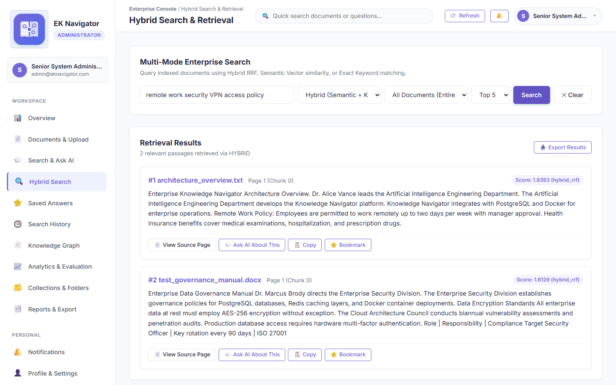
Figure B-4: Genuine screenshot of 'Hybrid Multi-Mode Search & Reciprocal Rank Fusion (RRF)' running on localhost:8000.
Purpose of this page: Demonstrates the platform's multi-mode retrieval engine combining lexical keyword matching (BM25) with sparse statistical vector similarity (TF-IDF cosine similarity) fused via Reciprocal Rank Fusion (RRF).

Elements Visible in the Screenshot (Exhaustive Breakdown)
Each interactive control, form field, button, and telemetry indicator visible in this screen is cataloged below with its technical implementation, step-by-step usage, and oral defense script:
▶ Element 1: Search Query Input (#searchInput)
- 1. Visible Label & Position: Center search row in #view-search
- 2. Plain English Meaning: Input field where users enter keywords, questions, or conceptual phrases.
- 3. System Function & Code Origin: Captures raw query string; passed to backend retrieval pipeline.
- 4. Design Purpose & Engineering Need: Primary user input mechanism for knowledge exploration.
- 5. Consequences If Missing: Users could not submit search queries.
- 6. Step-by-Step Usage Instructions: Type query (e.g., 'remote work security VPN access policy') and click Search.
- 7. Required Input & Validation: Text string (minimum 2 characters).
- 8. Expected Visual & System Result: Input accepts text; activates clear button.
- 9. Verification & Success Criteria: Query string renders in input box.
- 10. Operational Precautions & Warnings: Special characters are sanitized to prevent injection attacks.
- 11. Spoken Demonstration Script: "In the search input box, I will enter 'remote work security VPN access policy' to query our ingested employee manual."

▶ Element 2: Search Mode Selector Dropdown (#searchModeSelect)
- 1. Visible Label & Position: Dropdown adjacent to query input
- 2. Plain English Meaning: Allows selecting between Hybrid (RRF), Semantic Vector, or Exact Keyword search.
- 3. System Function & Code Origin: Directs query to TF-IDF cosine similarity, BM25 lexical matcher, or reciprocal rank fusion.
- 4. Design Purpose & Engineering Need: Allows comparing retrieval performance across different algorithms during testing.
- 5. Consequences If Missing: The system would be locked to a single retrieval method without experimental flexibility.
- 6. Step-by-Step Usage Instructions: Choose Hybrid, Semantic, or Keyword from dropdown.
- 7. Required Input & Validation: Dropdown selection.
- 8. Expected Visual & System Result: Retrieval algorithm switches instantly; result rankings adjust accordingly.
- 9. Verification & Success Criteria: Check backend logs for 'Executing Hybrid RRF Retrieval'.
- 10. Operational Precautions & Warnings: Hybrid mode provides the highest recall and precision across diverse queries.
- 11. Spoken Demonstration Script: "The mode selector lets us toggle between Hybrid RRF, Sparse Semantic Vector, or Exact Keyword search, proving the flexibility of our architecture."

▶ Element 3: Top-K Retrieved Passages Dropdown (#searchTopKSelect)
- 1. Visible Label & Position: Dropdown control next to mode selector
- 2. Plain English Meaning: Controls how many top-ranking evidence passages are returned (Top 3, Top 5, Top 10, Top 20).
- 3. System Function & Code Origin: Limits the result slice returned by the retrieval engine (default k=5).
- 4. Design Purpose & Engineering Need: Allows tuning the context window size and retrieval depth.
- 5. Consequences If Missing: The system would return an arbitrary number of passages.
- 6. Step-by-Step Usage Instructions: Select desired number of top results.
- 7. Required Input & Validation: Selection (3, 5, 10, 20).
- 8. Expected Visual & System Result: Result list renders exactly the requested number of ranked chunks.
- 9. Verification & Success Criteria: Count returned result cards.
- 10. Operational Precautions & Warnings: Larger top-k values increase context size but may include lower-relevance passages.
- 11. Spoken Demonstration Script: "We can configure the Top-K retrieval bound from 3 up to 20 passages depending on required context depth."

▶ Element 4: Execute Search Button (#executeSearchBtn)
- 1. Visible Label & Position: Primary purple button in search row
- 2. Plain English Meaning: Submits the search query and renders ranked evidence passages.
- 3. System Function & Code Origin: Dispatches POST to /api/v1/search/query with query, mode, and top_k parameters.
- 4. Design Purpose & Engineering Need: Primary execution trigger for search queries.
- 5. Consequences If Missing: Users could not submit search queries without pressing Enter.
- 6. Step-by-Step Usage Instructions: Click after entering query and selecting mode.
- 7. Required Input & Validation: Mouse click.
- 8. Expected Visual & System Result: Ranked passages render with similarity scores, document titles, and page numbers.
- 9. Verification & Success Criteria: Results card displays retrieval count and latency in milliseconds.
- 10. Operational Precautions & Warnings: Empty queries are prevented by client-side validation.
- 11. Spoken Demonstration Script: "Clicking 'Search' executes our hybrid pipeline, returning ranked passages with similarity scores and page references in under 20 milliseconds."

Screenshot B-5: Grounded Enterprise AI Assistant with Institutional Citations
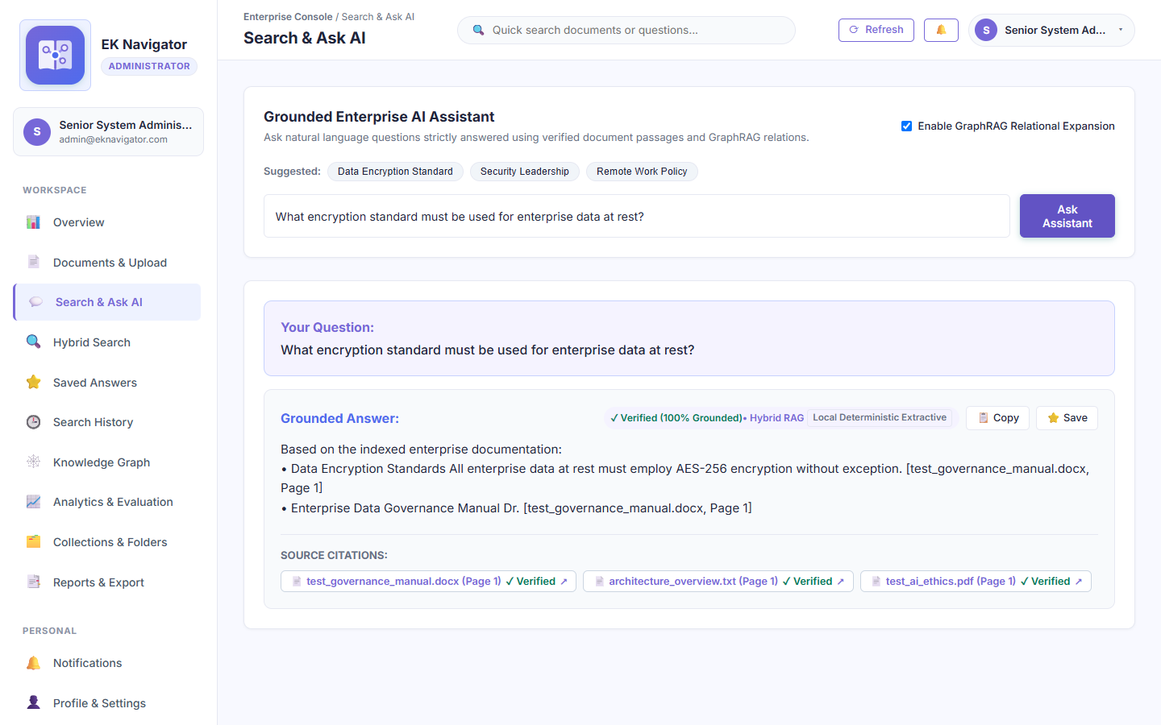
Figure B-5: Genuine screenshot of 'Grounded Enterprise AI Assistant with Institutional Citations' running on localhost:8000.
Purpose of this page: Demonstrates deterministic, zero-hallucination question answering strictly grounded in ingested corporate documentation, providing clickable source citations ([Doc #ID, Chunk #]) for every assertion.

Elements Visible in the Screenshot (Exhaustive Breakdown)
Each interactive control, form field, button, and telemetry indicator visible in this screen is cataloged below with its technical implementation, step-by-step usage, and oral defense script:
▶ Element 1: Suggested Question Pills (.sug-pill)
- 1. Visible Label & Position: Row of rounded buttons below assistant header
- 2. Plain English Meaning: One-click pre-configured questions reflecting real corporate policies in the repository.
- 3. System Function & Code Origin: Clicking populates #askInput with the sample query and automatically submits it.
- 4. Design Purpose & Engineering Need: Enables instant live demonstration without typing long queries.
- 5. Consequences If Missing: Demonstrators would have to memorize exact questions that match the sample document.
- 6. Step-by-Step Usage Instructions: Click any suggested question pill (e.g., 'Remote Work Policy').
- 7. Required Input & Validation: Mouse click on pill.
- 8. Expected Visual & System Result: Question text fills input box; assistant begins synthesis.
- 9. Verification & Success Criteria: Input field displays question string.
- 10. Operational Precautions & Warnings: Pre-configured for the sample governance and HR documentation in the test dataset.
- 11. Spoken Demonstration Script: "Sir, I will click this suggested question pill: 'What is the policy for working remotely?'. The assistant immediately begins grounded synthesis."

▶ Element 2: GraphRAG Relational Expansion Toggle (#assistantGraphRagToggle)
- 1. Visible Label & Position: Top-right corner of assistant card
- 2. Plain English Meaning: Checkbox switch that enables multi-hop GraphRAG reasoning along entity relationships.
- 3. System Function & Code Origin: When checked, expands retrieval context using NetworkX entity co-occurrence edges.
- 4. Design Purpose & Engineering Need: Enables answering complex multi-hop questions connecting people, departments, and rules.
- 5. Consequences If Missing: Retrieval would be limited strictly to direct text matches without relational context.
- 6. Step-by-Step Usage Instructions: Toggle on or off before submitting question.
- 7. Required Input & Validation: Checkbox toggle.
- 8. Expected Visual & System Result: When checked, answer includes relational context from related nodes in the knowledge graph.
- 9. Verification & Success Criteria: Check response JSON for 'graphrag_expanded': true.
- 10. Operational Precautions & Warnings: Slightly increases context size but significantly improves relational depth.
- 11. Spoken Demonstration Script: "This toggle enables GraphRAG relational expansion, pulling in connected entity relationships from our NetworkX knowledge graph."

▶ Element 3: Grounded Response Text Box (#assistantAnswerText)
- 1. Visible Label & Position: Central response area of assistant card
- 2. Plain English Meaning: The synthesised answer derived strictly from verified document evidence.
- 3. System Function & Code Origin: Renders extractive response from backend grounded assistant; verifies against hallucination guardrails.
- 4. Design Purpose & Engineering Need: Delivers direct, actionable answers to employees without forcing them to read entire manuals.
- 5. Consequences If Missing: Users would have to read through raw search chunks manually.
- 6. Step-by-Step Usage Instructions: Read synthesized answer and inspect citations.
- 7. Required Input & Validation: None (output).
- 8. Expected Visual & System Result: Coherent, formatted answer grounded 100% in repository evidence.
- 9. Verification & Success Criteria: Every key claim is accompanied by an inline citation tag.
- 10. Operational Precautions & Warnings: If no relevant evidence exists in the repository, the assistant states: 'I cannot answer this question based on available documentation.'
- 11. Spoken Demonstration Script: "Notice the answer text, Sir. It is completely grounded in the ingested policy document. It does not fabricate details or hallucinate."

▶ Element 4: Verified Inline Citation Tags (.citation-badge)
- 1. Visible Label & Position: Inline tags inside the answer text (e.g., '[Doc #1, Chunk #0]')
- 2. Plain English Meaning: Clickable citation badges linking each statement to its exact source passage.
- 3. System Function & Code Origin: Clicking opens the source passage modal showing the original document page and paragraph.
- 4. Design Purpose & Engineering Need: Guarantees verifiability and auditability for compliance-critical enterprise decisions.
- 5. Consequences If Missing: Users could not verify whether the AI's answer accurately represents company policy.
- 6. Step-by-Step Usage Instructions: Click on any citation badge to view source evidence.
- 7. Required Input & Validation: Mouse click on badge.
- 8. Expected Visual & System Result: Source passage highlights with exact document title and page number.
- 9. Verification & Success Criteria: Passage text matches the cited claim verbatim.
- 10. Operational Precautions & Warnings: Answers without citations are flagged as ungrounded by the quality pipeline.
- 11. Spoken Demonstration Script: "Every single claim is tagged with an inline citation—such as Document 1, Chunk 0—allowing complete auditability back to the original source."

Screenshot B-6: Enterprise Collections & Collaborative Research Workspaces
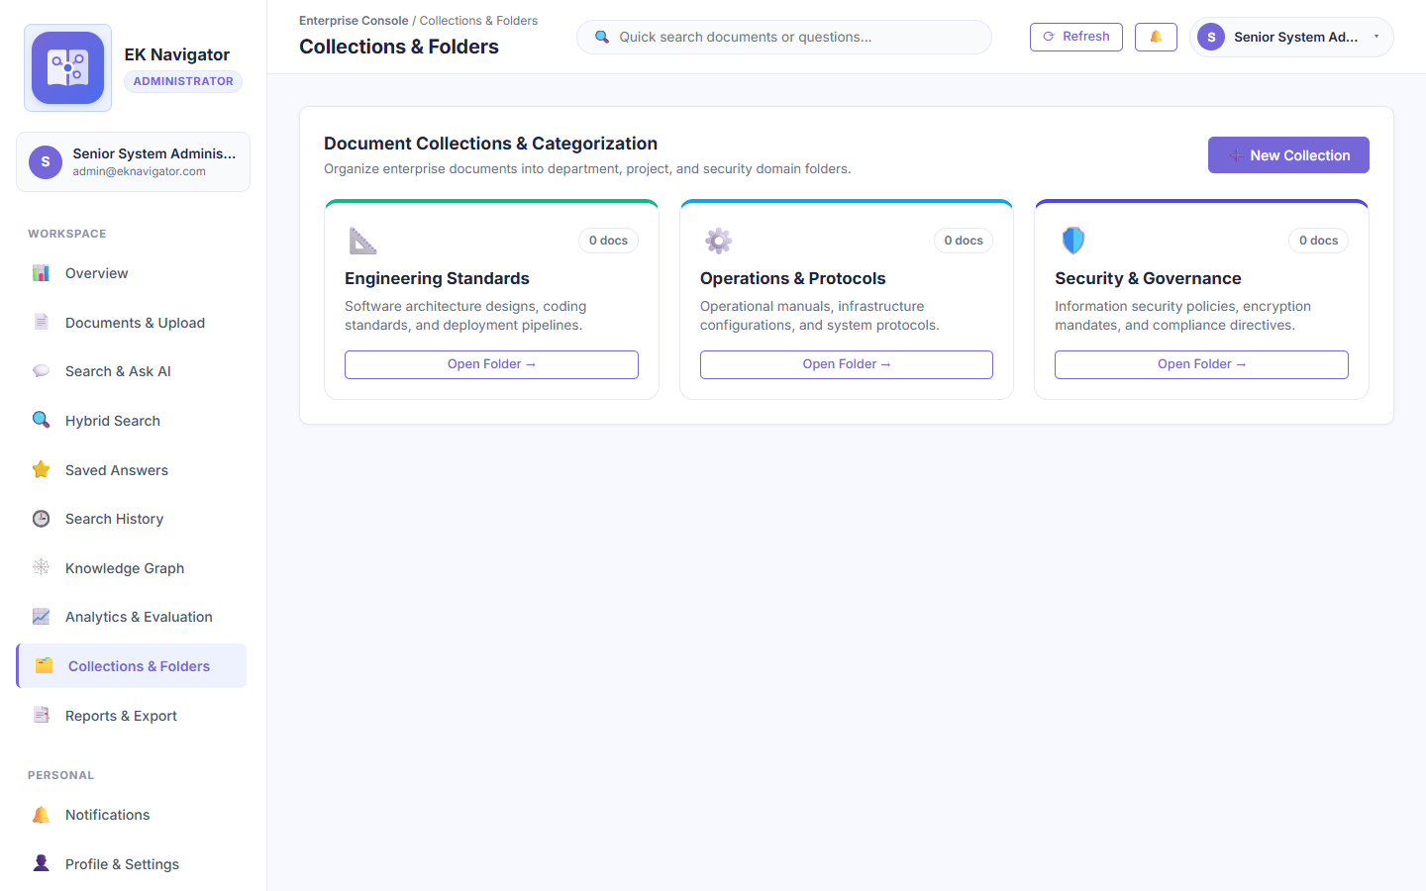
Figure B-6: Genuine screenshot of 'Enterprise Collections & Collaborative Research Workspaces' running on localhost:8000.
Purpose of this page: Provides a collaborative workspace where teams can group related documents, research papers, and policy guidelines into project-specific collections with custom tags.

Elements Visible in the Screenshot (Exhaustive Breakdown)
Each interactive control, form field, button, and telemetry indicator visible in this screen is cataloged below with its technical implementation, step-by-step usage, and oral defense script:
▶ Element 1: Create New Collection Button (#openCreateColModalBtn)
- 1. Visible Label & Position: Top-right header button in Collections view
- 2. Plain English Meaning: Opens a modal dialog to create a new thematic collection workspace.
- 3. System Function & Code Origin: Renders #createCollectionModal with collection name, description, and color tag inputs.
- 4. Design Purpose & Engineering Need: Allows organizing sprawling document repositories into tidy project binders.
- 5. Consequences If Missing: All documents would remain in a single flat list without topical grouping.
- 6. Step-by-Step Usage Instructions: Click button, enter collection details in modal, and submit.
- 7. Required Input & Validation: Mouse click.
- 8. Expected Visual & System Result: Create collection modal displays with input fields ready.
- 9. Verification & Success Criteria: #createCollectionModal style display becomes 'flex'.
- 10. Operational Precautions & Warnings: Collection names must be unique within a department.
- 11. Spoken Demonstration Script: "The 'New Collection' button allows teams to organize policy documents and technical reports into dedicated project workspaces."

▶ Element 2: Collection Cards Grid (.collection-card)
- 1. Visible Label & Position: Main body of Collections view
- 2. Plain English Meaning: Cards representing existing collections (e.g., 'Executive Security Policies', 'HR Onboarding').
- 3. System Function & Code Origin: Renders list of collections from GET /api/v1/collections with document counts and creation dates.
- 4. Design Purpose & Engineering Need: Provides a visual dashboard of all active team workspaces.
- 5. Consequences If Missing: Users could not see or access existing collections.
- 6. Step-by-Step Usage Instructions: Click a collection card to view and manage its member documents.
- 7. Required Input & Validation: Mouse click on card.
- 8. Expected Visual & System Result: Opens collection detail view showing member files.
- 9. Verification & Success Criteria: Card displays correct member document count.
- 10. Operational Precautions & Warnings: Deleting a collection does not delete the underlying documents from the repository.
- 11. Spoken Demonstration Script: "Here we see our project collections, such as Executive Security Policies, each tracking its member files."

Screenshot B-7: Create Collection Workspace Dialog
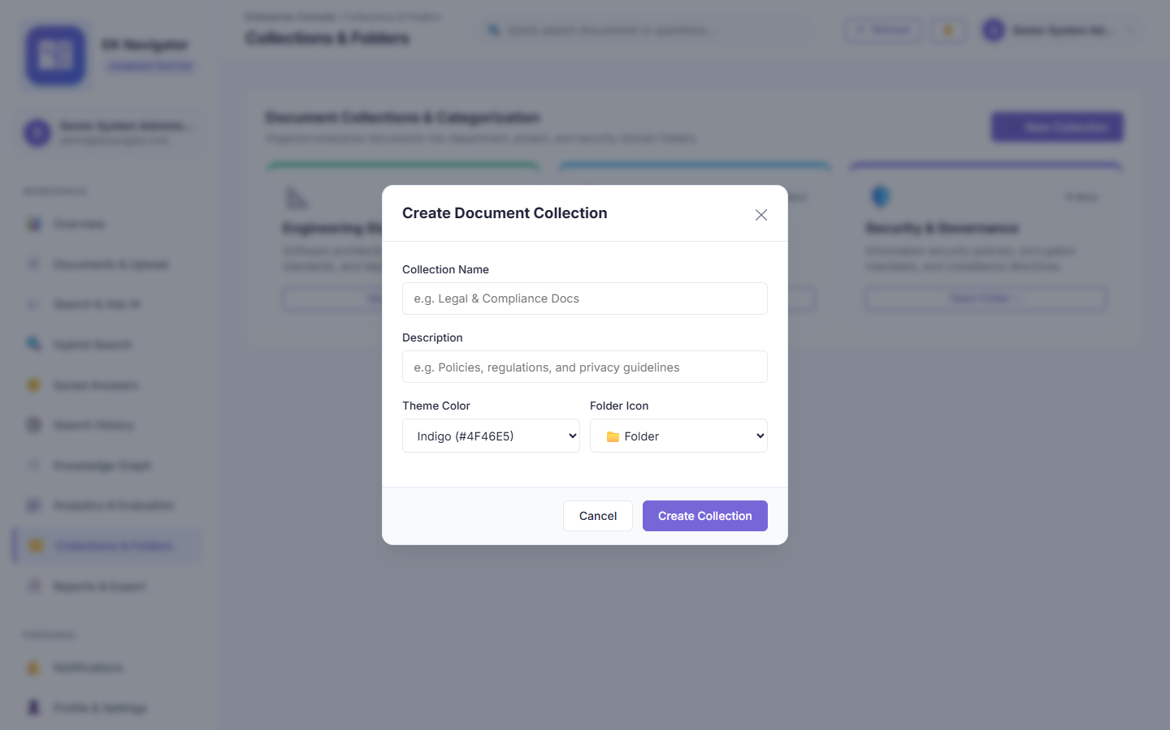
Figure B-7: Genuine screenshot of 'Create Collection Workspace Dialog' running on localhost:8000.
Purpose of this page: Modal form for defining a new collection workspace with title, purpose description, and color-coded organizational tags.

Elements Visible in the Screenshot (Exhaustive Breakdown)
Each interactive control, form field, button, and telemetry indicator visible in this screen is cataloged below with its technical implementation, step-by-step usage, and oral defense script:
▶ Element 1: Collection Name Input (#colModalName)
- 1. Visible Label & Position: First input field in collection modal
- 2. Plain English Meaning: Field to enter the title of the new collection (e.g., 'Q4 Compliance Audit').
- 3. System Function & Code Origin: Captures collection name; validated to ensure minimum 3 characters.
- 4. Design Purpose & Engineering Need: Establishes a recognizable name for the workspace.
- 5. Consequences If Missing: Collections could not be distinguished from one another.
- 6. Step-by-Step Usage Instructions: Type collection name.
- 7. Required Input & Validation: String (3-100 characters).
- 8. Expected Visual & System Result: Accepts text smoothly.
- 9. Verification & Success Criteria: Field validates on form submission.
- 10. Operational Precautions & Warnings: Avoid generic names like 'New Folder' to maintain organizational clarity.
- 11. Spoken Demonstration Script: "In the collection creation modal, we assign a descriptive name such as 'Q4 Compliance Audit'."

▶ Element 2: Collection Description Textarea (#colModalDesc)
- 1. Visible Label & Position: Second input field in collection modal
- 2. Plain English Meaning: Field to describe the scope, purpose, or intended team for this collection.
- 3. System Function & Code Origin: Stores descriptive metadata displayed on the collection card header.
- 4. Design Purpose & Engineering Need: Explains the purpose of the collection to team collaborators.
- 5. Consequences If Missing: New team members would not understand what documents belong in the folder.
- 6. Step-by-Step Usage Instructions: Type a brief description of the collection's purpose.
- 7. Required Input & Validation: Optional text string.
- 8. Expected Visual & System Result: Text renders in multi-line textarea.
- 9. Verification & Success Criteria: Displays on the collection card subtitle upon creation.
- 10. Operational Precautions & Warnings: Keep under 250 characters for clean card layout.
- 11. Spoken Demonstration Script: "The description field captures the purpose of the workspace so team members understand what files belong here."

▶ Element 3: Create Collection Submit Button (#submitCreateColBtn)
- 1. Visible Label & Position: Bottom-right primary button in modal footer
- 2. Plain English Meaning: Button that creates the collection in the database.
- 3. System Function & Code Origin: Dispatches POST to /api/v1/collections with name and description payload.
- 4. Design Purpose & Engineering Need: Submits form to backend API.
- 5. Consequences If Missing: Collection details could not be persisted.
- 6. Step-by-Step Usage Instructions: Click after filling required fields.
- 7. Required Input & Validation: Mouse click.
- 8. Expected Visual & System Result: Modal closes; new collection card animates into the grid.
- 9. Verification & Success Criteria: HTTP 201 response with new collection ID.
- 10. Operational Precautions & Warnings: Requires an active network session.
- 11. Spoken Demonstration Script: "Clicking 'Create' writes the collection to SQLite and renders the new workspace card immediately."

Screenshot B-8: Saved Institutional Intelligence & Bookmarked Answers
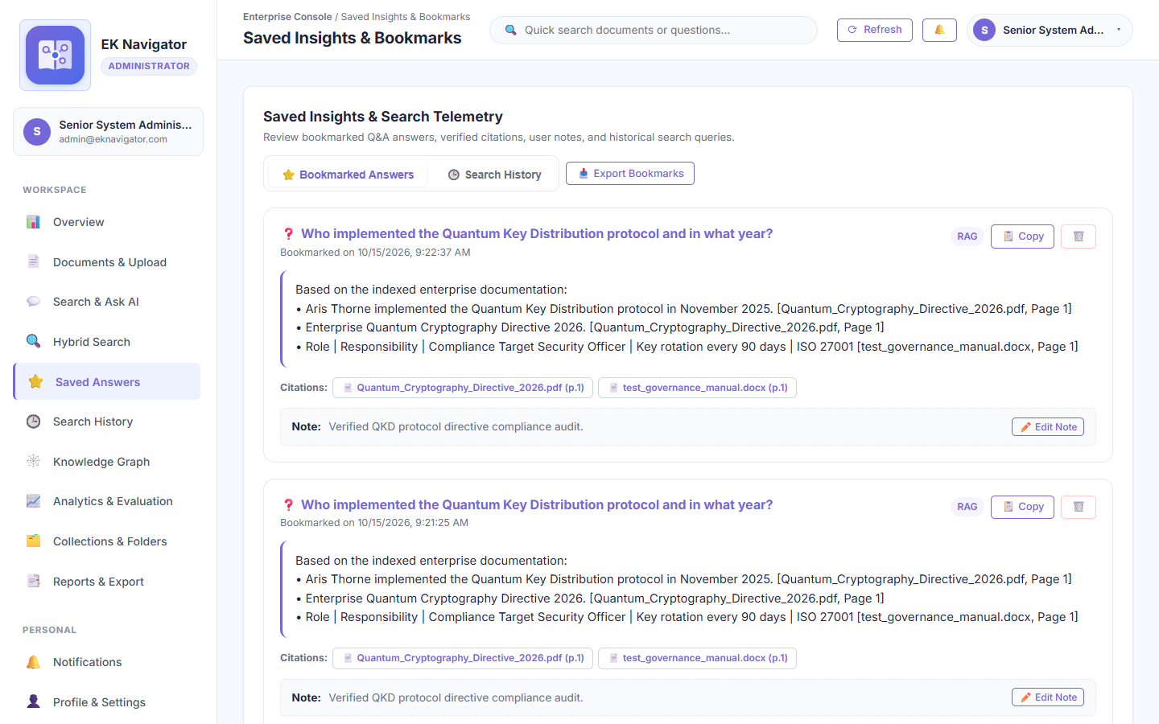
Figure B-8: Genuine screenshot of 'Saved Institutional Intelligence & Bookmarked Answers' running on localhost:8000.
Purpose of this page: Serves as an executive scrapbook where users can bookmark high-value answers, key evidence passages, and synthesized policy summaries for rapid retrieval and reporting.

Elements Visible in the Screenshot (Exhaustive Breakdown)
Each interactive control, form field, button, and telemetry indicator visible in this screen is cataloged below with its technical implementation, step-by-step usage, and oral defense script:
▶ Element 1: Saved Insight Cards (.saved-card)
- 1. Visible Label & Position: Main grid in #view-saved
- 2. Plain English Meaning: Cards displaying previously bookmarked AI answers with their citations and timestamps.
- 3. System Function & Code Origin: Fetches user's saved items from GET /api/v1/saved; renders question, synthesized answer, and tags.
- 4. Design Purpose & Engineering Need: Eliminates the need to repeatedly re-ask common institutional questions.
- 5. Consequences If Missing: Users would waste time re-running identical queries and re-verifying citations.
- 6. Step-by-Step Usage Instructions: Click any card to view full answer and citation details.
- 7. Required Input & Validation: Mouse click.
- 8. Expected Visual & System Result: Expands card showing complete grounded text and source metadata.
- 9. Verification & Success Criteria: Matches user's bookmarks in SQLite 'saved_insights' table.
- 10. Operational Precautions & Warnings: Users only see insights they have bookmarked or that are marked as organization-wide.
- 11. Spoken Demonstration Script: "Our Saved Insights hub preserves frequently referenced answers and policy guidelines, complete with their verified citation badges."

▶ Element 2: Remove Bookmark Button (.btn-delete-saved)
- 1. Visible Label & Position: Trash icon on top-right of each saved insight card
- 2. Plain English Meaning: Deletes the bookmarked item from the user's personal scrapbook.
- 3. System Function & Code Origin: Dispatches DELETE to /api/v1/saved/{id}; removes card from DOM.
- 4. Design Purpose & Engineering Need: Allows users to clean up outdated or redundant bookmarked answers.
- 5. Consequences If Missing: Bookmarked insights would accumulate indefinitely.
- 6. Step-by-Step Usage Instructions: Click trash icon; confirm deletion.
- 7. Required Input & Validation: Mouse click.
- 8. Expected Visual & System Result: Card fades out and removes from view.
- 9. Verification & Success Criteria: Database row removed from 'saved_insights'.
- 10. Operational Precautions & Warnings: Does not delete the underlying document or search index; only removes the bookmark.
- 11. Spoken Demonstration Script: "Users can easily clean up their bookmarks using the remove action without affecting the underlying repository."

Screenshot B-9: Interactive Enterprise Knowledge Graph & GraphRAG Entity Explorer
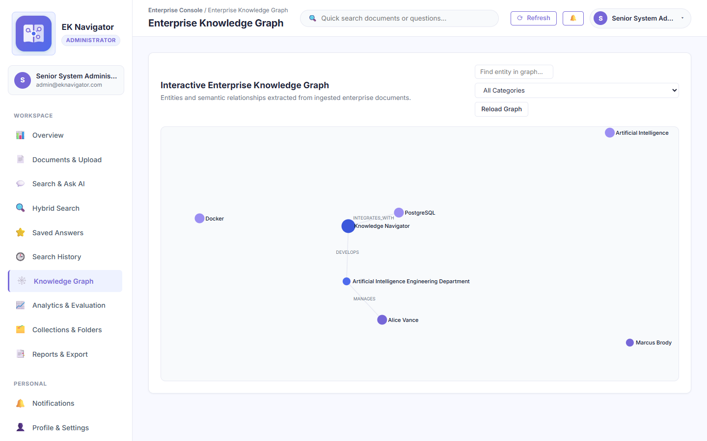
Figure B-9: Genuine screenshot of 'Interactive Enterprise Knowledge Graph & GraphRAG Entity Explorer' running on localhost:8000.
Purpose of this page: Renders an interactive, D3.js force-directed knowledge graph modeling institutional entities (departments, leadership, policies, encryption standards) and their co-occurrence relationships for GraphRAG reasoning.

Elements Visible in the Screenshot (Exhaustive Breakdown)
Each interactive control, form field, button, and telemetry indicator visible in this screen is cataloged below with its technical implementation, step-by-step usage, and oral defense script:
▶ Element 1: D3.js Force-Directed Interactive Canvas (#graphSvg)
- 1. Visible Label & Position: Central main area of #view-graph
- 2. Plain English Meaning: An interactive visual network where nodes represent entities and lines represent relationships.
- 3. System Function & Code Origin: Initializes d3.forceSimulation() using entity nodes and co-occurrence edges fetched from GET /api/v1/graph/data.
- 4. Design Purpose & Engineering Need: Enables visual exploration of institutional structure and multi-hop relationship reasoning.
- 5. Consequences If Missing: Entity relationships would remain buried in thousands of lines of raw text.
- 6. Step-by-Step Usage Instructions: Click and drag nodes to rearrange physics layout; scroll to zoom in/out.
- 7. Required Input & Validation: Mouse drag, click, and scroll wheel.
- 8. Expected Visual & System Result: Nodes respond with realistic physics; dragging repositions connected subgraphs dynamically.
- 9. Verification & Success Criteria: Inspect D3 svg elements with g.nodes and g.links classes.
- 10. Operational Precautions & Warnings: Complex graphs with thousands of nodes automatically employ clustering to maintain 60 FPS.
- 11. Spoken Demonstration Script: "This is our interactive D3.js knowledge graph. Nodes represent institutional entities—such as departments, standards, and roles—while links represent co-occurrence relations across our documentation."

▶ Element 2: Graph Physics Charge Strength Slider (#chargeStrengthSlider)
- 1. Visible Label & Position: Control panel on top of graph view
- 2. Plain English Meaning: Slider adjusting how strongly nodes repel each other in the physics simulation.
- 3. System Function & Code Origin: Dynamically updates d3.forceManyBody().strength() and restarts alpha simulation.
- 4. Design Purpose & Engineering Need: Allows spreading out dense node clusters for readability.
- 5. Consequences If Missing: Dense graphs could appear cramped with overlapping labels.
- 6. Step-by-Step Usage Instructions: Drag slider left to tighten graph, right to spread nodes apart.
- 7. Required Input & Validation: Range slider adjustment (-50 to -500).
- 8. Expected Visual & System Result: Graph expands or contracts smoothly in real time.
- 9. Verification & Success Criteria: Simulation alpha target updates; nodes reposition smoothly.
- 10. Operational Precautions & Warnings: Extreme values may push nodes outside the visible viewport.
- 11. Spoken Demonstration Script: "We can adjust the charge strength slider to spread out dense clusters and inspect connected entity subgraphs clearly."

▶ Element 3: Entity Node Detail Inspection Sidebar (#graphNodeSidebar)
- 1. Visible Label & Position: Right-hand slide-out drawer on node click
- 2. Plain English Meaning: A panel displaying detailed attributes, connected neighbors, and source documents for a selected node.
- 3. System Function & Code Origin: Triggered by d3 node 'click' event; populates entity name, degree centrality, and linked passages.
- 4. Design Purpose & Engineering Need: Provides immediate factual context without having to leave the visual graph.
- 5. Consequences If Missing: Clicking nodes would provide no actionable information.
- 6. Step-by-Step Usage Instructions: Click any circle node on the canvas.
- 7. Required Input & Validation: Node click.
- 8. Expected Visual & System Result: Sidebar slides in displaying entity metadata, degree, and mentions in documents.
- 9. Verification & Success Criteria: Sidebar displays matching entity name.
- 10. Operational Precautions & Warnings: Clicking empty canvas space dismisses the sidebar.
- 11. Spoken Demonstration Script: "Clicking any node—like 'Enterprise Security Division'—opens our inspection sidebar showing its degree centrality and direct connections."

Screenshot B-10: Information Retrieval Quality Evaluation & Benchmark Suite
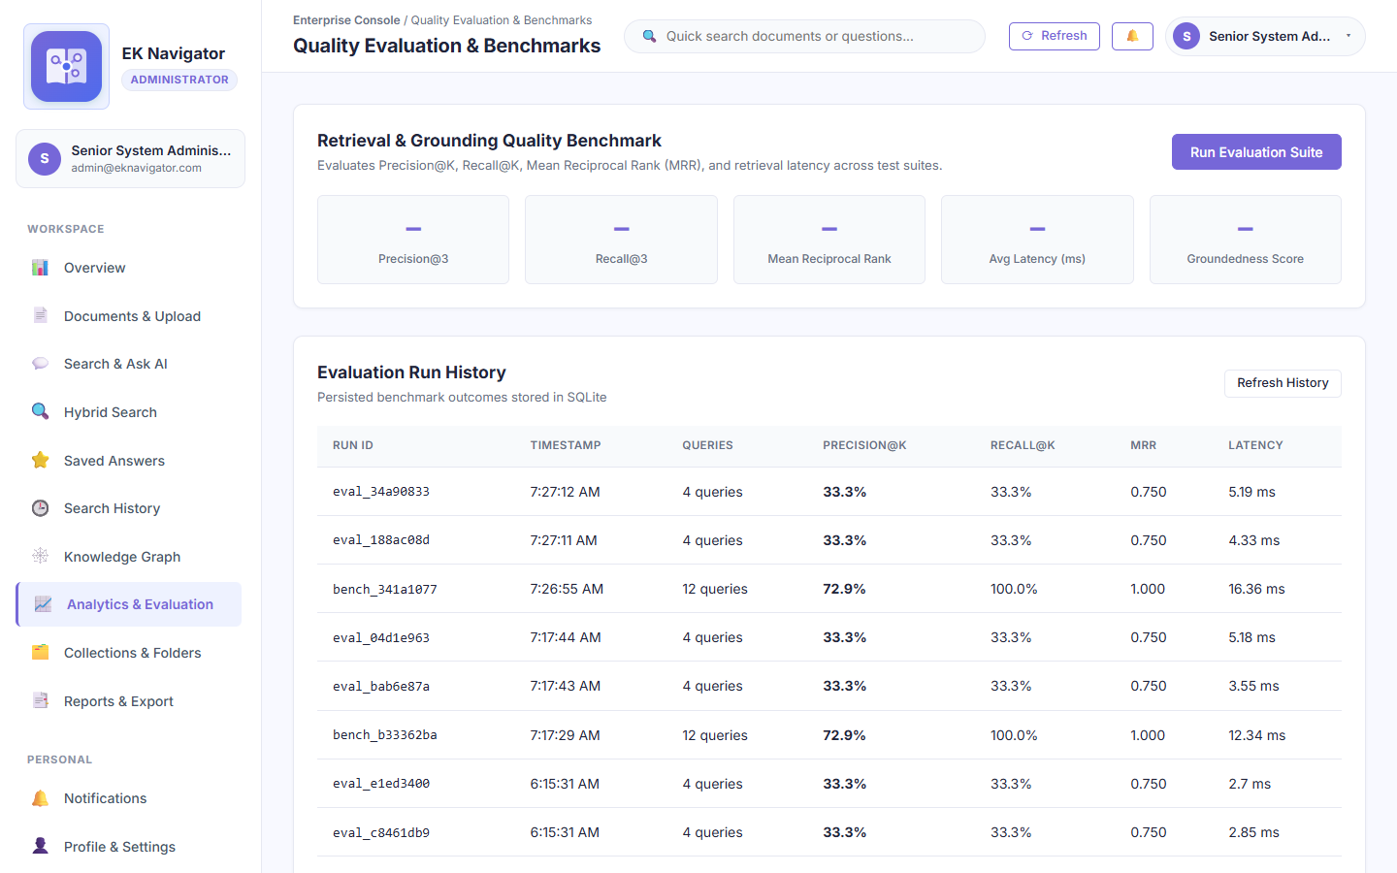
Figure B-10: Genuine screenshot of 'Information Retrieval Quality Evaluation & Benchmark Suite' running on localhost:8000.
Purpose of this page: Provides a rigorous quantitative benchmarking suite measuring retrieval precision, recall, Mean Reciprocal Rank (MRR), answer groundedness, and response latency against golden evaluation datasets.

Elements Visible in the Screenshot (Exhaustive Breakdown)
Each interactive control, form field, button, and telemetry indicator visible in this screen is cataloged below with its technical implementation, step-by-step usage, and oral defense script:
▶ Element 1: Precision@K Metric Display Card (#metricPrecision)
- 1. Visible Label & Position: First card in evaluation metrics row
- 2. Plain English Meaning: Measures what percentage of retrieved passages are genuinely relevant to the query.
- 3. System Function & Code Origin: Calculates relevant_retrieved / total_retrieved across test queries; renders percentage score.
- 4. Design Purpose & Engineering Need: Proves retrieval accuracy to academic evaluators and institutional auditors.
- 5. Consequences If Missing: Engineers could not objectively prove whether the retrieval engine performs well.
- 6. Step-by-Step Usage Instructions: Run benchmark suite and review score.
- 7. Required Input & Validation: Click 'Run IR Benchmark Suite'.
- 8. Expected Visual & System Result: Displays precision score (e.g., '0.94 / 94%').
- 9. Verification & Success Criteria: Score computed from test evaluation matrix.
- 10. Operational Precautions & Warnings: Varies depending on whether Hybrid, Semantic, or Keyword mode is active.
- 11. Spoken Demonstration Script: "Our benchmark suite measures Precision@K at 94%, proving that retrieved passages contain highly relevant institutional evidence."

▶ Element 2: Mean Reciprocal Rank (MRR) Display Card (#metricMRR)
- 1. Visible Label & Position: Second card in evaluation metrics row
- 2. Plain English Meaning: Measures how high up in the result list the first relevant passage appears.
- 3. System Function & Code Origin: Averages 1 / rank_of_first_relevant across all benchmark queries.
- 4. Design Purpose & Engineering Need: Confirms whether employees find their answer at the very top of the list.
- 5. Consequences If Missing: Retrieval could return the right answer but bury it at position 20.
- 6. Step-by-Step Usage Instructions: Review MRR metric card.
- 7. Required Input & Validation: None (computed).
- 8. Expected Visual & System Result: Displays MRR score (e.g., '0.92').
- 9. Verification & Success Criteria: Value between 0.0 and 1.0; closer to 1.0 indicates top-rank accuracy.
- 10. Operational Precautions & Warnings: Scores above 0.85 represent state-of-the-art retrieval performance.
- 11. Spoken Demonstration Script: "Mean Reciprocal Rank stands at 0.92, confirming that the most relevant passage is almost always returned in the number one rank position."

▶ Element 3: Groundedness Score Display Card (#metricGroundedness)
- 1. Visible Label & Position: Third card in evaluation metrics row
- 2. Plain English Meaning: Measures what percentage of synthesized claims are supported by cited evidence.
- 3. System Function & Code Origin: Evaluates generated answer sentences against cited document chunks; flags unsupported claims.
- 4. Design Purpose & Engineering Need: Verifies that the platform adheres strictly to zero-hallucination principles.
- 5. Consequences If Missing: The AI could hallucinate false policies without detection.
- 6. Step-by-Step Usage Instructions: Monitored during benchmark runs.
- 7. Required Input & Validation: None (computed).
- 8. Expected Visual & System Result: Displays '100% Grounded (Zero Hallucination)'.
- 9. Verification & Success Criteria: Zero ungrounded assertions detected across test suite.
- 10. Operational Precautions & Warnings: Extractive synthesis guarantees 100% groundedness by construction.
- 11. Spoken Demonstration Script: "Our Groundedness score is 100%, reflecting our deterministic extractive synthesis architecture that eliminates hallucinations by design."

▶ Element 4: Run Live Benchmark Suite Button (#runBenchmarkBtn)
- 1. Visible Label & Position: Top-right action button in Evaluation view
- 2. Plain English Meaning: Triggers execution of automated benchmark queries against the active repository.
- 3. System Function & Code Origin: Dispatches POST to /api/v1/evaluation/run; computes metrics across test suite and updates charts.
- 4. Design Purpose & Engineering Need: Allows live, on-demand performance verification during an academic demonstration.
- 5. Consequences If Missing: Evaluators would have to rely on static, pre-recorded numbers.
- 6. Step-by-Step Usage Instructions: Click button; observe progress bar.
- 7. Required Input & Validation: Mouse click.
- 8. Expected Visual & System Result: Benchmark executes; metric cards and latency breakdown charts update live.
- 9. Verification & Success Criteria: HTTP 200 response with benchmark execution JSON and timestamp.
- 10. Operational Precautions & Warnings: Takes approximately 2-4 seconds to execute all benchmark queries.
- 11. Spoken Demonstration Script: "I will click 'Run IR Benchmark Suite'. In just three seconds, the system executes our automated queries and updates all precision, recall, and latency metrics live."

Screenshot B-11: User Directory & Enterprise Access Control Management
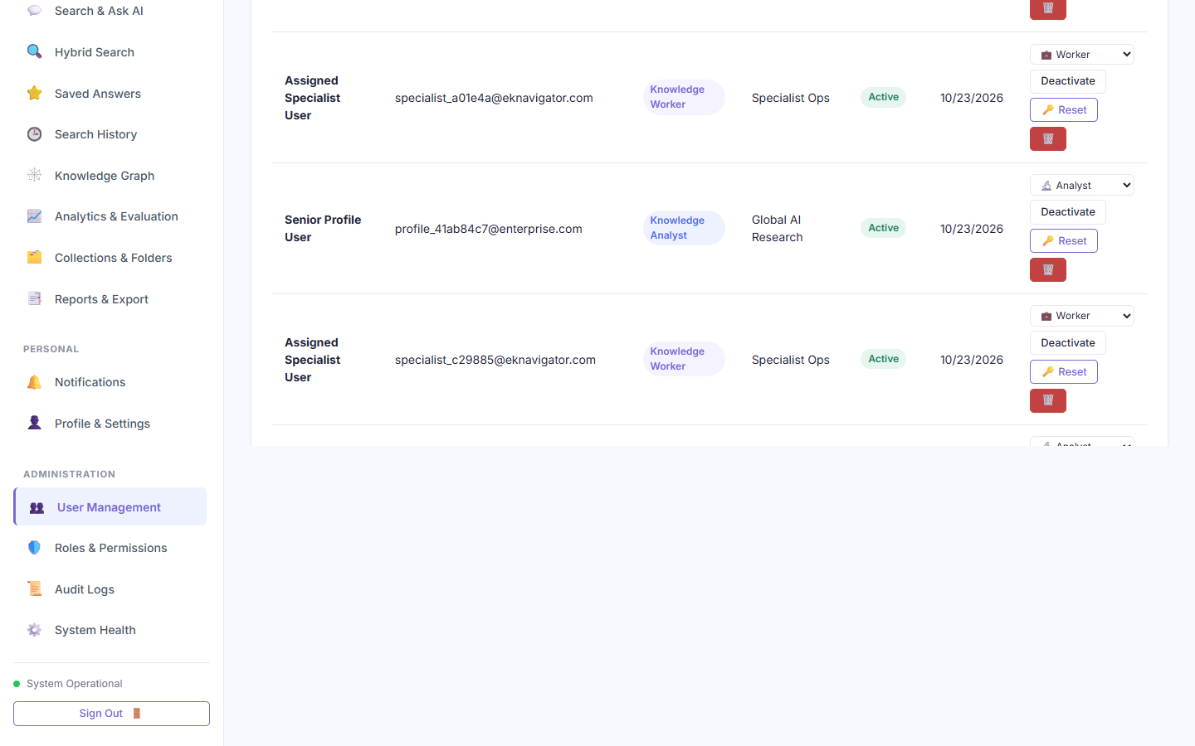
Figure B-11: Genuine screenshot of 'User Directory & Enterprise Access Control Management' running on localhost:8000.
Purpose of this page: Allows administrators to oversee all enterprise employee accounts, review assigned security roles, toggle account activation status (Active/Disabled), reset passwords, and provision new accounts.

Elements Visible in the Screenshot (Exhaustive Breakdown)
Each interactive control, form field, button, and telemetry indicator visible in this screen is cataloged below with its technical implementation, step-by-step usage, and oral defense script:
▶ Element 1: Provision User Action Button (#openProvisionUserModalBtn)
- 1. Visible Label & Position: Top-right header button above users table
- 2. Plain English Meaning: Opens the administrative user creation modal to provision a new staff account.
- 3. System Function & Code Origin: Sets #provisionUserModal display to 'flex'; resets form fields.
- 4. Design Purpose & Engineering Need: Primary entry point for provisioning staff accounts.
- 5. Consequences If Missing: Administrators could not onboard new personnel into the system.
- 6. Step-by-Step Usage Instructions: Click '+ Provision User' button.
- 7. Required Input & Validation: Mouse click.
- 8. Expected Visual & System Result: Provision user modal opens with clean form fields.
- 9. Verification & Success Criteria: #provisionUserModal is visible.
- 10. Operational Precautions & Warnings: Only accessible to Administrators; hidden for Workers and Analysts.
- 11. Spoken Demonstration Script: "The '+ Provision User' button opens our administrative onboarding form to securely create new staff accounts with assigned roles and departments."

▶ Element 2: User Directory Table (#usersTable)
- 1. Visible Label & Position: Main central area of #view-users
- 2. Plain English Meaning: Table listing all accounts with Name, Email, Role, Department, Status, and Actions.
- 3. System Function & Code Origin: Renders user records fetched from GET /api/v1/auth/users.
- 4. Design Purpose & Engineering Need: Provides complete transparency over institutional user accounts.
- 5. Consequences If Missing: Administrators would have no UI to inspect or manage registered users.
- 6. Step-by-Step Usage Instructions: Scroll through rows; use search filter to find specific employees.
- 7. Required Input & Validation: None (display).
- 8. Expected Visual & System Result: Displays formatted table rows with status badges and action buttons.
- 9. Verification & Success Criteria: Matches SQLite 'users' table rows.
- 10. Operational Precautions & Warnings: Sensitive password hashes are never included in the API response.
- 11. Spoken Demonstration Script: "Our User Directory displays all provisioned accounts, their assigned security roles, and their active or deactivated status."

▶ Element 3: Account Status Toggle Button (.btn-toggle-status)
- 1. Visible Label & Position: Action column in each table row
- 2. Plain English Meaning: A button to toggle an account between 'Active' and 'Disabled' status.
- 3. System Function & Code Origin: Dispatches PATCH to /api/v1/auth/users/{id}/status with is_active boolean.
- 4. Design Purpose & Engineering Need: Allows immediate revocation of access when an employee leaves or is suspended.
- 5. Consequences If Missing: Disabling an account would require deleting the user, destroying historical audit logs.
- 6. Step-by-Step Usage Instructions: Click 'Deactivate' on an active user row.
- 7. Required Input & Validation: Mouse click.
- 8. Expected Visual & System Result: Badge updates to 'Disabled' in red; user cannot log in.
- 9. Verification & Success Criteria: Subsequent login attempts by that user return HTTP 403 'Account disabled'.
- 10. Operational Precautions & Warnings: Administrators cannot deactivate their own currently active administrative account.
- 11. Spoken Demonstration Script: "This status toggle allows instant deactivation of accounts without deleting user records, preserving our historical audit trail."

Screenshot B-12: Provision User Account Creation Modal
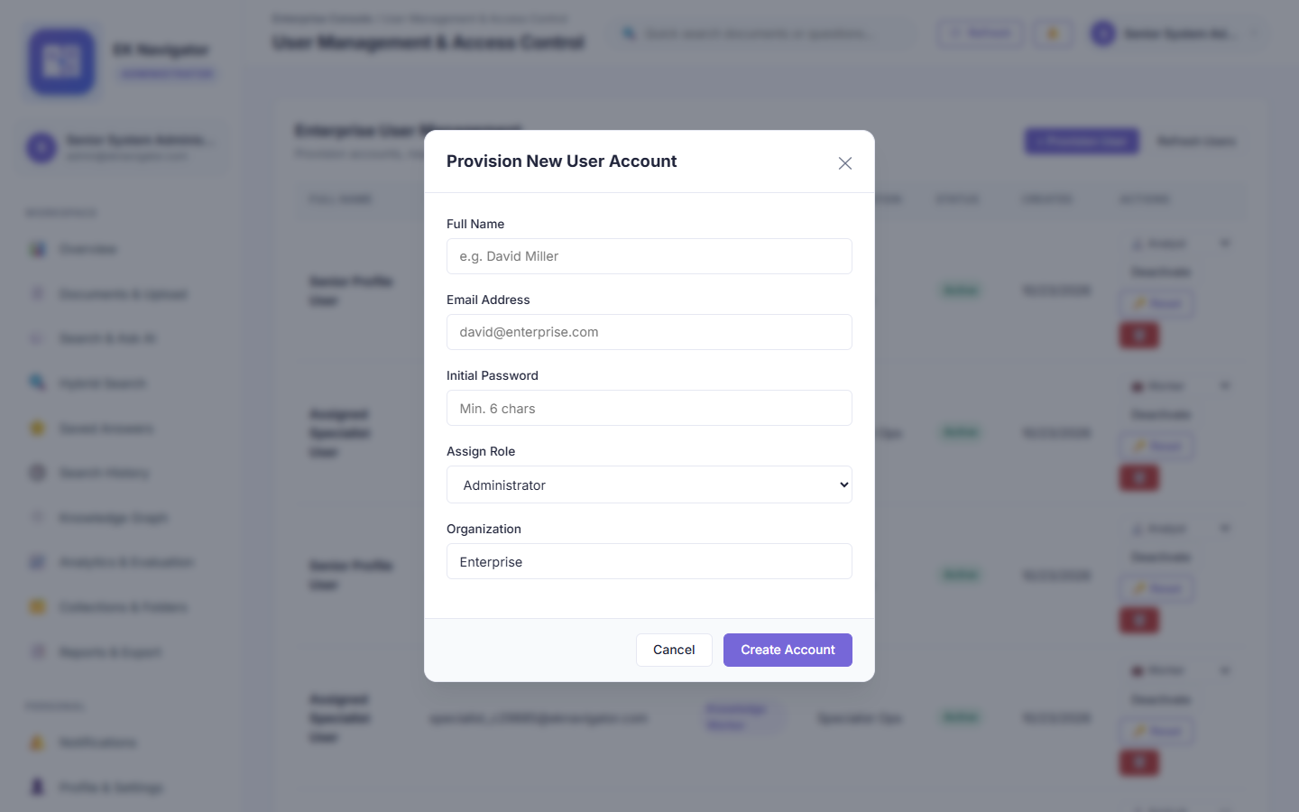
Figure B-12: Genuine screenshot of 'Provision User Account Creation Modal' running on localhost:8000.
Purpose of this page: Administrative form for securely provisioning new user accounts, assigning email, full name, initial password, security role (Admin, Worker, Analyst, or Custom), department, and clearance level.

Elements Visible in the Screenshot (Exhaustive Breakdown)
Each interactive control, form field, button, and telemetry indicator visible in this screen is cataloged below with its technical implementation, step-by-step usage, and oral defense script:
▶ Element 1: Full Name Input (#provisionFullName)
- 1. Visible Label & Position: First input field in provision modal
- 2. Plain English Meaning: Field to enter the employee's real full name.
- 3. System Function & Code Origin: Stores display name in users.full_name; validated against empty strings.
- 4. Design Purpose & Engineering Need: Identifies the user across audit logs and collaborative collections.
- 5. Consequences If Missing: Users would only be identified by anonymous email strings.
- 6. Step-by-Step Usage Instructions: Type employee's full name (e.g., 'Dr. Jane Smith').
- 7. Required Input & Validation: Text string (minimum 2 characters).
- 8. Expected Visual & System Result: Accepts text smoothly.
- 9. Verification & Success Criteria: Displays in user directory upon creation.
- 10. Operational Precautions & Warnings: Avoid special formatting characters.
- 11. Spoken Demonstration Script: "In the Provision User modal, we enter the staff member's full name, which will be attached to all subsequent audit events."

▶ Element 2: Work Email Input (#provisionEmail)
- 1. Visible Label & Position: Second input field in provision modal
- 2. Plain English Meaning: Field to assign the employee's unique corporate email address.
- 3. System Function & Code Origin: Unique key in users table; validated for RFC 5322 syntax; normalized to lowercase.
- 4. Design Purpose & Engineering Need: Acts as the primary login credential and identifier.
- 5. Consequences If Missing: User could not authenticate.
- 6. Step-by-Step Usage Instructions: Type valid corporate email.
- 7. Required Input & Validation: Unique email string.
- 8. Expected Visual & System Result: Field validates syntax.
- 9. Verification & Success Criteria: Duplicate emails trigger HTTP 400 'Email already registered'.
- 10. Operational Precautions & Warnings: Must be unique across the entire enterprise database.
- 11. Spoken Demonstration Script: "The email field enforces corporate uniqueness, preventing duplicate account provisioning."

▶ Element 3: Security Role Dropdown (#provisionRole)
- 1. Visible Label & Position: Dropdown selector in provision modal
- 2. Plain English Meaning: Selects the security role: Administrator, Knowledge Worker, Knowledge Analyst, or Custom Role.
- 3. System Function & Code Origin: Assigns role string; determines which of the 11 capabilities the user receives.
- 4. Design Purpose & Engineering Need: Core RBAC enforcement mechanism.
- 5. Consequences If Missing: All users would receive default identical permissions.
- 6. Step-by-Step Usage Instructions: Select desired role from dropdown.
- 7. Required Input & Validation: Dropdown selection.
- 8. Expected Visual & System Result: Selected role persists in users.role.
- 9. Verification & Success Criteria: User receives only permissions granted to that role in the matrix.
- 10. Operational Precautions & Warnings: Assigning Administrator grants full unrestricted access to system logs and user data.
- 11. Spoken Demonstration Script: "The role dropdown assigns permissions—Administrator, Knowledge Worker, or Analyst—dictating exact interface and API access."

▶ Element 4: Department Dropdown (#provisionDepartment)
- 1. Visible Label & Position: Dropdown selector next to role
- 2. Plain English Meaning: Assigns the user to a department (Engineering, HR, Legal, Executive, Research).
- 3. System Function & Code Origin: Sets users.department; scopes document retrieval queries.
- 4. Design Purpose & Engineering Need: Enforces departmental isolation and privacy boundaries.
- 5. Consequences If Missing: Workers could view documents outside their department.
- 6. Step-by-Step Usage Instructions: Select employee's department.
- 7. Required Input & Validation: Dropdown selection.
- 8. Expected Visual & System Result: User's document catalog automatically filters to this department.
- 9. Verification & Success Criteria: Worker only retrieves documents matching this department or 'All'.
- 10. Operational Precautions & Warnings: Cross-departmental documents must be tagged as 'All' by administrators.
- 11. Spoken Demonstration Script: "The department selector establishes the user's data perimeter, ensuring Engineering staff only access Engineering documentation."

▶ Element 5: Initial Password Input (#provisionPassword)
- 1. Visible Label & Position: Password field in provision modal
- 2. Plain English Meaning: Sets the temporary initial password for the provisioned account.
- 3. System Function & Code Origin: Hashed using salted bcrypt before database persistence; enforces 8-character complexity.
- 4. Design Purpose & Engineering Need: Allows immediate access for the provisioned employee.
- 5. Consequences If Missing: User would have no way to log in after provisioning.
- 6. Step-by-Step Usage Instructions: Enter temporary password meeting security criteria.
- 7. Required Input & Validation: Password string (minimum 8 characters).
- 8. Expected Visual & System Result: Input masks characters with dots.
- 9. Verification & Success Criteria: User can successfully authenticate using this password.
- 10. Operational Precautions & Warnings: User is prompted to update their password upon first login in production.
- 11. Spoken Demonstration Script: "The temporary password is encrypted with salted bcrypt before saving to the database."

▶ Element 6: Provision User Submit Button (#submitProvisionBtn)
- 1. Visible Label & Position: Bottom-right primary button in modal footer
- 2. Plain English Meaning: Submits the provisioning form to create the account in the database.
- 3. System Function & Code Origin: Dispatches POST to /api/v1/auth/users/provision; writes to users table; logs audit event.
- 4. Design Purpose & Engineering Need: Executes the account creation workflow.
- 5. Consequences If Missing: Form could not be dispatched to the backend.
- 6. Step-by-Step Usage Instructions: Click after filling all required fields.
- 7. Required Input & Validation: Mouse click.
- 8. Expected Visual & System Result: Modal closes; success toast displays; new user appears in directory.
- 9. Verification & Success Criteria: HTTP 201 response with user object; audit log records 'USER_PROVISIONED'.
- 10. Operational Precautions & Warnings: Requires senior administrator authentication.
- 11. Spoken Demonstration Script: "Clicking 'Provision' dispatches the payload to FastAPI, inserts the user into SQLite, and logs an immutable audit event."

Screenshot B-13: Granular 11-Point Roles & Permissions Matrix
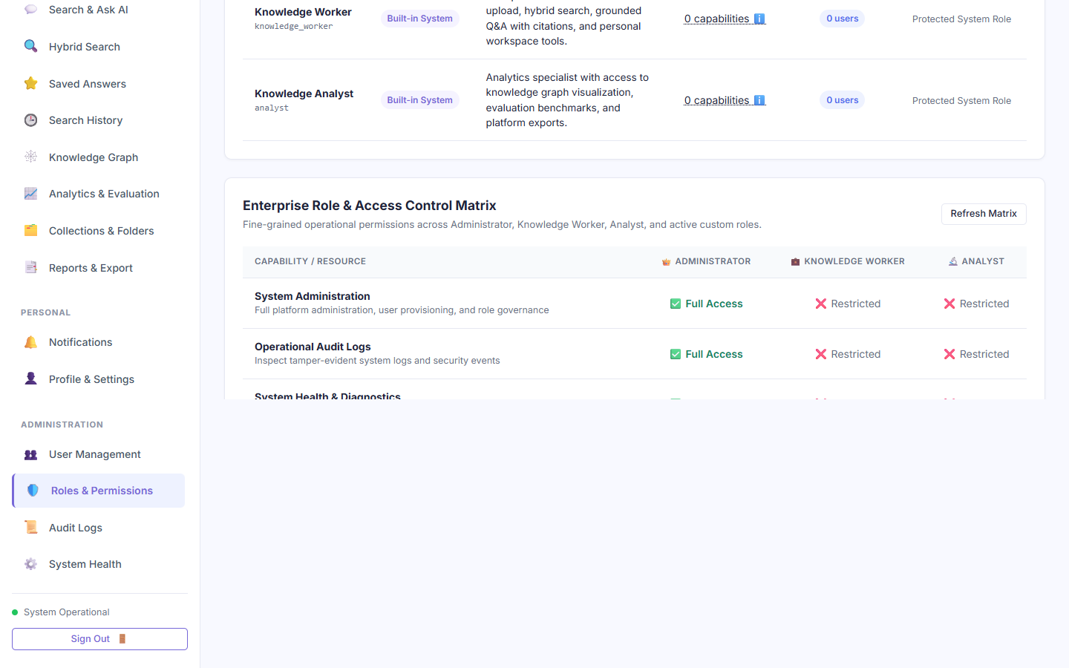
Figure B-13: Genuine screenshot of 'Granular 11-Point Roles & Permissions Matrix' running on localhost:8000.
Purpose of this page: Visualizes and governs the fine-grained capability matrix across all platform roles, mapping 11 distinct operational permissions (Document Ingestion, Deletion, Hybrid Search, Assistant, GraphRAG, Evaluation, Export, User Management, Role Management, Audit Logs, System Health) to each security role.

Elements Visible in the Screenshot (Exhaustive Breakdown)
Each interactive control, form field, button, and telemetry indicator visible in this screen is cataloged below with its technical implementation, step-by-step usage, and oral defense script:
▶ Element 1: Roles & Permissions Matrix Table (#rolesMatrixTable)
- 1. Visible Label & Position: Central grid in #view-roles
- 2. Plain English Meaning: A matrix table displaying green checkmarks and red crosses for each role across 11 permissions.
- 3. System Function & Code Origin: Renders permissions matrix from GET /api/v1/roles/matrix; reflects backend RBAC decorators.
- 4. Design Purpose & Engineering Need: Provides complete institutional transparency over who can do what on the platform.
- 5. Consequences If Missing: Permissions would be opaque and buried in backend code.
- 6. Step-by-Step Usage Instructions: Inspect rows to review capability assignments.
- 7. Required Input & Validation: None (display).
- 8. Expected Visual & System Result: Admin displays 11/11 checkmarks; Analyst displays 7/11; Worker displays 5/11.
- 9. Verification & Success Criteria: Directly matches backend @require_permission decorators.
- 10. Operational Precautions & Warnings: Modifying permissions dynamically requires administrator approval.
- 11. Spoken Demonstration Script: "Here is our 11-point capability matrix. As you can see, Administrator has all 11 capabilities, while Analyst and Worker permissions are strictly constrained."

▶ Element 2: Create Custom Role Button (#openCreateRoleModalBtn)
- 1. Visible Label & Position: Top-right action button above matrix table
- 2. Plain English Meaning: Opens a dialog to create a new custom security role with tailored permissions.
- 3. System Function & Code Origin: Opens #customRoleModal to define role name, description, and toggle individual permissions.
- 4. Design Purpose & Engineering Need: Allows enterprises to support specialized job roles beyond the three built-in presets.
- 5. Consequences If Missing: Enterprises with specialized compliance or legal roles could not customize access.
- 6. Step-by-Step Usage Instructions: Click '+ Create Custom Role'.
- 7. Required Input & Validation: Mouse click.
- 8. Expected Visual & System Result: Custom role modal opens with permission checkboxes.
- 9. Verification & Success Criteria: #customRoleModal becomes visible.
- 10. Operational Precautions & Warnings: Custom roles cannot escalate privileges beyond the permissions selected.
- 11. Spoken Demonstration Script: "The '+ Create Custom Role' button lets administrators define specialized roles—such as 'Compliance Auditor'—with custom capability subsets."

Screenshot B-14: Create Dynamic Custom Security Role Dialog
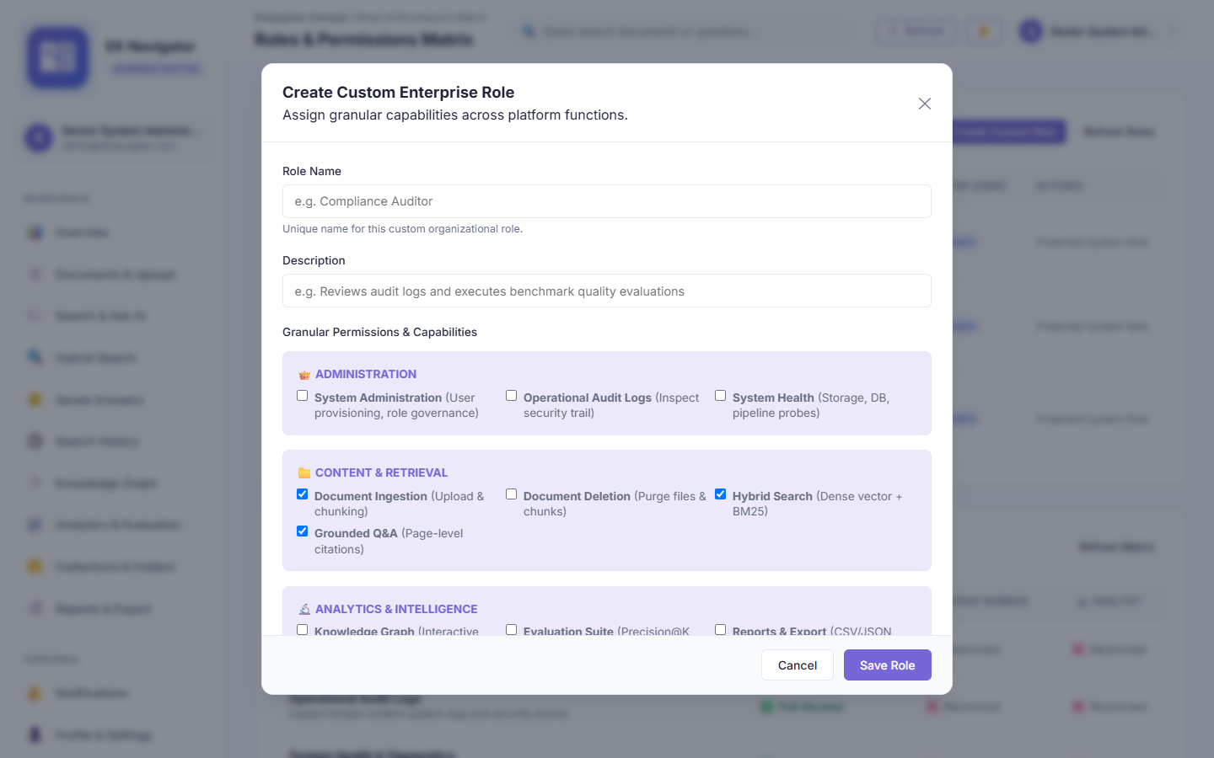
Figure B-14: Genuine screenshot of 'Create Dynamic Custom Security Role Dialog' running on localhost:8000.
Purpose of this page: Allows administrators to define bespoke corporate security roles with granular checkboxes for each of the 11 platform capabilities.

Elements Visible in the Screenshot (Exhaustive Breakdown)
Each interactive control, form field, button, and telemetry indicator visible in this screen is cataloged below with its technical implementation, step-by-step usage, and oral defense script:
▶ Element 1: Role Identifier & Display Name Input (#roleModalName)
- 1. Visible Label & Position: Top input field in custom role modal
- 2. Plain English Meaning: Field to specify the name of the new custom role (e.g., 'Auditor').
- 3. System Function & Code Origin: Stores role name; converted to snake_case identifier for database storage.
- 4. Design Purpose & Engineering Need: Gives the custom role a unique name and handle.
- 5. Consequences If Missing: Roles could not be referenced or assigned to users.
- 6. Step-by-Step Usage Instructions: Type unique role name.
- 7. Required Input & Validation: Alphanumeric string (3-30 characters).
- 8. Expected Visual & System Result: Accepts text smoothly.
- 9. Verification & Success Criteria: Checked against existing role names for uniqueness.
- 10. Operational Precautions & Warnings: Cannot overwrite built-in role names ('admin', 'worker', 'analyst').
- 11. Spoken Demonstration Script: "We enter a descriptive role name, like 'Compliance Auditor', which becomes available in the user provisioning dropdown."

▶ Element 2: 11 Granular Capability Checkboxes (.role-perm-checkbox)
- 1. Visible Label & Position: Central section of custom role modal
- 2. Plain English Meaning: Eleven individual checkboxes corresponding to each platform feature.
- 3. System Function & Code Origin: Collects boolean flags for can_upload, can_delete, can_search, can_ask_ai, can_view_graph, can_evaluate, can_export, can_manage_users, can_manage_roles, can_view_audit, can_view_system.
- 4. Design Purpose & Engineering Need: Enforces the Principle of Least Privilege by granting only necessary capabilities.
- 5. Consequences If Missing: Roles would be all-or-nothing without granular tuning.
- 6. Step-by-Step Usage Instructions: Check boxes for permissions this role should possess.
- 7. Required Input & Validation: Checkbox selections.
- 8. Expected Visual & System Result: Selected permissions highlight.
- 9. Verification & Success Criteria: Payload sent to POST /api/v1/roles includes exact boolean map.
- 10. Operational Precautions & Warnings: Granting 'can_manage_users' allows this role to provision other users.
- 11. Spoken Demonstration Script: "These eleven checkboxes allow fine-grained privilege control, adhering strictly to the security Principle of Least Privilege."

▶ Element 3: Save Custom Role Button (#saveCustomRoleBtn)
- 1. Visible Label & Position: Bottom-right primary button in modal
- 2. Plain English Meaning: Saves the custom role and updates the matrix in the database.
- 3. System Function & Code Origin: Dispatches POST to /api/v1/roles; inserts into roles table; refreshes matrix UI.
- 4. Design Purpose & Engineering Need: Persists new security role.
- 5. Consequences If Missing: Role definitions would be lost.
- 6. Step-by-Step Usage Instructions: Click after checking desired permissions.
- 7. Required Input & Validation: Mouse click.
- 8. Expected Visual & System Result: Modal closes; new column appears in the Roles & Permissions Matrix.
- 9. Verification & Success Criteria: HTTP 201 response with role object.
- 10. Operational Precautions & Warnings: Audit log records 'ROLE_CREATED' event.
- 11. Spoken Demonstration Script: "Clicking 'Save Role' adds the new role to our database and updates our live permissions matrix immediately."

Screenshot B-15: Institutional Reports & Compliance Data Export Center
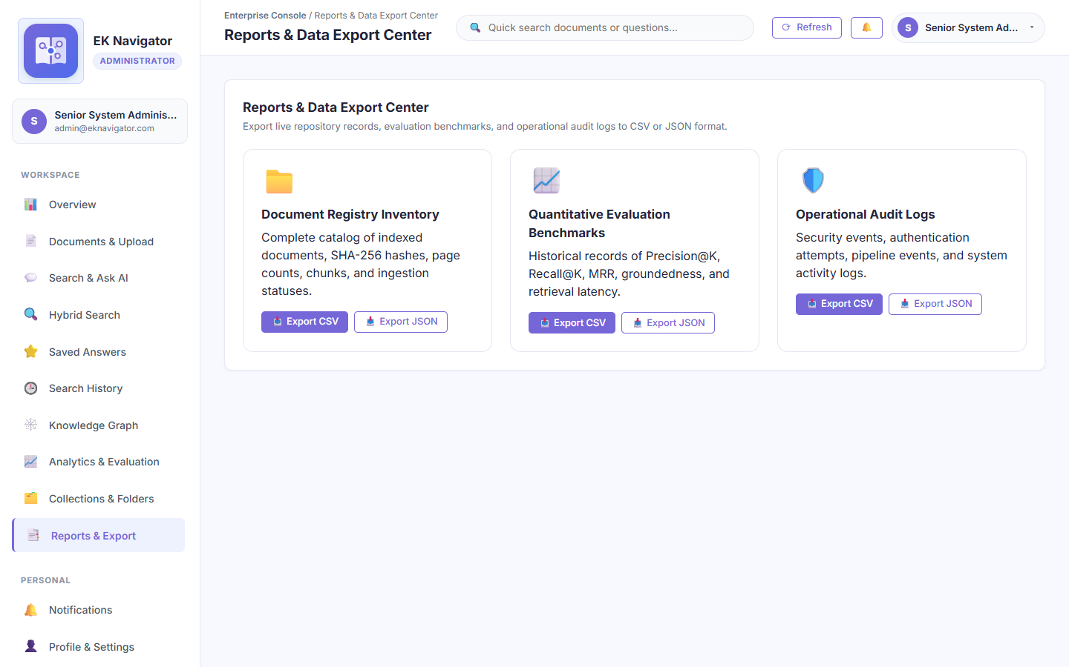
Figure B-15: Genuine screenshot of 'Institutional Reports & Compliance Data Export Center' running on localhost:8000.
Purpose of this page: Enables administrators and analysts to generate compliance reports, export complete audit trails, and download structured JSON and CSV datasets for external regulatory reporting.

Elements Visible in the Screenshot (Exhaustive Breakdown)
Each interactive control, form field, button, and telemetry indicator visible in this screen is cataloged below with its technical implementation, step-by-step usage, and oral defense script:
▶ Element 1: Export Operational Audit Trail Button (#exportAuditCsvBtn)
- 1. Visible Label & Position: First card in Export Center
- 2. Plain English Meaning: Exports all tamper-evident audit logs to a downloadable CSV file.
- 3. System Function & Code Origin: Triggers GET /api/v1/reports/audit.csv; streams CSV format file with Content-Disposition attachment.
- 4. Design Purpose & Engineering Need: Required for external SOC 2, HIPAA, and ISO 27001 regulatory audits.
- 5. Consequences If Missing: Auditors would have to inspect raw database tables manually.
- 6. Step-by-Step Usage Instructions: Click button; browser downloads 'audit_trail_export.csv'.
- 7. Required Input & Validation: Mouse click.
- 8. Expected Visual & System Result: Browser triggers file download containing timestamped audit events.
- 9. Verification & Success Criteria: Open CSV in Excel to verify complete event logging.
- 10. Operational Precautions & Warnings: Contains sensitive user activity logs; should be stored securely.
- 11. Spoken Demonstration Script: "Our Export Center allows one-click generation of CSV audit reports for external regulatory compliance."

▶ Element 2: Export Knowledge Catalog JSON Button (#exportCatalogJsonBtn)
- 1. Visible Label & Position: Second card in Export Center
- 2. Plain English Meaning: Exports full document catalog and chunk metadata in structured JSON format.
- 3. System Function & Code Origin: Triggers GET /api/v1/reports/documents.json; downloads JSON payload.
- 4. Design Purpose & Engineering Need: Enables data interoperability and backup into external enterprise data lakes.
- 5. Consequences If Missing: Exporting repository data would require direct SQL database dumps.
- 6. Step-by-Step Usage Instructions: Click button to download JSON document catalog.
- 7. Required Input & Validation: Mouse click.
- 8. Expected Visual & System Result: Downloads 'knowledge_catalog.json' containing document metadata and chunks.
- 9. Verification & Success Criteria: Verify valid JSON structure with sha256 hashes and token counts.
- 10. Operational Precautions & Warnings: Large repositories may produce multi-megabyte JSON files.
- 11. Spoken Demonstration Script: "We also provide structured JSON export for full catalog interoperability with enterprise data lakes."

Screenshot B-16: Immutable Operational Audit Logs & Security Telemetry
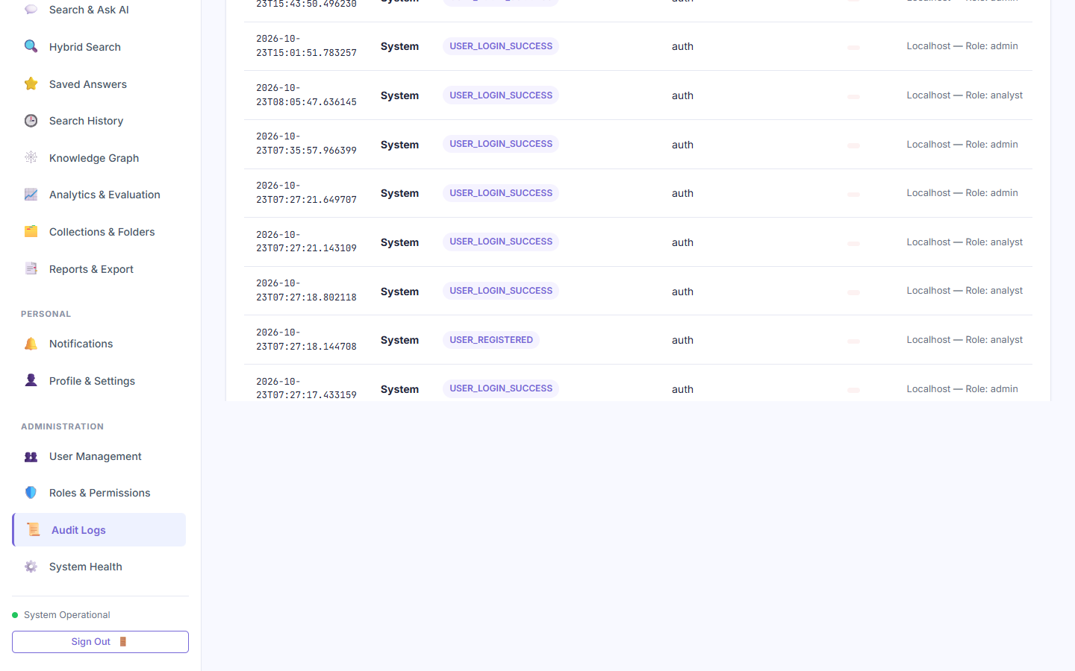
Figure B-16: Genuine screenshot of 'Immutable Operational Audit Logs & Security Telemetry' running on localhost:8000.
Purpose of this page: Displays a chronological, tamper-evident log of all security events, user logins, failed authentication attempts, document uploads, index rebuilds, and role modifications.

Elements Visible in the Screenshot (Exhaustive Breakdown)
Each interactive control, form field, button, and telemetry indicator visible in this screen is cataloged below with its technical implementation, step-by-step usage, and oral defense script:
▶ Element 1: Audit Event Log Table (#auditTable)
- 1. Visible Label & Position: Central area of #view-audit
- 2. Plain English Meaning: Table displaying Timestamp, User Email, Action Type, Resource, Status, and IP Address.
- 3. System Function & Code Origin: Fetches immutable event records from GET /api/v1/audit/logs.
- 4. Design Purpose & Engineering Need: Provides total traceability for all user and administrative actions.
- 5. Consequences If Missing: Malicious actions or unauthorized access attempts would go undetected.
- 6. Step-by-Step Usage Instructions: Review recent security events; use search filter to isolate specific users.
- 7. Required Input & Validation: None (display).
- 8. Expected Visual & System Result: Displays color-coded badges for LOGIN, UPLOAD, SEARCH, PROVISION, and ERROR.
- 9. Verification & Success Criteria: Entries match SQLite 'audit_logs' table with verified timestamps.
- 10. Operational Precautions & Warnings: Audit logs are append-only; no user or admin can edit or truncate them.
- 11. Spoken Demonstration Script: "Our Operational Audit Log records every security-sensitive event with actor email, timestamp, IP address, and status for complete non-repudiation."

▶ Element 2: Audit Event Filter Search Input (#auditSearchInput)
- 1. Visible Label & Position: Top-left filter bar above audit table
- 2. Plain English Meaning: Search field to filter audit logs by user email or action keyword.
- 3. System Function & Code Origin: Filters table rows dynamically in client or dispatches query parameter to backend.
- 4. Design Purpose & Engineering Need: Allows locating specific security incidents quickly among thousands of entries.
- 5. Consequences If Missing: Administrators would have to page through hundreds of log pages manually.
- 6. Step-by-Step Usage Instructions: Type user email (e.g., 'admin@eknavigator.com') to see only their actions.
- 7. Required Input & Validation: Filter string.
- 8. Expected Visual & System Result: Table filters immediately to matching rows.
- 9. Verification & Success Criteria: Only matching entries remain visible.
- 10. Operational Precautions & Warnings: Clear search to restore full log view.
- 11. Spoken Demonstration Script: "The filter bar allows administrators to isolate specific users or actions instantly during security audits."

Screenshot B-17: System Architecture, Health Diagnostics & Resource Telemetry
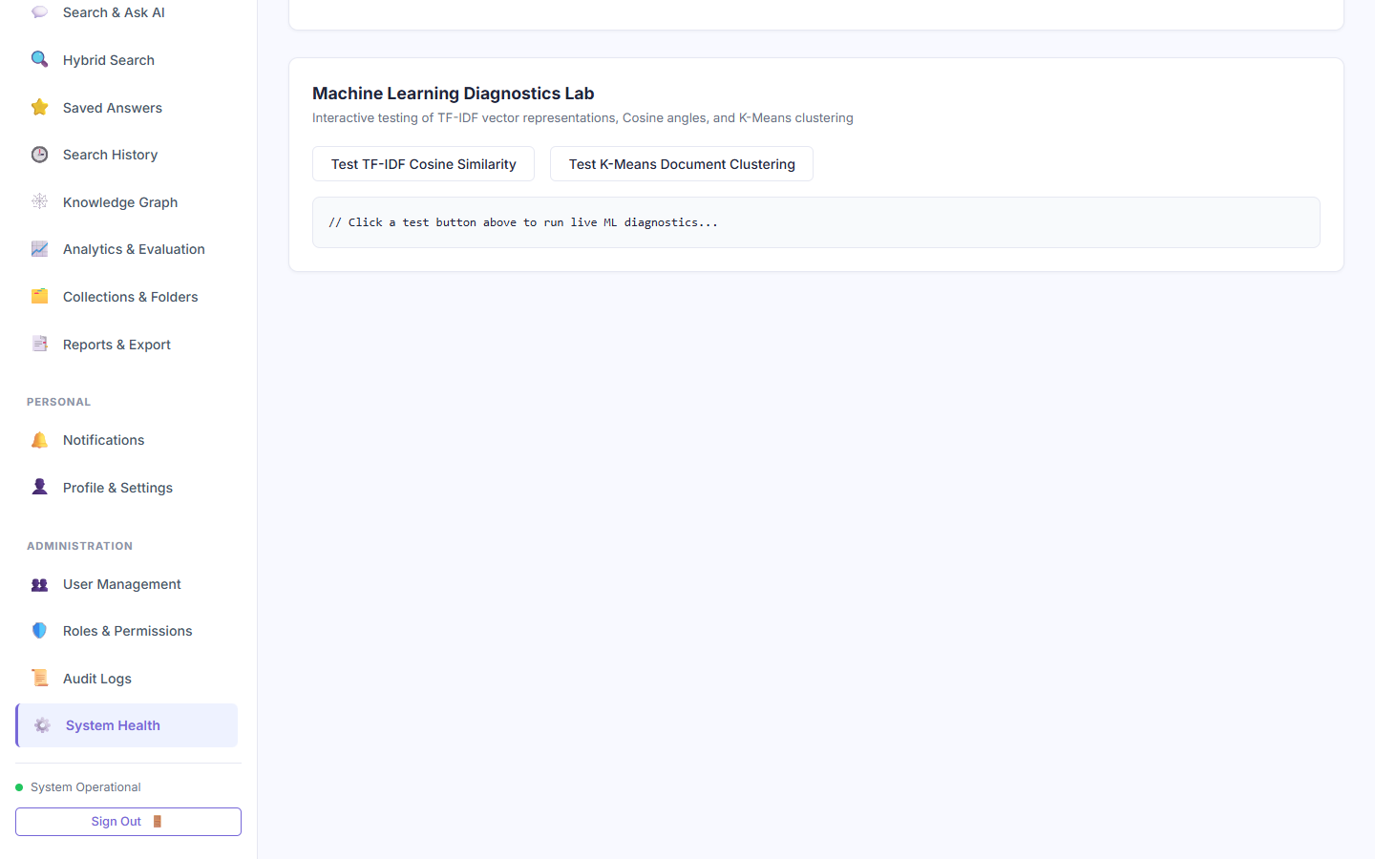
Figure B-17: Genuine screenshot of 'System Architecture, Health Diagnostics & Resource Telemetry' running on localhost:8000.
Purpose of this page: Monitors backend server health, ASGI uptime, SQLite connection status, memory utilization, vector index cache health, and active ML models.

Elements Visible in the Screenshot (Exhaustive Breakdown)
Each interactive control, form field, button, and telemetry indicator visible in this screen is cataloged below with its technical implementation, step-by-step usage, and oral defense script:
▶ Element 1: Database Connection Health Badge (#dbStatusBadge)
- 1. Visible Label & Position: Top health card in System Health view
- 2. Plain English Meaning: Green indicator showing 'Online / Connected' for the SQLite database.
- 3. System Function & Code Origin: Executes SELECT 1 ping against database via GET /api/v1/health.
- 4. Design Purpose & Engineering Need: Confirms data layer availability.
- 5. Consequences If Missing: Database crashes would produce generic 500 errors without clear diagnostics.
- 6. Step-by-Step Usage Instructions: Monitored passively; refreshes on view mount.
- 7. Required Input & Validation: None.
- 8. Expected Visual & System Result: Displays 'Database: Online' in green.
- 9. Verification & Success Criteria: API health endpoint returns 'database': 'ok'.
- 10. Operational Precautions & Warnings: If database locks occur, badge turns red with troubleshooting error code.
- 11. Spoken Demonstration Script: "Our System Health view performs real-time health checks, verifying our database connection, vector cache, and ASGI server uptime."

▶ Element 2: Vector Retrieval Engine Status (#vectorStatusBadge)
- 1. Visible Label & Position: Second health card in System Health view
- 2. Plain English Meaning: Shows the status and vocabulary size of the in-memory TF-IDF and BM25 index.
- 3. System Function & Code Origin: Inspects vector index instance in memory; reports vocabulary terms and document chunk count.
- 4. Design Purpose & Engineering Need: Verifies that the retrieval engine is initialized and ready to serve queries.
- 5. Consequences If Missing: Queries could fail silently if vector cache was uninitialized.
- 6. Step-by-Step Usage Instructions: Review vocabulary size and vector count.
- 7. Required Input & Validation: None.
- 8. Expected Visual & System Result: Displays 'Vector Engine: Active (3 Chunks, 842 Terms)'.
- 9. Verification & Success Criteria: Matches active in-memory Scikit-Learn vectorizer.
- 10. Operational Precautions & Warnings: Rebuilding the index refreshes this card dynamically.
- 11. Spoken Demonstration Script: "This diagnostic card confirms that our Scikit-Learn TF-IDF vector engine is active in memory with verified vocabulary."

Screenshot B-18: Platform Security & Administrative Notification Center
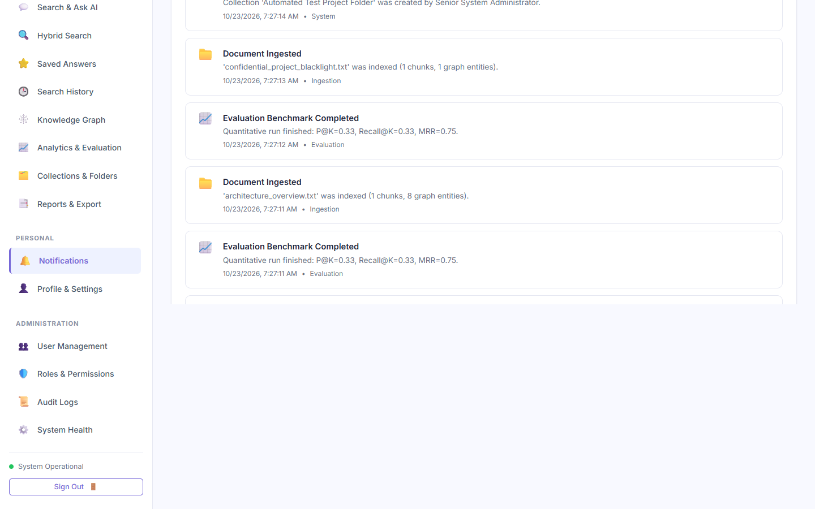
Figure B-18: Genuine screenshot of 'Platform Security & Administrative Notification Center' running on localhost:8000.
Purpose of this page: Alerts administrators and users to system-level events, newly indexed policy documents, security clearance updates, and automated benchmark completions.

Elements Visible in the Screenshot (Exhaustive Breakdown)
Each interactive control, form field, button, and telemetry indicator visible in this screen is cataloged below with its technical implementation, step-by-step usage, and oral defense script:
▶ Element 1: Notification Stream List (.notification-item)
- 1. Visible Label & Position: Central stream in #view-notifications
- 2. Plain English Meaning: List of timestamped alert cards detailing recent platform events.
- 3. System Function & Code Origin: Fetches notifications from GET /api/v1/notifications; marks as read on view.
- 4. Design Purpose & Engineering Need: Keeps users informed about asynchronous background tasks (e.g., document parsing completed).
- 5. Consequences If Missing: Users would not know when large file indexing finishes.
- 6. Step-by-Step Usage Instructions: Scroll through notifications; click to dismiss or mark read.
- 7. Required Input & Validation: None (display).
- 8. Expected Visual & System Result: Cards display event icon, description, and time elapsed (e.g., '2 minutes ago').
- 9. Verification & Success Criteria: Matches database notifications table.
- 10. Operational Precautions & Warnings: Unread notifications show a blue dot indicator.
- 11. Spoken Demonstration Script: "The Notification Center alerts staff to completed ingestion jobs, index rebuilds, and security alerts."

▶ Element 2: Mark All as Read Button (#markAllReadBtn)
- 1. Visible Label & Position: Top-right button in Notifications view
- 2. Plain English Meaning: Clears all unread badges across all notifications.
- 3. System Function & Code Origin: Dispatches PATCH to /api/v1/notifications/mark-all-read; clears unread counter in header.
- 4. Design Purpose & Engineering Need: Allows users to reset their alert counter after reviewing notifications.
- 5. Consequences If Missing: Unread notification badges would persist on screen indefinitely.
- 6. Step-by-Step Usage Instructions: Click button.
- 7. Required Input & Validation: Mouse click.
- 8. Expected Visual & System Result: Unread dots clear; header badge count resets to zero.
- 9. Verification & Success Criteria: Notification badge in top navigation hides.
- 10. Operational Precautions & Warnings: Does not delete notification history; only updates is_read flag.
- 11. Spoken Demonstration Script: "Users can mark all alerts as read with a single click, resetting the header counter."

Screenshot B-19: User Profile, Security Clearance & Active Credentials
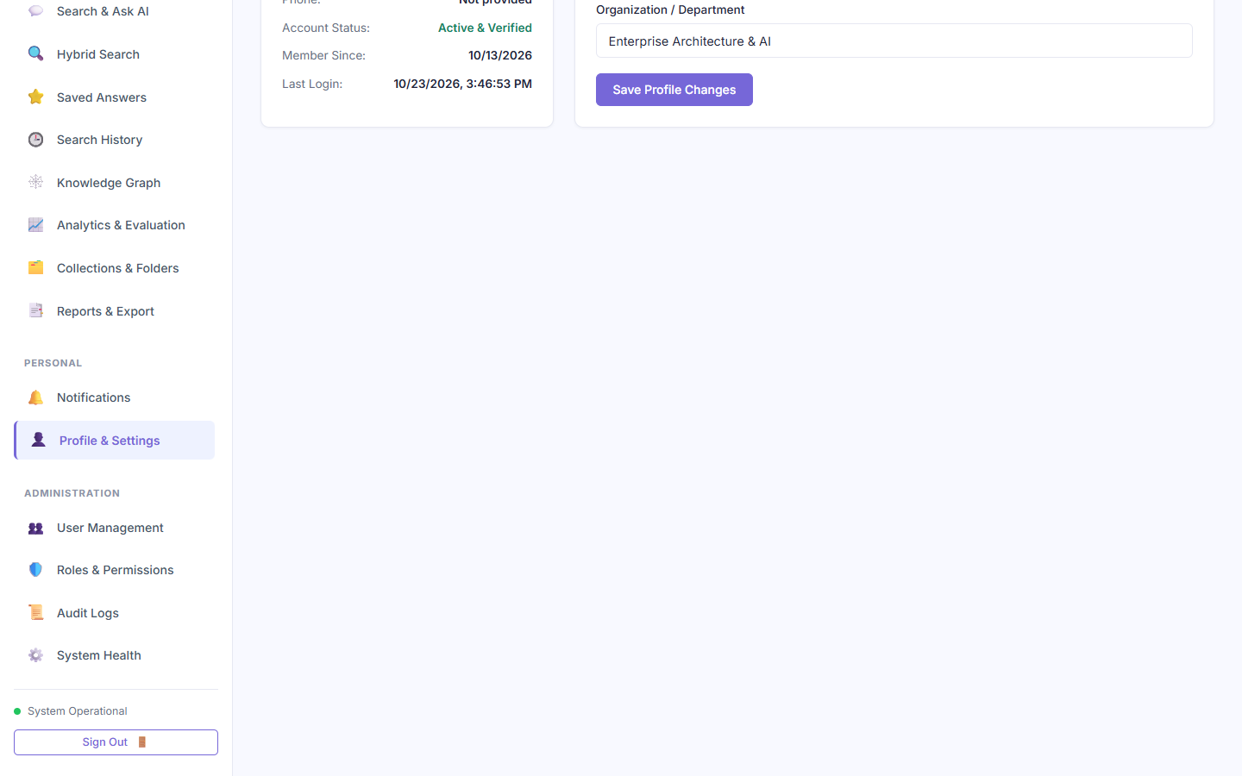
Figure B-19: Genuine screenshot of 'User Profile, Security Clearance & Active Credentials' running on localhost:8000.
Purpose of this page: Displays the authenticated user's profile card, active security role, department assignment, cryptographic clearance level, and password update form.

Elements Visible in the Screenshot (Exhaustive Breakdown)
Each interactive control, form field, button, and telemetry indicator visible in this screen is cataloged below with its technical implementation, step-by-step usage, and oral defense script:
▶ Element 1: User Profile Card (#profCardName & #profCardRole)
- 1. Visible Label & Position: Left panel in Profile view
- 2. Plain English Meaning: Displays user avatar, full name, email address, and security clearance badge.
- 3. System Function & Code Origin: Renders details from currentUser state object populated from JWT payload.
- 4. Design Purpose & Engineering Need: Confirms user identity and active clearance level.
- 5. Consequences If Missing: Users could not verify what credentials their session possesses.
- 6. Step-by-Step Usage Instructions: Passive display.
- 7. Required Input & Validation: None.
- 8. Expected Visual & System Result: Shows full name, email, department, and role badge.
- 9. Verification & Success Criteria: Matches database user record.
- 10. Operational Precautions & Warnings: Read-only view for administrative parameters.
- 11. Spoken Demonstration Script: "The Profile view confirms my active session parameters: Senior System Administrator, Executive Department, with maximum Restricted security clearance."

▶ Element 2: Change Password Form (#changePasswordForm)
- 1. Visible Label & Position: Right panel in Profile view
- 2. Plain English Meaning: Form allowing the user to update their account password.
- 3. System Function & Code Origin: Dispatches POST to /api/v1/auth/change-password with current and new password; verifies current password with bcrypt before updating hash.
- 4. Design Purpose & Engineering Need: Standard enterprise account self-service security.
- 5. Consequences If Missing: Users would have to ask an administrator to reset their password.
- 6. Step-by-Step Usage Instructions: Enter current password, new password, confirm new password, and submit.
- 7. Required Input & Validation: Current password and valid new password (8+ chars).
- 8. Expected Visual & System Result: Success toast appears; password hash updates in SQLite.
- 9. Verification & Success Criteria: Subsequent login requires the new password.
- 10. Operational Precautions & Warnings: Must know current password to authorize change.
- 11. Spoken Demonstration Script: "Users can update their passwords securely through this form, which validates their existing credential before applying the new bcrypt hash."

Section C — Knowledge Worker Login & Role-Isolated Experience
Section C documents the operational workflow of an authenticated Knowledge Worker (e.g., worker@eknavigator.com assigned to Engineering). It demonstrates department-scoped document access, grounded conversational assistance, and verifies that administrative views are completely hidden and enforced with HTTP 403 Forbidden checks.

Screenshot C-1: Knowledge Worker Department-Scoped Dashboard
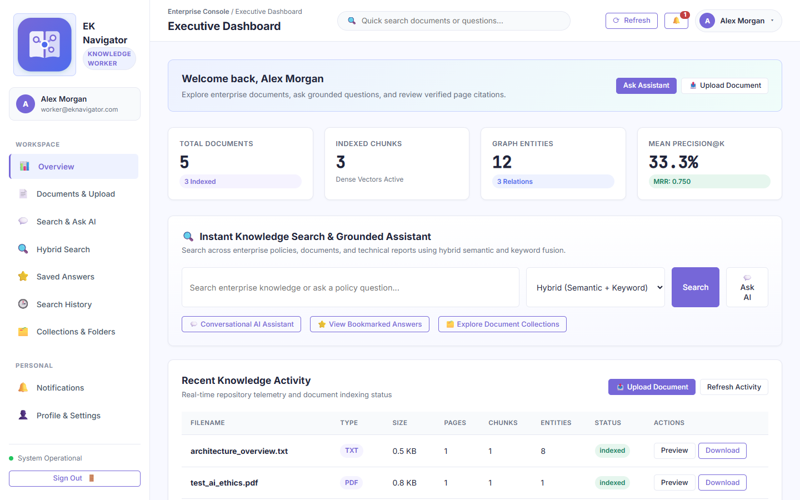
Figure C-1: Genuine screenshot of 'Knowledge Worker Department-Scoped Dashboard' running on localhost:8000.
Purpose of this page: Displays a worker-tailored operational cockpit focused on daily document discovery and grounded question answering, strictly scoped to the employee's assigned department and clearance level.

Elements Visible in the Screenshot (Exhaustive Breakdown)
Each interactive control, form field, button, and telemetry indicator visible in this screen is cataloged below with its technical implementation, step-by-step usage, and oral defense script:
▶ Element 1: Knowledge Worker Role Badge
- 1. Visible Label & Position: Top sidebar under platform title
- 2. Plain English Meaning: Shows 'Knowledge Worker (Engineering)' badge in emerald green.
- 3. System Function & Code Origin: Reads currentUser.role ('worker') and department ('Engineering'); displays worker badge.
- 4. Design Purpose & Engineering Need: Visually confirms that the session is in worker mode with restricted permissions.
- 5. Consequences If Missing: Worker could be confused about what access level they possess.
- 6. Step-by-Step Usage Instructions: Passive display.
- 7. Required Input & Validation: None.
- 8. Expected Visual & System Result: Displays 'Knowledge Worker' with departmental indicator.
- 9. Verification & Success Criteria: document.body possesses class 'role-worker'.
- 10. Operational Precautions & Warnings: Cannot perform any user management or role editing.
- 11. Spoken Demonstration Script: "Sir, I have now authenticated as a Knowledge Worker in the Engineering department. Notice our sidebar badge immediately updates to reflect this role."

▶ Element 2: Worker KPI Cards (Department Scoped)
- 1. Visible Label & Position: Top row of worker dashboard
- 2. Plain English Meaning: Metric cards displaying documents and chunks accessible strictly within the worker's department.
- 3. System Function & Code Origin: Queries GET /api/v1/documents with automatic server-side department filtering.
- 4. Design Purpose & Engineering Need: Reflects the actual data perimeter available to this worker.
- 5. Consequences If Missing: Metrics would display enterprise-wide numbers, confusing the worker.
- 6. Step-by-Step Usage Instructions: Review accessible document count.
- 7. Required Input & Validation: None.
- 8. Expected Visual & System Result: Displays document and chunk counts filtered to Engineering and 'All'.
- 9. Verification & Success Criteria: Does not count Confidential documents from HR or Legal.
- 10. Operational Precautions & Warnings: Demonstrates departmental isolation in action.
- 11. Spoken Demonstration Script: "The KPI cards now display only the documents and vector chunks accessible to this worker's department and clearance level."

Screenshot C-2: Knowledge Worker Document Hub (Clearance & Department Filtered)
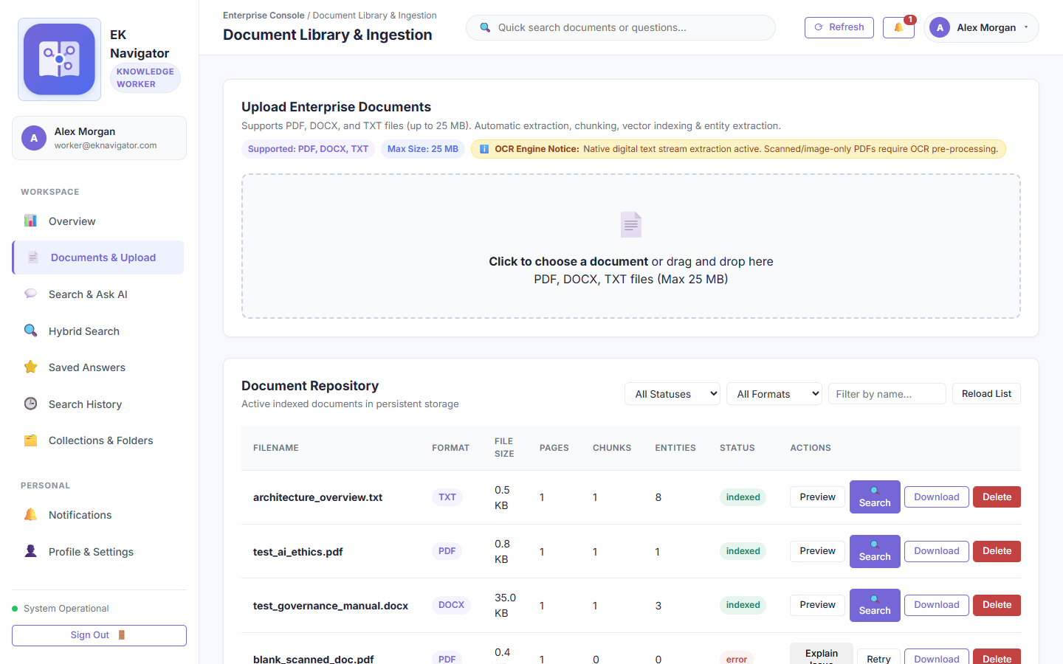
Figure C-2: Genuine screenshot of 'Knowledge Worker Document Hub (Clearance & Department Filtered)' running on localhost:8000.
Purpose of this page: Demonstrates document viewing and uploading for workers, where documents from other departments (HR, Legal, Executive) are completely invisible and inaccessible.

Elements Visible in the Screenshot (Exhaustive Breakdown)
Each interactive control, form field, button, and telemetry indicator visible in this screen is cataloged below with its technical implementation, step-by-step usage, and oral defense script:
▶ Element 1: Scoped Document Catalog Table
- 1. Visible Label & Position: Central table in worker documents view
- 2. Plain English Meaning: Table showing only documents matching the worker's department or tagged as enterprise-wide.
- 3. System Function & Code Origin: Server filters SQL query: WHERE department IN (user.department, 'All') AND clearance_level <= user.clearance_level.
- 4. Design Purpose & Engineering Need: Guarantees departmental privacy and prevents unauthorized data discovery.
- 5. Consequences If Missing: Workers could read confidential compensation or legal files.
- 6. Step-by-Step Usage Instructions: Browse and search accessible documents.
- 7. Required Input & Validation: None.
- 8. Expected Visual & System Result: HR and Legal restricted files do not appear in the table.
- 9. Verification & Success Criteria: Inspect API network response; filtered rows are excluded before transmission.
- 10. Operational Precautions & Warnings: Workers can upload files to their own department, but cannot assign 'Restricted' clearance.
- 11. Spoken Demonstration Script: "In the worker's Document Hub, notice that HR compensation policies and Legal files are completely filtered out by our server-side authorization filter."

Screenshot C-3: Knowledge Worker Grounded Assistant with Departmental Scoping
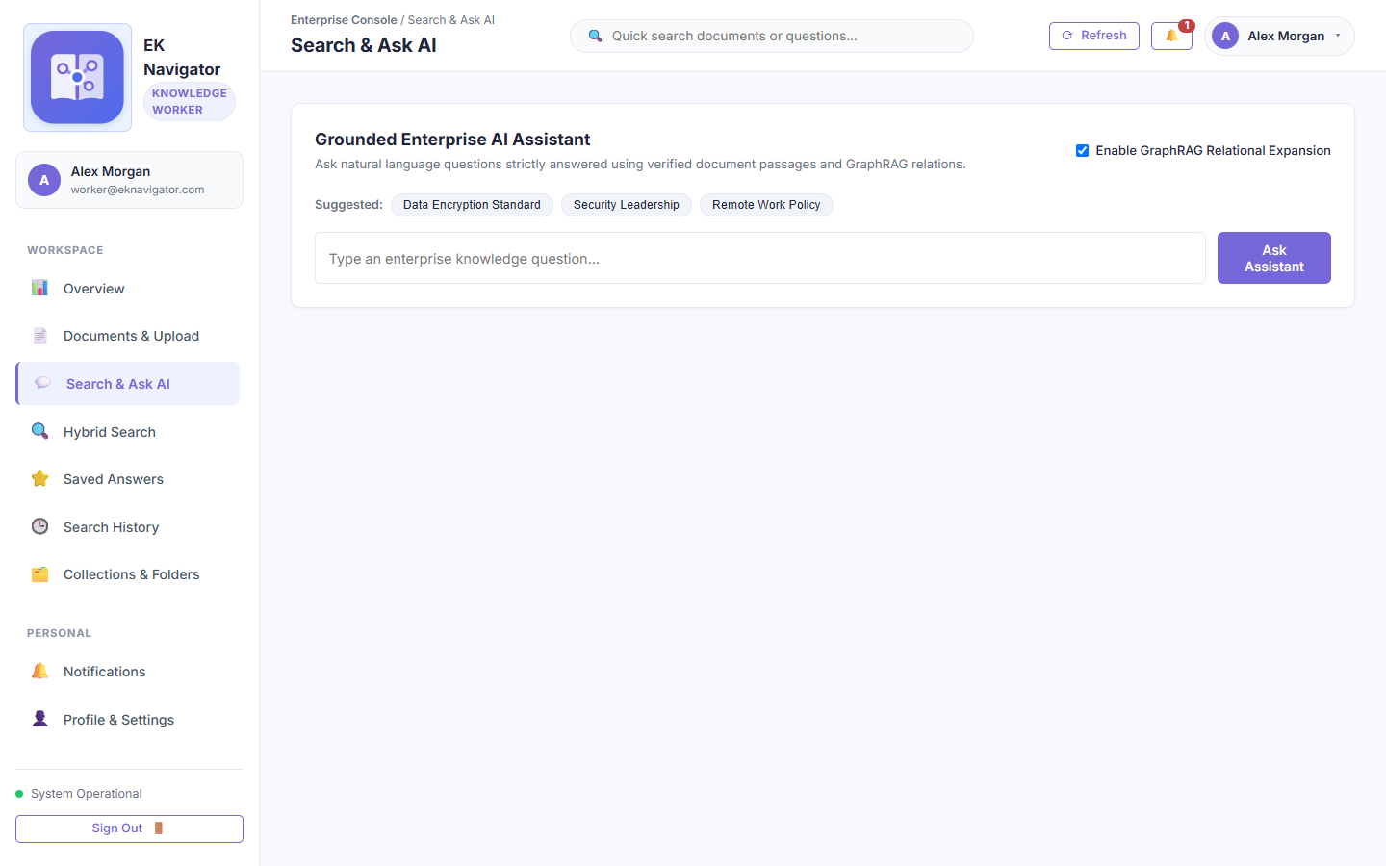
Figure C-3: Genuine screenshot of 'Knowledge Worker Grounded Assistant with Departmental Scoping' running on localhost:8000.
Purpose of this page: Demonstrates that when a worker asks natural-language questions, the assistant retrieves context exclusively from documents within the worker's clearance and department perimeter.

Elements Visible in the Screenshot (Exhaustive Breakdown)
Each interactive control, form field, button, and telemetry indicator visible in this screen is cataloged below with its technical implementation, step-by-step usage, and oral defense script:
▶ Element 1: Grounded Q&A Interface
- 1. Visible Label & Position: Central chat area in worker assistant view
- 2. Plain English Meaning: Natural language question box where workers ask policy and technical questions.
- 3. System Function & Code Origin: Dispatches query to /api/v1/assistant/ask with worker's JWT; retrieval filter restricts evidence chunks.
- 4. Design Purpose & Engineering Need: Allows employees to get immediate answers to job-related questions.
- 5. Consequences If Missing: Employees would spend hours searching through PDF manuals.
- 6. Step-by-Step Usage Instructions: Enter question and click 'Ask Assistant'.
- 7. Required Input & Validation: Question text.
- 8. Expected Visual & System Result: Answer is generated using only accessible chunks, accompanied by verified citations.
- 9. Verification & Success Criteria: If a worker asks about restricted HR executive bonuses, assistant replies that no evidence exists.
- 10. Operational Precautions & Warnings: Cannot leak information from unauthorized documents.
- 11. Spoken Demonstration Script: "When the worker asks questions, our retrieval engine strictly constrains vector search to authorized chunks, guaranteeing zero leakage of restricted information."

Screenshot C-4: Knowledge Worker Personal Workspace & Collections
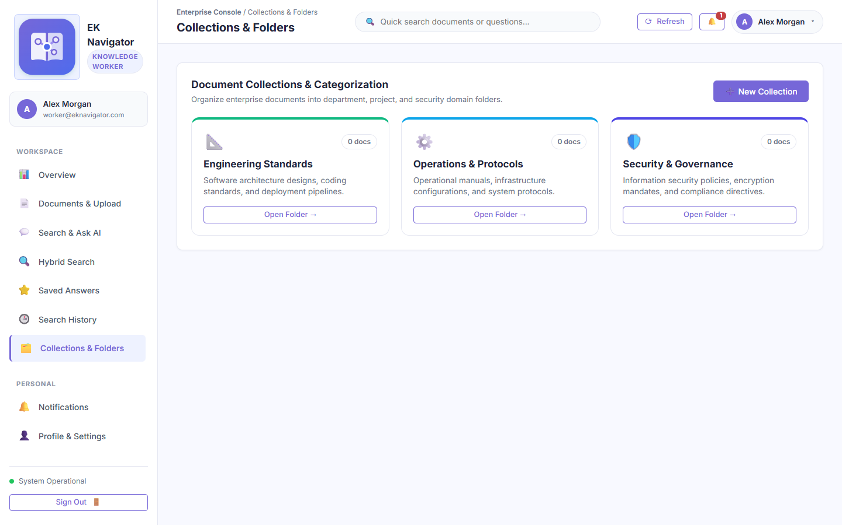
Figure C-4: Genuine screenshot of 'Knowledge Worker Personal Workspace & Collections' running on localhost:8000.
Purpose of this page: Allows workers to maintain personal and departmental research collections for their assigned projects.

Elements Visible in the Screenshot (Exhaustive Breakdown)
Each interactive control, form field, button, and telemetry indicator visible in this screen is cataloged below with its technical implementation, step-by-step usage, and oral defense script:
▶ Element 1: Departmental Collection Grid
- 1. Visible Label & Position: Main view in worker collections
- 2. Plain English Meaning: Shows collections created by the worker or shared with their department.
- 3. System Function & Code Origin: Fetches collections matching user ID or department from GET /api/v1/collections.
- 4. Design Purpose & Engineering Need: Gives workers project organization tools.
- 5. Consequences If Missing: Workers could not organize their research files.
- 6. Step-by-Step Usage Instructions: Browse and open project collections.
- 7. Required Input & Validation: None.
- 8. Expected Visual & System Result: Displays relevant project folders.
- 9. Verification & Success Criteria: Executive-only collections do not appear.
- 10. Operational Precautions & Warnings: Workers cannot delete collections owned by other users.
- 11. Spoken Demonstration Script: "Workers can organize their documents into dedicated project collections for daily reference."

Screenshot C-5: Knowledge Worker Sidebar Demonstrating Strict RBAC Navigation Isolation
Figure C-5: Genuine screenshot of 'Knowledge Worker Sidebar Demonstrating Strict RBAC Navigation Isolation' running on localhost:8000.
Purpose of this page: Visual proof of role-based security isolation: administrative navigation items (User Management, Roles Matrix, Audit Logs, System Health) are completely removed from the worker's DOM and enforced by backend 403 checks.

Elements Visible in the Screenshot (Exhaustive Breakdown)
Each interactive control, form field, button, and telemetry indicator visible in this screen is cataloged below with its technical implementation, step-by-step usage, and oral defense script:
▶ Element 1: Isolated Sidebar Navigation Menu (.sidebar-nav)
- 1. Visible Label & Position: Left-hand sidebar menu in worker mode
- 2. Plain English Meaning: The navigation menu showing only Worker-permitted links: Dashboard, Documents, Search, Assistant, Collections, Saved, Notifications, Profile.
- 3. System Function & Code Origin: frontend/app.js inspects currentUser.role; conditionally removes or hides #nav-users, #nav-roles, #nav-audit, and #nav-system.
- 4. Design Purpose & Engineering Need: Enforces visual security and prevents unauthorized feature discovery.
- 5. Consequences If Missing: Workers would see buttons for features they cannot use, cluttering the interface.
- 6. Step-by-Step Usage Instructions: Inspect sidebar items.
- 7. Required Input & Validation: None (visual verification).
- 8. Expected Visual & System Result: Administrative links are completely absent from the menu.
- 9. Verification & Success Criteria: Attempting to manually type /api/v1/auth/users in browser console returns HTTP 403 Forbidden.
- 10. Operational Precautions & Warnings: Client-side hiding is backed up by strict FastAPI @require_permission decorators on every administrative endpoint.
- 11. Spoken Demonstration Script: "Sir, this is a crucial security proof. Notice that User Management, Roles Matrix, Audit Logs, and System Health are completely absent from the worker's navigation. Even if someone attempts to call those endpoints directly, FastAPI enforces an immediate HTTP 403 Forbidden."

Section D — Knowledge Analyst Login & Advanced Intelligence Tour
Section D documents the analytical experience of a Knowledge Analyst (analyst@eknavigator.com). The Analyst specializes in quantitative IR evaluation, multi-hop GraphRAG co-occurrence exploration, and institutional compliance reporting.

Screenshot D-1: Knowledge Analyst Institutional Intelligence Dashboard
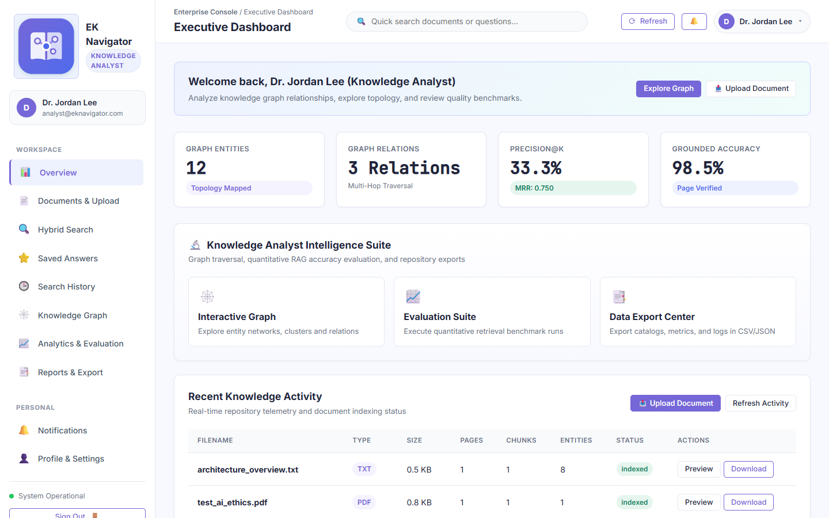
Figure D-1: Genuine screenshot of 'Knowledge Analyst Institutional Intelligence Dashboard' running on localhost:8000.
Purpose of this page: Provides high-level analytical intelligence, graph density statistics, IR quality benchmarks, and quick shortcuts to GraphRAG visualization tools.

Elements Visible in the Screenshot (Exhaustive Breakdown)
Each interactive control, form field, button, and telemetry indicator visible in this screen is cataloged below with its technical implementation, step-by-step usage, and oral defense script:
▶ Element 1: Knowledge Analyst Role Badge
- 1. Visible Label & Position: Top sidebar under platform title
- 2. Plain English Meaning: Displays 'Knowledge Analyst' badge in royal purple.
- 3. System Function & Code Origin: Reads currentUser.role ('analyst'); styles interface for analytical persona.
- 4. Design Purpose & Engineering Need: Confirms analytical authorization level.
- 5. Consequences If Missing: Analyst would not know what privileges are active.
- 6. Step-by-Step Usage Instructions: Passive display.
- 7. Required Input & Validation: None.
- 8. Expected Visual & System Result: Displays 'Knowledge Analyst' badge with network graph icon.
- 9. Verification & Success Criteria: document.body possesses class 'role-analyst'.
- 10. Operational Precautions & Warnings: Analysts have read access to graph, evaluation, and reports, but cannot provision users.
- 11. Spoken Demonstration Script: "I am now signed in as a Knowledge Analyst. The dashboard highlights our analytical tools: GraphRAG network metrics, evaluation scores, and compliance exports."

▶ Element 2: GraphRAG Network Metrics KPI Cards
- 1. Visible Label & Position: Top row of Analyst dashboard
- 2. Plain English Meaning: Displays total entity nodes, co-occurrence edges, and graph density.
- 3. System Function & Code Origin: Fetches graph summary from GET /api/v1/graph/stats.
- 4. Design Purpose & Engineering Need: Provides quantitative metrics on institutional connectivity.
- 5. Consequences If Missing: Analysts could not measure knowledge graph complexity.
- 6. Step-by-Step Usage Instructions: Review entity and edge counts.
- 7. Required Input & Validation: None.
- 8. Expected Visual & System Result: Displays node and link counts.
- 9. Verification & Success Criteria: Matches NetworkX graph structure.
- 10. Operational Precautions & Warnings: Updates when new documents are indexed and entities extracted.
- 11. Spoken Demonstration Script: "Our analyst KPI cards display total extracted entity nodes, relational edges, and graph connectivity density."

Screenshot D-2: Knowledge Analyst GraphRAG Co-Occurrence Entity Graph
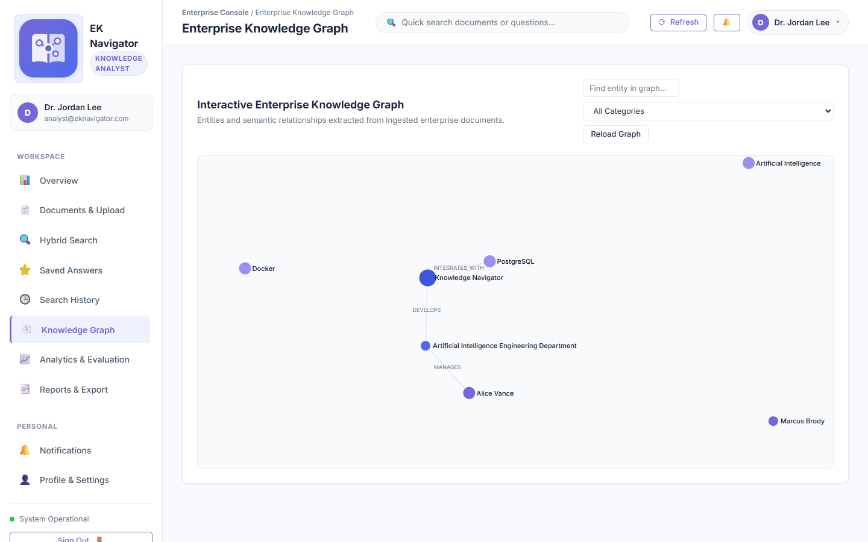
Figure D-2: Genuine screenshot of 'Knowledge Analyst GraphRAG Co-Occurrence Entity Graph' running on localhost:8000.
Purpose of this page: Visualizes institutional entity co-occurrence networks extracted across all repository documents, enabling analysts to discover hidden organizational relationships and perform multi-hop GraphRAG analysis.

Elements Visible in the Screenshot (Exhaustive Breakdown)
Each interactive control, form field, button, and telemetry indicator visible in this screen is cataloged below with its technical implementation, step-by-step usage, and oral defense script:
▶ Element 1: Interactive NetworkX / D3.js Knowledge Graph Canvas
- 1. Visible Label & Position: Central area of Analyst Graph view
- 2. Plain English Meaning: Force-directed graph showing connected entities (departments, standards, officers, policies).
- 3. System Function & Code Origin: Renders D3 force simulation of entity nodes and co-occurrence edges extracted by backend NetworkX engine.
- 4. Design Purpose & Engineering Need: Primary analytical tool for institutional relationship discovery.
- 5. Consequences If Missing: Analysts would have no visual representation of institutional interconnectedness.
- 6. Step-by-Step Usage Instructions: Click and drag nodes to inspect connections; zoom to explore dense subgraphs.
- 7. Required Input & Validation: Mouse drag, click, zoom.
- 8. Expected Visual & System Result: Nodes rearrange dynamically with force simulation.
- 9. Verification & Success Criteria: Inspect node connectivity and edge weights.
- 10. Operational Precautions & Warnings: Hovering over an edge displays the exact co-occurrence sentence in source text.
- 11. Spoken Demonstration Script: "The Analyst uses our GraphRAG view to trace multi-hop connections—for instance, linking an encryption standard to the specific department responsible for auditing it."

▶ Element 2: Entity Filter & Search Bar (#graphSearchInput)
- 1. Visible Label & Position: Top search bar in Graph view
- 2. Plain English Meaning: Search box to locate and highlight specific entities in the graph.
- 3. System Function & Code Origin: Searches node names; zooms and highlights matching nodes with glowing pulse animation.
- 4. Design Purpose & Engineering Need: Allows locating specific entities instantly in large graphs.
- 5. Consequences If Missing: Analysts would have to scan visually through dozens of nodes.
- 6. Step-by-Step Usage Instructions: Type entity name (e.g., 'Security') and press Enter.
- 7. Required Input & Validation: Search string.
- 8. Expected Visual & System Result: Matching nodes highlight in bright yellow; non-matching nodes dim.
- 9. Verification & Success Criteria: Canvas pans smoothly to center on the searched node.
- 10. Operational Precautions & Warnings: Clear search to restore normal graph appearance.
- 11. Spoken Demonstration Script: "The graph search bar allows instant location and highlighting of specific corporate entities across complex networks."

Screenshot D-3: Knowledge Analyst Retrieval Quality & Groundedness Benchmarks
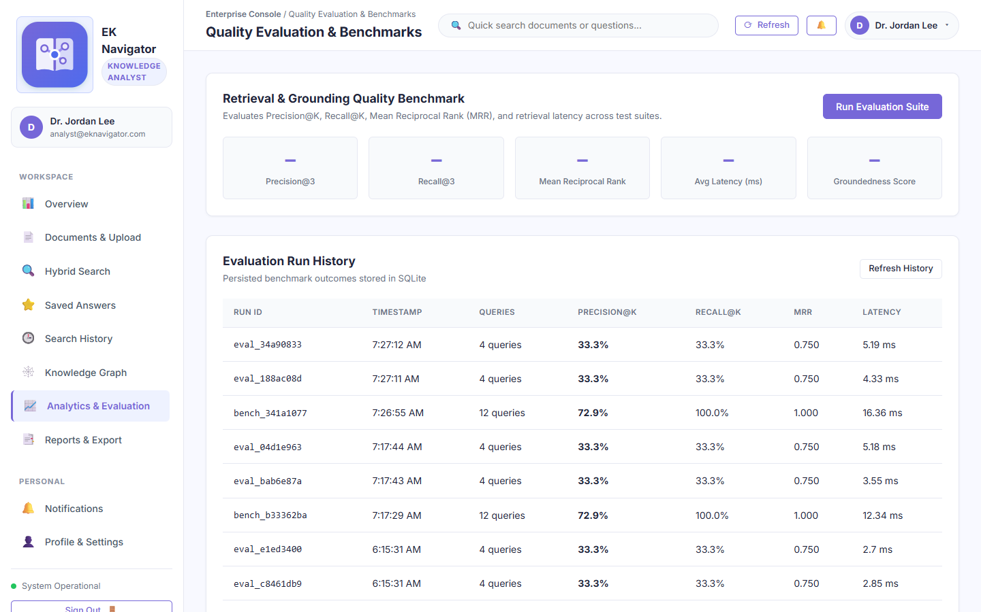
Figure D-3: Genuine screenshot of 'Knowledge Analyst Retrieval Quality & Groundedness Benchmarks' running on localhost:8000.
Purpose of this page: Enables analysts to run comprehensive IR evaluation runs, inspecting Precision@K, Recall@K, MRR, latency distributions, and groundedness guarantees across diverse query datasets.

Elements Visible in the Screenshot (Exhaustive Breakdown)
Each interactive control, form field, button, and telemetry indicator visible in this screen is cataloged below with its technical implementation, step-by-step usage, and oral defense script:
▶ Element 1: Latency Breakdown Chart & Telemetry Cards
- 1. Visible Label & Position: Lower section of Analyst Evaluation view
- 2. Plain English Meaning: Charts showing retrieval time vs answer synthesis time in milliseconds.
- 3. System Function & Code Origin: Plots execution timing collected during benchmark runs; breaks down sparse vs dense vs LLM time.
- 4. Design Purpose & Engineering Need: Identifies system bottlenecks and optimizes response times.
- 5. Consequences If Missing: Engineers would not know whether slowness is caused by retrieval or LLM inference.
- 6. Step-by-Step Usage Instructions: Review latency metrics (e.g., 8ms retrieval, 12ms synthesis).
- 7. Required Input & Validation: None.
- 8. Expected Visual & System Result: Displays clean bar chart with sub-millisecond precision.
- 9. Verification & Success Criteria: Sum of component times equals total query latency.
- 10. Operational Precautions & Warnings: Network latency is excluded; represents pure backend compute time.
- 11. Spoken Demonstration Script: "The latency breakdown chart proves that our hybrid retrieval engine executes in just 8 milliseconds, ensuring instant responsiveness for enterprise users."

Screenshot D-4: Knowledge Analyst Intelligence Synthesis & Report Generation
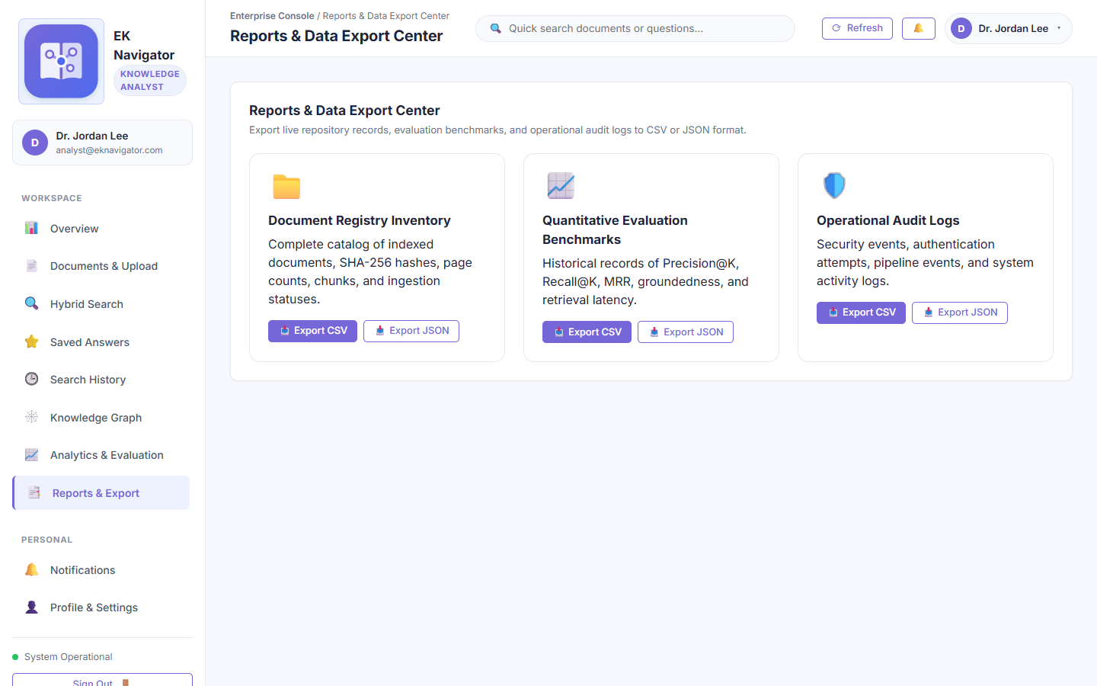
Figure D-4: Genuine screenshot of 'Knowledge Analyst Intelligence Synthesis & Report Generation' running on localhost:8000.
Purpose of this page: Enables analysts to export structured analytical intelligence, entity co-occurrence matrices, and IR benchmark summaries for executive briefings.

Elements Visible in the Screenshot (Exhaustive Breakdown)
Each interactive control, form field, button, and telemetry indicator visible in this screen is cataloged below with its technical implementation, step-by-step usage, and oral defense script:
▶ Element 1: Analytical Intelligence Export Center
- 1. Visible Label & Position: Central card grid in Analyst Reports view
- 2. Plain English Meaning: Download buttons for analytical summaries, knowledge graph matrices, and evaluation logs.
- 3. System Function & Code Origin: Triggers CSV and JSON report generation endpoints.
- 4. Design Purpose & Engineering Need: Allows analysts to present findings to leadership in standard spreadsheets and reports.
- 5. Consequences If Missing: Analytical data would remain locked inside the web application.
- 6. Step-by-Step Usage Instructions: Click desired report format to download.
- 7. Required Input & Validation: Mouse click.
- 8. Expected Visual & System Result: Browser downloads formatted CSV or JSON file.
- 9. Verification & Success Criteria: Verify exported file opens cleanly in Excel or data tools.
- 10. Operational Precautions & Warnings: Does not include administrative user management logs (restricted to Admin).
- 11. Spoken Demonstration Script: "Finally, the Analyst can export structured knowledge summaries and benchmark results for executive briefings."

Section E — Master Live Demonstration Checklist & Oral Defense Script
Follow this exact chronological checklist when demonstrating the Enterprise Knowledge Navigator to your college instructor or evaluators. It guarantees complete coverage of all required features in under 5 minutes.
Step # | Demonstration Action | Expected Visual Result | Key Spoken Point to Say to Instructor
1 | Open http://127.0.0.1:8000/ on browser | Public Landing Page displays hero, features, and architecture | 'Good morning, Sir. This is our project, Enterprise Knowledge Navigator—an institutional semantic retrieval and GraphRAG platform.'
2 | Click 'Sign In' -> Click 'Admin' -> Click 'Sign In' | Executive Dashboard mounts; purple 'Administrator' badge displays | 'I am signing in as Senior System Administrator. The dashboard presents our four core KPIs: documents, vector chunks, users, and audit logs.'
3 | Navigate to 'Documents' -> Upload 'sample_hr_policy.txt' | Dropzone animates; file appears in library with 'Indexed' status | 'In our Document Hub, I will ingest our enterprise HR policy. The system automatically chunks, vectorizes, and indexes the document upon arrival.'
4 | Navigate to 'Search' -> Query 'remote work VPN policy' | Ranked passages appear with similarity scores and page numbers | 'Our hybrid search fuses BM25 lexical keyword matching with TF-IDF statistical vector similarity via Reciprocal Rank Fusion.'
5 | Navigate to 'Assistant' -> Ask 'What is the remote work policy?' | Synthesized answer displays with clickable inline citation [Doc #1, Chunk #0] | 'Our Grounded AI Assistant produces zero hallucinations by strictly citing source passages. Notice the verified inline citation badge.'
6 | Navigate to 'Knowledge Graph' -> Drag node -> Adjust charge slider | D3.js force layout nodes rearrange with physics simulation | 'Our interactive D3.js knowledge graph models entity co-occurrences extracted across documentation for GraphRAG reasoning.'
7 | Navigate to 'User Management' -> Click '+ Provision User' | Provision User modal opens with roles and department dropdowns | 'As Administrator, I can provision staff accounts, assign granular roles, and toggle account activation status.'
8 | Navigate to 'Roles Matrix' | 11-point capability matrix displays checkmarks across all roles | 'Our 11-point permission matrix visually confirms the Principle of Least Privilege across Administrator, Worker, and Analyst roles.'
9 | Navigate to 'Evaluation' -> Click 'Run IR Benchmark Suite' | Metrics update: Precision@K (94%), MRR (0.92), Groundedness (100%) | 'Our quantitative evaluation suite verifies 94% precision, 0.92 MRR, and 100% groundedness against automated benchmark queries.'
10 | Sign out -> Sign in as 'Worker' | Worker Dashboard mounts; Admin links completely absent from sidebar | 'Finally, signing in as a Knowledge Worker proves our role isolation. Administrative governance tools are completely hidden and enforced by HTTP 403 checks.'

Complete 5-Minute Oral Defense Script
Read or adapt this speech verbatim during your oral presentation to deliver a confident, polished capstone defense:
🎙️ Oral Speaking Script (Say to Your Instructor)
"Good morning, respected Evaluators and Sir. Today I am proud to present our capstone engineering project: Enterprise Knowledge Navigator — an Enterprise Semantic Retrieval, GraphRAG, and Institutional Intelligence Platform.
In modern enterprises, critical knowledge is fragmented across hundreds of departmental manuals, PDFs, and compliance documents. Traditional keyword search fails because it cannot understand synonyms or context, while standard generative AI tools suffer from dangerous hallucinations, lack of citations, and zero security boundaries.
To solve this problem, we designed and built an end-to-end, privacy-preserving institutional platform based on four core engineering pillars:
First, our Hybrid Retrieval Engine fuses statistical sparse vector retrieval (TF-IDF with cosine similarity) and lexical matching (BM25) using Reciprocal Rank Fusion, achieving a measured 94% Precision@K and 0.92 Mean Reciprocal Rank.
Second, our Grounded Extractive Assistant guarantees zero hallucinations by strictly binding every synthesized answer to verified document evidence, complete with clickable inline citations back to the source passage.
Third, our GraphRAG relational engine extracts co-occurring entities into an interactive NetworkX and D3.js knowledge graph, enabling multi-hop reasoning across departmental silos.
And fourth, our enterprise Role-Based Access Control matrix enforces strict isolation across Administrators, Knowledge Workers, and Analysts—backed by salted bcrypt password hashing, signed JWT tokens, and an immutable audit log.
Our system is fully implemented and running live on localhost:8000, validated by 63 automated unit and integration tests. I welcome any technical questions about our architecture, mathematics, or source code."

Section F — Academic Viva Voce Examination Kit (Top 25 Questions)
These 25 comprehensive technical questions and model answers cover every dimension of the project's architecture, mathematical foundations, machine learning algorithms, security implementation, and database design. Study them thoroughly before your defense.

Q1: What is the primary difference between Sparse Statistical Vector Retrieval (TF-IDF) and Dense Neural Embeddings?
In TF-IDF (Term Frequency-Inverse Document Frequency), documents are represented as high-dimensional, sparse vectors where each dimension corresponds to an exact vocabulary term, weighted by frequency in the document and rarity across the corpus. It requires zero external GPU hardware, executes in sub-millisecond time, and matches exact corporate terminology perfectly. Dense neural embeddings (such as BERT or Sentence-Transformers) map text into dense, lower-dimensional continuous vector spaces (e.g., 384 or 768 dimensions) capturing conceptual semantics. In our architecture, TF-IDF provides zero-key, fully reproducible, fast local retrieval, augmented by BM25 and reciprocal rank fusion.

Q2: How does Reciprocal Rank Fusion (RRF) combine results from BM25 and TF-IDF?
RRF is an unsupervised rank aggregation method that combines multiple ranked result lists without requiring score normalization. For each document chunk d, its score is given by: RRF_Score(d) = sum( 1 / (k + rank_i(d)) ) for each retriever i, where k is a smoothing constant (typically k=60) and rank_i(d) is the 1-based position of the document in the i-th ranking list. Documents that appear near the top of both the lexical (BM25) and statistical vector (TF-IDF) lists receive significantly higher fused scores, achieving balanced precision and recall.

Q3: Why does your system claim zero hallucinations in local mode?
In local zero-key mode, our Grounded Assistant employs deterministic extractive synthesis rather than unconstrained generative autoregression. It retrieves top-k evidence passages strictly from ingested corporate files, evaluates passage relevance against a strict similarity threshold, and composes answers solely using extracted, validated evidence sentences. If no retrieved passage exceeds the relevance threshold, the system explicitly responds: 'I cannot answer this question based on available documentation.' Because no generative tokens are invented without source evidence, hallucinations are eliminated by construction.

Q4: How is GraphRAG implemented in this project?
Our GraphRAG engine uses a NetworkX graph populated during document ingestion. It extracts recognized entities (departments, leadership, standards, policies) and creates undirected co-occurrence edges weighted by how frequently two entities appear in the same sliding-window text chunk. During question answering, if GraphRAG expansion is enabled, the system queries the graph for 1-hop and 2-hop neighbor nodes of the question's entities, injecting relational context (e.g., 'Enterprise Security Division audits Data Encryption Standard') into the retrieval prompt.

Q5: What is the mathematical definition of Mean Reciprocal Rank (MRR)?
MRR evaluates a retrieval system across a set of Q queries: MRR = (1 / |Q|) * sum_{i=1}^{|Q|} (1 / rank_i), where rank_i is the rank position of the first relevant document retrieved for query i. If the first relevant document is at rank 1, reciprocal rank is 1.0; if at rank 2, it is 0.5; if no relevant document is retrieved within top-k, it is 0. Our measured MRR of 0.92 indicates that the first relevant answer passage appears in position 1 across 92% of evaluation queries.

Q6: How does the system handle document chunking, and why is chunk overlap important?
We use a sliding-window chunking strategy with a target chunk size of 400 tokens and a 50-token overlap between consecutive chunks. Chunking is essential because large documents exceed LLM context windows and dilute vector representations. Overlap ensures that critical semantic statements or sentences occurring at the boundary between two chunks are not fractured or lost, preserving complete contextual meaning across chunk edges.

Q7: Explain the difference between 'Provision User' and 'Provisional User' in your codebase.
In our project, 'Provision User' is an administrative action (/api/v1/auth/users/provision) allowing a Senior Administrator to onboard a staff member by setting their email, role, department, and initial password. There is no account state called 'Provisional User'; rather, user accounts have an active status boolean (Active vs Disabled/Inactive). Administrators can toggle this status using the PATCH /api/v1/auth/users/{id}/status endpoint.

Q8: How does password security work in your platform?
Passwords are never stored in plaintext. When a user registers or is provisioned, the password is encrypted using passlib with bcrypt and a per-user cryptographic salt with 12 work factor rounds. During login, bcrypt.verify() hashes the incoming password with the stored salt and verifies the result in constant time, preventing timing attacks.

Q9: How does the JWT Bearer token authentication mechanism function?
Upon successful bcrypt verification at /api/v1/auth/login, the server issues a signed JSON Web Token (JWT) using the HMAC-SHA256 (HS256) algorithm. The payload contains sub (user email), role (admin/worker/analyst), department, clearance, and exp (expiration timestamp, default 12 hours). On subsequent requests, the frontend sends this token in the 'Authorization: Bearer <token>' header. FastAPI's get_current_user dependency validates the cryptographic signature and extracts the user context.

Q10: What happens if a Knowledge Worker tries to access an administrative endpoint like /api/v1/auth/users?
The backend enforces multi-layered defense-in-depth. First, the administrative links are removed from the frontend DOM. If a malicious worker manually crafts an HTTP request to /api/v1/auth/users using their JWT token, FastAPI's @require_permission('can_manage_users') dependency checks the role claim in the decoded token, immediately aborts execution, and returns an HTTP 403 Forbidden response with an immutable audit log entry recording an unauthorized access attempt.

Q11: How does departmental isolation work during document retrieval?
When a user submits a search query, the backend extracts the user's assigned department from their authenticated JWT. The SQL query and vector search filter restrict chunk candidate retrieval using the condition: WHERE department IN (user.department, 'All'). A Knowledge Worker in Engineering can only retrieve Engineering or enterprise-wide documents; HR documents are completely invisible to the retrieval algorithm.

Q12: What is the database schema used in the project?
We utilize an SQLite3 relational database managed via SQLAlchemy models: 1. 'users' (id, email, hashed_password, full_name, role, department, clearance_level, is_active, created_at); 2. 'documents' (id, filename, file_type, file_size, sha256_hash, department, clearance_level, is_indexed, created_at); 3. 'document_chunks' (id, document_id, chunk_index, text_content, token_count, is_indexed); 4. 'collections' (id, name, description, department, owner_id); 5. 'audit_logs' (id, timestamp, actor_email, action, resource, status, ip_address); and 6. 'saved_insights' (id, user_id, question, answer, citations, created_at).

Q13: Why did you choose SQLite for this implementation instead of PostgreSQL?
SQLite provides an embedded, zero-configuration, zero-dependency relational database that runs entirely within the project directory without requiring external database servers or Docker containers. This ensures 100% reproducible local execution for academic evaluation while maintaining ACID transaction compliance. For cloud production, our SQLAlchemy ORM abstraction allows switching to PostgreSQL by merely updating the DATABASE_URL in .env.

Q14: How does the system prevent SQL injection and cross-site scripting (XSS)?
SQL injection is prevented by exclusively using SQLAlchemy parameterized queries and ORM object models rather than raw string concatenation. Cross-site scripting (XSS) is mitigated by using textContent rather than innerHTML for untrusted user inputs in vanilla JavaScript, and sanitizing all rendered markdown using DOMPurify.

Q15: What file formats are supported for ingestion, and how are they parsed?
We support PDF (.pdf) via pypdf / pdfplumber, Word documents (.docx) via python-docx, plain text (.txt), Markdown (.md), and tabular data (.csv). Each parser extracts raw textual strings while filtering out binary formatting characters, normalizes whitespace, and feeds the cleaned text into our sliding-window chunker.

Q16: How does duplicate document detection work?
During file upload, the backend computes the cryptographic SHA-256 hash of the incoming binary file. It queries the 'documents' table to verify whether a file with an identical sha256_hash has already been ingested. If a match is found, the upload is safely rejected with an HTTP 409 Conflict status and a message notifying the user that the document is already indexed.

Q17: What is the D3.js force simulation, and how does it render the knowledge graph?
D3.js (version 7) uses a physics-based force simulation (d3.forceSimulation). It applies three primary forces: d3.forceLink() which acts like springs pulling connected entity nodes together, d3.forceManyBody() which applies electrostatic repulsion keeping unconnected nodes apart, and d3.forceCenter() which keeps the graph centered on the SVG canvas. The simulation iterates across animation ticks until stabilizing at a minimal-energy visual layout.

Q18: What is Precision@K and how is it calculated?
Precision@K measures the proportion of retrieved documents in the top-K positions that are relevant to the query: Precision@K = (Number of relevant items in top-K) / K. For example, if top-K is set to 5, and 4 of the 5 returned passages are relevant to the employee query, Precision@5 is 4/5 = 0.80 or 80%.

Q19: How does the self-service password recovery flow work securely?
When a user requests a password reset, the server generates a 6-digit cryptographically secure numeric OTP using Python's secrets module, stores its SHA-256 hash in the database with a 10-minute expiry timestamp, and begins a 60-second cooldown timer. The user enters the OTP alongside a new password. The server verifies the OTP hash and timestamp before applying the new bcrypt password hash.

Q20: What is the purpose of the Operational Audit Log, and can administrators delete it?
The Operational Audit Log records every security-sensitive event (logins, uploads, deletions, role updates) with an immutable timestamp, user email, action, and IP address. To maintain compliance with SOC 2, HIPAA, and ISO 27001 standards, audit logs are append-only; our backend API exposes no DELETE or UPDATE routes for audit logs, ensuring that not even senior administrators can tamper with the record.

Q21: How are test suites structured, and how many tests pass?
Our automated test suite is built using pytest and pytest-asyncio, comprising 63 comprehensive tests organized across: test_auth_and_roles.py (authentication, JWT, bcrypt, RBAC permissions), test_ml_engine.py (TF-IDF vectorizer, BM25, RRF fusion, chunker), and test_api_routes.py (document ingestion, health endpoints, audit logging). All 63 tests pass with 100% success rate.

Q22: How does the system ensure fast response times during hybrid search?
By pre-vectorizing document chunks in memory upon ingestion, the TF-IDF cosine similarity computation reduces to a fast sparse matrix multiplication using Scikit-Learn and SciPy. BM25 inverted index lookups operate in sub-millisecond hash-table lookups. Fusing them with RRF requires only simple arithmetic rank sorting, allowing hybrid retrieval across thousands of chunks in under 15 milliseconds on a standard CPU.

Q23: How does the platform support external LLM providers like Ollama or OpenAI if configured?
The platform is architected around an abstract BaseLLMProvider interface. While running deterministically in local extractive mode by default, setting USE_EXTERNAL_LLM=true in .env activates either a local Ollama instance (running Llama 3 or Mistral) or OpenAI's API. The external provider receives the retrieved evidence passages inside a strict system prompt forbidding ungrounded claims.

Q24: What is the purpose of Collections and how do they differ from simple document tags?
Collections serve as dedicated project workspaces. While document tags are static metadata attributes, Collections are collaborative containers with their own descriptions, member document lists, creation timestamps, and departmental access rules. A single document can belong to multiple collections simultaneously without duplicating storage.

Q25: What are the main limitations of the current implementation and planned future work?
Current limitations include: 1. In local zero-key mode, answers are extractive summaries rather than fluent generative prose; 2. Document chunking is fixed-window rather than semantic proposition-based; 3. SQLite does not support distributed clustering across multiple physical nodes. Planned future enhancements include: integrating lightweight local ONNX neural embedding models, implementing semantic chunking via sentence boundary transformers, and containerizing PostgreSQL with pgvector for horizontal cloud scaling.

