Query 1: Copy the provided csv files in a directory named AirlinesOntimeAnalysis



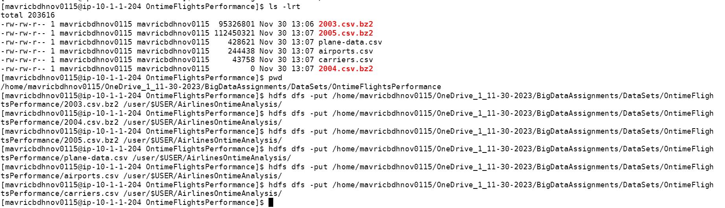

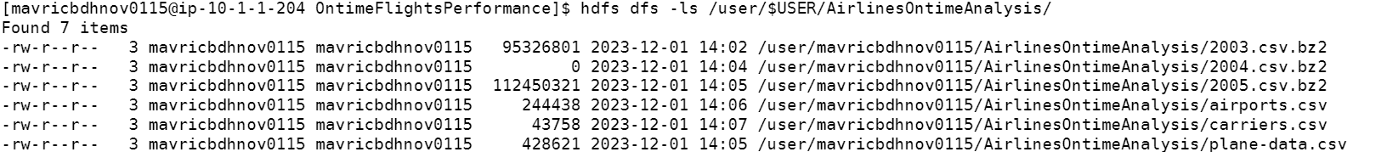

Step 3: **Create the directories in hdfs where your data will reside**

rawdata/airline/flights

rawdata/airline/planeinfo

rawdata/airline/airport

rawdata/airline/carriers

Step 4: **copy the respective files to the above created hdfs structure**



