**CREATE DATABASE airline_db_sweta;**

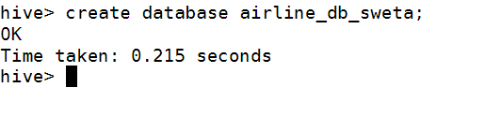

1. External airport table created below

CREATE EXTERNAL TABLE airline_db_sweta.airports_stg (

IATA VARCHAR(3),

Name VARCHAR(255),

City VARCHAR(255),

State VARCHAR(255),

Country VARCHAR(255),

Lat DECIMAL(9,6),

Long DECIMAL(9,6)

)

ROW FORMAT DELIMITED FIELDS TERMINATED BY ','

LINES TERMINATED BY '\n'

STORED As TextFile

LOCATION '/user/mavricbdhnov0115/AirlinesOntimeAnalysis/rawdata/airline/airport'

tblproperties(

"skip.header.line.count"="1"

);

LOAD DATA LOCAL INPATH ‘home/mavricbdhnov0115/OneDrive_1_11-29-2023/Big Data DV Batch – Assignments/Datasets/OntimeFlightPerformance/airports.csv’ INTO TABLE airline_db_sweta.airports_stg;

Data loaded in airports_stg

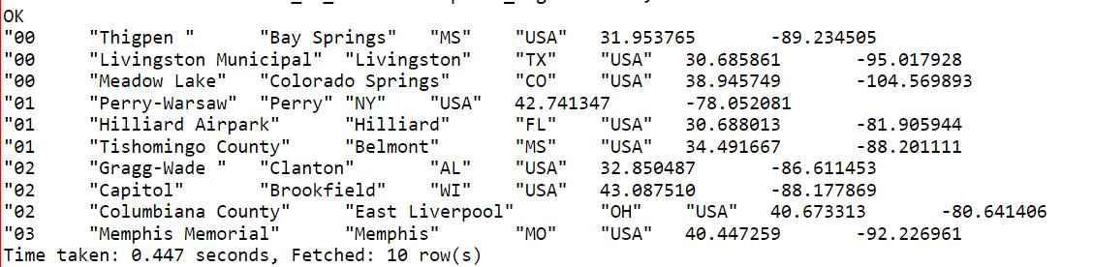

1. External carriers table created below

CREATE EXTERNAL TABLE airline_db_sweta.carriers_stg (

Code VARCHAR(255),

Description VARCHAR(255)

)

ROW FORMAT DELIMITED FIELDS TERMINATED BY ','

LINES TERMINATED BY '\n'

STORED As TextFile

LOCATION '/user/mavricbdhnov0115/AirlinesOntimeAnalysis/rawdata/airline/carriers'

tblproperties(

"skip.header.line.count"="1"

);

LOAD DATA LOCAL INPATH ‘home/mavricbdhnov0115/OneDrive_1_11-29-2023/Big Data DV Batch – Assignments/Datasets/OntimeFlightPerformance/carriers.csv’ INTO TABLE airline_db_sweta.carriers_stg;

Data loaded in carriers table

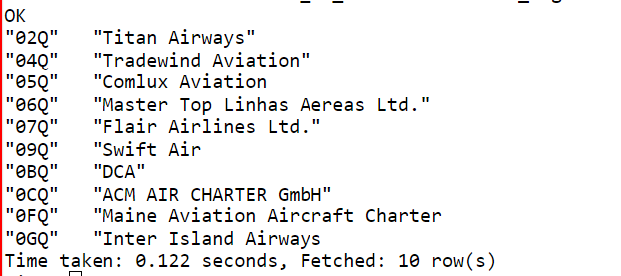

1. External planeinfo table created below

CREATE EXTERNAL TABLE airline_db_sweta.planeinfo (

tailNum VARCHAR(255),

type VARCHAR(255),

manufacturer VARCHAR(255),

issue_date VARCHAR(10),

model VARCHAR(255),

status VARCHAR(255),

aircraft_type VARCHAR(255),

engine_type VARCHAR(255),

year INT

)

ROW FORMAT DELIMITED FIELDS TERMINATED BY ','

LINES TERMINATED BY '\n'

STORED As TextFile

LOCATION '/user/mavricbdhnov0115/AirlinesOntimeAnalysis/rawdata/airline/planeinfo'

tblproperties(

"skip.header.line.count"="1"

);

LOAD DATA LOCAL INPATH ‘home/mavricbdhnov0115/OneDrive_1_11-29-2023/Big Data DV Batch – Assignments/Datasets/OntimeFlightPerformance/plane-data.csv’ INTO TABLE airline_db_sweta.planeinfo_stg;

Data loaded in planeinfo table

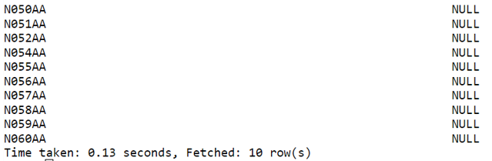

1. External flight table create below

CREATE EXTERNAL TABLE flights (

Year INT,

Month INT,

DayofMonth INT,

DayOfWeek INT,

DepTime INT,

CRSDepTime INT,

ArrTime INT,

CRSArrTime INT,

UniqueCarrier VARCHAR(255),

FlightNum VARCHAR(255),

TailNum VARCHAR(255),

ActualElapsedTime INT,

CRSElapsedTime INT,

AirTime INT,

ArrDelay INT,

DepDelay INT,

Origin VARCHAR(255),

Dest VARCHAR(255),

Distance INT,

TaxiIn INT,

TaxiOut INT,

Cancelled INT,

CancellationCode VARCHAR(1),

Diverted INT,

CarrierDelay INT,

WeatherDelay INT,

NASDelay INT,

SecurityDelay INT,

LateAircraftDelay INT

)

ROW FORMAT DELIMITED FIELDS TERMINATED BY ','

LINES TERMINATED BY '\n'

STORED As TextFile

LOCATION '/user/mavricbdhnov0115/AirlinesOntimeAnalysis/rawdata/airline/flights'

tblproperties(

"skip.header.line.count"="1"

);

LOAD DATA LOCAL INPATH ‘home/mavricbdhnov0115/OneDrive_1_11-29-2023/Big Data DV Batch – Assignments/Datasets/OntimeFlightPerformance/2003.csv’ INTO TABLE airline_db_sweta.flights_stg;

LOAD DATA LOCAL INPATH ‘home/mavricbdhnov0115/OneDrive_1_11-29-2023/Big Data DV Batch – Assignments/Datasets/OntimeFlightPerformance/2004.csv’ INTO TABLE airline_db_sweta.flights_stg;

LOAD DATA LOCAL INPATH ‘home/mavricbdhnov0115/OneDrive_1_11-29-2023/Big Data DV Batch – Assignments/Datasets/OntimeFlightPerformance/2005.csv’ INTO TABLE airline_db_sweta.flights_stg;

**What is the average arrival delay and average departure delay in each month of the year 2004?**

Answer: SELECT Month, AVG(ArrDelay) AS AvgArrivalDelay, AVG(DepDelay) AS AvgDepartureDelay FROM airline_db_sweta.flights_stg WHERE Year = 2004 GROUP BY Month;

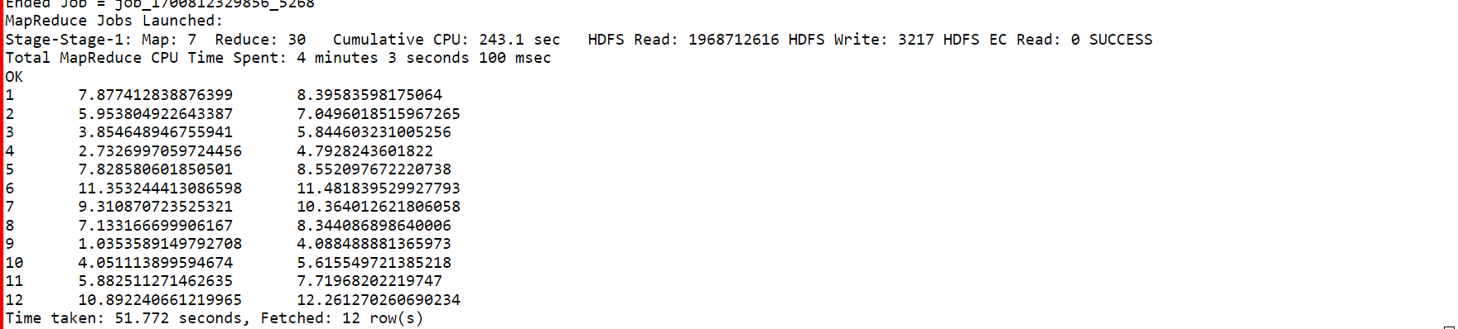

Question 3: Create the parquet table as external tables for flights from the above staging table.

Name the new table with _pq as a suffix: Ex : flights_pq

Point all the table location output/airline/pq_flights

CREATE EXTERNAL TABLE airline_db_sweta.flights_pq (  
    Year INT,  
    Month INT,  
    DayofMonth INT,  
    DayOfWeek INT,  
    DepTime INT,  
    CRSDepTime INT,  
    ArrTime INT,  
    CRSArrTime INT,  
    UniqueCarrier VARCHAR(255),  
    FlightNum VARCHAR(255),  
    TailNum VARCHAR(255),  
    ActualElapsedTime INT,  
    CRSElapsedTime INT,  
    AirTime INT,  
    ArrDelay INT,  
    DepDelay INT,  
    Origin VARCHAR(255),  
    Dest VARCHAR(255),  
    Distance INT,  
    TaxiIn INT,  
    TaxiOut INT,  
    Cancelled INT,  
    CancellationCode VARCHAR(1),  
    Diverted INT,  
    CarrierDelay INT,  
    WeatherDelay INT,  
    NASDelay INT,  
    SecurityDelay INT,  
    LateAircraftDelay INT  
)

ROW FORMAT DELIMITED FIELDS TERMINATED BY ','  
LINES TERMINATED BY '\n'  
STORED AS PARQUET  
LOCATION '/user/mavricbdhnov0115/AirlinesOntimeAnalysis/rawdata/airline/pq_flights'  
tblproperties(  
"skip.header.line.count"="1"  
);

Loading data into the table flights_pq

LOAD DATA LOCAL INPATH ‘home/mavricbdhnov0115/OneDrive_1_11-29-2023/Big Data DV Batch – Assignments/Datasets/OntimeFlightPerformance/2004.csv’ INTO TABLE airline_db_sweta.flights_pq;

Query : SELECT Month, AVG(ArrDelay) AS AvgArrivalDelay, AVG(DepDelay) AS AvgDepartureDelay FROM airline_db_shubham.flights_stg WHERE Year = 2004 GROUP BY Month;



Question : **Is there a difference between the response times for the queries(2 and 3)**

Answer: Yes there is difference of **22** sec

|  |  |  |  |  |
| --- | --- | --- | --- | --- |
| **Table type** | **Table Name** | **Start time** | **End time** | **time elapsed** |
| Normal table | airline_db_sweta.flights_stg | Fri Nov 30 15:15:32 +0550 2023 | Fri Nov 30 15:16:29 +0550 2023 | 57sec |
| Parquet Table | airline_db_sweta.flights_pq | Fri Nov 30 15:58:50 +0550 2023 | Fri Nov 30 15:59:25 +0550 2023 | 35sec |