Creating a table called Facebook

Database name -facebook_sweta

Table Name-facebook

Query :

CREATE TABLE facebook_sweta.facebook (

userid INT,

age INT,

dob_day INT,

dob_year INT,

dob_month INT,

gender STRING,

tenure INT,

friend_count INT,

friendships_initiated INT,

likes INT,

likes_received INT,

mobile_likes INT,

mobile_likes_received INT,

www_likes INT,

www_likes_received INT

)

ROW FORMAT DELIMITED FIELDS TERMINATED BY ','

LINES TERMINATED BY '\n'

STORED As TextFile

tblproperties(

"skip.header.line.count"="1"

);



Loading the pseudo_facebook.csv file into the table facebook

LOAD DATA LOCAL INPATH 'home/mavricbdhnov0115/OneDrive_1_11-30-2023/BigDataAssignments/DataSets/Facebook/pseudo_facebook.csv' INTO TABLE facebook_sweta.facebook;



Query 1: Find out the total no of users in the dataset

SELECT COUNT(*) AS total_users FROM facebook_sweta.facebook;

total_users = 99003

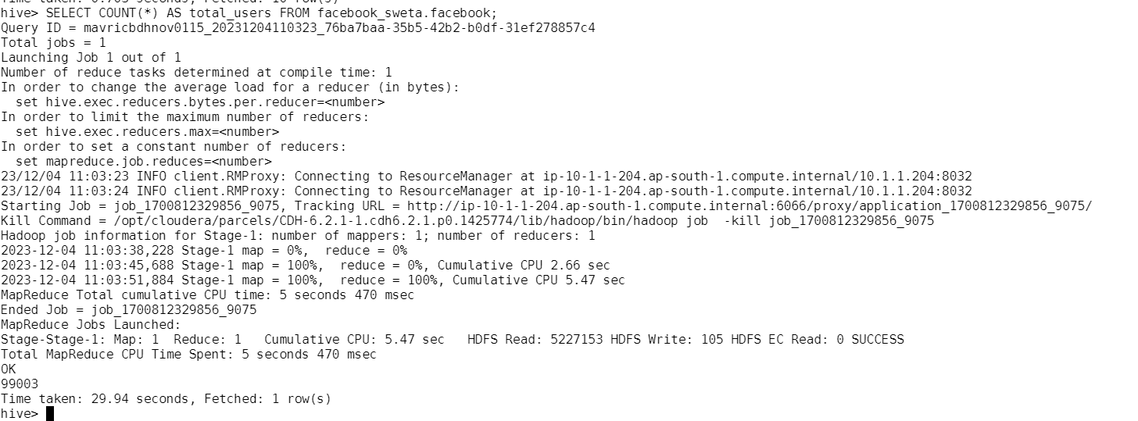

# Q2: Find out the no of users above the age of 25

SELECT COUNT(*) AS users_above_25 FROM facebook_sweta.facebook WHERE age > 25;

Users_above_25 = 56676

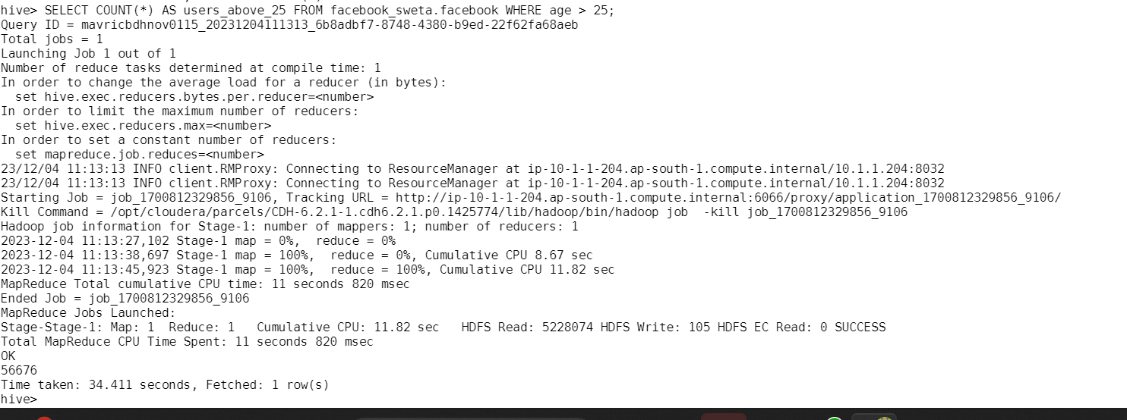

# Q3: Do male face book users tend to have more friends or female users

SELECT gender, count(friend_count) as avg_friend_count from facebook_sweta.facebook group by gender;

Avg_friend_count

|  |  |
| --- | --- |
| NA | 175 |
| female | 40254 |
| male | 58574 |

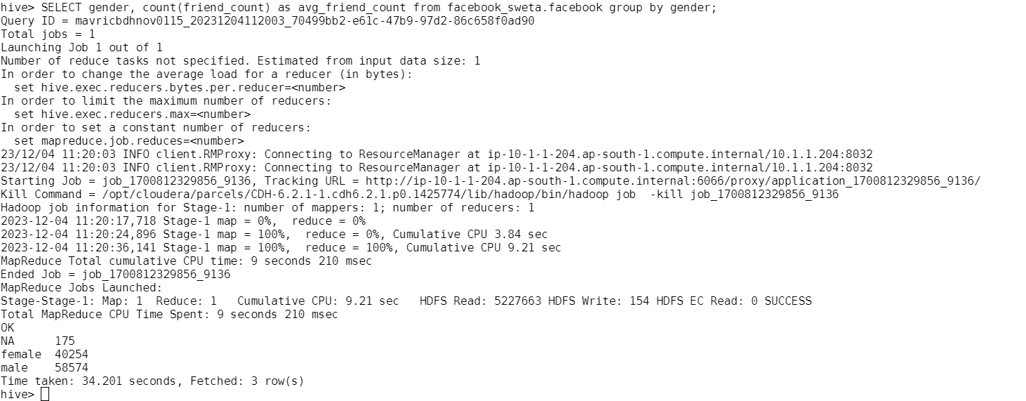

# Q4: How many likes do young people receive on facebook as opposed to old people

select if (age <= 25, 'Young', 'Old') as age_group,sum(likes_received) as total_likes_received from facebook_sweta.facebook group by if(age <=

25, 'Young', 'Old')

|  |  |
| --- | --- |
| Old | 5649125 |
| Young | 8477550 |

# Q5: Find out the count of facebook users for each birthday month

SELECT dob_month, COUNT(*) AS user_count FROM facebook_sweta.facebook GROUP BY dob_month;

|  |  |
| --- | --- |
| 1 | 11772 |
| 2 | 7632 |
| 3 | 8110 |
| 4 | 7810 |
| 5 | 8271 |
| 6 | 7607 |
| 7 | 8021 |
| 8 | 8266 |
| 9 | 7939 |
| 10 | 8476 |
| 11 | 7205 |
| 12 | 7894 |

# Q6: Do young members use mobile phones or computers for facebook browsing

select 'Young' as age_group,SUM(mobile_likes) as mobile_likes, SUM(www_likes) as computer_likes FROM facebook_sweta.facebook where age < 18 group by 'Young';

Young 1615213 828252

# Q7: Do adult members use mobile phones or computers for facebook browsing

select 'Adult' as age_group,SUM(mobile_likes) as mobile_likes,SUM(www_likes) as computer_likes FROM facebook_sweta.facebook where age >= 18 and age < 61 group by 'Adult';

ADULT 7633769 310838390

