UNIVERSITY OF COMPUTER STUDIES (MANDALAY)



RESTAURANT ORDERING & MANAGEMENT SYSTEM (ROMS)
Advanced Database System
(CS-4225)

SUBMITTED BY
GROUP - III
FOURTH YEAR (CS-SR)
2025-2026 (ACEDEMIC YEAR)

Group Members
No. | Name | Roll Number
1 | Shwe Htet Ei Win | KPTM-9541
2 | Nang Aye Myint Mo Thinn | KPTM-10877
3 | Nang Myint Thu | KPTM-9578
4 | Shwe Yee San Aung | KPTM-9278
5 | Zue Zue Hlaing | KPTM-11341
6 | May Thu Kyaw | KPTM-11002

Table of Contents
Contents | Page
Abstract
- Introduction | 1
- Objectives | 2
- Business Process | 3
- Requirement Specification  - Functional Requirements  4.1.1 Customer / Guest Functions  4.1.2 Manager Functions  4.1.3 Kitchen Functions  4.1.4 Reservation Handling  4.1.5 Inventory Handling  - Non-Functional Requirements  4.2.1 Usability  4.2.2 Performance  4.2.3 Reliability  4.2.4 Maintainability  4.2.5 Security | 4  4  4  4  4  5  5  6  6  6  6  6  6
- Database Design  5.1. ROLES  5.2. USERS  5.3. RESTAURANT_TABLES  5.4. MENU_CATEGORIES  5.5. MENU_ITEMS  5.6. INVENTORY  5.7. MENU_INVENTORY  5.8. RESERVATIONS  5.9. ORDERS  5.10. OTPS | 7  7  7  8  8  8  9  9  10  10  11
- ER Diagram | 12
- Implementation  7.1 Dashboard  7.1.1 Home Page  7.1.2 Menu  7.1.3 Cancel Future Reservation  7.1.4 Order Status (View Order Status)  7.1.5 Profile Page  7.1.6 Login Page  7.1.7 Register Page  7.2 Manager/Kitchen  7.2.1 Staff Login Page  7.2.2 Manage menu  7.2.3 Manage Table  7.2.4 View Sales Records  7.2.5 Manage Inventory  7.2.6 Manage Menu Category  7.2.7 View Active Orders  7.3 Customer/Guess  7.3.1 Make Reservation Form | 13  13  13  14  15  16  17  18  19  20  20  21  22  23  24  25  26  27  27
- Software Development Tools | 28
- Conclusion | 29

Abstract
The Restaurant Ordering & Management System (ROMS) is a web-based application designed to automate restaurant operations such as self-service ordering, table reservations, inventory tracking, and order management. The system allows customers or guests to browse menus, reserve tables, place orders, and view bills, while managers and kitchen staff manage restaurant operations through role-based access. ROMS aims to replace manual processes with a centralized digital solution to improve efficiency, accuracy, and customer experience.

1. Introduction
The Restaurant Ordering & Management System (ROMS) provides a digital platform to manage restaurant activities efficiently. The system supports customers, a single manager (administrator), and kitchen staff with different access levels.
ROMS is intended for use by:
- Customers or guests for ordering and reservations
- Managers for administrative control
- Kitchen staff for order preparation and tracking
This document defines the functional and non-functional requirements to guide system development and testing.

2. Objectives
The main objectives of ROMS are:
- To allow customers and guests to place orders and reserve tables easily
- To reduce manual work through automated order and inventory management
- To provide real-time order status updates for kitchen staff and customers
- To enable managers to manage menu items, tables, inventory, staff, and sales
- To ensure accurate tracking of orders, reservations, and inventory
- To support guest usage without mandatory login

3. Business Process
- Customers or guests access the system through a web browser.
- Customers browse the menu, check table availability, and make reservations.
- Walk-in customers can select available tables immediately.
- Customers place orders linked to selected tables.
- Orders are sent to the kitchen staff in real time.
- Kitchen staff update order status (Received → Cooking → Ready → Completed).
- Inventory levels are automatically reduced when orders are placed.
- Managers manage menus, tables, inventory, staff accounts, and view sales records.
- Customers can view order status and generated bills.

4. Requirement Specification
4.1 Functional Requirements

4.1.1 Customer / Guest Functions
- Browse menu items with prices and availability
- View available tables for current time or future reservation
- Make table reservations
- Place orders linked to a selected table
- View order status
- View generated bill
- Register for an account (optional)
- Log in (optional, for registered users only)

4.1.2 Manager Functions
- Add, edit, or remove menu items
- Add, edit, or remove restaurant tables
- Manage inventory by updating stock quantities
- Monitor low-stock items
- View sales records
- Create and manage kitchen staff accounts

4.1.3 Kitchen Functions
- View active customer orders
- Update order status (RECEIVED → COOKING → READY → COMPLETED)

4.1.4 Reservation Handling
- Display available tables based on selected time or “Now”
- Prevent double-booking of tables
- Automatically update table availability during reservation periods
- Allow walk-in customers without login
- The system shall allow immediate table selection for walk-in customers.

4.1.5 Inventory Handling
- Maintain inventory records for all ingredients
- Automatically reduce inventory quantities when orders are placed
- Generate low-stock alerts based on predefined thresholds
- Allow managers to manually update inventory quantities

4.2 Non-Functional Requirements

4.2.1 Usability
- The system shall provide a simple and intuitive user interface
- Minimal training shall be required for staff users

4.2.2 Performance
- The system shall update order and table status in real time
- System response time shall be under 4 seconds for common actions

4.2.3 Reliability
- Orders and inventory updates shall be accurately recorded
- The system shall prevent data loss during normal operation

4.2.4 Maintainability
- The system shall be modular and well-documented
- Future enhancements can be added with minimal impact

4.2.5 Security
- Authentication is required for manager and kitchen staff
- Guests can access limited features without login
- User credentials shall be securely stored

5. Database Design

5.1 ROLES
Attribute | Data Type | Key | Null | Unique | Description
role_id | INT | PK | NO | YES | Unique role ID
role_name | VARCHAR(50) |  | NO | YES | Role name (Manager / Kitchen / Customer)

5.2 USERS
Attribute | Data Type | Key | Null | Unique | Description
user_id | INT | PK | NO | YES | Unique user ID
name | VARCHAR(100) |  | NO | NO | User full name
email | VARCHAR(150) |  | NO | YES | Login email
password_hash | VARCHAR(255) |  | NO | NO | Encrypted password
role_id | INT | FK | NO | NO | References Roles
photo_url | VARCHAR(255) |  | YES | NO | Profile photo path or URL
created_at | DATETIME |  | NO | NO | Account creation time

5.3. RESTAURANT_TABLES
Attribute | Data Type | Key | Null | Unique | Description
table_id | INT | PK | NO | YES | Table internal ID
table_number | INT |  | NO | YES | Table number
capacity | INT |  | NO | NO | Number of seats
status | ENUM |  | NO | NO | AVAILABLE / RESERVED / OCCUPIED

5.4 MENU_CATEGORIES
Attribute | Data Type | Key | Null | Unique | Description
category_id | INT | PK | NO | YES | Category ID
category_name | VARCHAR(100) |  | NO | YES | Category name

5.5 MENU_ITEMS
Attribute | Data Type | Key | Null | Unique | Description
menu_item_id | INT | PK | NO | YES | Menu item ID
name | VARCHAR(150) |  | NO | NO | Item name
description | TEXT |  | YES | NO | Item description
price | DECIMAL(10,2) |  | NO | NO | Item price
availability | BOOLEAN |  | NO | NO | In stock or not
photo_url | VARCHAR(255) |  | YES | NO | Menu Item photo path or URL
category_id | INT | FK | YES | NO | References Menu Categories

5.6 INVENTORY
Attribute | Data Type | Key | Null | Unique | Description
inventory_id | INT | PK | NO | YES | Inventory ID
item_name | VARCHAR(150) |  | NO | YES | Ingredient name
quantity | DECIMAL(10,2) |  | NO | NO | Current stock
unit | VARCHAR(50) |  | NO | NO | kg / pcs / liters
low_stock_threshold | DECIMAL(10,2) |  | NO | NO | Alert level (Minimum quantity)
expiry_date | DATE |  | NO | NO | Expiration date

5.7 MENU_INVENTORY
Attribute | Data Type | Key | Null | Unique | Description
menu_item_id | INT | PK, FK | NO | NO | References Menu Items
inventory_id | INT | PK, FK | NO | NO | References Inventory
quantity_used | DECIMAL(10,2) |  | NO | NO | Quantity used per item

5.8 RESERVATIONS
Attribute | Data Type | Key | Null | Unique | Description
reservation_id | INT | PK | NO | YES | Reservation ID
table_id | INT | FK | NO | NO | References Restaurant Tables
user_id | INT | FK | YES | NO | Registered user
customer_name | VARCHAR(100) |  | NO | NO | Guest or customer name
reservation_time | DATETIME |  | NO | NO | Start time
finished_time | DATETIME |  | NO | NO | Duration of booking
status | ENUM |  | NO | NO | ACTIVE / CANCELLED / COMPLETED
created_at | DATETIME |  | NO | NO | For log

5.9 ORDERS
Attribute | Data Type | Key | Null | Unique | Description
order_id | INT | PK | NO | YES | Order ID
table_id | INT | FK | NO | NO | References Restaurant Tables
user_id | INT | FK | YES | NO | Guest or registered user
order_time | DATETIME |  | NO | NO | Order timestamp
status | ENUM |  | NO | NO | RECEIVED / COOKING / READY / COMPLETED
total_amount | DECIMAL(10,2) |  | NO | NO | Total bill amount

5.10. OTPS

Attribute | Data Type | Key | Null | Unique | Description
otp_id | INT | PK | NO | YES | Otp ID
code | VARCHAR(255) |  | NO | NO | Code
purpose | VARCHAR(255) |  | YES | NO | Otp Purpose
expires_at | DATETIME |  | NO | NO | Otp expires
is_used | BOOLEAN |  | NO | NO | Check the used otp
user_id | INT |  | NO | YES | User ID
created_at | DATETIME |  | NO | NO | Current timestamp

6. ER Diagram

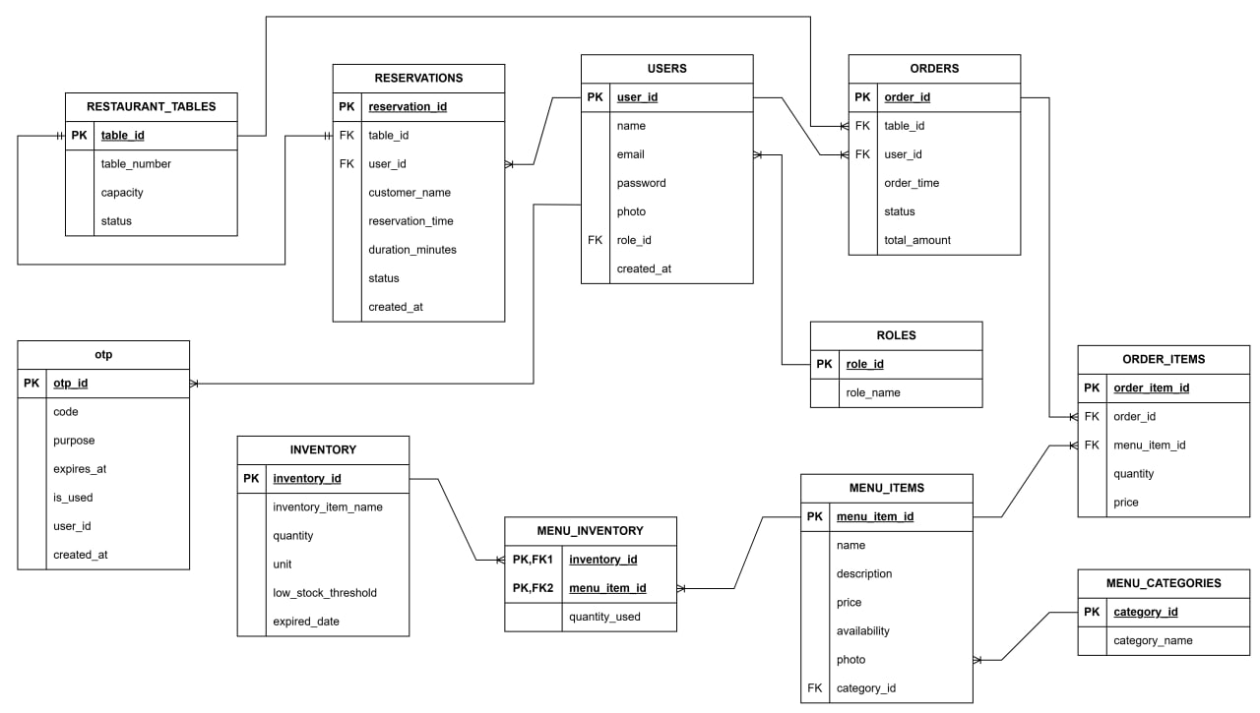

7. Implementation
7.1 Dashboard
7.1.1 Home Page
Our webpage represents the Customer Interface of the Restaurant Ordering & Management System (ROMS). At the top of the page, there is a navigation bar that includes Home, Menu, My Reservation, Order History, Profile, and Login/Sign-up, allowing users to easily access different system functions. The Home section displays a banner image that introduces the restaurant and enhances the user experience. When users click on the Menu, they can browse available food items with their prices and availability, and they can place orders accordingly.
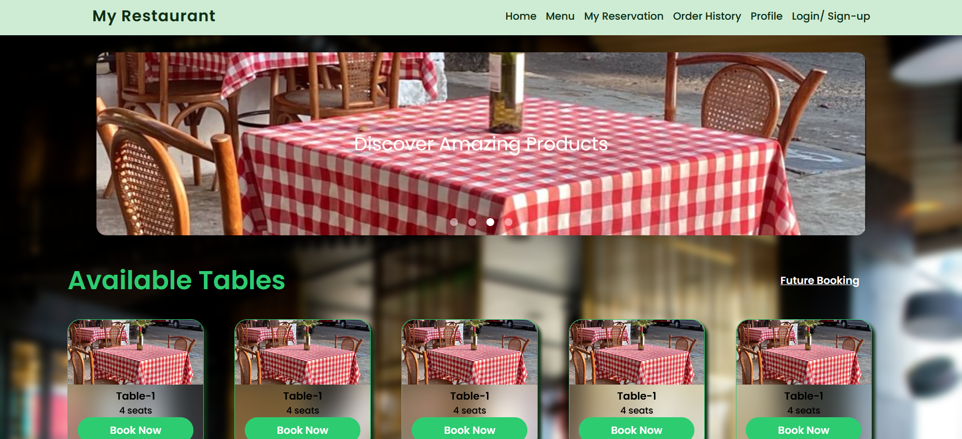
In the main section of the page, the “Available Tables” area displays the currently available tables along with their seating capacity. Each table card includes a “Book Now” button, which allows customers to select and reserve a table. When the button is clicked, the system checks table availability, prevents double booking, and stores the reservation information in the database. Registered users can also make future reservations and manage them through the My Reservation section. Overall, this page is designed to make browsing menus, reserving tables, and managing orders simple and convenient for customers.
Figure 7.1.1 Home Page
7.1.2 Menu
The Menu page of the Restaurant Ordering & Management System (ROMS) allows customers or guests to easily browse all available food and drink items offered by the restaurant. On this page, menu items are clearly displayed with images, names, categories (such as Pizza, Burger, Drinks, Vegan, etc.), prices, and availability, making it simple for users to understand their options at a glance. Customers can filter menu items by category to quickly find what they want, view item details, and select items to place an order. When an order is made, the system automatically prepares the order information to be linked with a selected table and sends it to the kitchen in real time. Overall, the Menu page acts as the main interaction point for customers to explore the restaurant’s offerings and start the ordering process smoothly and efficiently.
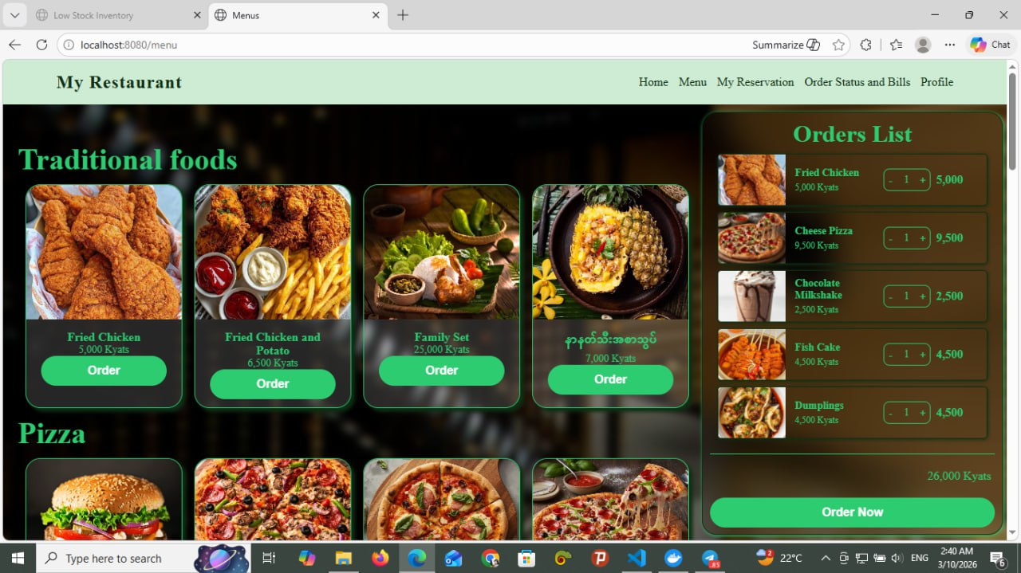
Figure 7.1.2 Menu Page

7.1.3 Cancel Future Reservation
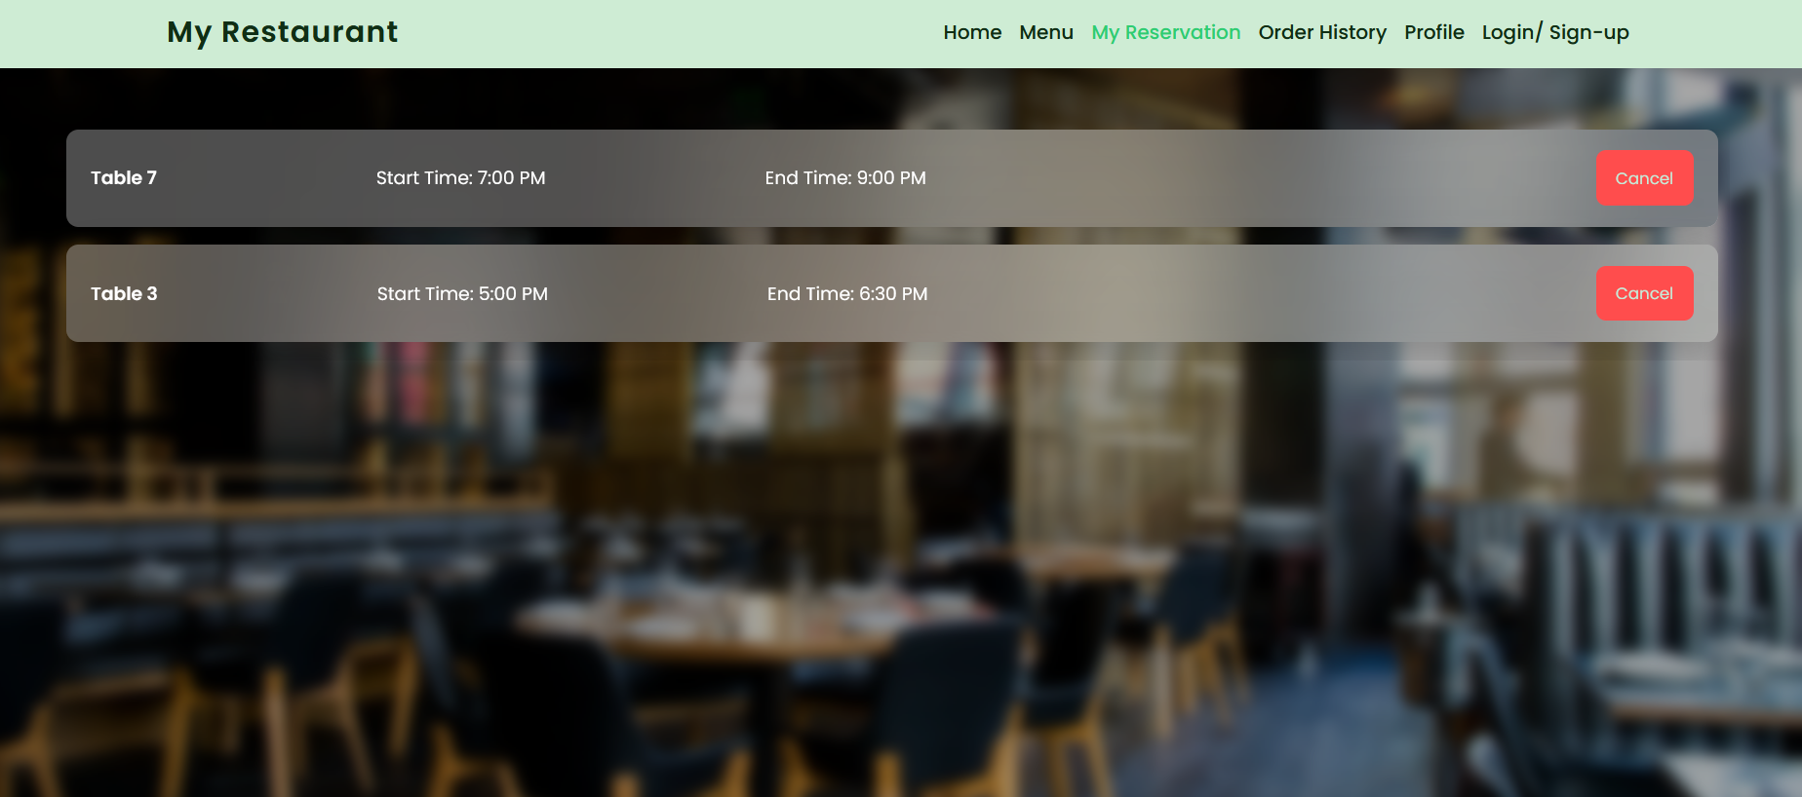
The My Reservation page allows registered customers to view and manage their table reservations in a clear and organized way. On this page, customers can see a list of their current and upcoming reservations, including table number, start time, and end time. Each reservation is displayed separately so users can easily understand their booking details at a glance. The page also provides a Cancel option, allowing customers to cancel eligible future reservations according to system rules. This page helps customers keep track of their reservations, make changes when necessary, and ensures better control over their dining plans without needing to contact restaurant staff directly.

Figure 7.1.3 My Reservation Page

7.1.4 Order Status (View Order Status)
The Order Status and Bills page in the Restaurant Ordering & Management System (ROMS) is used to display and track customer orders in the restaurant. Each order is shown in a separate card with its Order ID, ordered food items, quantity, and the total price.
The page allows kitchen staff or the system to monitor the progress of each order through different stages. These stages include Received, Cooking, Ready, and Complete. When an order is placed, it first appears as Received. Then the kitchen staff prepares the food and updates the status to Cooking. After the food is prepared, the status becomes Ready, and finally it changes to Complete when the order is served to the customer.
Each card also shows the table number and the total bill amount for that order. This helps restaurant staff easily track which table ordered which items and how much the customer needs to pay. Therefore, this page helps improve order management, monitor order progress in real time, and display the billing information clearly.
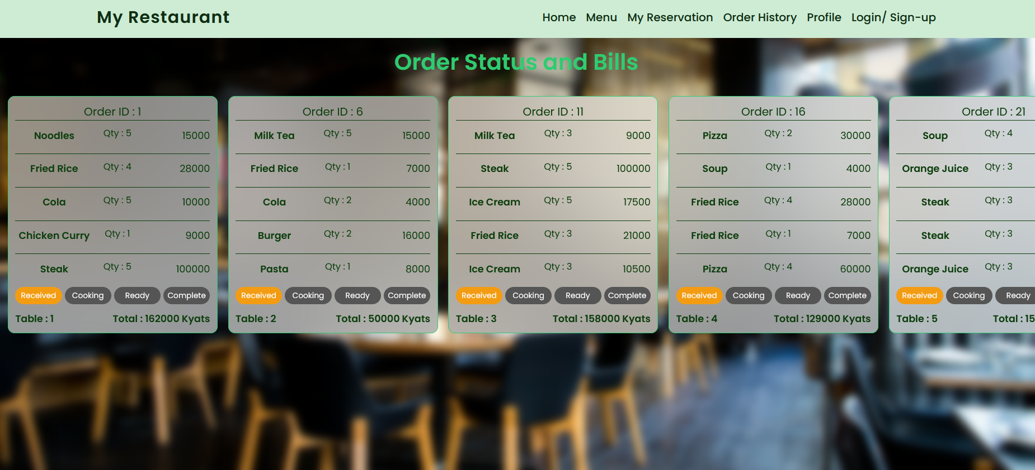
Figure 7.1.4 Order History Page

7.1.5 Profile Page
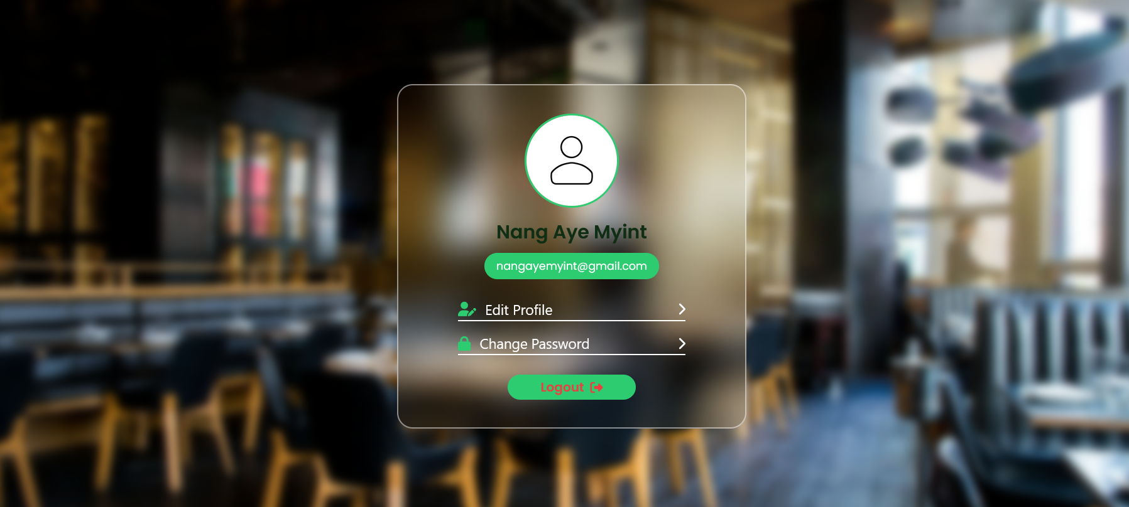
The Profile page in the Restaurant Ordering & Management System (ROMS) allows a registered user (Manager or Customer) to view and manage their personal account information. On this page, the user can see their profile details such as name and email address, and they are given options like Edit Profile, Change Password, and Logout. When the user selects “Edit Profile,” the system displays editable fields including name, email, photo, and password. After the user updates the required information and clicks save, the system validates the input data and updates the information in the database, then shows a success confirmation message along with the updated profile details. The “Change Password” option allows the user to securely update their password, and the “Logout” button enables the user to exit the system safely. Overall, the Profile page provides account management features that help users maintain and secure their personal information within the system.

Figure 7.1.5 Profile Page

7.1.6 Login Page
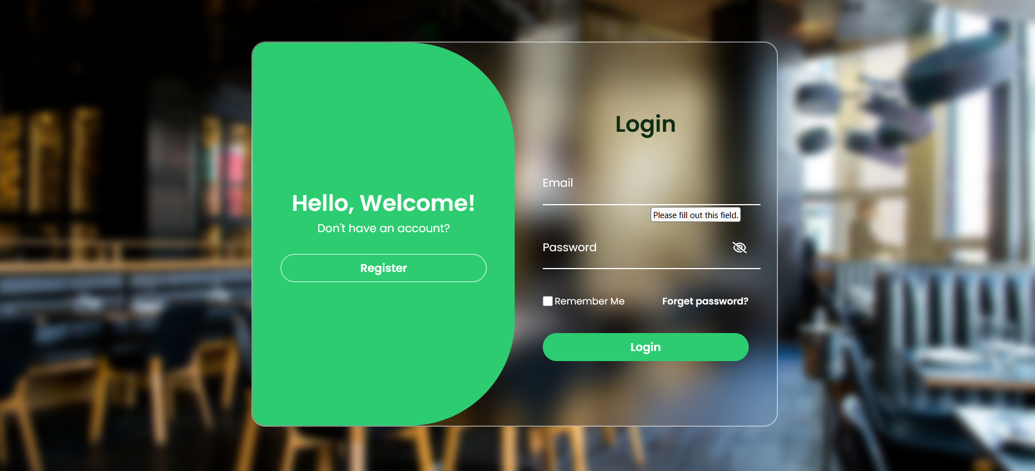
The Login page in the Restaurant Ordering & Management System (ROMS) allows registered users such as Customers, Managers, and Kitchen Staff to securely access the system according to their roles. On this page, the user enters their email and password, and the system first validates the input format before verifying the credentials with the database. If the information is correct, the system grants access based on the user’s role and redirects them to their respective dashboard (Customer, Manager, or Kitchen). If the credentials are incorrect or required fields are empty, the system displays an appropriate error message. The page also includes additional features such as “Remember Me” for saving login sessions and “Forget Password” for password recovery through email verification and OTP. Overall, the Login page ensures secure authentication and controlled access to the system’s functions.

Figure 7.1.6 Login Page

7.1.7 Register Page
This page is the Registration (Sign-Up) Interface of the Restaurant Ordering & Management System (ROMS). It allows new users to create an account in order to access system features such as making future reservations, viewing order history, and managing their profile. On the left side, there is a registration form that requires the user to enter their Name, Email, Password, and Confirm Password. The system validates the input data to ensure all required fields are filled correctly and that the password and confirm password match. If the email already exists in the database, the system will display a message asking the user to log in instead. Once the registration is successful, the system creates a new customer account and stores the user’s information securely in the database.
On the right side, there is a “Welcome Back” section designed for users who already have an account. It includes a Login button that redirects existing users to the login page. Overall, this page provides a secure and user-friendly way for new customers to register and for existing users to quickly access their accounts.
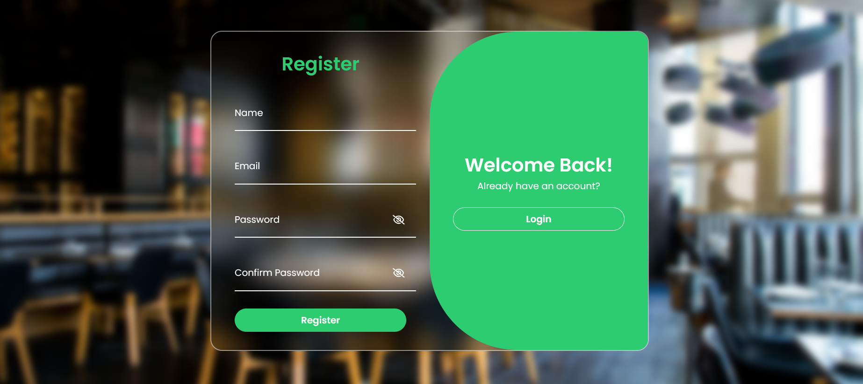

Figure 7.1.7 Register Page

7.2 Manager/Kitchen
7.2.1 Staff Login-Page
This page is the Login Interface of the Restaurant Ordering & Management System (ROMS), designed for staff members such as the Manager or Kitchen Staff to access the system. In the center of the page, there is a login form where the user must first select their Position (Role), such as Manager or Kitchen Staff. After selecting the role, the user needs to enter their Security Key (Password).
When the user clicks the Login button, the system verifies the entered credentials by checking them against the records stored in the database. If the information is correct, the system grants access and redirects the user to the appropriate dashboard based on their role. If the credentials are incorrect, an error message is displayed, and the user is asked to try again.
Overall, this page implements role-based authentication to ensure that only authorized staff members can securely access their respective system functions.
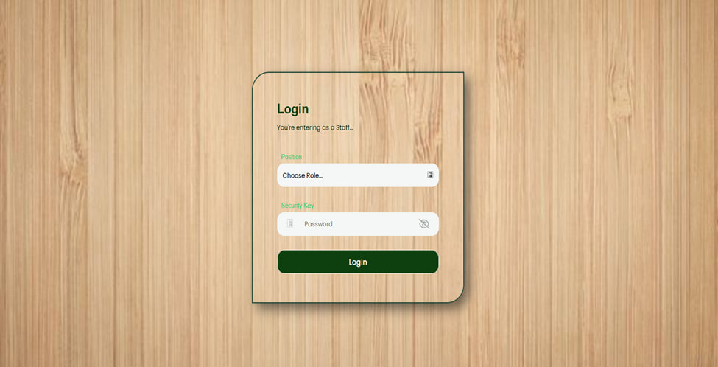
Figure 7.2.1 Staff Login Page

7.2.2 Manage Menu
The Manage Menu function in the Restaurant Ordering & Management System (ROMS) allows the manager to control and organize the restaurant’s menu items. When the manager selects the Manage Menu option, the system retrieves all menu items from the database and displays them in a list. From this page, the manager can add new menu items, edit existing menu details, or remove menu items that are no longer available.
When adding a new menu item, the manager enters the item information such as name, category, price, and description, and the system stores the new data in the database after confirmation. For editing a menu item, the system displays the current details, and the manager can update the information before saving the changes. If the manager chooses to remove a menu item, the system asks for confirmation before deleting it from the database. This function helps the restaurant keep its menu updated and properly managed.
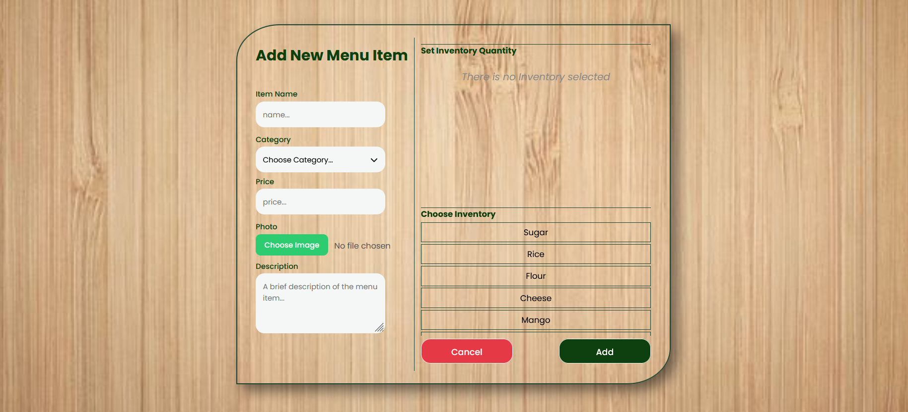
Figure 7.2.2 Manage Menu Page

7.2.3 Manage Table
The Manage Table function in the Restaurant Ordering & Management System (ROMS) allows the manager to manage all restaurant tables in the system. When the manager selects the Manage Table option, the system retrieves all table information from the database and displays a list of tables with their details such as table number and seating capacity.
From this page, the manager can add new tables, edit existing table information, or remove tables from the system. When adding a new table, the manager enters details such as the table name or number and seating capacity, and the system stores the information in the database after confirmation. For editing, the system displays the current table details, and the manager can update the information before saving the changes. If the manager chooses to remove a table, the system asks for confirmation before deleting the table record from the database. This function helps the restaurant maintain accurate table information and manage seating efficiently.
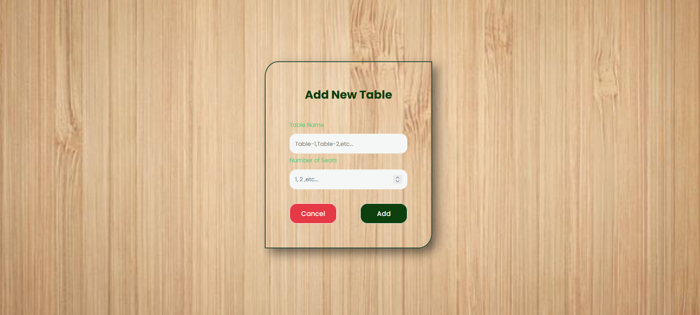
Figure 7.2.3 Manage Table Page

7.2.4 View Sales Records
The View Sales Records function in the Restaurant Ordering & Management System (ROMS) allows the manager to monitor and review the restaurant’s sales performance. When the manager selects the View Sales Records option, the system retrieves sales data from the database and displays the records. By default, the system shows the daily sales records, including information about orders, total sales amounts, and transaction details.
The manager can also select a specific time period, such as a particular date or range of dates, to view sales records for that period. The system then retrieves the relevant data from the database and displays it accordingly. This function helps the manager analyze sales performance, track revenue, and make better business decisions.
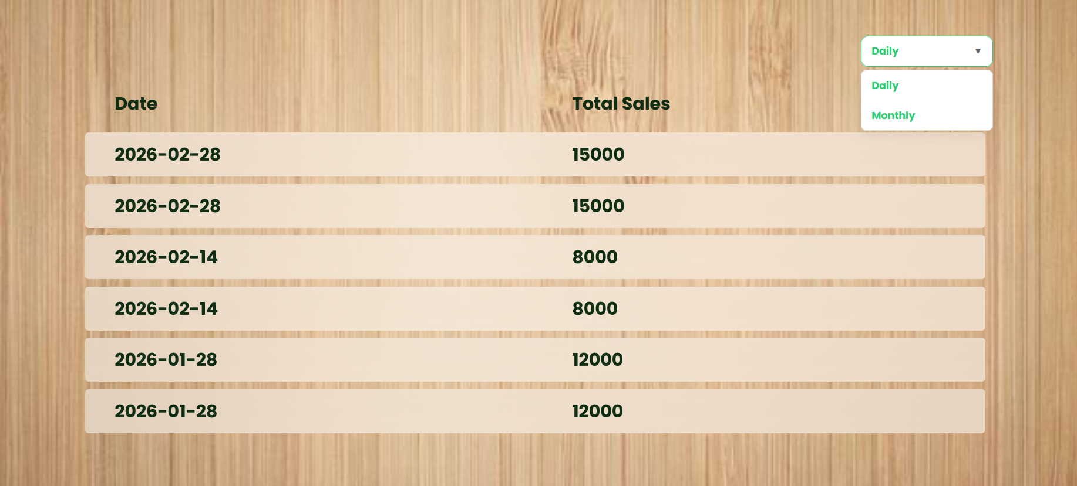
Figure 7.2.4 View Sales Records Page

7.2.5 Manage Inventory
The Manage Inventory function in the Restaurant Ordering & Management System (ROMS) allows the manager to monitor and control the restaurant’s inventory items. When the manager selects the Manage Inventory option, the system retrieves all inventory records from the database and displays them in a list with details such as item name, quantity, unit, and stock level and expiration date. The expiration date helps the manager identify items that are close to expiring so that they can be used or replaced in time to maintain food quality and safety.
From this page, the manager can perform several actions such as updating stock quantities, adding new inventory items, deleting inventory items, or viewing low-stock items. When the manager updates the stock quantity, the system saves the new value in the database after confirmation. The manager can also add new inventory items by entering details like the inventory name, quantity, unit, and threshold level, and expired date.
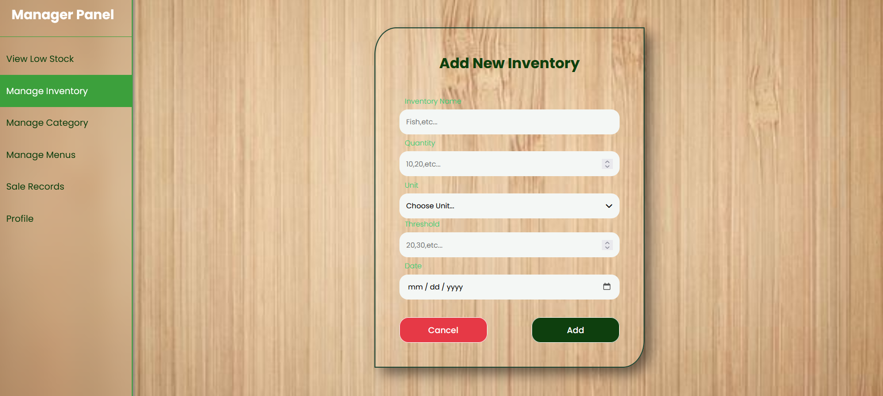
Additionally, the system can identify and display low-stock items by comparing the current stock level with the predefined threshold. This function helps the restaurant maintain proper inventory levels, avoid ingredient shortages, and manage kitchen supplies efficiently.
Figure 7.2.5 Manage Inventory Page

7.2.6 Manage Menu Category
The Manage Menu Category function in the Restaurant Ordering & Management System (ROMS) allows the manager to organize and control the different categories of menu items. When the manager selects the Manage Menu Category option, the system retrieves all existing categories from the database and displays them in a list.
From this page, the manager can add a new category, edit an existing category, or remove a category. When adding a new category, the manager enters the category name and confirms the action, and the system saves the new category in the database. If the manager chooses to edit a category, the system displays the current category details and allows the manager to update the information. When removing a category, the system asks for confirmation before deleting it from the database. This function helps keep the menu organized by grouping menu items into categories such as drinks, desserts, or main dishes.
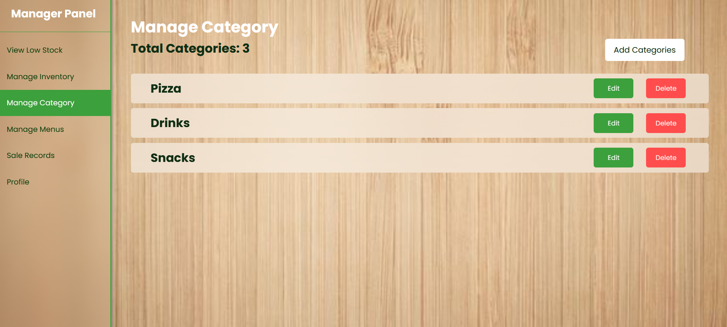
Figure 7.2.6 Manage Menu Category Page

7.2.7 View Active Orders
The View Active Orders function in the Restaurant Ordering & Management System (ROMS) allows kitchen staff to view all current customer orders that are being processed in the restaurant. When the kitchen staff selects the View Active Orders option, the system retrieves active order data from the database and displays a list of orders along with their details.
Each order shows important information such as the order ID, ordered items, quantity, and current order status. The kitchen staff can select an order to view more detailed information about the items that need to be prepared. This function helps the kitchen staff track ongoing orders and manage the food preparation process efficiently.
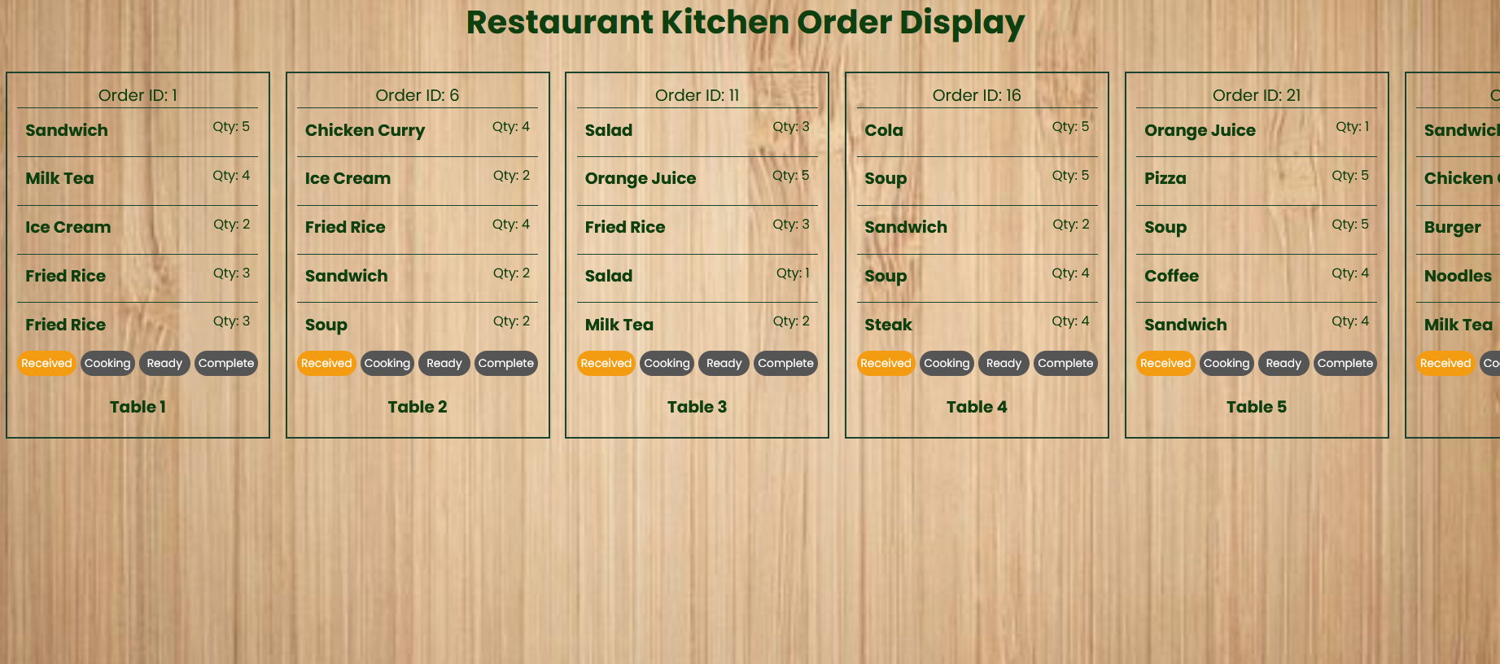

Figure 7.2.7 View Active Orders

7.3 Customer/Guess
7.3.1 Make Reservation Form
The Reservation Form page in the Restaurant Ordering & Management System (ROMS) allows customers or guests to reserve a table for immediate dining. When a customer selects an available table and clicks the reservation option, the system displays this reservation form.
On this page, the customer enters their name and the reservation duration, which is specified in hours and minutes. The system validates the entered duration according to the system rules, where the maximum duration for a “Now” reservation is 3 hours.
After entering the required information, the customer clicks the “Make Reservation” button. The system then verifies the input, creates the reservation, updates the table status as Reserved, and stores the reservation details in the database. Finally, the system confirms the reservation and allows the customer to proceed with dining or ordering food.
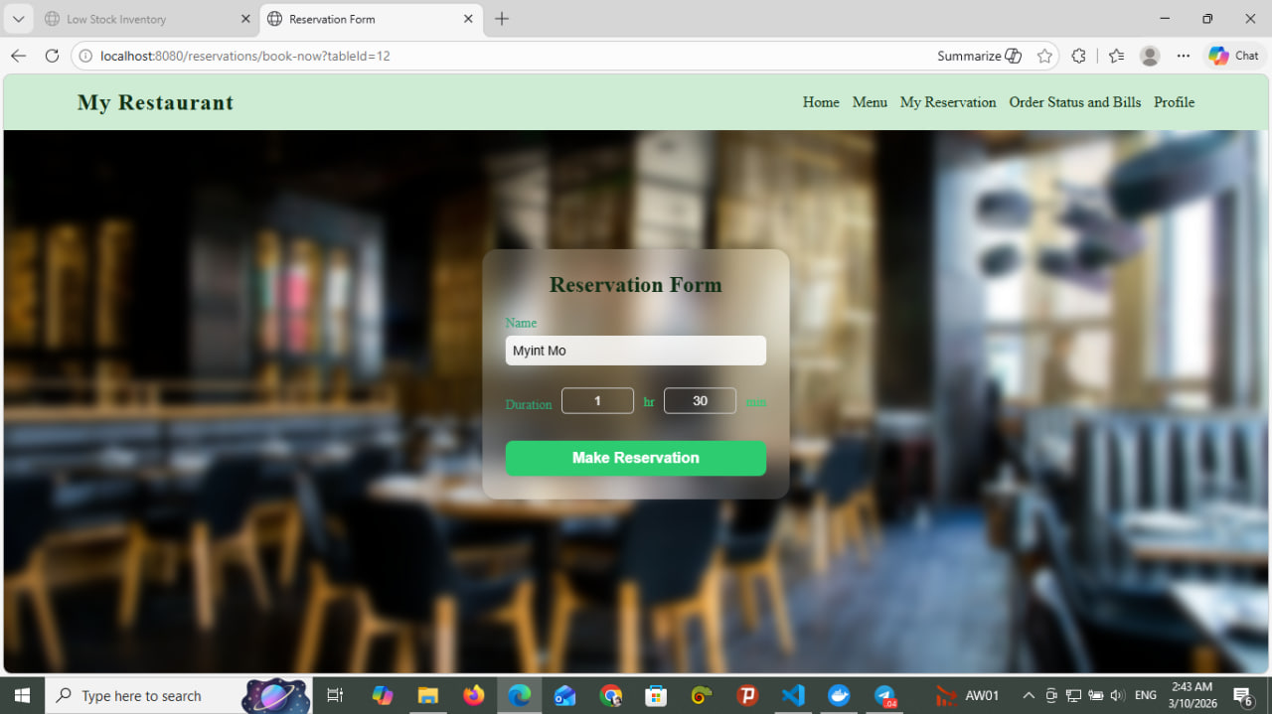
Figure 7.3.1 Make Reservation Form

8. Conclusion
In conclusion, the Restaurant Ordering & Management System (ROMS) provides an efficient digital solution for managing restaurant operations. The system allows customers to browse menus, reserve tables, place orders, and track order status easily, while managers and kitchen staff can manage menus, tables, inventory, and sales records through organized system functions. By automating these processes, the system reduces manual work, improves accuracy, and enhances service efficiency. Overall, ROMS helps restaurants manage their operations more effectively and provides a better experience for both customers and staff.

