UNIVERSITY OF COMPUTER STUDIES (MANDALAY)



RESTAURANT ORDERING & MANAGEMENT SYSTEM (ROMS)
OBJECT ORIENTED DESIGN AND DEVELOPMENT
(CS-4223)

SUBMITTED BY
GROUP - VII
FOURTH YEAR (CS-SR)
2025-2026 (ACEDEMIC YEAR)

Group Members
No. | Name | Roll Number
1 | Shwe Htet Ei Win | KPTM-9541
2 | Nang Aye Myint Mo Thinn | KPTM-10877
3 | Nang Myint Thu | KPTM-9578
4 | Zue Zue Hlaing | KPTM-11341
5 | May Thu Kyaw | KPTM-11002

Supervised By
Daw Theint Theint Htwe
Lecturer
Faculty of Information Science
University of Computer Studies (Mandalay)

Table of Contents
Contents | Page
Abstract
- Introduction | 1
- Objectives | 2
- Business Process | 3
- Requirement Specification  - Functional Requirements  4.1.1 Customer / Guest Functions  4.1.2 Manager Functions  4.1.3 Kitchen Functions  4.1.4 Reservation Handling  4.1.5 Inventory Handling  - Non-Functional Requirements  4.2.1 Usability  4.2.2 Performance  4.2.3 Reliability  4.2.4 Maintainability  4.2.5 Security | 4  4  4  4  4  4  5  6  6  6  6  6  6
- Preliminary Use Case Diagram | 7
- Text Description  Table 6.1 Use case “Browse Menu”  Table 6.2 Use case “Place Order”  Table 6.3 Use case “View Available Tables”  Table 6.4 Use case “Make Reservation (Now)”  Table 6.5 Use case “Make Reservation (Future)”  Table 6.6 Use case “Cancel Future Reservation”  Table 6.7 Use case “Manage Table”  Table 6.8 Use case “Edit Table”  Table 6.9 Use case “Add Table”  Table 6.10 Use case “Remove Table”  Table 6.11 Use case “Manage Inventory”  Table 6.12 Use case “Edit Inventory”  Table 6.13 Use case “Add New Inventory”  Table 6.14 Use case “Delete Inventory”  Table 6.15 Use case “View Low-Stock Items”  Table 6.16 Use case “View Sales Records”  Table 6.17 Use case “Manage Menu”  Table 6.18 Use case “Add Menu”  Table 6.19 Use case “Edit Menu”  Table 6.20 Use case “Remove Menu”  Table 6.21 Use case “Sign Up”  Table 6.22 Use case “Login”  Table 6.23 Use case “Forget Password”  Table 6.24 Use case “View Bill”  Table 6.25 Use case “View Order Status”  Table 6.26 Use case “View Active Orders (Kitchen)”  Table 6.27 Use case “Update Order Status”  Table 6.28 Use case “Manage Menu Category”  Table 6.29 Use case “Edit Menu Category”  Table 6.30 Use case “Add Menu Category”  Table 6.31 Use case “Remove Menu Category”  Table 6.32 Use case “Edit Profile” | 8  8  9  10  10  11  11  12  12  12  13  13  13  14  14  14  15  15  15  15  16  16  16  17  17  18  18  18  19  19  19  20  20
- Final Use Case Diagram | 21
- Domain Modeling | 22
- Interaction Modeling  9.1 Browse Menu  9.2 Place Order  9.3 View Available Table  9.4 Make Reservation (Now)  9.5 Make Reservation (Future)  9.6 Cancel Future Reservation  9.7 Manage Table  9.8 Edit Table  9.9 Add Table  9.10 Remove Table  9.11 Manage Inventory  9.12 Edit Inventory  9.13 Add New Inventory  9.14 Delete Inventory  9.15 View Low-Stock Items  9.16 View Sales Records  9.17 Manage Menu  9.18 Add Menu  9.19 Edit Menu  9.20 Remove Menu  9.21 Sign Up  9.22 Login  9.23 Forget Password  9.24 View Order Status and Bill  9.25 Update Order Status (View Active Orders)  9.26 Manage Menu Category  9.27 Edit Menu Category  9.28 Add Menu Category  9.29 Remove Menu Category  9.30 Edit Profile | 23  23  23  24  24  25  25  26  26  27  27  28  28  29  29  30  30  31  31  32  32  33  34  35  36  36  37  37  38  38  39
- Class Diagram | 40
- Implementation  11.1 Dashboard  11.1.1 Home Page  11.1.2 Menu  11.1.3 Cancel Future Reservation  11.1.4 Order Status and Bills  11.1.5 Profile Page  11.1.6 Login Page  11.1.7 Register Page  11.1.8 Change Password  11.2 Manager/Kitchen  11.2.1 Staff Login Page  11.2.2 Manage menu  11.2.3 Manage Table  11.2.4 View Sales Records  11.2.5 Manage Inventory  11.2.6 Manage Menu Category  11.2.7 View Active Orders  11.2.8 View Low Stock Items  11.3 Customer/Guess  11.3.1 Make Reservation Form | 41  41  41  42  43  44  45  46  47  48  49  49  50  51  52  53  54  55  56  57  57
- Conclusion | 58
- References | 59

Abstract
The Restaurant Ordering & Management System (ROMS) is a web-based application designed to automate restaurant operations such as self-service ordering, table reservations, inventory tracking, and order management. The system allows customers or guests to browse menus, reserve tables, place orders, and view bills, while managers and kitchen staff manage restaurant operations through role-based access. ROMS aims to replace manual processes with a centralized digital solution to improve efficiency, accuracy, and customer experience.

1. Introduction
The Restaurant Ordering & Management System (ROMS) provides a digital platform to manage restaurant activities efficiently. The system supports customers, a single manager (administrator), and a kitchen staff with different access levels.
ROMS is intended for use by:
- Customers or guests for ordering and reservations
- Managers for administrative control
- Kitchen staff for order preparation and tracking
This document defines the functional and non-functional requirements to guide system development and testing.

2. Objectives
The main objectives of ROMS are:
- To allow customers and guests to place orders and reserve tables easily
- To reduce manual work through automated order and inventory management
- To provide real-time order status updates for kitchen staff and customers
- To enable managers to manage menu items, tables, inventory, and sales
- To ensure accurate tracking of orders, reservations, and inventory
- To support guest usage without mandatory login

3. Business Process
- Customers or guests access the system through a web browser.
- Customers browse the menu, check table availability, and make reservations.
- Walk-in customers can select available tables immediately.
- Customers place orders linked to selected tables.
- Orders are sent to the kitchen staff in real time.
- Kitchen staff update order status (Received → Cooking → Ready → Completed).
- Inventory levels are automatically reduced when orders are placed.
- Managers manage menus, tables, inventory and view sales records.
- Customers can view order status and generated bills.

4. Requirement Specification
4.1 Functional Requirements

4.1.1 Customer / Guest Functions
- Browse menu items with prices and availability
- View available tables for current time or future reservation
- Make table reservations
- Place orders linked to a selected table
- View order status
- View generated bill
- Register for an account (optional)
- Log in (optional, for registered users only)

4.1.2 Manager Functions
- Add, edit, or remove menu items
- Add, edit, or remove restaurant tables
- Manage inventory by updating stock quantities
- Monitor low-stock items
- View sales records
4.1.3 Kitchen Functions
- View active customer orders
- Update order status (RECEIVED → COOKING → READY → COMPLETED)
4.1.4 Reservation Handling
- Display available tables based on selected time or “Now”
- Prevent double-booking of tables
- Automatically update table availability during reservation periods
- Allow walk-in customers without login
- The system shall allow immediate table selection for walk-in customers.

4.1.5 Inventory Handling
- Maintain inventory records for all ingredients
- Automatically reduce inventory quantities when orders are placed
- Generate low-stock alerts based on predefined thresholds
- Allow managers to manually update inventory quantities

4.2 Non-Functional Requirements

4.2.1 Usability
- The system shall provide a simple and intuitive user interface
- Minimal training shall be required for staff users

4.2.2 Performance
- The system shall update order and table status in real time
- System response time shall be under 4 seconds for common actions

4.2.3 Reliability
- Orders and inventory updates shall be accurately recorded
- The system shall prevent data loss during normal operation

4.2.4 Maintainability
- The system shall be modular and well-documented
- Future enhancements can be added with minimal impact

4.2.5 Security
- Authentication is required for manager and kitchen staff
- Guests can access limited features without login
- User credentials shall be securely stored

5. Preliminary Use Case Diagram

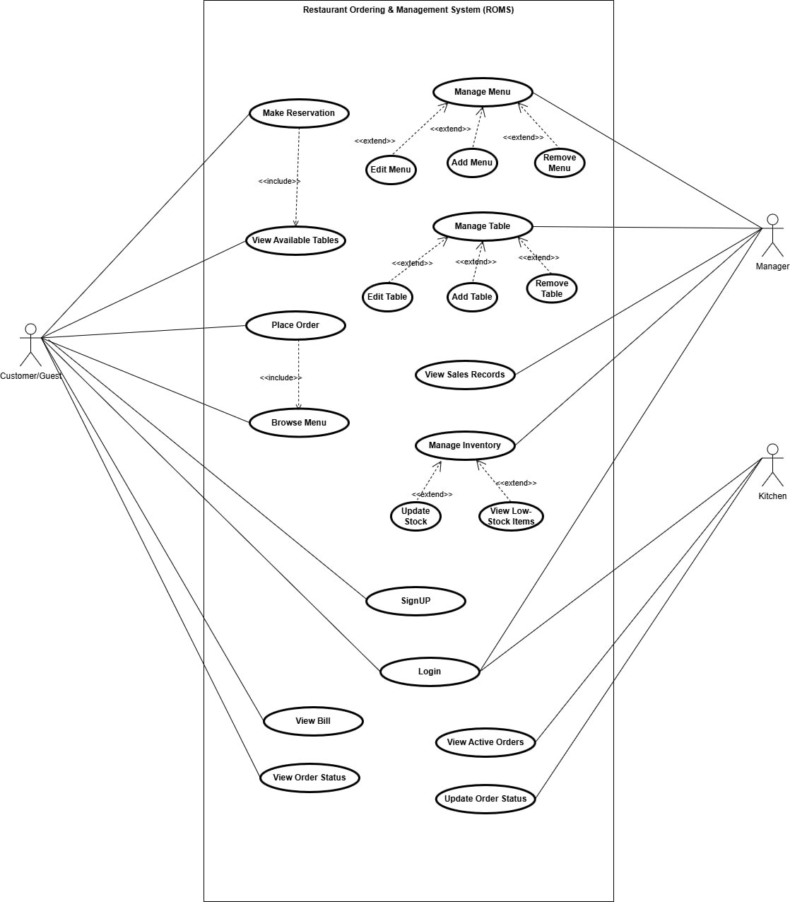

6. Text Description
Rules for ROMS
Rule number | Rule
Rule 1 | Maximum duration for “Now” reservation is 3 hours.
Rule 2 | Future reservations can only be cancelled within 24 hours before the booking time.

Table 6.1 — Use Case: Browse Menu
Actor: Customer/Guest
Actions Performed by the Actor | Responses from the System
1. Customer / Guest selects “Browse Menu”
 | 2. System retrieves menu from database and displays menu items with price, category, description.
3. Customer / Guest filters by category
 | 4. System updates menu display accordingly
5. Customer / Guest selects an item
 | 6. System displays item details

Table 6.2 — Use case "Place Order"
Actor: Customer/Guest
Actions performed by the actor | Responses from the system
1. Customer/Guest selects menu items and quantities
 | 2. System adds selected items to the order list
3. Customer/Guest reviews the order and select another menu items and quantities
 | 4. System displays order summary in real time and go to step 2 and the system ask for table.
5. Customer/Guest selects a table for dining
 | 6. System confirms table selection and updates order summary automatically
7. Customer/Guest place order
 | 8. System creates a new order linked to selected table, sets order status to RECEIVED, reduces inventory quantities, sends order to kitchen staff, generates bill, and displays order confirmation

Table 6.3 — Use Case: View Available Tables
Actor: Customer/Guest
Actions Performed by the Actor | Responses from the System
1. Customer / Guest selects “View Tables”
 | 2. System retrieves table status from database and displays current time available tables by seating capacity as default
3. Only registered customer may make future reservation.
 | 4. System allows the registered customer to make the future reservation.

Table 6.4 — Use Case: Make Reservation (Now)
Actor: Customer/Guest
Actions Performed by the Actor | Responses from the System
1. Customer / Guest selects Tables
 | 2. System displays all currently available tables by seating capacity
3. Customer / Guest selects an available table
 | 4. System displays reservation form
5. Customer / Guest enters name and desired duration
 | 6. System validates duration (Rule 1); if invalid, shows error and asks re-entry
7. Customer / Guest re-enters valid duration
 | 8. System accepts duration and updates table status as "Occupied" and stores in database and displays reservation confirmation message

Table 6.5 — Use Case: Make Reservation (Future)
Actor: Registered customer
Actions Performed by the Actor | Responses from the System
1. Registered customer selects “Make Future Reservation”
 | 2. System displays reservation form
3. Registered customer enters name, date, start time, end time
 | 4. System validates duration. If invalid show in error and asks re-entry
5. Registered customer re-enters valid duration
 | 6. System show available table
7. Registered customer select table
 | 8.System create reservation, update table status, and stores in database and display reservation confirmation message

Table 6.6 — Use Case: Cancel Future Reservation
Actor: Registered customer
Actions Performed by the Actor | Responses from the System
1. Registered Customer selects “My Reservations”
 | 2. System retrieves and displays future reservations
3. Registered Customer selects reservation to cancel
 | 4. System displays reservation details and checks cancellation eligibility (Rule 2). If the reservation does not meet cancellation eligibility (Rule 2), the system displays a message indicating that “cancellation not allowed”. Otherwise, the system delete reservation, updates the table status to Available, and display cancellation information

Table 6.7 — Use Case: Manage Table
Actor: Manager
Actions Performed by the Actor | Responses from the System
1. Manager selects “Manage Table”
 | 2. System displays all tables from database
3. Manager chooses add, edit, or remove table
 | 4. System processes selected action

Table 6.8 — Use Case: Edit Table
Actor: Manager
Actions Performed by the Actor | Responses from the System
1. Manager selects "Edit Table"
 | 2. System displays existing table details
3. Manager updates table information
 | 4. System saves changes and displays updated table information. It then asks if the manager wants to edit another table.
5. Manager answer affirmative or negative
 | 6. If the answer is in the affirmative, the system goes to Step 1.

Table 6.9 — Use Case: Add Table
Actor: Manager
Actions Performed by the Actor | Responses from the System
1. Manager selects “Add Table”
 | 2. System display add table form
3. Manager enters table name, and capacity
 | 4. system saves changes and displays updated table information. It then asks if the manager wants to add another table.
5. Manager answer affirmative or negative
 | 6. If the answer is in the affirmative, the system goes to Step 1.

Table 6.10 — Use Case: Remove Table
Actor: Manager
Actions Performed by the Actor | Responses from the System
1. Manager selects “Remove Table”
 | 2. If confirms, system checks rather table is reserved or not. If reserved, show deletion not allow message. If not reserved, system deletes table and displays success message. It then asks if the manager wants to remove another table.
5. Manager answer affirmative or negative
 | 6. If the answer is in the affirmative, the system goes to Step 1.

Table 6.11 — Use Case: Manage Inventory
Actor: Manager
Actions Performed by the Actor | Responses from the System
1. Manager selects “Manage Inventory”
 | 2. System displays inventory list
3. Manager selects Add, Delete or Edit inventory.
 | 4. System opens related page.

Table 6.12 — Use Case: Edit Inventory
Actor: Manager
Actions Performed by the Actor | Responses from the System
1. Manager selects “Edit Inventory”
 | 2. System displays exiting item details
3. Manager enters new data of inventory
 | 4. System saves changes, and displays success message. It then asks if the manager wants to edit another inventory.
5. Manager answer affirmative or negative
 | 6. If the answer is in the affirmative, the system goes to Step 1.

Table 6.13— Use Case: Add New Inventory
Actor: Manager
Actions Performed by the Actor | Responses from the System
1. Manager selects “Add New Inventory”.
 | 2. System displays inventory creation form.
3. Manager enters inventory details
(Inventory name, quantity, unit, threshold level).
 | 4. System stores the new inventory record in the database and show success message. It then asks if the manager wants to add another inventory.
5. Manager answer affirmative or negative
 | 6. If the answer is in the affirmative, the system goes to Step 1.

Table 6.14 — Use Case: Delete Inventory
Actor: Manager
Actions Performed by the Actor | Responses from the System
1. Manager selects an inventory item from the inventory list to delete
2. System verifies whether the inventory item is linked to any menu items.
If linked, system prevents deletion and displays dependency error.
If not linked, system deletes the inventory item. System refreshes and displays deletion success message. It then asks if the manager wants to remove another inventory.
3. Manager answer affirmative or negative
 | 4. If the answer is in the affirmative, the system goes to Step 1.

Table 6.15 — Use Case: View Low-Stock Items
Actor: Manager
Actions Performed by the Actor | Responses from the System
1. Manager selects “View Low Stock”
 | 2. System displays item list with quantities which are compared with thresholds and identified.
3. Manager reviews list

Table 6.16 — Use Case: View Sales Records
Actor: Manager
Actions Performed by the Actor | Responses from the System
1. Manager selects “View Sales Records”
 | 2. System shows daily records by default
3. Manager selects time period
 | 4. System retrieves sales data related time period
5. Manager views sales records

Table 6.17— Use Case: Manage Menu
Actor: Manager
Actions Performed by the Actor | Responses from the System
1. Manager selects “Manage Menu”
 | 2. System displays menu list
3. Manager chooses add, edit, or remove
 | 4. System processes action

Table 6.18— Use Case: Add Menu
Actor: Manager
Actions Performed by the Actor | Responses from the System
1. Manager selects “Add Menu”
 | 2. System displays input form
3. Manager enters item details
 | 4. System adds item and displays updated menu. It then asks if the manager wants to add another menu.
5. Manager answer affirmative or negative
 | 6. If the answer is in the affirmative, the system goes to Step 1.

Table 6.19— Use Case: Edit Menu
Actor: Manager
Actions Performed by the Actor | Responses from the System
1. Manager selects “Edit”
 | 2. System displays existing menu detail data
3. Manager updates information
 | 4. System saves changes and displays updated information. It then asks if the manager wants to edit another menu.
5. Manager answer affirmative or negative
 | 6. If the answer is in the affirmative, the system goes to Step 1.

Table 6.20 — Use Case: Delete Menu
Actor: Manager
Actions Performed by the Actor | Responses from the System
1. Manager selects a menu to delete
 | 2. System deletes menu and displays success message. It then asks if the manager wants to remove another menu.
3. Manager answer affirmative or negative
 | 4. If the answer is in the affirmative, the system goes to Step 1.

Table 6.21 — Use Case: Sign Up
Actor: Guest
Actions performed by the actor | Responses from the system
1. Guest selects Sign Up.
 | 2. Systems displays registration form.
3. Guest enters required details (name, email).
4. Systems validates entered information.
System sends OTP to his email.
5.Guest enter the OTP code.
 | 6. System checks the OTP. If correct, system request to set password.
7. Guest enter the password.
 | 8. System displays a successful registration message.

Table 6.22 — Use Case: Login
Actor: Customer, Manager, Kitchen
Actions Performed by the Actor | Responses from the System
1. Customer, Manager, Kitchen selects “Login”
 | 2. System displays login form
3. Customer, Manager, Kitchen enters credentials
 | 4. System validates format and ask for confirmation
5. Customer, Manager, Kitchen submits
 | 6. System verifies credentials, grants access based on role, and displays dashboard

Table 6.23 — Use Case: Forget Password
Actor: Registered Customer
Actions Performed by the Actor | Responses from the System
1. Registered Customer selects Forget Password.
 | 2. System displays password recovery form and requests registered email to send OTP.
3. Registered Customer enters registered email and clicks Send.
 | 4. System validates the account. If the account is in database, system sends OTP to his email. If not, system displays account not found message.
5. Registered Customer submits OTP and clicks Check OTP.
 | 6. System checks the OTP. If correct, system shows Reset Password Form and requests new password and confirm new password. If not, shows incorrect OTP message and allow the customer to request OTP again.
7. Registered Customer submits requested data and clicks Reset.
 | 8. System validates the inputs passwords. If valid, system replaces old password with new one in database, then shows successful message and go to Dashboard. If not, system shows invalid error message and requests to try again.

Table 6.24 — Use Case: View Bill
Actor: Customer / Guest
Actions Performed by the Actor | Responses from the System
1. Customer / Guest selects “View Bill”
 | 2. System retrieves bill, displays items and quantities, calculates tax and total

Table 6.25 — Use Case: View Order Status
Actor: Customer/Guest
Actions Performed by the Actor | Responses from the System
1. Customer / Guest selects “View Order Status”
 | 2. System retrieves order details and displays status (RECEIVED → COOKING → READY → COMPLETED)
3. Customer/ Guest tracks progress
 | 4. System updates in real time

Table 6.26 — Use Case: View Active Orders (Kitchen)
Actor: Kitchen
Actions Performed by the Actor | Responses from the System
1. Staff selects “View Active Orders”
 | 2. System retrieves active orders and displays list with status
3. Staff selects an order
 | 4. System shows order details

Table 6.27 — Use Case: Update Order Status
Actor: Kitchen Staff
Actions Performed by the Actor | Responses from the System
1. Staff selects an active order
 | 2. System displays current status
3. Staff updates status
 | 4. System saves new status. If not, system discard and notifies customer

Table 6.28 — Use Case: Manage Menu Category
Actor: Manager
Actions Performed by the Actor | Responses from the System
1. Manager selects “Manage Menu Category”
 | 2. System displays all categories from database
3. Manager chooses add, edit, or remove table
 | 4. System processes selected action
Table 6.29 — Use Case: Edit Menu Category
Actor: Manager
Actions Performed by the Actor | Responses from the System
1. Manager selects a menu category to edit
 | 2. System displays existing data details
3. Manager updates information
 | 4. System saves changes and displays updated information. It then asks if the manager wants to edit another menu category.
5. Manager answer affirmative or negative
 | 6. If the answer is in the affirmative, the system goes to Step 1.
Table 6.30 — Use Case: Add Menu Category
Actor: Manager
Actions Performed by the Actor | Responses from the System
1. Manager selects “Add menu category”
 | 2. System display add form
3. Manager enters category name
 | 4. System saves changes and displays updated information. It then asks if the manager wants to add another menu inventory.
5. Manager answer affirmative or negative
 | 6. If the answer is in the affirmative, the system goes to Step 1.

Table 6.31 — Use Case: Remove Menu Category
Actor: Manager
Actions Performed by the Actor | Responses from the System
1. Manager selects “Remove menu category”
 | 2. System deletes the category and displays updated list. It then asks if the manager wants to remove another menu category.
3. Manager answer affirmative or negative
 | 4. If the answer is in the affirmative, the system goes to Step 1.

Table 6.32 __ Use Case: Edit Profile
Actors: Registered Customer
Actions Performed by the Actor | Responses from the System
1. Registered Customer selects Edit Profile.
 | 2. System displays editable profile fields. (name, email, photo and password)
3. Registered Customer modifies the required information and clicks Save.
 | 4. System validates the input data. If valid, system updates Customer’s information in database, displays success confirmation message and updated profile. If not, system return validation error.
5. Customer views updated Profile.

7. Final Use Case Diagram
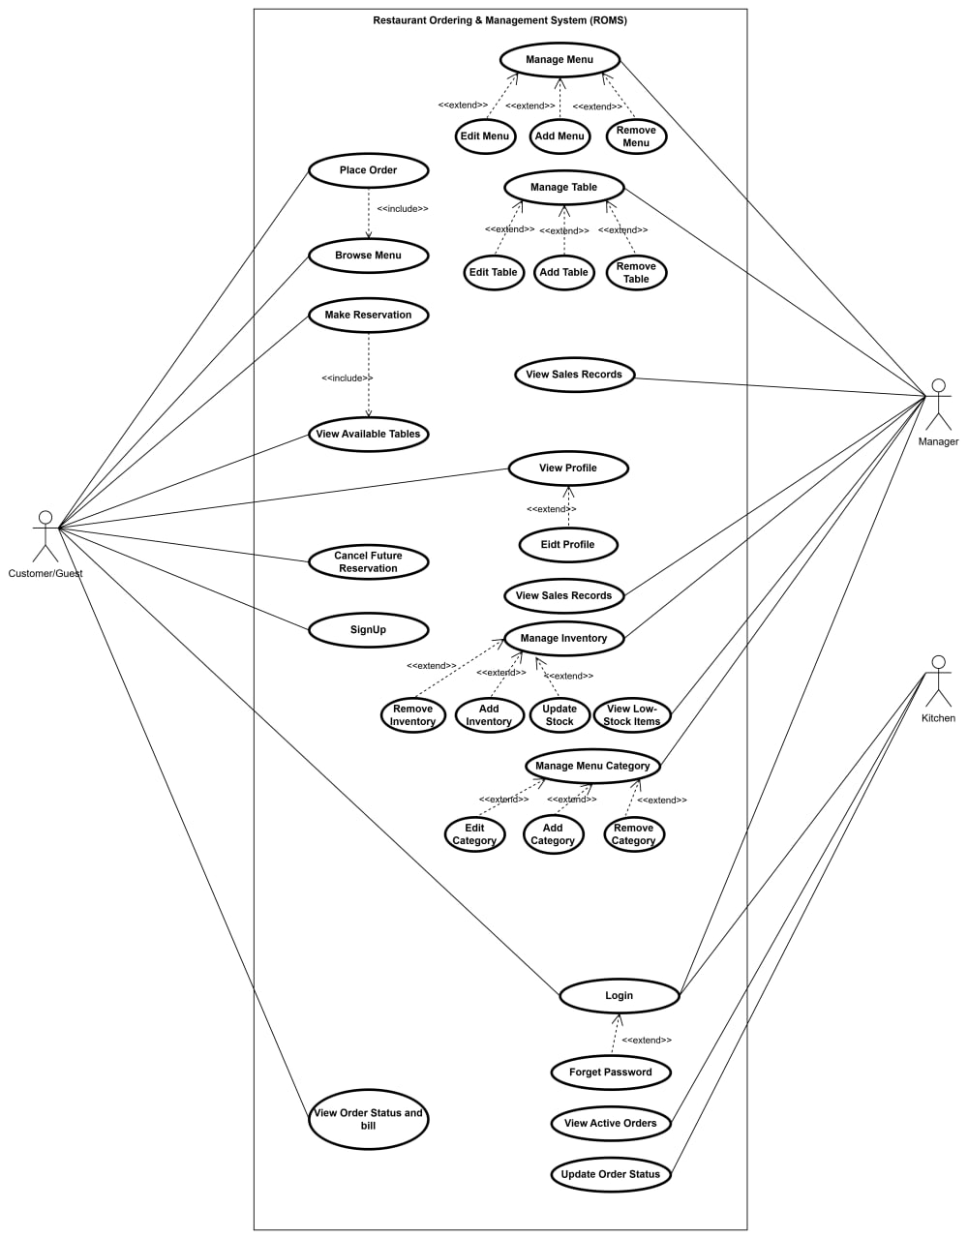

8. Domain Modeling

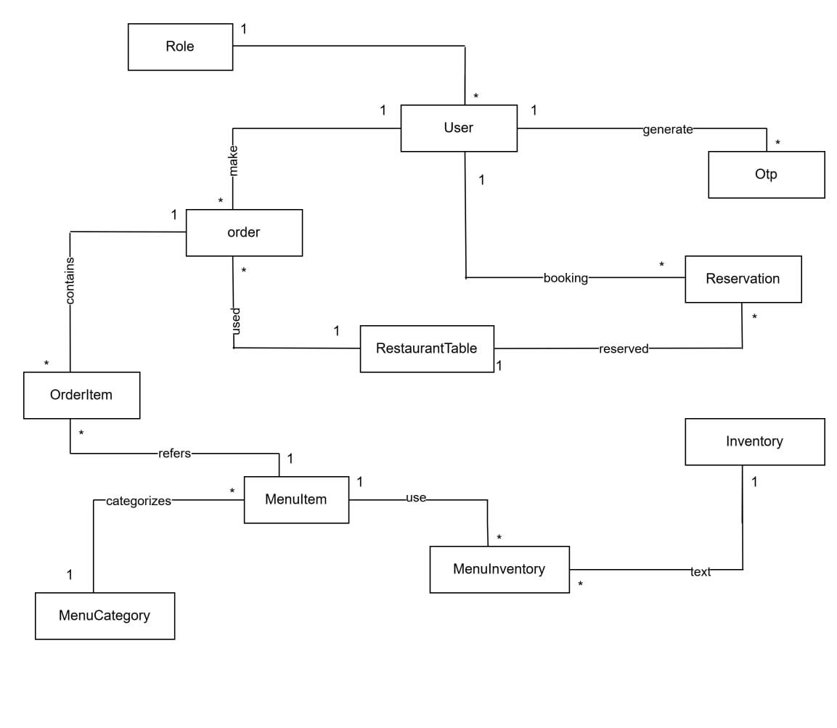

9. Interaction Modeling

9.1 Browse Menu
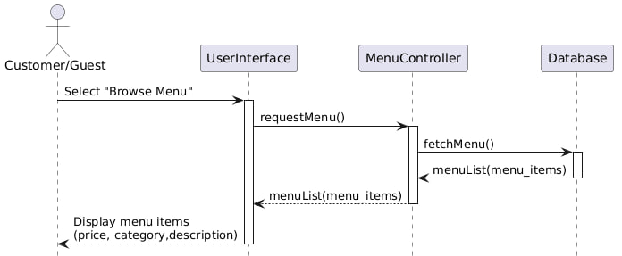

9.2 Place Order
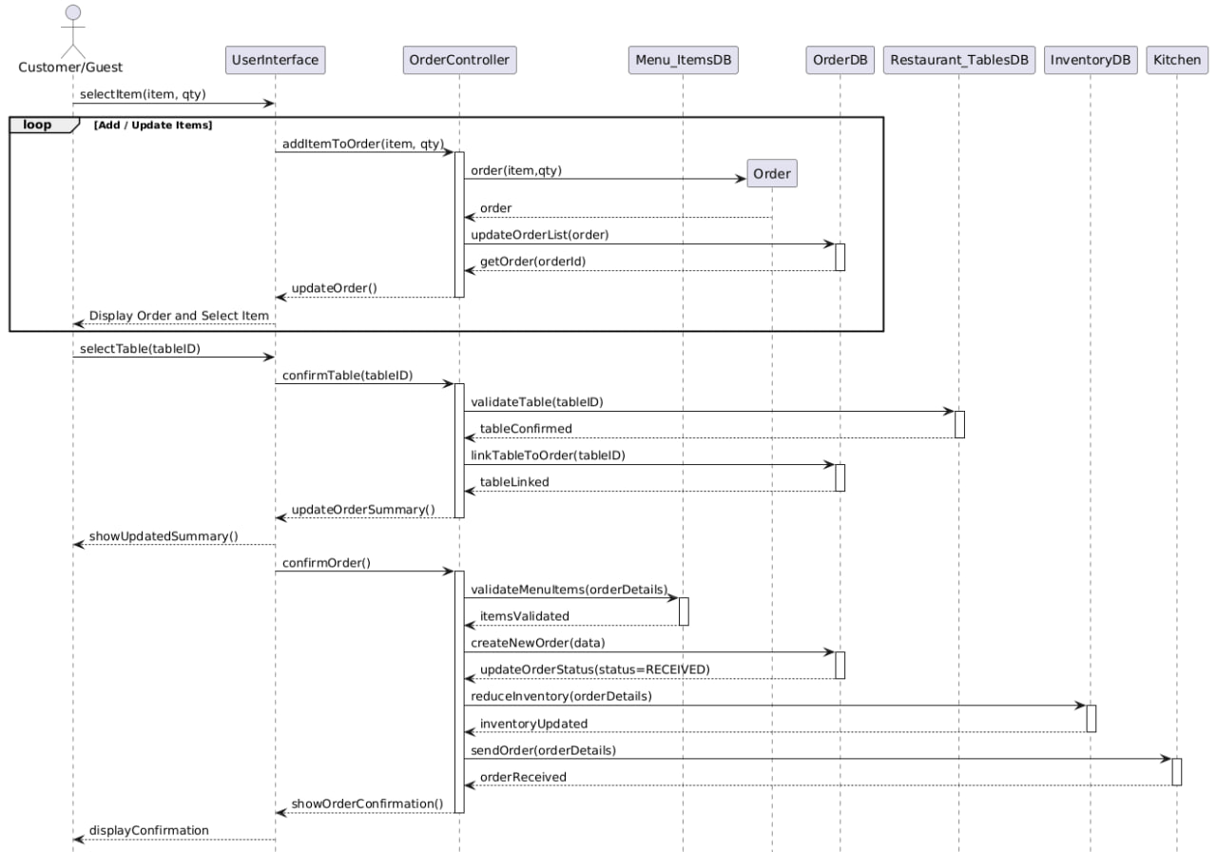

9.3 View Available Table

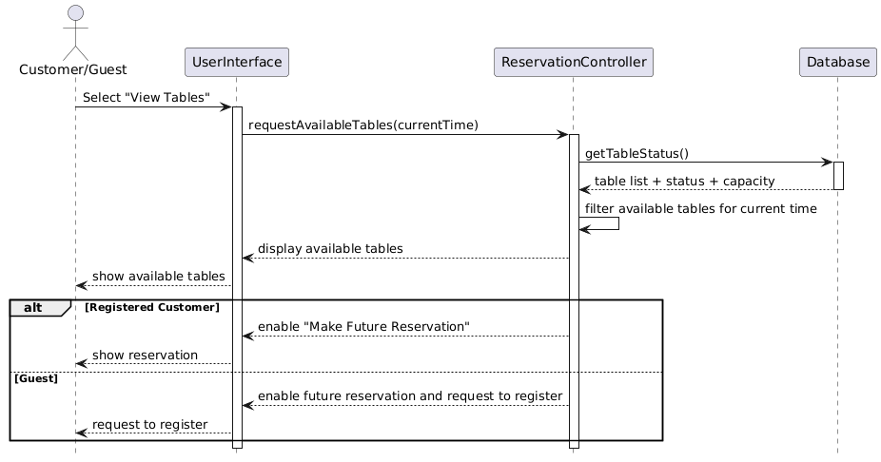

9.4 Make Reservation (Now)

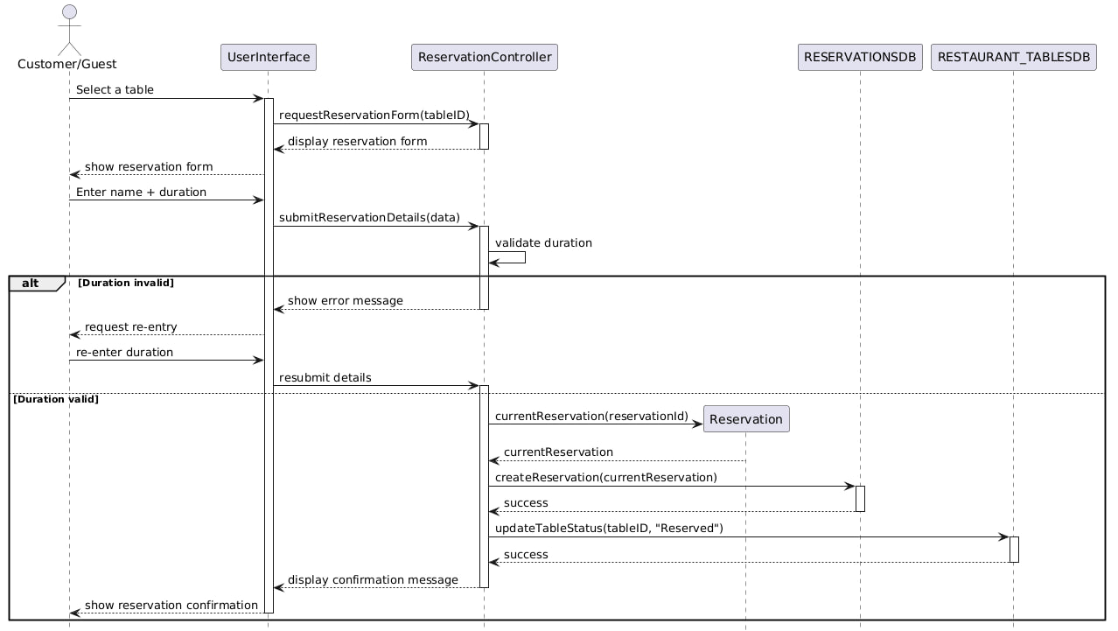

9.5 Make Reservation (Future)
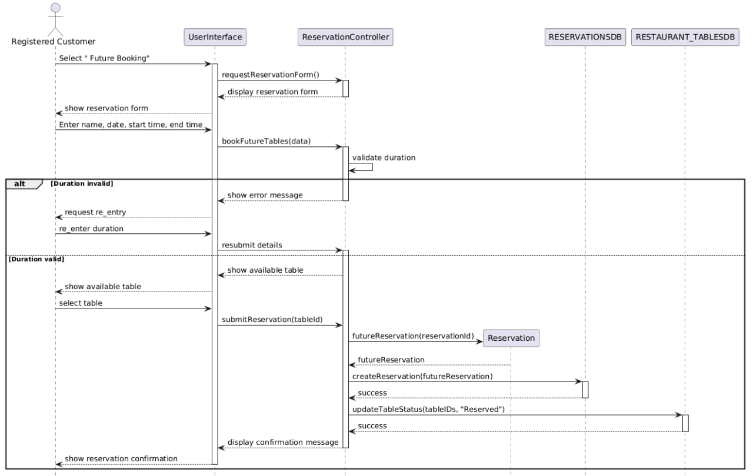

9.6 Cancel Future Reservation

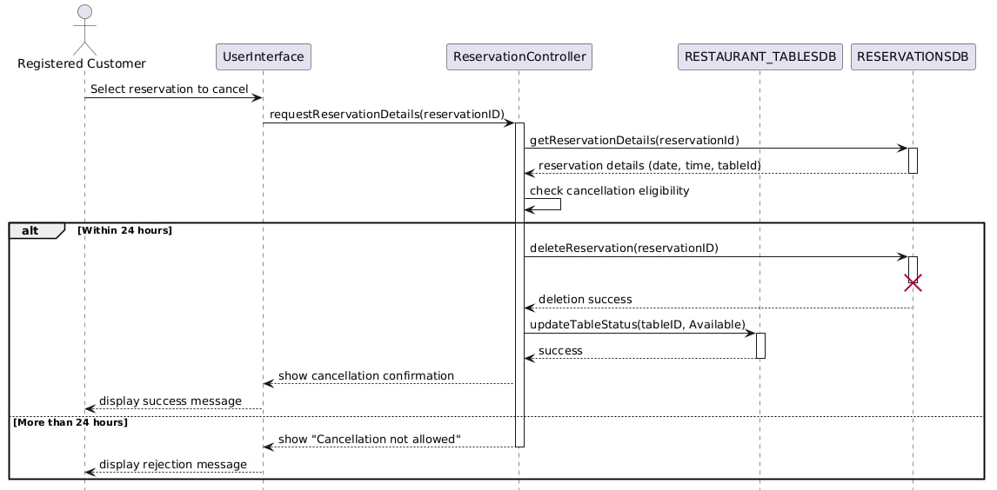

9.7 Manage Table

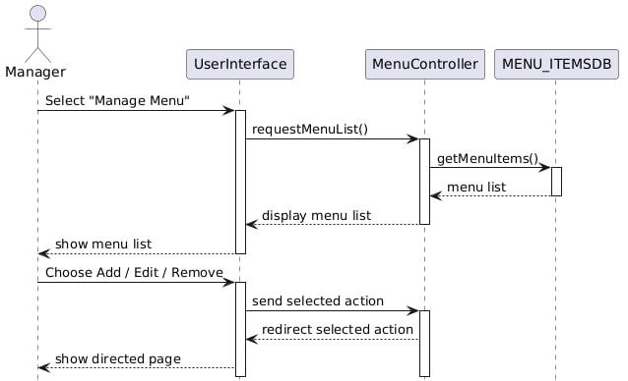

9.8 Edit Table

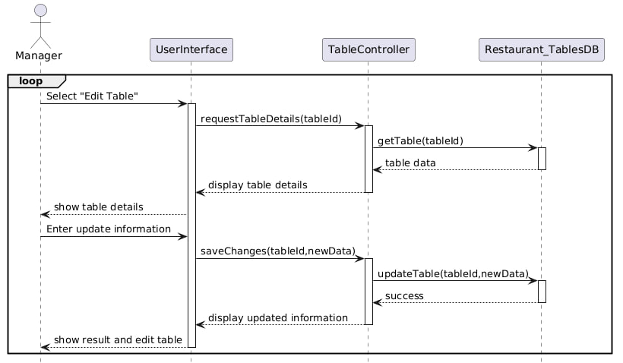

9.9 Add Table
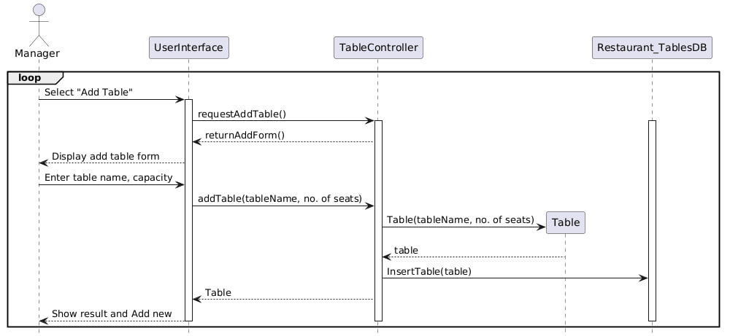

9.10 Remove Table

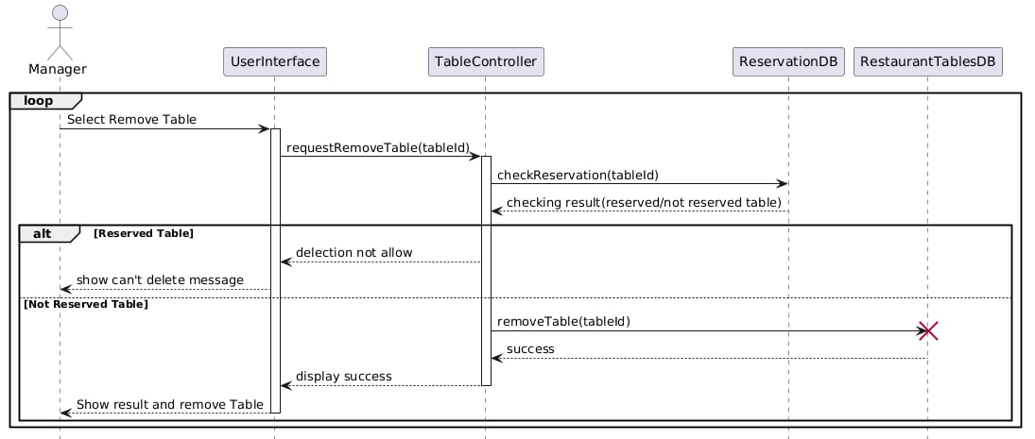

9.11 Manage Inventory
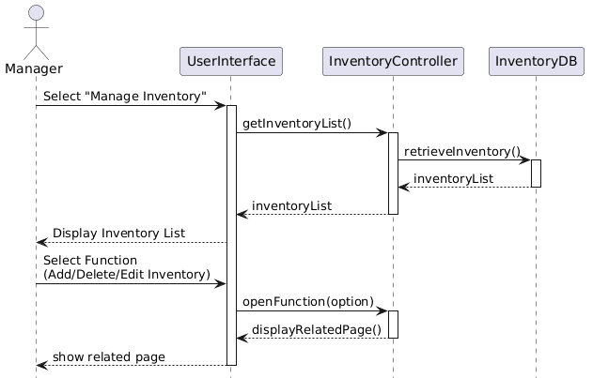

9.12 Edit Inventory
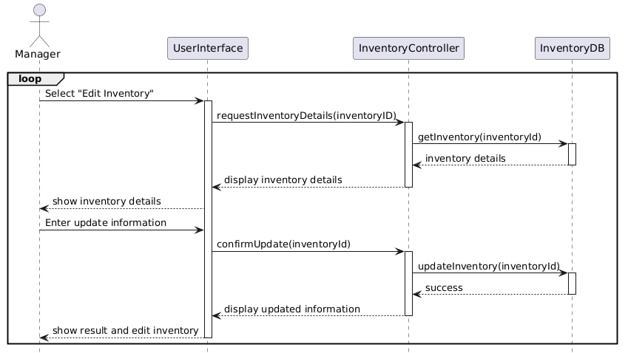

9.13 Add New Inventory

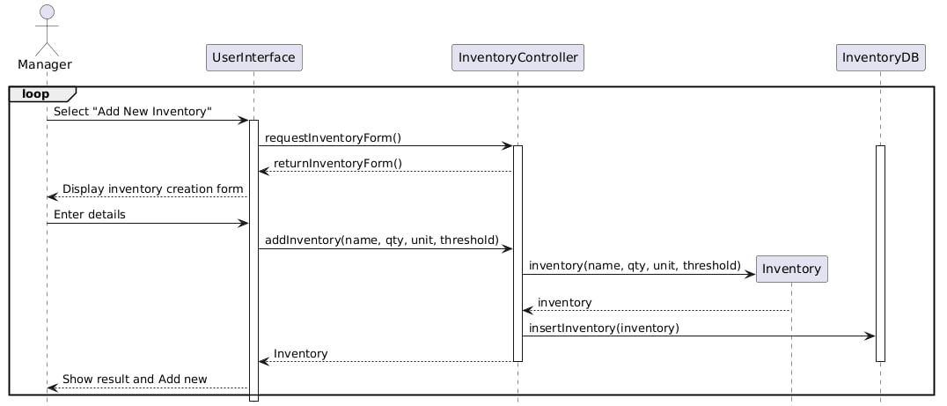

9.14 Delete Inventory
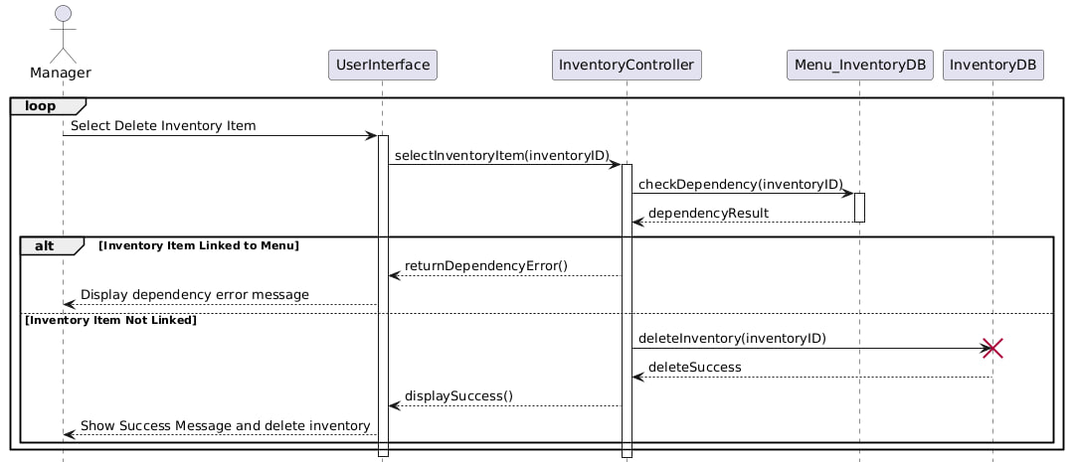

9.15 View Low-Stock Items

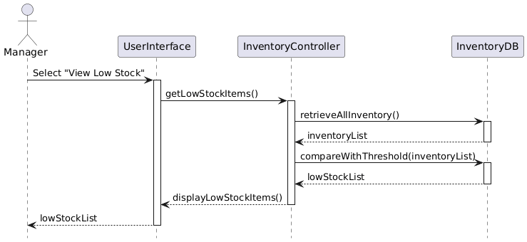

9.16 View Sales Records

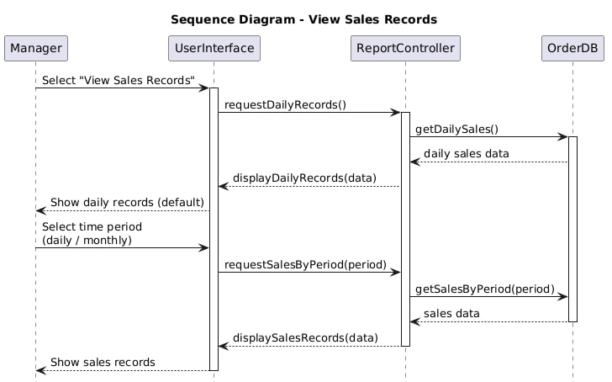

9.17 Manage Menu
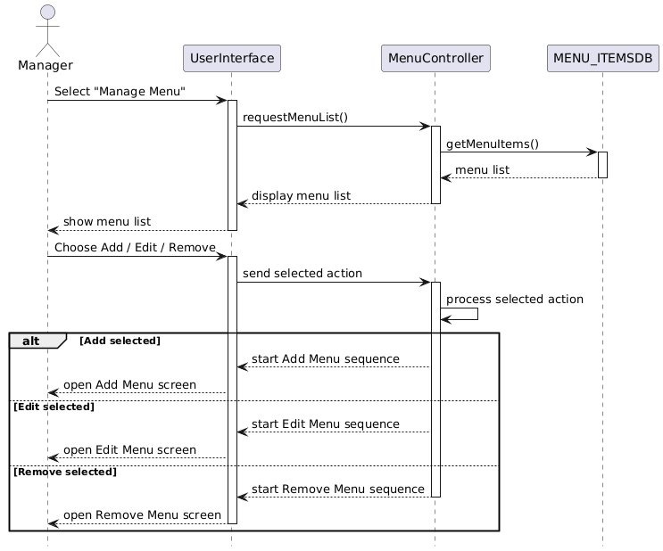

9.18 Add Menu

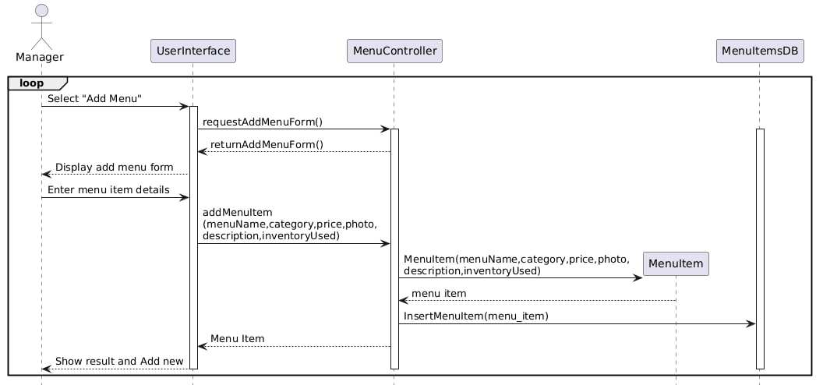

9.19 Edit Menu

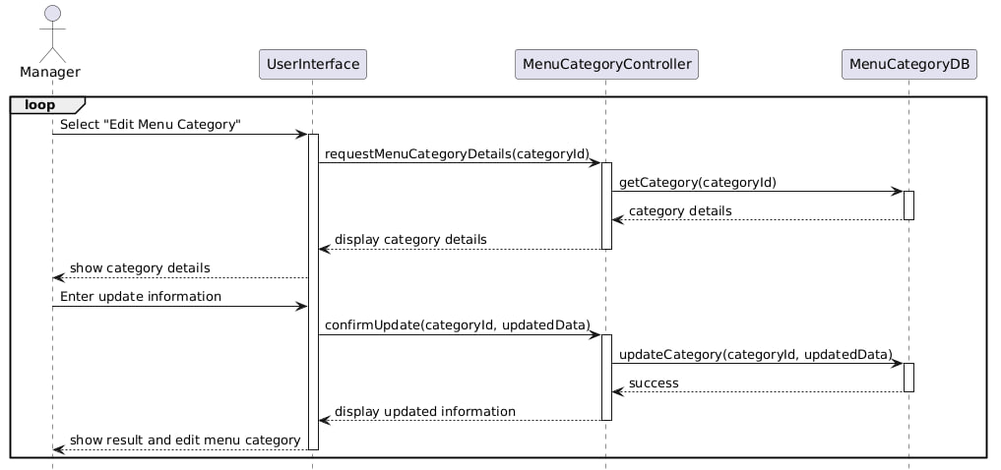

9.20 Remove Menu
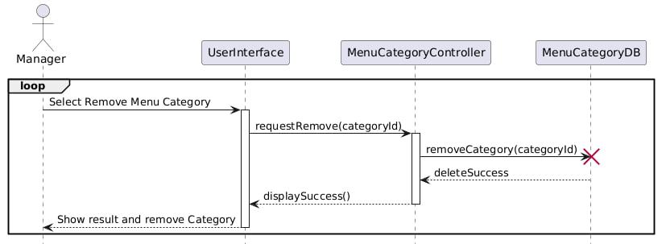

9.21 Sign up

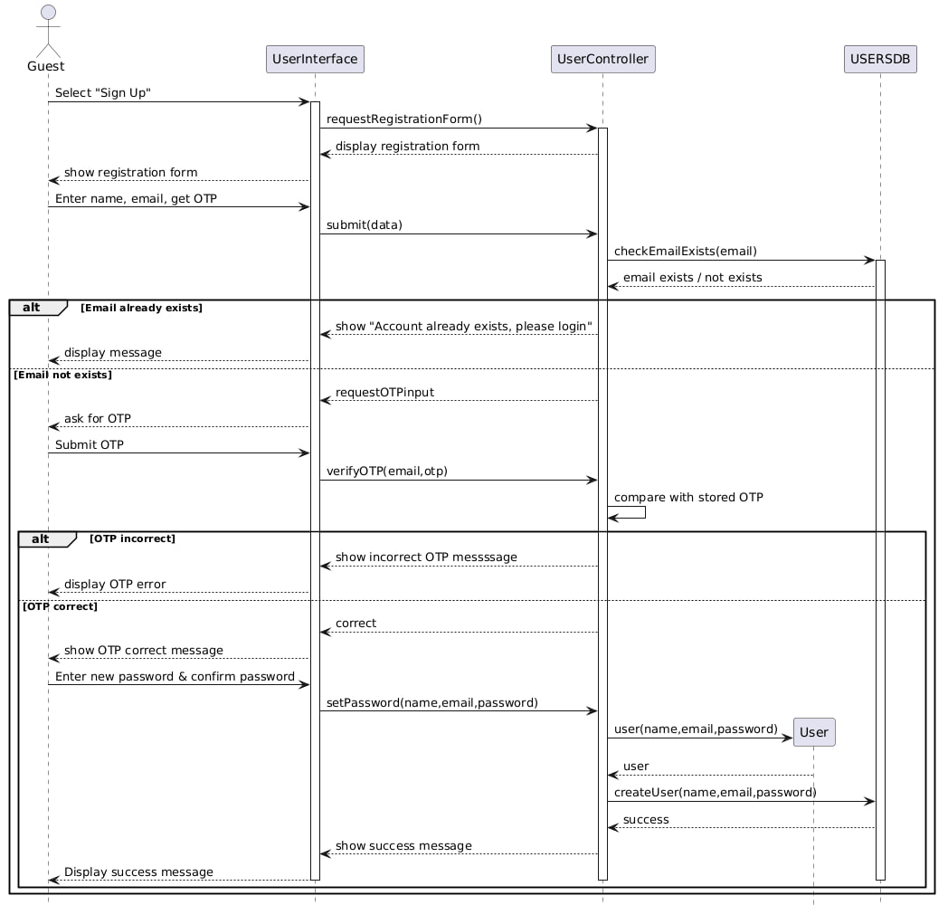

9.22 Login
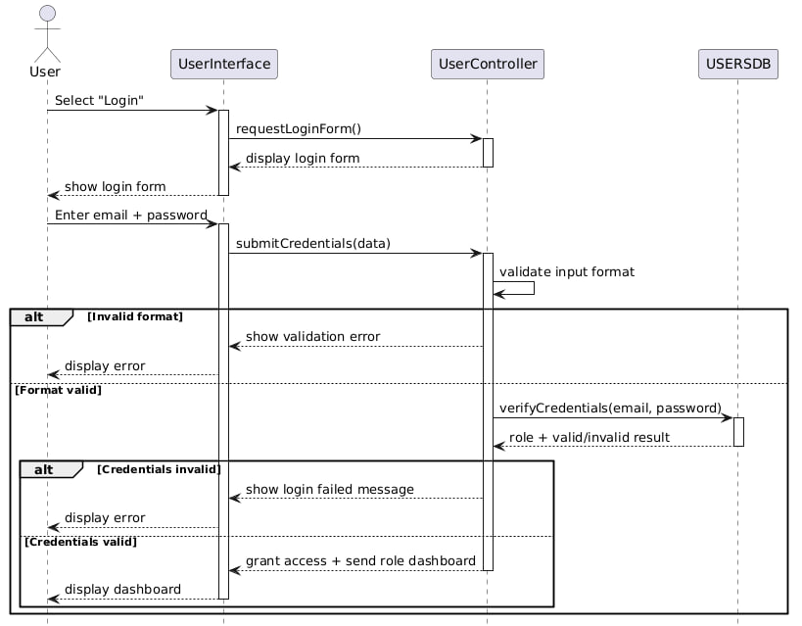

9.23 Forget Password
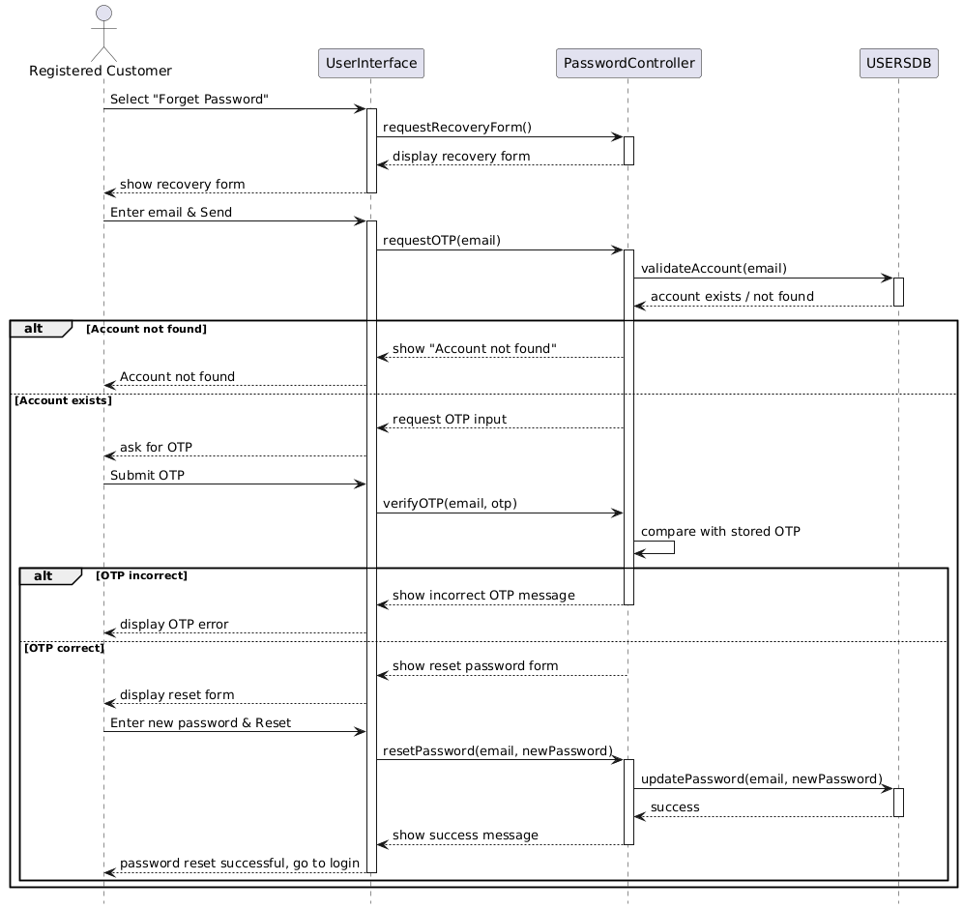

9.24 View Order Status and Bill
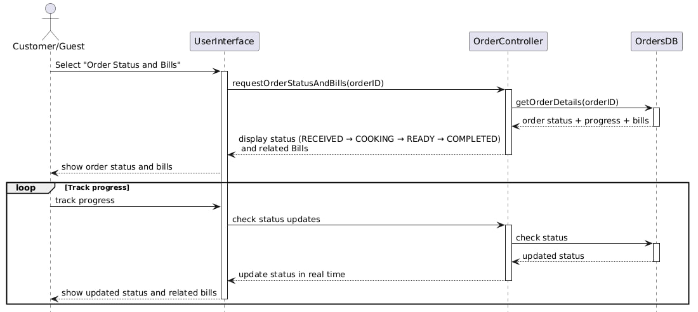

9.25 View Active Orders (Update Order Status)

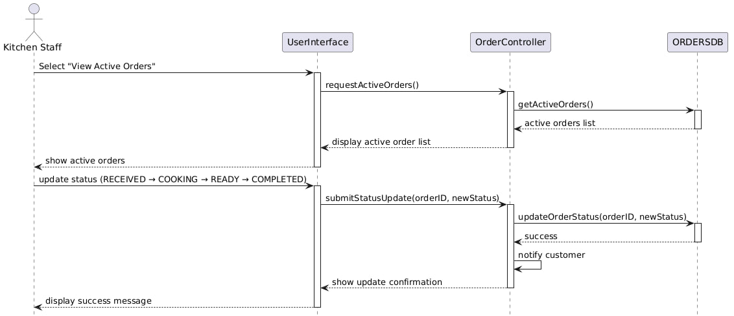

9.26 Manage Menu Category

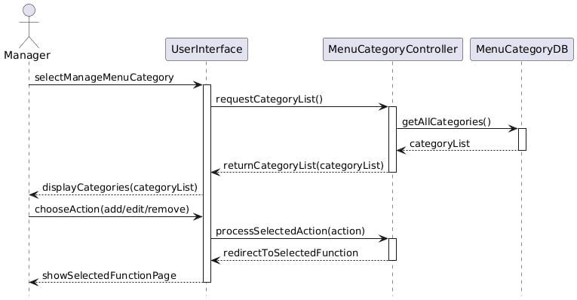

9.27 Edit Menu Category

9.28 Add Menu Category

9.29 Remove Menu Category

9.30 Edit Profile
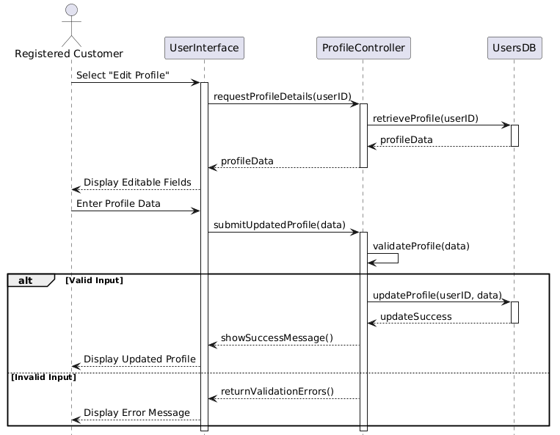

10. Class Diagram

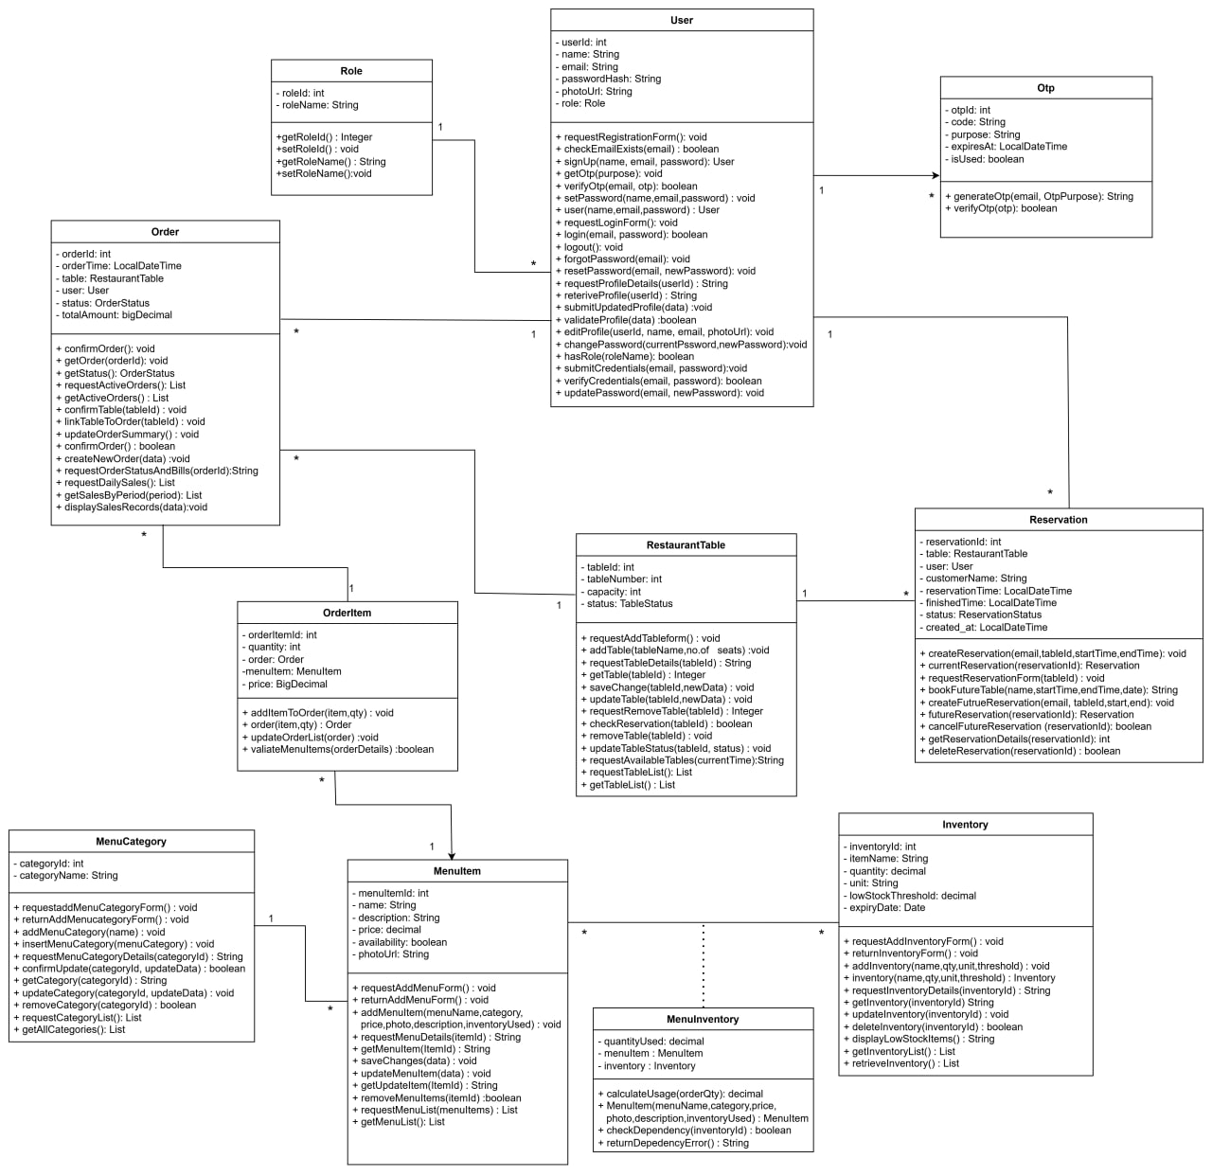

11. Class Diagram
11.1 Dashboard
11.1.1 Home Page
Our webpage represents the Customer Interface of the Restaurant Ordering & Management System (ROMS). At the top of the page, there is a navigation bar that includes Home, Menu, My Reservation, Order History, Profile, and Login/Sign-up, allowing users to easily access different system functions. The Home section displays a banner image that introduces the restaurant and enhances the user experience. When users click on the Menu, they can browse available food items with their prices and availability, and they can place orders accordingly.
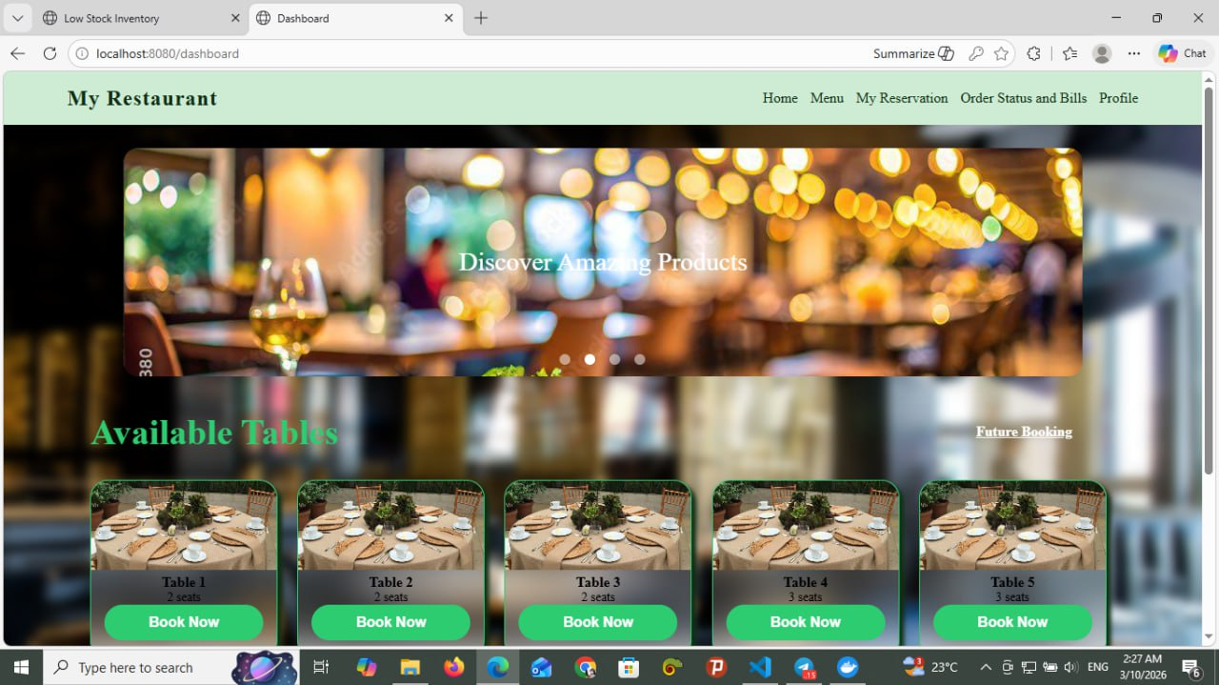
In the main section of the page, the “Available Tables” area displays the currently available tables along with their seating capacity. Each table card includes a “Book Now” button, which allows customers to select and reserve a table. When the button is clicked, the system checks table availability, prevents double booking, and stores the reservation information in the database. Registered users can also make future reservations and manage them through the My Reservation section.

Figure 11.1.1 Home Page

11.1.2 Menu
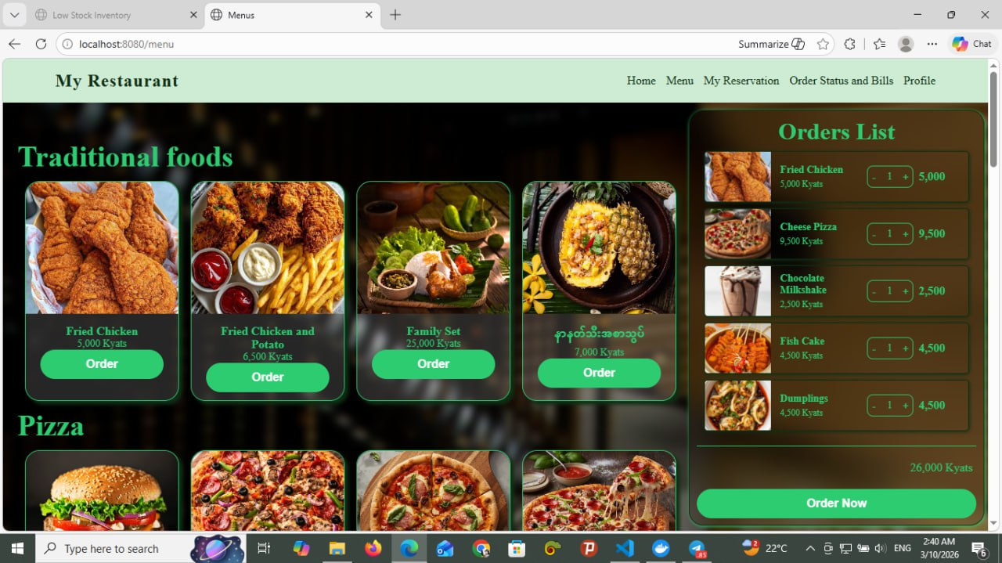
The Menu page of the Restaurant Ordering & Management System (ROMS) allows customers or guests to easily browse all available food and drink items offered by the restaurant. On this page, menu items are clearly displayed with images, names, categories (such as Pizza, Burger, Drinks, Vegan, etc.), prices, and availability, making it simple for users to understand their options at a glance. Customers can filter menu items by category to quickly find what they want, view item details, and select items to place an order. When an order is made, the system automatically prepares the order information to be linked with a selected table and sends it to the kitchen in real time. Overall, the Menu page acts as the main interaction point for customers to explore the restaurant’s offerings and start the ordering process smoothly and efficiently.

Figure 11.1.2 Menu Page

11.1.3 Cancel Future Reservation
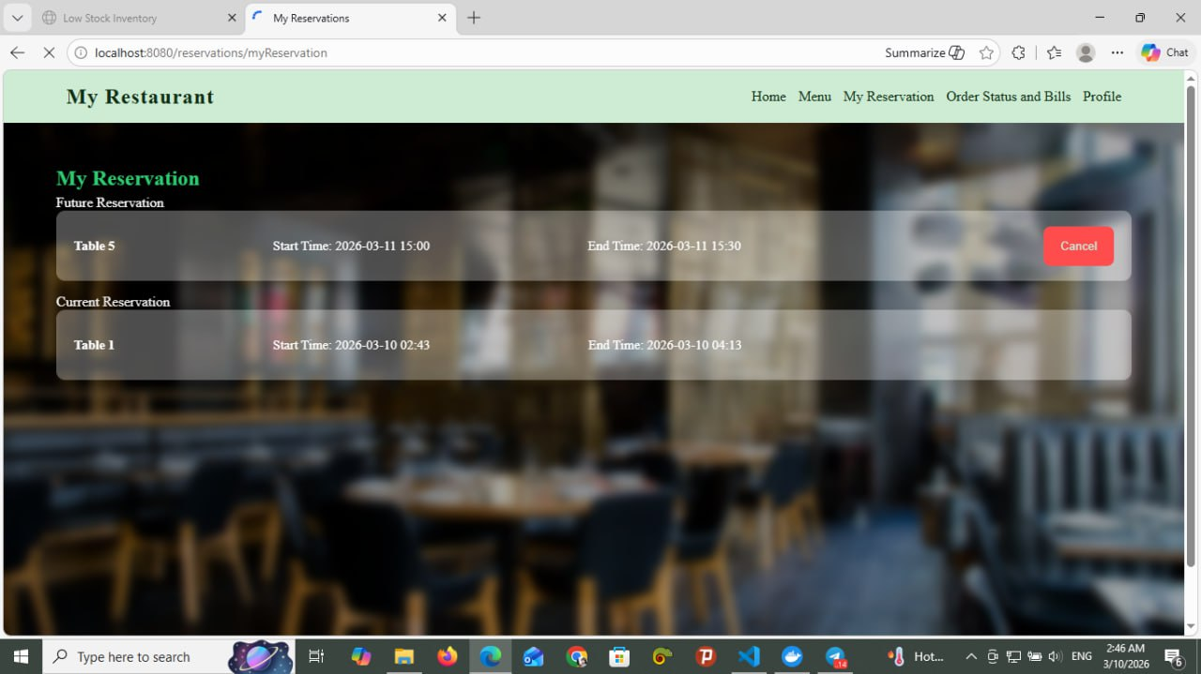
The My Reservation page allows registered customers to view and manage their table reservations in a clear and organized way. On this page, customers can see a list of their current and upcoming reservations, including table number, start time, and end time. Each reservation is displayed separately so users can easily understand their booking details at a glance. The page also provides a Cancel option, allowing customers to cancel eligible future reservations according to system rules. This page helps customers keep track of their reservations, make changes when necessary, and ensures better control over their dining plans without needing to contact restaurant staff directly.
Figure 11.1.3 My Reservation Page

11.1.4 Order Status and Bills
The Order Status and Bills page in the Restaurant Ordering & Management System (ROMS) is used to display and track customer orders in the restaurant. Each order is shown in a separate card with its Order ID, ordered food items, quantity, and the total price.
The page allows kitchen staff or the system to monitor the progress of each order through different stages. These stages include Received, Cooking, Ready, and Complete. When an order is placed, it first appears as Received. Then the kitchen staff prepares the food and updates the status to Cooking. After the food is prepared, the status becomes Ready, and finally it changes to Complete when the order is served to the customer.
Each card also shows the table number and the total bill amount for that order. This helps restaurant staff easily track which table ordered which items and how much the customer needs to pay. Therefore, this page helps improve order management, monitor order progress in real time, and display the billing information clearly.
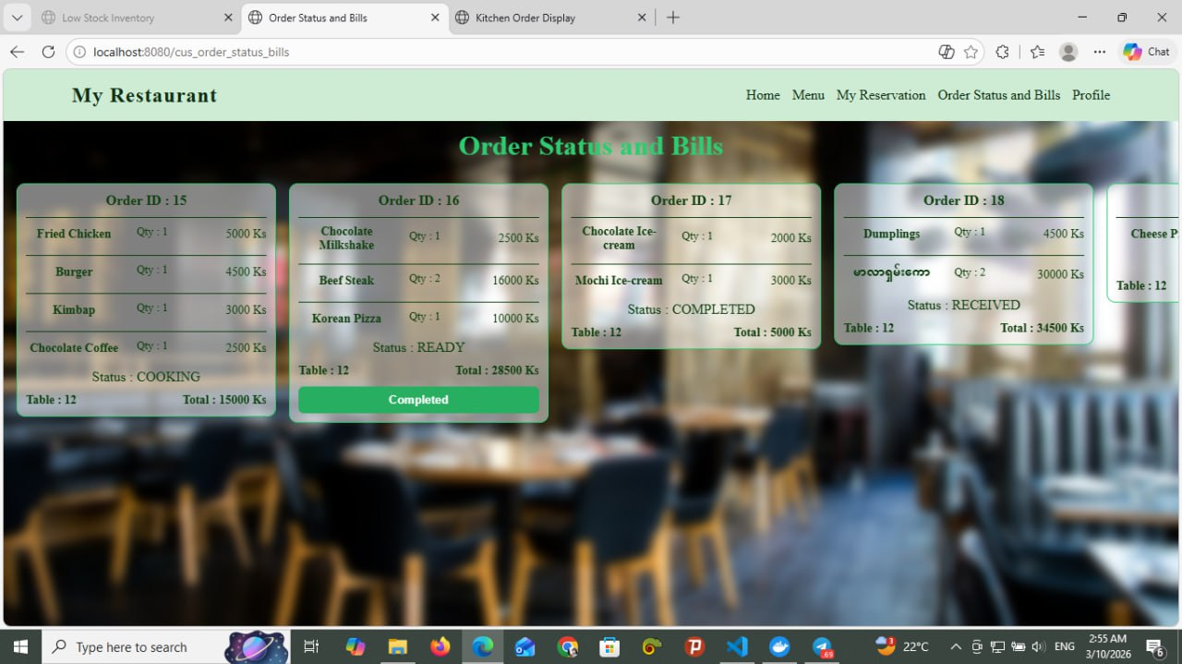
Figure 11.1.4 Order Status and Bills

11.1.5 Profile Page
The Profile page in the Restaurant Ordering & Management System (ROMS) allows a registered user (Manager or Customer) to view and manage their personal account information. On this page, the user can see their profile details such as name and email address, and they are given options like Edit Profile, Change Password, and Logout. When the user selects “Edit Profile,” the system displays editable fields including name, email, photo, and password. After the user updates the required information and clicks save, the system validates the input data and updates the information in the database, then shows a success confirmation message along with the updated profile details. The “Change Password” option allows the user to securely update their password, and the “Logout” button enables the user to exit the system safely. Overall, the Profile page provides account management features that help users maintain and secure their personal information within the system.
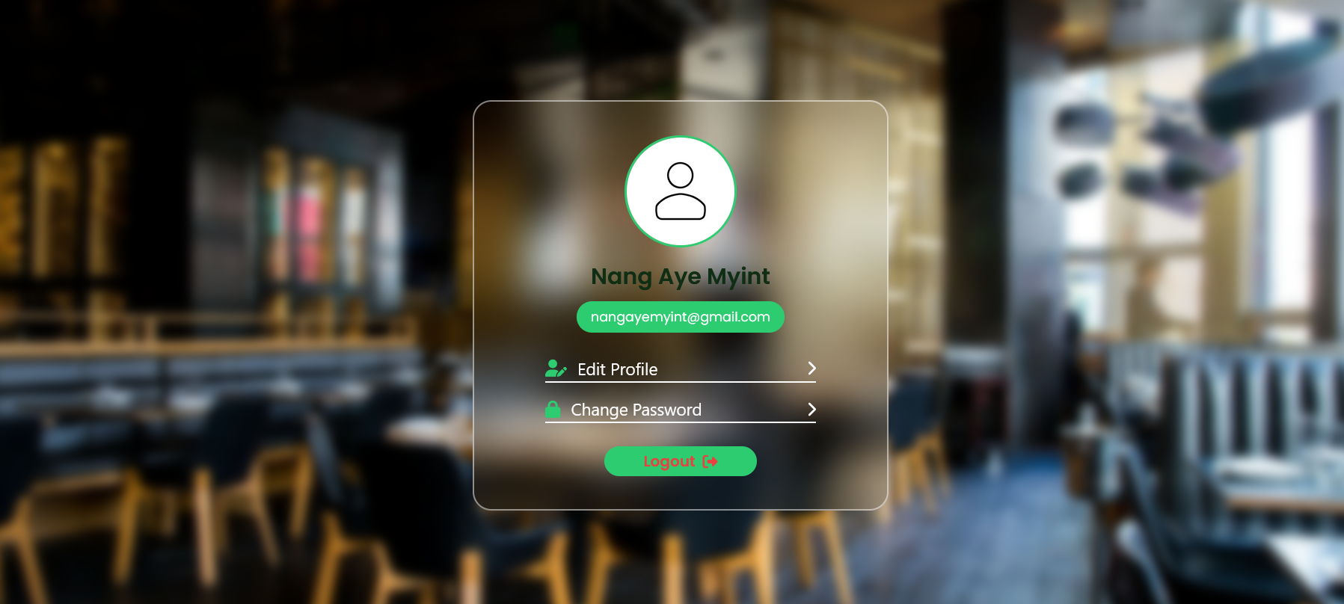
Figure 11.1.5 Profile Page

11.1.6 Login Page
The Login page in the Restaurant Ordering & Management System (ROMS) allows registered users such as Customers, Managers, and Kitchen Staff to securely access the system according to their roles. On this page, the user enters their email and password, and the system first validates the input format before verifying the credentials with the database. If the information is correct, the system grants access based on the user’s role and redirects them to their respective dashboard (Customer, Manager, or Kitchen). If the credentials are incorrect or required fields are empty, the system displays an appropriate error message. The page also includes additional features such as “Remember Me” for saving login sessions and “Forget Password” for password recovery through email verification and OTP. Overall, the Login page ensures secure authentication and controlled access to the system’s functions.
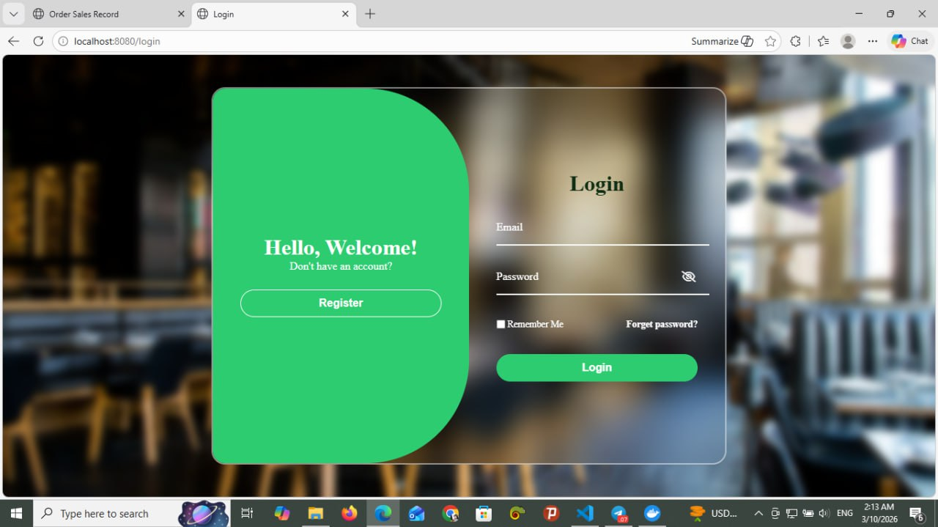
Figure 11.1.6 Login Page

11.1.7 Register Page
This page is the Registration (Sign-Up) Interface of the Restaurant Ordering & Management System (ROMS). It allows new users to create an account in order to access system features such as making future reservations, viewing order history, and managing their profile. On the left side, there is a registration form that requires the user to enter their Name, Email, Password, and Confirm Password. The system validates the input data to ensure all required fields are filled correctly and that the password and confirm password match. If the email already exists in the database, the system will display a message asking the user to log in instead. Once the registration is successful, the system creates a new customer account and stores the user’s information securely in the database.
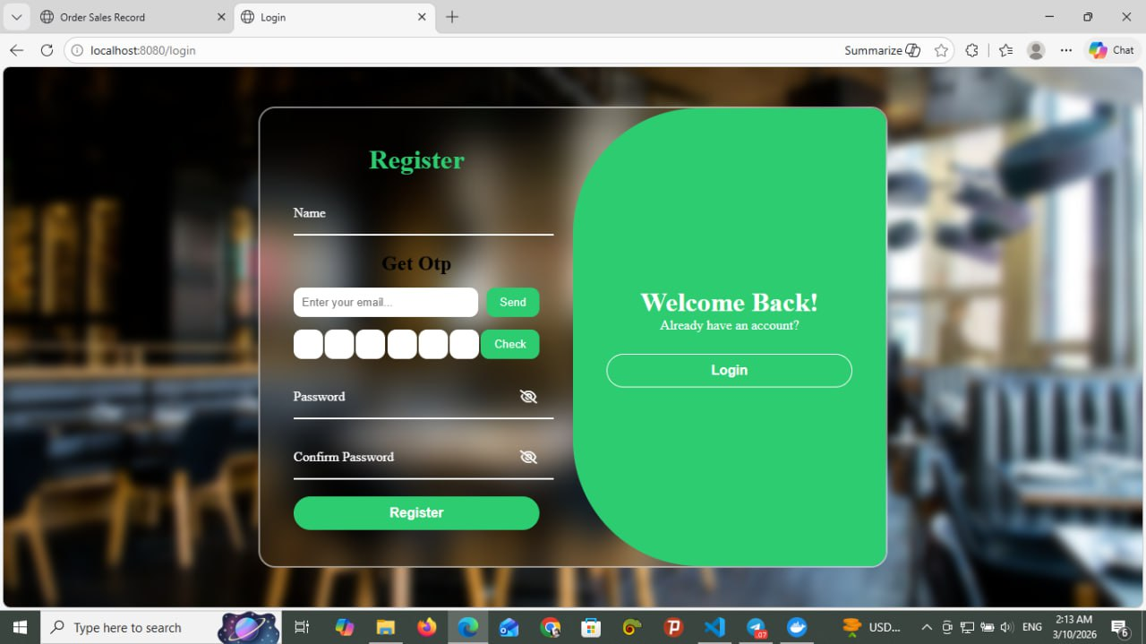
On the right side, there is a “Welcome Back” section designed for users who already have an account. It includes a Login button that redirects existing users to the login page. Overall, this page provides a secure and user-friendly way for new customers to register and for existing users to quickly access their accounts.
Figure 11.1.7 Register Page

11.1.8 Change Password
The Change Password page in the Restaurant Ordering & Management System (ROMS) allows users to update their account password to maintain account security. When the user opens the Change Password page, the system displays a form that requires the user to enter the current password, new password, and confirm password.
First, the user enters their current password to verify their identity. Then, the user types a new password and re-enters the same password in the confirm password field to ensure accuracy. After entering all required information, the user can click the Apply button to submit the request. The system then validates the information and updates the password in the database if all inputs are correct. If the user decides not to change the password, they can click the Discard button to cancel the action. This function helps protect user accounts and ensures that only authorized users can access the system.
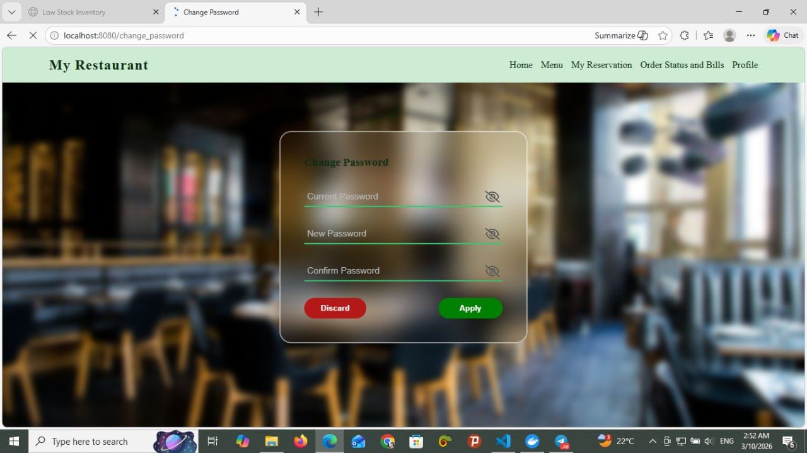
Figure 11.1.8 Change Password

11.2 Manager/Kitchen
11.2.1 Staff Login-Page
This page is the Login Interface of the Restaurant Ordering & Management System (ROMS), designed for staff members such as the Manager or Kitchen Staff to access the system. In the center of the page, there is a login form where the user must first select their Position (Role), such as Manager or Kitchen Staff. After selecting the role, the user needs to enter their Security Key (Password).
When the user clicks the Login button, the system verifies the entered credentials by checking them against the records stored in the database. If the information is correct, the system grants access and redirects the user to the appropriate dashboard based on their role. If the credentials are incorrect, an error message is displayed, and the user is asked to try again.
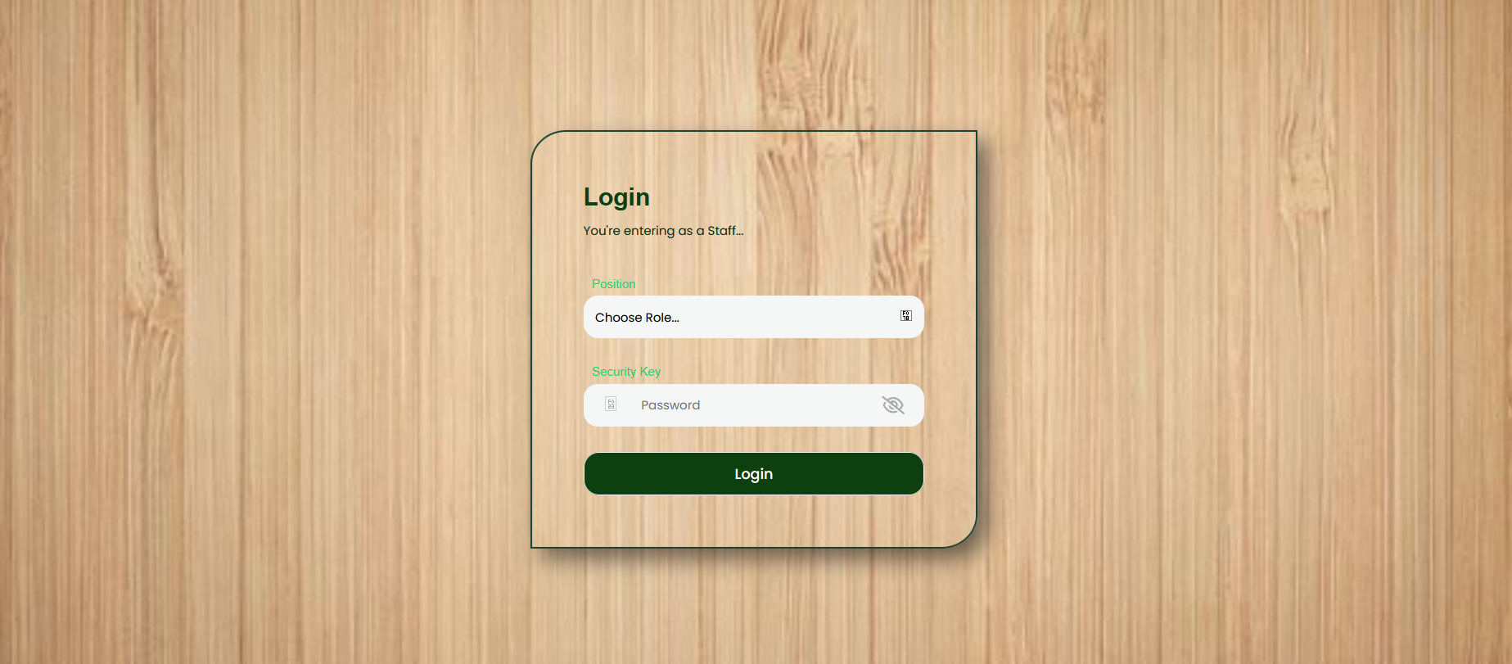
Overall, this page implements role-based authentication to ensure that only authorized staff members can securely access their respective system functions.
Figure 11.2.1 Staff Login Page

11.2.2 Manage Menu
The Manage Menu function in the Restaurant Ordering & Management System (ROMS) allows the manager to control and organize the restaurant’s menu items. When the manager selects the Manage Menu option, the system retrieves all menu items from the database and displays them in a list. From this page, the manager can add new menu items, edit existing menu details, or remove menu items that are no longer available.
When adding a new menu item, the manager enters the item information such as name, category, price, and description, and the system stores the new data in the database after confirmation. For editing a menu item, the system displays the current details, and the manager can update the information before saving the changes. If the manager chooses to remove a menu item, the system asks for confirmation before deleting it from the database. This function helps the restaurant keep its menu updated and properly managed.
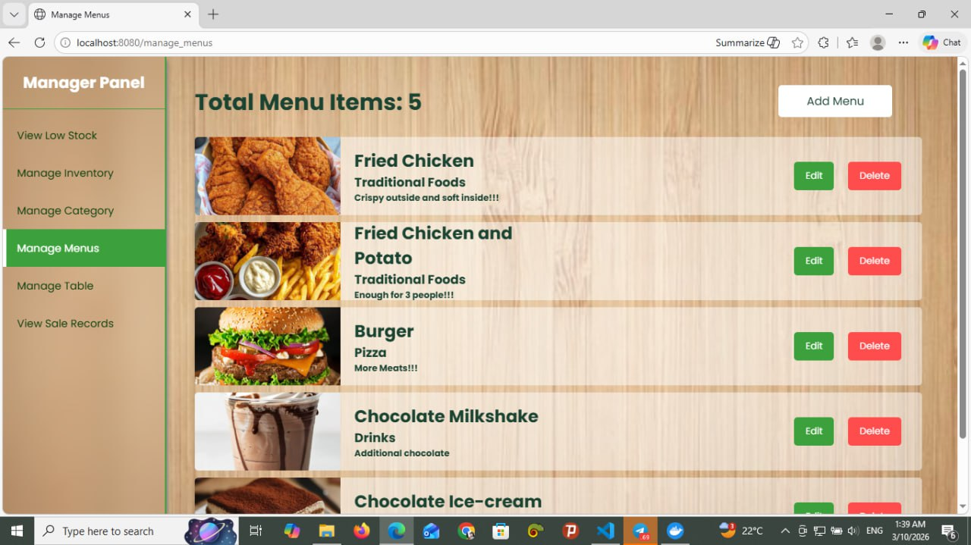
Figure 11.2.2 Manage Menu

11.2.3 Manage Table
The Manage Table function in the Restaurant Ordering & Management System (ROMS) allows the manager to manage all restaurant tables in the system. When the manager selects the Manage Table option, the system retrieves all table information from the database and displays a list of tables with their details such as table number and seating capacity.
From this page, the manager can add new tables, edit existing table information, or remove tables from the system. When adding a new table, the manager enters details such as the table name or number and seating capacity, and the system stores the information in the database after confirmation. For editing, the system displays the current table details, and the manager can update the information before saving the changes. If the manager chooses to remove a table, the system asks for confirmation before deleting the table record from the database. This function helps the restaurant maintain accurate table information and manage seating efficiently.
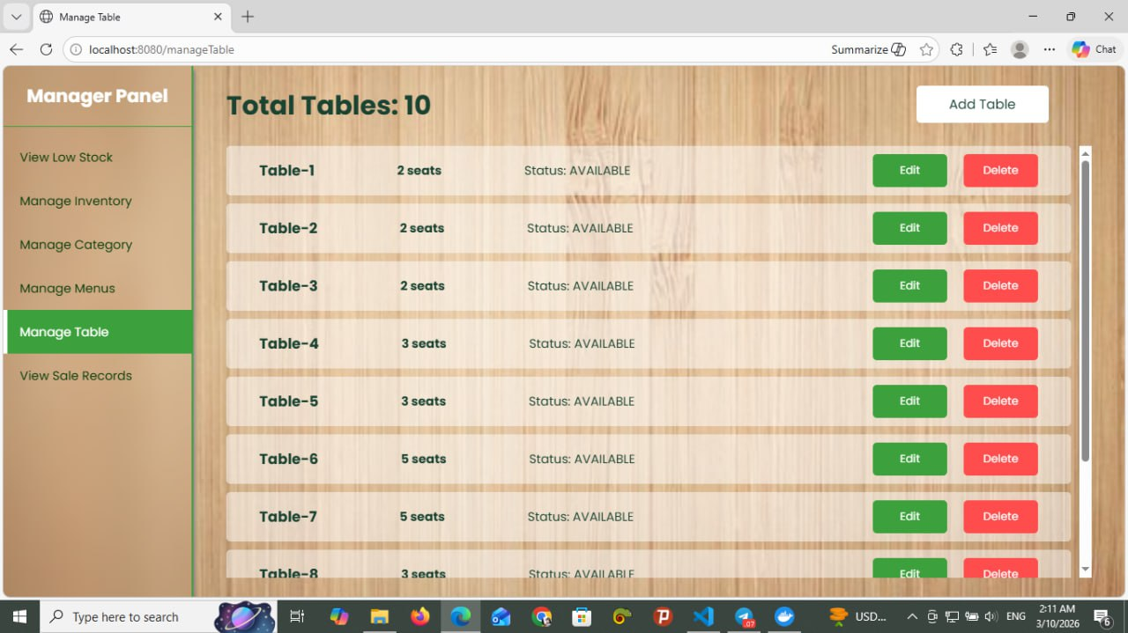
Figure 11.2.3 Manage Table Page

11.2.4 View Sales Records
The View Sales Records function in the Restaurant Ordering & Management System (ROMS) allows the manager to monitor and review the restaurant’s sales performance. When the manager selects the View Sales Records option, the system retrieves sales data from the database and displays the records. By default, the system shows the daily sales records, including information about orders, total sales amounts, and transaction details.
The manager can also select a specific time period, such as a particular date or range of dates, to view sales records for that period. The system then retrieves the relevant data from the database and displays it accordingly. This function helps the manager analyze sales performance, track revenue, and make better business decisions.
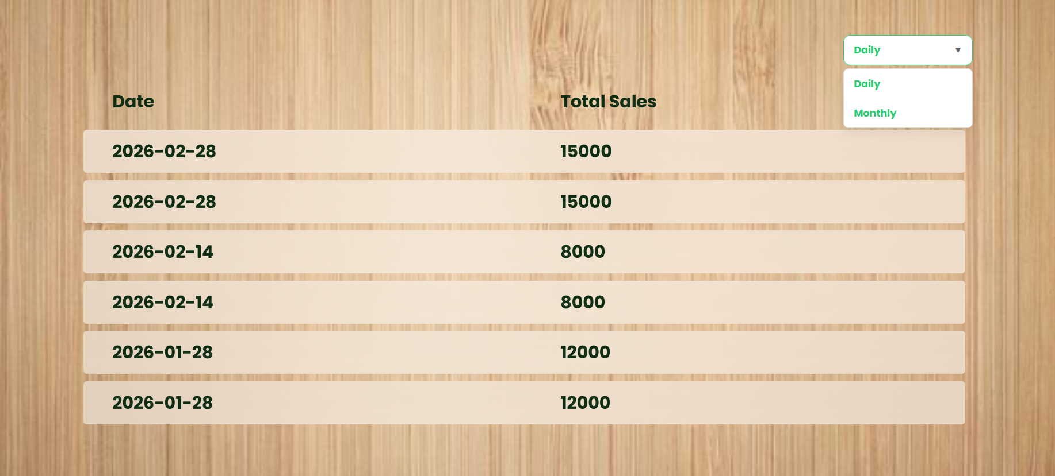
Figure 11.2.4 View Sales Records Page

11.2.5 Manage Inventory
The Manage Inventory function in the Restaurant Ordering & Management System (ROMS) allows the manager to monitor and control the restaurant’s inventory items. When the manager selects the Manage Inventory option, the system retrieves all inventory records from the database and displays them in a list with details such as item name, quantity, unit, and stock level and expiration date. The expiration date helps the manager identify items that are close to expiring so that they can be used or replaced in time to maintain food quality and safety.
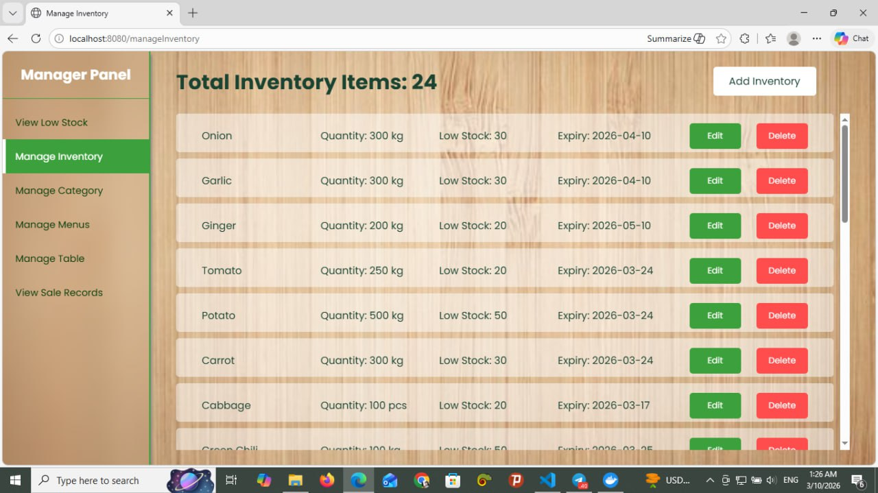
From this page, the manager can perform several actions such as updating stock quantities, adding new inventory items, deleting inventory items, or viewing low-stock items. When the manager updates the stock quantity, the system saves the new value in the database after confirmation. The manager can also add new inventory items by entering details like the inventory name, quantity, unit, and threshold level, and expired date. Additionally, the system can identify and display low-stock items by comparing the current stock level with the predefined threshold. This function helps the restaurant maintain proper inventory levels, avoid ingredient shortages, and manage kitchen supplies efficiently.

Figure 11.2.5 Manage Inventory Page

11.2.6 Manage Menu Category
The Manage Menu Category function in the Restaurant Ordering & Management System (ROMS) allows the manager to organize and control the different categories of menu items. When the manager selects the Manage Menu Category option, the system retrieves all existing categories from the database and displays them in a list.
From this page, the manager can add a new category, edit an existing category, or remove a category. When adding a new category, the manager enters the category name and confirms the action, and the system saves the new category in the database. If the manager chooses to edit a category, the system displays the current category details and allows the manager to update the information. When removing a category, the system asks for confirmation before deleting it from the database. This function helps keep the menu organized by grouping menu items into categories such as drinks, desserts, or main dishes.
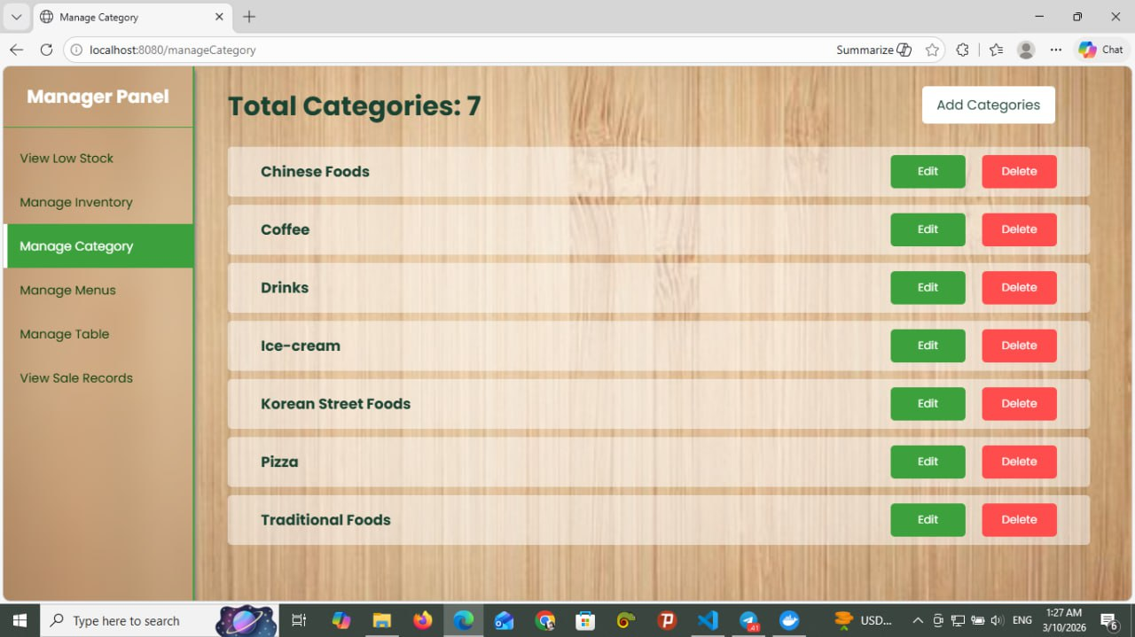
Figure 11.2.6 Manage Menu Category Page

11.2.7 View Active Orders
The View Active Orders function in the Restaurant Ordering & Management System (ROMS) allows kitchen staff to view all current customer orders that are being processed in the restaurant. When the kitchen staff selects the View Active Orders option, the system retrieves active order data from the database and displays a list of orders along with their details.
Each order shows important information such as the order ID, ordered items, quantity, and current order status. The kitchen staff can select an order to view more detailed information about the items that need to be prepared. This function helps the kitchen staff track ongoing orders and manage the food preparation process efficiently.
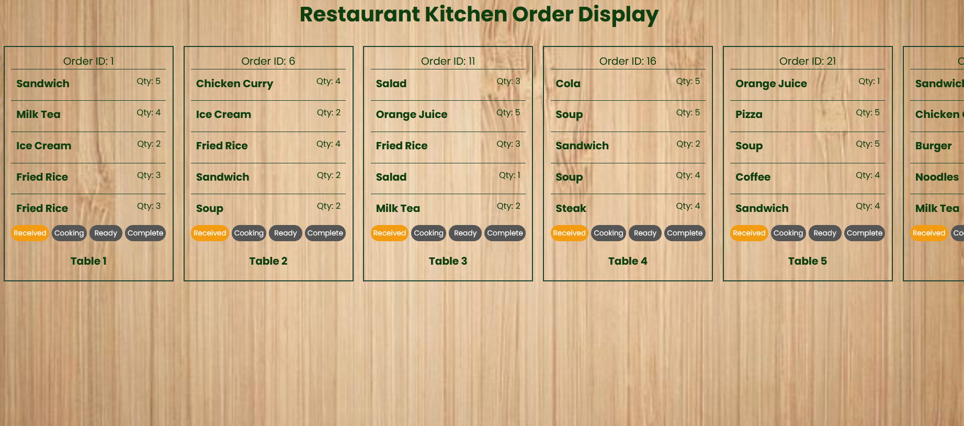
Figure 11.2.7 View Active Orders

11.2.8 View Low Stock Items
The View Low-Stock Items function in the Restaurant Ordering & Management System (ROMS) allows the manager to identify inventory items that are running low in quantity. When the manager selects the View Low-Stock Items option, the system compares the current stock quantity of each inventory item with its predefined threshold level stored in the database.
If the stock quantity is less than or equal to the threshold level, the system automatically identifies it as a low-stock item and displays it in a list. The list includes important information such as the item name, current quantity, unit, threshold level, and expiration date. This helps the manager quickly recognize which ingredients need to be restocked or replaced.
This function helps the restaurant maintain sufficient ingredient supplies, prevent shortages during food preparation, and ensure that kitchen operations continue smoothly.
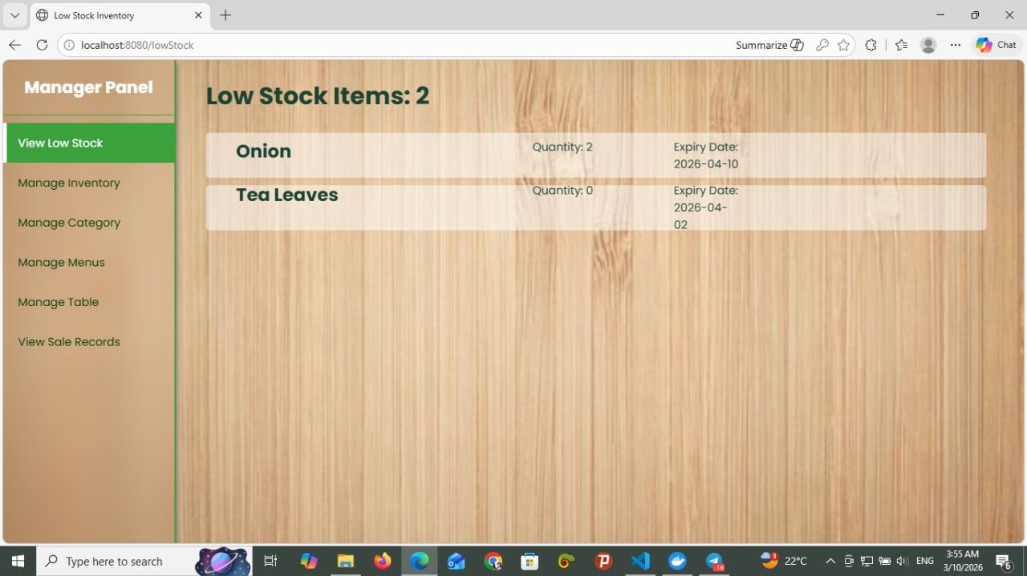
Figure 11.2.8 View Low Stock Items

11.3 Customer/Guess
11.3.1 Make Reservation Form
The Reservation Form page in the Restaurant Ordering & Management System (ROMS) allows customers or guests to reserve a table for immediate dining. When a customer selects an available table and clicks the reservation option, the system displays this reservation form.
On this page, the customer enters their name and the reservation duration, which is specified in hours and minutes. The system validates the entered duration according to the system rules, where the maximum duration for a “Now” reservation is 3 hours.
After entering the required information, the customer clicks the “Make Reservation” button. The system then verifies the input, creates the reservation, updates the table status as Reserved, and stores the reservation details in the database. Finally, the system confirms the reservation and allows the customer to proceed with dining or ordering food. 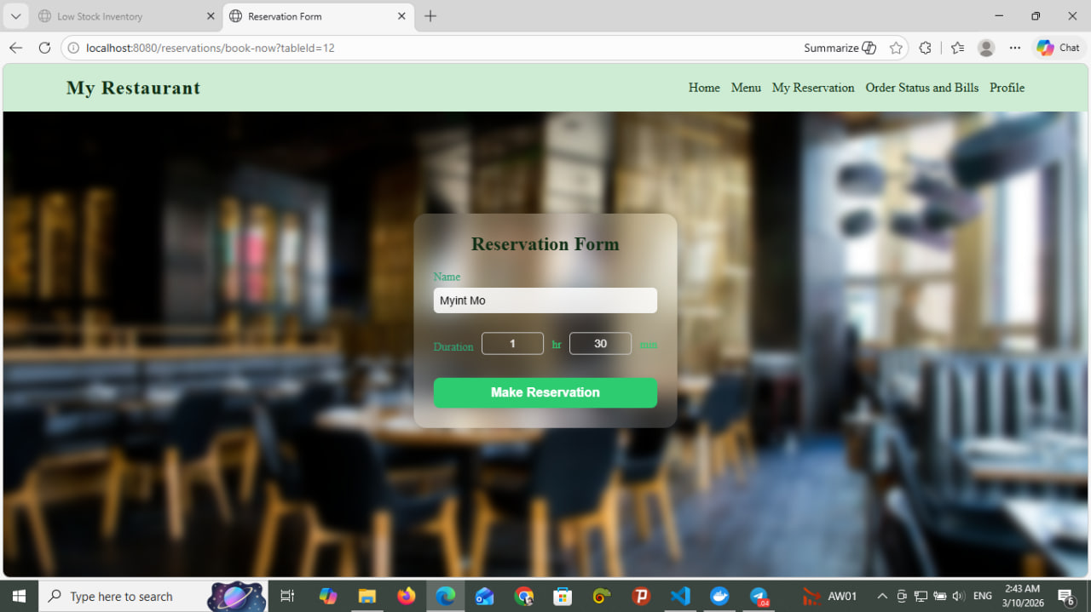
Figure 11.3.1 Make Reservation Form

12. Conclusion
In conclusion, the Restaurant Ordering & Management System (ROMS) provides an efficient digital solution for managing restaurant operations. The system allows customers to browse menus, reserve tables, place orders, and track order status easily, while managers and kitchen staff can manage menus, tables, inventory, and sales records through organized system functions. By automating these processes, the system reduces manual work, improves accuracy, and enhances service efficiency. Overall, ROMS helps restaurants manage their operations more effectively and provides a better experience for both customers and staff.

13. References
1. OBJECT-ORIENTED Design Development
2.Advanced Database System
3.PlantUML Documentation, Available at: https://plantuml.com
4.Figma Design Tool, Available at: https://www.figma.com
5.Visual Studio Development Environment, Available at: https://visualstudio.microsoft.com

