**Final Project Report**

**Submitted by**

Shwel Alshehri

Cloud Computing project

### Under Supervision of

### Prof. Baek-Young Choi



### [University of Missouri - Kansas City](https://www.umkc.edu/)

May 2019

I am pleased to acknowledge Prof. Choi for her invaluable guidance during the course of this project work.

I would like to express my special thanks of gratitude for her who gave me the golden opportunity to do this wonderful project on the topic (Crimes analysis), which also helped me in doing a lot of Research and I came to know about so many new things I am really thankful to her.

May 2019 Shwel Alshehri

s

Chapter 1: INTRODUCTION

## Overview

This report discusses the result of the work done in development of "Crimes analysis and visualization for four cities in USA" on cloud computing. This project is an analysis and visualization of crime data based on several factors and suggestions serving users who are looking for safe places to live. The target cities were Kansas city, Chicago, New York and San Francisco.

## Background and Motivation

With the exponential growth of the usage of web services, crimes data analysis has become more and more popular. A massive volume of structured and unstructured data posts great challenges on data processing, search, analysis, and visualization. Data mining and information visualization techniques enable users to explore data and hidden patterns and relationships, and use interactive graphical tools to gain an understanding of data by highlighting, comparing information and even revealing patterns and trends. This project show how we can use cloud computing to make crimes analysis and visualization available for public with simple way.

## Objective

The final goal of the project was twofold.

1.An Integrated Framework was required for interaction with the various tools (like Software, Designing, Partitioning, Visualization tools etc.) with the platform specification being done in the website itself.

2.Based on the final platform configuration and bindings, an Analysis and Visualization framework was required for getting visualization of the analysis results and published it on cloud.

* Along with above main goals, capability to design the website using html and java script.

## Methodology

To implement the above goals, the following methodology needs to be followed :

* 1. Specifying the Application and various components of the Architecture.
  2. Specifying the bindings between the tasks and the resources either manually or by the design tools.
  3. Specifying the port interconnections between the resources.
  4. Analysis: Extracting the data required for analysis and the doing the analysis.
  5. Using visualization tools to fully understand the data.

Chapter 2: TOOL DESCRIPTION

Data sources and type of data

* Data sources:

Opened data sources for each city. (these opened data usually provided through the internet by department of cities councils).And here are each city along with its own open data source.

* Kansas city. [https://data.kcmo.org](https://data.kcmo.org/)
* Chicago.<https://data.cityofchicago.org/>
* New York.<https://opendata.cityofnewyork.us/>
* San Francisco .<https://datasf.org/opendata/>
* Type of data:

Police departments’ reports and statistics.

* Duration
* For Kansas City and Chicago (2010-2018).
* For New York (2015-2018).
* For San Francisco (2003-2018).
* Project Structure

Designing website for the project.

* Tools and programing languages used for the designing:
* Angular 7 framework. (APIs)
* Html and java script.
* Cloud service (digital ocean).
* Operating System (Ubuntu 19.4).
* For visualization (Any Chart JavaScript Charting and angular libraries).
* Tableau Software.
* Website face

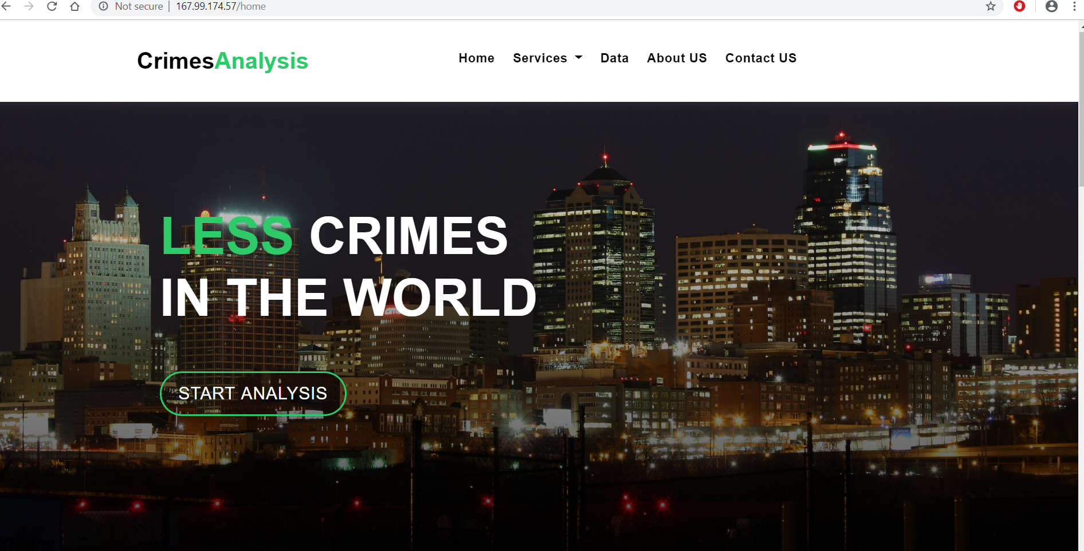

* Cloud service

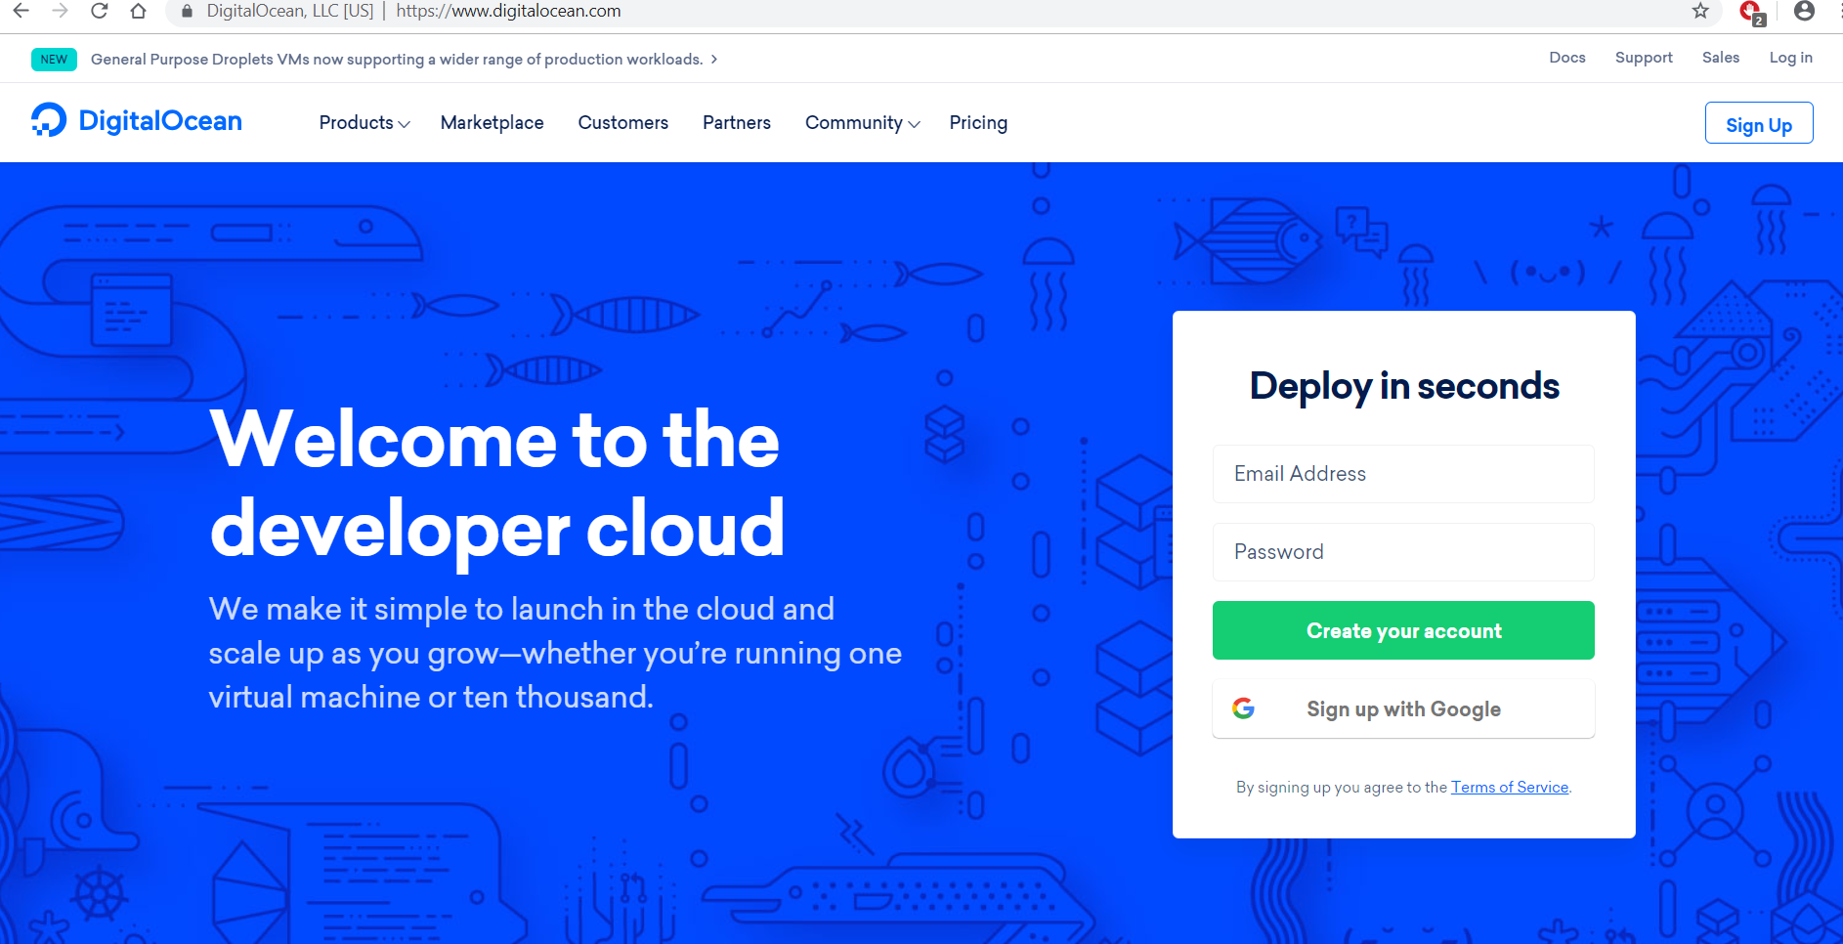

**Chapter 3: Data Analysis and Visualization**

* Create 5 classes for each data samples for all cities:
* Type of crimes
* Age
* Sex
* Zip code
* Address
* Using charts to present different classes and values.
* Comparing between cities in different classes.

Excution of project:

Kansas City: Year:2015

Analysis and visualization here show us the type of crimes and the numbers of crimes are in 2015.

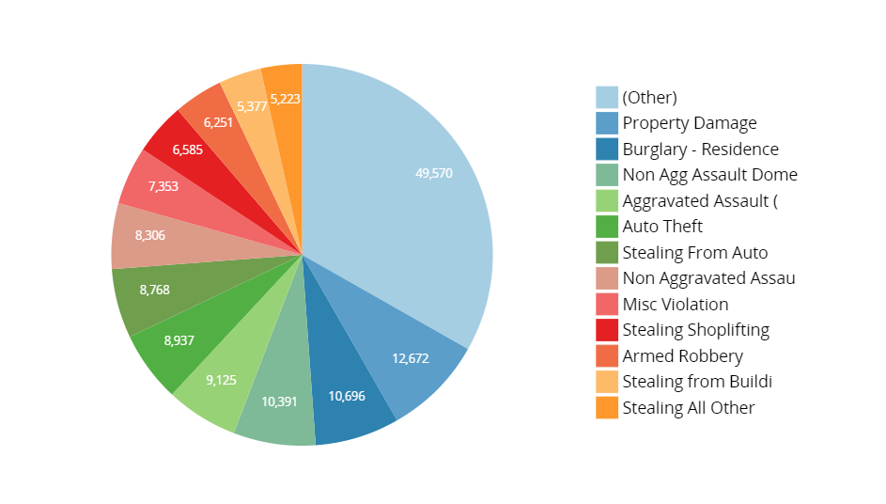

Kansas City Crimes’ map:

Here the visualization the map for Kansas City crimes in 2015.

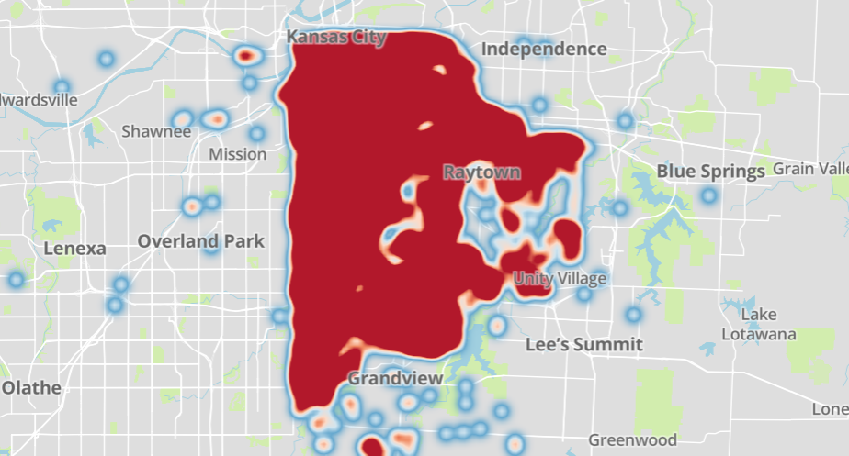

Chicago:

Here the analysis and visualization depend on the type of crimes

And the numbers of them for (2010-2018).

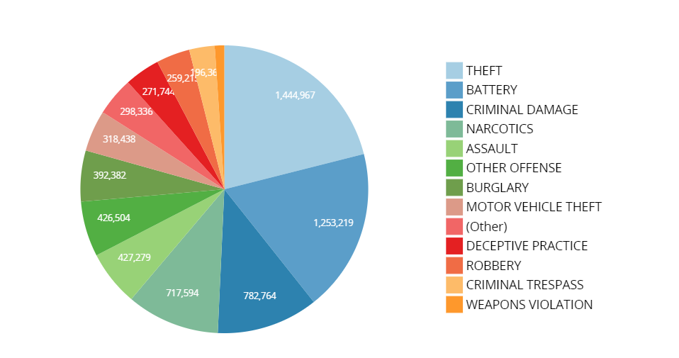

And here the map for the same data

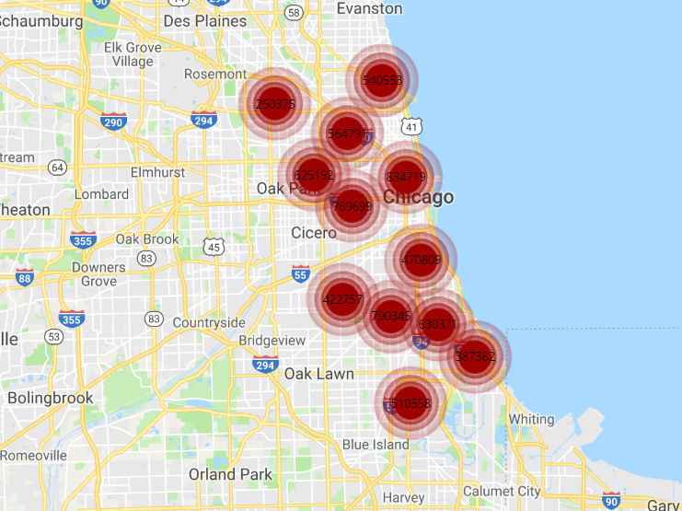

And here is comparing between numbers of crimes per year for same data

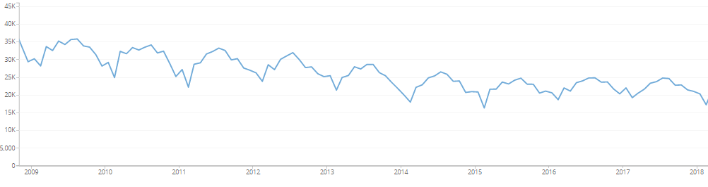

New York City: data (2018)

Depending on age and number of crimes

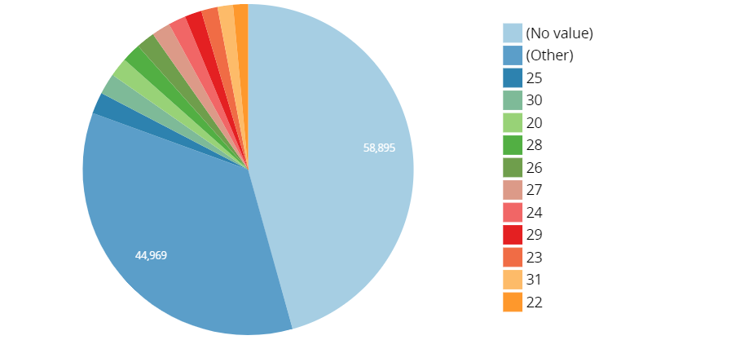

And here is depending on type of sex

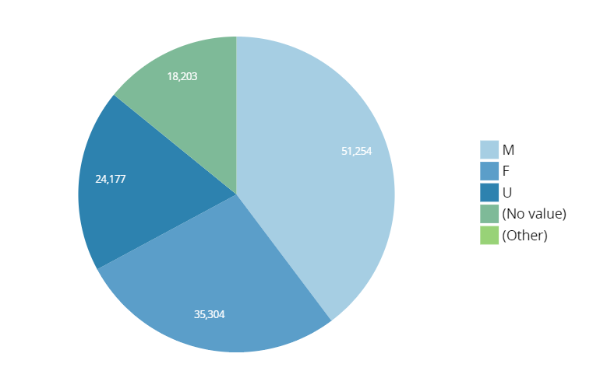

* San Francisco : data for (2003 -2018)

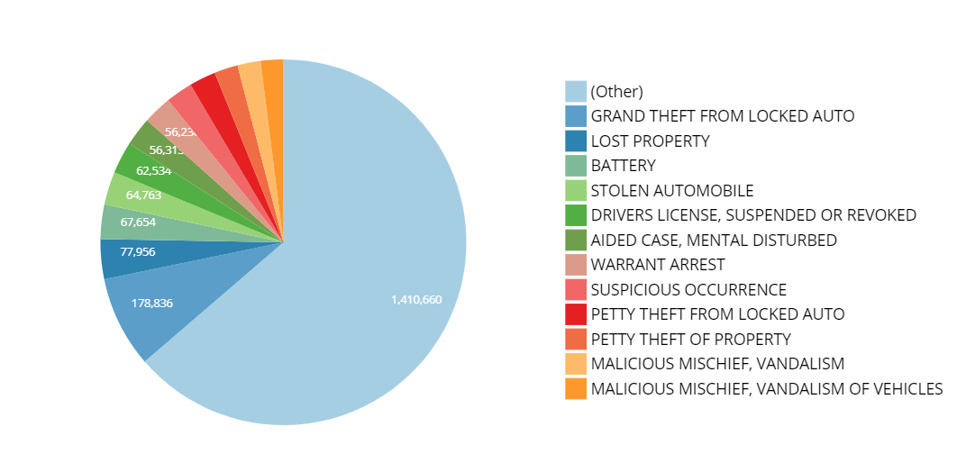

Crime per year in San Francisco:

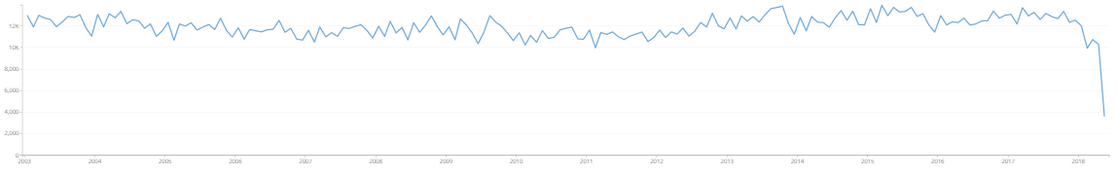

**Fetching Data**

* Bringing data from original sources using APIs.

Such as

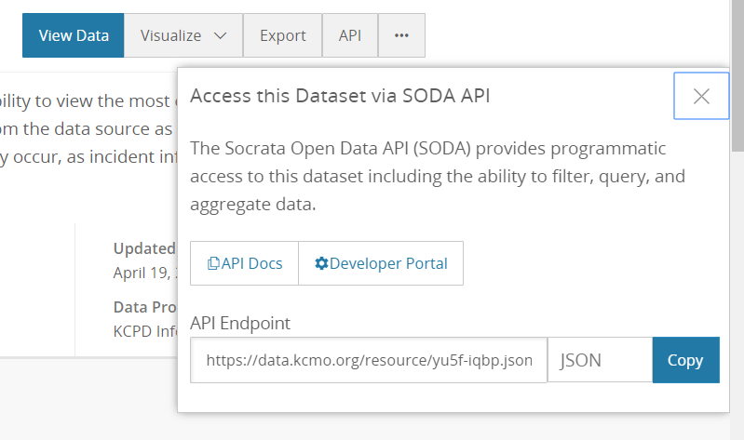

**Demo for the project:**

You can follow the link here to make analysis and visualization

In real time.

[http://167.99.174.57](http://167.99.174.57/)

Conclusion:

* From the analysis and visualization, we can notice that crimes are decrease every year.
* Chicago is most city has the crime rate among the four cities.
* The most significant type of crimes in all cities are theft and property damages.

FUTURE WORK

Adding more cities and adding additional classes to get fully understanding of crimes.

REFERENCES

[1] <https://data.kcmo.org>

[2] <https://data.cityofchicago.org/>

[3]  [https://opendata.cityofnewyork.us/](%20https://opendata.cityofnewyork.us/)

[4]  [https://datasf.org/opendata/](%20https://datasf.org/opendata/)