Project1 submitted by:

Name: Shweta Arande Net ID: mq3395

Sayali Peshwe Net ID: wn7569

1. DimAnimals

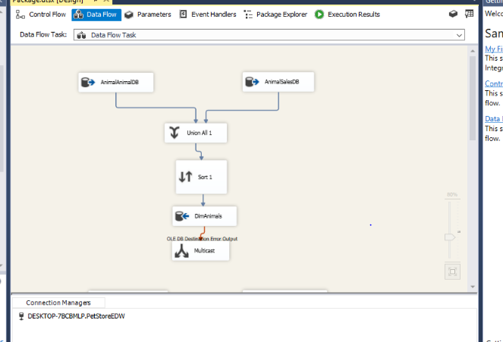

1. DimSupplier

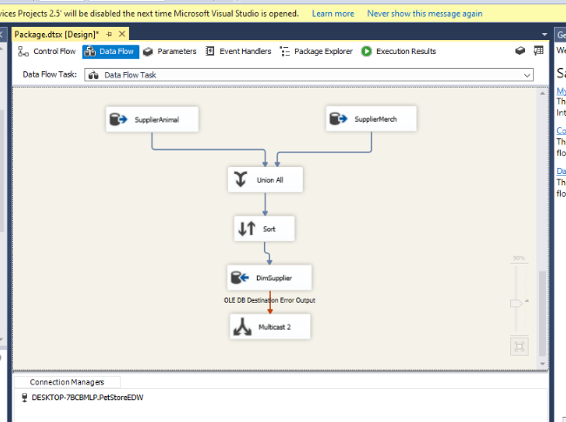

1. DimMerchandise

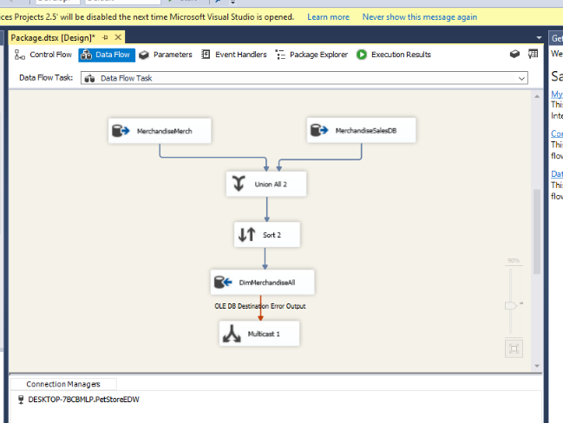

Identify dimensions

1. Employee
2. Supplier
3. Customer
4. Animal
5. Merchandise
6. City

Fact Tables

1. Sale
2. Sale Animal
3. Sale Item
4. Customer Account
5. Animal Order
6. Order Item
7. Merchandise Order

Conformed dimensions

* DimEmployee
* DimDate
* DimAnimal
* DimSupplier
* DimMerchandise

Are there any factless fact table and outriggers?

* Customer Account and Category are outrigger
* There are no factless fact table.

OLAP cube

1. Sale by customer

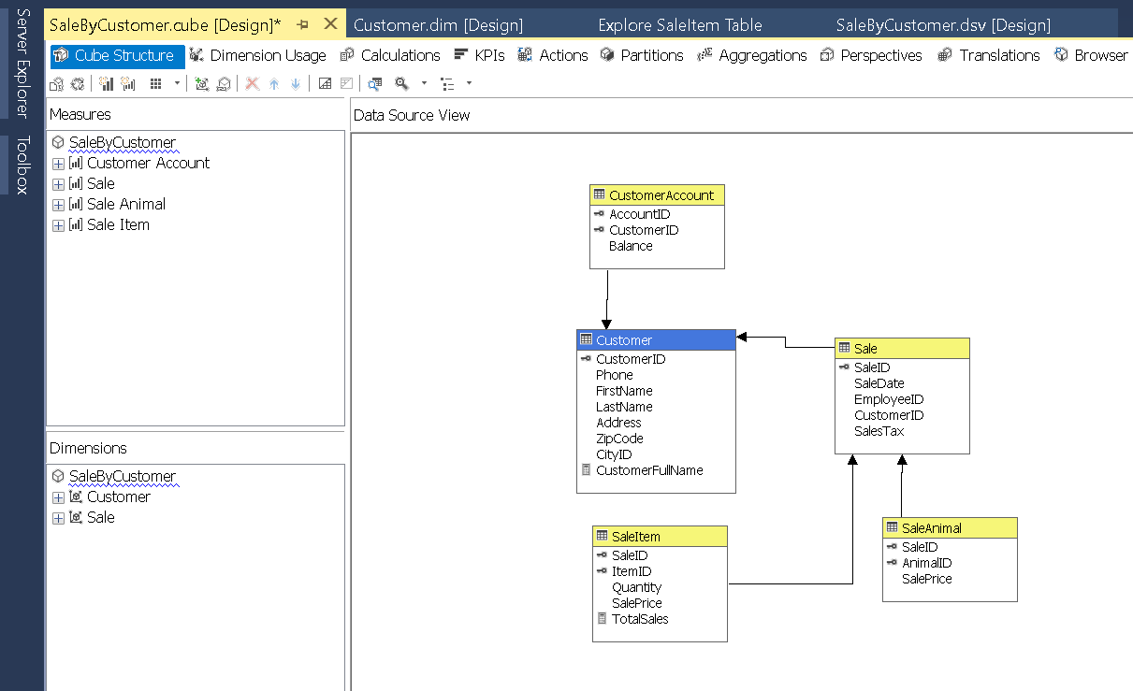

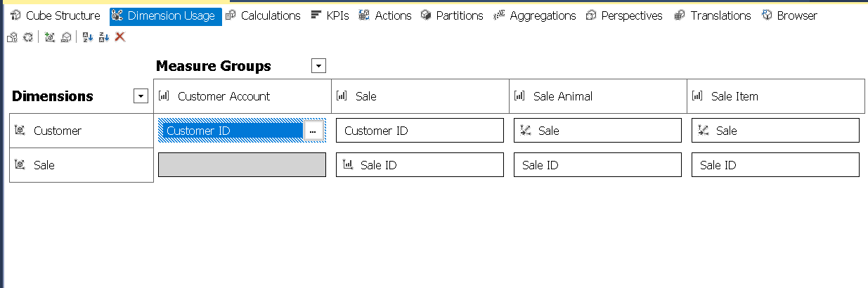

1. **Shipping costs By Supplier**

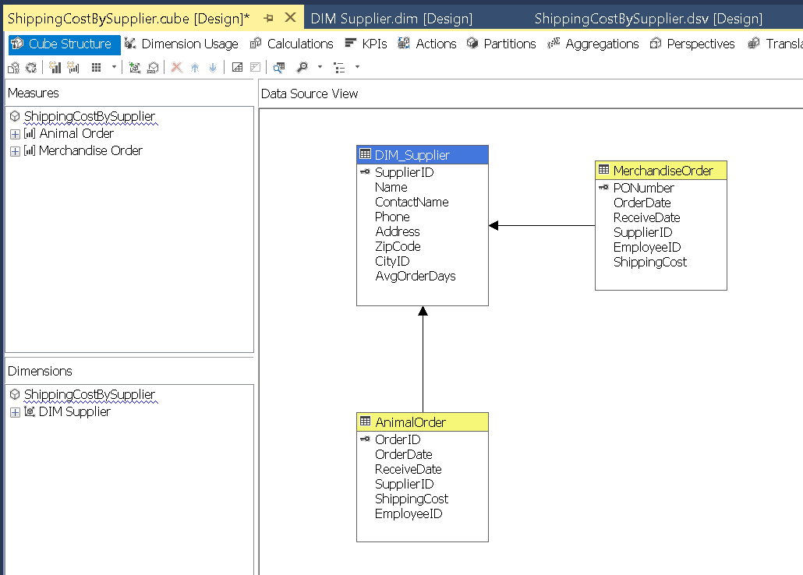

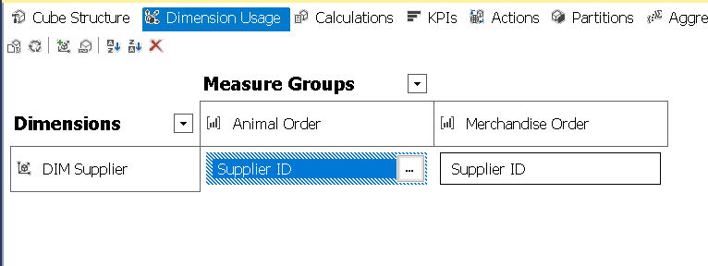

**Difference between list and sale prices By AnimalID**

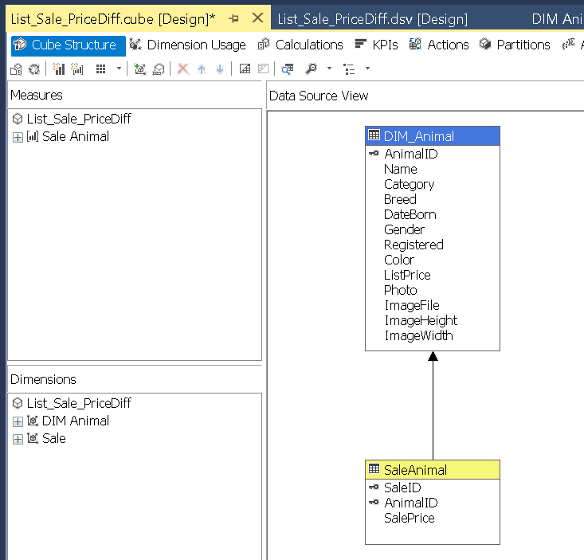

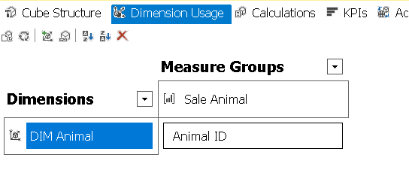

MDX Query

