Experiment -11
Name: Bhagyashri Uttam Chavan
Roll No: 4123
Title: Create a Simple Open Source To-Do List Application
1. Aim
To create a simple open-source To-Do List application that allows users to:
- Add new tasks
- Edit existing tasks
- Delete tasks
- Mark tasks as completed
2. Objectives
After completing this experiment, students will be able to:
- Understand the basic structure of an open-source web application.
- Create a simple user interface using HTML and CSS.
- Implement task operations using JavaScript.
- Understand basic CRUD operations:
  - Create → Add task
  - Read → Display task
  - Update → Edit task
  - Delete → Remove task
- Create a Git repository and share the project as an open-source project.

3. Software Requirements
Requirement | Software/Technology
Operating System | Windows/Linux
Editor | VS Code
Front-end | HTML, CSS
Programming | JavaScript
Browser | Chrome/Firefox/Edge
Version Control | Git
Repository | GitHub

4. Basic Concept
A To-Do List application is used to manage daily tasks.
For example:
My To-Do List

[ Enter a task................ ] [Add]

☐ Complete Java Assignment [Edit] [Delete]
☐ Attend OST Lecture [Edit] [Delete]
☑ Submit Lab Record [Edit] [Delete]
The application performs four basic operations:
To-Do Application
|
┌────────────┼────────────┐
↓ ↓ ↓
Add Edit Delete
| | |
Create Update Remove
Task Task Task

5. Project Folder Structure
Ask students to create the following folder:
TodoList/
│
├── index.html
├── style.css
└── script.js

6. Program
File 1: index.html
<!DOCTYPE html>
<html>
<head>
<title>Simple To-Do List</title>
<link rel="stylesheet" href="style.css">
</head>

<body>

<div class="container">

<h1>My To-Do List</h1>

<div class="input-section">
<input type="text" id="taskInput"
placeholder="Enter a task">

<button onclick="addTask()">Add Task</button>
</div>

<ul id="taskList"></ul>

</div>

<script src="script.js"></script>

</body>
</html>

File 2: style.css
body {
font-family: Arial, sans-serif;
background-color: #f2f2f2;
}

.container {
width: 500px;
margin: 50px auto;
background: white;
padding: 25px;
border-radius: 10px;
}

h1 {
text-align: center;
}

.input-section {
display: flex;
gap: 10px;
}

input {
flex: 1;
padding: 10px;
}

button {
padding: 10px;
cursor: pointer;
}

li {
margin-top: 15px;
padding: 10px;
background-color: #eeeeee;
list-style: none;
}

.completed {
text-decoration: line-through;
}

.edit-btn {
margin-left: 20px;
}

.delete-btn {
margin-left: 5px;
}

File 3: script.js
function addTask() {

let taskInput = document.getElementById("taskInput");
let taskText = taskInput.value.trim();

if (taskText === "") {
alert("Please enter a task.");
return;
}

let li = document.createElement("li");

li.innerHTML = `
<span onclick="completeTask(this)">
${taskText}
</span>

<button class="edit-btn"
onclick="editTask(this)">
Edit
</button>

<button class="delete-btn"
onclick="deleteTask(this)">
Delete
</button>
`;

document.getElementById("taskList").appendChild(li);

taskInput.value = "";
}

function editTask(button) {

let task = button.parentElement
.querySelector("span");

let newTask = prompt("Edit your task:", task.innerText);

if (newTask !== null && newTask.trim() !== "") {
task.innerText = newTask.trim();
}
}

function deleteTask(button) {

let task = button.parentElement;

task.remove();
}

function completeTask(task) {

task.classList.toggle("completed");
}

7. How the Program Works
Step 1 – Enter Task
The user enters:
Complete Java Assignment
and clicks Add Task.
JavaScript obtains the entered text using:
document.getElementById("taskInput")

Step 2 – Add Task
A new <li> element is created:
let li = document.createElement("li");
The task is then inserted into the task list.

Step 3 – Edit Task
When the user clicks Edit, the following function is called:
editTask(this);
A prompt appears:
Edit your task:
Complete Java Assignment
The user can enter:
Complete Java Assignment and Submit
The task is updated.

Step 4 – Delete Task
When Delete is clicked:
task.remove();
The selected task is removed from the webpage.

Step 5 – Mark Task as Completed
Clicking on the task calls:
completeTask(this);
The CSS class:
completed
is added or removed.
The completed task appears with a strikethrough.

8. Expected Output
Initially:
My To-Do List

[ Enter a task................ ] [Add Task]
After adding tasks:
My To-Do List

[ Enter a task................ ] [Add Task]

Complete Java Assignment [Edit] [Delete]

Attend OST Lecture [Edit] [Delete]

Submit Lab Record [Edit] [Delete]
After completing a task:
Complete Java Assignment [Edit] [Delete]
----------------------------
After editing:
Complete Java Assignment and Submit [Edit] [Delete]
After deleting:
Attend OST Lecture [Edit] [Delete]

Submit Lab Record [Edit] [Delete]

9. Open-Source Component
To connect this experiment with Open Source Technology, students should put the project on GitHub.
Step 1: Create Repository
Create a repository named:
simple-todo-list
Recommended description:
A simple open-source To-Do List application using HTML, CSS and JavaScript.
Step 2: Add Files
Upload:
index.html
style.css
script.js
Step 3: Add README
Students can create a README.md containing:
# Simple To-Do List

A simple open-source To-Do List application developed
using HTML, CSS and JavaScript.

## Features

- Add tasks
- Edit tasks
- Delete tasks
- Mark tasks as completed

## Technologies Used

- HTML
- CSS
- JavaScript

## How to Run

1. Download or clone the repository.
2. Open index.html in a web browser.

## License

MIT License

10. Git Commands
Experiment can also be performed using Git:
git init
git add .
git commit -m "Initial To-Do List application"
Connect the local repository to GitHub:
git remote add origin <repository-url>
Then:
git branch -M main
git push -u origin main
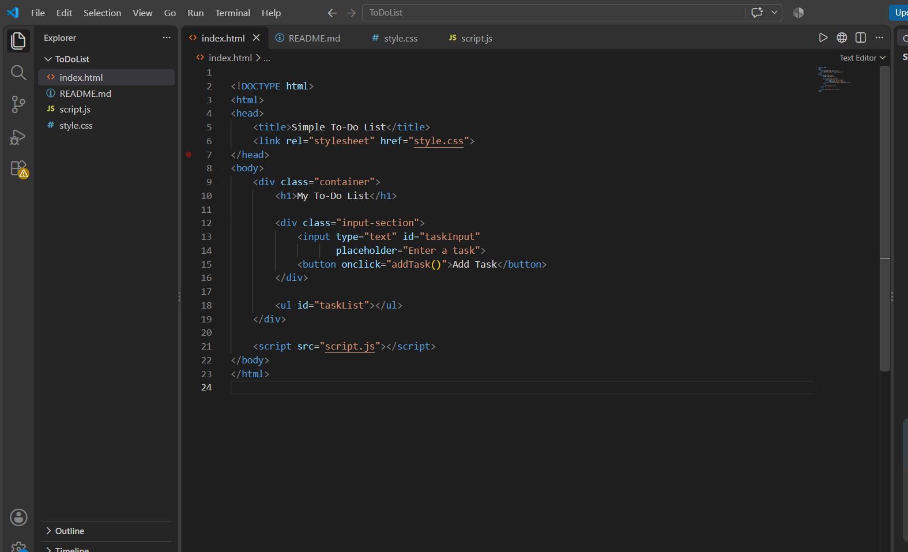
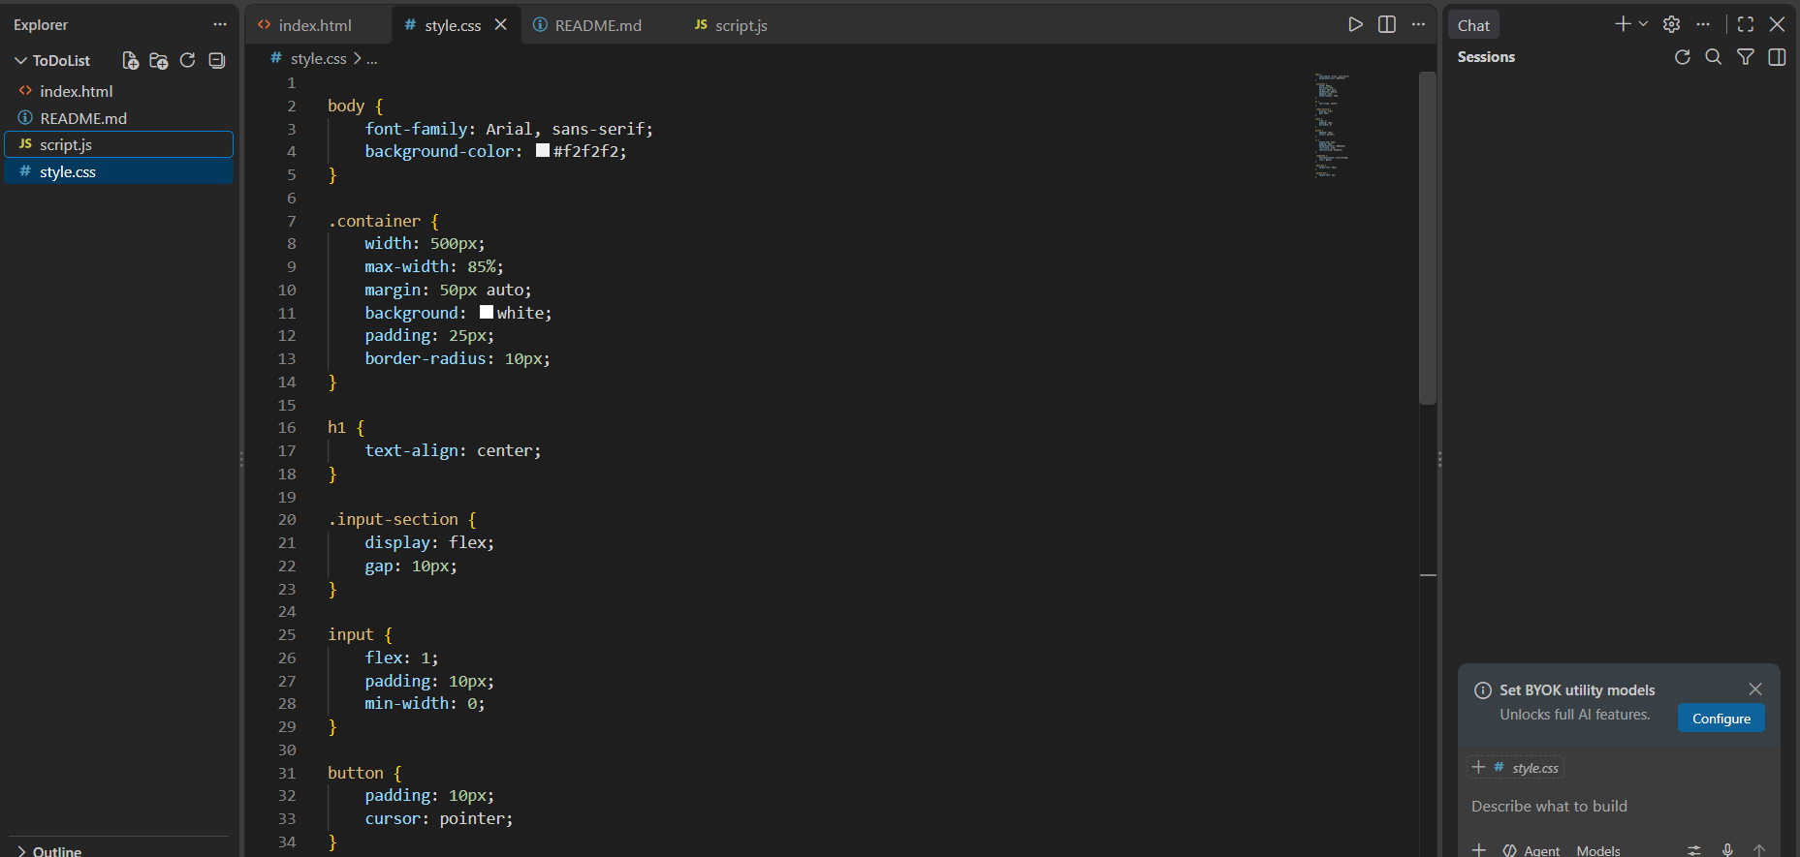
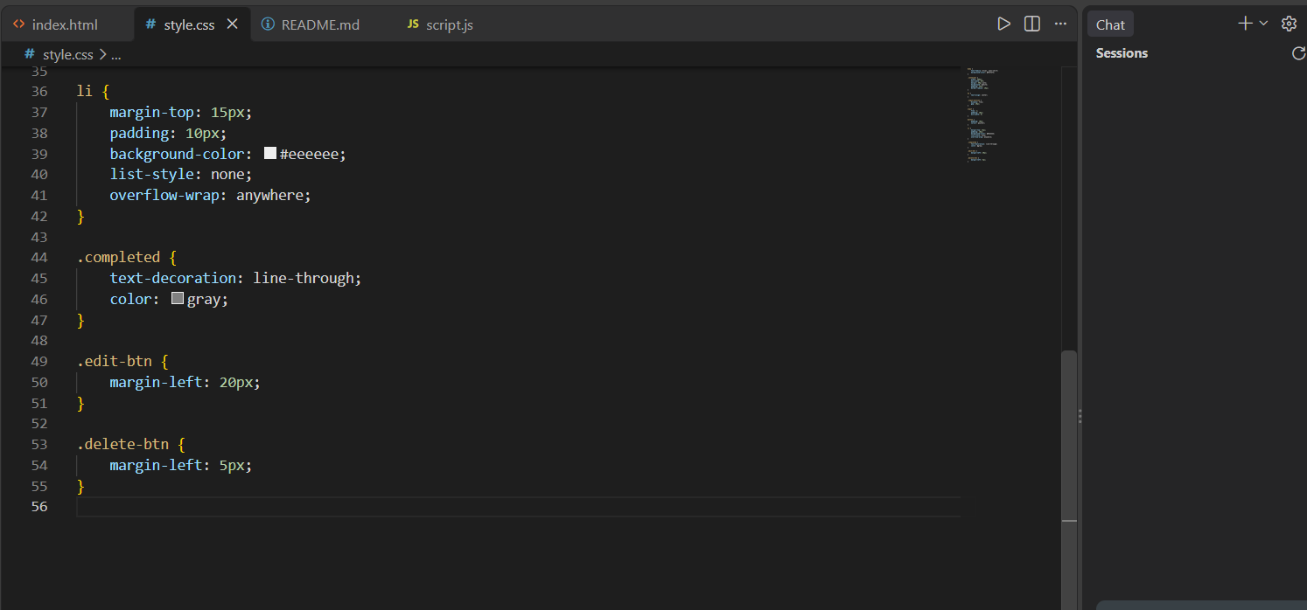
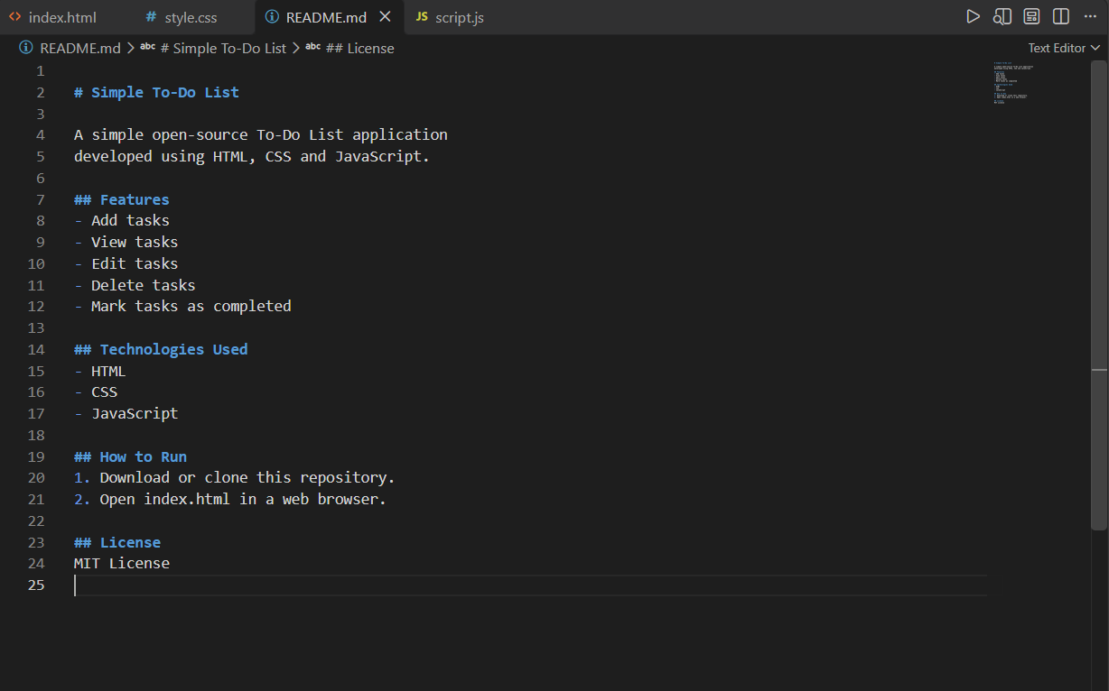
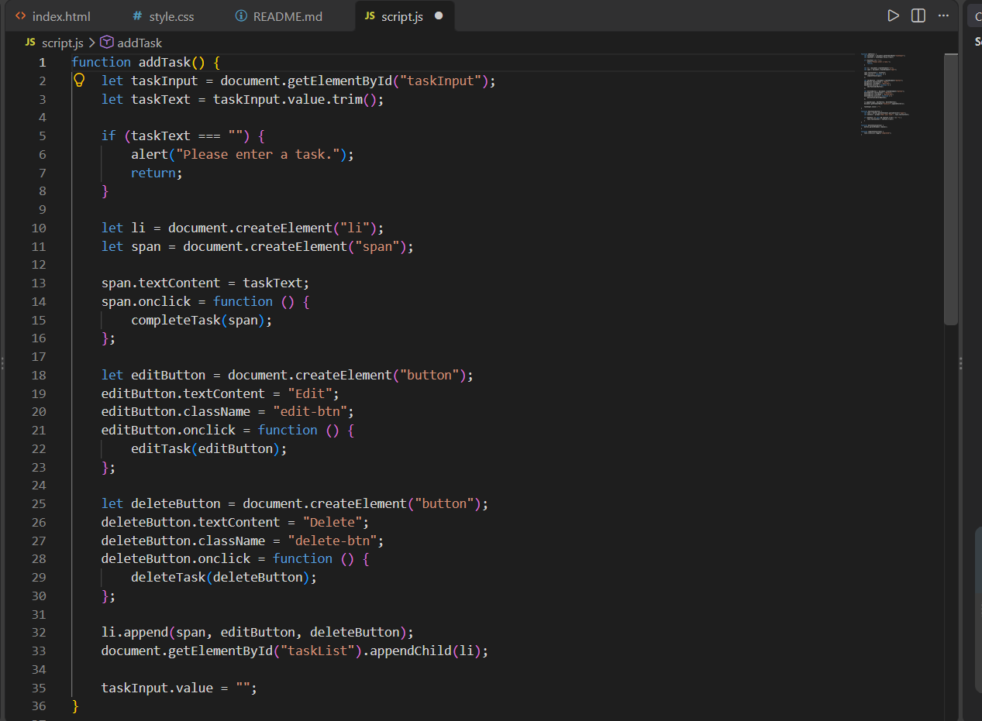
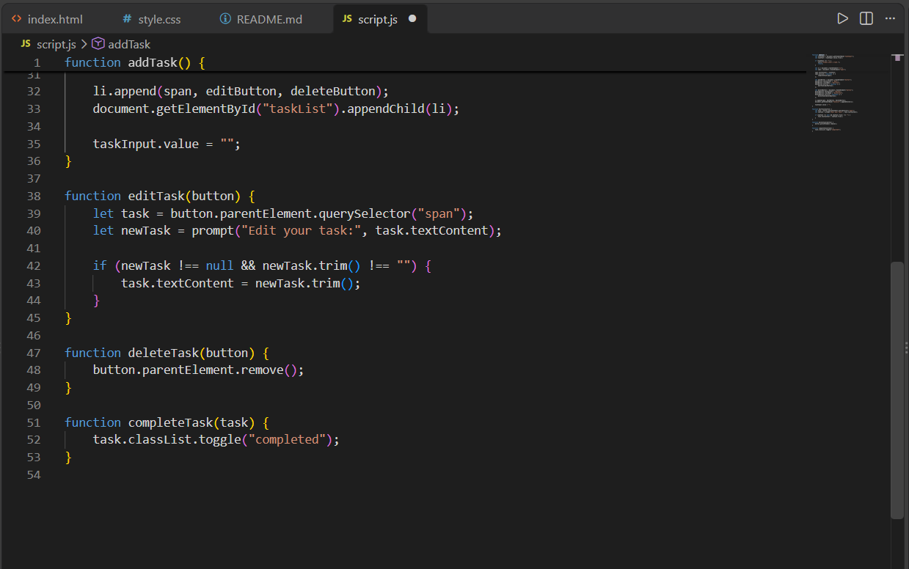
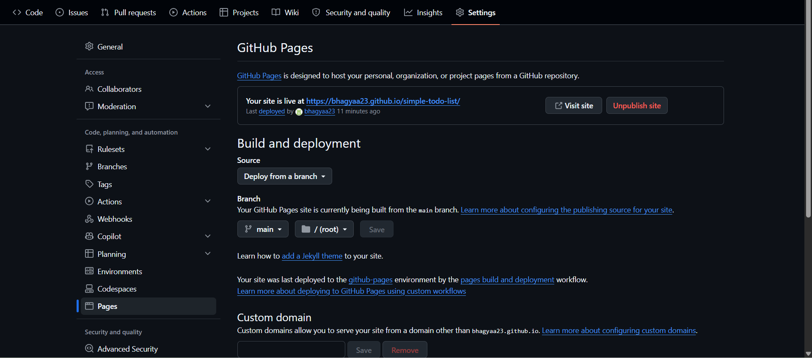
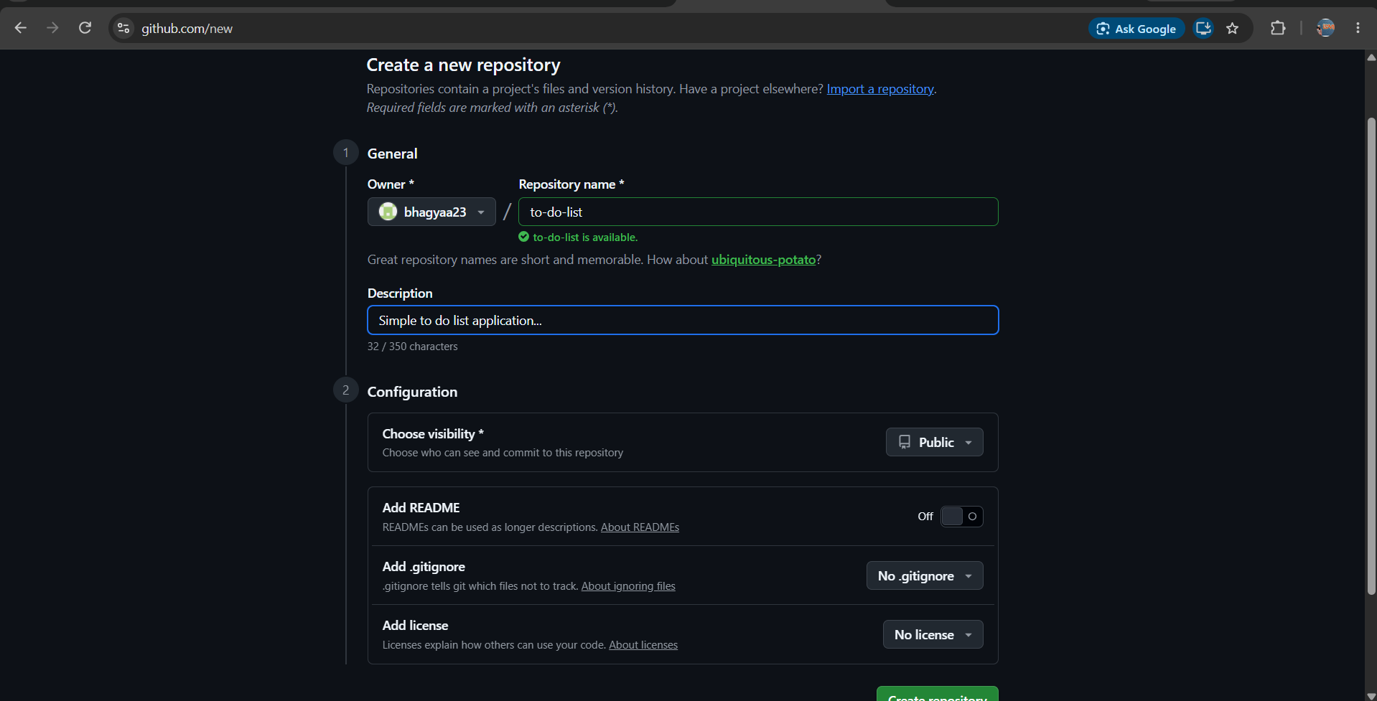
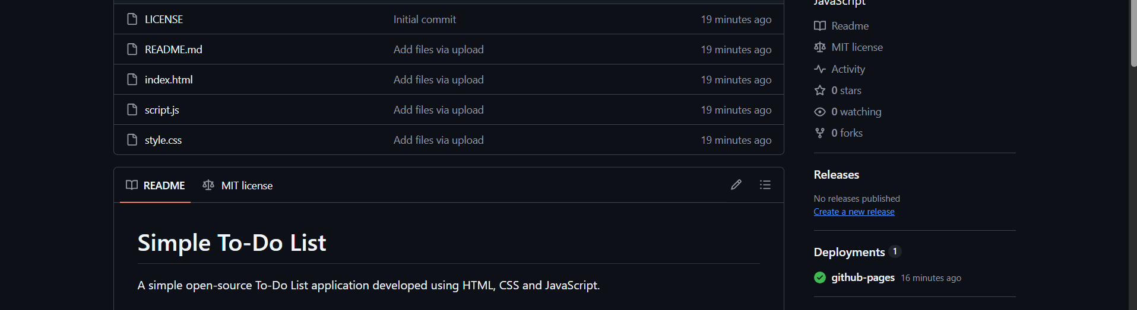
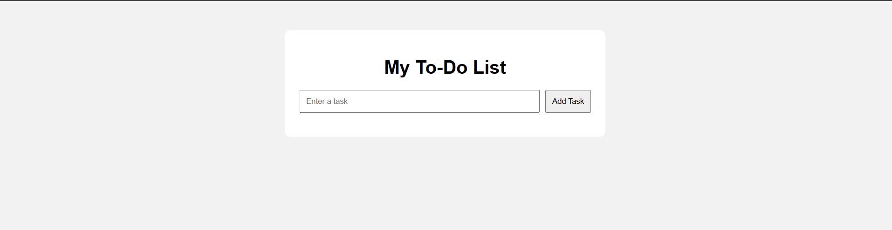
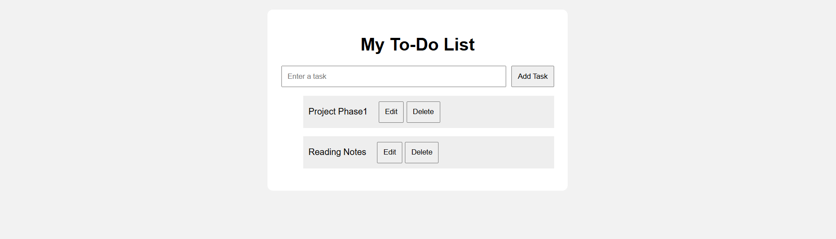

11. Result
The Simple Open Source To-Do List application was successfully developed using HTML, CSS and JavaScript. The application allows users to add, edit, delete, and mark tasks as completed. The project was also prepared for sharing through a Git/GitHub repository.

